**Abstract**

This project aims to develop a comprehensive Placement Management System to streamline and automate the placement process for students, placement officers, and administrators. The system enables students to register, explore active companies, and view announcements, while allowing administrators to manage company activations, registrations, and placement records. Built using PHP and MariaDB, the system ensures efficient data handling, user-friendly interfaces, and robust functionality.

**Technical Keywords**: PHP,MariaDB, HTML, CSS, Bootstrap, JavaScript, SQL, MySQL, Localhost, Responsive Web Design, Dashboard, Student Dashboard, Placement Officer Dashboard, Head of Department Dashboard, User-Friendly Interface, College Website Integration, Google Image Sourcing, CRUD Operations, Role-Based Access Control (RBAC)

**Introduction**

Social Requirements-

The placement process is a critical component of educational institutions, connecting students with potential employers. A centralized platform is essential to:

* Simplify and manage student-company interactions.
* Provide real-time updates on placement activities.
* Maintain accurate placement records for institutional transparency.

Existing Solutions-

1. Manual handling of placement processes using spreadsheets.
2. Isolated systems with limited integration for students and administrators.
3. External third-party platforms with generic solutions.

Drawbacks of Existing Solutions-

* Lack of customization for institution-specific needs.
* Inconsistencies in data storage and accessibility.
* Inefficiency in tracking and managing placement-related activities.
* Absence of real-time notifications and updates.

**CHAPTER 2:**

**Problem Definition**

The existing methods of managing placement activities are disorganized and inefficient, leading to delays, errors, and a lack of proper communication between stakeholders.

**Proposed Solution**

Developing a centralized Placement Management System to:

1. Digitize student registrations and company activations.
2. Provide a streamlined dashboard for administrators to monitor placement activities.
3. Facilitate seamless communication through announcements and notifications.
4. Allow students to explore placement opportunities and track their progress.

**Objectives**

* Simplify placement-related tasks for all users.
* Ensure data security and accuracy through a robust database.
* Enhance user experience with an intuitive interface.
* Enable future scalability and integration with external systems.

CHAPTER 3

DATABASE DIAGRAMS

DFD DIAGRAM

HOME PAGE

ADMIN LOGIN

HOD LOGIN

STUDENT LOGIN

ADMIN DASHBOARD:

* View Student Details
* Adds Announcement File
* Activate Registration for Specific company

HOD DASHBOARD:

* View Student Details
* View Announcement Section

STUDENT DASHBOARD:

* View Profile[They can update also]
* View Announcement Section
* Register for active company
* If they are registered they can see their allotted room

**CHAPTER 4**

**Results And Discussions**

**Results**

* Login System: Allows students, HODs, and admins to access role-specific dashboards.
* Explore:Recommends students to use some open source platforms.
* Admin Dashboard: Includes features to activate companies, view registrations, and manage announcements,update and delete students information,with appropriate useful filters for sorting based on their needs.
* Student Dashboard: Displays profile details,update details,apply for active companies, view allocated lab and announcements.

**Screenshots with Explaination**

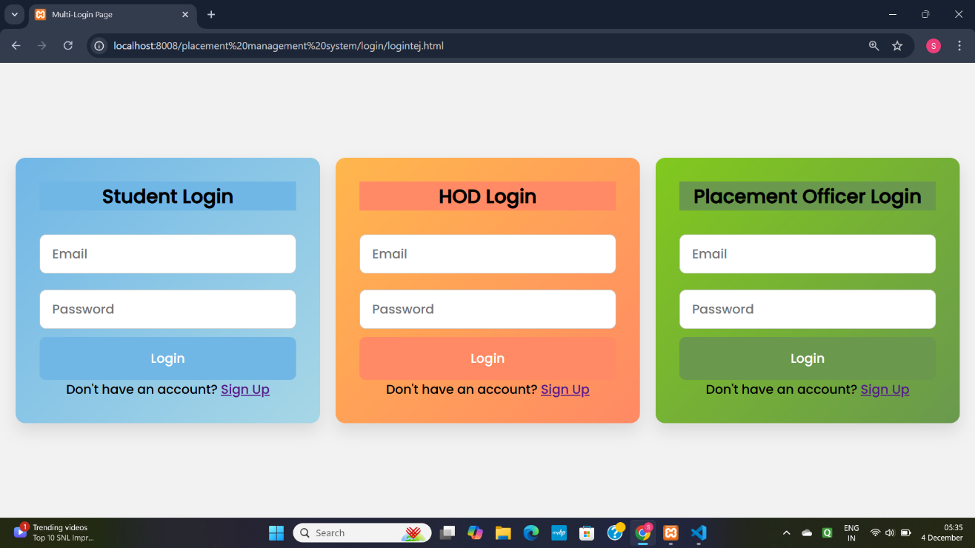

**Figure 1-Login page**

Figure 1shows login page for students,HoD,Admin or placement Officer based on their Specific Role.

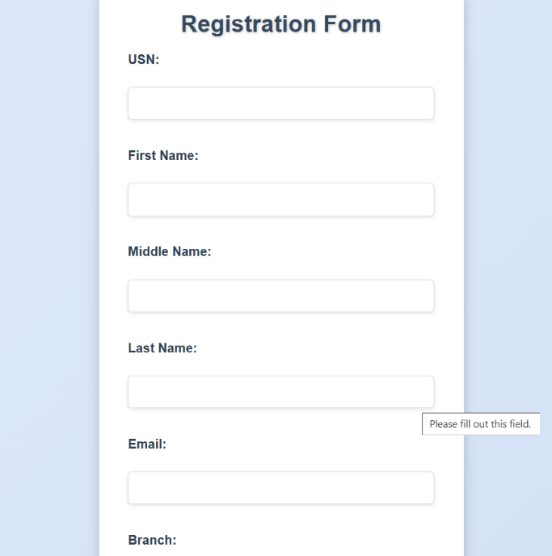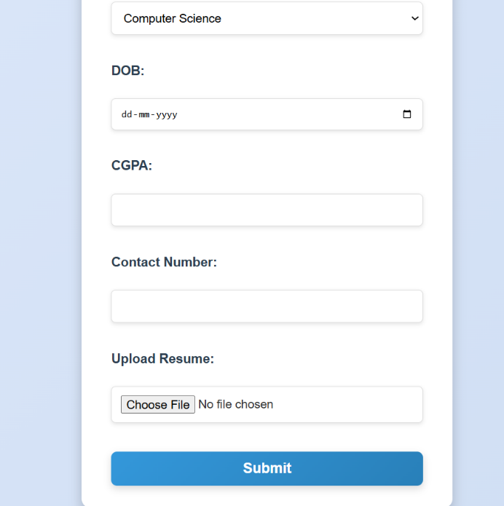

**Figure 2-Student Registration Form**

Figure 2:Shows registration form which captures essential student details.



**Figure 3-Student Dasboard**

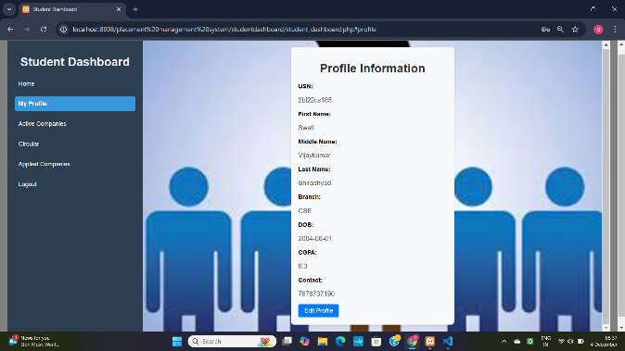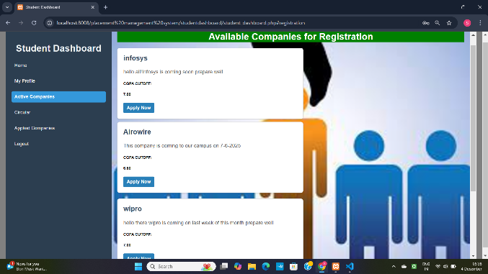

Fig.3(1) Fig.3(2)

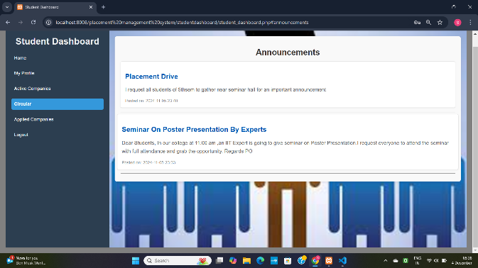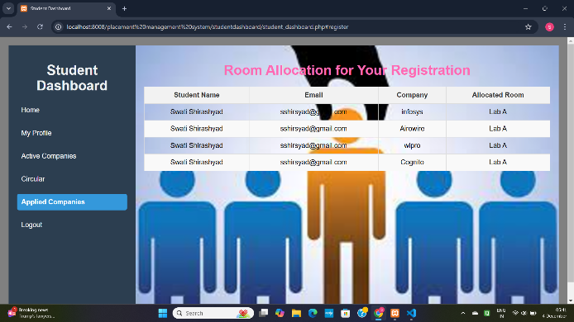

Fig.3(3) Fig.3(4)

**Figure 3 shows the student dashboard and the features thay can extract.**



**Figure 4-Admin Dashboard**

**ALGORITHM DETAILS**

Login and Authentication

* + Utilizes secure password hashing algorithms to store and verify user credentials, ensuring the system's security.

Company Activation

* + Implements a condition-based SQL logic to toggle the activation status of companies in the database. This logic enables administrators to mark companies as active or inactive.

Registration Management

* + Includes logic to insert, update, or retrieve registration data:
    - Ensures foreign key constraints maintain data consistency.
    - Checks the active status of companies to allow valid registrations.

Data Display and Management

* + Relies on sorting and filtering mechanisms within SQL:
    - ORDER BY for sorting data (e.g., by GPA or registration date).
    - GROUP BY for categorizing information (e.g., by department or job type).
    - JOIN queries for consolidating data across multiple tables.

Announcement System

* + Follows a structured approach for managing announcements through CRUD (Create, Read, Update, Delete) operations:
    - Insertion and updates of announcements.
    - Retrieval with sorting or filtering for relevance.
    - Deletion of outdated announcements.

**Conclusion**

The Placement Management System successfully streamlines the placement process, reduces manual effort, and enhances communication between stakeholders. The modular architecture ensures scalability and reliability.

**Future Scope**

* Integration with external job portals.
* Implementation of analytics for placement statistics.
* Addition of features like resume building and interview scheduling.
* Expanding the system to include alumni placement tracking.

**References**

**1.**ChatGPT

Used to obtain code snippets and suggestions for improvements in project design and functionality. It also provided detailed explanations for implementing PHP and database connectivity.

2.YouTube Tutorials

Referred to various instructional videos to understand:

* + - Running PHP scripts effectively.
    - Connecting PHP with databases for dynamic functionality.

1. College Website
   * URL: <https://www.bldeacet.com>
   * Used as a source for relevant images and for studying placement processes followed at the institution.
2. Google Search
   * Utilized for additional research, including documentation, troubleshooting guides, and general programming resources.