

**CAPSTONE PROJECT REPORT**

**Report 4 – Software Design Document**

**I. Project Report**

**1. Status Report**

| **#** | **Work Item** | **Status** | **Notes(Work Item in Details)** |
| --- | --- | --- | --- |
| 1 | Overall Description | Pending |  |
| 2 | System Architecture Design | Pending |  |
| 3 | System Detail Design | Pending |  |
| 4 | Object Specification | Pending |  |
| 5 | Data & Database Design | Pending |  |

**2. Team Involvements**

| **#** | **Work Item** | **Meber** | **Notes(Work Item in Details)** |
| --- | --- | --- | --- |
| 1 | Overall Description |  |  |
| 2 | System Architecture Design |  |  |
| 3 | System Detail Design |  |  |
| 4 | Object Specification |  |  |
| 5 | Data & Database Design |  |  |

**3. Issues/Suggestions**

**II. Software Design Document**

**1. Overall Description**

**1.1 Assumption**

This system is designed based on the following assumptions:

* Window 10, 11
* ReactJs
* MySQL

**1.2 Design Constraints**

**1.3 Technology Suggestion**

* Database: MySQL
* Web Application: SpringBoot
* Server: Local server

**2. System Architecture Design**

**2.1 Overall Architecture**

**2.1.1 Diagram**

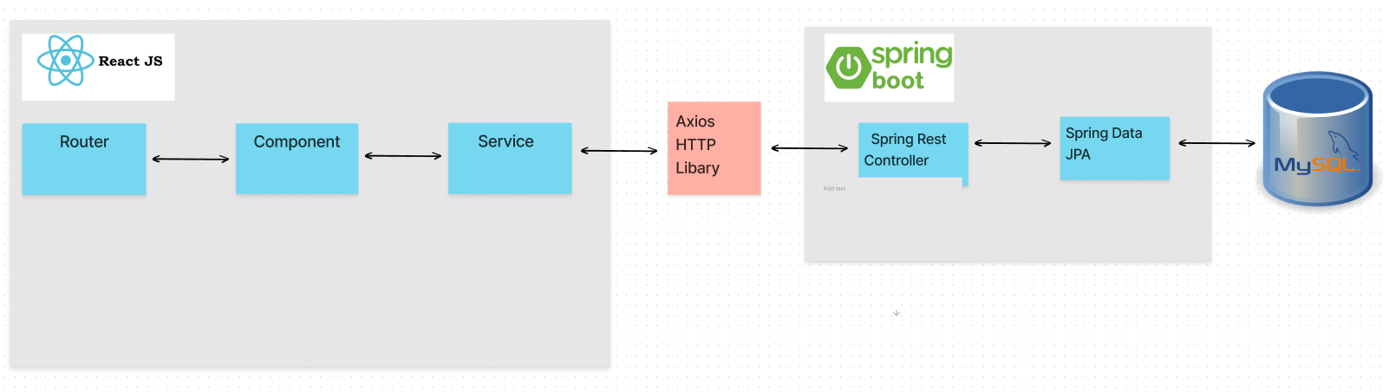

**2.2.2 Component Explanation**

**2.2.2.1 ReactJS**

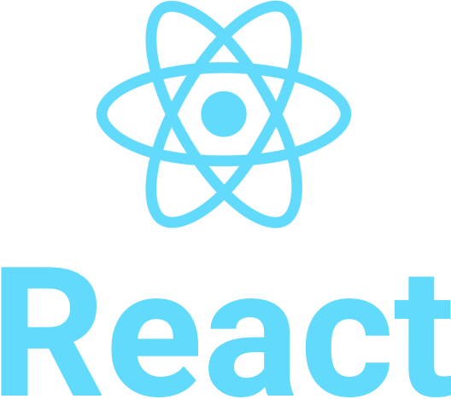

ReactJS is a free and open-source front-end JavaScript library for building user interfaces based on UI components. It is maintained by Meta (formerly Facebook) and a community of individual developers and companies. React can be used as a base in the development of single-page, mobile, or server-rendered applications with frameworks like Next.js. However, React is only concerned with state management and rendering that state to the DOM, so creating React applications usually requires the use of additional libraries for routing, as well as certain client-side functionality.

**2.2.2.2 MySQL**

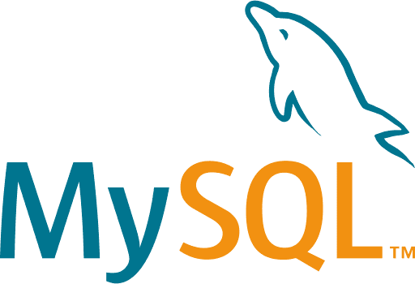

MySQL is an open-source relational database management system (RDBMS). A relational database organizes data into one or more data tables in which data types may be related to each other; these relations help structure the data. SQL is a language programmers use to create, modify and extract data from the relational database, as well as control user access to the database. In addition to relational databases and SQL, an RDBMS like MySQL works with an operating system to implement a relational database in a computer’s storage system, manages users, allows for network access and facilitates testing database integrity and creation of backups.

**2.2.2.3 Spring Boot Framework**

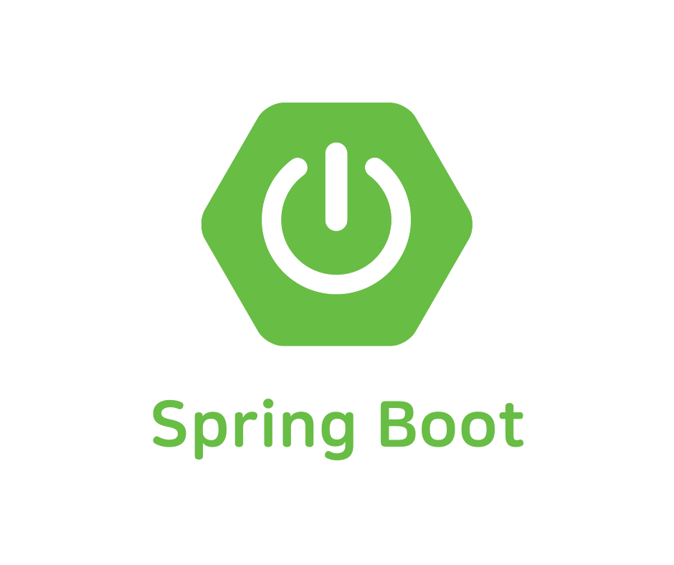

The Spring Boot Framework is an application framework and inversion of control container for the Java platform. The framework’s core features can be used by any Java application, but there are extensions for building web applications on top of the Java EE (Enterprise Edition) platform. Although the framework does not impose any specific programming model, it has become popular in the Java community as an addition to the Enterprise Javabeans (EJB) model. The Spring Framework is open source