Practical Exam: SWD392 –SP26

Duration: 85 Minutes

Business Overview
Vincom Food Court hosts multiple restaurants serving dine-in customers inside the shopping mall. To support daily operations, a restaurant management system is introduced to manage menu presentation, order placement, food preparation, and payment processing.
Customers browse the menu and place food orders. Staff members are responsible for receiving and confirming orders, while chefs prepare dishes in the kitchen. Once an order is paid, it is processed, prepared, served, and finally completed.
The system does not support food delivery or advanced promotional features. The purpose of this exam is to assess your ability to design system architecture and UML models rather than implement application logic
This examination evaluates your understanding of software architecture design and UML modeling. You are not required to write any source code. All answers must be presented using UML diagrams, including Class Diagram, Sequence Diagram, and State Diagram.
Students may choose either Layered Architecture or Microservices Architecture. The selected architecture must be applied consistently across all diagrams.
The use of the Repository Pattern is mandatory.
Students may make reasonable assumptions if necessary, provided they do not contradict the given business context.

Question 1 (3.0 points) – Class Diagram
You are required to design a design-level Class Diagram that represents the core structure of the restaurant management system. The system involves multiple user roles with shared attributes and specialized responsibilities. Customers place orders, staff members handle order confirmation and service, and chefs are responsible for food preparation.
Menus consist of multiple menu items, and each order is composed of several order items. Every order is associated with a payment. To ensure clean architecture and separation of concerns, business logic is handled by a service layer, while data access operations are delegated to repositories that implement a generic repository interface.
Your Class Diagram must satisfy the following requirements:
- Customer, Staff, and Chef must be specialized types of User using inheritance.
- A Menu contains multiple MenuItem objects.
- A Customer can create multiple Order objects.
- Each Order is composed of multiple OrderItem objects.
- Each Order is associated with exactly one Payment.
- Repository classes must implement a generic Repository<T> interface.
- The service layer depends on repository classes to perform business operations.
The diagram must correctly apply UML relationships, including:
- Inheritance and interface implementation
- Association, aggregation, and composition where appropriate
- Dependency relationships between service and repository layers
Attributes, methods, and multiplicities should be defined clearly and reasonably.
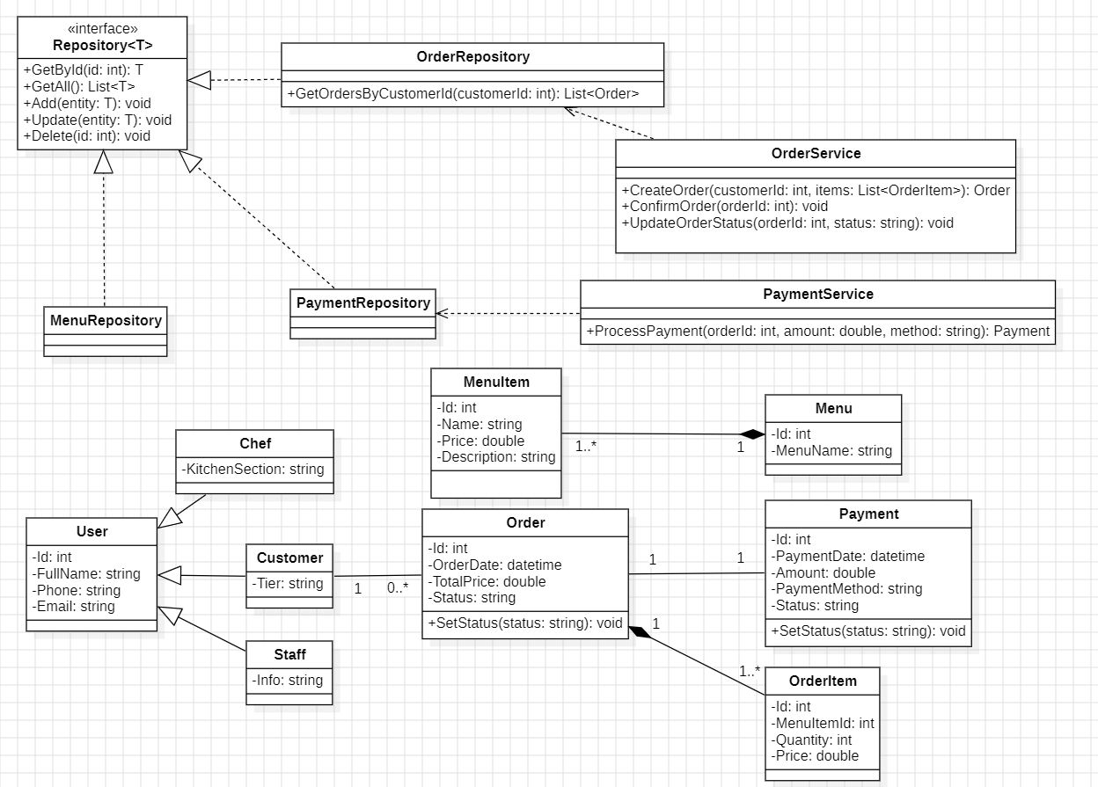

Question 2 (4.0 points) – Sequence Diagram

Use Case: Place Order and Pay
This question focuses on the interaction flow that occurs when a customer places a food order and completes payment. The process begins with the customer selecting menu items and creating an order. The order is then confirmed by staff members, followed by payment processing. If the payment is successful, the order is forwarded to the kitchen for preparation. If payment fails, the process ends without further order handling.
You are required to model this workflow using a Sequence Diagram, showing how interactions flow through system components or services based on the selected architecture.
Your Sequence Diagram must meet the following requirements:
- The architecture must be either Layered Architecture or Microservices Architecture and applied consistently.
- The interaction flow must clearly include:
  - A user-facing component (UI or boundary, such as POS or Customer App)
  - A controller or service component handling business logic
  - Repository components responsible for data access
  - Domain entities such as Order, OrderItem, and Payment
- Repository Pattern usage must be explicit through repository method calls.
- Conditional behavior must be modeled using alt fragments for:
  - Payment success
  - Payment failure
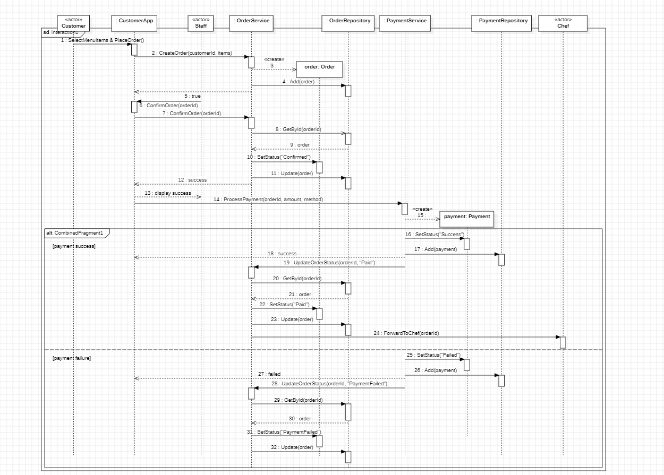

Question 3 (3.0 points) – State Diagram

Target: Order Lifecycle Management
In the Vincom restaurant system, each Order goes through a series of states from the moment it is created until it is completed or cancelled. The system must track order status to ensure proper coordination between staff members and chefs, and to handle cases such as payment failure or order cancellation.
You are required to design a State Diagram for the Order entity, describing the full lifecycle of an order in a dine-in restaurant scenario. The diagram should clearly show the states an order can be in, as well as the events that trigger transitions between those states.
Your State Diagram must satisfy the following requirements:
- The diagram must include a clearly defined initial state and final state.
- The diagram must include at least the following states (state names may vary, but the meaning must be preserved):
  - Created – the order has been created by the customer
  - Confirmed – the order has been confirmed by staff
  - Paid – payment has been completed successfully
  - Preparing – the kitchen is preparing the food
  - ReadyToServe – the food is ready to be served
  - Served – the food has been served to the customer
  - Completed – the order lifecycle is finished
- The diagram must include an alternative termination state such as Cancelled or PaymentFailed to represent unsuccessful scenarios.
- At least six state transitions must be shown, each with a clear triggering event, such as:
  - confirmOrder
  - paySuccess
  - payFail
  - startCooking
  - finishCooking
  - serveOrder
  - closeOrder
- At least one branching path must represent payment failure or order cancellation.
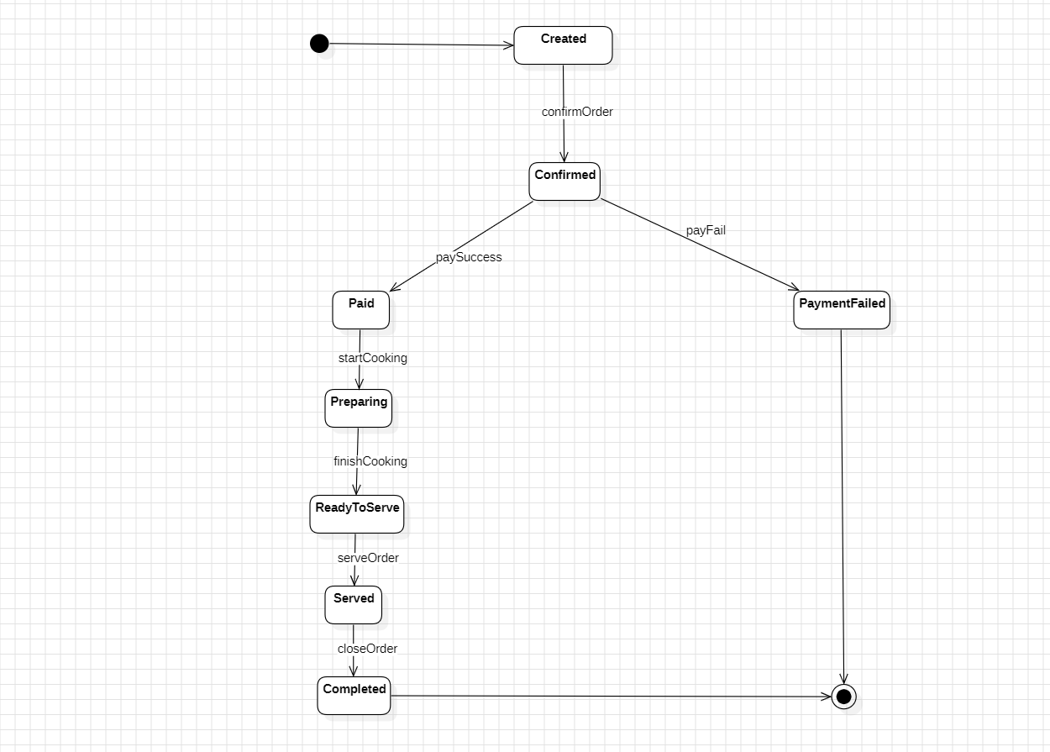
END OF EXAMINATION
(Invigilators will not provide further explanations)

