**Login Page of the Todo List App:**

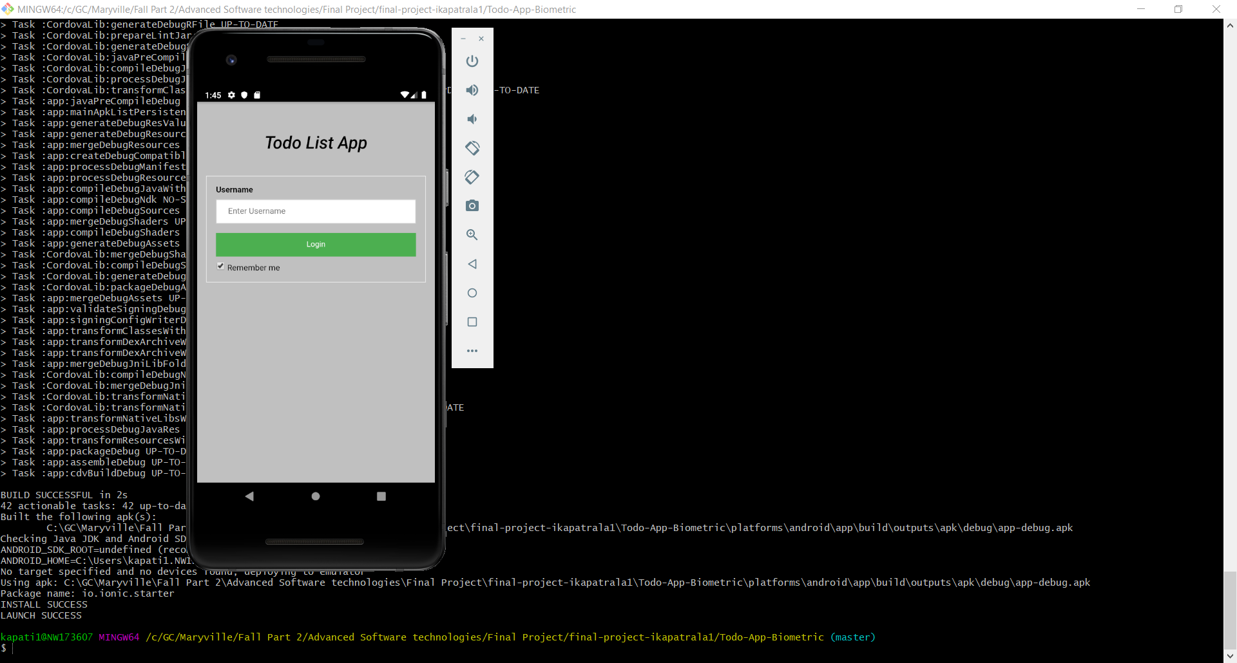

**FingerPrint Authentication:**

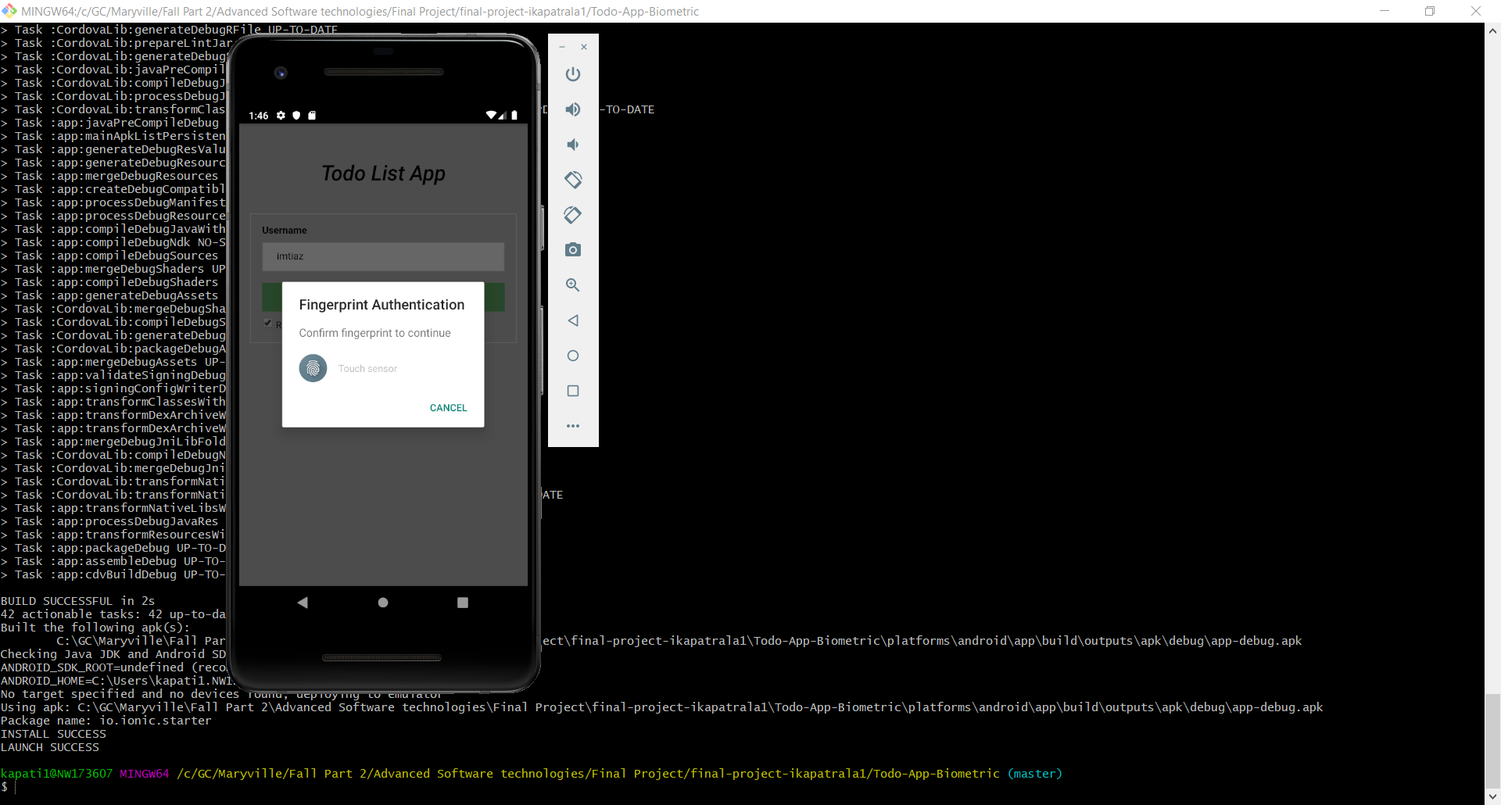

**User Logged In after the authentication, and navigated to “Dashboard” page**

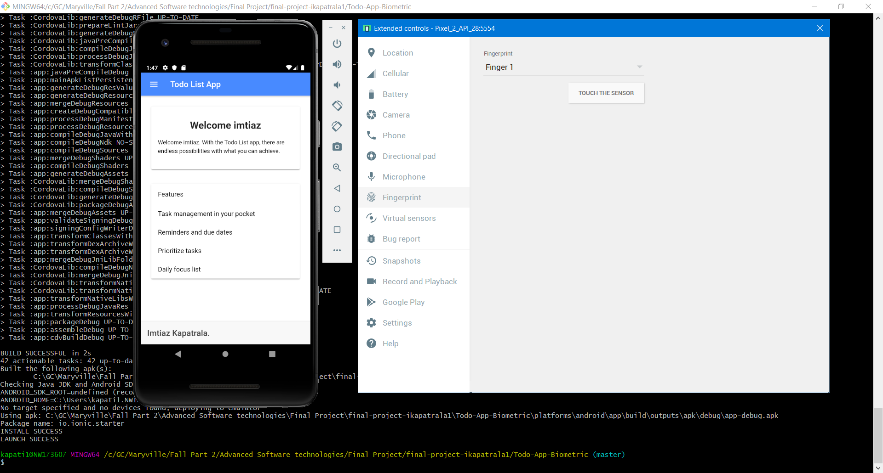

**User navigated to the “Home” page**

