Week 8 | Final App Project – Vendor Blendor  
**Developer:**   
Kerry Faine

**Background**:   
The F-M Vendor Blendor group is an event planning organization that provides low-cost opportunities to home-based businesses to market and sell products in a brick-and-mortar setting. It is a constant challenge to market through social media outlets due to changing rules and limitations. Therefore an idea was presented by the founding member, Kerry Faine, to create a mobile application in which our group would have control over the marketing and provide our members an added marketing benefit.

**Purpose:**   
As a small home-business owner it can be a challenge to find quality public events to participate in for marketing and promotion. As an event or fundraiser coordinator it can be equally difficult to find quality home-based businesses to feature. As an event attendee, it can be difficult to find vendor events that have diverse product lines. The *Vendor Blendor* app hopes to solve this problem by providing tools to connect event coordinators with home-based business owners for more successful events for the community.

**Current Features for initial beta-release version:**

* Events
  + List of events registered with the application that includes a slide effect to display buttons that give the ability to:
    - View vendors registered for the event
    - Send an application to register a business for an event
    - Share the events with friends via social sharing functions.
  + Ability to add new events
* Vendors
  + List of vendors registered with the application
  + Ability to share the business with friends via social media, email or text.
  + Ability to visit the business website to shop directly with them.
  + Contact information to businesses for direct customer service or reorders.
  + Ability to add a new vendor to the list.
* About Us
  + Information regarding the goal of the application
  + Contact information for the development group (aka me)
  + Notice of application development in progress by student developer

Note: All styles are sourced from the app.scss file in order to provide a consistent look and feel through themes.

**Future Features for release to market version:**

* Maps – the ability to click an address and pull up a map to the event.
* Ratings – the ability to rate an event or vendor
* Login/Authorization/Registration – the ability to log in for personalization features (i.e. ratings, one-click event registration, etc.)
* Integrated Calling feature – ability to make phone calls from within the application.
* Integrated Email feature – ability to create emails from within the application.
* Incorporation of remote backend database (i.e. SQL server or MongoDB)

**Assignment Questions:**

1. GitHub Repository URL  
   <https://github.com/SWDV-665/final-project-kerryfaine>
2. How many hours do you estimate you used completing this assignment?  
   It took me approximately 30 hours to finish this assignment along the course of the past 6 weeks.
3. What was easiest for you when completing this assignment?  
   Overall the items in this assignment were not difficult to complete. I enjoyed learning about the different elements contains within this application.
4. What was the most difficult challenge you experienced when completing this assignment?  
   Coming up with an idea was a challenge. Also, incorporating Cordova elements proved to also be a challenge. I will continue my work on this application to bring it up to a releasable version.

**Project Walkthrough with Technical Details**

1. Events
   1. Upon initial load, users are presented with a list of events. All event data is managed by a custom Angular service called the VendorBlendorServiceProvider.

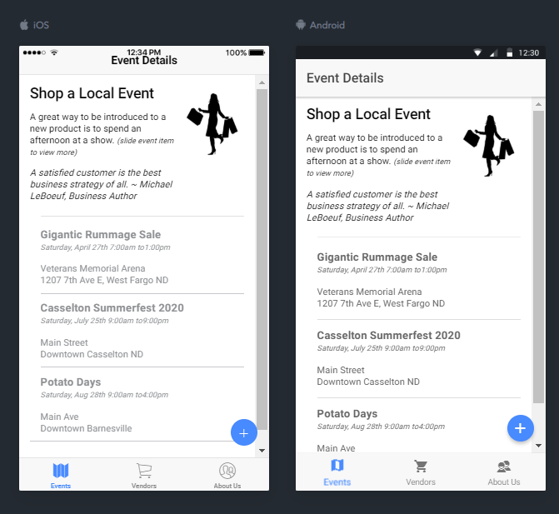

* 1. User’s can slide any item to the right to view a context menu of additional options: Vendors, Add and Share.

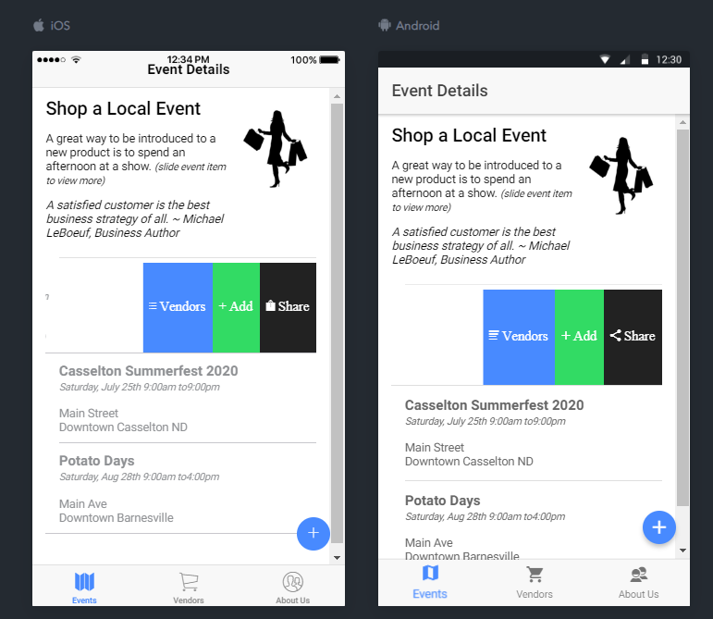

* 1. When a user clicks the Vendors button, the Angular DialogServiceProvider serves up an alert box that displays a list of vendors currently registered to the event.

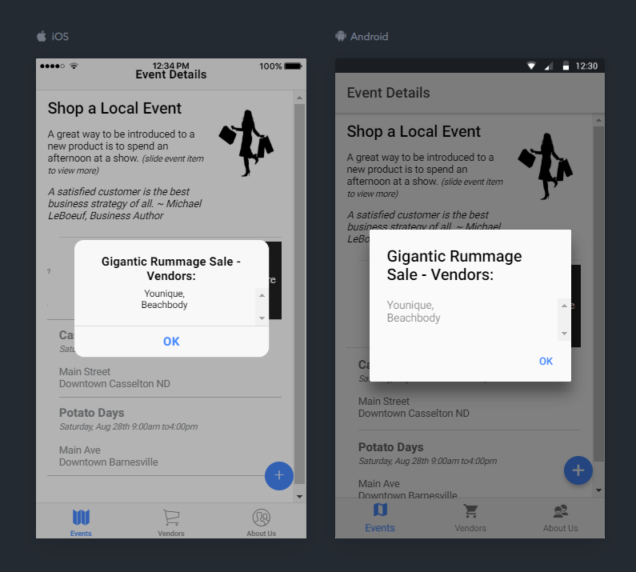

d. When a user clicks the Add button, the user’s registration information is forwarded onto the event organizer and the Angular DialogServiceProvider pops a Toast notification to the user indicating what has happened.

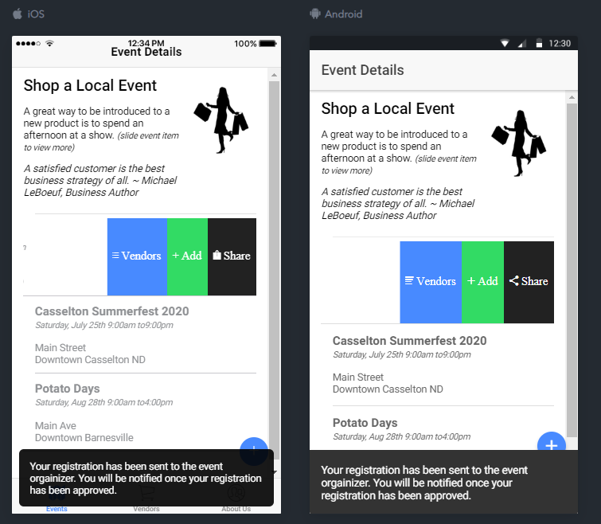

e. When a user clicks on the Share button, the event triggers the Cordova Plug-in (Social Sharing) to share this event to the user’s friends. Once complete, the user is presented with a Thank You message indicating the importance of friend to friend marketing of events.

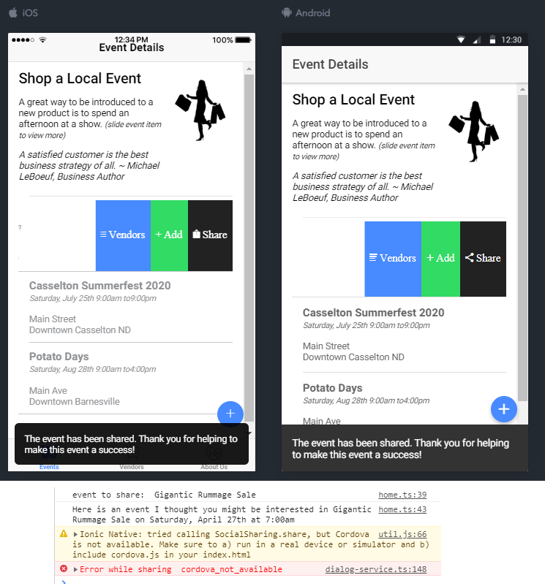

f. When a user clicks the floating action add button, the Angular DialogServiceProvider is triggered to pop a custom data entry form in which the user can add a new event to the list.

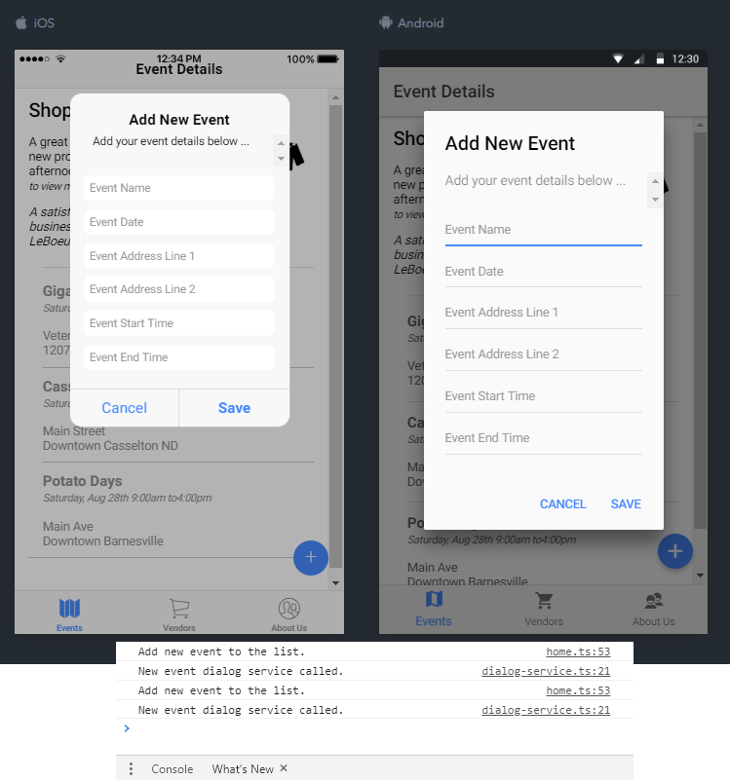

g. The user then fills in the form giving the information about the new event. Once saved the VendorBlendorServiceProvider is triggered to save the new data, reload the screen and present the new information to the user.

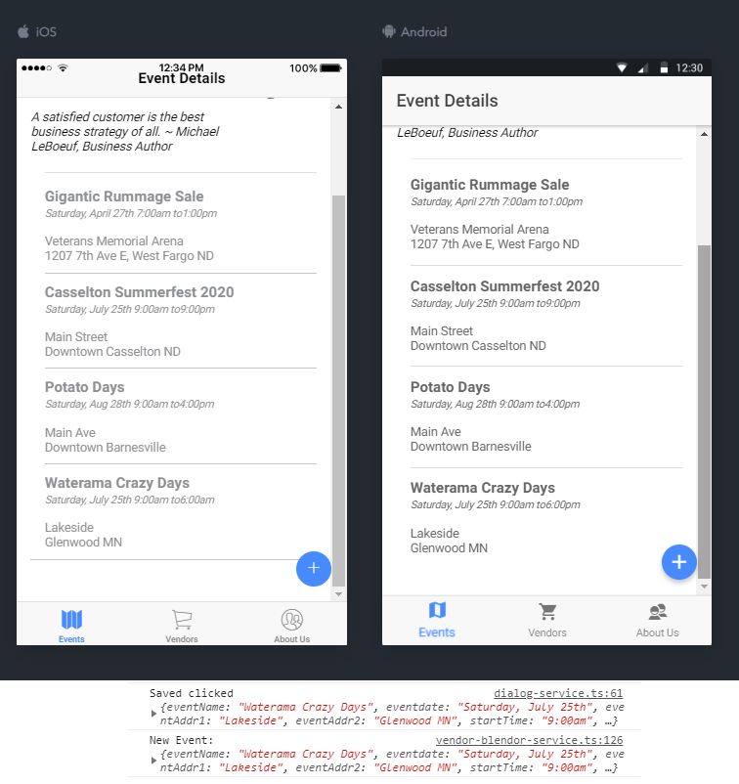

1. Vendors
   1. When a user clicks the bottom navigation button called vendors, they are presented with a list of all businesses who have been registered with the application. All vendor data is maintained by the VendorBlendorServiceProvider.

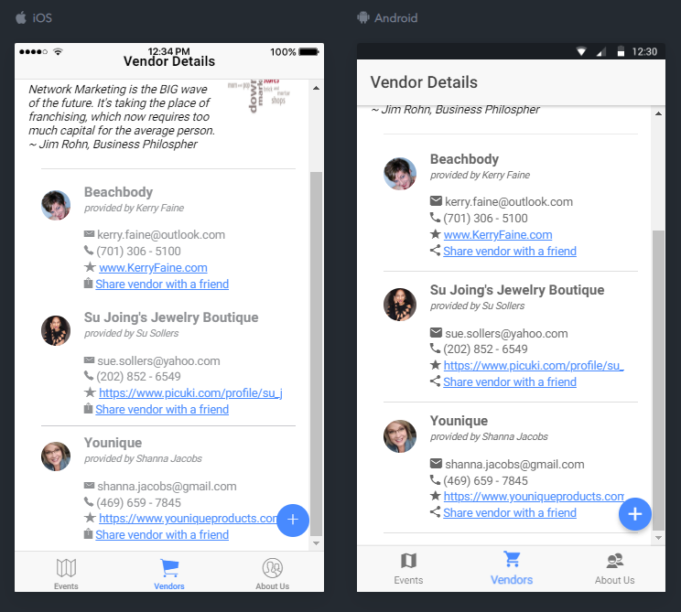

* 1. When a user clicks the floating action add button, the Angular DialogServiceProvider is triggered to pop a custom data entry form in which the user can add a new business to the vendor list.

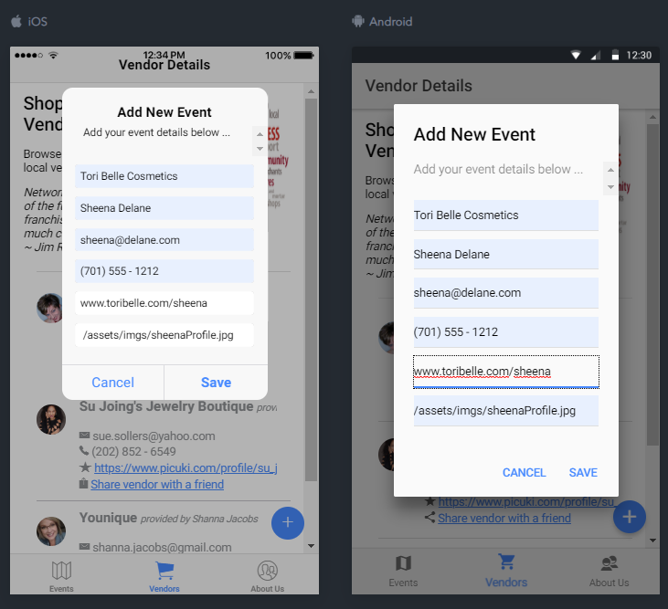

* 1. The user then fills in the form giving the information about the new business. Once saved the VendorBlendorServiceProvider is triggered to save the new data, reload the screen and present the new information to the user.

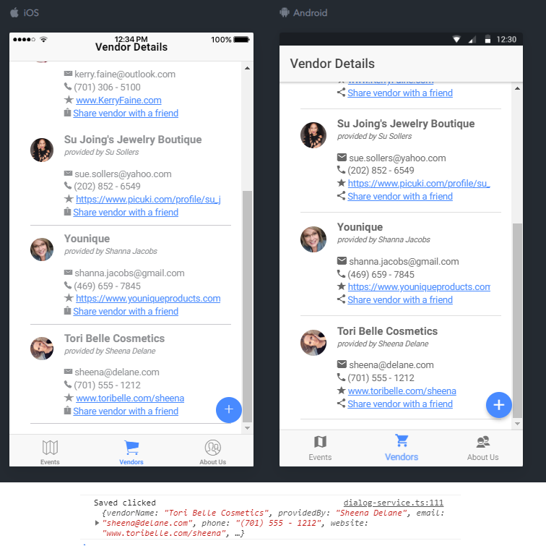

* 1. When a user clicks on the Share button, the event triggers the Cordova Plug-in for Social Sharing to share this event to the user’s friends. This is code that is shared by the DialogServiceProvider in order to reduce duplication of code. Once complete, the user is presented with a Thank You message indicating the importance of friend to friend sharing of small businesses.

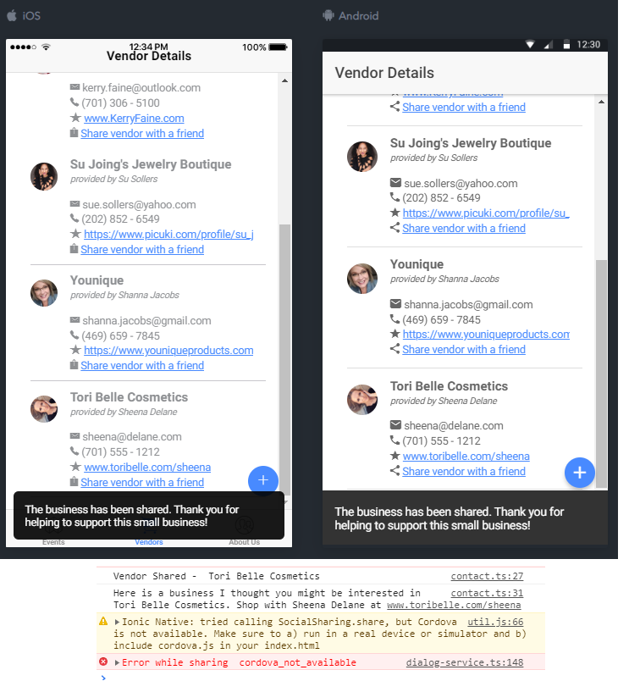

1. About Us   
   This page includes the goals of the application along with how to contact the developer. The screen also includes the logo that I currently use while promoting events in the Fargo, West Fargo and Moorhead areas. The hope is that our group can promote this application at events to expand the capabilities of the “F-M Vendor Blendor” event planning group.   
      
   