Brad Burkett

Week 2 Create Groceries App

SWDV 665 – Screenshots

10/31/20

The first thing I did was basically create the start of the app by following along with your “Creating a Sample Application Using Ionic CLI”. That gave me the tabs I needed to create my list and modify the “About” tab.

Here is a screen shot of the list from the ionic site that I used for my grocery app.

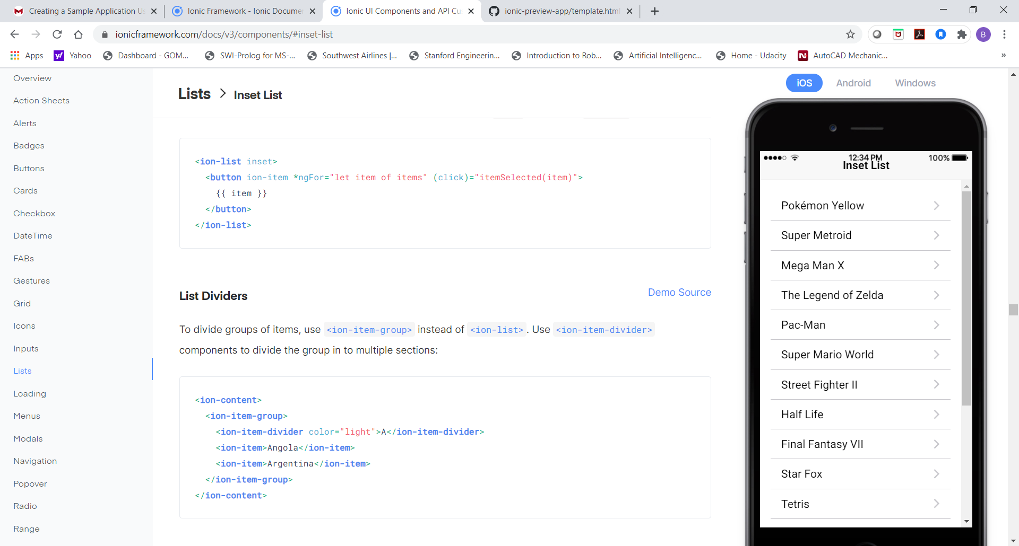

Here is a screenshot on how I modified the html code.

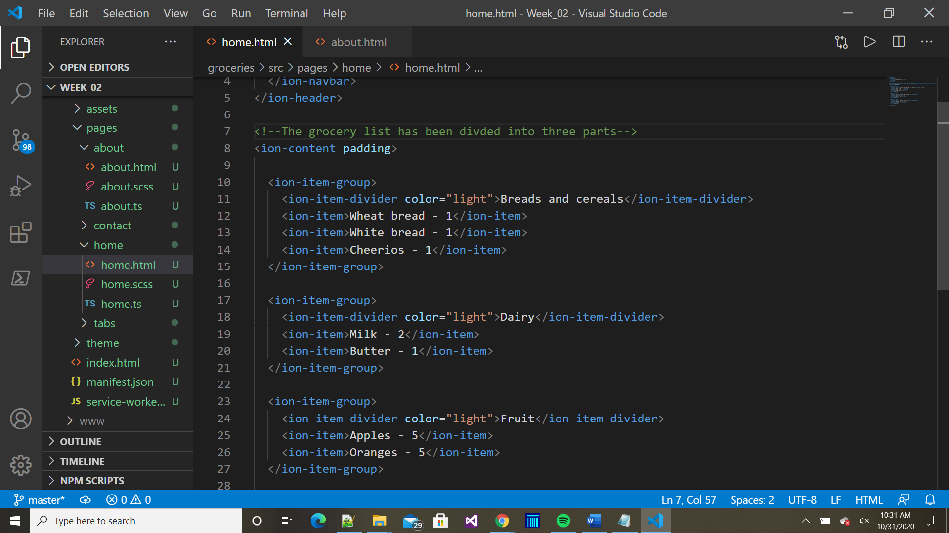

Here is a screenshot of how I modified the “About” tab.

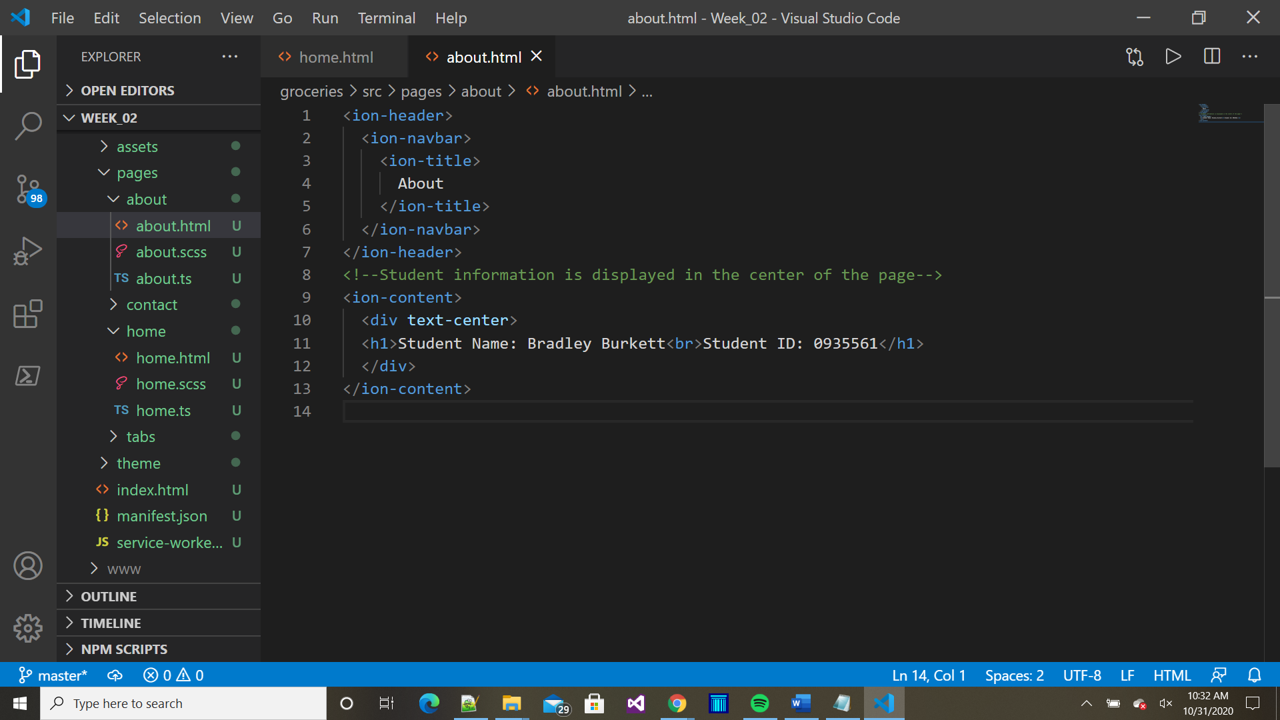

Here is the tab for the grocery list.

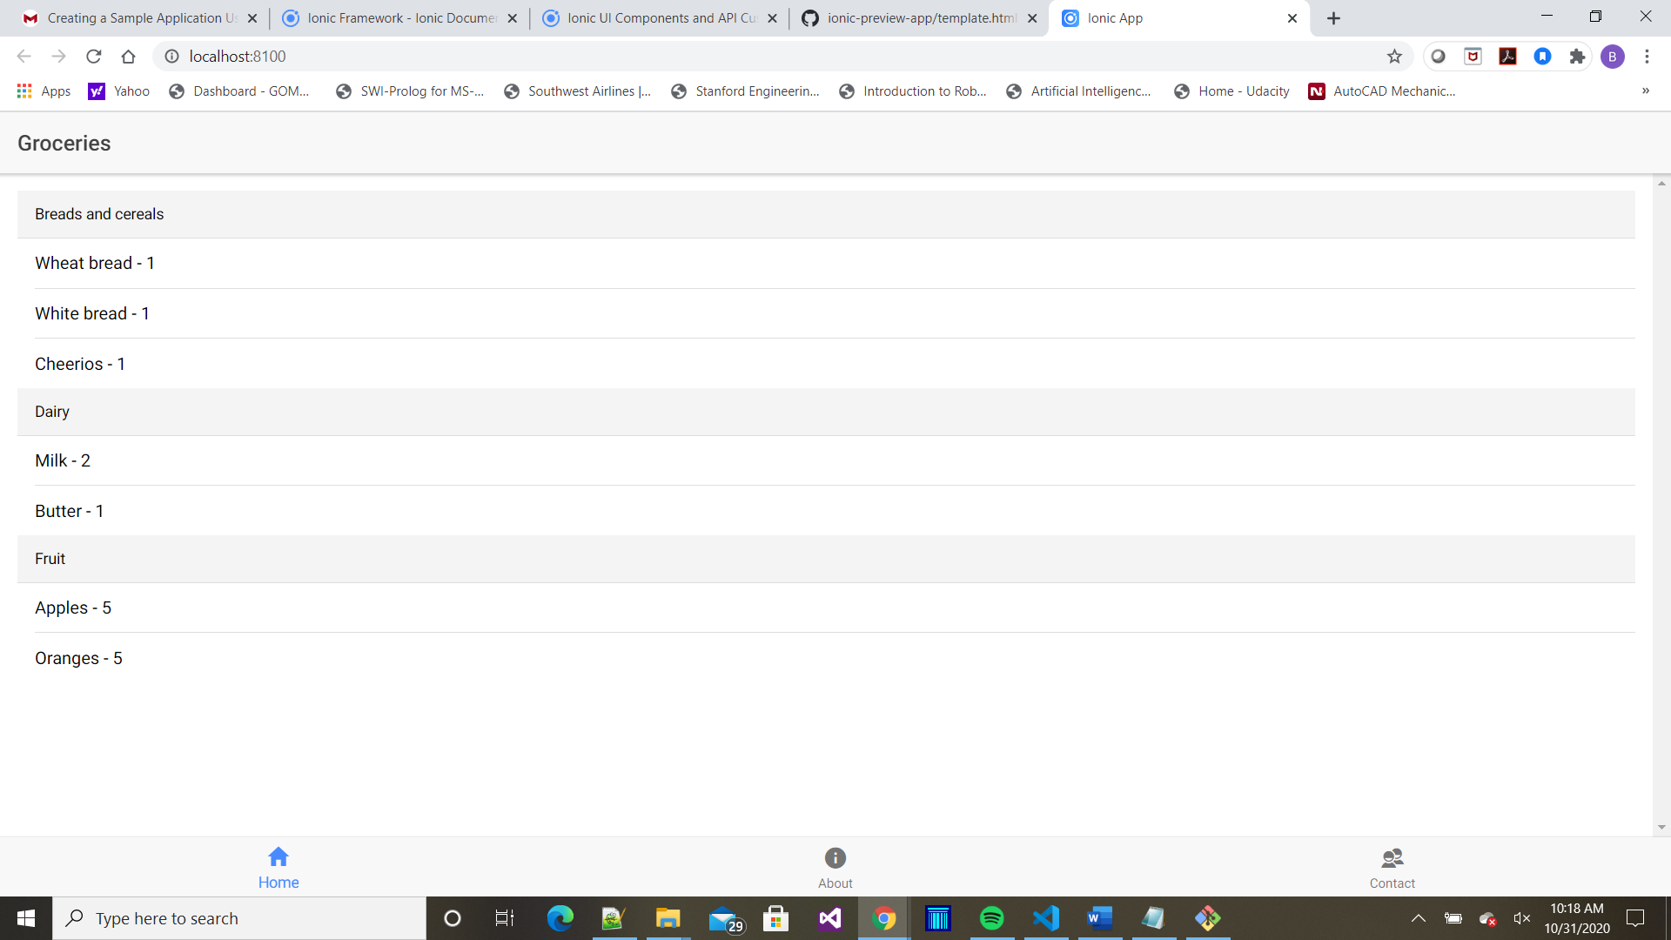

Here is the tab for the “About” information.

