Index.html – below is the “lab” view that showcases all 3 types of options for mobile screens.  
My edits include additions of “Butter”, “Ham” and “Cheese” to the list in addition “Milk” and “Bread” added from watching the demo.

Also, added a slider with a checkmark icon w/a completed tag.  
  
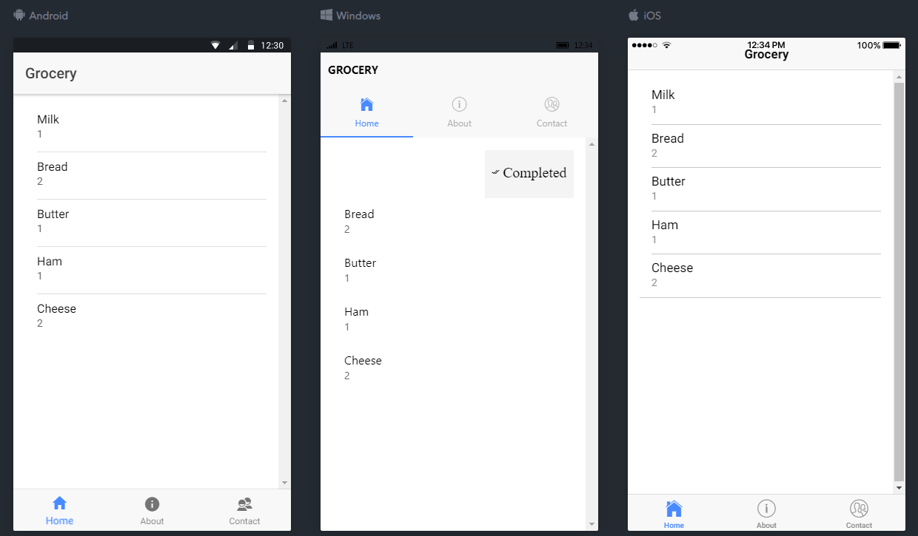

About.html – below is the “lab” view that showcases all 3 types of options for mobile screens.

I added my Name, Student ID, and Avatar for fun.

