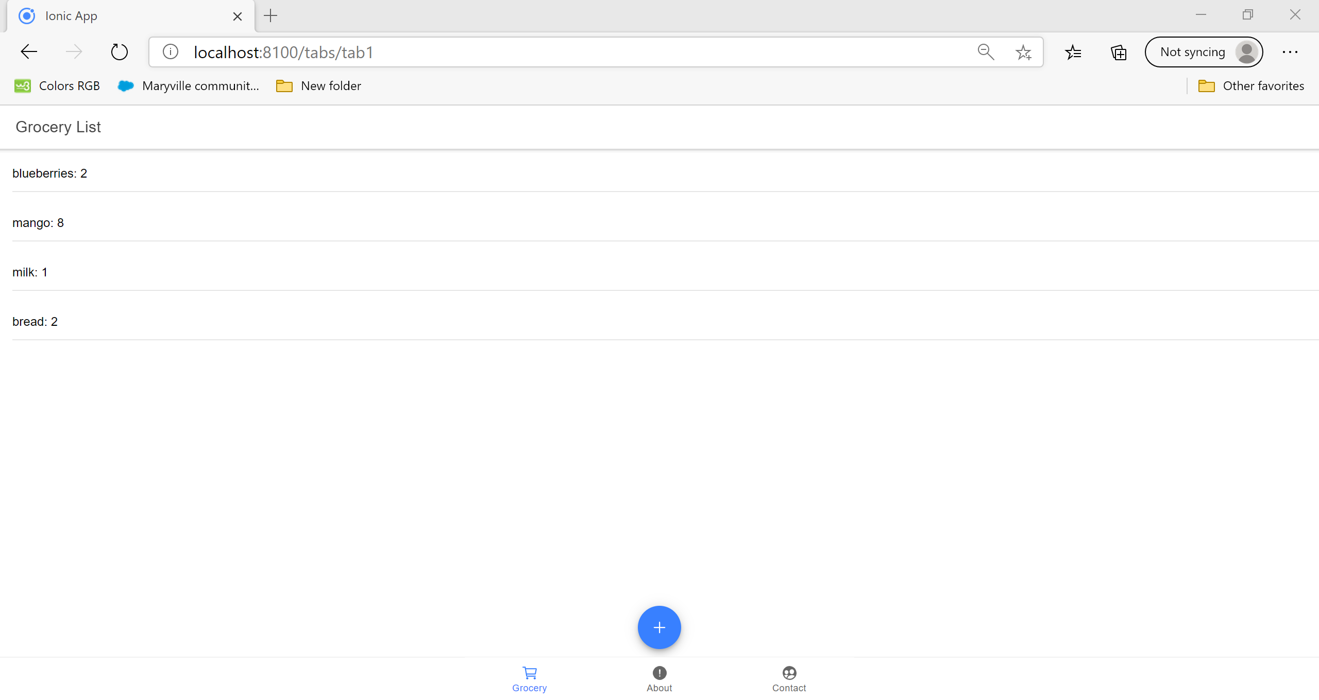

Above was the regular screen.

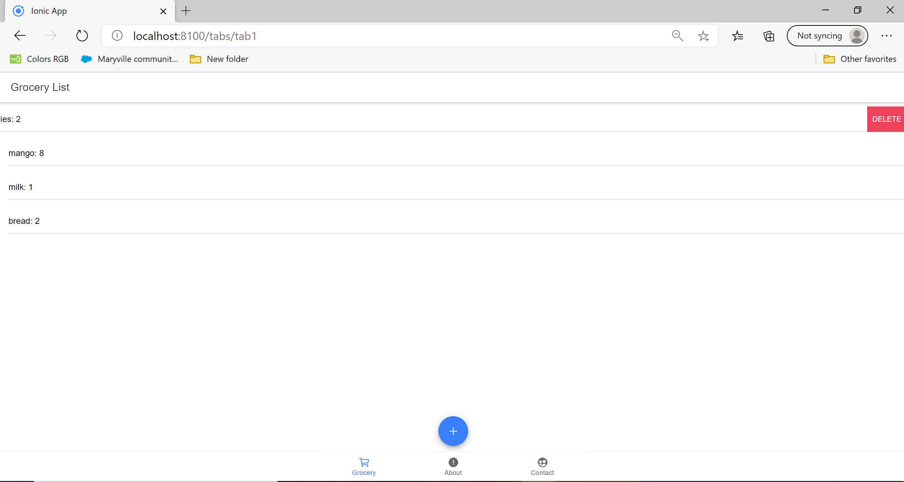

This is showing that I want to delete an item. After I click delete it will get removed from the list as shown in the next slide.

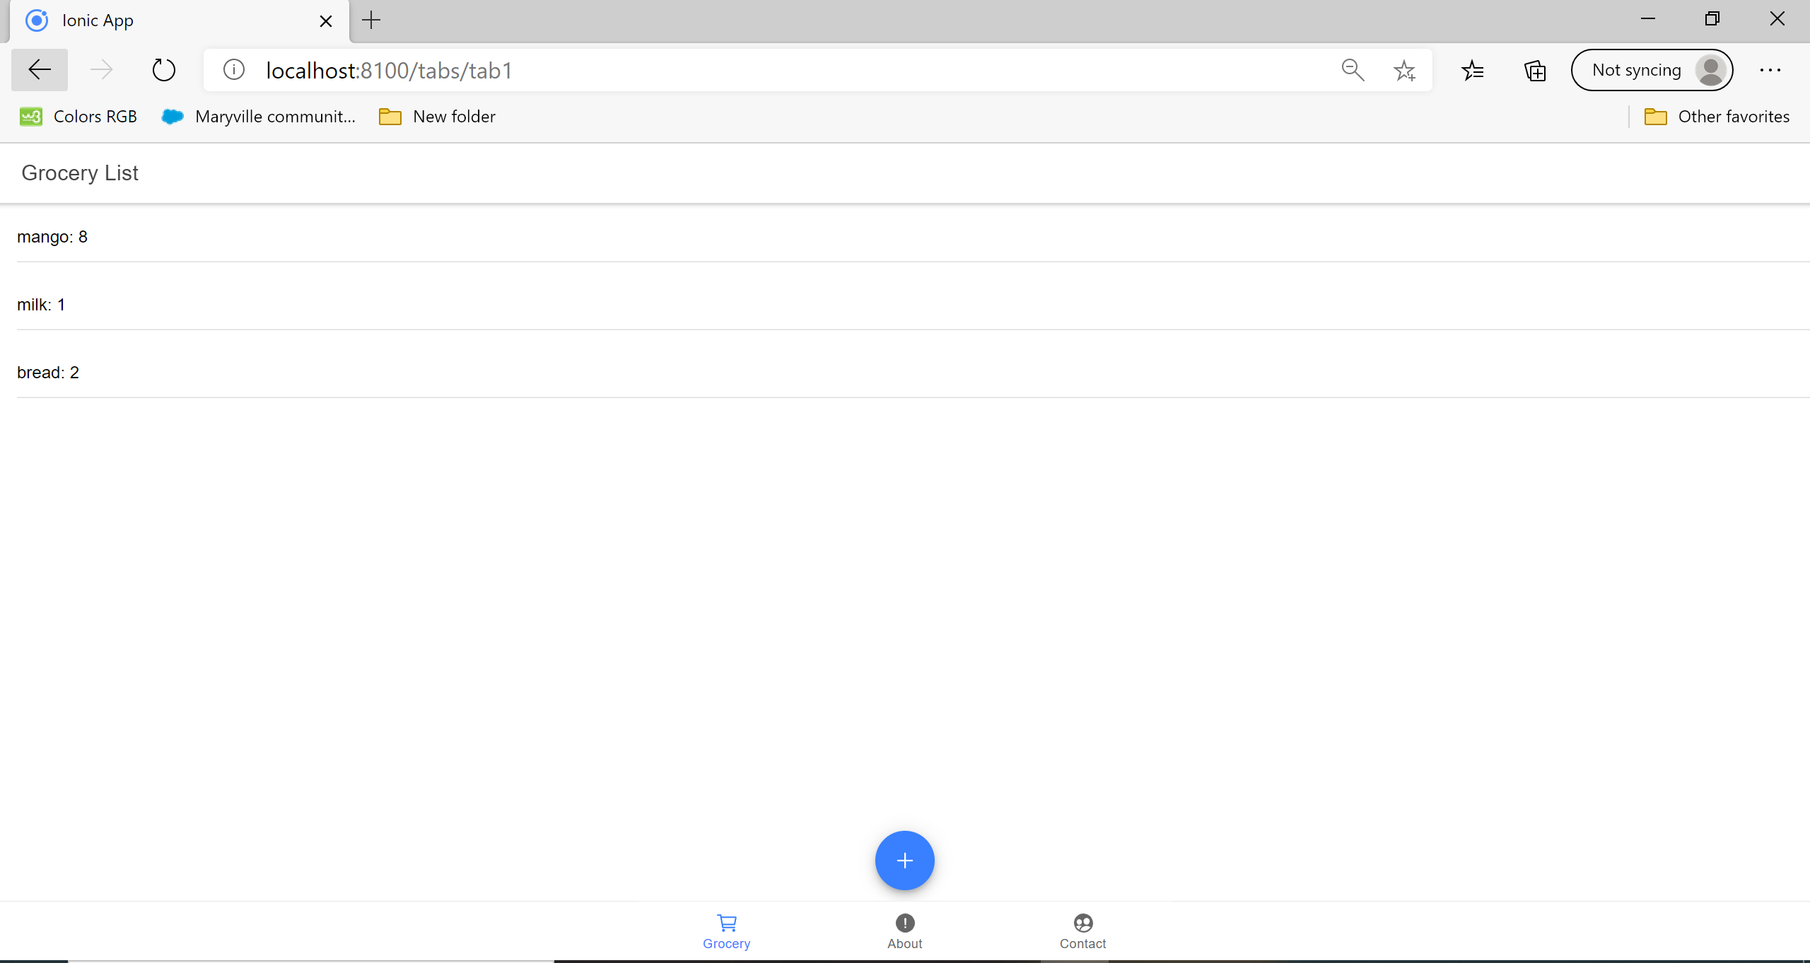

This is after the item was deleted.

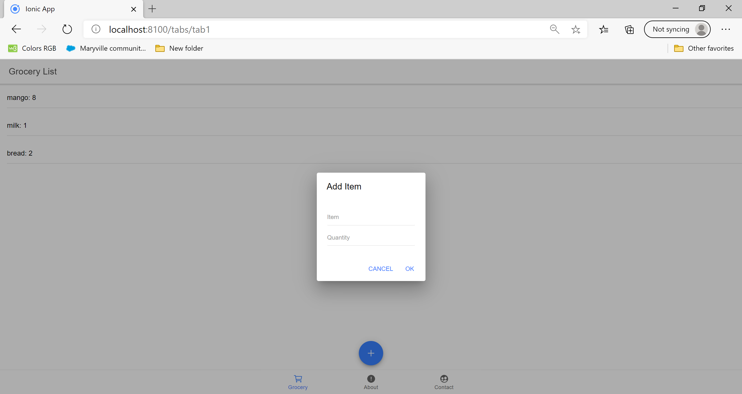

Now we clicked the add item to add an item to the list.

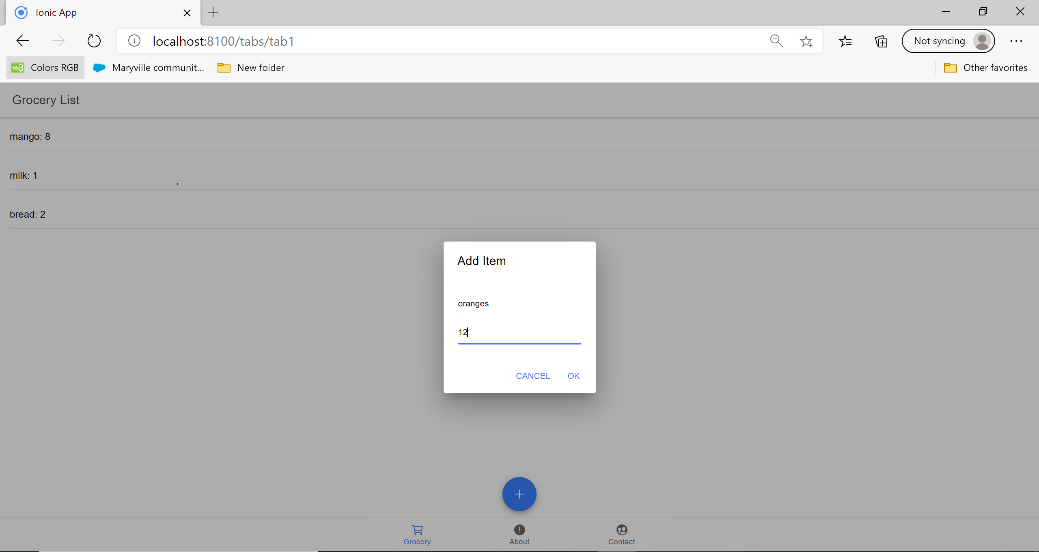

As shown above we are adding 12 oranges to the list.

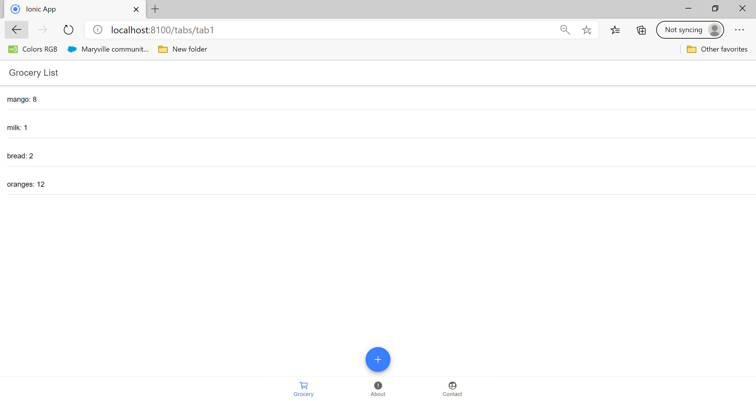

This shows that the 12 oranges were added to the list.

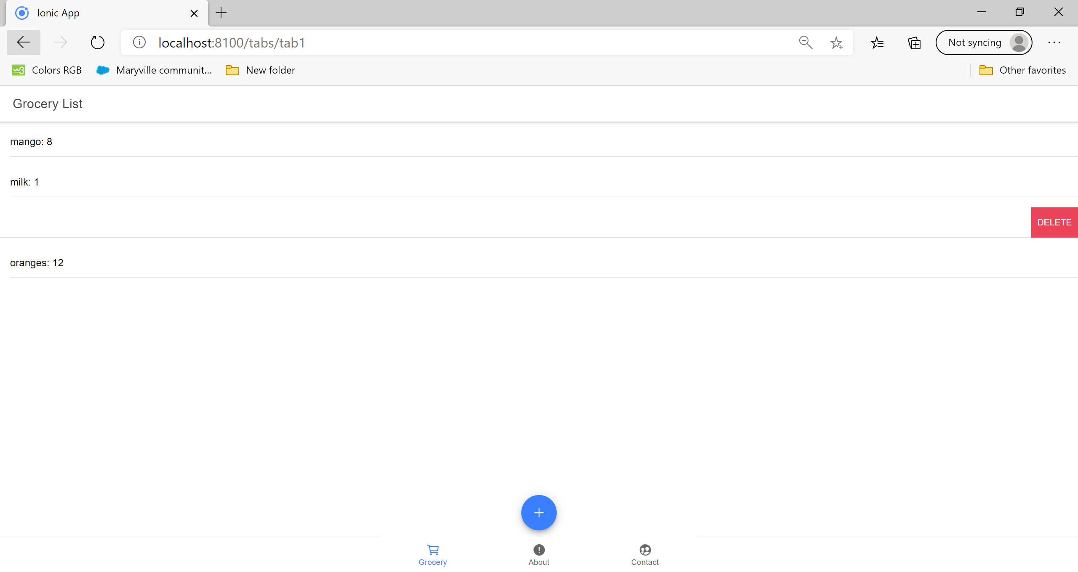

Now I highlighted the bread to delete.

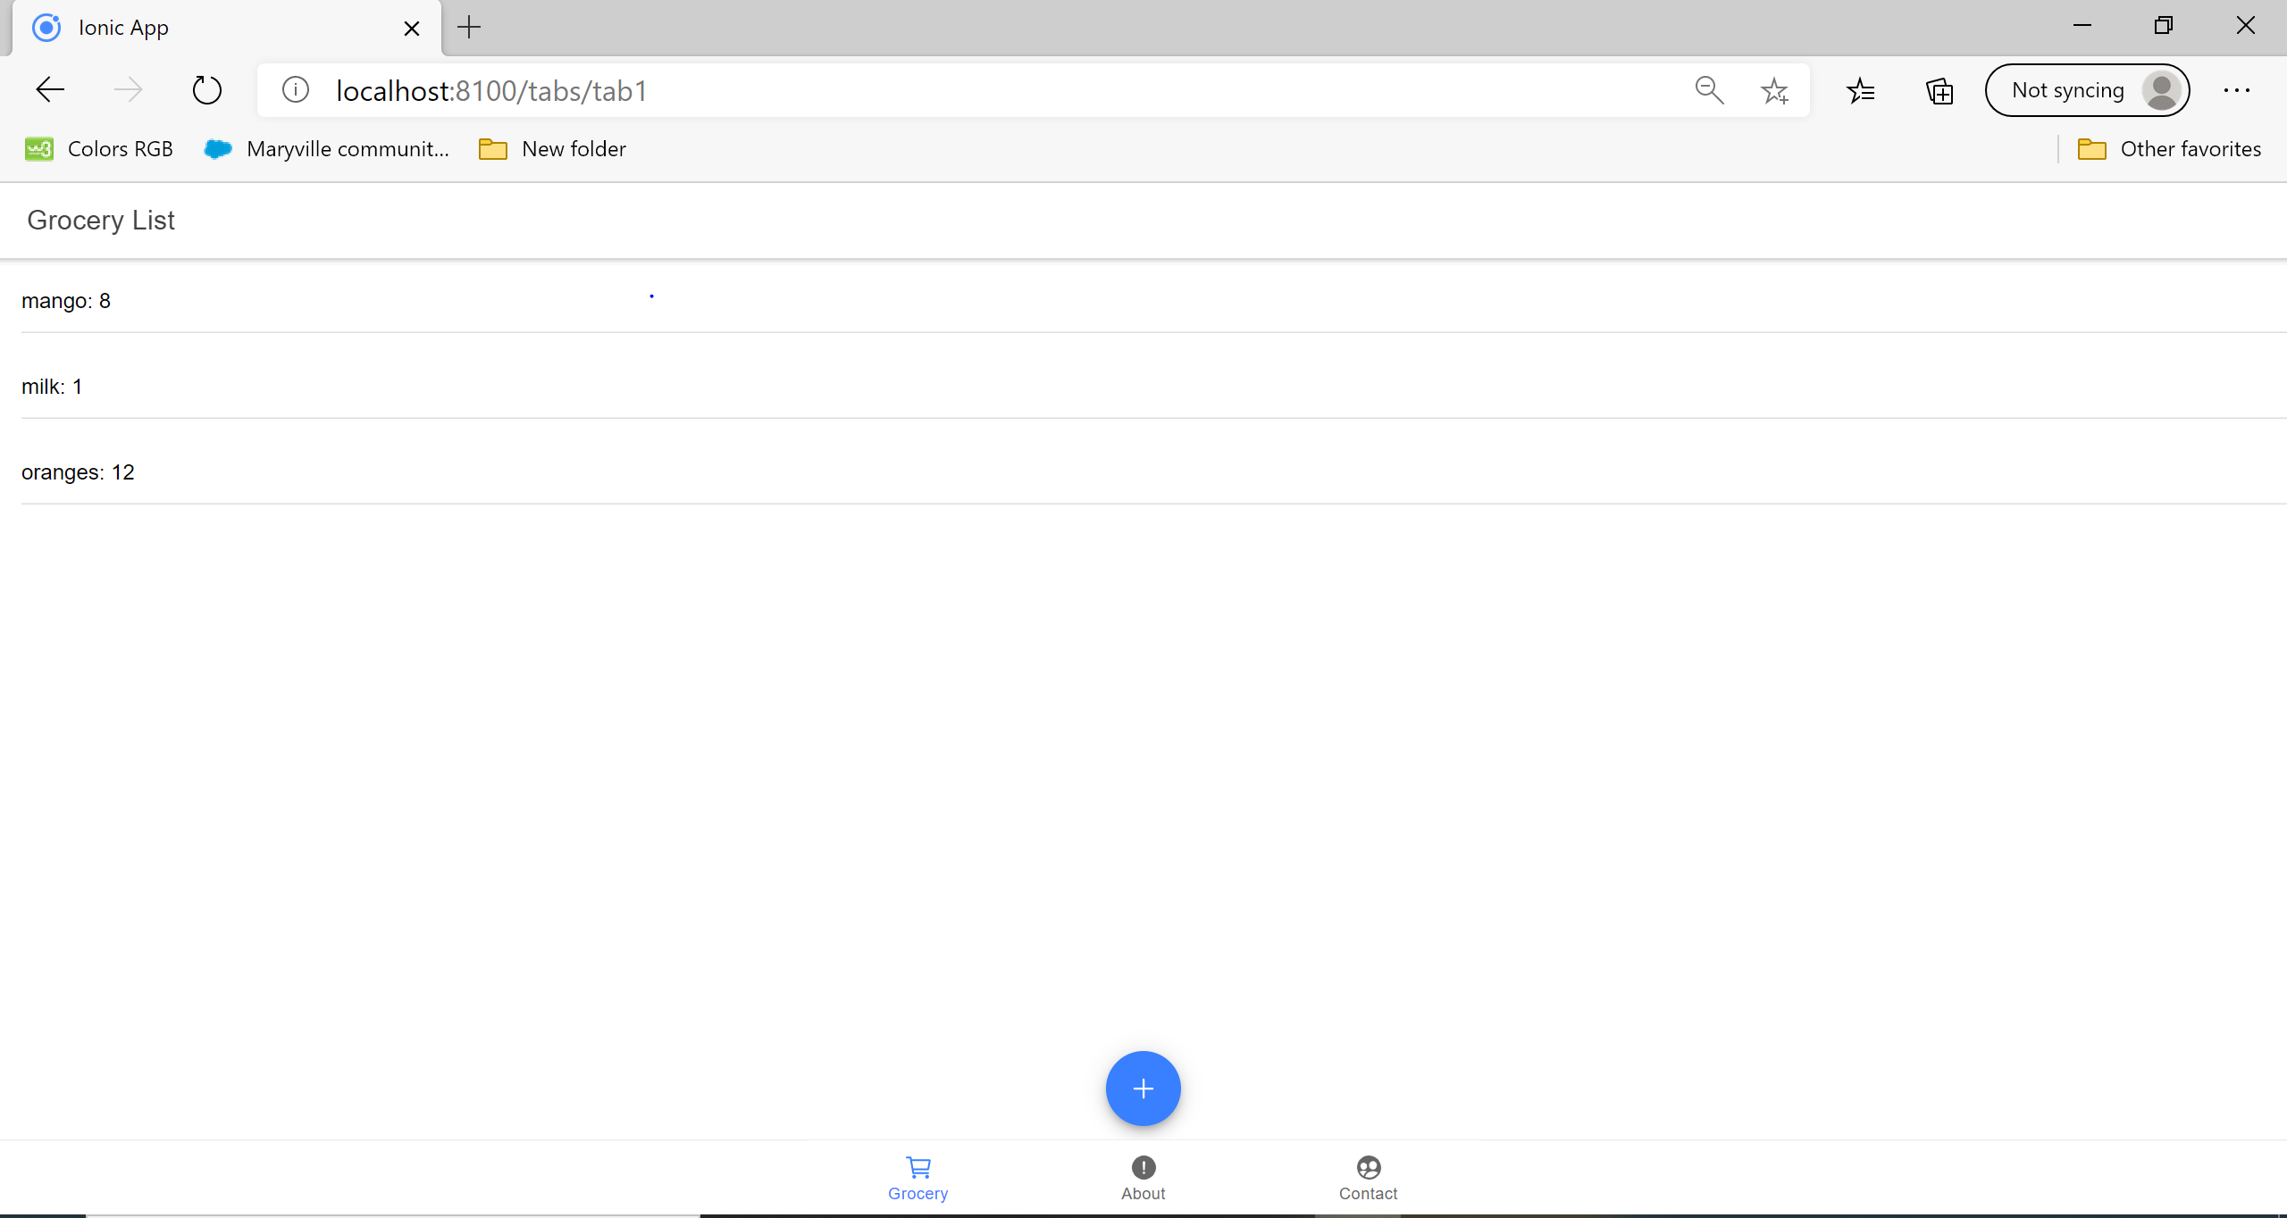

As shown after clicking delete it gets removed.