Week 3 | Add / Remove Items – Groceries App

Home.html

Changes to this screen include the ability to:

1. Add Grocery Items
2. Remove Grocery Items

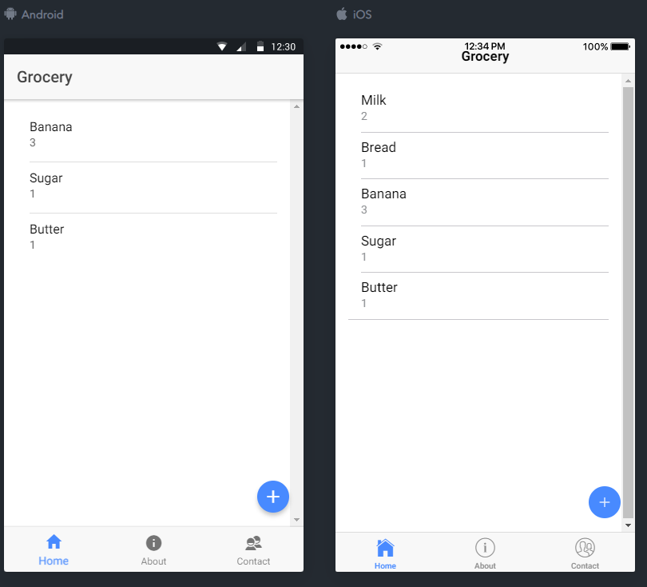

1. To add Grocery Items
2. Click on the “+” FAB (floating action button)
3. Fill in the alert box prompts
4. Click Save

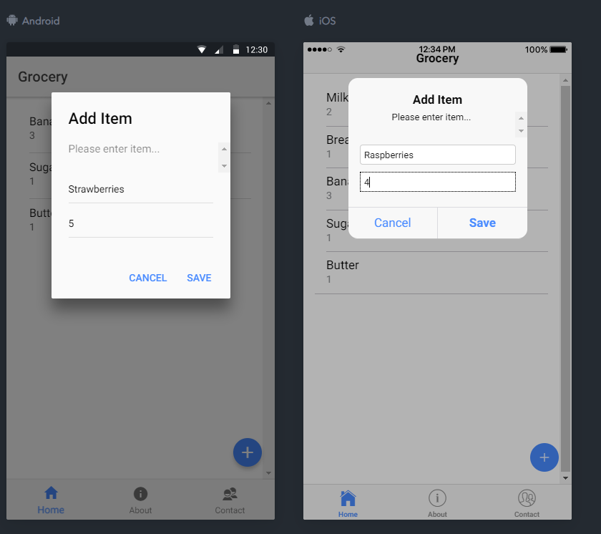

Result: upon clicking save, the groceries item(s) are added  
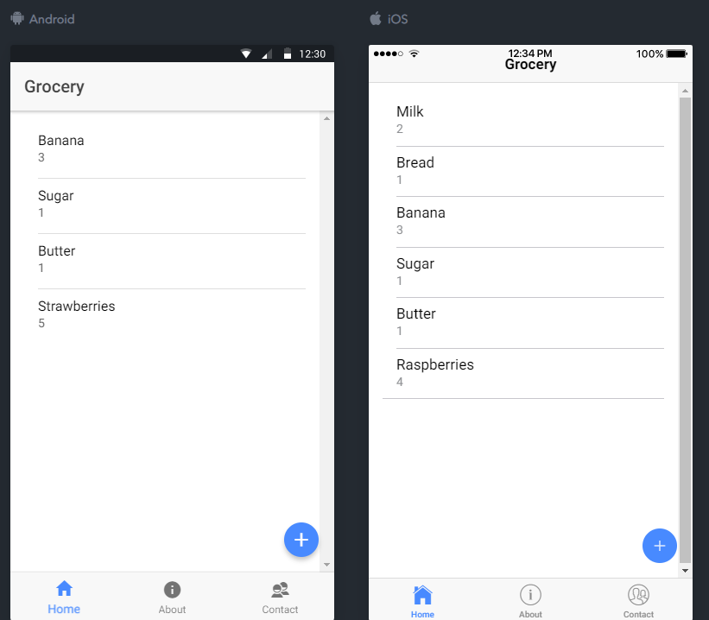

1. To Remove Grocery items:
2. Slide the item to remove left
3. Click on the exposed “Mark Complete” text

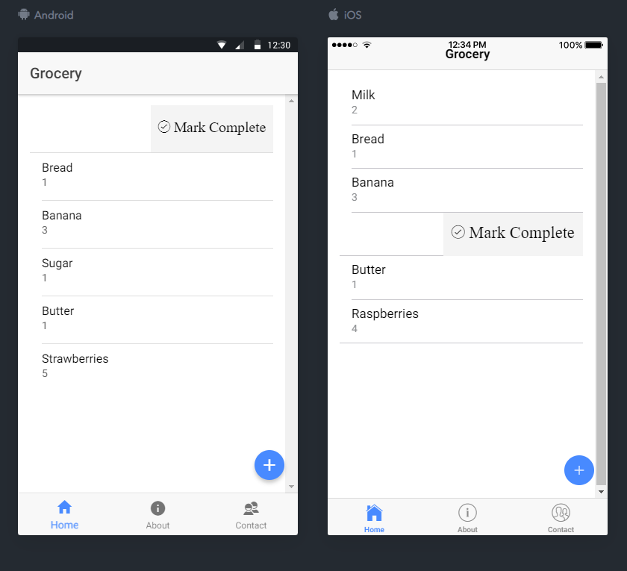

Result: upon clicking “Mark Complete”, the grocery item is removed and a “toast” notification is displayed indicating which item was removed.   
