This is my starting screen.

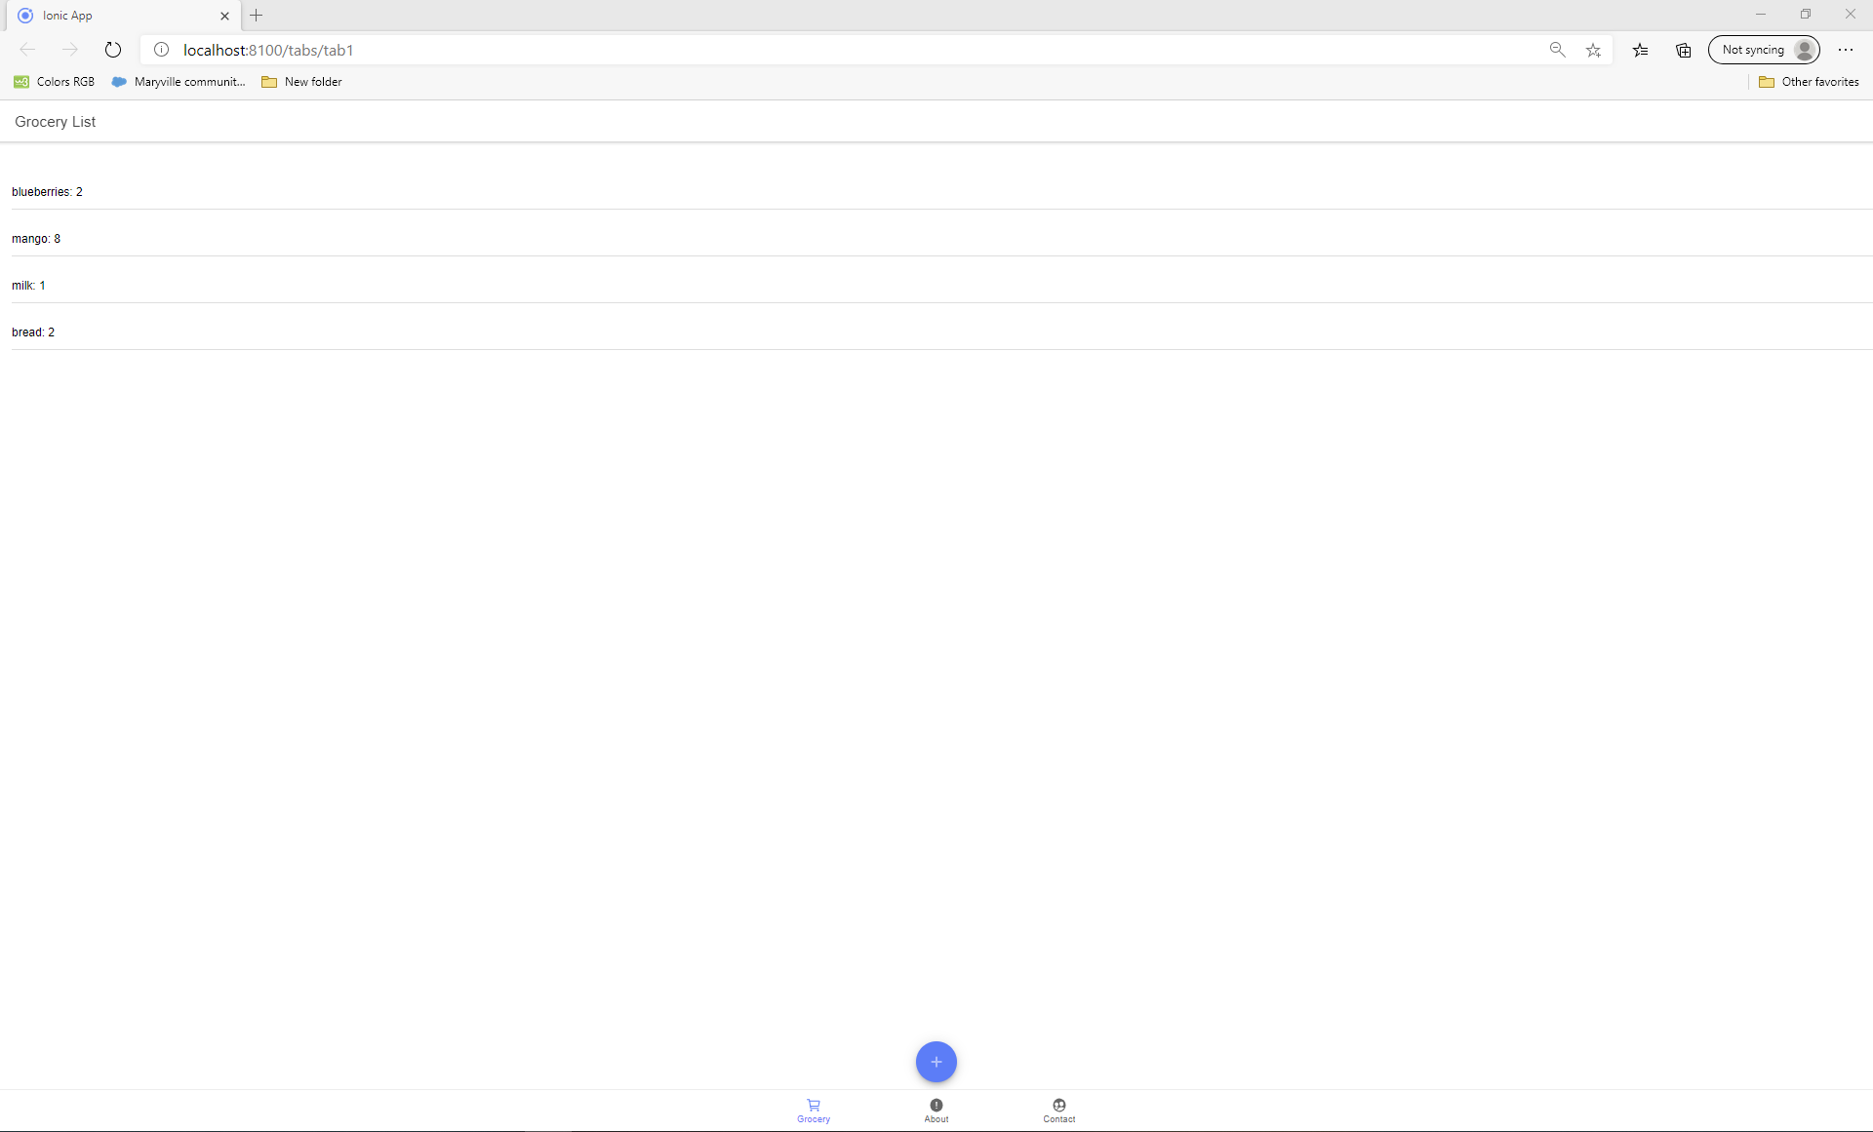

I can slide each item over to either edit or delete it as shown below:

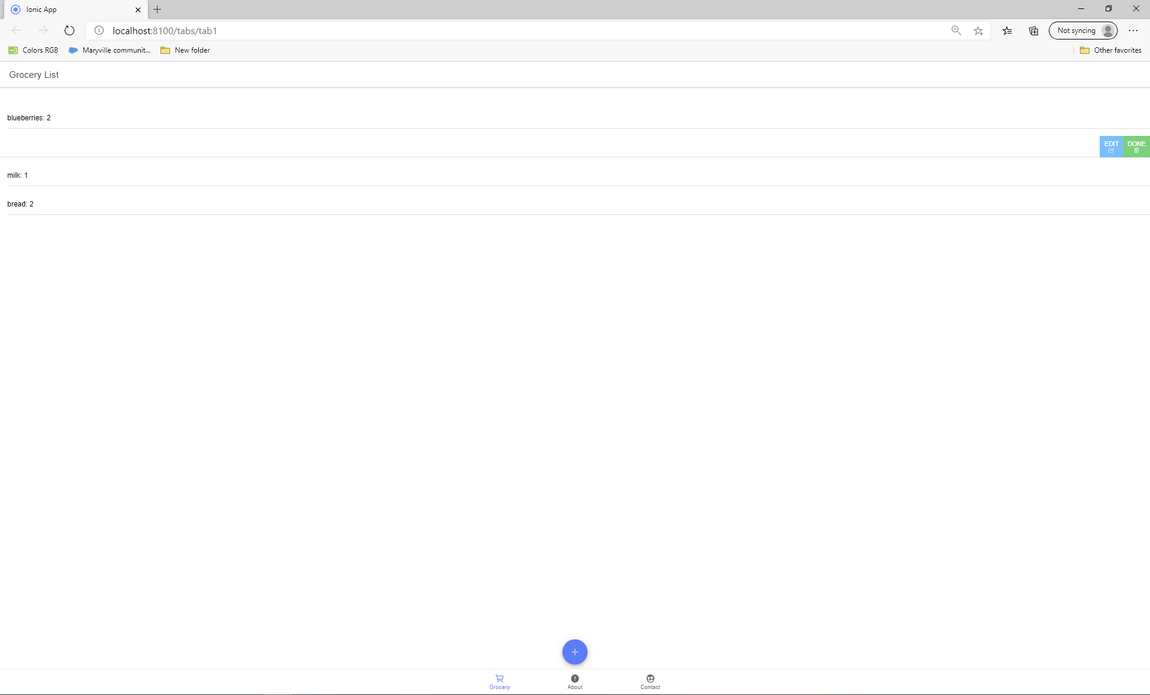

If I click Edit for mango as an example, I’ll get the following:

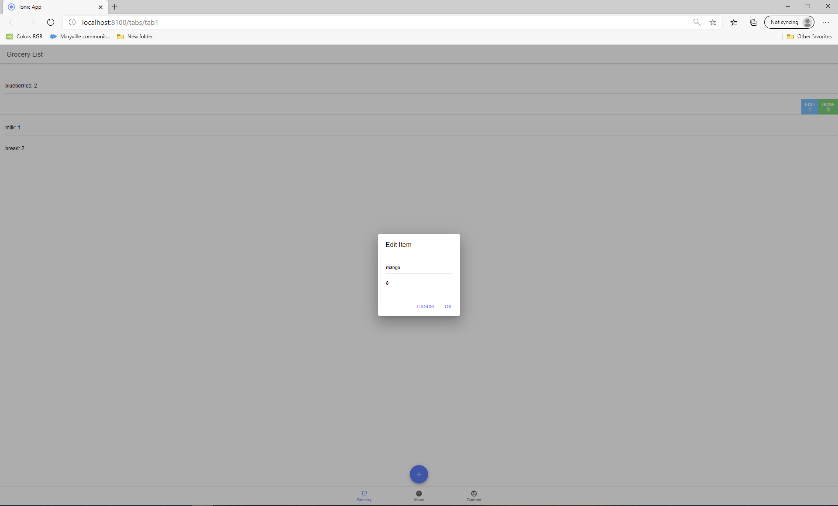

For this example, I will change it to 4 mangos as shown:

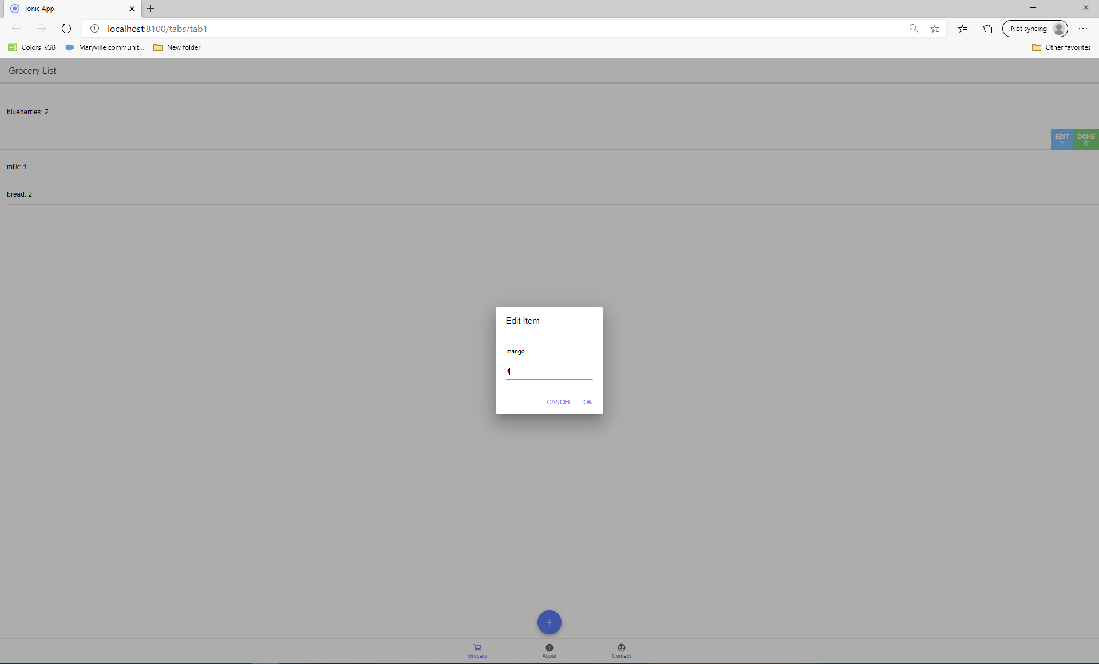

As you can see the list has now been updated to show 4 mangos.

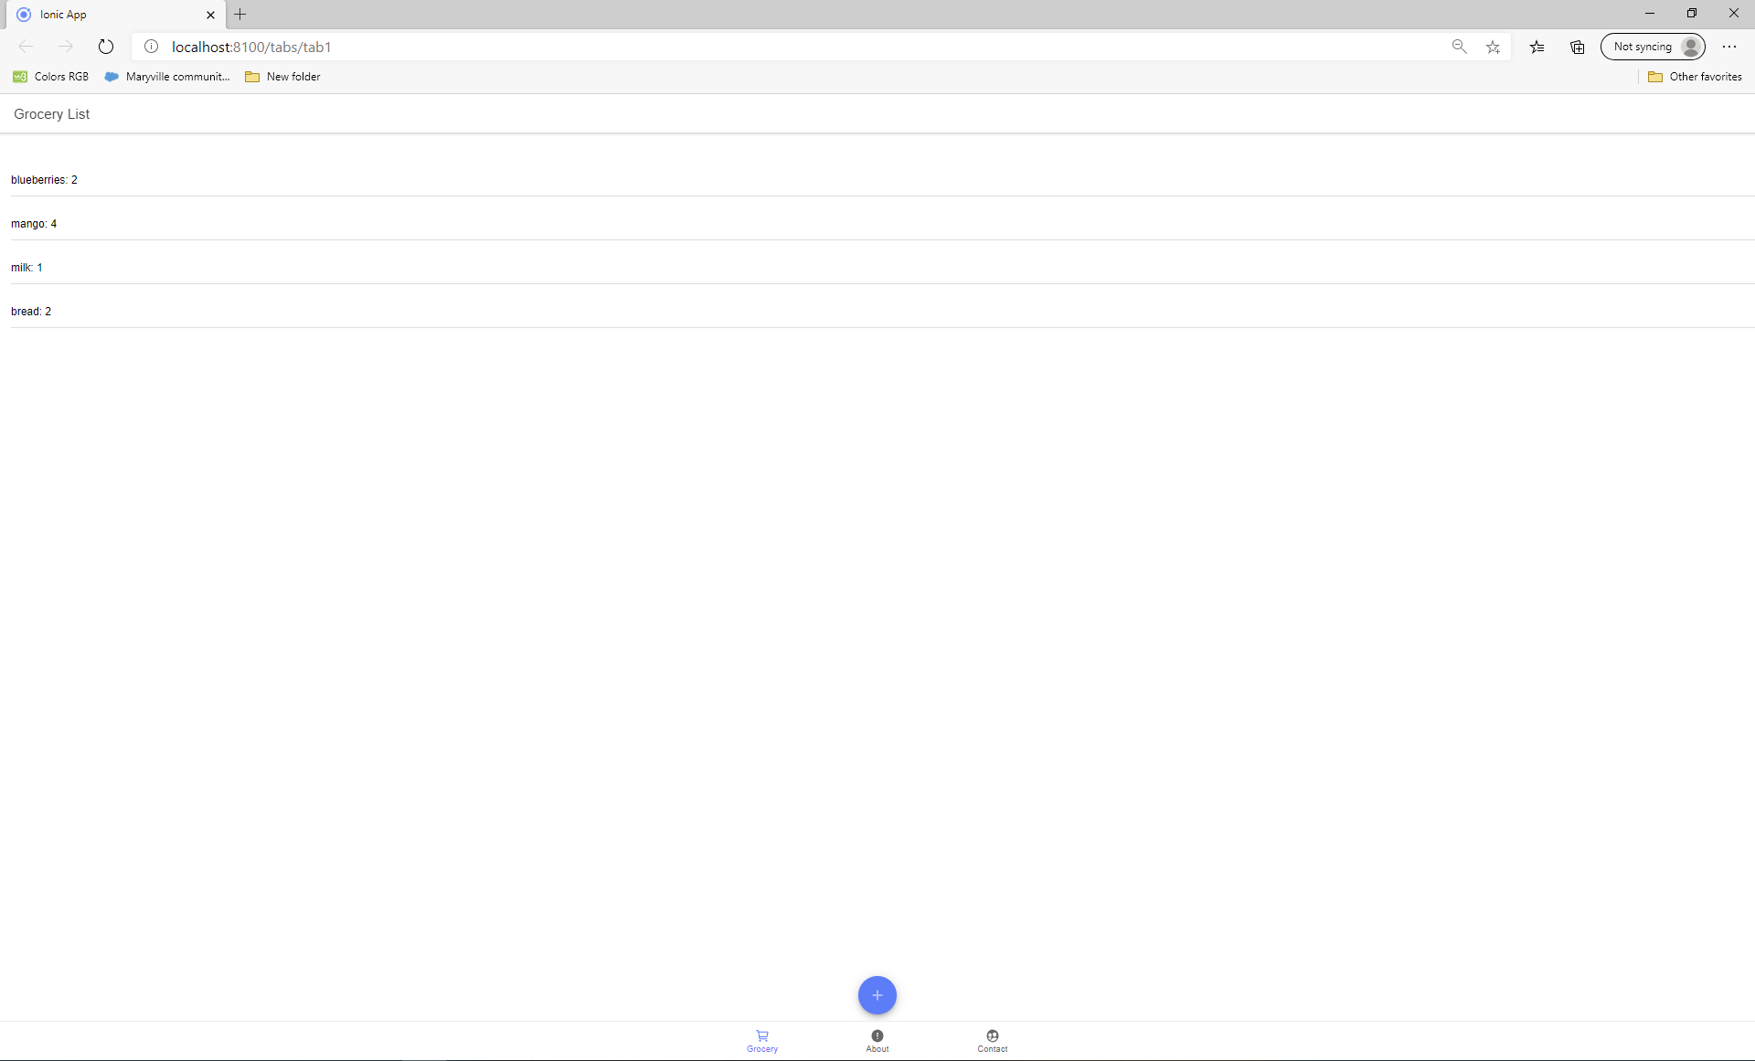

I can still delete an item as shown below when I delete milk:

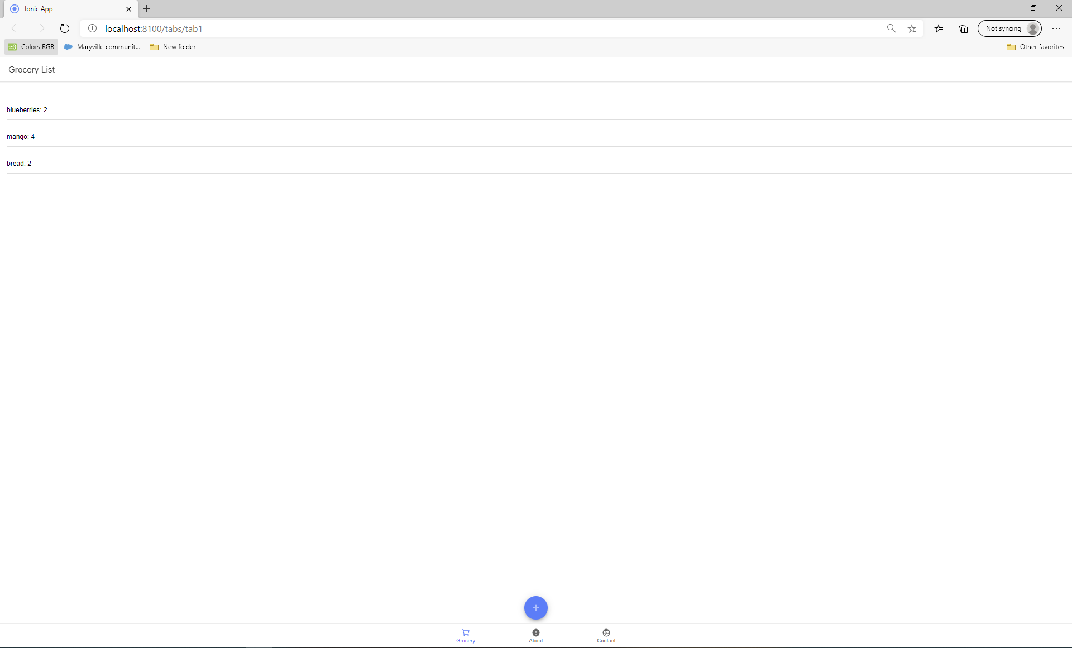

And now I will add it back in as 3 milk:

