1. Home Page

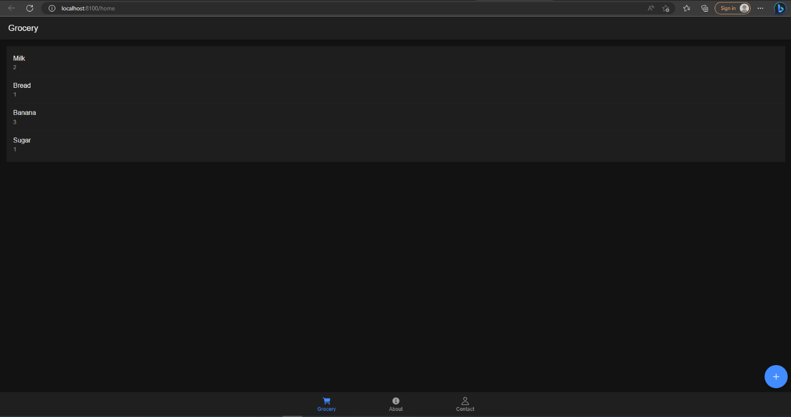

1. Remove Item

1. Add Item



