Week 4 | Groceries App: CRUD Operations

**This week’s changes include:**

* Removal of the automatic loading of grocery items / changing the workflow of the application.
* Adding an empty list message
* Addition of 2 services on the backend for code efficiencies of CRUD operations and Data Entry screens.
* Addition of styling of elements:
  + Color coded buttons
  + Color of warnings (i.e. empty list message)

(Screen shots showcasing these changes can be found on the following screen. )

**Weekly Questions:**

1. GitHub Repository URL  
   <https://github.com/SWDV-665/week-4-groceries-app-crud-operations-kerryfaine>
2. How many hours do you estimate you used completing this assignment?  
   This assignment took me approximately 3 hours to complete.
3. What was easiest for you when completing this assignment?  
   All the elements were relatively easy.
4. What was the most difficult challenge you experienced when completing this assignment?  
   I had no issues this week.

**Home.html**

1. On load, the screen is empty  
   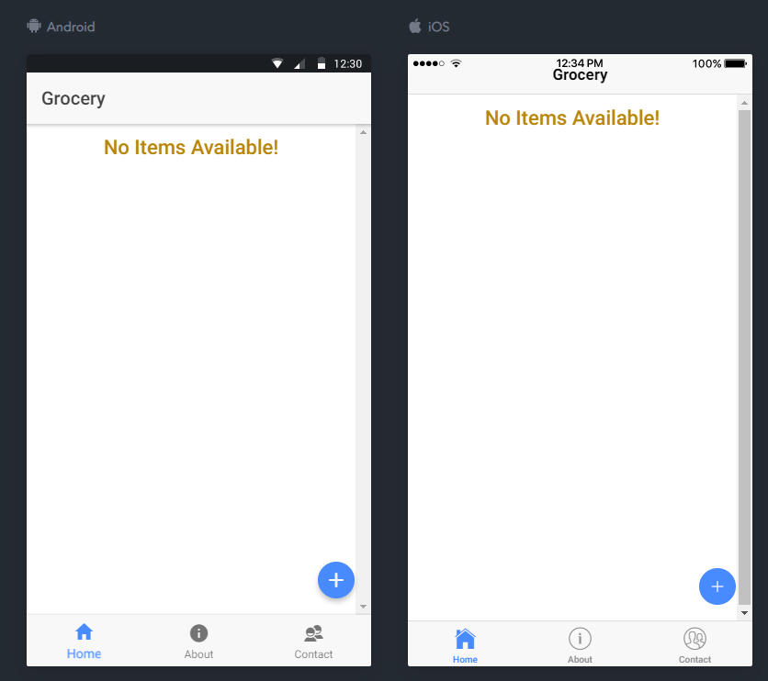
2. Clicking the “plus” launches the entry popup screen through the input-dialog-service  
   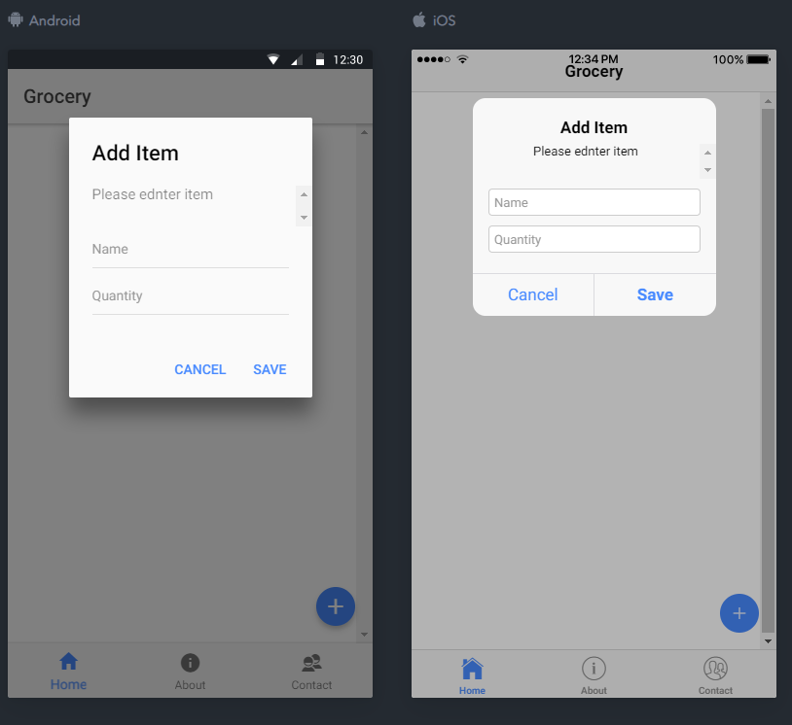
3. Entering values and click save adds the entries to the grocery screen through the groceries-service  
   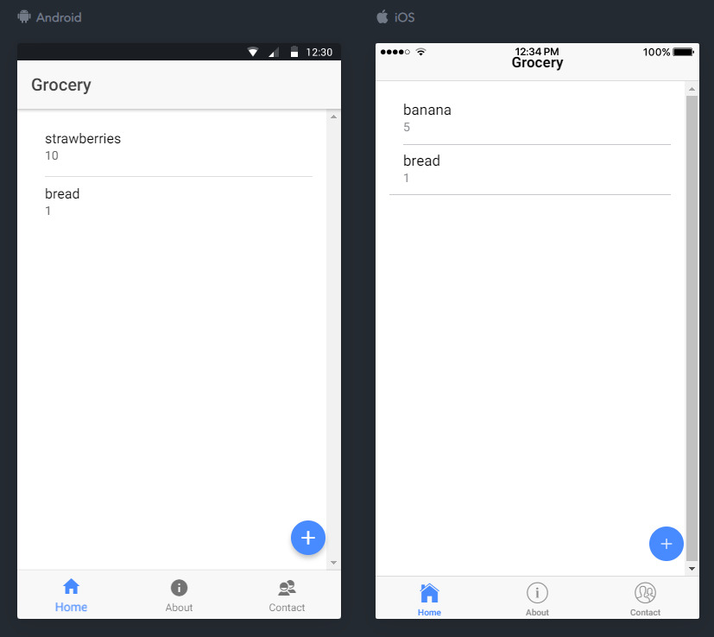
4. The groceries app now has the ability to edit an item by sliding an existing item to the left and choosing “edit”. The data save is done using the editItem method of the groceries-services   
   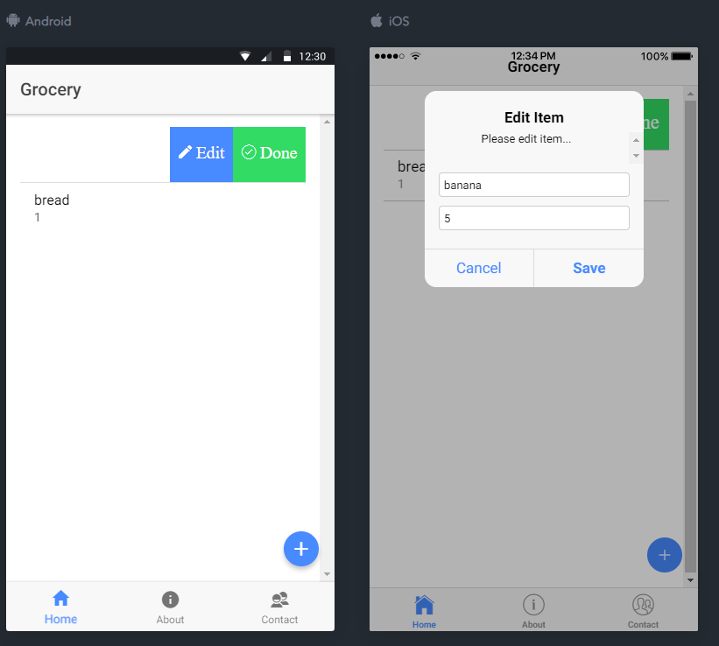  
   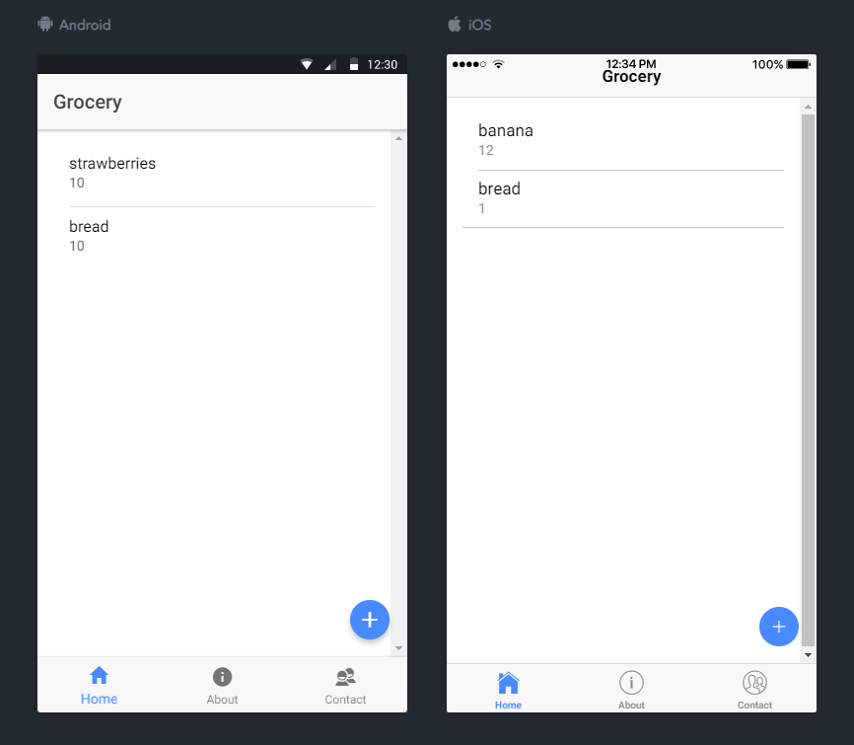
5. Finally, the ability to remove items has been moved to the groceries-service as well. To invoke this action, slide the item left and choose “Done”.   
   