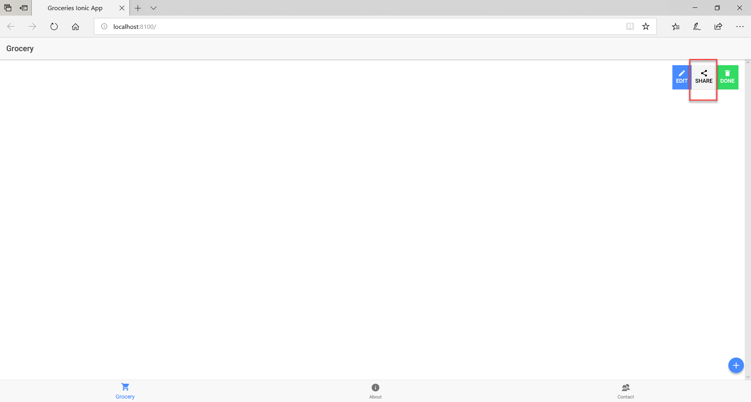

Share Icon has been added to the Grocery application.