1. Home Page

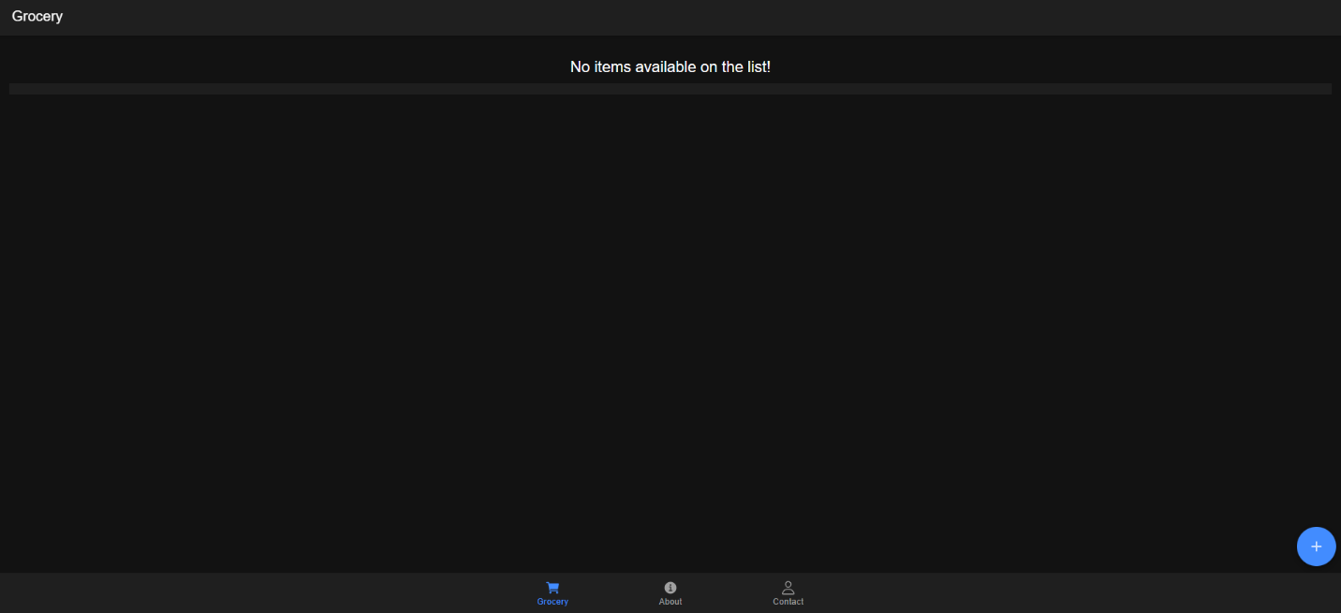

1. Add Items



Add more items

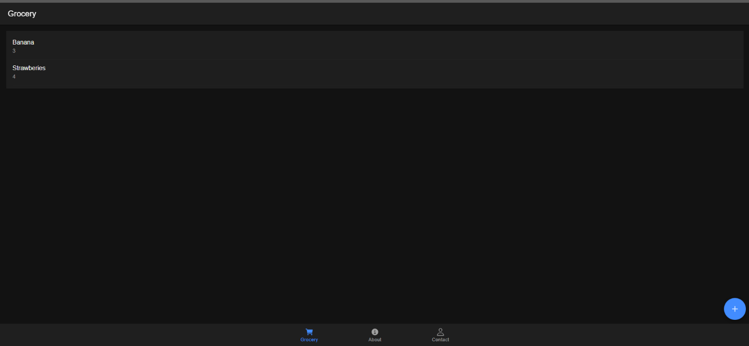

1. Share



