Week 5 | Groceries App: Ionic Native

This week’s improvents include:

1. Inclusion of “sharing button” in the UI.
2. Inclusion of Cordova native plugins – specifically social sharing
3. Installation of Android Studio emulator to test Cordova code

*See screenshots below showcasing these changes …*

Weekly Questions:

1. GitHub Repository URL  
   <https://github.com/SWDV-665/week-5-ionic-native-kerryfaine>
2. How many hours do you estimate you used completing this assignment?  
   This assignment took me approximately 5 hours to complete.
3. What was easiest for you when completing this assignment?  
   It was pretty easy to implement the feature into the application once I got the Cordova elements installed and the circular reference issue resolved.
4. What was the most difficult challenge you experienced when completing this assignment?  
   I struggled a bit with the version of open source that installed with the commands I used from the video. Once I found which version of the social sharing library to use I was able to quickly finish the assignment. (i.e. SocialSharing vs SocialSharingOriginal)   
     
   I also took some time to play with Andriod Studio and I would like to learn how to eventually take a completed application and install it on my Samsung phone.

Screenshots

#1 – Inclusion of “sharing button” in the UI

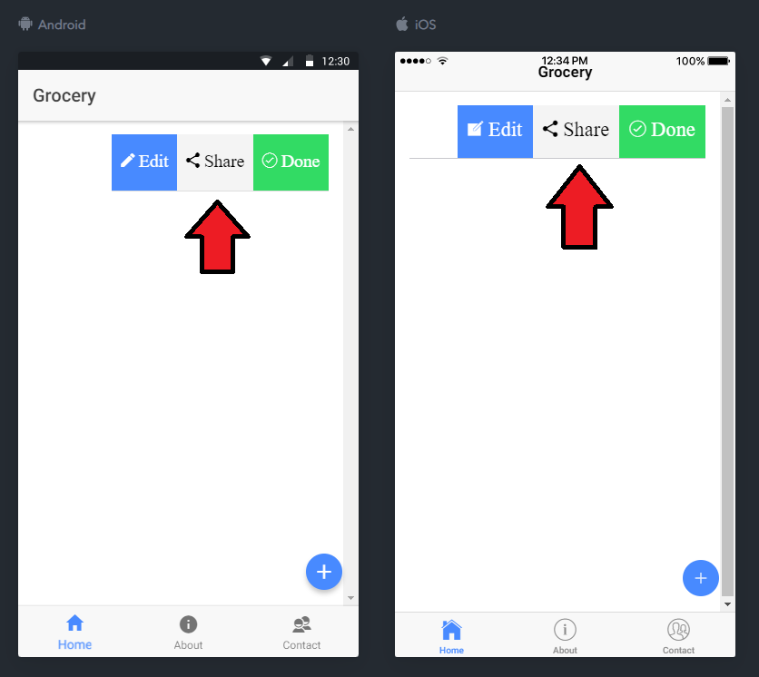

#2 – Inclusion of Cordova Social Sharing Native Feature

1. Added toast notification to indicate sharing had occurred.
2. Also, notice to the right of the screen Cordova Native library was accessed even though request could not be processed due to the browser based test.

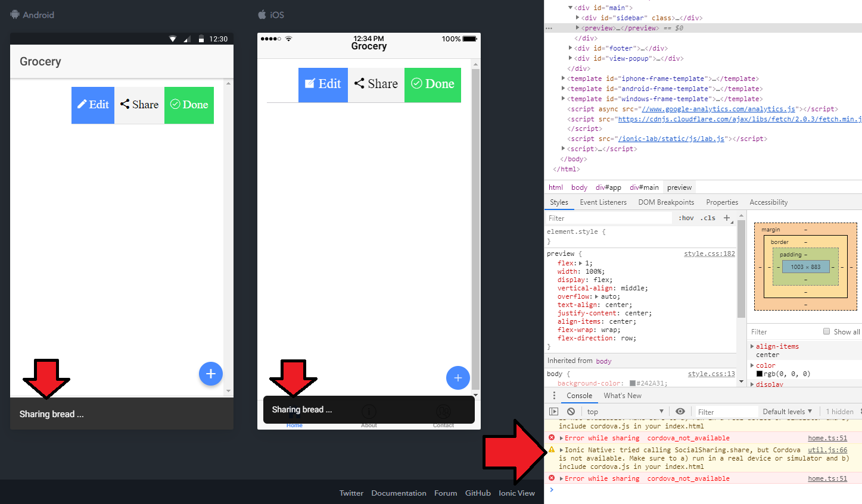

1. and with the Android Studio emulator …

