1. Home Page

1. Add Item

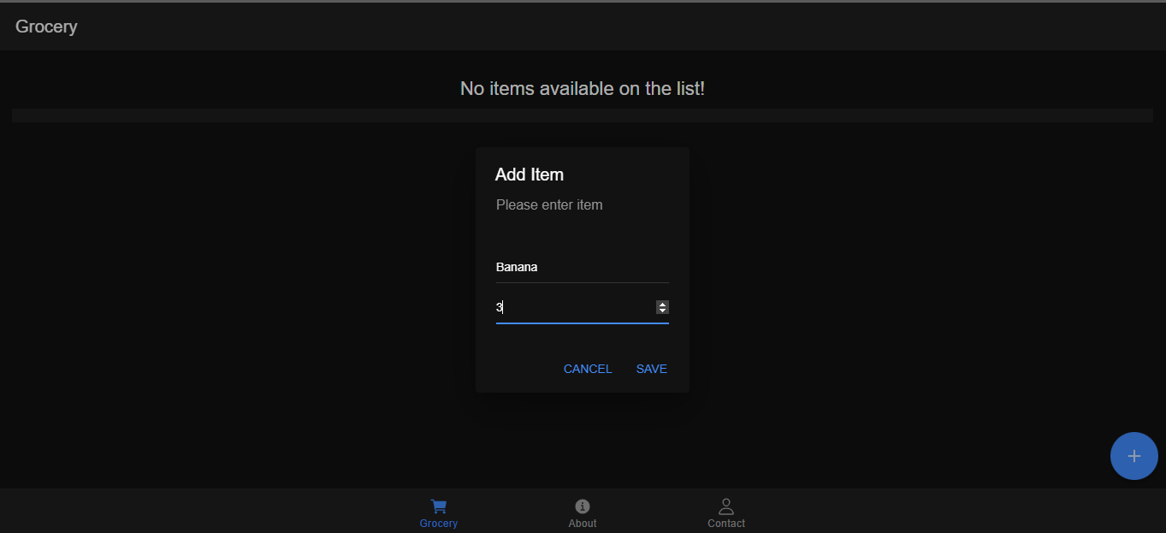

1. Add more items

1. Edit Item

1. Remove Item

1. All Items

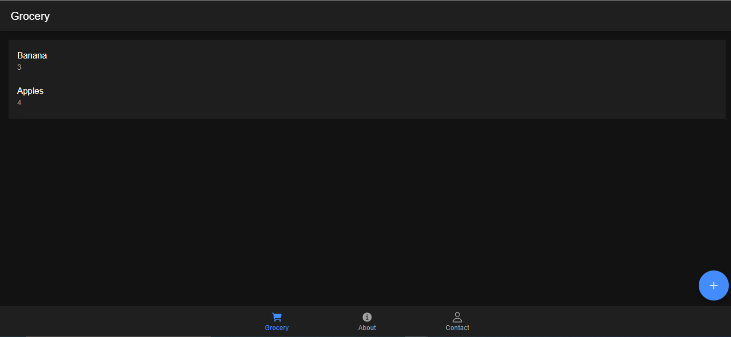

Backend

