Week 7 | Groceries Server on Heroku (Optional)

This week’s improvement includes:

* Deploy the Groceries Server API to Heroku (cloud)

*See screenshots below showing the deployment and testing artifacts.*

Weekly Questions:

1. GitHub Repository URL  
   <https://github.com/SWDV-665/week-7-groceries-app-on-heroku-kerryfaine>
2. How many hours do you estimate you used completing this assignment?  
   I spent approximately 2 hours on this assignment this week.
3. What was easiest for you when completing this assignment?  
   Most of the activities were not difficult this week.
4. What was the most difficult challenge you experienced when completing this assignment?  
   The only issue I had was with an error upon initial deployment. Once that was fixed the deployment was successful.

Screenshots

1. I have set up a Heroku account with Mongo Lab for hosting the Groceries Services API.   
   URL: https://groceries-server-4kerry.herokuapp.com/

GIT: https://git.heroku.com/groceries-server-4kerry.git

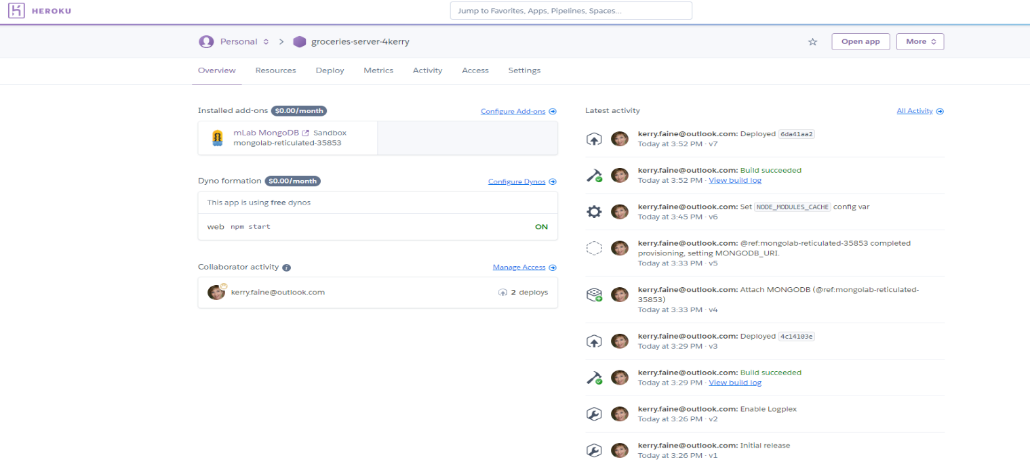

1. Initial test: visit <https://groceries-server-4kerry.herokuapp.com/api/groceries>   
   Upon deployment, no errors are showing up in the log.   
   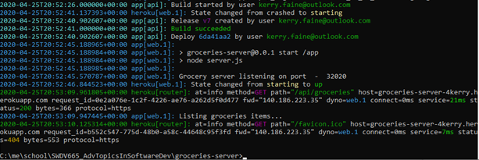
2. After making an update to the local Groceries application to point to the new server location, test the application to show basic CRUD operations.
   1. Adding items:   
      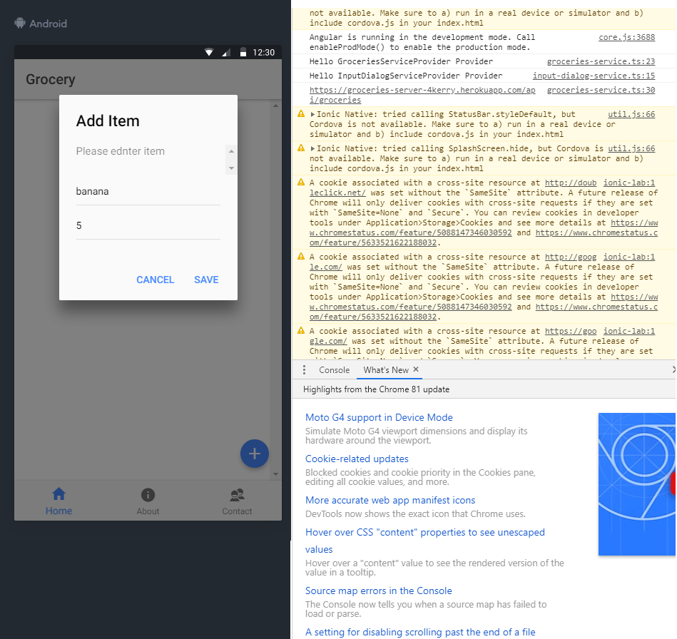

Results:   
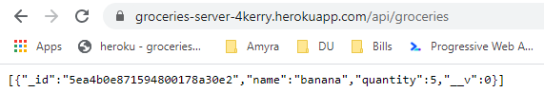

* 1. Deleting an item:   
     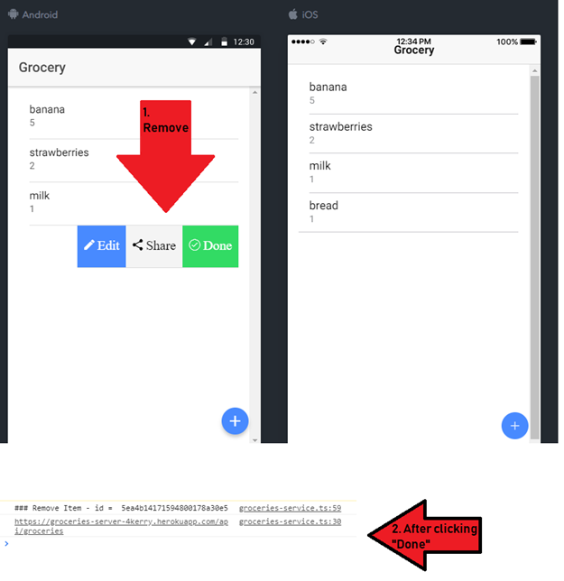

Results:  


* 1. Update an item:  
     