1. Go to [www.swe.org](http://www.swe.org). On the homepage there is a side tab labeled “JOIN”. Click side tab.

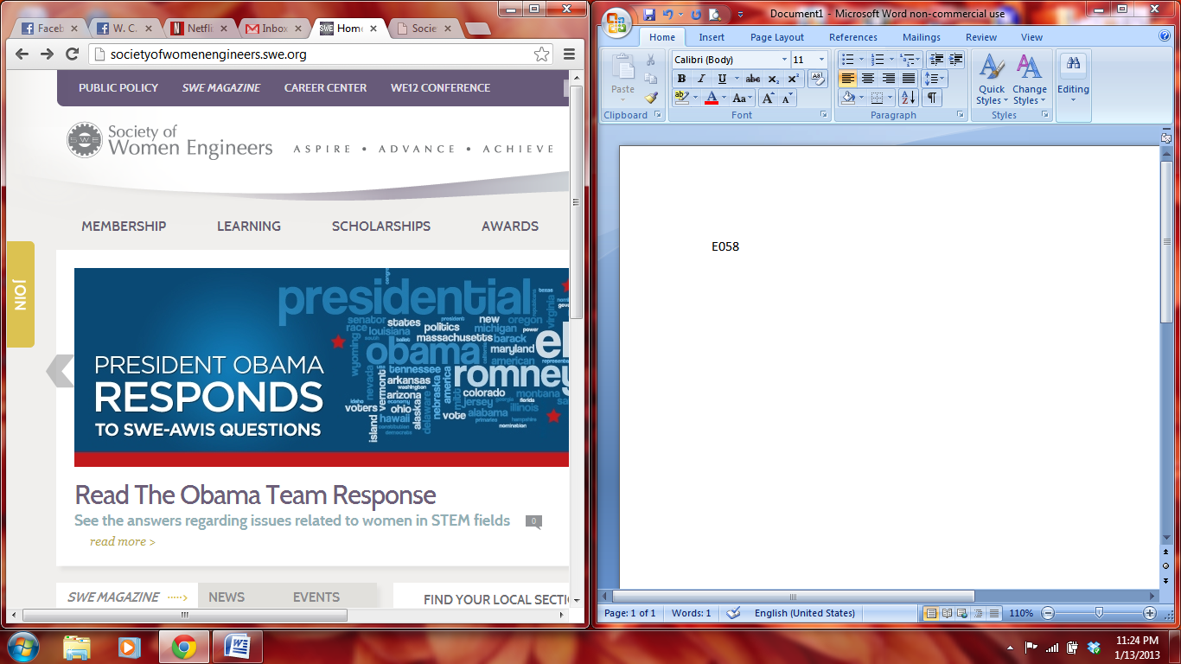

1. Your screen should look like this. Click “JOIN NOW!”



1. Tab will open in a new window. Click the link labeled “Become a member (nonmember).

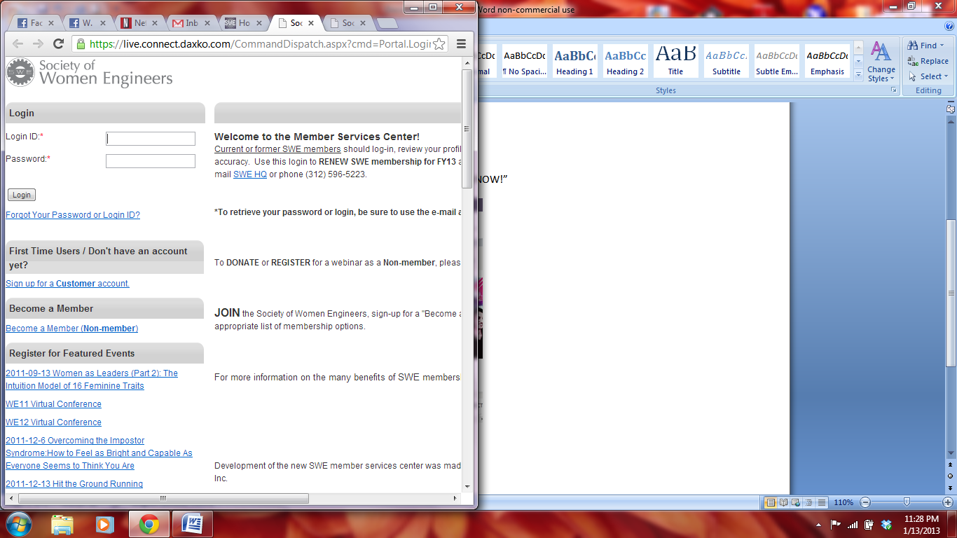

1. Fill out the form with name, email, etc.

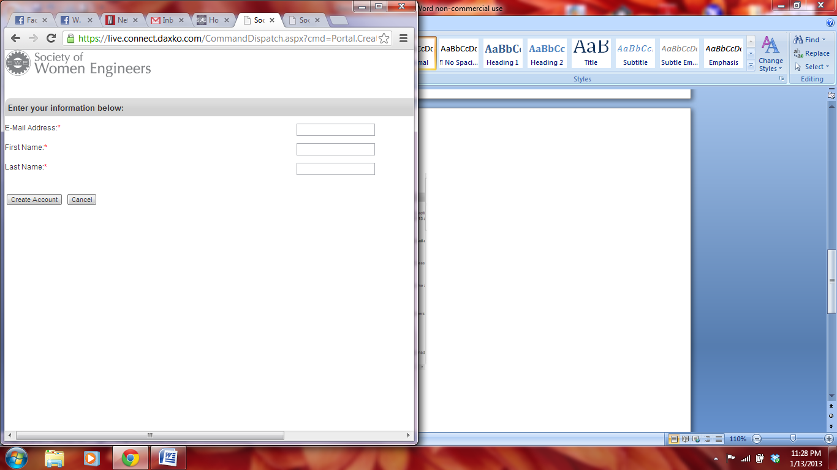

1. Fill out the longer form on the next page.

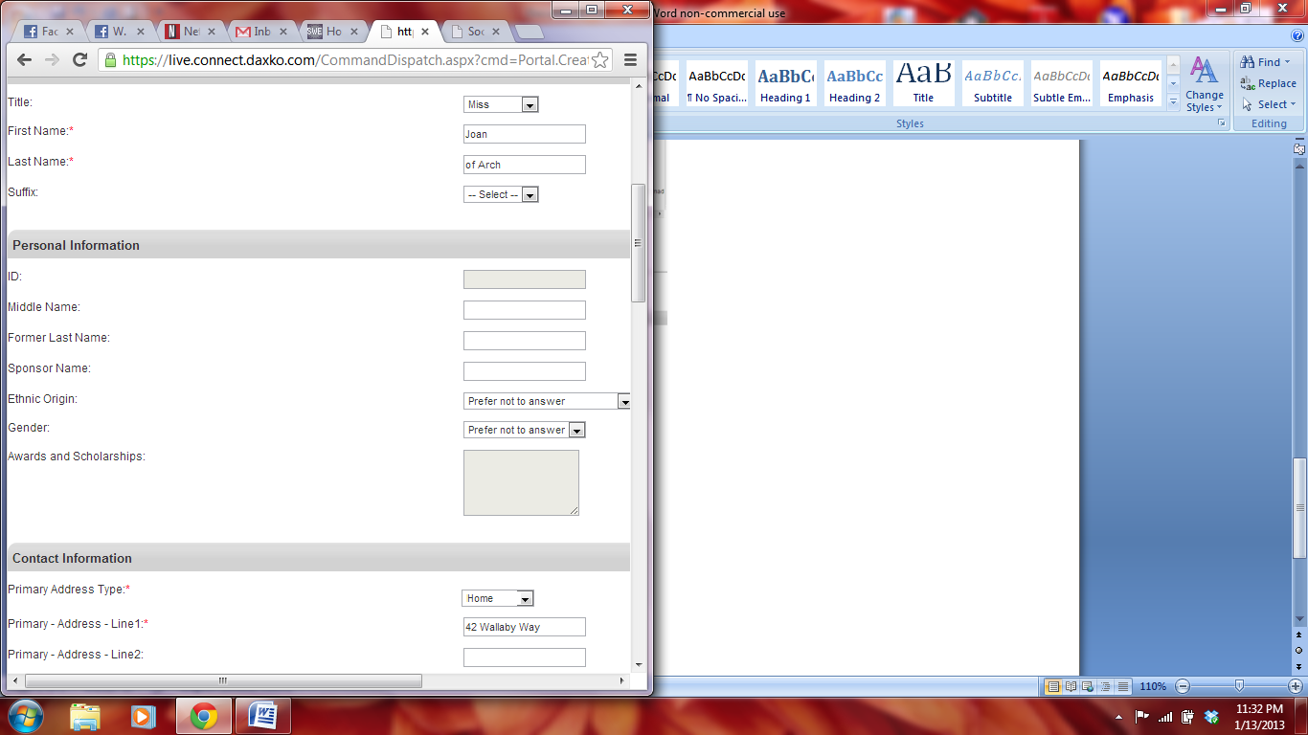

1. Choose the package membership you would like. Collegiate to Career membership is suggested because with the 5yr program you save the most money.

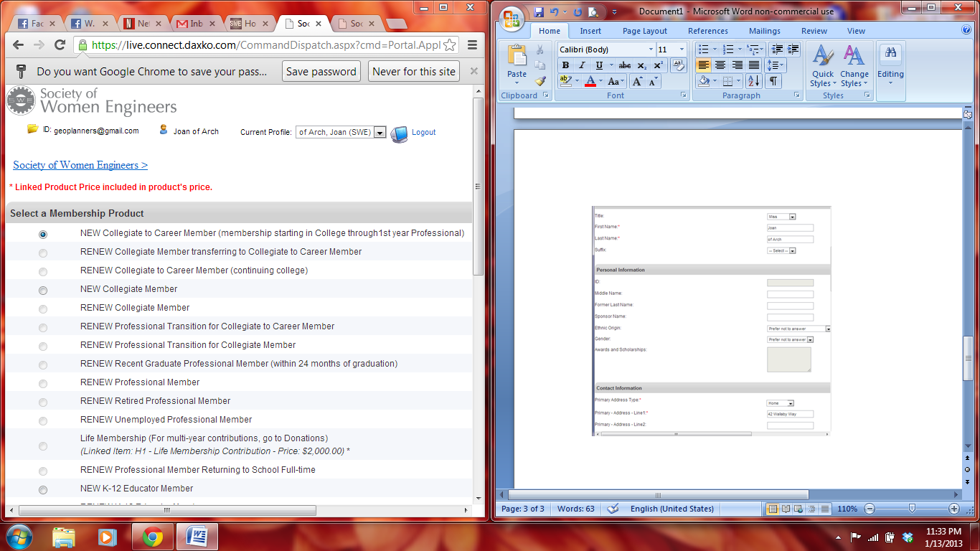

1. Select the Drexel Chapter (E058).

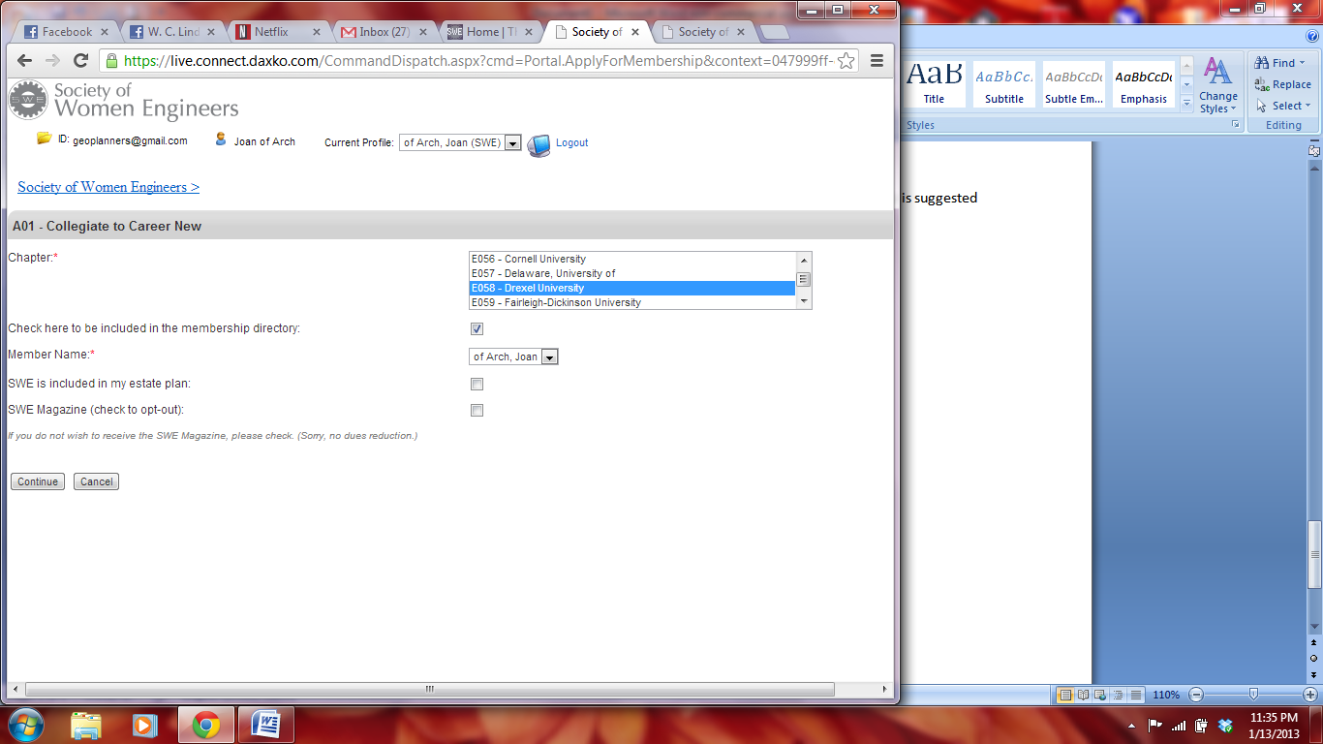

1. Put in your credit card info and you’re home free.

