**Software Design Document (SWDD) Template**

Note: This is only an example and has not been reviewed by LANL to ensure it is truly IEEE 1016 or Ch. 21 compliant.

Background

Software design is a process by which the software requirements are translated into a representation of software components, interfaces, and data necessary for the implementation phase. The SWDD shows how the software system will be structured to satisfy the requirements. It is the primary reference for code development and, therefore, it must contain all the information required by a programmer to write code. The SWDD is performed in two stages. The first is a preliminary design in which the overall system architecture and data architecture is defined. In the second stage—i.e., the detailed design stage—more detailed data structures are defined and algorithms are developed for the defined architecture.

This template is an annotated outline for a software design document adapted from the *IEEE Recommended Practice for Software Design Descriptions*. The *IEEE Recommended Practice for Software Design Descriptions* have been reduced in order to simplify this assignment while still retaining the main components and providing a general idea of a project definition report. For your own information, please refer to IEEE Std 1016[1] for the full *IEEE Recommended Practice for Software Design Descriptions*.

SWDD- [obtain number from Conduct of Engineering Document Numbering [SharePoint site](https://coe.lanl.gov/APs/DocNum/SitePages/Home.aspx)]

**Thoth**

#### Software Design Document

Name (s): Dana Alkhouri - Bemen Girgis - Ziad Hassan - Layla Hussein - Shaza Ali - Omar Bahgat

Section: 1

Date: (9/12/2023)

**TABLE OF CONTENTS**

Software Design Page 1

1. **INTRODUCTION**  4
   1. Purpose 4
   2. Scope 4
   3. Overview 4
   4. Reference Material
2. **SYSTEM OVERVIEW**
3. **SYSTEM ARCHITECTURE**
   1. Architecture Design
   2. Decomposition Description
4. **DATA DESIGN**
   1. Data Description
5. **COMPONENT DESIGN**
6. **HUMAN INTERFACE DESIGN**
   1. Overview of User Interface
   2. Screen Images

## INTRODUCTION

## Purpose

This software design document delineates the functionality of our C++ language whose primary objective is to facilitate the comprehension of the language for everyone.

## Scope

This software aims to create an engaging and customized learning environment for students, emphasizing visual interactions with a variety of C++ algorithms. The program is equipped with the ability to track student performance through assessments designed to evaluate their understanding and progress in the learning journey. Additionally, it provides lessons and YouTube videos to enhance comprehension and clarity for users.

## Overview

Thoth is a specialized C++ learning tutorial program that employs assessments, lessons, and videos to create an engaging and tailored learning environment. Focused on software engineering, Thoth provides features a robust assessment mechanism through purpose-built quizzes, enhancing the overall learning experience by systematically evaluating student performance. Thoth seamlessly integrates these elements to offer a concise and effective pathway for mastering C++.

## SYSTEM OVERVIEW

Designed as a web application using React, HTML, and CSS, the user interface (UI) comprises page activities that act as orchestrators for various essential backed features in our system. This design places the UI as a pivotal component responsible for communicating with the majority of other system components. It is structured as a road map, incorporating several quizzes, videos, and exercises that participants must complete before reaching the tutorial's conclusion.

## SYSTEM ARCHITECTURE

## Architectural Design

## Decomposition Description

Sign-Up/In Sequence Diagram

Authentication Provider Sequence Diagram

User Interaction Sequence Diagram

Playground Sequence Diagram

Practice Problems Sequence Diagram

## DATA DESIGN

## Data Description

Information about the user are collected in one of two situations. First of all, when the user signs up, username, email and password are stored in firebase authentication database. In addition, firebase live database was used to store user related information that were collected after signing up. The user can access his profile and add these additional information. Firebase live database was also used to store the content of each of the existing lessons.

## COMPONENT DESIGN

Components are designed to have states that changes based on the user interactions with the page.

## HUMAN INTERFACE DESIGN

## Overview of User Interface

The website has a user friendly interface that starts with showing the sign in or sign up options. In addition, the user interface integrates a responsive app bar that is existing all time as long as the user is authenticated and logged in. The App bar can be used to navigate and access any of the pages in the website directly except for lessons which is accessed indirectly through the road map which is accessed directly from the App bar menu. The road map is interactive and it gives the user a better experience as it highlights the currently lesson on which the user hovers and make it interacts live with the user. In addition the user can submit code and interact with the two code and text editors provided. The UI returns feedback to the user live based on his code as well.

## Screen Images

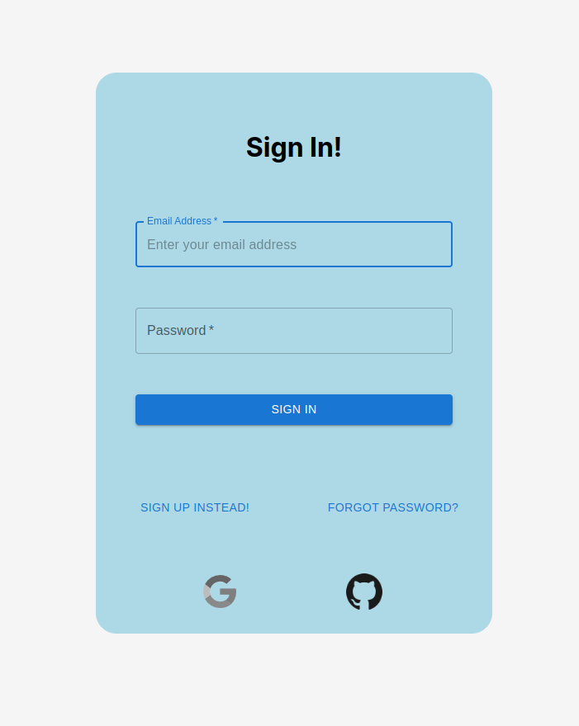

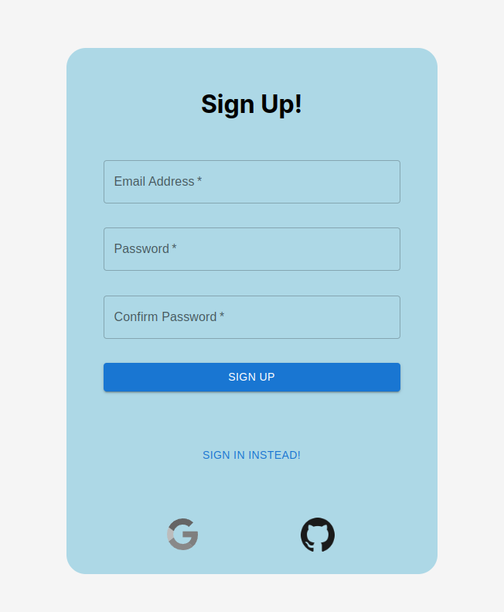

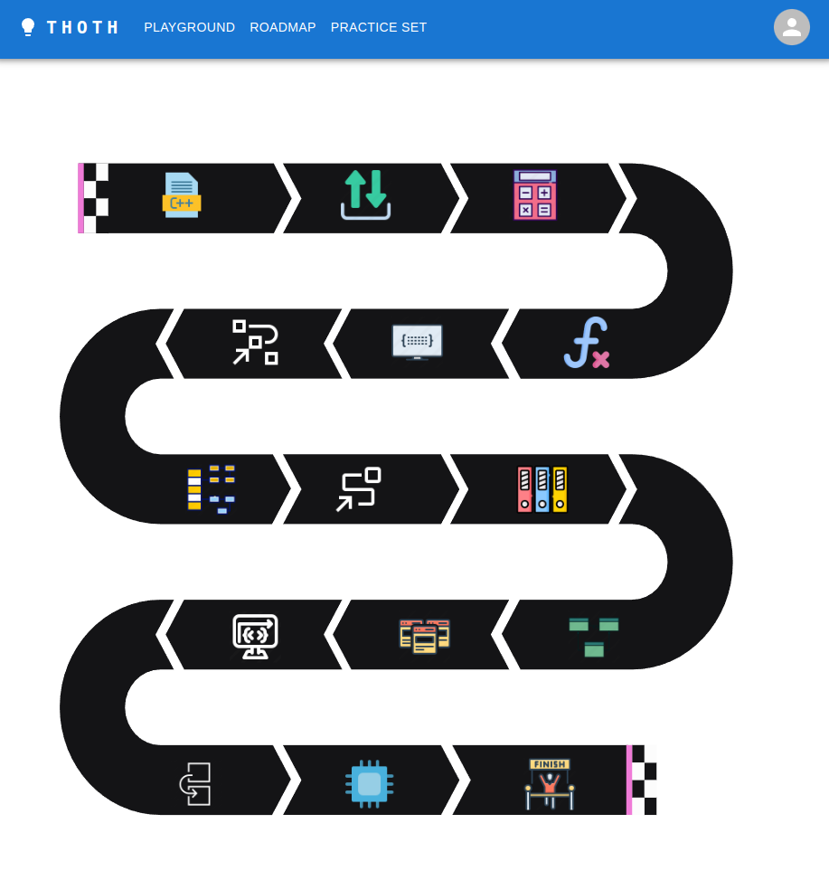

1. Available to LANL users at <http://ieeexplore.ieee.org/browse/standards/collection/ieee>