# Lab 2 Submission

## **Class Diagram**

Deliverables involved:

1. Class diagram of entity classes
2. Key boundary classes and control classes

Diagram:

## **Sequence Diagrams**

Deliverables involved:

1. Sequence diagrams of some use cases

Diagrams:

Route Planning Sequence Diagram

Modify Personal Information Sequence Diagram

Sign Up Sequence Diagram

Interact With Route Card Sequence Diagram

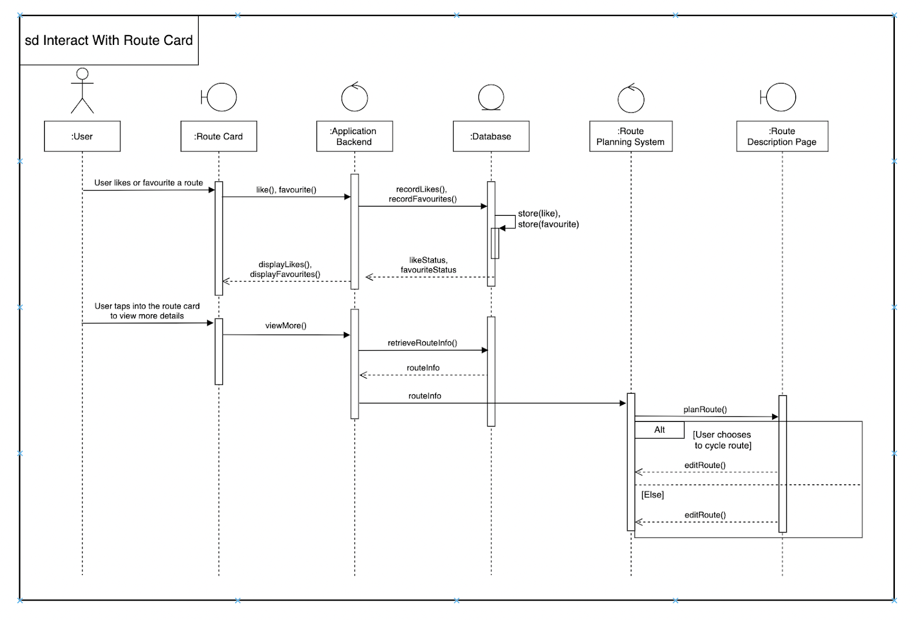

**Dialog Map**

Deliverables:

1. Initial Dialog Map

Diagram:

