# 发布自己的composer包

参考：<https://blog.csdn.net/huangjinao/article/details/102631054>

<https://segmentfault.com/a/1190000020024870>

https://blog.csdn.net/m_nanle_xiaobudiu/article/details/104231469

composer镜像地址：<https://packagist.org/>

composer config -g repo.packagist composer <https://packagist.org>

重置镜像

设置阿里镜像

composer config -g repo.packagist composer https://mirrors.aliyun.com/composer/

取消设置

composer config -g --unset repos.packagist

# composer.json参数含义

## Package Type：项目类型

library, project, metapackage, composer-plugin

minimum-stability 配置项定义了包在选择版本时对稳定性的选择的默认行为。默认是stable。它的值如下（按照稳定性排序）：dev，alpha，beta，RC和stable。

Minimum Stability 最低稳定版本stable, RC, beta, alpha, dev

# composer如何造轮子

以Symfony框架的httpfoundation组件封装请求为例

## 先创建一个空仓库并pull下来

## Composer init初始化 composer.json

### Composer init 命令后续详解

参考：<https://blog.csdn.net/github_38336924/article/details/92839546>

root@dduan:/home/dduan/test_composer# php composer.phar init

Do not run Composer as root/super user! See https://getcomposer.org/root for details

Welcome to the Composer config generator

This command will guide you through creating your composer.json config.

# 1. 输入项目命名空间

# 注意<vendor>/<name> 必须要符合 [a-z0-9_.-]+/[a-z0-9_.-]+

Package name (<vendor>/<name>) [root/test_composer]:yourname/projectname

# 2. 项目描述

Description []:这是一个测试composer init 项目

# 3. 输入作者信息，直接回车可能出现如下提示，有的系统可以直接回车，具体为什么？这里不详细介绍

Invalid author string. Must be in the format: John Smith <john@example.com>

# 3.1. 注意必须要符合 John Smith <john@example.com>

Author [, n to skip]: John Smith <john@example.com>

# 4. 输入最低稳定版本，stable, RC, beta, alpha, dev

Minimum Stability []:dev

# 5. 输入项目类型

Package Type (e.g. library, project, metapackage, composer-plugin) []:library

# 6. 输入授权类型

License []:

Define your dependencies.

# 7. 输入依赖信息

Would you like to define your dependencies (require) interactively [yes]?

# 7.1. 如果需要依赖，则输入要安装的依赖

Search for a package:php

# 7.2. 输入版本号

Enter the version constraint to require (or leave blank to use the latest version): >=5.4.0

# 如需多个依赖，则重复以上两个步骤(7.1/7.2)

Search for a package:

# 8. 是否需要require-dev，

Would you like to define your dev dependencies (require-dev) interactively [yes]?

{

"name": "dduan/test_compser",

"description": "这是一个测试composer init 项目",

"type": "library",

"require": {

"php": ">=5.4.0"

},

"authors": [

{

"name": "John Smith",

"email": "john@example.com"

}

],

"minimum-stability": "dev"

}

# 9. 是否生成composer.json

Do you confirm generation [yes]?

# 现在安装依赖项吗

Would you like to install dependencies now [yes]?

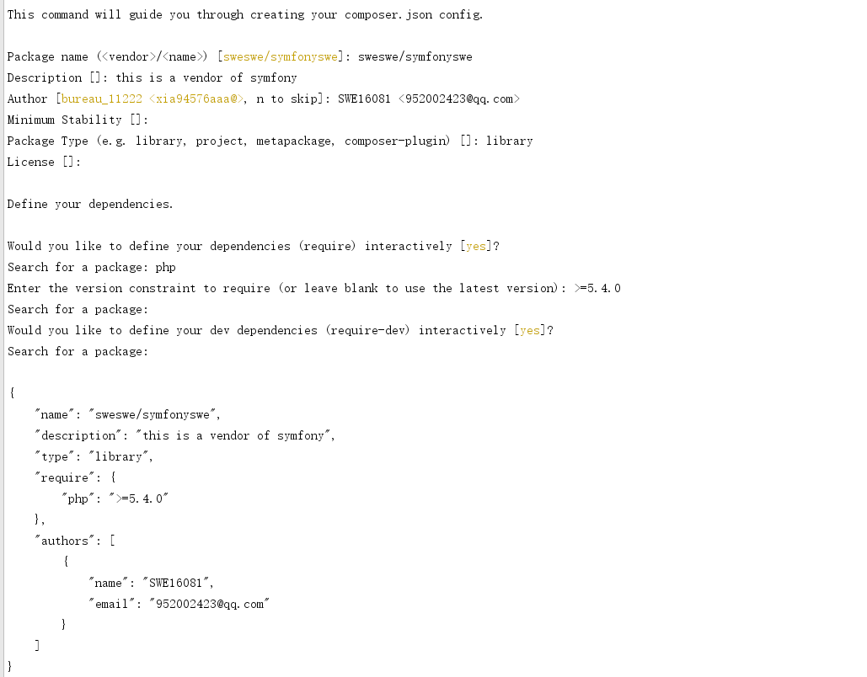

## 安装symfony的httpfoundation组件

<http://www.symfonychina.com/doc/current/components/http_foundation.html>

## 编写代码

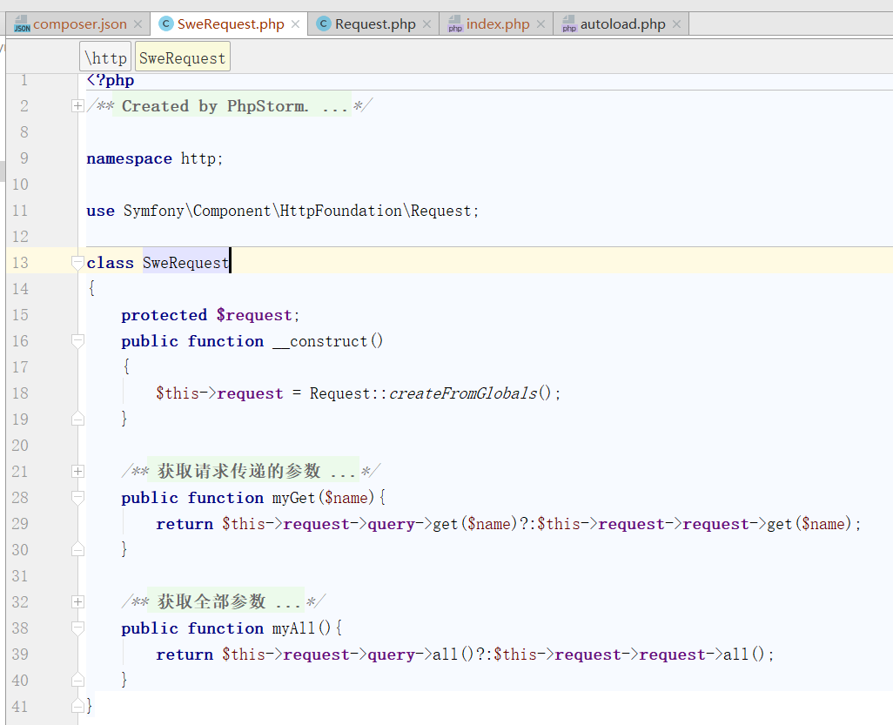

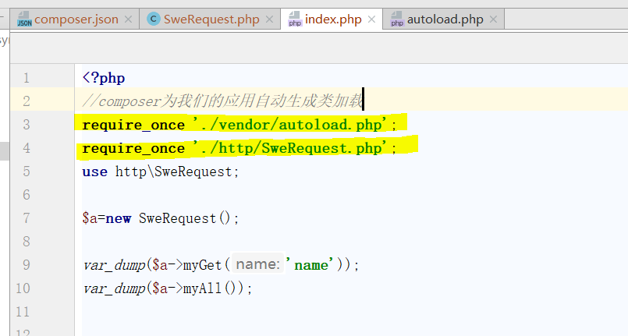

## 编辑.gitignore并上传

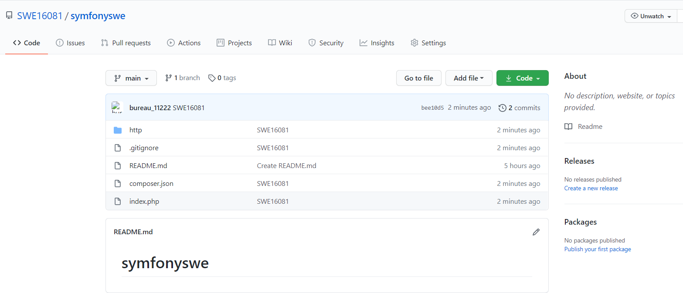

## 6.发布到 Packagist

登录 https://packagist.org/packages/submit

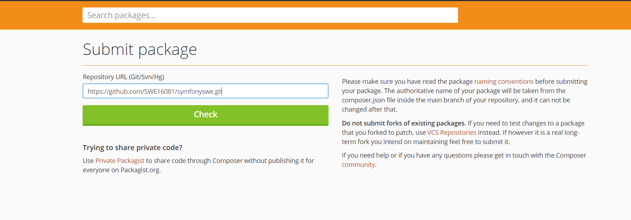

并提交

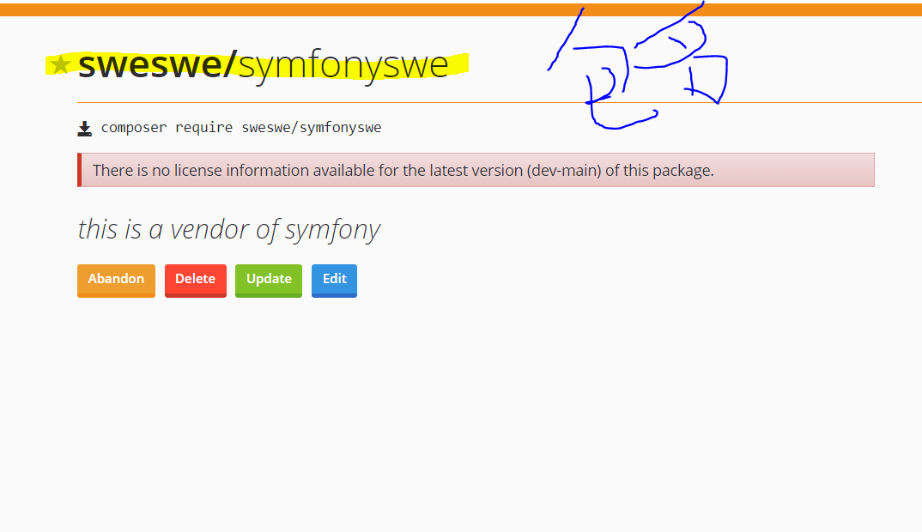

## 7.设置自动同步

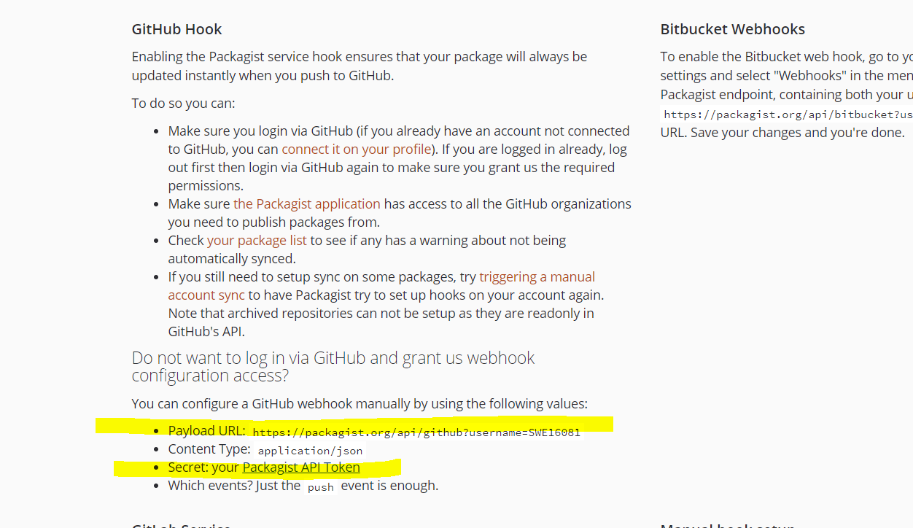

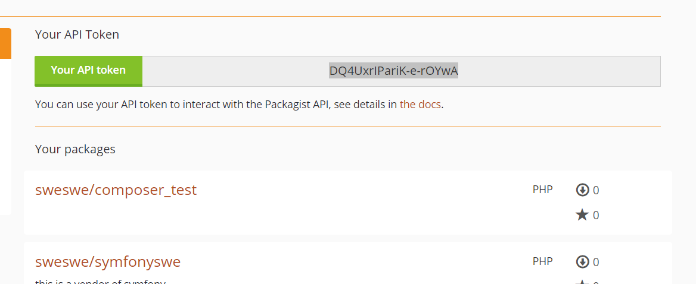

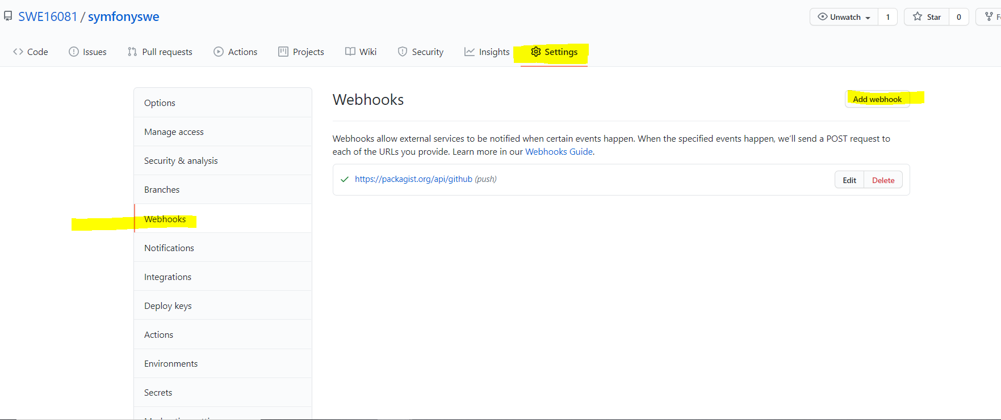

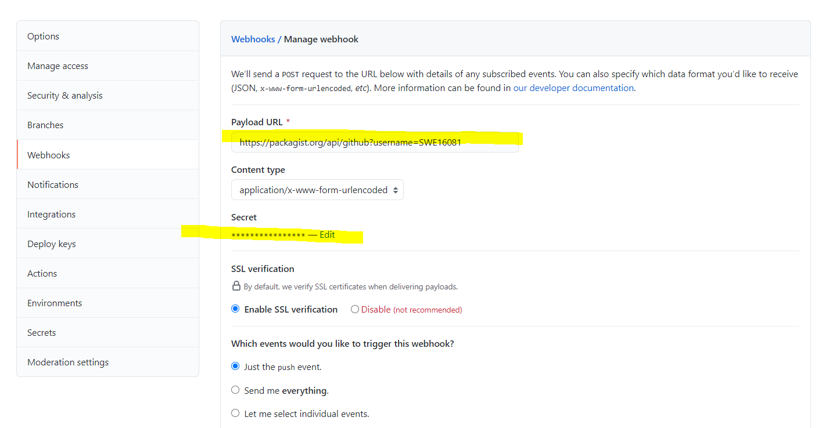

## 8.composer 安裝自己的包

Composer require [sweswe/](https://packagist.org/packages/sweswe/)symfonyswe