1. 使用HTML5的Placeholder属性实现input输入框背景文字提示效果

效果图：

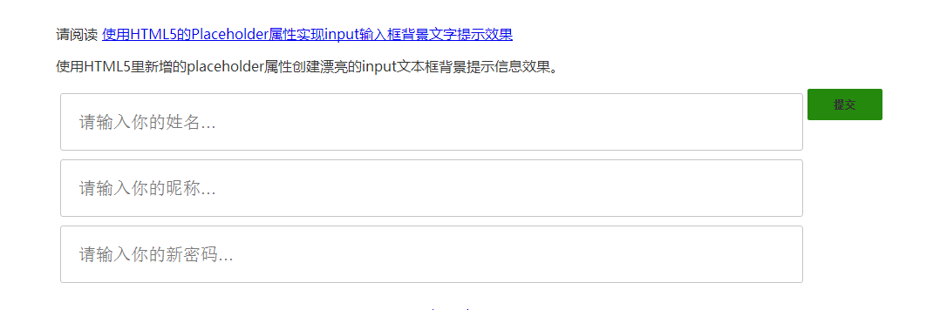

实现代码：

<form>

<input type="text" placeholder="你的姓名..." name="lname">

<input type="password" placeholder="你的密码..." name="pass">

<input type="submit" value="提交">

</form>

**CSS美化Placeholder提示信息的样式**

::-webkit-input-placeholder { color:#f00; }

::-moz-placeholder { color:#f00; } /* firefox 19+ */

:-ms-input-placeholder { color:#f00; } /* ie */

input:-moz-placeholder { color:#f00; }

/* individual: webkit */

#field2::-webkit-input-placeholder { color:#00f; }

#field3::-webkit-input-placeholder { color:#090; background:lightgreen; text-transform:uppercase; }

#field4::-webkit-input-placeholder { font-style:italic; text-decoration:overline; letter-spacing:3px; color:#999; }

/* individual: mozilla */

#field2::-moz-placeholder { color:#00f; }

#field3::-moz-placeholder { color:#090; background:lightgreen; text-transform:uppercase; }

#field4::-moz-placeholder { font-style:italic; text-decoration:overline; letter-spacing:3px; color:#999; }