# apache安装SSL_http转换https

文档

<https://cloud.tencent.com/document/product/400/35243>

<https://www.pw88.com/teach/seo/297.html>

<https://blog.51cto.com/dnuser/2309650>

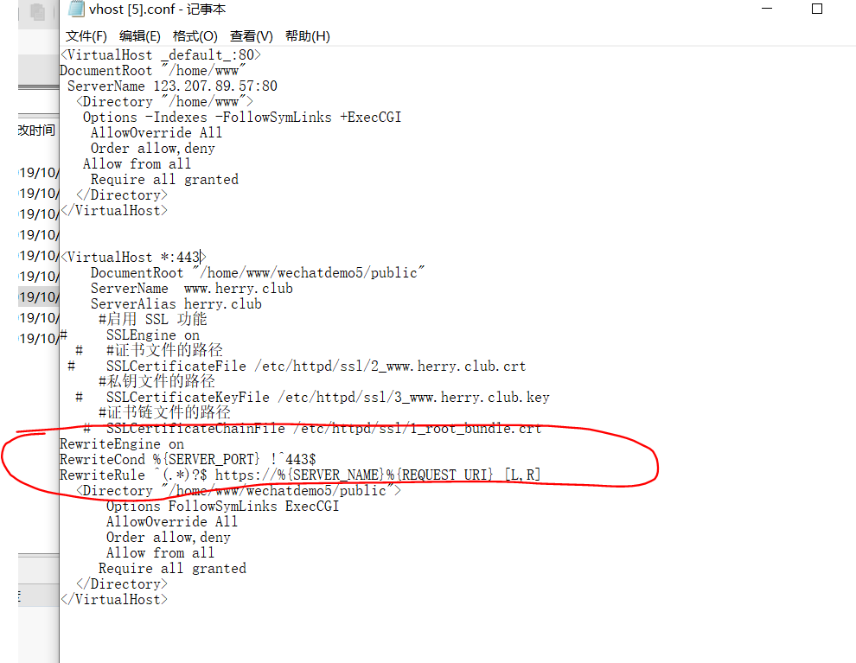

#启用 SSL 功能

SSLEngine on

#证书文件的路径

SSLCertificateFile /etc/httpd/ssl/2_www.herry.club.crt

#私钥文件的路径

SSLCertificateKeyFile /etc/httpd/ssl/3_www.herry.club.key

#证书链文件的路径

SSLCertificateChainFile /etc/httpd/ssl/1_root_bundle.crt

Ssl.conf要配置成下面的样子

