## xshell,xftp下载

<https://www.netsarang.com/zh/free-for-home-school/>

## 2.腾讯云文档

<https://cloud.tencent.com/document/product/213/2502>

## 3.linux安装ftp服务

<https://blog.csdn.net/u012567885/article/details/77943388>

<https://www.cnblogs.com/Wang352051443/p/9805980.html>

<https://blog.csdn.net/putao2062/article/details/79668880>

systemctl restart vsftpd.service

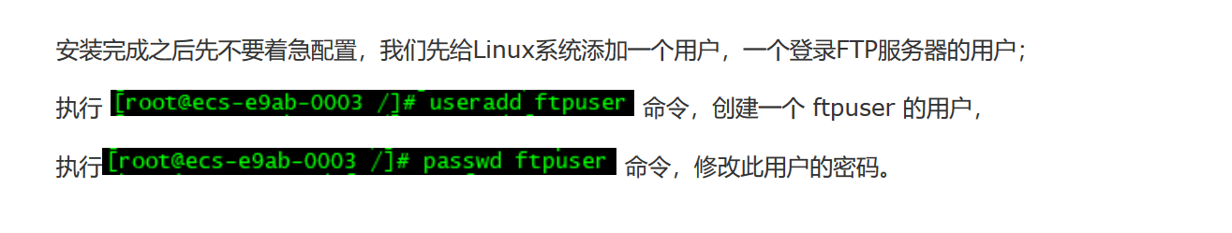

上传失败权限问题：

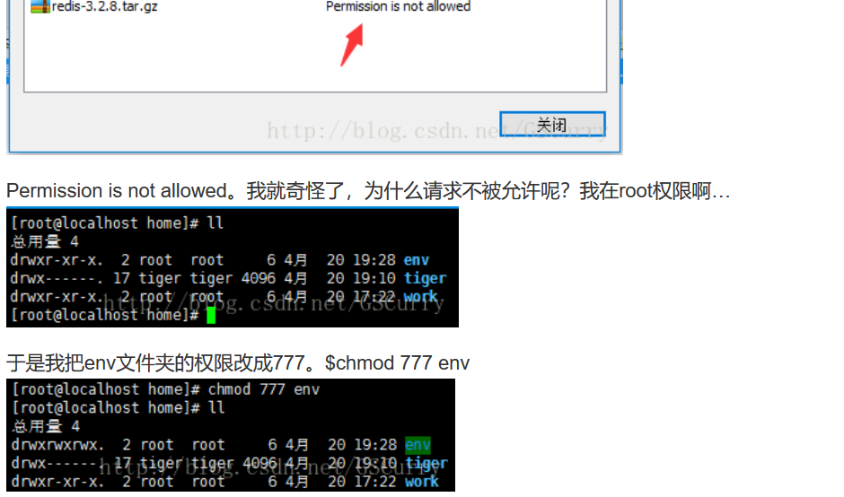

chmod 777 /home/www

laravel项目传上去一开始会用failed to open stream: Permission denied的错误

解决办法

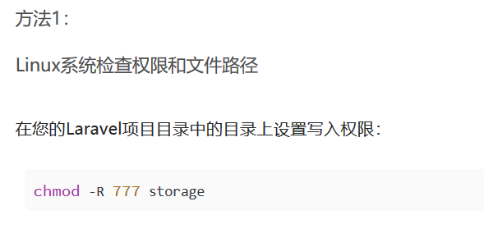

## 4.vhost.conf 和httpd.conf作用详解

虚拟主机可以有多个，一个ip可以指定多个域名，然后配置不同的虚拟主机就可以访问不同的站点文件

chmod -R 755 /home/www

## 5.linux下安装phpmyadmin

<https://blog.csdn.net/weixin_40325128/article/details/81038715>

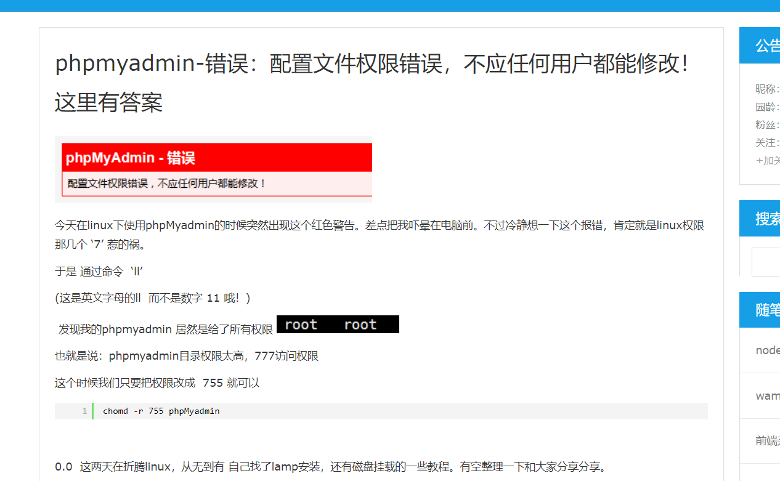

## 6. apache虚拟主机原理

<https://blog.51cto.com/13669226/2121391>

<https://blog.51cto.com/jackcui/1858989>

## 7,mysql指令

## Mysql设置远程连接

<https://www.cnblogs.com/shyy/archive/2012/03/30/2453034.html>

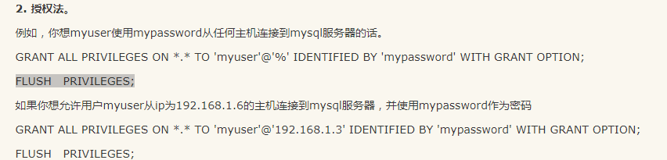

我的服务器mysql相关相关指令

启动systemctl start mysqld.service

开机自启动 systemctl enable mysqld.service

查看状态 systemctl status mysqld.service

重启 systemctl restart mysqld.service

Apache相关指令

Systemctl start httpd.service

Systemctl enable httpd.service

Systemctl restart httpd.service

Php安装：

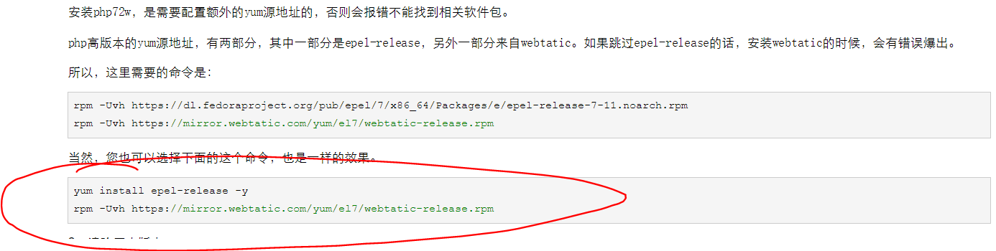

安装的时候选择下面的，上面的报错