## . GuzzleHttp安装

composer require guzzlehttp/guzzle

文档：

<https://guzzle-cn.readthedocs.io/zh_CN/latest/>

## GuzzleHttp访问https报错

参考<https://www.jianshu.com/p/392f966fc4d1>

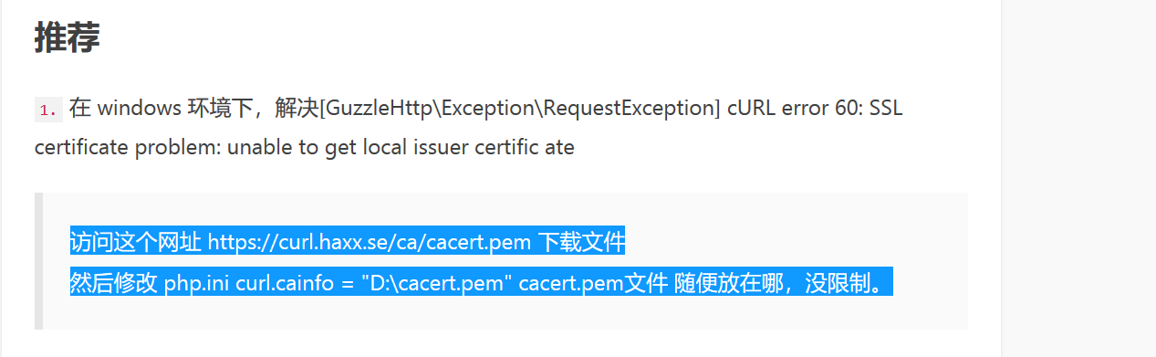

访问这个网址 [https://curl.haxx.se/ca/cacert.pem](https://link.jianshu.com?t=https:/curl.haxx.se/ca/cacert.pem) 下载文件  
然后修改 php.ini curl.cainfo = "D:\cacert.pem" cacert.pem文件 随便放在哪，没限制。

## GET请求

$AppId=config(**'appId'**);  
$AppSecret=config(**'appSecret'**);  
$code=$data[**'code'**];  
$type=**'authorization_code'**;  
$client=**new** Client();  
$res=$client->request(**'get'**,**'https://api.weixin.qq.com/sns/jscode2session'**,[  
 **'query'**=> [  
 **'appid'** => $AppId,  
 **'secret'** => $AppSecret,  
 **'js_code'** =>$code,  
 **'grant_type'** => $type,  
 ]  
]);  
$data=*json_decode*($res->getBody(),**true**);  
**return** json($data);

## Post请求

<https://www.jianshu.com/p/5d489f2d39f5>

$client=**new** \GuzzleHttp\Client();  
$res=$client->request(**'POST'**,$url,[**'json'**=> $data,**'headers'**=>$headers]);  
$result=*json_decode*($res->getBody(),**true**);  
**return** $result;

## body请求体

$res=$client->request(**'post'**,**'https://api.mch.weixin.qq.com/pay/unifiedorder'**,[  
 **'body'**=>$post_xml,  
 **'headers'** => [  
 **'Accept'** => **'application/xml'** ]  
]);

## Get post 封装

**function** guzzleGet($url, $data)  
{  
 $client = **new** \GuzzleHttp\Client();  
 $res = $client->request(**'get'**, $url, [  
 **'query'** => $data  
 ]);  
 $result = *json_decode*($res->getBody(), **true**);  
 **return** $result;  
}  
  
**function** guzzlePost($url, $data)  
{  
 $client = **new** \GuzzleHttp\Client();  
 $res = $client->request(**'POST'**, $url, [**'json'** => $data]);  
 $result=*json_decode*($res->getBody(),**true**);  
 **return** $result;  
}