官方文档：<http://lbsyun.baidu.com/index.php?title=webapi/guide/webservice-geocoding>

## 地理编码

将地址转换成经纬度

*//百度地图 地理编码***function** mapCode($address){  
 $url = **'http://api.map.baidu.com/geocoding/v3/'**;  
 $get_data[**'address'**]= $address;  
 $get_data[**'output'**] = **'json'**;  
 $get_data[**'ak'**] = env(**'BAIDUAK'**);  
 $res=$this->guzzleGet($url,$get_data);  
 **return** $res;  
}

{

    "status": "fail",

    "code": 400,

    "message": "地址转码错误",

    "data": {

        "status": 0,

        "result": {

            "location": {

                "lng": 120.59241222959322,

                "lat": 31.303564074441766

            },

            "precise": 0,

            "confidence": 20,

            "comprehension": 100,

            "level": "城市"

        }

    }

}

<https://windfire.oss-cn-hangzhou.aliyuncs.com/pic/20210120/6007bd02ef120.jpg>

## 坐标转换

将非百度坐标转换成百度坐标

http://lbsyun.baidu.com/index.php?title=webapi/guide/changeposition

### 地址

**http://api.map.baidu.com/geocoding/v3/**

### 参数

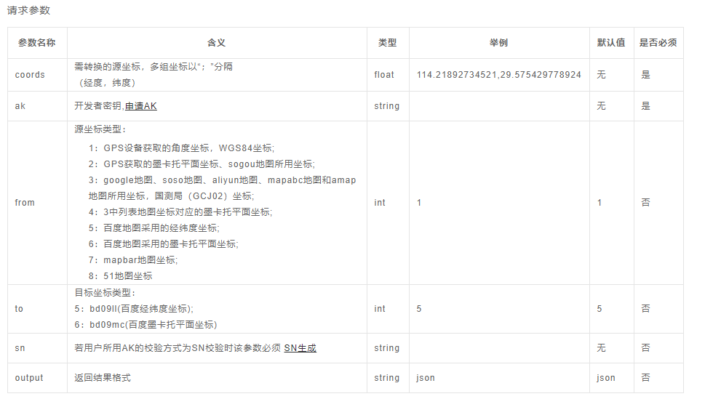

### 返回结果

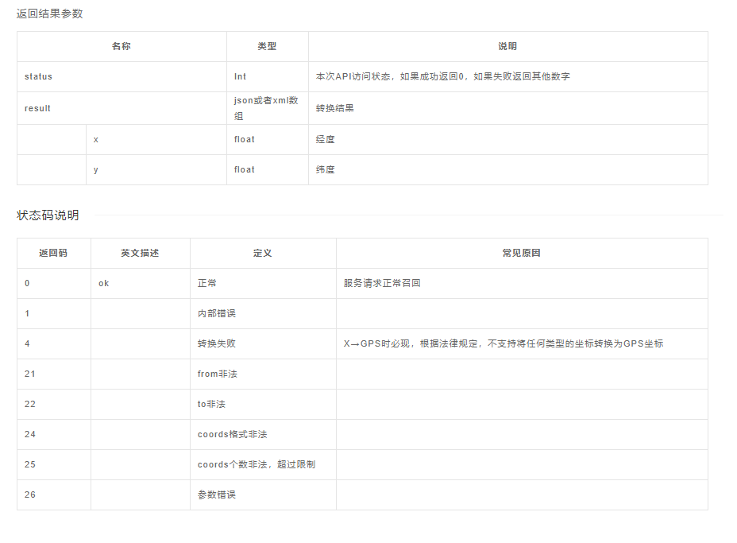

### 实例

**function** mapChangeToB($coords){  
 $url = **'http://api.map.baidu.com/geoconv/v1/'**;  
 $get_data[**'coords'**]= $coords;  
 $get_data[**'from'**] = 1;*//* $get_data[**'to'**] = **'5'**;  
 $get_data[**'ak'**] = env(**'BAIDUAK'**);  
 $res=$this->guzzleGet($url,$get_data);  
 **return** $res;