官方文档：

<https://help.aliyun.com/document_detail/32101.html?spm=a2c4g.11186623.6.1233.39a026fdbxJ5I7>

下载sdk 传到具体的buket下

https://developer.aliyun.com/article/719897

## 安装sdk

composer require aliyuncs/oss-sdk-php

## 存储空间

### 创建存储空间

存储空间的命名规则：必须小写 大写报错

*//阿里oss创建bucket* **function** ossCreate($name){  
 $accessKeyId=env(**'OSSAPPKEYID'**);  
 $accessSecret=env(**'OSSAPPSECRET'**);  
 $endpoint = **"http://oss-cn-hangzhou.aliyuncs.com"**;  
 *//存储空间名称* $bucket=$name;  
 **try**{  
 $ossClient=**new** OssClient($accessKeyId,$accessSecret,$endpoint);  
  
*// $ossClient->createBucket($bucket);  
 // 设置存储空间的存储类型为低频访问类型，默认是标准类型。* $options = **array**(  
 OssClient::***OSS_STORAGE*** => OssClient::***OSS_STORAGE_IA*** );  
 *//判断存储空间名称是否存在  
 // 设置存储空间的权限为公共读，默认是私有读写。* $ossClient->createBucket($bucket, OssClient::***OSS_ACL_TYPE_PUBLIC_READ***, $options);  
 **return true**;  
 }**catch** (OssException $e){  
 **throw new** MyException(**'oss创建bucket失败'**.$e->getMessage().**'_'**.$e->getLine().**'_'**.$e->getFile());  
 }  
 }

### 存储空间列表

*//bucket列表***function** ossBucketList(){  
 $accessKeyId=env(**'OSSAPPKEYID'**);  
 $accessSecret=env(**'OSSAPPSECRET'**);  
 $endpoint = **"http://oss-cn-hangzhou.aliyuncs.com"**;  
 **try**{  
 $ossClient=**new** OssClient($accessKeyId,$accessSecret,$endpoint);  
 *// 列举所有的Bucket。* $bucketListInfo = $ossClient->listBuckets();  
 $bucketList = $bucketListInfo->getBucketList();  
 $mtdata=[];  
 **foreach**($bucketList **as** $bucket) {  
 $arr[**'location'**]=$bucket->getLocation();  
 $arr[**'name'**]=$bucket->getName();  
 $arr[**'date'**]=$bucket->getCreatedate();  
 $mtdata[]=$arr;  
 }  
 **return** $mtdata;  
 }**catch** (OssException $e){  
 **throw new** MyException(**'获取bucket列表失败'**.$e->getMessage().**'_'**.$e->getLine().**'_'**.$e->getFile());  
 }  
}

### 判断存储空间是否存在

*//判断bucket是否存在***function** ossBucketExist($name){  
 $accessKeyId=env(**'OSSAPPKEYID'**);  
 $accessSecret=env(**'OSSAPPSECRET'**);  
 $endpoint = **"http://oss-cn-hangzhou.aliyuncs.com"**;  
 *//存储空间名称* $bucket=$name;  
 **try**{  
 $ossClient=**new** OssClient($accessKeyId,$accessSecret,$endpoint);  
 $res = $ossClient->doesBucketExist($bucket);  
 **return** $res;  
 }**catch** (OssException $e){  
 **throw new** MyException(**'oss创建bucket失败'**.$e->getMessage().**'_'**.$e->getLine().**'_'**.$e->getFile());  
 }  
}

## 上传文件

### 简单文件上传

参考：获取文件地址：

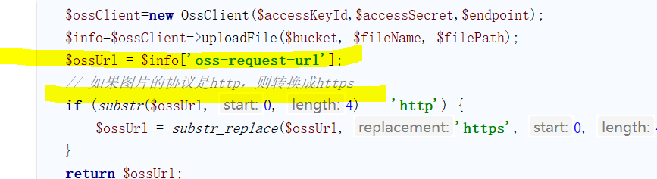

*//简单文件上传*function ossSimpleUpload($bucket,$fileName,$filePath){  
 $accessKeyId=env('OSSAPPKEYID');  
 $accessSecret=env('OSSAPPSECRET');  
 $endpoint = "http://oss-cn-hangzhou.aliyuncs.com";  
 // 设置存储空间名称。  
 // 设置文件名称  
 // 设置文件路径由本地文件路径加文件名包括后缀组成，例如/users/local/myfile.txt。  
 try{  
 $ossClient=new OssClient($accessKeyId,$accessSecret,$endpoint);  
 $info=$ossClient->uploadFile($bucket, $fileName, $filePath);  
 $ossUrl = $info['oss-request-url'];  
 // 如果图片的协议是http，则转换成https  
 if (substr($ossUrl, 0, 4) == 'http') {  
 $ossUrl = substr_replace($ossUrl, 'https', 0, 4);  
 }  
 return $ossUrl;  
 }catch (OssException $e){  
 throw new MyException('oss简单上传文件失败'.$e->getMessage().'_'.$e->getLine().'_'.$e->getFile());  
 }  
}

### 追加上传

## 图片处理参数

文档：<https://help.aliyun.com/document_detail/135444.html?spm=a2c4g.11186623.6.745.4cfc7fd8QkFTcE>

https://windfire.oss-cn-hangzhou.aliyuncs.com/pic/20210219/602f1d71a4e32.png?x-oss-processs=[image/format, **WebP**/resize,l_750,h_435](https://image-demo-oss-zhangjiakou.oss-cn-zhangjiakou.aliyuncs.com/sample.jpg?x-oss-process=image/format,heic/resize,l_900,h_600)

https://image-demo-oss-zhangjiakou.oss-cn-zhangjiakou.aliyuncs.com/sample.jpg?x-oss-process=image/format,WebP