## 微服务的理解

### 杂项

### Web server failed to start. Port 8080 was already in use.

netstat -ano

tasklist | findstr "7676"

taskkill /f /t /im java.exe

### 创建spring boot 项目出现Whitelabel Error Page

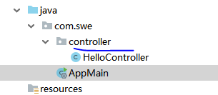

Controller 要和主程序同目录

<https://blog.csdn.net/u014788227/article/details/53670112>