# **Documentation for Interest program**

This project is created for the purpose of re-factoring the interest project int he previous semester by separating the program’s process using functions and re-factoring that code again by implementing as user defined data type(in our case using **struct**).

The reason behind the re-factoring of the code is to make the code more readable and to remove redundancy form our previous programs by using modular programming and hopefully making the program less complicated than the previous one.

Modular programming is an approach to programs that are written in multiple functions, and these functions do a specific task in a program. This makes it easier to read and understand the code. Besides it uses the technique of breaking down a problem into small problems, which is the core principle of software engineering. We tried to embrace our code with functions that will do some tasks. Therefore, we’re going through our code and try to describe all about the code we wrote.

# **Basic Components of The Program**

As usual we started writing our program by including the **iostream** pre-processor which enables the flow of data in the program as an input and output. Besides we inserted **using namespace std** in our program which enables us to access some standard identifiers like **cin, cout** and **endl.** Other main component of the main function, in which it display the program.

# **Used Functions**

In this project we used three different functions:

* An **inpuT** function to input interest rate and the amount of loan.
* A **dataCalc** function to calculate the the payment, interest, reaming loan and rate of payment.
* Finally an **outpuT** function, as it’s name suggests it prints out the table for our program.

# **The working’s of the code**

After including header file and using the standard name space we started with declaring and initializing global variables, secondly function declaration or writing the function prototype of the function. This is good practice of writing a function code, besides we will call some of the functions in another function so this will avoid compilation error. Here is how we declared our function in our program:

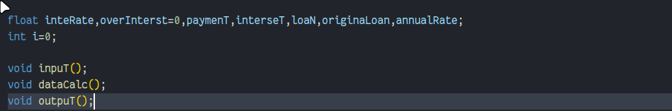

The three function that we used are void function, meaning they don’t have a return type. The functions are also parameter less as the use case of global variables to minimize the usage of passing by value(it create an issue where there are unnecessary amount of variables declared), and passing by reference was deemed not needed as the program didn’t need to edit the value of the variables.

The **inpuT** function is a function that is supposed to ask for input from the used and store them to the global variable’s. The function includes the storing of the loan in the variable **loaN** and the storing of the interest rate in the **inteRate** variable.

**The initialization of the function looks like this:**

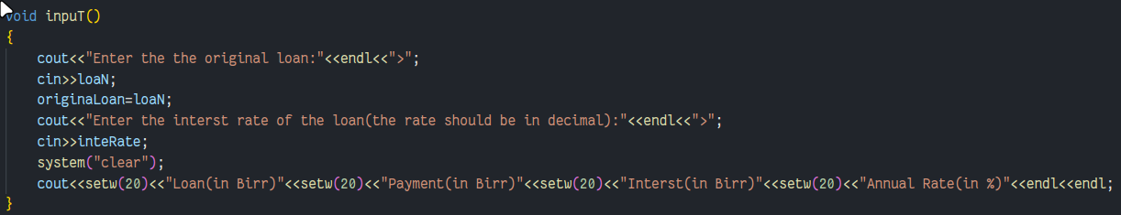

The second function is the **dataCalc** function, this function is used to do the mathematical intensive part of the program that includes:

* Calculating the interest,
* Calculating the payment,
* Calculating the annual rate,
* The payment over the interest,
* Finally the new(remaining) loan.

After calculating the function stores the data to there variable; interest in **interseT**, payment in **paymenT**, annual rate in **annualRate**, the payment over the interest in **overInterst**, the remaining loan in **loaN**.

**The initialization of the function looks like this:**

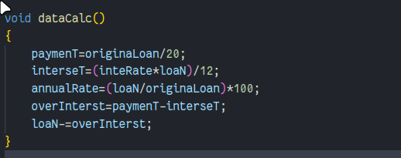

The last function is the **outpuT** function that handles the presentation of the data. After some discussion we understood that there was no reason to delicately store the data of each cycle of the program so we opted to displaying the data every time one cycle of the program ends and calling again the **dataCalc** function until the loan is below zero.

We used a recursive function in the program to handle the execution of the function, and using if, else if and else statements for conditions of execution. The conditions being:

* If the loan is greater than zero and less than the previous loan(original loan), print out the loan, payment, interest and annual rate then call the **dataCalac** function and call it’s self.
* If the loan is greater than the previous loan(original loan) then print the first line of the data and exit printing the “loan can’t be payed”. This case allows to avoid cases where the loan can’t be payed and the program runs infinitely.
* If the loan in less than zero it prints out a summary of the program and exits.
  + The summary includes the the rate of interest and the cycles needed for the loan to be paid.

**The initialization of the function looks like this:**

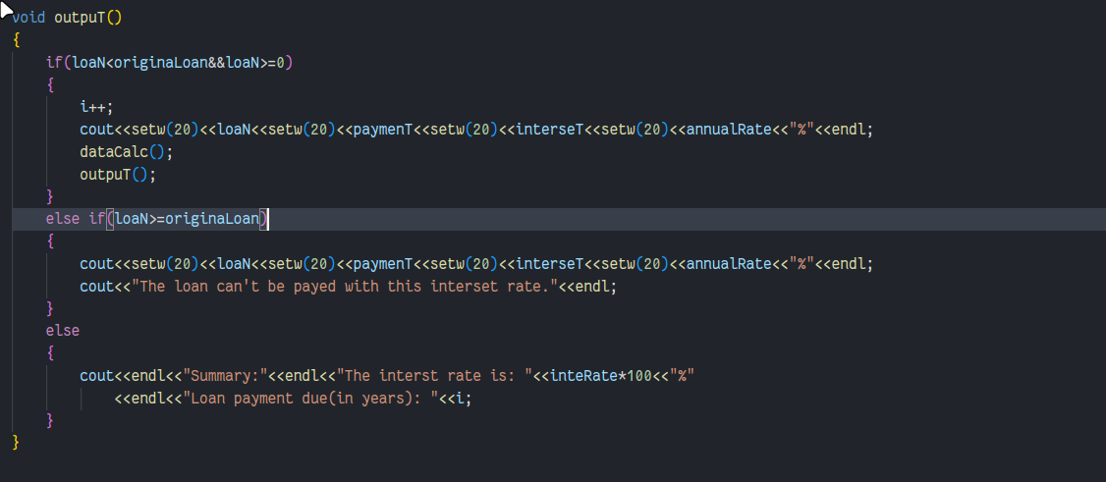

## **Final output**

Case the interest rate is 0.2 and the loan is 4000:

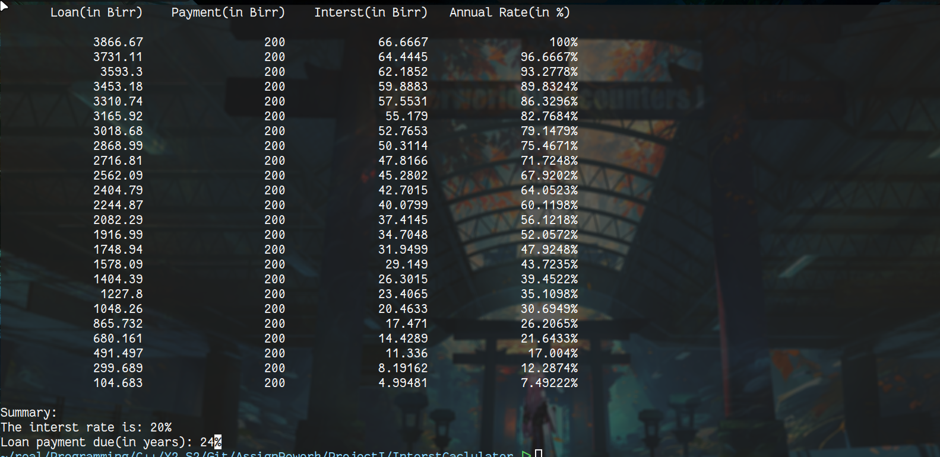

# **Version2 of the re-factoring**

This part includes the usage of a user defined data type(**struct** in our case) to store different types of data type globally.

In this version of the program the only significant change from the previous implementation is the declaration of a **struct datA** and initialization of it using a **tyP** variable. The rest of the program includes the rewriting of the data’s to complement the usage of the data type **datA**.

The data type **datA** included two data types:

* Float
* Int

The **struct datA** looks like this:

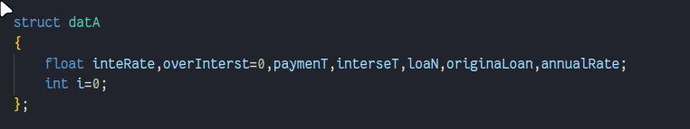

**The new implementation of the code looks like this:**

For the **inpuT** function:

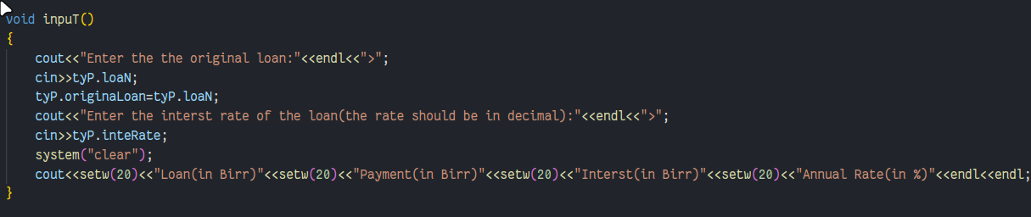

For the **dataCalc** function:

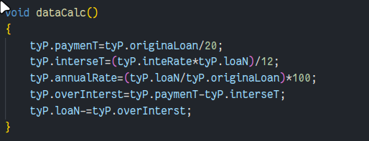

For the **outPut** function;

