Product Requirements Document

Submission 1 Specification

**2Pizzas**

SWEN90007 SM2 2021 Project

**In charge:**

Ben Nguyen – benn1@student.unimelb.edu.au

Mahardini Rizky Putri – mahardinip@student.unimelb.edu.au

Max Plumley – mplumley@student.unimelb.edu.au

Sothea-Roth Bak – sbak@student.unimelb.edu.au



Revision History

|  |  |  |  |
| --- | --- | --- | --- |
| Date | Version | Description | Author |
| 05/08/2021 | 01.00-D01 | Initial draft | Ben Nguyen  Mahardini Rizky Putri  Max Plumley  Sothea-Roth Bak |
| 05/08/2021 | 01.00-D02 | Completed Use Cases in Section 3.2, 3.3, 3.5, 3.6, 3.8, 3.9, 3.13 | Ben Nguyen  Mahardini Rizky Putri  Max Plumley  Sothea-Roth Bak |
| 10/08/2021 | 01.00-D03 | Inserted diagram into Section 4.2 Domain Model Diagram | Max Plumley |
| 10/08/2021 | 01.00-D04 | Completed description in Section 4.1 Domain Model Description | Ben Nguyen |
| 10/08/2021 | 01.00-D05 | Completed Use Cases in Section 3.1, 3.4, 3.7, 3.10, 3.11, 3.12, 3.14, 3.15 | Ben Nguyen  Mahardini Rizky Putri  Max Plumley  Sothea-Roth Bak |
| 10/08/2021 | 01.00-D06 | Inserted diagram into Section 3.1 Use Case Diagram | Max Plumley |
| 10/08/2021 | 01.00-D07 | Completed Section 1.3 Conventions, terms, and abbreviations | Mahardini Rizky Putri |
| 10/08/2021 | 01.00-D08 | Completed Section 2 Actors | Ben Nguyen  Sothea-Roth Bak |
| 10/08/2021 | 01.00 | Review final version of report | Ben Nguyen  Mahardini Rizky Putri  Max Plumley  Sothea-Roth Bak |

1. Introduction 5

1.1 Proposal 5

1.2 Target Users 5

1.3 Assumptions, conventions, terms, and abbreviations 5

2. Actors 5

3. Use Case 6

3.1 Use Case Diagram 6

3.2 Use Case 1: Administrator logs in 8

3.3 Use Case 2: Administrator creates Airport 8

3.4 Use Case 3: Administrator disables Airport 8

3.5 Use Case 4: Administrator creates Airline 8

3.6 Use Case 5: Administrator searches for Airline 9

3.7 Use Case 6: Administrator removes Airline 9

3.8 Use Case 7: Airline logs in 9

3.9 Use Case 8: Airline creates Flight 9

3.10 Use Case 9: Airline cancels Flight 10

3.11 Use Case 10: Airline edits Flight 10

3.12 Use Case 11: Customer logs in 10

3.13 Use Case 12: Customer books Flight 11

3.14 Use Case 13: Customer looks up Booking information 11

3.15 Use Case 14: Customer searches for a Flight 11

4. Domain Model 12

4.1 Domain Model Description 12

4.2 Domain Model Diagram 13

# Introduction

## Proposal

This document specifies the SWEN90007 project use cases, actors to be implemented, and the system’s domain model.

## Target Users

This document is mainly intended for SWEN90007 students and teaching team.

## Assumptions, conventions, terms, and abbreviations

This section explains the concept of some important terms that will be used throughout this document. These terms are detailed alphabetically in the following table.

|  |  |
| --- | --- |
| Term | Description |
| Flight | A flight is a trip involving a single airline and airplane type that can contain multiple stopover airports between the origin and destination airports.  A return flight is another trip that will be booked using the same airline and airports (including stopovers), but with a flipped itinerary.  Example: Return flight with Airline A from Melbourne to Jakarta, through 1 stopover in Singapore  Original flight = MEL -> SIN -> CGK using Airline A  Return flight = CGK -> SIN -> MEL using Airline A |
| URL | Uniform Resource Locator |
| Username | Equivalent to and interchangeable with Email |

# Actors

|  |  |
| --- | --- |
| Actor | Description |
| Administrator | *An individual who is responsible for managing the application, which includes adding airlines and airports to the system and aggregating flights.* |
| Airline | *An entity who is responsible for adding, removing, and modifying flights from their airline on the system.* |
| Customer | *Individuals who use the application to search and book flights.* |

# Use Case

## Use Case Diagram

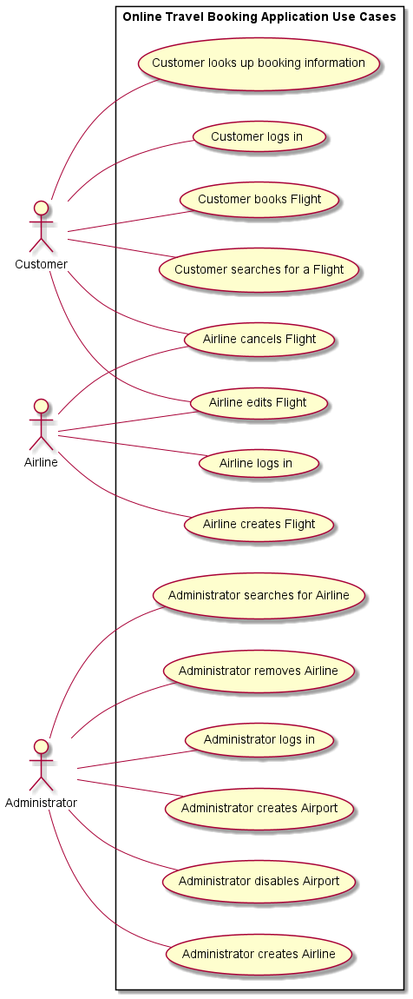

## Use Case 1: Administrator logs in

**Actors**

1. Administrator

**Preconditions**

* Account has already been created for the administrator

**Basic Flow**

Administrator enters the website URL for the travel booking application, which directs them to the application home page. Then they click on the Login option in the navigation bar and are presented with the email and password text fields, where they then enter their login credentials. Finally, upon clicking the Login button, they are presented with the Administrator dashboard page, which contains Administrator-only actions such as managing airports and airlines.

## Use Case 2: Administrator creates Airport

**Actors**

1. Administrator

**Basic Flow**

Administrator logs into system and selects option to create a new airport, inputs airport name, short name and location and selects create. If the airport does not already exist, then the input is persisted in the system and a success message is shown. Alternatively, if the airport already exists an error is shown to the Administrator.

## Use Case 3: Administrator disables Airport

**Actors**

1. Administrator

**Preconditions**

* Airport currently exists and not disabled in the system

**Basic Flow**

Administrator logs into system and selects an existing airport and selects disable and a success message is shown to the Administrator. Airlines can no longer create flights such that the disabled airport acts as the origin, stopover, or destination airport.

## Use Case 4: Administrator creates Airline

**Actors**

1. Administrator

**Basic Flow**

Administrator logs into system and selects to create a new Airline. The administrator inputs the Airline name, Airline code and the email address and name of the Airline user account and selects create. If the Airline does not already exist, the Airline details and Airline user account is persisted by the system and a success message is shown to the Administrator. If the Airline already exists, then an error message is shown to the Administrator.

## Use Case 5: Administrator searches for Airline

**Actors**

1. Administrator

**Basic Flow**

Administrator logs into system, selects the search bar, and inputs the name of the Airline they are searching for. If there are no airlines in the system or if no airlines match the search query, then the list is empty.

## Use Case 6: Administrator removes Airline

**Actors**

1. Administrator

**Preconditions**

* Administrator is logged in and has searched for airlines, such that the results are available

**Basic Flow**

Administrator selects an Airline from the search results. The administrator is presented with a page containing a remove option and the details of the airline, which includes the airline name and code, the email address and name of the airline’s user account, and a list of the airlines ongoing or future flights. The remove option is only enabled if the Airline does not have any ongoing or future flights. Then the administrator clicks the remove option, and the airline user account is disabled

## Use Case 7: Airline logs in

**Actors**

1. Airline

**Preconditions**

* Account has already been created for the airline

**Basic Flow**

Airline enters the website URL for the travel booking application, which directs them to the application home page. Then they click on the Login option in the navigation bar and are presented with the email and password text fields, where they then enter their login credentials. Finally, upon clicking the Login button, they are presented with the Airline dashboard, which contains Airline-only actions such as managing flights.

## Use Case 8: Airline creates Flight

**Actors**

1. Airline

**Preconditions**

* Airline has an existing account in the system
* Origin and destination airport have been added into the system

**Basic Flow**

Airline logs into system and selects the option to create a flight. Then they select the airplane type for the flight, the origin airport, destination airport, departure time, and stopover airport(s) if applicable. They then click the Confirm button to finalise the flight, a success message is then shown to the Airline.

## Use Case 9: Airline cancels Flight

**Actors**

1. Airline
2. Customer

**Preconditions**

* Airline has an existing account in the system
* Airline has existing future flight(s) already in the system

**Basic Flow**

Airline logs into system and selects to view all flights, they then select the Cancel option for a chosen flight that is due to commence in the future. The Cancel option for flights that are ongoing or have run are disabled. They then are presented with the details of the flight including the origin, stopover (if any), destination airports and the departure and arrival times from and to each airport, the seats that have been booked for the flight, an Edit button, and a Cancel button. Finally, the Airline clicks the Cancel button to finalise the flight’s cancellation, a success message is shown to the Airline and a notification email is sent to the customer.

## Use Case 10: Airline edits Flight

**Actors**

1. Airline
2. Customer

**Preconditions**

* Airline has an existing account in the system
* Airline has existing future flight(s) already in the system

**Basic Flow**

Airline logs into system and selects to view all flights, they then select the Edit option for a chosen flight that is due to commence in the future. The Edit option for flights that are ongoing or have run are disabled. They then are presented with the details of the flight including the origin, stopover (if any), destination airports and the departure and arrival times from and to each airport, the seats that have been booked for the flight, an Edit button, and a Cancel button. The Airline then clicks the Edit button to initiate editing the flight. They are then able to edit the time and/or date of the flights. The Airline then clicks the Confirm button and a success message is shown if the change is possible and a notification email is sent to the customer, else an error message is shown if there is a clash with the use of the airplane.

## Use Case 11: Customer logs in

**Actors**

1. Customer

**Preconditions**

* Account has already been created for the customer

**Basic Flow**

Customer enters the website URL for the travel booking application, which directs them to the application home page. Then they click on the Login option in the navigation bar and are presented with the email and password text fields, where they then enter their login credentials. Finally, upon clicking the Login button, they are presented with the home page, which shows them search bar for flights.

## Use Case 12: Customer books Flight

**Actors**

1. Customer

**Precondition**

* Customer has searched for flights and the results are available

**Basic Flow**

Customer selects a flight from the search results, if the customer has elected to search for return flights, then the customer also selects a return flight from the return flight search results. The customer is presented with a page to select their seats for each selected flight, the customer selects seats on each flight for each passenger and selects done. The customer is presented with a page to input the details for each passenger, such as passenger name, age, and passport ID, the customer inputs their email address and selects book. The booking is persisted in the system and the seats are reserved to the booking; the details of the booking are emailed to the customer at the email address provided.

## Use Case 13: Customer looks up Booking information

**Actors**

1. Customer

**Precondition**

* Customer is an existing user of the application
* Customer has an existing flight booked on the system

**Basic Flow**

Customer logs into the system, they then click on the View Bookings button. They then are presented with a list of all future and ongoing flights that they have booked; they can also select to view previous bookings. When they click on a booking, their booking details including passenger details, flights date(s) and time(s) and seat numbers will be displayed.

## Use Case 14: Customer searches for a Flight

**Actors**

1. Customer

**Basic Flow**

Customer selects to search for flights, customer inputs the number of passengers that will be travelling as well as origin and destination airports, a range of departure dates, and whether the flight is to be a one-way or return flight, if the flight is a return flight the customer also selects a range of dates for the return flight, finally the customer selects search. The system looks up available flights for each Airline and each seat class available for each flight and presents the results to the customer, if the search is for a return flight, then the system also searches for all appropriate return flights and presents them as a second list to the customer.

# Domain Model

## Domain Model Description

Based on the specifications provided for the Online Travel Reservation System, the system entities, attributes, and business rules can be summarised as:

* **Users** can be either an **Administrator, Airline, or Customer**;
* Only **Administrators** can create **Airports**;
* Only **Airlines** can create, modify and remove **Flights**;
* Only **Customers** can search for and book **Flights**;
* **Seats** *are either* in **First**, **Business**, or **Economy** class;
* **Planes** *are either* **Airbus** or **Boeing** type;
* **Customers** must have an email;
* **Passengers** must have a passport number;
* **Passengers** can have *one or more* **Bookings;**
* **Bookings** must have a bookingReference;
* **Bookings** are for *one or more* **Passengers;**
* **Booking** are for *one or more* **Seats;**
* **Bookings** have *one* **Flight;**
* **Bookings** may have *one* return **Flight;**
* **Flights** may have *one or more* **Stopovers;**

**Entities** have been bolded; attributes have been underlined; and important *associations* have been italicized.

## Domain Model Diagram

