Product Requirements Document

Submission 1 Specification

**SDA8**

SWEN90007 SM2 2021 Project

In charge:

|  |  |  |
| --- | --- | --- |
| Student Name | Student ID | Email |
| Jiashuai Yu | 954064 | jiashuaiy@student.unimelb.edu.au |
| Sufan Xia | 828840 | sufanx@student.unimelb.edu.au |
| Thomas Capicchiano | 831209 | tcapicchiano@student.unimelb.edu.au |
| Zhuolun Wu | 954465 | zhuolunw@student.unimelb.edu.au |



Revision History

|  |  |  |  |
| --- | --- | --- | --- |
| Date | Version | Description | Author |
| 13/08/2021 | 01.00 | Initial draft | Zhuolun Wu |
| 13/08/2021 | 02.00 | Initial draft | Zhuolun Wu |
| 13/08/2021 | 03.00-D1 | Add use cases 1, 2, 3, 4, 5, and 6 | Zhuolun Wu |
| 13/08/2021 | 03.00-D2 | Add use cases 7, 8, 9, 10, and 11 | Jiashuai Yu |
| 13/08/2021 | 03.00 | Add use cases diagram | Jiashuai Yu |
| 15/08/2021 | 04.00-D1 | Added domain model draft | Shufan Xia |
| 15/08/2021 | 04.00-D2 | Refined and updated the domain model | Tom Capicchiano |
| 15/08/2021 | 04.00 | Added description for domain model | Tom Capicchiano  Shufan Xia |
|  |  |  |  |
|  |  |  |  |
|  |  |  |  |

Contents

1. Introduction 5

1.1 Proposal 5

1.2 Target Users 5

1.3 Conventions, terms and abbreviations 5

2. Actors 5

3. Use Cases 6

3.1 <students to add info here> Use Case 1: Student Undertakes Examination 6

4. Domain Model 6

4.1 ﻿<students to add info here> Domain Model Description 6

4.2 ﻿<students to add info here> Domain Model Diagram 7

# Introduction

## Proposal

This document specifies the SWEN90007 project use cases, actors to be implemented, and the system’s domain model.

## Target Users

This document is mainly intended for SWEN90007 students and teaching team.

## Conventions, terms and abbreviations

This section explains the concept of some important terms that will be used throughout this document. These terms are detailed alphabetically in the following table.

|  |  |
| --- | --- |
| Term | Description |
| AF | Alternative flow(s) |
| EF | Exception flow(s) |
|  |  |
|  |  |

# Actors

|  |  |
| --- | --- |
| Actor | Description |
| Administrator | The system admin has access to all functionalities. |
| Health Care Provider | Provides vaccination services |
| Vaccine Recipient | Individuals who are making an appointment for vaccination |

# Use Cases

## System Admin Operations

**[UC001] Administrator creates accounts**

**Actors**

Administrator

**Pre-condition**

The administrator has been contacted by the user who wants to create an account.

**Main Events Flow**

1. The administrator opens the register window
2. The administrator fills in all relative information [AF1] [AF2]
3. The system stores the registered account and relative information
4. The system sends the username and password to the user through email

**Alternative Flows**

**[AF1] Type of account is vaccine recipient**

1. Required fields include email, password, and date of birth
2. The account has access to book for vaccine and other related functionalities

**[AF2] Type of account is health care provider**

1. Required fields include name, postcode, and type of provider
2. The account has access to manage and provide vaccines and other related functionalities

**Additional Information**

|  |  |  |  |  |  |  |  |
| --- | --- | --- | --- | --- | --- | --- | --- |
| Field | Description | Type (Length) | Mandatory | Unique | Editable | Filtered | Details |
| Email |  | Text | **√** | **√** | **√** |  |  |
| Password |  | 8-16 (length) | **√** |  | **√** |  |  |
| Date of Birth |  | Date | **√** |  |  |  |  |
| Name (of provider) | Name of the health care provider | Text | **√** |  |  |  |  |
| Postcode (of provider) | Postcode of the health care provider | Integer | **√** |  |  |  |  |
| Type of Provider |  | Text | **√** |  |  |  | GP, hospital, etc. |

**[UC002] Administrator Adds Vaccine Types**

**Actors**:

Administrator

**Pre-condition**

The administrator is logged on and has access to the vaccine type management window. The vaccine type being added is a new one that has not been added before.

**Main Events Flow**

1. The administrator opens the vaccine type management window
2. The administrator enters the new vaccine type [EF1]
3. The system stores the new vaccine type (AstraZeneca/Pfizer)

**Exception Flow**

**[EF1] The Vaccine Type Exists Already**

1. The system shows an error to the administrator

**[UC003] Administrator views all users**

**Actors:**

Administrator

**Pre-condition**

The administrator is logged on and has access to access the database and view all users.

**Main Events Flow**

1. The administrator opens the database window (only accessible to admin)
2. The administrator selects “all users”
3. The System shows all users in a list view

**[UC004] Administrator views all timeslots**

**Actors:**

Administrator

**Pre-condition**

The administrator is logged on and has access to view all timeslots.

**Main Event Flow**

1. The administrator opens the timeslot window
2. The system shows all timeslots in a calendar view

**[UC005] Administrator views vaccine recipients**

**Actors:**

Administrator

**Pre-condition**

The administrator is logged on and has access to the database and filter out all vaccinated users.

**Main Event Flow**

1. The administrator opens the database window
2. The administrator selects “all users”
3. The administrator adds a filter of “vaccinated”
4. The system shows all vaccinated users in list view

## Health Care Provider Operations

**[UC006] Health Care Provider adds timeslots**

**Actors:**

Health Care Provider

**Pre-condition**

The health care provider is logged on and has access to set timeslots.

**Main Event Flow**

1. The health care provider opens the vaccine timeslots setting window
2. The health care provider views all available timeslots
3. The health care provider customizes the duration of any timeslot
4. The health care provider sets the number of shots available during any timeslot
5. The system stores all above information and make it bookable to vaccine recipients

**[UC007] Health Care Provider views all timeslots**

**Actors:**

Health Care Provider

**Pre-condition**

The recipient has been vaccinated and his Health Care Provider has recorded the vaccination.

**Main Event Flow**

1. The health care provider logs in the system
2. The health care provider records this vaccination details on system
3. The recipient is recorded as vaccinated

## Vaccine Recipient Operations

**[UC008] Recipient answers questionnaire for eligibility**

**Actors:**

Vaccine Recipient

**Pre-condition**

The recipient is logged on and planning to book for a vaccination.

**Main Event Flow**

1. The recipient clicks the booking button
2. The system shows a questionnaire
3. The recipient enters all required information (age and other underlying health factors)
4. The system stores the questionnaire
5. The recipient now has access to view timeslots

**Additional Information**

|  |  |  |  |  |  |  |  |
| --- | --- | --- | --- | --- | --- | --- | --- |
| Field | Description | Type (Length) | Mandatory | Unique | Editable | Filtered | Details |
| Age |  | Integer | **√** |  | **√** |  |  |
| Health factors |  | Text |  |  | **√** |  |  |

**[UC009] Recipient searches for available timeslots**

**Actors:**

Vaccine Recipient

**Pre-condition**

The recipient has answered the questionnaire and now trying to book for a vaccination.

**Main Event Flow**

1. The recipient enters the booking page (timeslots window)
2. The recipient searches for suitable timeslots to himself [AF1] [AF2]

**Alternative Flows**  
**[AF1] Select timeslots in a calendar view**

1. The recipient selects timeslots calendar view
2. The system shows timeslots in a calendar view

**[AF2] Select timeslots of a selected Health Care Provider**

1. The recipient selects a specific Health Care Provider
2. The system shows all timeslots of the selected Health Care Provider

**[UC010] Recipient books for vaccination**

**Actors:**

Vaccine Recipient

**Pre-condition**

The recipient has answered the questionnaire and selected a timeslot.

**Main Event Flow**

1. The recipient enters other information
2. The system replies if the recipient can receive the injection [AF1] [AF2]

**Alternative Flows**  
**[AF1] The booking is successful**

1. The recipient receives system’s reply that he/she can receive the vaccine injection

**[AF2] Select timeslots of a selected Health Care Provider**

1. The recipient receives system’s reply that he/she cannot receive the vaccine injection
2. The recipient tries to book again

**[UC011]** **Recipient shows vaccination certification**

**Actors:**

Vaccine Recipient

**Pre-condition**

The recipient is vaccinated and logged on.

**Main Event Flow**

1. The recipient opens his/her vaccination history
2. The recipient selects the vaccination record (assume COVID-19 vaccine requires at least two shots to assure effectiveness)
3. The system shows recipient’s vaccination certification

## Use case diagram

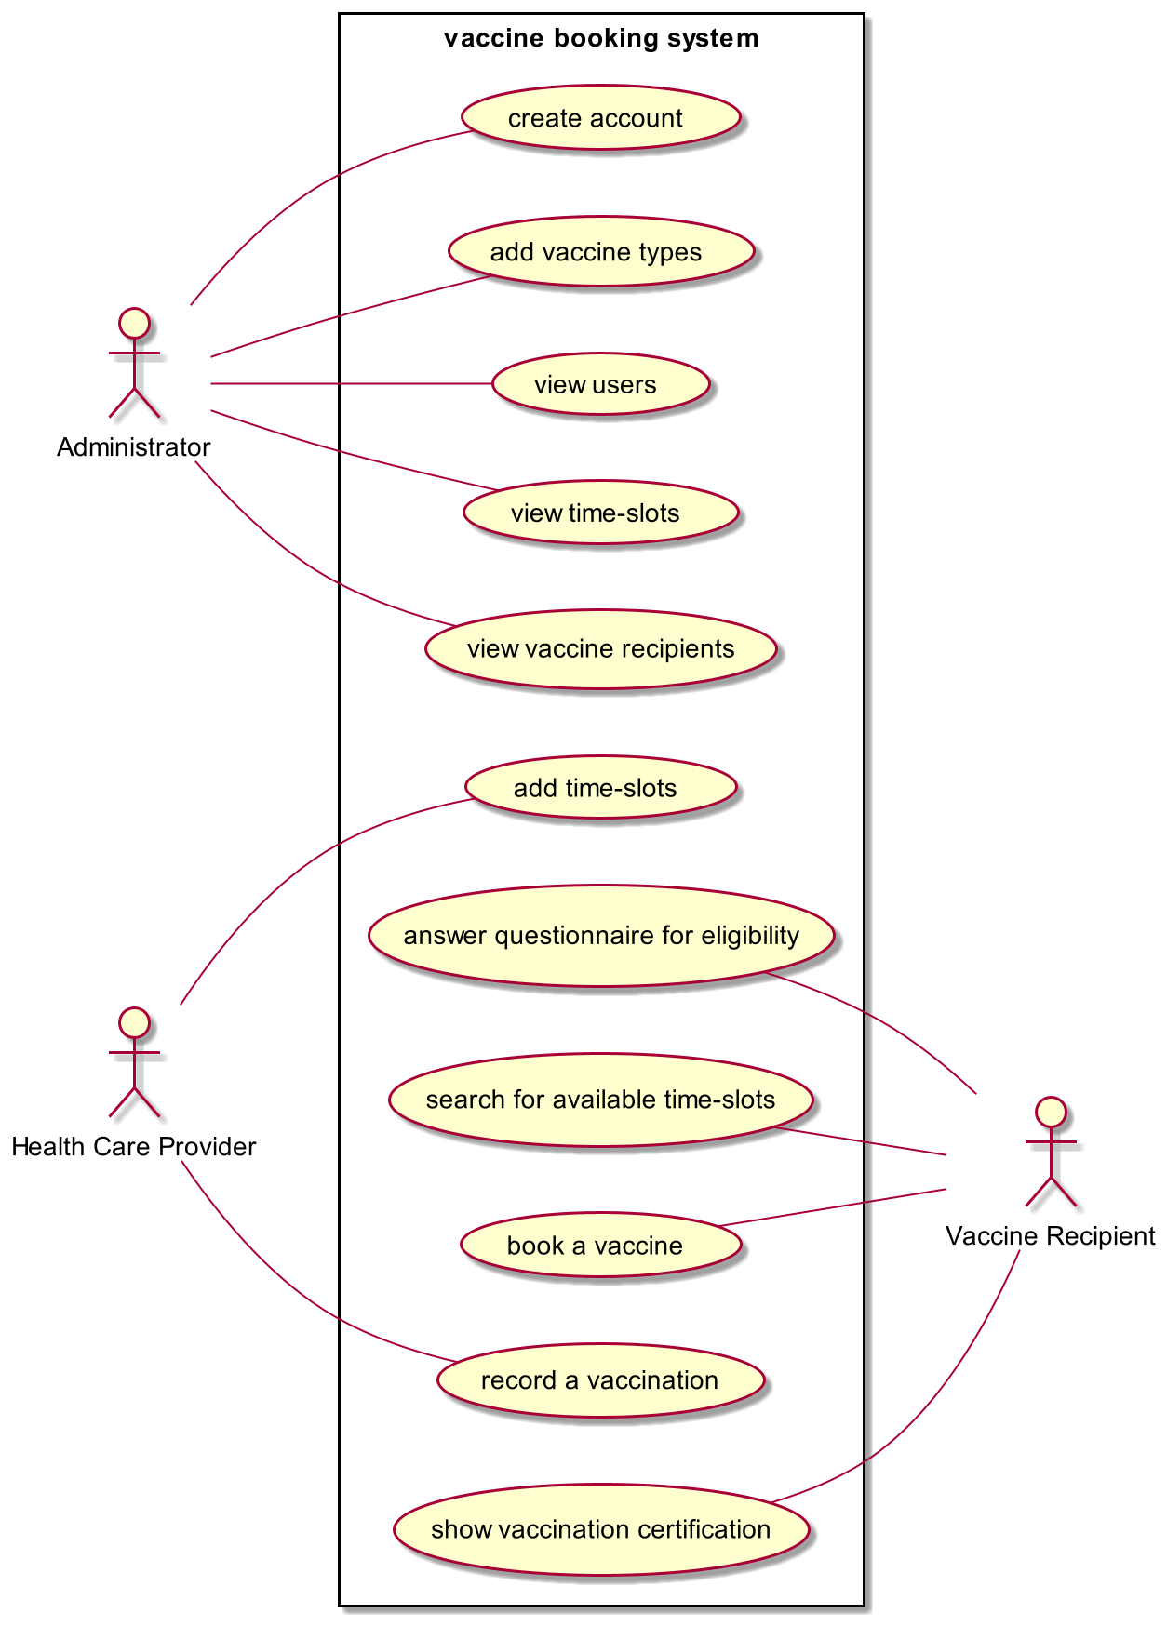

# Domain Model

## Domain Model Description

Based on the specifications provided for the COVID 19 Vaccine Booking and Management System, the system entities, attributes, and business rules can be summarised as:-

* One **Administrator** can create *one or more* **Vaccine Recipients** and *one or more* **Health Care Providers** and adds **vaccine types**
* There can be *one or more* **vaccine types**
* **Vaccine Recipients** must complete *one* **Questionnaire**
* **Vaccine Recipients** can make *one* **Booking** in *one* **Timeslot**
* **Health Care Providers** can create *one or more* **Timeslots**
* **Health Care Providers** will record a vaccination against a **Vaccine Recipient**
* A **Vaccine Recipient** can view their *one* **Vaccination Certification** once they are vaccinated

**Entities** have been bolded; attributes have been underlined; and important *associations* have been italicized.

## Domain Model Diagram

