CREATING TABLE :

Now we are going to create our own table ,

CREATE TABLE();

DATA TYPES :

INT - numbers

DECIMAL - (M.N)

VARCHAR - strings

BLOB - binary object,stores large data

DATE - (YYYY-MM-DD)

TIMESTAMP - (YYYY-MM-DD.HH:MM:SS)

ADDING COLUMNS IN TABLE:

CREATE TABLE student(

Student_id INT PRIMARY KEY(),

Name VARCHAR(20),

age INT,

Gender VARCHAR(10),

Email VARCHAR(30),

Dob DATE ,

Major VARCHAR(40)

);

INSERTING VALUES :

INSERT INTO student VALUES (1 , [‘swetha’, 22 , ’female’ , ’swethajk@gmail.com’ , 2001-03-15 , 'bio' );](mailto:‘swetha’,22,’female’,’swethajk@gmail.com’,2001-03-15);)

INSERT INTO student VALUES (2 , ‘sowmiya’ , 23 , ‘female’ , [‘sow@gmail.com’](mailto:‘sow@gmail.com’) , 2001-11-25 , ‘bio’ );

So on ……..,

TO GRAB ALL INFO:

SELECT * FROM student;

DELETE THE TABLE:

DROP TABLE student;

DELETE FROM student

WHERE name = ‘sowmiya’ AND major = ‘bio’;

DELETE FROM student;

TO ALTER:

ALTER TABLE student ADD gpa DECIMAL(M,N);

TO UPDATE:

UPDATE student

SET major = ‘biology’

WHERE major = ‘bio’;

UPDATE student

SET major = ‘computer science’

WHERE student_id = 4;

UPDATE student

SET major = ‘biochemistry’

WHERE major = ‘bio’ or major = ‘chemistry’;

Q & A:

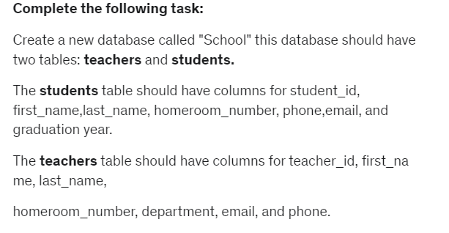

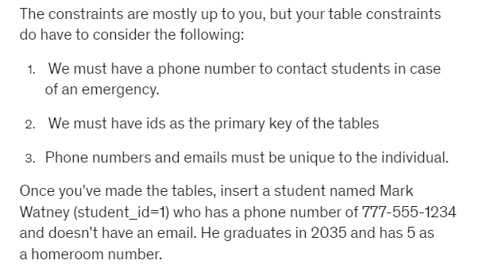

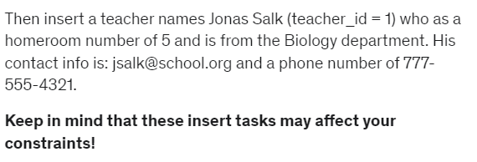

ANSWERS:

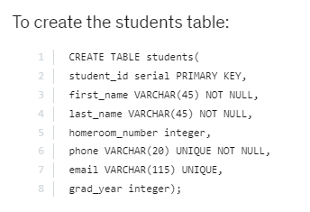

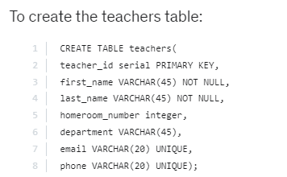

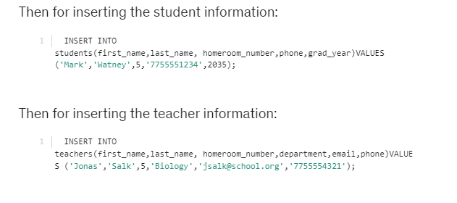

**Assessment Test 3**

#### Assessment Test 3

Welcome to your final assessment test! This will test your knowledge of the previous section, focused on creating databases and table operations. This test will actually consist of a more open-ended assignment below:

**Complete the following task:**

Create a new database called "School" this database should have two tables: **teachers** and **students.**

The **students**table should have columns for student_id, first_name,last_name, homeroom_number, phone,email, and graduation year.

The **teachers**table should have columns for teacher_id, first_name, last_name,

homeroom_number, department, email, and phone.

The constraints are mostly up to you, but your table constraints do have to consider the following:

1} We must have a phone number to contact students in case of an emergency.

2} We must have ids as the primary key of the tables

3} Phone numbers and emails must be unique to the individual.

Once you've made the tables, insert a student named Mark Watney (student_id=1) who has a phone number of 777-555-1234 and doesn't have an email. He graduates in 2035 and has 5 as a homeroom number.

Then insert a teacher names Jonas Salk (teacher_id = 1) who as a homeroom number of 5 and is from the Biology department. His contact info is: jsalk@school.org and a phone number of 777-555-4321.

**Keep in mind that these insert tasks may affect your constraints!**