**TRAFFIC MANAGEMENT SYSTEM**

TEAM MEMBER

820421104069: SWETHA G

Phase 4: Submission document

Project Title: Traffic Management System

Phase 4: Development Part 2

Topic:

* Use web development technologies (e.g., HTML, CSS, JavaScript) to create a platform that displays real-time traffic information.
* Design mobile apps for iOS and Android platforms that provide users with access to real-time traffic updates and route recommendations

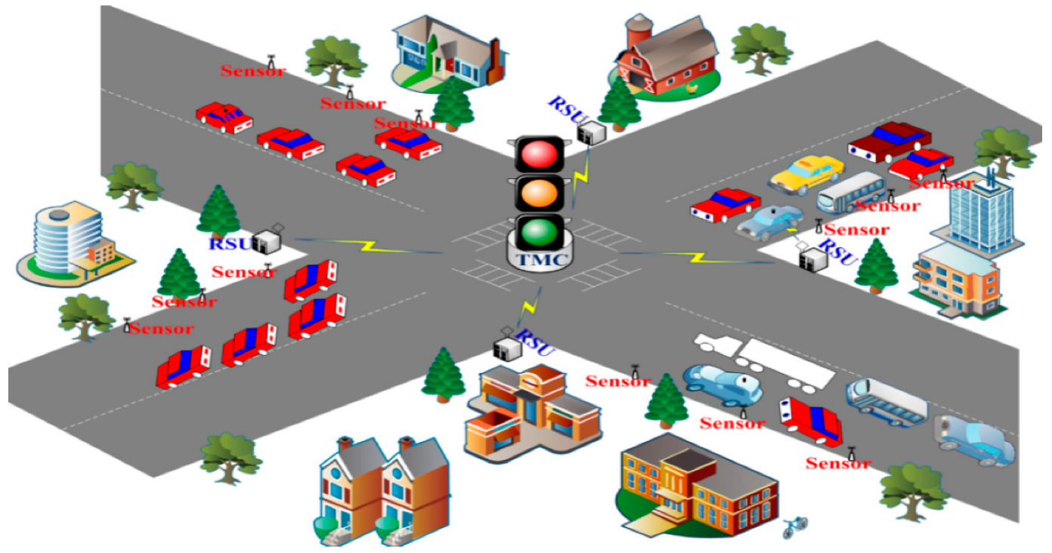

INTRODUCTION:

An Internet of Things (IoT) Traffic Monitoring System is a cutting-edge technology solution that leverages interconnected devices and sensors to revolutionize the way traffic is managed and monitored in urban and suburban environments. It's a powerful system designed to enhance road safety, alleviate congestion, and improve transportation efficiency by collecting, analysing, and disseminating real-time data related to vehicle movements and traffic conditions. This innovative system integrates various IoT components, such as cameras, sensors, communication networks, and data analytics, to provide a comprehensive view of traffic flow and patterns.

The IoT Traffic Monitoring System plays a pivotal role in addressing the increasingly complex challenges associated with urbanization, rapid population growth, and the expansion of transportation networks. By continuously gathering data from various sources, it empowers traffic management authorities, city planners, and commuters with valuable insights to make informed decisions, optimize traffic control, and reduce the environmental impact of transportation.

Key features and components of an IoT Traffic Monitoring System typically include:

**Sensors and Cameras:** These devices are strategically placed at intersections, highways, and key traffic points to capture real-time information, including vehicle speed, volume, and congestion.

**Communication Networks:** IoT systems rely on robust communication networks to transmit data from sensors to centralized servers, ensuring that the information is accessible in real-time.

**Data Analytics:** Advanced analytics and machine learning algorithms process the data to derive valuable insights, such as traffic patterns, peak hours, and accident detection.

**Traffic Management Software:** Centralized software platforms enable authorities to monitor traffic conditions, adjust signal timings, and implement responsive strategies to alleviate congestion.

**Public Information Dissemination:** Valuable traffic information is often made available to the public through websites, mobile apps, and variable message signs to help commuters plan their routes and avoid traffic jams.

**Environmental Benefits:** IoT Traffic Monitoring Systems can contribute to reducing emissions and fuel consumption by optimizing traffic flow, thus promoting environmental sustainability.

**Real-Time Traffic Management:** IoT Traffic Monitoring Systems offer real-time data that enables traffic management authorities to respond swiftly to changing conditions. This can include adjusting traffic signal timings, rerouting traffic, and deploying emergency services more effectively.

**Traffic Flow Optimization:** By analysing the data collected from sensors and cameras, traffic engineers can identify bottlenecks and congestion points. They can then implement strategies to optimize traffic flow, reducing travel times and fuel consumption.

**Accident Detection and Response:** These systems can quickly detect accidents or road incidents, allowing for faster response times from emergency services. This not only saves lives but also minimizes traffic disruptions.

**Data-Driven Decision Making:** The wealth of data collected by IoT Traffic Monitoring Systems provides valuable insights for long-term planning and decision-making. City planners can use this data to design more efficient road infrastructure and transportation systems.

**Public Engagement:** Many IoT Traffic Monitoring Systems make real-time traffic data available to the public through websites, mobile apps, or electronic message signs. This empowers commuters to make informed decisions about their routes and contributes to reduced travel stress.

IoT Traffic Monitoring Systems represent a powerful solution that contributes to safer, more efficient, and environmentally conscious transportation systems. These systems are at the forefront of using technology to shape the future of urban mobility and smart cities.

OBJECTIVES:

When creating a platform that displays real-time traffic management information and web development technologies like HTML, CSS, and JavaScript, it's important to define clear objectives to guide your project. Here are some objectives to consider:

**Real-Time Traffic Monitoring:** Develop a system that can collect and display real-time traffic data from IoT sensors, cameras, and other devices to provide accurate and up-to-date information on traffic conditions.

**Traffic Data Visualization:** Create an intuitive and interactive user interface that visually represents traffic data, making it easy for users, including traffic management authorities and commuters, to understand traffic conditions.

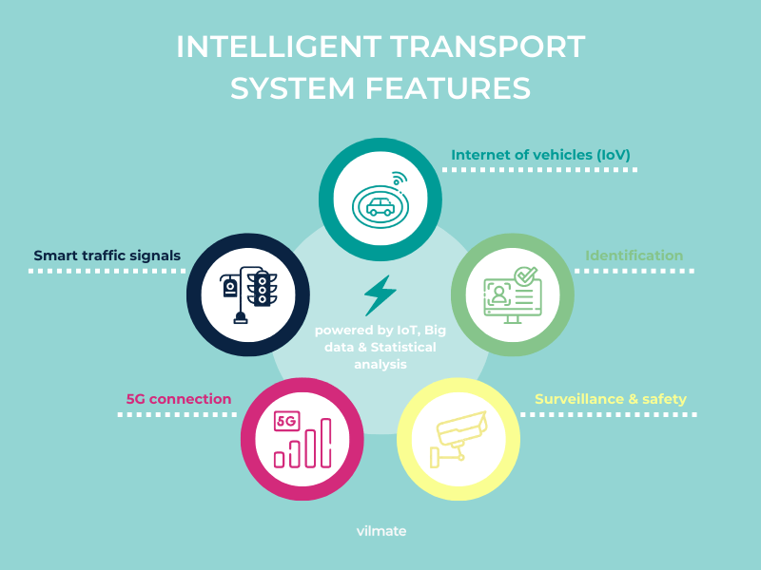

**Traffic Congestion Detection:** Implement algorithms and analytics to detect traffic congestion, bottlenecks, and other anomalies in real time and provide alerts to relevant authorities for immediate action.

**Incident Detection and Reporting:** Develop a system that can identify and report incidents such as accidents, road closures, and adverse weather conditions in real time, facilitating timely responses.

**Route Recommendations:** Offer users, especially commuters, intelligent route recommendations based on real-time traffic data to help them navigate congested areas and reach their destinations faster.

**User-Friendly UI/UX:** Ensure that the platform's user interface is user-friendly and accessible to both traffic management personnel and commuters, enabling efficient interaction with traffic data.

**Alerting and Notification System:** Implement an alerting and notification system that informs relevant parties, including emergency services, about critical incidents and traffic disruptions.

**Data Security and Privacy:** Prioritize data security and user privacy, implementing measures to protect sensitive data collected by IoT devices and ensuring compliance with data protection regulations.

**Scalability:** Design the platform to be scalable, capable of handling an increasing volume of IoT data and users as the platform grows in usage and popularity.

**Machine Learning for Traffic Prediction:** Utilize machine learning models to analyze historical traffic data and make accurate predictions about future traffic conditions, aiding in traffic planning and management.

**Emergency Response Planning:** Establish procedures and capabilities for immediate responses to emergency situations, ensuring the safety of commuters and the efficient management of incidents.

**Performance Optimization:** Continuously optimize the platform's performance, ensuring minimal latency in data processing and visualization.

**Compliance and Legal Requirements:** Ensure that the platform adheres to legal and regulatory requirements, such as data privacy laws and traffic management regulations.

**Documentation and Training:** Provide comprehensive documentation for users and administrators, along with training programs to ensure effective utilization of the platform's features.

**User Engagement and Feedback:** Encourage user engagement and feedback to continuously improve the platform, making it more responsive to user needs and preferences.

**Emergency Services Integration:** Integrate the platform with local emergency services, enabling them to access real-time traffic data and incident reports for more effective emergency responses.

**Environmental Impact Reduction:** Strive to reduce the environmental impact of traffic by improving traffic flow, reducing congestion, and promoting eco-friendly transportation options.

**Cost Efficiency:** Aim to reduce traffic management and infrastructure costs through optimized traffic planning and incident management.

**Public Safety:** Prioritize public safety by providing accurate and timely traffic information, which can reduce the risk of accidents and improve emergency response times.

**Public Awareness:** Increase public awareness about traffic conditions and the availability of real-time traffic information, encouraging responsible and informed commuting.

SCOPE:

The scope of a project in a traffic management system should define the specific geographical areas or locations where IoT devices will be deployed to monitor and manage traffic conditions. This helps in setting clear boundaries for the project and provides a better understanding of its extent. The scope can include:

**Geographical Area:**

Specify the exact geographical region where the project will be implemented. For example, it could be a specific city, a metropolitan area, a highway network, or a rural region.

**Deployment Locations:**

Identify the precise locations within the chosen geographical area where IoT devices will be deployed. This could include:

* Specific intersections or junctions.
* Key highways or road segments.
* High-traffic zones or congestion-prone areas.
* Locations near public transportation hubs.
* School zones or areas with special traffic considerations.

**Coverage Extent:**

Define the extent of coverage at each deployment location. For instance, specify how many traffic flow sensors or cameras will be installed at each location and the area they will cover.

**Exclusions:**

Clearly state any geographical areas or locations that are excluded from the project scope. This could include areas where deployment is not feasible due to logistical or budget constraints.

**Future Expansion:**

Mention whether the project has provisions for future expansion to cover additional geographical areas or locations. If expansion is within the project's scope, outline the criteria for selecting new locations.

**Integration with Existing Infrastructure:**

If applicable, describe how the IoT devices will integrate with existing traffic management infrastructure in the defined geographical area.

**Limitations:**

Highlight any limitations or constraints related to the geographical scope, such as legal or regulatory boundaries that may affect deployment.

By clearly defining the scope in terms of geographical areas and deployment locations, by provide a comprehensive understanding of where the IoT devices will be used to monitor and manage traffic conditions, making it easier to plan and execute the project effectively.

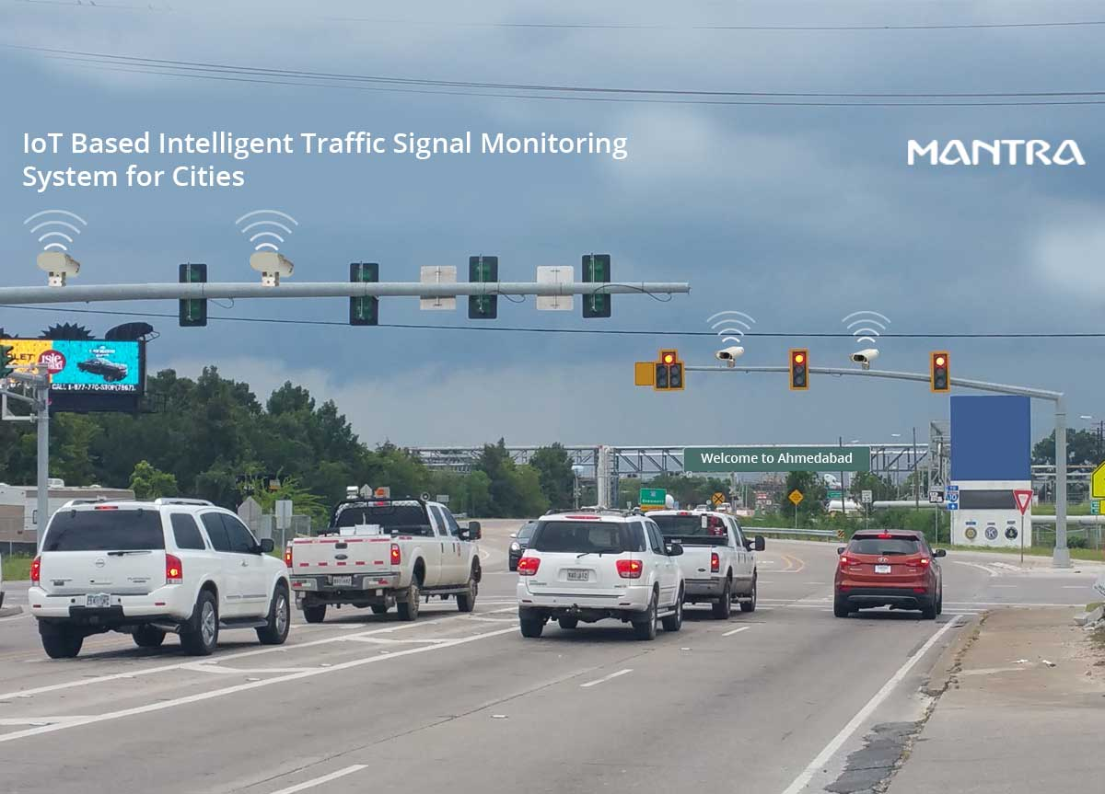

DATA COLLECTION:

Data collection from IoT devices in a traffic management system is a critical component to monitor and manage traffic conditions effectively. The types of data collected, such as traffic flow and camera footage, and the intervals at which data is collected can significantly impact the system's performance. Here's an explanation of data collection:

**Types of Data:**

Traffic Flow Data: IoT devices, such as traffic flow sensors, collect data related to the movement and behaviour of vehicles on the road. This data can include:

**Vehicle speed:** Measured in miles per hour (mph) or kilometres per hour (km/h).

**Vehicle count:** The number of vehicles passing a specific point over a set period.

**Lane occupancy:** Information on the portion of the road occupied by vehicles.

**Camera Footage:** Cameras are used to capture visual data, including:

**Live video feeds:** Real-time footage of traffic conditions at monitored locations.

**Image snapshots:** Periodic images captured to document specific traffic situations or incidents.

**License plate recognition:** Specialized cameras can recognize and record license plate numbers for various purposes, including law enforcement and toll collection.

**Data Collection Intervals:**

Data collection intervals determine how frequently data is gathered from the IoT devices. The selection of these intervals depends on the specific project's goals, budget, and the level of detail required for traffic management. Common intervals include:

**Real-Time Monitoring:** For critical traffic management applications, data is collected continuously in real-time or at very short intervals, often seconds or milliseconds. This ensures that traffic managers have up-to-the-minute information.

**High-Frequency Data:** Intervals may range from a few seconds to a few minutes. This level of detail is useful for analysing traffic patterns, identifying congestion, and providing accurate estimates of travel times.

**Low-Frequency Data:** In cases where detailed real-time monitoring is not necessary, data may be collected at longer intervals, such as every 5 to 15 minutes. This is common in applications where a general overview of traffic conditions is sufficient.

**Event-Triggered Data:** Some data collection may be triggered by specific events, such as accidents, congestion, or irregular traffic conditions. In these cases, data is collected as needed.

HARDWARE PARTS OF INTELLIGENT TRAFFIC MANAGEMENT SYSTEMS:

1.RGB LED:

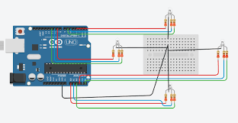

2. USB CAMERA:

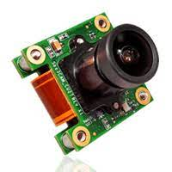

3.IR SENSOR:

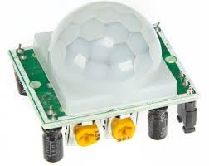

*4*.RASPBERRY PI 3 B+:

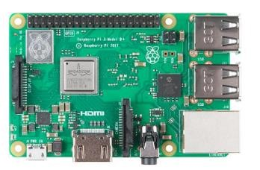

5.TRAFFIC LIGHT LED WITH CIRCUITS:

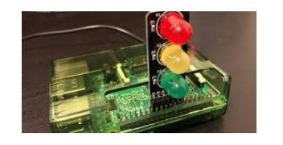

6.ACOUSTIC SENSOR:

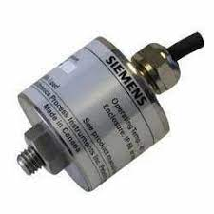

**Use web development technologies (e.g., HTML, CSS, JavaScript) to create a platform that displays real-time traffic information**

Creating a platform that displays real-time traffic management information using IoT (Internet of Things) and web development technologies like HTML, CSS, and JavaScript involves a comprehensive set of topics and content areas

**IoT Hardware Selection and Deployment:**

**Sensor Types:** Choose the appropriate sensors for your traffic management system. Consider cameras, vehicle detectors, smart traffic lights, environmental sensors, and other relevant hardware.

**Deployment Strategy:** Plan the strategic deployment of IoT devices and sensors at key traffic points, intersections, highways, and areas with traffic congestion. Determine optimal locations to capture relevant data.

**Connectivity:** Ensure that IoT devices are equipped with the necessary connectivity options, such as Wi-Fi, cellular, or Ethernet, to transmit data to a central system.

**Environmental Considerations:** Account for environmental factors, such as weather conditions, temperature extremes, and exposure to the elements, when selecting and deploying IoT hardware.

**Scalability:** Consider the scalability of the hardware infrastructure to accommodate future expansion and additional sensors as traffic management requirements grow.

**Data Collection and Sensors:**

**Sensor Types:** Discuss the various sensor types used in your project. These may include video cameras, radar, LIDAR, inductive loop sensors, and environmental sensors (for weather and road conditions).

**Data Capture:** Define how each sensor captures data, whether its vehicle counts, speed measurements, traffic flow patterns, or environmental data.

**Data Accuracy:** Assess the accuracy of each sensor type for collecting specific types of data. Consider factors that might affect data quality, such as sensor calibration and maintenance.

**Integration:** Ensure that the sensors are integrated into the overall IoT infrastructure, enabling them to communicate data to a central processing system.

**Data Validation and Cleaning:** Implement mechanisms for data validation, cleaning, and filtering to ensure the quality and reliability of the collected data.

**IoT Communication Protocols:**

**Protocol Selection:** Choose the appropriate communication protocols for data transmission between IoT devices and the central system. Examples include MQTT, HTTP, and CoAP.

**Security:** Implement security measures to protect data transmission, ensuring that data is not intercepted or tampered with during transmission.

**Efficiency:** Optimize communication protocols for efficiency, especially in scenarios where bandwidth or network resources may be limited.

**Interoperability:** Ensure that the chosen communication protocols are compatible with the sensors, IoT devices, and the central processing system.

**Alerts and Notifications:**

**Alerting System:** Establish an alerting system that can detect and notify relevant parties about critical incidents and traffic disruptions in real time.

**Alert Types:** Define the types of alerts to be generated, such as accidents, road closures, extreme weather conditions, and traffic congestion.

**Delivery Channels:** Determine the channels through which alerts will be delivered, including push notifications, emails, SMS, and visual alerts on user interfaces.

**Recipients:** Identify the recipients of alerts, including traffic management authorities, emergency services, and commuters.

**Response Mechanisms**: Implement response mechanisms that can trigger immediate action in response to critical alerts, such as adjusting traffic signals or dispatching emergency services.

**User Interface Design (UI/UX):**

**User-Centered Design:** Design user interfaces with a user-centered approach, considering the needs and expectations of various user groups, including traffic management personnel, commuters, and emergency responders.

**Data Presentation:** Determine how real-time traffic data will be presented to users through interactive dashboards, maps, and charts.

**Customization:** Allow users to customize their views, select the type of data they want to see, and configure their own alert preferences.

**Accessibility:** Ensure that the user interface is accessible to all users, including those with disabilities, by adhering to accessibility standards.

**Feedback Mechanisms:** Implement feedback mechanisms that allow users to report incidents, provide input, and request assistance.

**Power Management for IoT Devices:**

**Power Supply:** Consider the power supply options for IoT devices. They may be powered by mains electricity, solar panels, batteries, or a combination of these.

**Power Consumption:** Evaluate power consumption to ensure that devices can operate continuously without frequent battery replacements or recharging.

**Low-Power Modes:** Implement low-power modes or sleep modes for devices to conserve energy when not actively collecting data.

**Battery Life Estimation:** Develop battery life estimation models to predict when batteries need replacement or recharging.

**Environmental Impact:** Minimize the environmental impact by choosing energy-efficient IoT devices and sustainable power sources.

HTML:

<!DOCTYPE html>

<html lang="en">

<head>

<meta charset="UTF-8">

<meta name="viewport" content="width=device-width, initial-scale=1.0">

<title>Real-Time Traffic Platform</title>

<link rel="stylesheet" href="styles.css">

</head>

<body>

<header>

<h1>Real-Time Traffic Updates</h1>

</header>

<main>

<div id="map"></div>

<div id="traffic-updates">

<h2>Live Traffic Updates</h2>

<ul id="traffic-list">

<!-- Real-time traffic updates will be added here -->

</ul>

</div>

<section id="contact">

<h2>Contact Us</h2>

<p>

If you have any questions, suggestions, or feedback, please don't hesitate to reach out to our support team. We're here to assist you.

</p>

<address>

Email: <a href="mailto:info@trafficplatform.com">info@trafficplatform.com</a><br>

Phone: +1 (555) 123-4567

</address>

</section>

</main>

<footer>

&copy; 2023 Real-Time Traffic Platform

</footer>

<button id="refresh-button">Refresh Traffic Data</button>

<script src="script.js"></script>

</body>

</html>

CSS:

body {

font-family: Arial, sans-serif;

margin: 0;

padding: 0;

background-color:pink;

}

header {

background-color: gray;

color: white;

text-align: center;

padding: 20px;

}

h1 {

margin: 0;

}

main {

display: flex;

flex-direction: column; /* Changed from "row" to "column" */

align-items: center; /* Center content horizontally */

padding: 20px;

}

#map {

flex: 1;

height: 400px;

background-color:

border: 1px solid #ccc;

border-radius: 5px;

margin: 10px 0; /* Added margin for spacing */

}

#traffic-updates {

flex: 1;

padding: 10px;

border: 1px solid #ccc;

border-radius: 8px;

background-color: orange;

font:bold;

margin: 10px 0; /* Added margin for spacing */

}

h2 {

margin: 0 0 10px;

}

#traffic-list {

list-style: none;

padding: 0;

}

#traffic-list li {

margin: 10px 0;

padding: 10px;

background-color: #f0f0f0;

border: 1px solid #ddd;

border-radius: 5px;

}

footer {

background-color: #333;

color: #fff;

text-align: center;

padding: 10px;

}

button {

display: block;

margin: 20px auto;

background-color: #0074d9;

color: #fff;

border: none;

border-radius: 5px;

padding: 10px 20px;

cursor: pointer;

}

button:hover {

background-color: #0056b3;

}

JAVASCRIPT:

document.addEventListener("DOMContentLoaded", function () {

// Function to display traffic updates

function displayTrafficUpdates() {

const trafficList = document.getElementById("traffic-list");

trafficList.innerHTML = "";

// Replace the following static trafficUpdates with dynamic data retrieval

// For this example, we'll use a simplified array of traffic updates.

const dynamicTrafficData = [

{ location: "New Street", status: "Moderate", details: "Roadwork in progress" },

{ location: "Broadway Ave", status: "Clear", details: "No reported incidents" },

{ location: "Highway 5", status: "Congested", details: "Heavy traffic due to an accident" },

];

dynamicTrafficData.forEach((update) => {

const listItem = document.createElement("li");

listItem.innerHTML = `

<strong>${update.location}</strong><br>

Status: ${update.status}<br>

Details: ${update.details}

`;

trafficList.appendChild(listItem);

});

}

// Refresh button event handler

document.getElementById("refresh-button").addEventListener("click", () => {

// Fetch and update real-time traffic data here (replace this with actual data retrieval)

// For this example, we'll simply call the displayTrafficUpdates function again.

displayTrafficUpdates();

});

// Call the function to display traffic updates initially

displayTrafficUpdates();

});

**OUTPUT:**

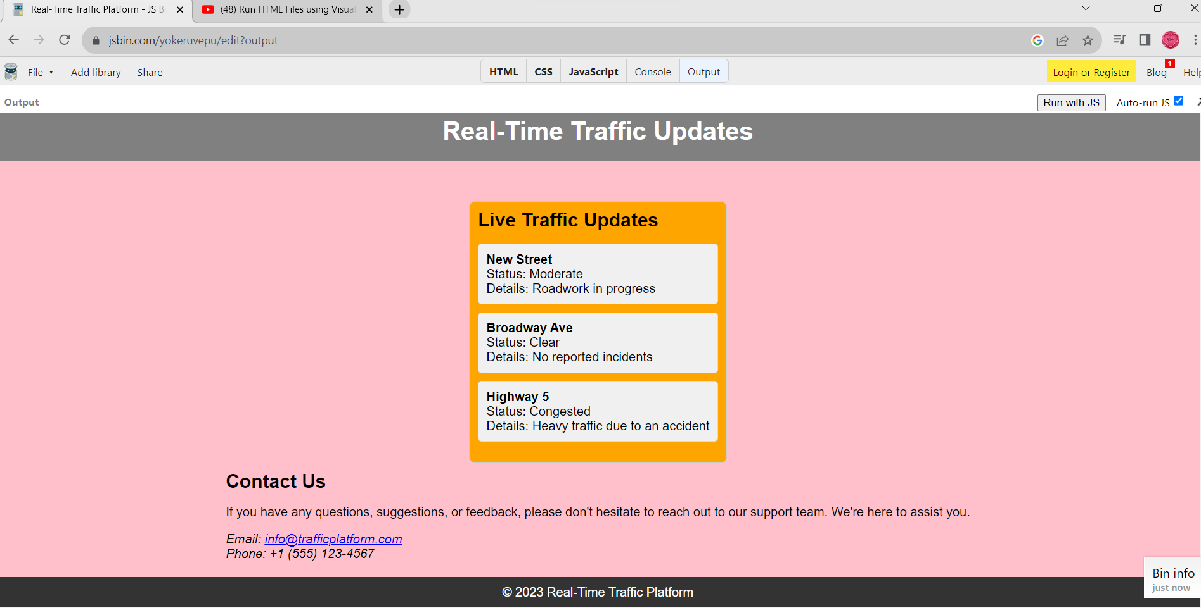

Design mobile apps for iOS and Android platforms that provide users with access to real-time traffic updates and route recommendations.

In a world increasingly defined by rapid urbanization, efficient traffic management is becoming a critical concern for cities and commuters alike. The need for up-to-the-minute traffic information and route recommendations has paved the way for innovative mobile applications designed to streamline daily commutes and alleviate traffic congestion.

This document serves as an introductory overview of the design considerations and key features of a mobile app built for both iOS and Android platforms. Our aim is to create a user-friendly, real-time traffic information platform that provides commuters with the tools to make informed decisions about their daily journeys.

Project Objectives

**Real-Time Traffic Updates:** The app will deliver real-time traffic updates to users, ensuring they are well-informed about current road conditions.

**Route Recommendations**: It will offer intelligent route recommendations to help users navigate around traffic congestion and find the quickest path to their destination.

**User-Friendly Design:** The user interface (UI/UX) will be intuitive and easy to navigate, ensuring a seamless user experience.

**Customization:** Users will have the ability to customize their preferences and receive personalized traffic alerts.

**Cross-Platform Compatibility:** The app will be accessible on both iOS and Android devices.

**Features and Functionality**

**Real-Time Traffic Updates:** One of the core features of the app is the provision of real-time traffic updates. Users will have access to information about traffic conditions, accidents, road closures, and other incidents. This information will be displayed on an interactive map, providing a clear visual representation of traffic flow.

**Route Recommendations:** The app will not only inform users about traffic conditions but also offer route recommendations to optimize their journeys. These recommendations will consider real-time data and provide alternative routes to avoid traffic jams, construction work, or accidents.

**User-Customized Alerts:** To enhance the user experience, the app will allow users to set up customized alerts based on their preferences. They can choose to receive notifications about specific routes, time of day, or types of incidents, ensuring that they receive information relevant to their daily commute.

**Navigation and GPS Integration:** The app will seamlessly integrate with the device's GPS system to provide turn-by-turn navigation. Users can set their destination, and the app will guide them along the recommended route.

**Historical Data Analysis:** In addition to real-time data, the app will offer access to historical traffic data. Users can analyze past traffic patterns to plan their journeys more effectively.

Code:

import React, { Component } from 'react';

import { View, Text, Button, FlatList, TextInput } from 'react-native';

const trafficUpdates = [

{ id: '1', location: 'Main Street', status: 'Congested', details: 'Accident reported' },

{ id: '2', location: 'Highway 101', status: 'Moderate', details: 'Construction work' },

{ id: '3', location: 'Park Avenue', status: 'Clear', details: 'No incidents reported' },

];

class App extends Component {

// State to hold user input

state = {

destination: '',

};

// Function to handle search

handleSearch = () => {

// You can implement logic here to fetch route recommendations based on the user's input (this is a placeholder)

alert(`Searching for routes to ${this.state.destination}`);

};

renderTrafficUpdate = ({ item }) => (

<View style={{ padding: 10, margin: 5, backgroundColor: '#f0f0f0' }}>

<Text>Location: {item.location}</Text>

<Text>Status: {item.status}</Text>

<Text>Details: {item.details}</Text>

</View>

);

render() {

return (

<View style={{ flex: 1, backgroundColor: '#f5f5f5' }}>

<Text style={{ fontSize: 24, fontWeight: 'bold', backgroundColor: '#333', color: '#fff', padding: 10 }}>

Real-Time Traffic Updates

</Text>

<View style={{ backgroundColor: 'white', padding: 10, margin: 10 }}>

<TextInput

style={{ height: 40, borderColor: 'gray', borderWidth: 1, paddingLeft: 10 }}

onChangeText={(text) => this.setState({ destination: text })}

placeholder="Enter your destination"

/>

<Button title="Search" onPress={this.handleSearch} />

</View>

<FlatList

data={trafficUpdates}

keyExtractor={(item) => item.id}

renderItem={this.renderTrafficUpdate}

/>

<Button title="Refresh Traffic Data" onPress={() => alert('Refreshing data')} />

<View style={{ backgroundColor: 'gray', flexDirection: 'row', justifyContent: 'space-around', padding: 10 }}>

<Button title="Menu 1" onPress={() => alert('Menu 1 pressed')} />

<Button title="Menu 2" onPress={() => alert('Menu 2 pressed')} />

<Button title="Menu 3" onPress={() => alert('Menu 3 pressed')} />

</View>

</View>

);

}

export default App;

OUTPUT:

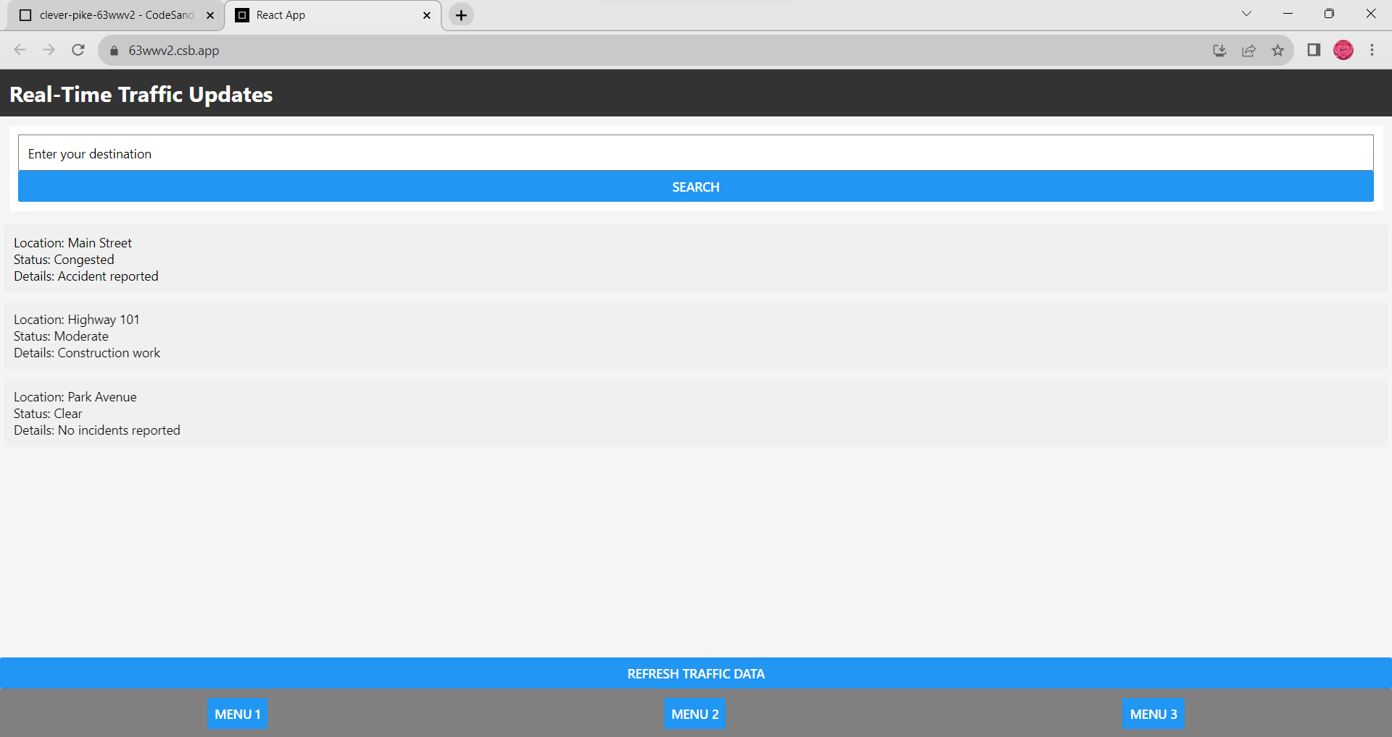

CONCLUSION:

In conclusion, the project to utilize web development technologies such as HTML, CSS, and JavaScript to create a platform for displaying real-time traffic information, along with the design of mobile apps for iOS and Android, is a significant and multifaceted undertaking that addresses a critical need for today's commuters and travelers.

The web platform, built on the foundations of HTML, CSS, and JavaScript, serves as a central hub for providing real-time traffic data to users through their web browsers. This approach ensures accessibility to a broader audience and offers an informative and visually engaging experience.

Simultaneously, native mobile apps for both iOS and Android platforms are being developed, enabling users to access real-time traffic updates and receive valuable route recommendations while on the go. These apps not only enhance the user experience but also cater to the specific needs of mobile users who depend on such information for their daily commutes.

The heart of this project lies in the integration of real-time traffic data from reliable sources, as the accuracy and timeliness of this data are paramount for the project's success. Users will not only be presented with real-time information but also empowered with route recommendations, helping them avoid congestion and save time during their journeys.

User interface design plays a crucial role in this project. The user experience is carefully considered, with an emphasis on intuitive navigation, clear data presentation, and interactive maps. The goal is to make accessing and understanding real-time traffic data as effortless as possible.

Additionally, the project incorporates notifications and alerts, ensuring that users are informed about critical traffic incidents. This feature enhances user safety and helps them make informed decisions while on the road.

In summary, this project represents a holistic approach to addressing the contemporary need for accurate and accessible traffic information. By combining web and mobile platforms, real-time data integration, effective user interface design, and route recommendations, it strives to provide a valuable service that can significantly improve the daily lives of its users. In an era where traffic information is of paramount importance, this project holds the potential to make a substantial positive impact on the daily commutes and travels of individuals.