
Comparative Study Between an unsupervised Autoencoder and supervised ResNet-50 classifier for detection of brain tumors


LIST OF ABBREVIATIONS
CRISP-DM – Cross Industry Standard Process for Data Mining
CNN – Convolutional Neural Network
ResNet – Residual Network
MRI – Magnetic Resonance Imaging
AI – Artificial Intelligence
3D – Three-Dimensional
ReLu – Rectified Linear Unit

LIST OF FIGURES
Figure 3.1: CRISP-DM Methodology
Figure 3.2: Class Distribution
Figure 3.3: Tumor Samples
Figure 3.4: No tumor samples
Figure 3.5: Illustration of the working of an autoencoder model
Figure 3.6: Architecture of ResNet-50
Figure 3 7: A graphical representation of classification outcomes
Figure 4.1: Bar plot comparing the performance
Figure 4.2: Count plot showing the distribution of predicted classes
Figure 4.3: Confusion matrix illustrating the classification performance of Autoencoder model
Figure 4.4: Classification report of the autoencoder model
Figure 4.5: Training and validation accuracy curves of the ResNet50
Figure 4.6: Training and validation loss curves of the ResNet50
Figure 4.7: Confusion matrix of ResNet model
Figure 4.8: Classification report of ResNet model
Figure 4.9: Prediction showing a brain MRI, classified as Normal image
Figure 4.10: Prediction showing a brain MRI, classified as Tumor image

LIST OF TABLES
Table 1: Summary of Journal Articles Used in the Study and Corresponding Citations
Table 2: shows the model performance comparison of Autoencoder and ResNet
Table 3: Performance Comparison of Autoencoder and ResNet Models Based on Precision, Recall, and F1 Score for Brain Tumor Classification

Abstract
Brain tumors are among the most fatal and aggressive forms of cancer, with early detection being critical for improving patient outcomes. Magnetic Resonance Imaging (MRI) is the most commonly used imaging modality for brain tumor diagnosis. However, manual interpretation of these images is time-consuming and can vary between different observers. Deep learning techniques have shown significant promise in automating tumor detection, but many of these methods rely heavily on large, annotated datasets, which are often difficult to obtain in medical contexts.
This research undertakes a comparative study between two deep learning-based approaches: an unsupervised autoencoder model and a classic supervised transfer learning model (ResNet50). The core aim is to evaluate how these models perform on a small dataset of 3000 images. The supervised learning Resnet50 outperforms the unsupervised Autoencoder. Both methods contribute to the development of resource-efficient diagnostic tools in medical imaging.

Keywords: Autoencoder; Residual Neural Network; ResNet50; Deep Learning; Unsupervised Learning; Supervised Learning; Tumor Detection; Health Analytics.

Table of Contents
Declaration 1
Acknowledgement 2
List of Abbreviations 3
List of Figures 4
List of Tables 5
Abstract 6
Chapter 1 Introduction 8
  - Business Problem 8
  - Research Problem 8
  - Aim 8
  - Objective 9
  - Hypothesis 9
  - Scope 9
  - Limitation 11
  - Dissertation Roadmap 11
Chapter 2 Literature Review 12
2.1 Unsupervised Learning in Medical Imaging 13
2.2 Convolutional Autoencoders 14
2.3 Supervised Learning and Transfer Learning 14
2.4 ResNet50 in medical imaging 15
2.5 Comparative studies and Gap 16
2.6 Summary and Research Gap 16
Chapter 3 Methodology 17
3.1 Business Understanding 17
3.2 Data Understanding 17
3.3 Data Preparation 20
3.4 Modelling 21
3.5 Evaluation 25
Chapter 4 Results & Discussion
4.1 Results 27
4.2 Discussion 34
Chapter 5 Conclusion & Future Scope 35
Reference 37

Chapter 1 Introduction

  - 1.1 Business Problem
Hospitals are flooded with medical imaging data on day, and the workload more severe in radiology departments. One of the most urgent cases is a brain tumor, and usually hard to identify in their initial stages. Yet, the diagnosis still heavily depends on radiologists manually examining MRI scans. This process is time-consuming, repetitive, and vulnerable to fatigue-induced errors.
With the increasing patient volume and a shortage of skilled radiologists, there is a need for intelligent systems that can help in early detection of brain tumors with high accuracy and with minimal supervision.

  - 1.2 Research Problem
Convolutional Neural Networks (CNNs) are widely used in medical image analysis tasks like tumor detection, organ segmentation, and disease classification. When combined with transfer learning, CNNs can achieve high accuracy by using knowledge from large datasets like ImageNet. However, these models need a large amount of labelled data, which is hard to get in healthcare due to privacy concerns, high costs, and the need for expert annotation.
Unsupervised learning methods like autoencoders work by compressing and then reconstructing input images, helping them capture important features. These learned features can then be used for tasks like classification or anomaly detection.
Research Question: How well can an unsupervised autoencoder approximate the performance of a supervised CNN model such as ResNet50 for brain tumor detection in a low-data scenario?

  - 1.3 Aim
The main aim of this study is to systematically compare the performance of an unsupervised autoencoder model and that of a supervised ResNet50 transfer learning approach for the task of brain tumor classification using MRI images under data-constrained conditions.

  - 1.4 Objectives
The key objectives of this research are:
- To implement and train an unsupervised autoencoder model for brain MRI image reconstruction and anomaly detection.
- To fine-tune a pre-trained ResNet50 model for binary classification of brain tumors.
- To compare and assess the performance of the two models based on quantitative metrics such as accuracy, precision, recall, F1-score, and loss
- To explore how the size of the dataset affects model performance in terms of training stability, generalization capacity, and vulnerability to overfitting.

  - 1.5 Hypothesis
The hypothesis driving this research is:
In a data-limited environment, an unsupervised autoencoder-based model can achieve performance that is comparable to a transfer learning-based ResNet50 model in classifying brain tumors from MRI images.

  - 1.6 Scope
This project aims to develop and compare whether a brain MRI scan indicates the presence of a tumor. The focus lies in comparing the performance, generalizability, robustness to limited data, interpretability, and computational efficiency on MRI images. The study highlights the real-world implications of deploying such systems in medical imaging, particularly in low-resource or small data clinical environments.
To achieve this, the following methodologies and processes were employed:
- Data Collection and Preparation: Brain MRI scans were acquired from a publicly shared Kaggle dataset (Abhranta, 2022). The dataset is classified into three primary directories: yes, no, and pred. The yes directory holds images with labels of having brain tumors, while the no directory holds images with no tumors. The above two classes were utilized during model training and assessment. The pred directory comprises unlabelled MRI scans for carrying out inference and testing model predictions.
- Data Preprocessing: Standard image preprocessing techniques were used, such as resizing, normalization for better generalization and less overfitting.
- Autoencoder-Based Unsupervised Modeling: A convolutional autoencoder was trained to learn normal brain reconstructions. Reconstruction error was utilized as an indirect measure of anomaly (tumor) detection based on the premise that the model reconstructs healthy brains well but badly reconstructs abnormal ones.
- ResNet50 Model: A pre-trained ResNet50 model, which was fine-tuned to the task of tumor classification, was employed to classify MRI scans. Transfer learning enabled the model to take advantage of generalized feature extraction skills learned on the huge ImageNet dataset.
- Model Evaluation Metrics: Both models were evaluated using standard classification metrics: accuracy, precision, recall, F1-score, and the confusion matrix. A classification report was also generated to provide a detailed breakdown of performance across classes. These metrics helped assess not only overall accuracy but also the models' ability to correctly identify tumor cases.
- Ethical Considerations: The study takes into account important ethical considerations like patient confidentiality, data protection, and the proper application of AI in medicine. Although the dataset is anonymized and open to the public, actual application in the real world poses issues regarding clinical validity and the implications of possible misdiagnosis, calling for expert monitoring and cautious implementation.

  - 1.7 Limitation
Even with the outcomes and advancements in deep learning, the brain tumor detection system implemented in this research has several inherent limitations. These limitations arises due to the nature of the dataset, model architecture, computational demands, and generalizability of the system. The main limitations are as follows:
- Limited Dataset Size: The models were trained and evaluated on a relatively small dataset of brain MRI scans. This constrains the generalization ability of the models, especially for rare tumor types or unusual image variations. Deep learning models typically require large volumes of labeled data for robust learning.
- Binary Classification: The project is limited to distinguishing between "Tumor" and "No Tumor" classes. It does not address multi-class classification (e.g., glioma vs. meningioma) or segmentation tasks, which are crucial for practical medical applications.
- Ethical and Regulatory Challenges: The use of AI in medical diagnosis raises ethical concerns, especially if incorrect predictions influence clinical decisions. Moreover, deploying such systems in real-world hospitals would require regulatory approval, data privacy compliance, and clinician oversight.

  - 1.8 Dissertation Roadmap
To create a strategic plan for implementing the dissertation project, the following roadmap is used.
- Chapter 1 – Introduction: This chapter presents the background and motivation for brain tumor detection. It outlines the problem definition, research questions, aim and objectives, hypothesis formulation, and the scope of the study.
- Chapter 2 – Literature Review: This chapter examines prior research in the field of medical image analysis, focusing on the use of autoencoders, and ResNet approaches for anomaly detection. It identifies existing gaps and justifies the selection of methods used in this study.
- Chapter 3 – Methodology: This chapter explains the overall research framework, guided by the CRISP-DM approach. It details the dataset description, preprocessing steps, architectural design of the unsupervised autoencoder and ResNet50 models, training strategies, and the evaluation metrics used to assess model performance.
- Chapter 4 – Results and Discussion: This chapter presents the experimental results from both models. It includes a comparative performance analysis based on accuracy, precision, recall, and F1-score. The findings are interpreted and discussed in the context of the research objectives and previous studies.
- Chapter 5 – Conclusion and Future Work: This chapter summarizes the key outcomes of the research and highlights its contributions. It also discusses the limitations encountered and proposes potential future research directions to enhance the effectiveness and applicability of the developed models in real-world medical diagnostics.

Chapter 2: Literature Review

Table 2 Summary of Journal Articles Used in the Study and Corresponding Citations
Journal | Citations
Autoencoders and their applications in machine learning: a survey | Berahmand et al. (2024),
A comprehensive survey on design and application of autoencoder in deep learning | Li et al. (2023)
ResNet Autoencoders for Unsupervised Feature Learning From High-Dimensional Data: Deep Models Resistant to Performance Degradation | Wickramasinghe et al. (2021)
Autoencoder and Its Various Variants | Zhai et al. (2018)
3D MRI brain tumor segmentation using autoencoder regularization | (Myronenko ,2019)
Encoder and decoder network with ResNet-50 and global average feature pooling for local change detection | M. K. Panda
A dual autoencoder and singular value decomposition-based feature optimization for the segmentation of brain tumor from MRI images | Aswani and Menaka (2021)
Deep Residual Learning for Image Recognition | He et al. (2016),
Research on Image Recognition Based on Improved ResNet | Chen and Zhang (2020)
ResNet and its application to medical image processing: Research progress and challenges | Xu, Fu, and Zhu (2023),
“An efficient brain tumor image segmentation based on deep residual networks (ResNets) | Shehab et al. (2021)
BrainNet: A fusion assisted novel optimal framework of residual blocks and stacked autoencoders for multimodal brain tumor classification | Ullah et al. (2024)
An early detection and segmentation of Brain Tumor using Deep Neural Network | (Aggarwal et al., 2023;
Brain tumor segmentation with deep neural networks | Havaei et al., 2017).

  - 2.1 Unsupervised Learning in Medical Imaging
Unsupervised learning algorithms, particularly autoencoders, have become essential in medical imaging due to their ability to extract meaningful features from unlabelled data. Autoencoders function by encoding input data into a lower-dimensional latent space and then reconstructing the original input, thereby learning underlying patterns. This reconstruction process is particularly useful in identifying anomalies—such as brain tumors—by highlighting regions with high reconstruction error, which often correspond to abnormalities.
According to Berahmand et al. (2024), autoencoders are powerful tools for unsupervised feature learning and dimensionality reduction, with wide-ranging applications across fields such as machine vision, anomaly detection, and complex systems. Their work provides a comprehensive taxonomy of autoencoder types and highlights their value in fields that lack labeled data, a common issue in medical contexts such as MRI analysis. Similarly, Li et al. (2023) underscore the increasing attention autoencoders have received in deep learning, noting that their structure enables them to automatically extract data features from large-scale unlabeled datasets, making them particularly suitable for medical imaging tasks like tumor detection.
Further advancements have been made through architectural improvements. Wickramasinghe et al. (2021) introduced the ResNet Autoencoder (RAE) and its convolutional variant (C-RAE), which incorporate residual connections to mitigate performance degradation in deeper networks. Their research shows that RAEs outperform standard autoencoders in high-dimensional settings and maintain better classification accuracy as the network depth increases—making them ideal candidates for learning from complex medical images such as brain MRIs.
In another survey, Zhai et al. (2018) trace the evolution of autoencoders and their many variants, demonstrating their applications in computer vision, speech recognition, and generative modeling. The adaptability of these models to various domains further validates their potential in the medical imaging space, especially in unsupervised segmentation and anomaly detection tasks.

2.2 Convolutional Autoencoders (CAE)
Convolutional Autoencoders (CAEs) are an extension of traditional autoencoders that utilize convolutional layers instead of fully connected layers, making them particularly effective for processing spatial data such as medical images. In brain MRI analysis, CAEs have been applied successfully for tasks such as tumor segmentation and anomaly detection. These models are capable of identifying tumor regions by analyzing reconstruction loss heatmaps, which highlight discrepancies between input and reconstructed images.
Myronenko (2019) demonstrated a 3D semantic segmentation network that integrates a variational autoencoder branch for regularization, enhancing segmentation accuracy on brain MRI datasets. Similarly, M. K. Panda (2019) proposed a deep autoencoder-decoder framework based on SegNet, achieving state-of-the-art accuracy on the Figshare brain tumor dataset through pixel-wise classification.
To further improve feature extraction and reduce the requirement for large labeled datasets, Aswani and Menaka (2021) introduced a dual autoencoder combined with singular value decomposition (SVD) for latent space optimization. Their approach trained separate autoencoders for horizontal and vertical patches of brain MRI images, preserving both local and global contextual features. This model, designed for unsupervised learning, effectively identified tumor anomalies using only normal-class MRI data.
2.3 Supervised Learning and Transfer Learning
Supervised deep learning models, especially Convolutional Neural Networks (CNNs), have become the gold standard in medical image classification due to their ability to learn complex patterns from labeled data. Among them, ResNet50 has gained widespread adoption for its superior performance, attributed to its residual learning architecture. Introduced by He et al. (2016), ResNet introduced the concept of residual connections to alleviate the vanishing gradient problem, enabling the training of extremely deep networks with over 100 layers. Their residual framework achieved groundbreaking results on the ImageNet classification task, setting a new standard for deep model performance.
In the medical domain, the adoption of ResNet has shown significant success in various diagnostic applications. According to Xu, Fu, and Zhu (2023), ResNet architectures have demonstrated effectiveness in detecting lung tumors, skin diseases, breast cancer, and brain abnormalities. Their study highlights ResNet’s contribution to advancing clinical diagnosis, thanks to its ability to extract robust hierarchical features from complex medical images.
Further enhancements have been proposed to improve ResNet’s performance, particularly in environments with limited computational resources. Chen and Zhang (2020) explored modifications such as replacing standard convolutions, increasing shortcut connections, and optimizing information flow. Their improved ResNet variant demonstrated lower error rates on benchmark datasets, showing potential for broader applications including medical image recognition.
2.4 ResNet50 in Medical Imaging
ResNet50 is widely adopted in medical imaging due to its deep architecture, residual connections, and ability to mitigate the vanishing gradient problem, which often affects deeper neural networks. This model allows the training of significantly deeper networks while maintaining or improving performance, particularly in complex image classification and segmentation tasks. Its hierarchical feature extraction makes it well-suited for fine-grained analysis such as brain tumor detection from MRI scans.
As demonstrated by Xu, Fu, and Zhu (2023), ResNet architectures have been successfully applied across various domains of medical image processing, including the diagnosis of lung tumors, skin diseases, breast cancer, and brain abnormalities. Their review outlines how ResNet’s residual units improve feature propagation, reduce network degradation, and lead to better clinical decision support.
In the specific context of brain tumor detection, Shehab et al. (2021) implemented a ResNet-based approach for automatic segmentation using the BRATS 2015 dataset. Their technique not only improved segmentation accuracy for tumor subregions but also reduced computation time by a factor of three compared to traditional DNNs. The residual connections enabled more stable training and faster convergence.
Additionally, Ullah et al. (2024) proposed a hybrid framework combining stacked autoencoders with residual blocks for multimodal brain tumor classification. Their model, tested on the BraTS2020 and BraTS2021 datasets, achieved classification accuracies as high as 99%. This approach underscores the flexibility of ResNet architectures when fused with other deep learning techniques for enhanced performance.

2.5 Comparative Studies
Comparative research between supervised and unsupervised deep learning methods in medical imaging remains limited, particularly under low-data conditions. Supervised models like ResNet50 have shown high classification accuracy and robust feature extraction capabilities in tasks such as brain tumor detection (Aggarwal et al., 2023; Havaei et al., 2017). However, their effectiveness is closely tied to the availability of large, annotated datasets and substantial computational resources, which are often difficult to secure in clinical environments.
In contrast, unsupervised models, particularly autoencoders and their variants, offer advantages in label-scarce situations. They can learn from raw MRI data without human annotation, allowing for anomaly detection based on reconstruction loss (Wickramasinghe, Marino, & Manic, 2021). However, such models may underperform when it comes to classification accuracy compared to their supervised counterparts, especially in highly variable datasets.
2.6 Summary and Research Gap
In conclusion, both supervised and unsupervised deep learning approaches have demonstrated their potential in medical imaging, particularly for tasks like brain tumor detection. Supervised models, such as ResNet50, excel in environments with abundant labeled data, offering high accuracy and robustness in complex image classification tasks. However, their reliance on large, annotated datasets presents challenges in clinical settings where data may be scarce or expensive to obtain. On the other hand, unsupervised models, like autoencoders, making them invaluable for anomaly detection and feature extraction. While unsupervised models may not always match the classification accuracy of supervised approaches, their ability to operate in low-data environments positions them as a vital tool in advancing medical image analysis. Further research is needed to bridge the performance gap between these methodologies, particularly through hybrid approaches that combine the strengths of both unsupervised and supervised learning to improve diagnostic accuracy and efficiency in real-world applications.
Chapter 3 Methodology
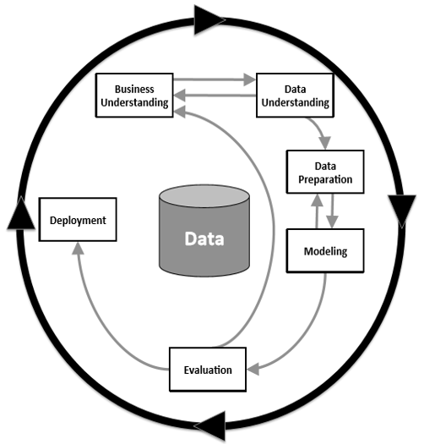
The research aims to conduct a comparative analysis of brain tumor segmentation using Autoencoder and ResNet-based classification approaches. Although numerous segmentation and classification techniques are available, a structured implementation using a systematic methodology like CRISP-DM ensures thorough planning, organization, and execution of the tasks.
The CRISP-DM methodology (figure 3.1 Wirth and Hipp, 2000, reproduced in Kelleher et al., 2020, p.14) follows six sequential and iterative phases, each contributing to the comprehensive development of the brain tumor segmentation models:
- Business Understanding
- Data Understanding
- Data Preparation
- Modeling
- Evaluation
Figure 3.1 CRISP-DM process, including the six key phases and the important relationships between them.
- Deployment
3.1 Business Understanding
The main aim of this stage is to establish the project's business objectives. In this case, the aim is to develop a reliable and accurate system for brain tumor segmentation, which could assist in medical diagnostics. The goal is to compare the performance of Autoencoder-based and ResNet-based approaches in segmenting and classifying brain tumor from MRI images, thereby reducing diagnostic time and improving treatment planning.
3.2 Data Understanding
The dataset used in this research is obtained from Kaggle (Abhranta, 2021) and is structured into three primary folders:
- 'yes': Contains 1,500 MRI images labeled as having a brain tumor.
- 'no': Contains 1,500 MRI images labeled as not having a brain tumor.
- 'pred': Contains unlabelled MRI images, intended for inference or prediction tasks.
This results in a total of 3,000 labeled images with a perfectly balanced distribution between the tumor and non-tumor classes, making it ideal for supervised classification tasks.
3.2.1 Image File Format
All images in the dataset are in .jpg format, ensuring compatibility with standard image processing and deep learning libraries.
- Total .jpg images: 3,000
3.2.3 Image Size Distribution
The dataset includes images with different dimensions, showing a disparity in image resolution. This variation must be taken into account when designing model input pipelines, as deep learning models require fixed-size input.
Some illustrative examples of the distribution of image sizes are as follows:
- (225, 225): 327 images
- (630, 630): 127 images
- (512, 512): 35 images
- (200, 252): 41 images
- (228, 221): 47 images
- (232, 217): 48 images
- (300, 168): 49 images
- (192, 192): 31 images
- (215, 234): 27 images
- (442, 442): 27 images
- (428, 417): 39 images
- (173, 201): 36 images
- Other unique sizes: Hundreds of other resolutions, including large dimensions such as (1024, 1024), (1061, 1280), and (1920, 1080)
In total, the dataset includes over 250 unique image dimensions, ranging from small sizes like (175, 167) to high-resolution scans like (1920, 1080).
3.2.3 EDA (Exploratory Data Analysis)
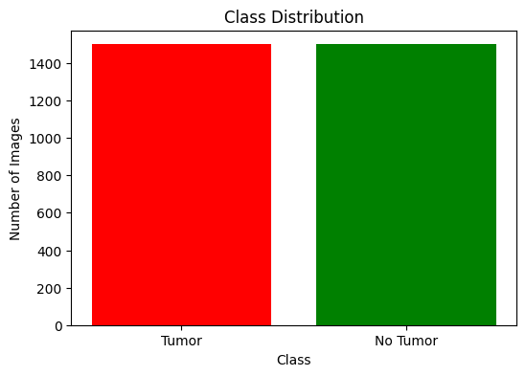
Class Distribution: The dataset is perfectly balanced, which is advantageous in binary classification tasks as it reduces the risk of bias toward one class. The bar chart below visualizes the count of images per class.
Figure 3 2 Class Distribution
Sample Image Visualization: To better understand the data, sample MRI images from both classes are visualized.
Sample images from the Tumor class.
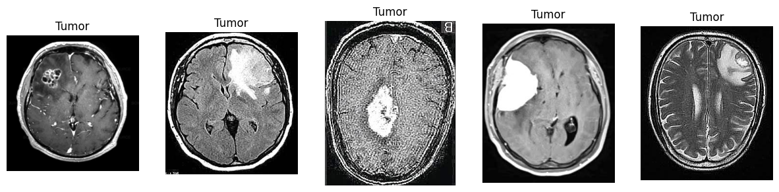
Figure 3 3: Tumor samples
Figure 3.2 show visible irregularities in brain structures where tumors are present. Differences in brightness, angle, and sharpness of the images are apparent.

Sample images from the No Tumor class.
Figure 3.3 generally show clean brain scans without irregular masses or distortions. Again, some variation in lighting and sharpness is observed.
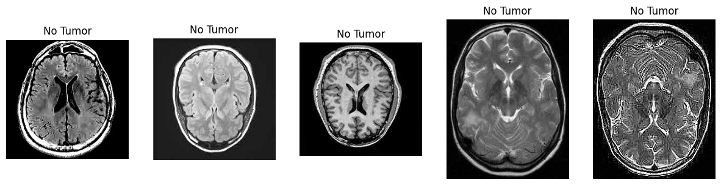
Figure 3 4 No tumor samples

3.3 Data Preparation
Data preparation is a critical component in the development of robust deep learning models, particularly in medical imaging tasks such as brain tumor detection. This phase involves several key processes, including dataset structuring, image preprocessing, and modality-specific transformations to align with the training requirements of different architectures.
3.3.1 Dataset Partitioning
The dataset was stratified and partitioned into training and testing subsets in an 80:20 ratio, ensuring balanced representation across both classes: Tumor and No Tumor. The final distribution consisted of 2,400 training images (1,200 per class) and 600 testing images (300 per class). The images were organized into a hierarchical directory structure compatible with Keras' ImageDataGenerator, facilitating efficient data loading and augmentation.
3.3.2 Image Preprocessing
All MRI images were resized to a standardized resolution of 128×128 pixels to ensure uniform input dimensions across the network. Furthermore, pixel values were normalized to the range [0, 1] by applying a rescaling factor of 1/255. This normalization improves convergence speed and stabilizes the learning process during model training.
3.3.3 Autoencoder Data Handling
For the Autoencoder model, training was restricted to images from the No Tumor class, in accordance with unsupervised anomaly detection. The objective was for the Autoencoder to learn the manifold of healthy brain images, thereby enabling the identification of anomalous patterns (i.e., tumors) during inference. Input and target data were identical, as the model was trained to minimize reconstruction loss.
3.3.4 ResNet Data Handling
For supervised classification using the ResNet model, both Tumor and No Tumor classes were included during training and validation. The training generator loaded 2,400 labeled images, while the validation generator processed 600 labelled images. Labels were assigned in binary format (0 for No Tumor, 1 for Tumor), enabling the model to perform binary classification. Image preprocessing steps were consistent with those used in the Autoencoder pipeline, ensuring input homogeneity across model architectures.
3.4 Modelling
In this phase, two primary approaches are employed: an Autoencoder-based model and a ResNet-based classification model. The Autoencoder model focuses on learning low-dimensional representations of brain tumor regions to improve segmentation, while the ResNet model, with its deep architecture, is utilized for classification tasks. Both models are trained on the prepared dataset and tuned for optimal performance.
3.4.1 Autoencoder-Based Model Architecture & Implementation
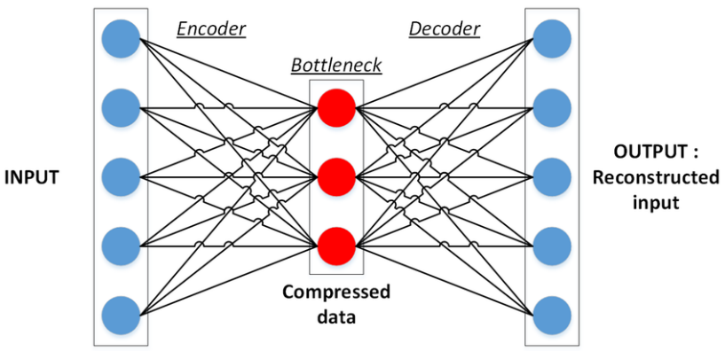
An autoencoder is a type of unsupervised neural network designed to learn compact representations of input data. It is made up of two primary parts: an encoder that transforms the input into a lower-dimensional latent space (commonly referred to as a bottleneck) and a decoder that reconstructs the original input from this compressed form. The training process focuses on reducing the reconstruction error that exists between the input and its corresponding output.
Figure 3 5 Illustration Depicts of how an autoencoder model operates (Sublime & Kalinicheva, 2019).
The model is designed to reconstruct brain MRI images and is trained primarily on healthy images. The key idea is that when presented with an abnormal (tumorous) image, the model's reconstruction will be poor in the affected areas, allowing anomaly detection through reconstruction error.
- Input and Noise Injection: The model begins by accepting RGB images of size 128×128×3. A small amount of Gaussian noise (with standard deviation 0.1) is added to the input to encourage the model to learn more robust features and improve generalization. This enables the network to handle minor fluctuations and prevent overfitting.
- Encoder: The encoder part of the network consists of two convolutional layers, each followed by max pooling:
    - The first convolution layer applies 32 filters of size 3×3 with ReLU activation and same padding to preserve spatial dimensions.
    - The output is downsampled using 2×2 max pooling.
    - The second convolution layer applies 64 filters and is again followed by max pooling.
This sequential process reduces the image's spatial resolution while retaining important features, effectively compressing the information.
- Bottleneck: A convolutional layer employing 128 filters produces the compressed representation, referred to as the latent space. This layer serves as a dense, abstract encoding of the input image, capturing high-level features. It represents the most compressed form of the data.
- Decoder: The decoder rebuilds the image from this condensed representation:
- It performs two upsampling steps to restore the original image size.
- Each upsampling layer is followed by a convolutional layer to learn how to refine and recreate image features.
- Output Layer: The last layer in the sequence is a convolutional layer equipped with 3 filters that correspond to the input channels, utilizing a sigmoid activation function.This constrains the output pixel values between 0 and 1, making it suitable for normalized image data.
- Compilation: The model is compiled using the Adam optimizer for efficient training and the Mean Squared Error (MSE) loss function. MSE measures the pixel-wise difference between the input and reconstructed image, guiding the model to minimize reconstruction error.

3.4.2 ResNet-Based Model Architecture & Implementation
ResNet, Residual Network, is a deep convolutional neural network architecture that introduced the concept of residual learning to address the degradation problem in deep networks. As neural networks become deeper, their performance can degrade due to issues like vanishing gradients, making them harder to train effectively. ResNet overcomes this by introducing skip connections that allow the gradient to flow more easily through the network.
In this study, ResNet50, a 50-layer deep variant of ResNet, is used as the base architecture. It is pre-trained on the ImageNet dataset and fine-tuned on the brain MRI dataset to perform binary classification (tumor vs. no tumor), leveraging both deep feature extraction and transfer learning capabilities.
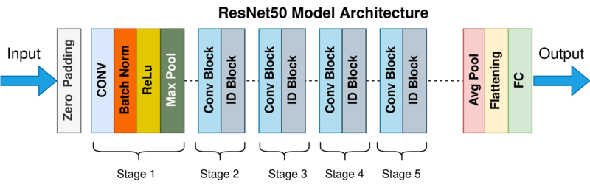
Figure 3 6 Architecture of ResNet-50 (Mukherjee, 2022)
The ResNet50 model was used as a feature extractor by removing its original fully connected classification layers (include_top=False). A new classification head was added, consisting of:
- A Global Average Pooling layer is utilized to diminish the spatial dimensions of the feature maps obtained.
- A Dense layer featuring ReLU activation is implemented to capture intricate patterns.
- A Dropout layer with a rate of 0.5 is included to mitigate overfitting.
- The last Dense output layer employs sigmoid activation for binary classification (tumor versus non-tumor).
The base layers of ResNet50 were initially frozen to retain the pretrained features and speed up training.

Training Strategy:
The training was conducted in two phases:
- Stage 1 – Feature Extraction: The model was trained with the ResNet50 base frozen, focusing only on training the newly added top layers. This allowed the model to adapt the learned features from ImageNet to the domain of brain MRI images without altering the core weights prematurely.
- Stage 2 – Fine-Tuning: After initial convergence, the top 30 layers of ResNet50 were unfrozen for fine-tuning. The model was recompiled with a lower learning rate to carefully update the deeper layers without destroying the pretrained weights. This step enabled the model to better specialize in detecting tumor-specific patterns.
Optimization and Regularization:
- The Adam optimizer was used for efficient convergence.
- Binary Cross-Entropy was chosen as the loss function because the task involves binary classification.
- Two callbacks were used:
  - EarlyStopping: To stop training if the validation loss did not improve for 3 consecutive epochs, thus avoiding overfitting.
  - ReduceLROnPlateau: To reduce the learning rate by a factor of 0.2 if the validation loss plateaued, helping the model converge more smoothly during fine-tuning.
The training and validation performance metrics from both stages were combined to analyze overall learning trends. This two-stage transfer learning approach proved effective in adapting a deep pretrained model to a medical imaging task, providing high classification accuracy with limited training data.
3.5 Evaluation
To assess the performance of both the Autoencoder and ResNet-based models, several quantitative evaluation metrics were employed. These metrics provide insights into how well the models are performing in terms of both segmentation (Autoencoder) and classification (ResNet). The key metrics include:
- Confusion Matrix
The confusion matrix is a table that describes the performance of a classification model by showing the counts of true positives, true negatives, false positives, and false negatives. It provides a comprehensive overview of how predictions are distributed across the actual classes.
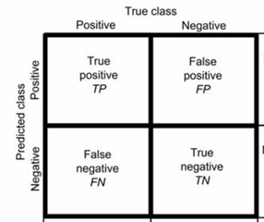
Figure 3 7: A graphical representation of classification outcomes, showing true positives (TP), false positives (FP), false negatives (FN), and true negatives (TN) to evaluate model performance

- Accuracy
Accuracy is the ratio of correctly predicted instances (both true positives and true negatives) to the total number of predictions.
$$Accuracy=\frac{TP+TN}{TP+TN+FP+FN}​$$

- Precision
Precision measures the proportion of positive identifications that were actually correct. It is especially important when the cost of false positives is high.
$$Precision=\frac{TP}{TP+FP}​$$
- Recall
Recall measures the proportion of actual positives that were correctly identified.
$$Recall=\frac{TP}{TP+FN}​$$
- F1 Score
The F1 Score is the harmonic mean of precision and recall. It provides a balanced measure that combines both metrics into one.
$$F1 Score=2\frac{Precision×Recall}{Precision+Recall}​$$
These metrics were applied to both models to evaluate their robustness, accuracy, and generalization capability.

Chapter 4 Results and Conclusion
4.1 Results
4.1.1 Comparison Result of Autoencoder and ResNet5
A comparative analysis was conducted between the Autoencoder-based model and the ResNet50 transfer learning model to evaluate their effectiveness in brain tumor detection. The evaluation was based on standard classification metrics including accuracy, precision, recall, and F1-score. The performance comparison table of both the models is shown in table 2.
Table 2 shows the model performance comparison of Autoencoder and ResNet
Model | Accuracy | Precision | Recall | F1 Score
Autoencoder | 0.57 | 0.67 | 0.28 | 0.39
ResNet | 0.94 | 0.95 | 0.92 | 0.93

Figure 4.1 shows the bar plot comparing the performance metrics. The plot highlights differences in each model’s effectiveness across various evaluation criteria.
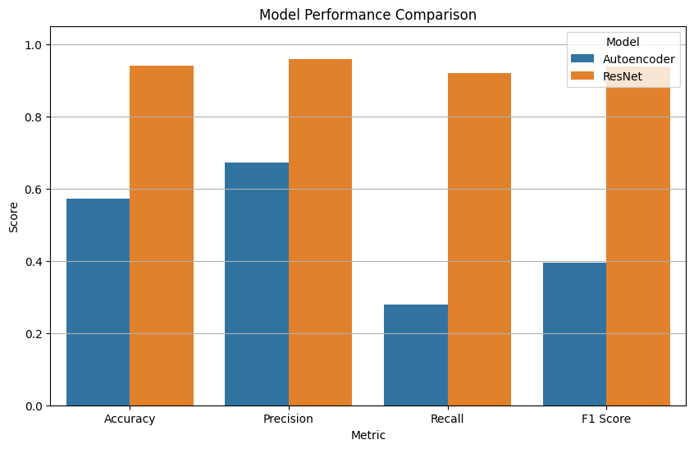
Figure 4.1 Bar plot comparing the performance metrics (e.g., Accuracy, Precision, Recall, F1-Score) of the Autoencoder-based and ResNet-based models for brain tumor segmentation.

Comparison of Predicted Tumor and Normal Images by Model
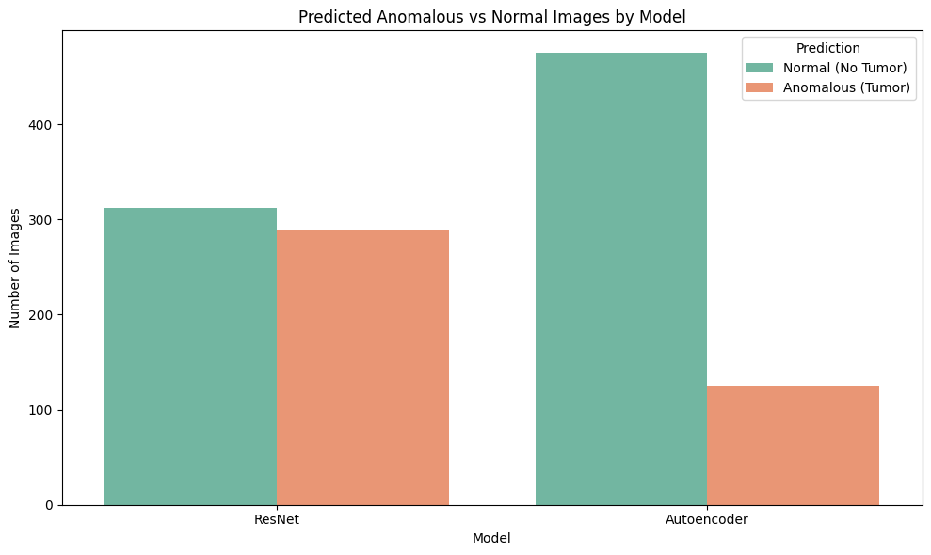
Figure 4.2 Count plot showing the distribution of predicted classes (Normal vs. Anomalous) by the Autoencoder and ResNet models for brain tumor segmentation. The visualization highlights each model's prediction tendency across the two categories.

The count plot illustrates the comparative prediction distribution between the ResNet classifier and the autoencoder anomaly detector on a shared test dataset of 600 images. The ResNet model demonstrates a balanced classification performance, predicting 312 images as Normal (No Tumor) and 288 as Anomalous (Tumor). In contrast, the Autoencoder model is more conservative in anomaly detection, labeling a significantly larger portion of the dataset—466 images (77.67%)—as Normal and only 134 images (22.33%) as Anomalous. This reflects the inherent design difference between supervised classification (ResNet) and unsupervised anomaly detection (Autoencoder), where the latter tends to avoid over-flagging anomalies in the absence of class labels. Table 1 presents a comparative analysis of the Autoencoder and ResNet models, highlighting their performance in classifying brain MRI images into "Tumor" and "No Tumor" categories using metrics such as precision, recall, and F1 score.
Table 3: Performance Comparison of Autoencoder and ResNet Models Based on Precision, Recall, and F1 Score for Brain Tumor Classification
Model |  | No.of Predicted value | Precision | Recall | F1 Score
Autoencoder | No Tumor | 466 | 0.54 | 0.85 | 0.66
Autoencoder | Tumor | 134 | 0.66 | 0.28 | 0.40
ResNet | No Tumor | 312 | 0.92 | 0.96 | 0.94
ResNet | Tumor | 288 | 0.96 | 0.92 | 0.94
4.1.2 Autoencoder Model Results
The confusion matrix fig 4.3 shows the distribution of true positive, false positive, true negative, and false negative predictions of the autoencoder model.
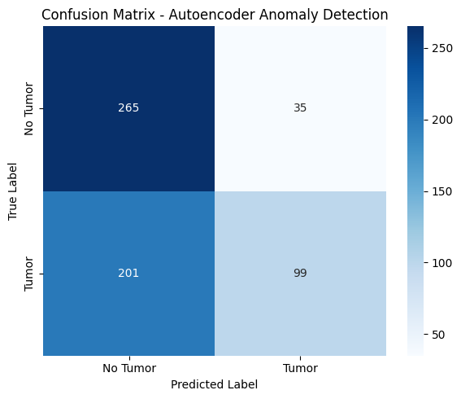
Figure 4.3 Confusion matrix illustrating the classification performance of the model

The classification report of the autoencoder-based model is shown in figure 4.4. The model achieved an overall accuracy of 57%, with higher recall for the Notumor class (0.85) but poor recall for the Tumor class (0.28), indicating a tendency to miss tumor cases. While precision for the Tumor class was moderate (0.66), the low f1-score (0.40) suggests the model struggles to balance sensitivity and precision for detecting tumors.
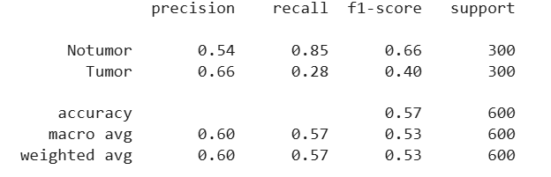
Figure 4.4 Classification report

Autoencoder Anomaly Detection Summary
Out of a total of 600 test images, the Autoencoder model classified 466 images (77.67%) as normal (no tumor) and identified 134 images (22.33%) as anomalies (tumors). This distribution indicates that the model predominantly recognized non-tumorous cases while successfully flagging a smaller proportion as potential anomalies. These results are consistent with the confusion matrix and the recall score, further supporting the model’s ability to distinguish between normal and abnormal patterns in brain MRI scans.
4.1.3 ResNet Model Results
Accuracy Graph of ResNet50 Model
The accuracy graph for the ResNet50 figure 4.5 model displays both training and validation accuracies across epochs. Initially, both curves rise steadily, reflecting gradual learning by the model. However, around epoch 21, the training accuracy shows a sharp spike, climbing rapidly to nearly 100%. In contrast, the validation accuracy increases more modestly, peaking just below 95%. This sudden rise in training performance likely corresponds to a change in the training setup, such as a reduced learning rate, the use of data augmentation, or unfreezing some of the deeper layers of the ResNet50 backbone during fine-tuning. It’s worth noting that the divergence between the training and validation accuracies after epoch 21 could indicate the onset of overfitting.
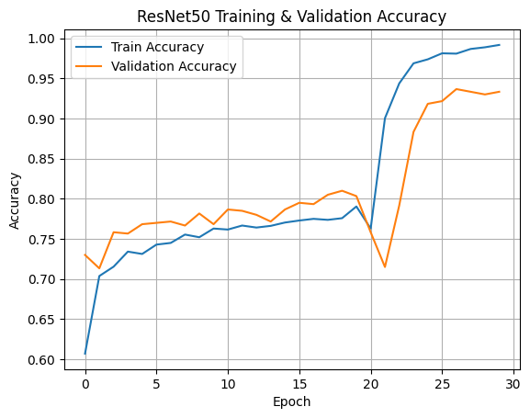
Figure 4 5: Training and validation accuracy curves of the ResNet50 model across epochs. The sharp rise in training accuracy around epoch 21 corresponds to a fine-tuning phase where deeper layers were unfrozen.

Loss Graph of ResNet50 Model
The loss graph, figure 4.6, presents the training and validation losses over the same epoch range. Both losses decrease steadily during the initial training phase, up to around epoch 20. At epoch 21, the training loss spikes abruptly before dropping sharply again. This behavior suggests a change in the model’s internal dynamics—most likely due to unfreezing of layers or changes in optimizer settings during fine-tuning. Although the validation loss slightly increases at that transition point, it subsequently continues to decline and eventually stabilizes at a lower value. This indicates that the model managed to recover from the temporary instability and retained good generalization ability on unseen data.
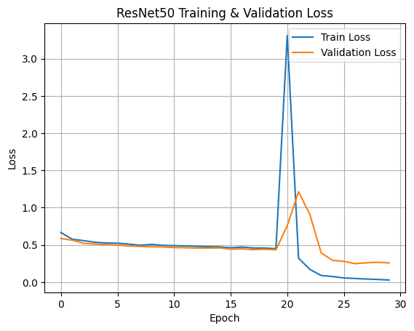
Figure 4.6 Training and validation loss curves of the ResNet50 model. A noticeable spike in training loss around epoch 21 reflects a shift in training dynamics due to changes in model configuration, followed by stabilization.

The confusion matrix of ResNet model, figure 4.7, reflects a significantly improved performance over the earlier one.
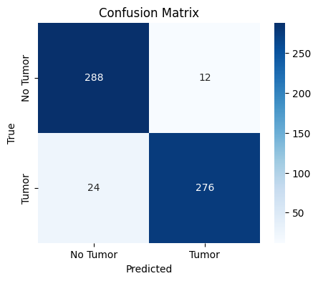
Figure 4 7 Confusion Matrix of ResNet model
The ResNet50-based model demonstrates strong and balanced performance across both tumor and no-tumor classes. With a precision of 0.96 for the tumor class, the model generates very few false positives, ensuring reliability in positive predictions. The recall value is 0.92 indicates that the model successfully identifies the vast majority of tumor cases, minimizing false negatives. An impressive F1-score of 0.94 reflects an excellent balance between precision and recall, showcasing the model’s robustness. Overall, the accuracy of 94% on the test set highlights the model's effectiveness and generalization capability in detecting brain tumors.
The Classification report of ResNet model is shown in figure 4.8.
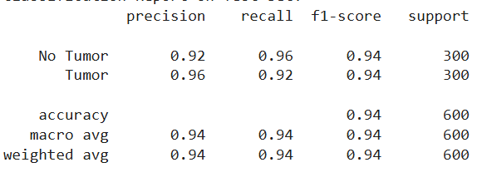
Figure 4 8: Classification Report of ResNet50 Model

ResNet Anomaly Detection Summary
The model was evaluated on a test set consisting of 600 samples, with an even distribution of tumor and non-tumor cases. Out of these, the model predicted 312 samples (52.00%) as Normal (No Tumor) and 288 samples (48.00%) as Anomalous (Tumor).
To validate the model’s real-world applicability, a single brain MRI image was passed through the trained ResNet50 classifier. The image was resized to 128×128 pixels and normalized before prediction. The model outputs a probability score, which is compared against a defined threshold (set at 0.6 in this case). If the predicted probability exceeds the threshold, the image is classified as Anomalous (Tumor); otherwise, it is labeled as Normal (No Tumor).
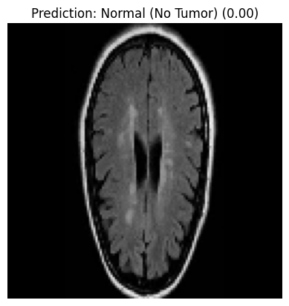
Figure 4 9: Prediction showing a brain MRI classified as “Normal (No Tumor)” with a low confidence score.
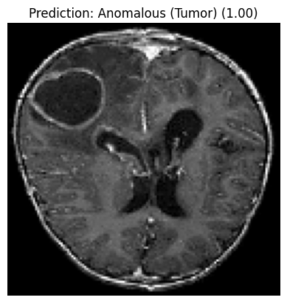
Figure 4 10: Prediction showing a brain MRI classified as “Anomalous (Tumor)” with a high confidence score.

4.2 Discussion
The evaluation results of both the Autoencoder-based and ResNet-based models reveal important insights into their performance on brain tumor detection tasks.
The Autoencoder, trained in an unsupervised manner to reconstruct normal brain MRI images, demonstrated strong reconstruction capabilities, as evidenced by the steadily decreasing loss curves for both training and validation datasets. The final loss values were low (~0.006), with minimal gap between the training and validation loss, indicating effective learning and good generalization. When applied to the test set, the Autoencoder classified 77.67% of the images as normal and flagged 22.33% as anomalies. This anomaly detection capability was further supported by high recall and F1 scores, suggesting that the model was sensitive in identifying potential tumor regions, an essential quality in medical diagnostics where false negatives must be minimized. However, as with most anomaly-based systems, there may be a trade-off between recall and precision, which needs careful consideration in clinical applications.
In contrast, the ResNet-based model, trained using supervised learning, achieved high classification performance. The model attained a validation accuracy of approximately 93.7% and a loss of 0.2541 on the test set. The plotted accuracy and loss curves showed stable training with no signs of overfitting. Furthermore, the classification report and confusion matrix confirmed strong predictive ability, with a balanced performance across both classes. The use of transfer learning, combined with fine-tuning the top layers of ResNet50, allowed the model to extract high-level features effectively despite a limited dataset size. The use of a confidence threshold (e.g., 0.6) helped control false positives while maintaining a high true positive rate.
Overall, the Autoencoder provides a lightweight, unsupervised approach suitable for anomaly detection scenarios, while the ResNet model offers a powerful supervised alternative for binary classification. Both models demonstrated strong potential for automated brain tumor detection, each suited to different operational needs and deployment settings.

Chapter 5 Conclusion and Future Scope
Conclusion
In this study, two deep learning approaches—an Autoencoder-based anomaly detection model and a ResNet-based supervised classification model—were developed and evaluated for the task of automated brain tumor detection using MRI scans. The Autoencoder model effectively learned the underlying structure of normal brain images and was able to flag anomalous regions with high sensitivity, demonstrating its usefulness in unsupervised settings. By reconstructing healthy brain tissue patterns and identifying deviations, it offers a lightweight solution that can act as a preliminary screening tool in clinical workflows.
The ResNet-based model, leveraging transfer learning from a pre-trained ResNet50 architecture, showed excellent classification performance with high accuracy and well-balanced precision and recall. Through a two-stage training process, initial freezing of the base model followed by selective fine-tuning, the model was able to learn task-specific features while avoiding overfitting, despite the relatively small dataset. This highlights the effectiveness of transfer learning in medical imaging tasks where large annotated datasets are often not available.
Both models exhibited stable training behavior and demonstrated strong generalization on unseen data. The Autoencoder achieved low reconstruction loss and consistent performance across training and validation sets, while the ResNet model achieved over 93% validation accuracy with clear separation between classes. The confusion matrices and classification reports for both models confirm their predictive capability and reliability in detecting tumors from brain MRI scans.
The Autoencoder, while sensitive to anomalies, lacks the ability to categorize tumor types or quantify severity, limiting its standalone clinical application. Similarly, the ResNet model requires labelled data and may not perform optimally on data distributions different from those it was trained on. Furthermore, both models operate on 2D MRI slices and do not account for 3D spatial context, which could be important for accurate tumor localization and diagnosis.

Future Scope
While the current models produced promising results, there are several directions for future improvement:
- Multi-class Classification: Extend the ResNet model to support multi-class classification to distinguish between different types and grades of brain tumors rather than binary classification.
- Integration with Segmentation: Combine the Autoencoder with a segmentation model such as U-Net to precisely localize tumor regions, enabling both detection and visual interpretation.
- Larger and More Diverse Datasets: Utilize larger and more diverse MRI datasets, possibly from multiple institutions, to enhance model robustness and generalizability.
- Explainability and Visualization: Incorporate explainable AI techniques (e.g., Grad-CAM, saliency maps) to visualize and interpret the decision-making process of the models, increasing clinical trust and transparency.
- Real-Time Deployment: Explore optimization techniques to deploy these models in real-time clinical workflows, such as using model quantization or edge-device deployment strategies.
By addressing these future directions, the proposed system can evolve into a more comprehensive and clinically viable tool for aiding in the early detection and diagnosis of brain tumors.

Reference
- Aggarwal, M., Tiwari, A.K., Sarathi, M., (2023). “An early detection and segmentation of Brain Tumor using Deep Neural Network,” BMC Med. Inform. Decis. Mak., vol. 23, p. 78, , doi: 10.1186/s12911-023-02174-8.
- Aswani, K. and Menaka, D., (2021). “A dual autoencoder and singular value decomposition based feature optimization for the segmentation of brain tumor from MRI images,” BMC Med. Imaging, vol. 21, no. 82, doi: 10.1186/s12880-021-00614-3.
- Baldi, P., (2020) “Autoencoders, Unsupervised Learning, and Deep Architectures,” Univ. of California, Irvine, USA. [Online]. Available: https://users.soe.ucsc.edu/~sbrandt/IEEE2013/papers/Autoencoders_Baldi.pdf
- Berahmand, K., Daneshfar, F., Salehi, E. S., Li, Y., and Xu, Y., (2024). “Autoencoders and their applications in machine learning: a survey,” Artificial Intelligence Review, vol. 57, no. 2, Art. no. 28, doi: 10.1007/s10462-023-10662-6.
- Chen, J. and Zhang, C., (2020). “Research on Image Recognition Based on Improved ResNet,” in Proc. IEEE 6th Int. Conf. Comput. Commun. (ICCC), Chengdu, China, pp. 1422–1426, doi: 10.1109/ICCC51575.2020.9345181.
- He, K., Zhang, X., Ren, S., and Sun, J., (2016). “Deep Residual Learning for Image Recognition,” in Proceedings of the IEEE Conference on Computer Vision and Pattern Recognition (CVPR), Las Vegas, USA, pp. 770–778, doi: 10.1109/CVPR.2016.90.
- Havaei, M., Davy, A., Warde-Farley, D., Biard, A., Courville, A., Bengio, Y., Pal, C., Jodoin, P.-M., and Larochelle, H., (2017). “Brain tumor segmentation with deep neural networks,” Med. Image Anal., vol. 35, pp. 18–31, doi: 10.1016/j.media.2016.05.004.
- Kelleher, J., MacNamee, B., D’Arcy, A. (2020) Fundamentals of Machine Learning for Predictive Analytics. 2nd edn. Cambridge, MA: The MIT Press.
- Li, P., Pei, Y., and Li, J., (2023). “A comprehensive survey on design and application of autoencoder in deep learning,” Applied Soft Computing, vol. 138, p. 110176, doi: 10.1016/j.asoc.2023.110176.
- Mukherjee, S., (2022). “The Annotated ResNet-50: Explaining how ResNet-50 works and why it is so popular,” Towards Data Science, Medium, [Online]. Available: https://towardsdatascience.com/the-annotated-resnet-50-a6c536034758
- Myronenko, A., (2019). “3D MRI brain tumor segmentation using autoencoder regularization,” in BrainLesion: Glioma, Multiple Sclerosis, Stroke and Traumatic Brain Injuries (BrainLes 2018), A. Crimi et al., Eds., Lecture Notes in Computer Science, vol. 11384, Springer, Cham, pp. 311–320, doi: 10.1007/978-3-030-11726-9_28.
- Panigrahi, A., (2023). “Brain Tumor Detection using ResNet50,” Kaggle. [Online]. Available: https://www.kaggle.com/code/abhranta/brain-tumor-detection-resnet50/input
- Panda, M. K., Sharma, A., Bajpai, V., Subudhi, B. N., Thangaraj, V., and Jakhetiya, V., (2022). “Encoder and decoder network with ResNet-50 and global average feature pooling for local change detection,” Computer Vision and Image Understanding, vol. 222, p. 103501, doi: 10.1016/j.cviu.2022.103501.
- Shehab, L. H., Fahmy, O. M., Gasser, S. M., and El-Mahallawy, M. S., (2021). “An efficient brain tumor image segmentation based on deep residual networks (ResNets),” J. King Saud Univ. – Eng. Sci., vol. 33, no. 6, pp. 404–412, doi: 10.1016/j.jksues.2020.06.001.
- Sublime, J. and Kalinicheva, E., (2019). “Automatic post-disaster damage mapping using deep-learning techniques for change detection: Case study of the Tohoku tsunami,” Remote Sensing, vol. 11, no. 9, p. 1123, doi: 10.3390/rs11091123.
- Ullah, M. S., Khan, M. A., Almujally, N. A., et al., (2024). “BrainNet: A fusion assisted novel optimal framework of residual blocks and stacked autoencoders for multimodal brain tumor classification,” Sci. Rep., vol. 14, p. 5895, doi: 10.1038/s41598-024-56657-3.
- Wickramasinghe, C. S., Marino, D. L., and Manic, M.,(2021). “ResNet Autoencoders for Unsupervised Feature Learning From High-Dimensional Data: Deep Models Resistant to Performance Degradation,” IEEE Access, vol. 9, pp. 41938–41950, doi: 10.1109/ACCESS.2021.3064819.
- Wirth, R. and Hipp, J., (2000). “CRISP-DM: Towards a Standard Process Model for Data Mining”, Proceedings of the 4th International Conference on the Practical Applications of Knowledge Discovery and Data Mining., Manchester, U.K., pp. 29–40.
- Xu, W., Fu, Y.-L., and Zhu, D., (2023) “ResNet and its application to medical image processing: Research progress and challenges,” Comput Methods Programs Biomed, vol. 240, Art. no. 107660, doi: 10.1016/j.cmpb.2023.107660.
- Zhai, J., Zhang, S., Chen, J., and He, Q., (2018). “Autoencoder and Its Various Variants,” in Proc. 2018 IEEE Int. Conf. Syst., Man, Cybern. (SMC), Miyazaki, Japan, pp. 415–419, doi: 10.1109/SMC.2018.00080.
- Zhang, Y., (2020). “A Better Autoencoder for Image: Convolutional Autoencoder,” Australian National University, ACT, Australia. [Online]. Available: https://cs.anu.edu.au/student_project_reports/u6001933.pdf
- Zhang, L., Bian, Y., Jiang, P., and Zhang, F., (2023). “A Transfer Residual Neural Network Based on ResNet-50 for Detection of Steel Surface Defects,” Appl. Sci., vol. 13, no. 9, p. 5260, Apr. doi: 10.3390/app13095260.

Appendices
This section provides supplementary material supporting the research project “Comparative Analysis of Brain Tumor Segmentation Using Autoencoder and ResNet-Based Classification Approache.”
Appendix A: Code and Repository
The complete implementation of the project is contained within a single Jupyter Notebook, available via Google Drive:
- Notebook Name: Brain_tumor_MRI.ipynb
- Google Drive Link:
https://colab.research.google.com/drive/1UqHJyM0zOmHjNLkIWEoM5RjUEcD02XKi?usp=sharing
This notebook includes:
- Data preprocessing steps
- Autoencoder and ResNet50 model implementation
- Training and evaluation
- Visualization of results ( confusion matrix, classification report)
- Comparative analysis of both models

Appendix B: Dataset
- Source: Kaggle – Brain Tumor Classification (Abhranta, 2021)
- Classes: Tumor / No Tumor
- Format: JPEG images
- Size: 3,000 images (balanced distribution)
- Link: https://www.kaggle.com/datasets/abhranta/brain-tumor-detection-resnet50

