import os

import cv2 as cv2

import numpy as np

from matplotlib import pyplot as plt

def histogram(img):

histogram_ = np.zeros(256, dtype=np.uint32) # 存放讀到的pixel值

for k in range(len(histogram_)):

histogram_[k] = np.sum(img.flat == k) # 將符合 SUM 起來

return histogram_

def equalize(img,histogram_):

def sumcdf(histogram_):

cdf = np.zeros_like(histogram_, dtype=np.uint32) # 累積分布函數（cdf）

cdf[0] = histogram_[0] # 因為下方 cdf[k-1], 在 cdf[0] 時前面沒有值,有可能會讀到亂七八糟的東西,因此要先將[0]先寫進去

for k in range(len(cdf)):

cdf[k] = cdf[k-1] + np.sum(img.flat == k) # 取的cdf累計"值"

return cdf

cdf_pro = sumcdf(histogram_) / (img.shape[0] * img.shape[1]) # 算出cdf的機率(probability)

cdf_value = np.zeros_like(img, dtype=np.uint8) # 存放乘以CDF的pixel值

for row in range(img.shape[0]):

for col in range(img.shape[1]):

cdf_value[row,col] = np.uint8(np.round((cdf_pro[img[row,col]] - np.min(cdf_pro)) / (np.max(cdf_pro) - np.min(cdf_pro)) * 255))

# 將row col的值,乘上對應cdf出現的機率值 = 均化

return cdf_value # 將均化後的值回傳

def gray():

img_path='E:/Program_File/PYTHON/數位影像處理作業/HW_1/snow.jpg'

img_filepath = os.path.splitext(img_path)[0] # 拆分路徑 & 副檔名，0 為路徑

img_fileextension = os.path.splitext(img_path)[1] # 1 為副檔名

img_filename = os.path.basename(img_filepath) # 取出檔名不含副檔名

img = cv2.imread(img_filename+img_fileextension,cv2.IMREAD_GRAYSCALE)

histogram_ = histogram(img)

cdf_value = equalize(img,histogram_)

histogram_equ = histogram(cdf_value)

plt.bar(range(len(histogram_)), histogram_, alpha=0.9, width = 1, lw=1)

plt.figure()

plt.bar(range(len(histogram_)), histogram_equ, alpha=0.9, width = 1, lw=1)

plt.show()

plt.close()

cv2.imshow('img',img)

cv2.imshow('equalize',cdf_value)

cv2.waitKey()

cv2.destroyAllWindows()

cv2.imwrite(img_filename+'_gray'+img_fileextension,img)

cv2.imwrite(img_filename+'_gray_equalize'+img_fileextension,cdf_value)

def multicolor():

img_path='E:/Program_File/PYTHON/數位影像處理作業/HW_1/star.jpg'

img_filepath = os.path.splitext(img_path)[0] # 拆分路徑 & 副檔名，0 為路徑

img_fileextension = os.path.splitext(img_path)[1] # 1 為副檔名

img_filename = os.path.basename(img_filepath) # 取出檔名不含副檔名

img = cv2.imread(img_filename+img_fileextension,-1) # 讀檔

img_b, img_g, img_r = cv2.split(img) # 將對檔案分割，順序為BGR，而非RGB

img_b_hist = histogram(img_b) # 分別將 BGR 做 histogram

img_g_hist = histogram(img_g)

img_r_hist = histogram(img_r)

img_b_eq = equalize(img_b, img_b_hist) # 各別接著做 equalize

img_g_eq = equalize(img_g, img_g_hist)

img_r_eq = equalize(img_r, img_r_hist)

img_b_eq_hist = histogram(img_b_eq) # 最後將 equalize 後的 BGR 做 histogram

img_g_eq_hist = histogram(img_g_eq)

img_r_eq_hist = histogram(img_r_eq)

plt.subplot(3,2,1) # 子圖，( 3 * 2 (列column * 行row), 第一個圖，左上)

plt.bar(np.arange(img_b_hist.shape[0]), img_b_hist, alpha=0.9, width = 1, lw=1, align = 'center',color = 'b')

plt.subplot(3,2,2) # 子圖，( 3 * 2 , 第二個圖，右上)

plt.bar(np.arange(img_b_eq_hist.shape[0]), img_b_eq_hist, alpha=0.9, width = 1, lw=1, align = 'center',color = 'b')

plt.subplot(3,2,3) # 子圖，( 3 * 2 , 第三個圖，左中)

plt.bar(range(len(img_g_hist)), img_g_hist, alpha=0.9, width = 1, lw=1, align = 'center',color = 'g')

plt.subplot(3,2,4)

plt.bar(range(len(img_g_eq_hist)), img_g_eq_hist, alpha=0.9, width = 1, lw=1, align = 'center',color = 'g')

plt.subplot(3,2,5)

plt.bar(range(len(img_r_hist)), img_r_hist, alpha=0.9, width = 1, lw=1, align = 'center',color = 'r')

plt.subplot(3,2,6)

plt.bar(range(len(img_r_eq_hist)), img_r_eq_hist, alpha=0.9, width = 1, lw=1, align = 'center',color = 'r')

plt.show()

plt.close() # 開啟圖片後要記得關閉，當有大量的圖片或資料開啟後，記憶體可能會爆，因此要手動關閉他

img_merge = cv2.merge([img_b_eq,img_g_eq,img_r_eq]) # 將均化後的 BGR 合併

cv2.imwrite(img_filename+'_merge_equalize'+img_fileextension,img_merge)

cv2.imshow('img',img)

cv2.imshow('equalize',img_merge)

cv2.waitKey(0)

cv2.destroyAllWindows()

# gray()

# multicolor()

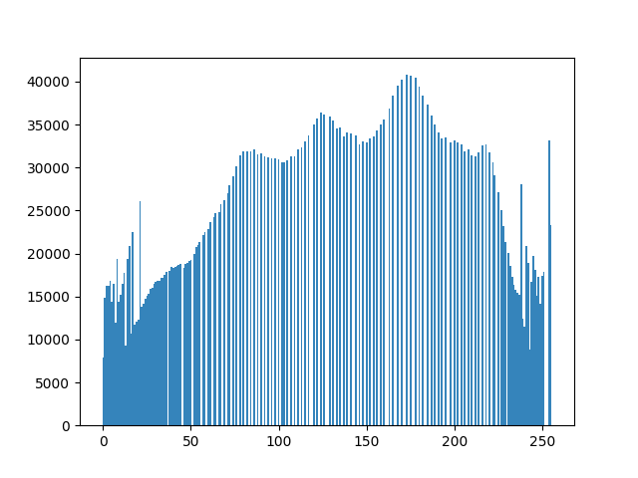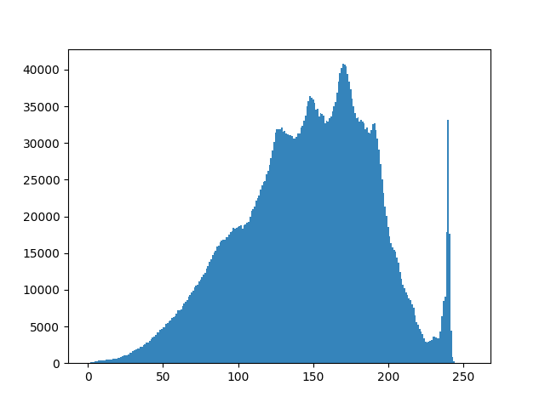GRAY :

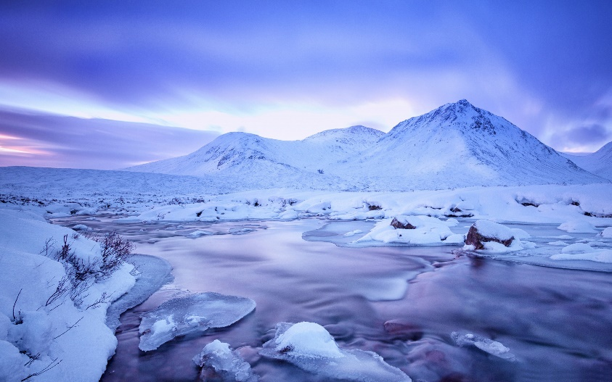

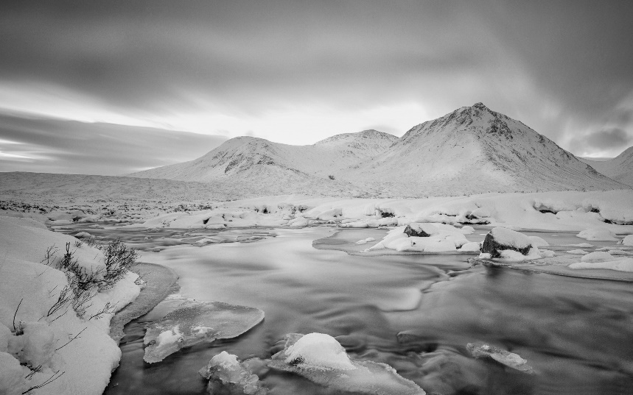

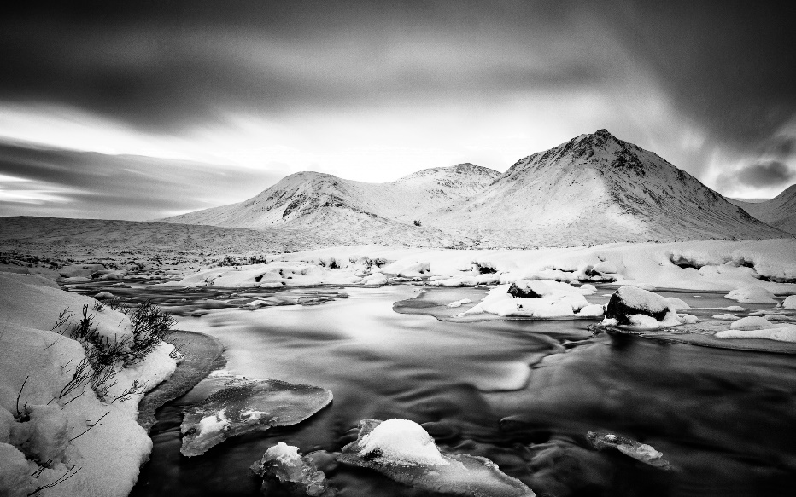

multicolor :

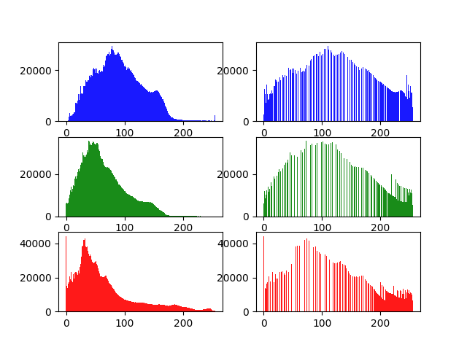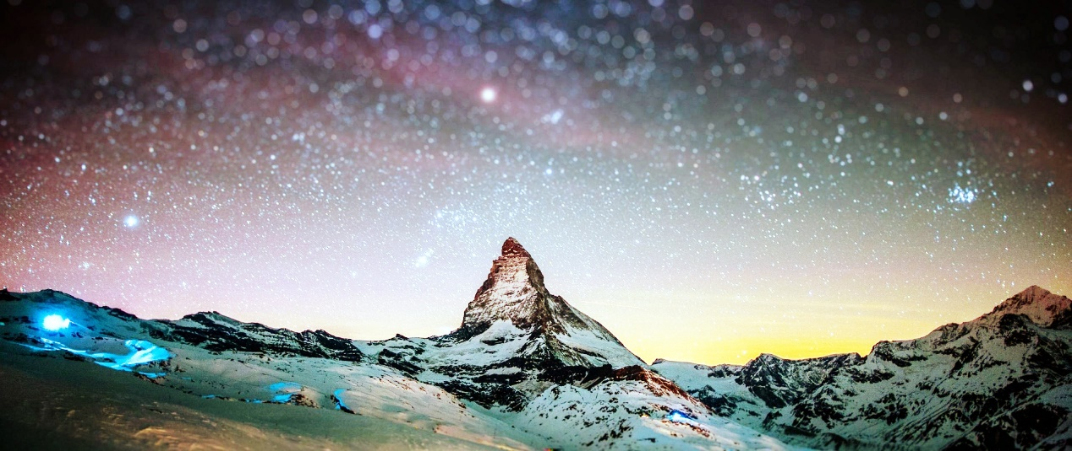

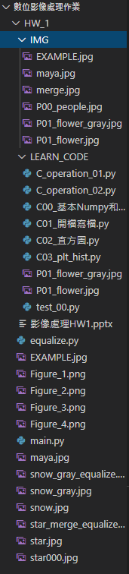心得 :

在做直方圖以及均化之前對numpy、cv2、matplotlib，完全沒有概念，花了許多時間對其各種用法進行嘗試。

在寫直方圖時整體還算順利，但是當要做均化時我參考了維基百科上的數學公式，有做出CDF，在我以為我已經成功時，跑出來的圖卻並不正確，因為實際上我只有算出機率，並沒有乘上原本的值，在與同學請教過後，才成功的求出均化後的值並成功輸出