Francs Tireurs
une armée irrégulière est une arme non conventionnelle

Anne Ogborn
rev 0.1

Abstract
Francs Tireurs is a web based MUD and ChatScript game.
The emphasis is on the ChatScript part. The MUD exists 'to give something to talk about' and control the action.
The storyline is important. The player plays a young female student at the Sorbonne who becomes involved in the resistance in a rather naïve way, almost as a college prank, and then gets seriously involved, eventually becoming a leader, recruiting others, and organizing large missions.
Most action takes place through others, as actually acting is very dangerous.

Screen
There are three web pages. The first is a title splash, the second gives a one page tutorial graphic, and the third is the main gameplay area.

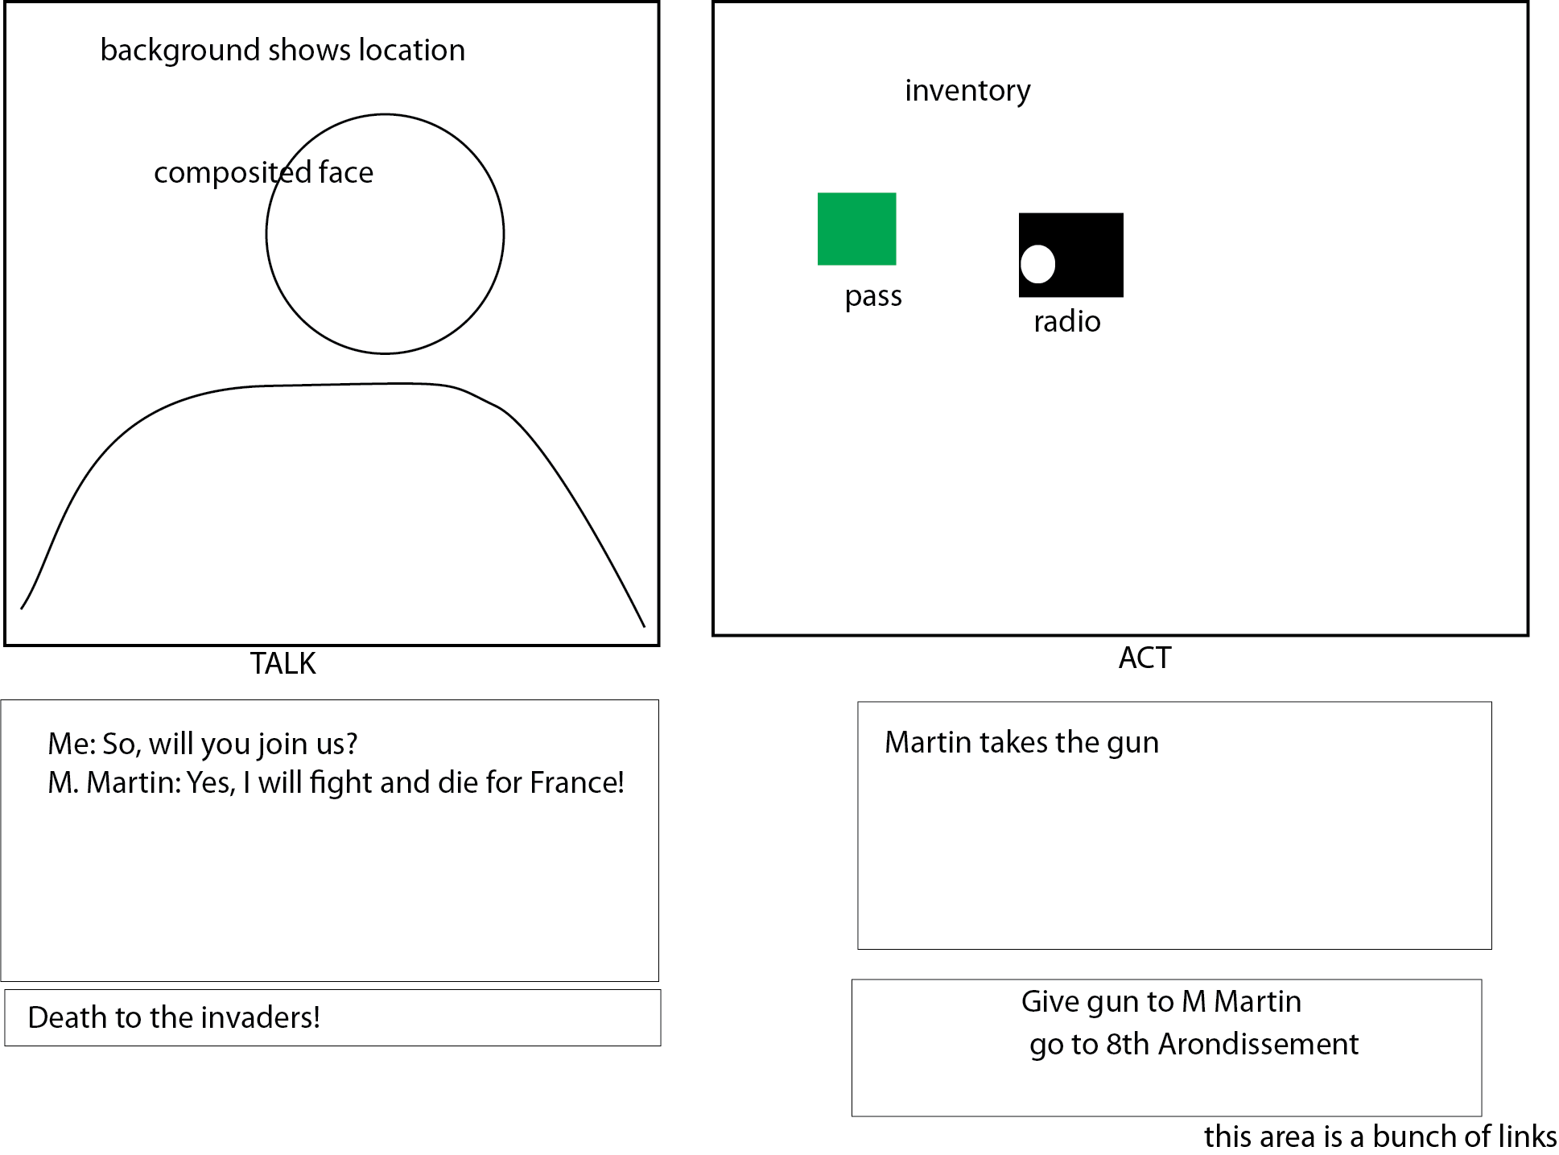

In the UL is an area with an image of the person you're talking to, if any, and possibly a graphic of the area.

In the UR is a tiled list of all the inventory items you're carrying on yourself

In the middle left column is a transcript of recent chat, and descriptions of the area from the MUD.
In the middle right column is action outputs. (might coalesce this into middle left)
At bottom left is an input area for talking
At bottom right is text with links to do MUD actions.
Across the very bottom (not shown) is a 'things to try saying' banner with a bunch of useful 'hints' things to say, taken from a file and not connected to the gameplay, and mixed with a fair proportion of useless or wrong advice. This is to reduce 'guess the verb'

Gameplay

MUD
The player moves around a fairly simple graph based MUD. Some locations have items or NPC's.
Movement is by clicking on links, as are actions like shooting and giving inventory. If it's easier, we might do this by sending input from the right textfield to the MUD, instead of clicking.
There's at most one NPC in a MUD room.

Chat
The central part of the game is chatting with the NPC's.
All NPC's chatscript files make them get 'bored' after a certain number of exchanges. So unless they're favorably disposed towards what you're saying, they'll do something like 'say Go away, go away', and will be less disposed to help you.
If you leave your turn # + nn gets recorded, and if you return after beyond this time they'll reetain their chatbot state, but won't be 'bored' any more.
The most important fact about an NPC is if they're recruited. If they are, they'll be in a topic that makes them tend to help you.
A few NPC's will offer specific services even if not recruited. E.g. the taxi driver might give you a ride, but won't hide guns. And not every recruited NPC will do everything, e.g. a new recruit probably won't store guns in his house or blow things up.
NPC's can be given a sequence of instructions to carry out.
NPC's without pending instructions will move back to their home base.

Capture/Kill
NPC's remember when they've interacted with other NPC's. This becomes important if they're captured.
NPC's are sometimes captured or killed, especially when doing things (like blowing something up). Each NPC will remember what other resistance members they've interacted with. If they're captured they will give out the names of other resistance member if they know them. Each NPC will have a bit to say if the Germans already know their addresses. If the Germans know an NPC's name and address, they'll also be captured, and the process will recurse.
If the Germans reach the player, the player will be moved to a special 'narrow escape' cut sequence. The probability of escaping will go down by a factor of two each time the player's captured.
If the player fails to escape, the game is over.

Recruiting
Either The player or other NPC's can try to recruit new members.
Each bot has a vector of values for these items:

- attitude towards authority, 'Orneriness' - think of how many KS farmers would join despite the risk, just because they have a f-you attitude towards authority
- desire for adventure
- community vs. family concern
- Ho Chi Minh's rule - is it better for me to support the resistance in the same way I ask 'is it better for me to put more money in my business?'
- factors making it better to collaborate - 'turn them in for money'
- factors making it better to resist - 'after the war it will be good for me'. 'at least I'll eat'
- ability to compromise this person and make them work for you
- fear of resistance retaliation
- desire to be part of a group
- pride/ego/self esteem - needs flattery
- neurotic 'I'm not worthy' if they're over complimented
- need to not see self as coward
- 'When the resistance has won, then I'll support them'
- confidence that the resistance will win
- trust in honesty - which goes down if you answer inconsistently or say things that make people think you're not honest
- trust in competency
- personal attitude - if you insult people they don't like you
- submission/resistance - apply pressure, this will either make them agree or increase polarization
- love of France
- hatred of the nazis, influenced by personal events
- fear due to past experiences - e.g. someone who'se been approached by gestapo already
- their politics in relation to yours - communists won't be attracted to degaullists
- their politics overall – obviously you can't recruit fascists
- If you're pro-jewish (or jewish), you can't recruit anti-semites.
- has the contact been developed, or is the approach 'cold'?
- recruiter is part of a family, work, or other social group 'cell'.
- Whether they like or dislike people in the group (not necc. The recruiter)

Each of these items also has a minimum potentiating cofactor. Things the player says can raise, but not lower, this potentiating factor.
So the overall opinion of the NPC towards joining is the scalar product of the factors above and the potentiating cofactors.
Some player statements trigger a 'close', (using the word like salespeople do). If the NPC is favorably disposed to join at the close, they're recruited. If not, they may either decline, or turn the recruiter in.
Whatever happens, the NPC now knows the recruiter is in the resistance.
NPC's also know about people they've met.
When the player interviews a bot the bot will tell the player about people they've met, and the player can instruct them to try to recruit the NPC. The recruiting NPC's chances of success are based on the base cofactors in some probabilistic fashion.
Initially NPC's will have terrible security practices – e.g. they'll tell each other their names. The player can explicitly turn this off. The player can also tell NPC's to tell all the resistance members they know blah blah, and it'll be as if they did it themselves.
Of course some NPC's are plants, or compromised (“We'll kill your family member if you don't cooperate”) and will forward info to the Germans. See https://en.wikipedia.org/wiki/Counterintelligence#Counter-HUMINT

Story
Opens on a web page with openingpic.jpg and this text:
My name is Fabron Darley. People call me Fabro. Let me tell you the story how I came to be here.
In 1939 I was quite young, and very good looking too! I was quite the hit with the young ladies.
I was studying at university, but I was much more interested in skiing in the Provence-Alpes-Côte d'Azur, how in English? the French Alps. I had become quite good, even with national reputation.
In August of that year a few friends of mine managed some leave from army, and we all went skiing in the mountains around Aiguille du Goûter. There is a, how you say, a refuge there for alpinists.
On one ski, I became, uh, confused, yes, confused on a downhill ski, and went over an escarpment. They say ones life comes before in such moments. All I remember was thinking 'Merde!'. I don't remember the landing.
Perhaps this was my lucky day. None of the others what were in that picture they survived the war. August and Pierre both gone in the fighting, and Remi, he was prisoner of Germans, and disappeared during the war.
I don't really know when I woke up, in a hospital in Lyon. It was winter, perhaps January when I left to live with my sister Antonette in Paris, and I, who had run five miles each day before my accident, now struggled around the block where my sister lived. I had broken nine bones, had ruptured my spleen, and now, all these years later, I still walk with a slight limp. The army had no use for a cripple, so I watched the boche march into Paris from my sister's flat.
By December 1940 I was well enough to look for work. And there my story begins...
Fabro finds work in a bakery, working for Jean Hardy.
Hardy enlists Fabro to sell bread on the black market.
Fabro is arrested selling bread
he can talk his way out of the arrest.

Characters
Fabro – the protagonist, Fabron Darley, former skier and mountain climber.
After an injury lives with his sister Antonette.

Chapt. 1 -
Antonette -

Jean Hardy

