Bluetooth wireless technology is a short-range communications system.

The key features of Bluetooth wireless technology are robustness, low power consumption, and low cost. Many features of the specification are optional, allowing product differentiation.

There are two forms of Bluetooth wireless technology systems: Basic Rate(BR) and Low Energy (LE). Both systems include device discovery, connection establishment and connection mechanisms.

The Basic Rate system includes optional Enhanced Data Rate (EDR) Alternate Media Access Control (MAC) and Physical (PHY) layer extensions. The Basic Rate system offers synchronous and asynchronous connections with data rates of 721.2 kb/s for Basic Rate, 2.1 Mb/s for Enhanced Data Rate and high speed operation up to 54 Mb/s with the 802.11 AMP.

The LE system includes features designed to enable products that require lower current consumption, lower complexity and lower cost than BR/EDR. The LE system is also designed for use cases and applications with lower data rates and has lower duty cycles. LE system includes an optional 2 Mb/s physical layer data rate and also offers isochronous data transfer in a connection-oriented and connectionless mechanism that uses the isochronous transports.

The Bluetooth core system consists of a Host and one or more Controllers.

A Host is a logical entity defined as all of the layers below the non-core profiles and above the Host Controller interface (HCI). A Controller is a logical entity defined as all of the layers below HCI.

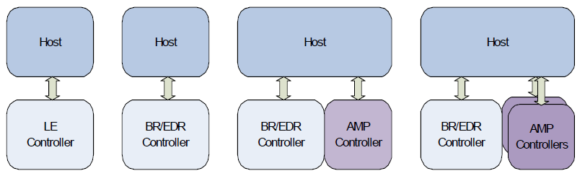

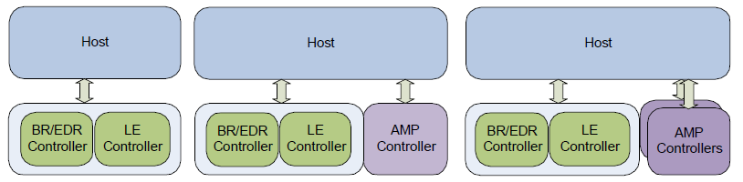

* a BR/EDR Controller including the Radio, Baseband, Link Manager and

optionally HCI.

* an LE Controller including the LE PHY, Link Layer and optionally HCI.
* an Alternate MAC/PHY (AMP) Controller including an 802.11 PAL (Protocol Adaptation Layer), 802.11 MAC and PHY, and optionally HCI.

*Bluetooth core system architecture*

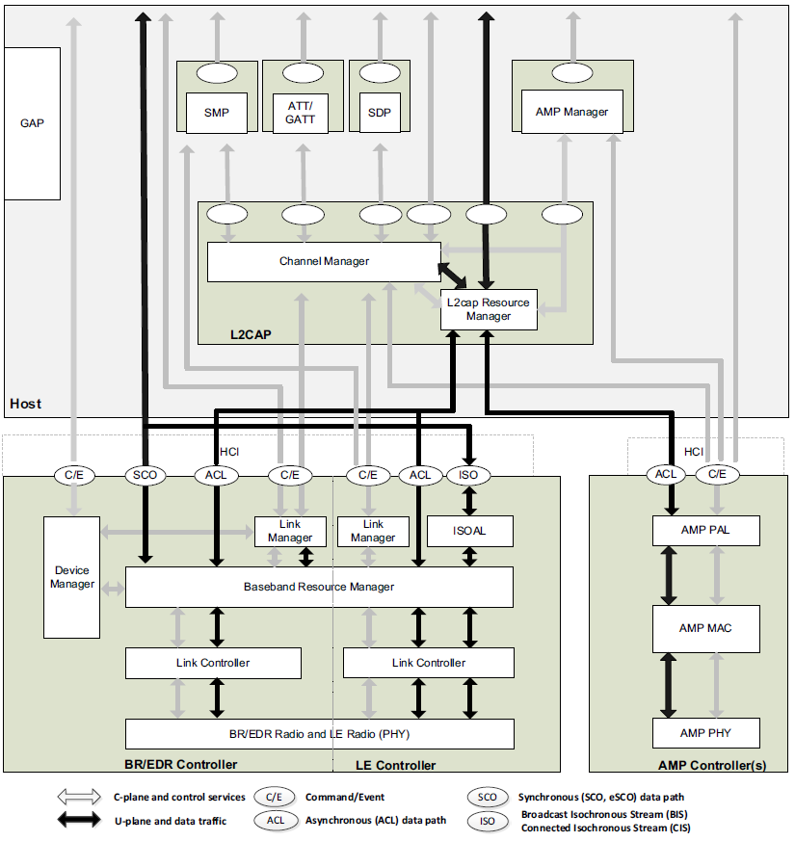

*Data transport architecture*

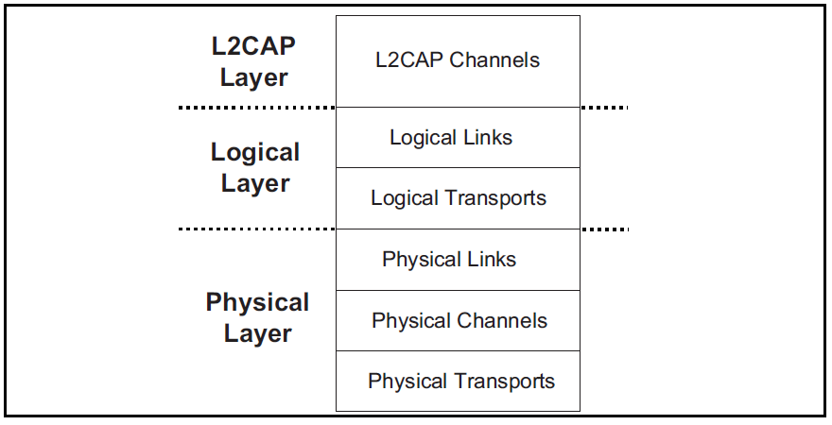

<https://www.jianshu.com/p/5e2bd7b63309>

<https://zhuanlan.zhihu.com/p/505095503>

<https://redmine-cn.verisilicon.com/redmine/projects/tws/wiki/Bluetooth_Knowledge>

<https://zhuanlan.zhihu.com/p/43516534>



Security:

• Pairing: the process for creating one or more shared secret keys

• Bonding: the act of storing the keys created during pairing for use in subsequent connections in order to form a trusted device pair

• Device authentication: verification that the two devices have the same keys

• Encryption: message confidentiality

• Message integrity: protects against message forgeries