When scanning, the Link Layer shall listen on the primary advertising physical channel. There are two types of scanning, determined by the Host: passive and active.

1. **Passive scanning**

When in passive scanning, the Link Layer will only receive packets; it shall not send any packets.

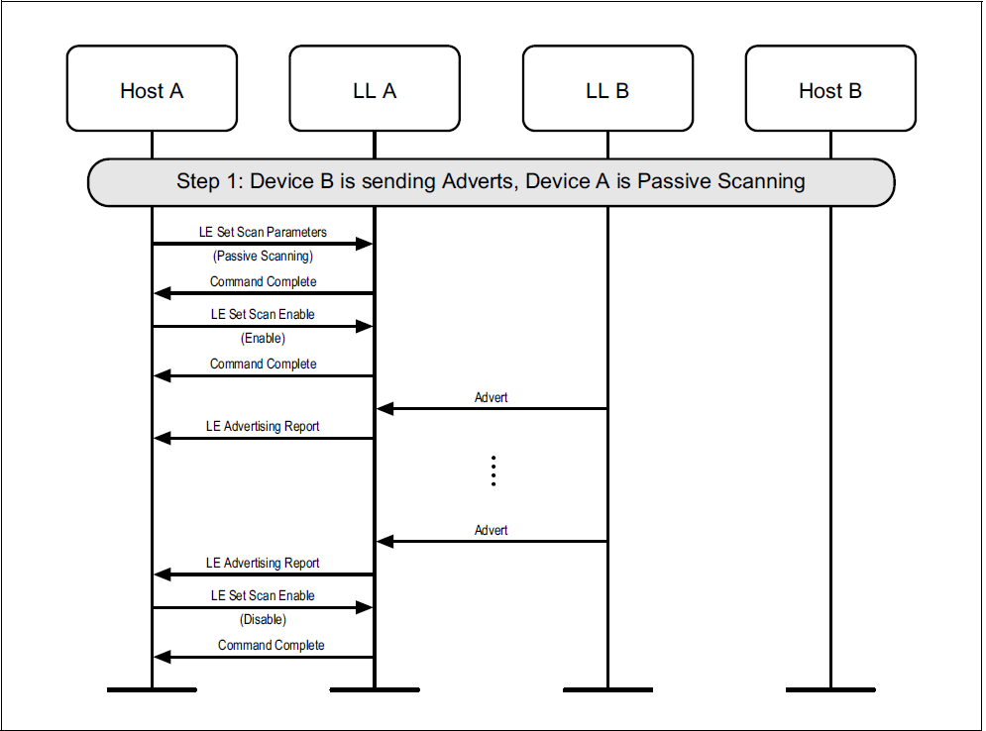

1. **Active scanning**

In active scanning, the Link Layer shall listen for advertising PDUs and, depending on the advertising PDU type, it may request an advertiser to send additional information.

If the Link Layer receives a scannable PDU (i.e. an ADV_IND, ADV_SCAN_IND, or scannable AUX_ADV_IND PDU) from an advertiser allowed by the scanner filter policy, it shall respond with a scan request PDU and then listen for the scan response PDU.

The Link Layer shall only send a SCAN_REQ PDU to an advertiser from which an ADV_IND PDU or ADV_SCAN_IND PDU is received. The Link Layer shall only send an AUX_SCAN_REQ PDU to an advertiser from which a scannable AUX_ADV_IND is received. The Link Layer shall ignore a scannable AUX_ADV_IND PDU if the TargetA field is present and it does not match the Link Layer’s device address.

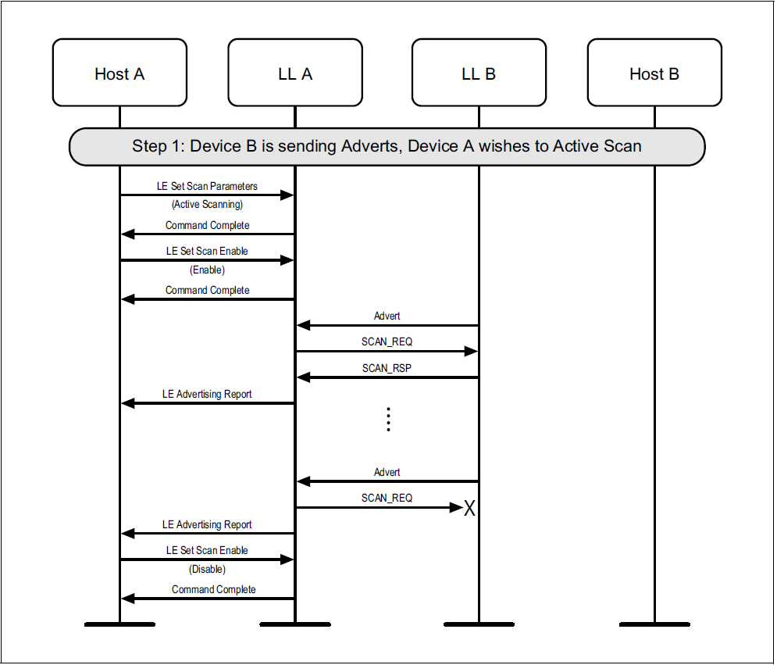

1. **SanWindow, ScanInterval**

During scanning, the Link Layer listens on a primary advertising channel index for the duration of the scan window, scanWindow. The scan interval, scanInterval, is defined as the interval between the start of two consecutive scan windows.

In each scan window, the Link Layer should scan on a different primary advertising channel index. The Link Layer shall use all the primary advertising channel indices.

If the scanWindow and the scanInterval parameters are set to the same value by the Host, the Link Layer should scan continuously.

On receiving a PDU with the AuxPtr field present, the scanner should also listen for the auxiliary PDU it points to and should then attempt to receive the entire subordinate set of the PDU.

1. **Advertising reports**

The Link Layer shall send an advertising report to the Host for each advertising PDU on the primary advertising physical channel and for each scan response PDU from an advertiser.

If the Controller receives an ADV_EXT_IND PDU with an AuxPtr field, it shall delay the report until after the corresponding AUX_ADV_IND PDU has been received and the report shall combine the information in the PDUs.

Note: The Controller may use more than one HCI event to send the report, for example, if the total data does not fit within a single event.

The Host may request that duplicate advertising reports are filtered and so not sent. Where a received ADV_EXT_IND PDU contains an ADI field, a duplicate advertising report is an advertising report for the same device address where the previous report that contained an ADI value with the same Advertising SID also had the same Advertising DID. Where the ADV_EXT_IND PDU does not contain an ADI field or a legacy PDU was received, a duplicate advertising report is an advertising report for the same device address.

1. **Scanning PDUs**

• SCAN_REQ

• SCAN_RSP

• AUX_SCAN_REQ

• AUX_SCAN_RSP

Where these PDUs are used to reply to a scannable advertisement

1. SCAN_REQ and AUX_SCAN_REQ

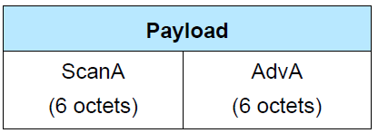

The ScanA field shall contain the scanner’s public or random device address

The AdvA field is the address of the device to which this PDU is addressed.

Note: These PDUs do not contain any Host Data.

1. SCAN_RSP

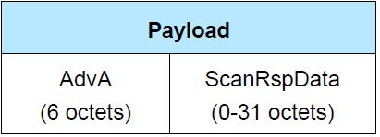

The AdvA field shall contain the advertiser’s public or random device address as indicated by

TxAdd. The ScanRspData field may contain any data from the advertiser’s Host.

1. AUX_SCAN_RSP

The AUX_SCAN_RSP PDU uses the Common Extended Advertising Payload Format.

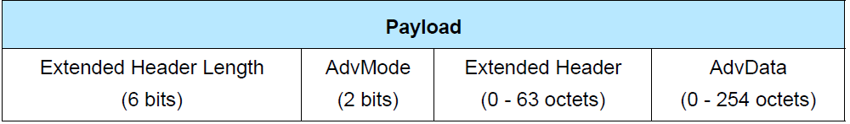

The AdvMode field shall be set to 0b00.

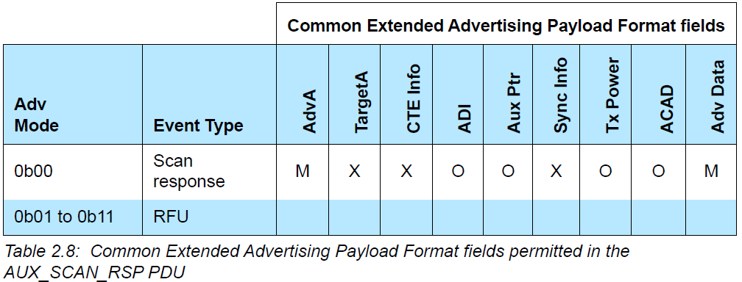

Any auxiliary PDU shall be an AUX_CHAIN_IND PDU.

The ADI field can be used to detect collisions.

A device may use active scanning on the secondary advertising physical channel in order to obtain more information about devices:

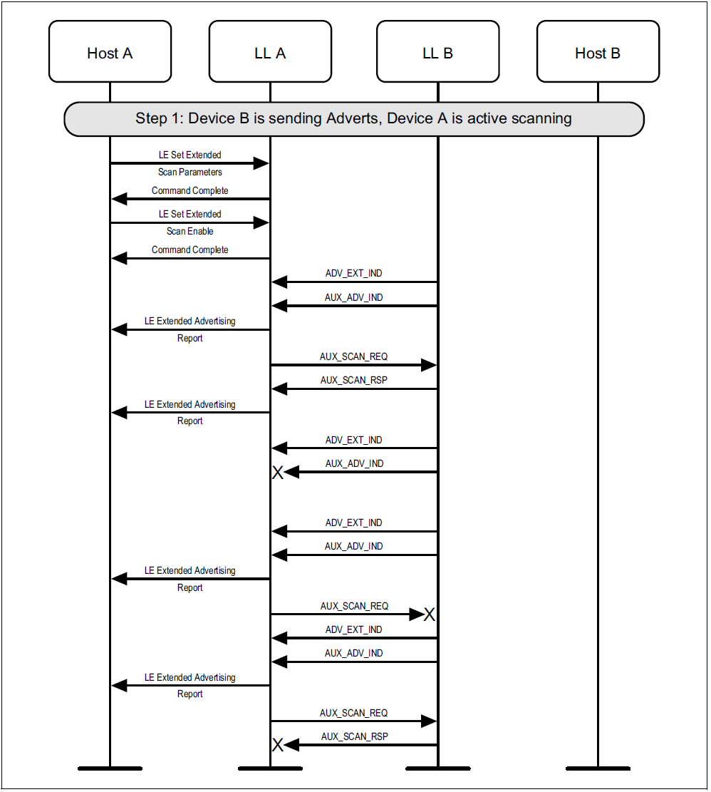

1. **Scanning for periodic advertisements**

When instructed by the Host, the scanner shall look for periodic advertising synchronization information located in the SyncInfo field of AUX_ADV_IND PDUs.

When it has received the complete information it shall start a new state machine that immediately transitions to the Synchronization State; the existing state machine shall remain in the Scanning State.

While in this state, the Link Layer shall listen on the secondary advertising channel for the AUX_SYNC_IND PDUs forming the periodic advertising train specified in the synchronization information.

In the synchronizing sub-state, if the Controller does not receive any of these AUX_SYNC_IND PDUs within 6 periodic advertising events, starting with the first periodic advertising event it listened for, it shall notify the Host and transition to the Standby State.

A device shall not attempt to synchronize to a periodic advertising train with the same address, address type, and Advertising SID as one that it is already synchronized to.

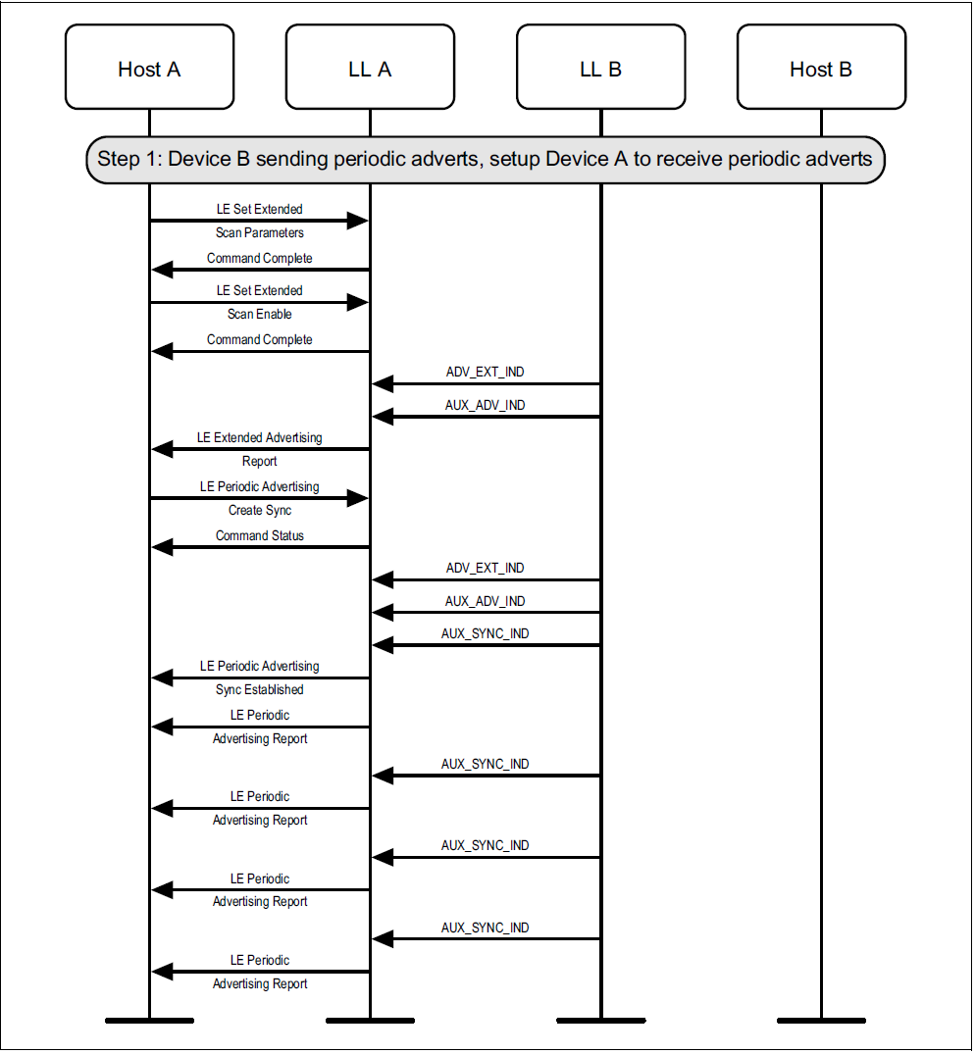

A device may lose synchronization with a periodic advertiser:

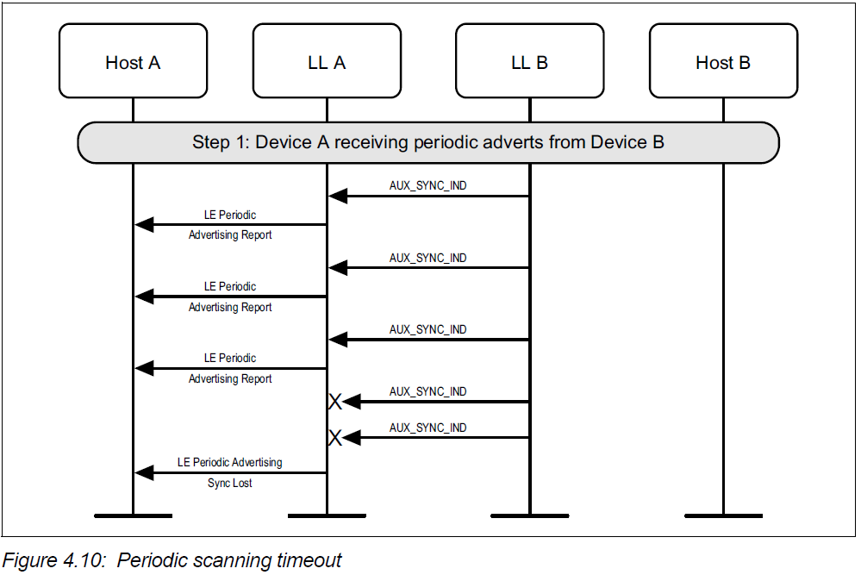

Once synchronized with a periodic advertiser, the Host can terminate the synchronization:

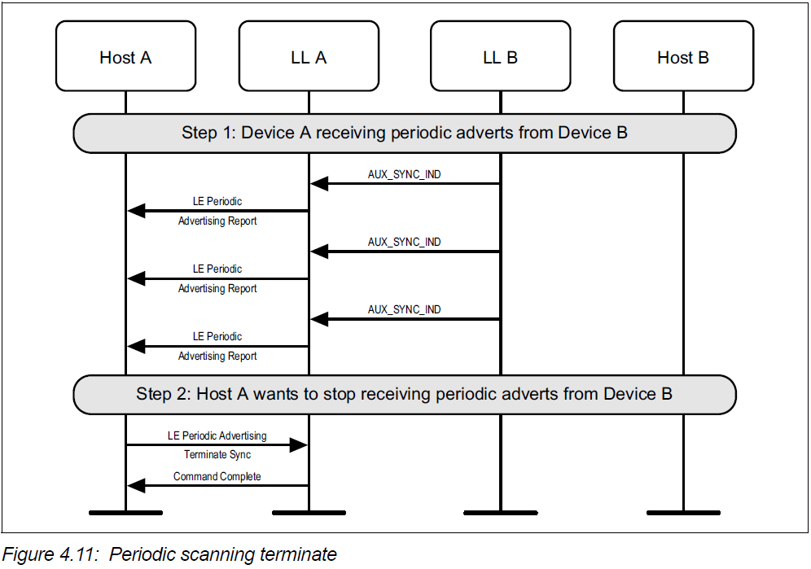

A device may enable or disable reports after establishing synchronization with a periodic advertising train.

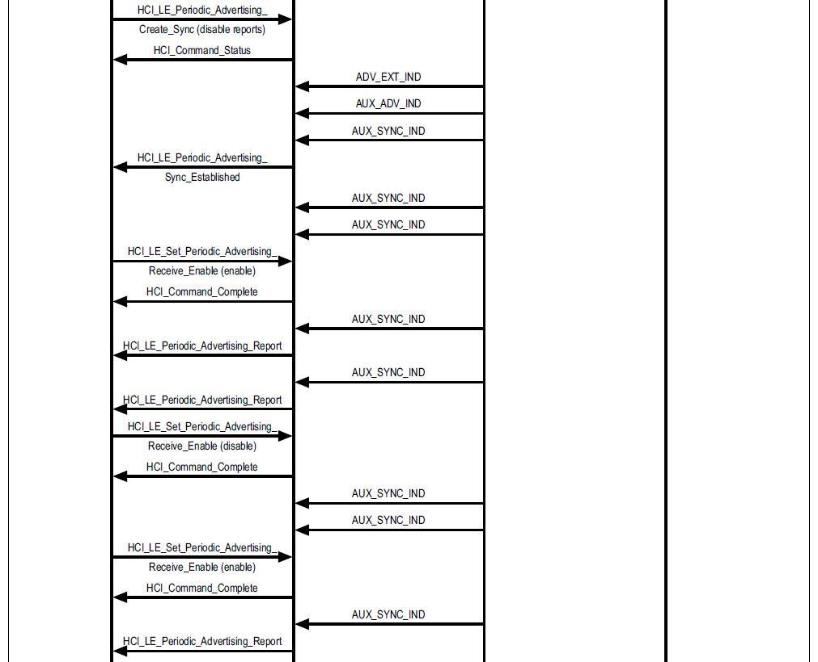

1. SCAN TIMEOUT

A device may scan for a limited duration of time:

