**Bluetooth Logical Link Control and Adaptation Protocol (L2CAP)**

# 1. Introduction

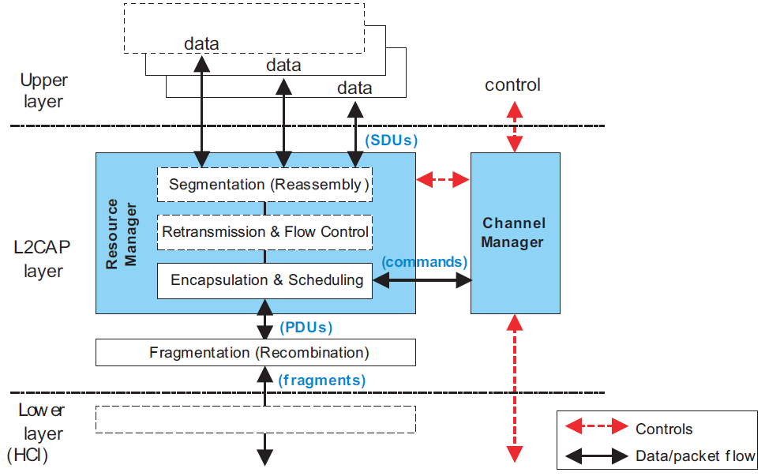

L2CAP provides connection oriented and connectionless data services to upper layer protocols with protocol multiplexing capability and segmentation and reassembly operation.

L2CAP permits higher level protocols and applications to transmit and receive upper layer data packets (L2CAP Service Data Units, SDU) up to 64 kilobytes in length.

L2CAP also permits per-channel flow control and retransmission.

## 1.1 Protocol/channel multiplexing

L2CAP supports multiplexing over individual Controllers and across multiple Controllers. An L2CAP channel shall operate over one Controller at a time.

During channel setup, protocol multiplexing capability is used to route the connection to the correct upper layer protocol.

For data transfer, logical channel multiplexing is needed to distinguish between multiple upper layer entities.

## 1.2 Segmentation and reassembly

Many multiplexed applications are better served if L2CAP has control over the PDU length.

**Benefits:**

(a) Segmentation will allow the interleaving of application data units in order to satisfy latency requirements.

(b) Memory and buffer management is easier when L2CAP controls the packet size.

(c) Error correction by retransmission can be made more efficient.

(d) The application is decoupled from the segmentation required to map the application packets into the lower layer packets.

## 1.3 Flow control per L2CAP channel

When several data streams run over the same Controller using separate L2CAP channels, each channel requires individual flow control.

A window based flow control scheme is provided.

## 1.4 Error control and retransmissions

L2CAP provides error checks and retransmissions of L2CAP PDUs.

The error checking in L2CAP protects against errors due to Controllers falsely accepting packets that contain errors but pass Controller-based integrity checks.

The error control works in conjunction with flow control in the sense that the flow control mechanism will throttle retransmissions as well as first transmissions.

## 1.5 Support for Streaming

Streaming applications such as audio set up an L2CAP channel with an agreed-upon data rate and do not want flow control mechanisms.

Streaming mode is used to stop HCI and Controller based flow control from being applied on the receiving side.

## 1.6 Fragmentation and Recombination

The HCI driver or Controller may fragment L2CAP PDUs to honor packet size constraints of a Host Controller Interface transport scheme. This results in HCI Data packet payloads carrying start and continuation fragments of the L2CAP PDU.

Each layer of the protocol stack may pass on different sized fragments of L2CAP PDUs, and the size of fragments created by a layer may be different in each peer device. However the PDU is fragmented within the stack, the receiving L2CAP entity still recombines the fragments to obtain the original L2CAP PDU.

# 2. General operation

L2CAP is based around the concept of ’channels’. Each one of the endpoints of an L2CAP channel is referred to by a *channel identifier (CID).*

## 2.1 Channel identifier (CID)

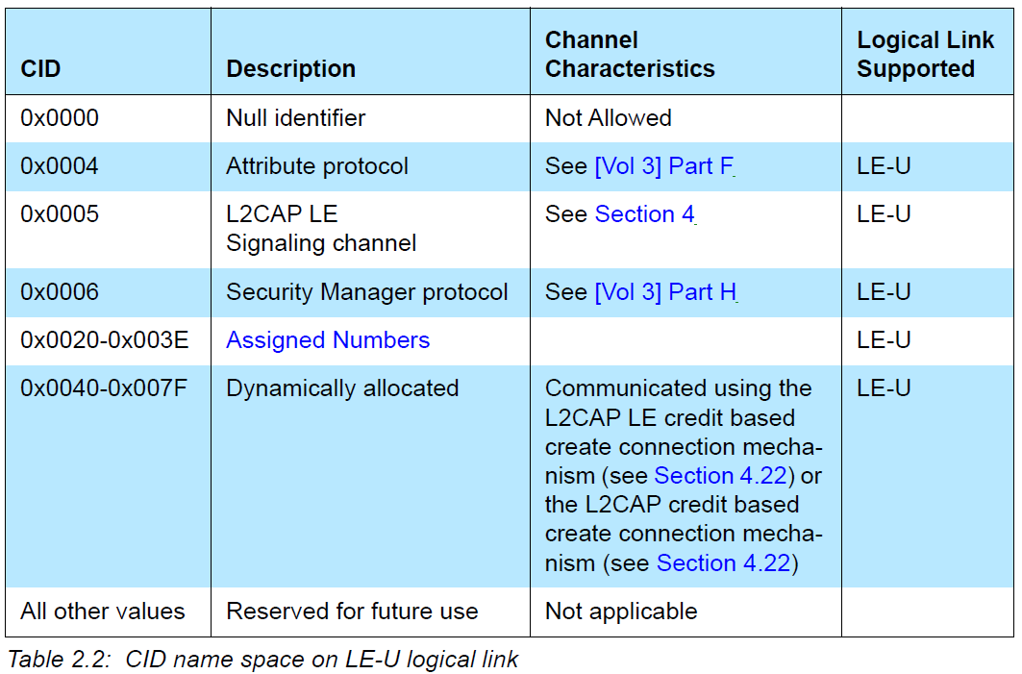

## 2.2 Modes of operation

• Basic L2CAP Mode

• Flow Control Mode

• Retransmission Mode

• Enhanced Retransmission Mode - ACL-U logical links

• Streaming Mode - ACL-U logical links

• LE Credit Based Flow Control Mode

• Enhanced Credit Based Flow Control Mode

Flow Control Mode and Retransmission mode shall only be enabled when communicating with L2CAP entities that do not support Enhanced Retransmission mode, Enhanced Credit Based Flow Control mode, or Streaming mode.

The Basic L2CAP Mode shall be the default mode, which is used when no other mode is agreed.

In Flow Control Mode no retransmissions take place, but missing PDUs are detected and can be reported as lost.

In Retransmission Mode a timer is used to ensure that all PDUs are delivered to the peer, by retransmitting PDUs as needed.

Streaming mode is for real-time isochronous traffic. PDUs are numbered but are not acknowledged. On the receiving side if receive buffers are full when a new PDU is received then a previously received PDU is overwritten by the newly received PDU. Missing PDUs can be detected and reported as lost.

LE Credit Based Flow Control Mode is used for LE L2CAP connection-oriented channels for flow control using a credit based scheme for L2CAP data. (i.e. not signaling packets).

Enhanced Credit Based Flow Control Mode is used for L2CAP connection-oriented channels on both LE and BR/EDR for flow control using a credit-based scheme for L2CAP data (i.e. not signaling packets).

## 2.3 Mapping channels to logical link

L2CAP maps channels to Controller logical links, which in turn run over Controller physical links. All channels going over an LE physical link between two devices shall be treated as best effort and mapped to a single LE-U logical link.

There is one ACL-U logical link per BR/EDR physical link and one LE-U logical link per LE physical link.

When a Guaranteed channel is created, a corresponding guaranteed logical link shall be created to carry the channel traffic.

# 3. Data packet format

All L2CAP layer packet fields shall use little-endian byte order with the exception of the information payload field. The endianness of higher layer protocols encapsulated within L2CAP information payload is protocol-specific.

If a PDU is received on a CID that is not assigned or is reserved for future use on the logical link type, the recipient shall ignore that PDU.

## 3.1 B-frame

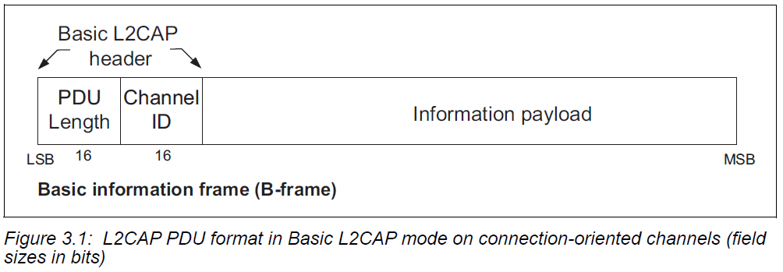

*• PDU Length: 2 octets (16 bits)*

For B-frames, the PDU Length equals the payload size and can be up to 65535 octets.

*• Channel ID: 2 octets*

*• Information payload: 0 to 65535 octets*

contains the payload received from the upper layer protocol (outgoing packet), or delivered to the upper layer protocol (incoming packet).

The payload size shall not be greater than the peer device's MTU for the channel.

## 3.2 G-frame

*• PDU Length: 2 octets*

*• Channel ID: 2 octets*

Channel ID (0x0002) reserved for connectionless traffic. – ACL-U logical links

*• Protocol/Service Multiplexer (PSM): 2 octets (minimum)*

*• Information payload: 0 to 65533 octets*

contains the payload information to be distributed to all Peripherals in the piconet for broadcast connectionless traffic.

## 3.3 I-frame and S-frame

The information frames (I-frames) are used for information transfer between L2CAP entities.

The supervisory frames (S-frames) are used to acknowledge I-frames and request retransmission of I-frames.

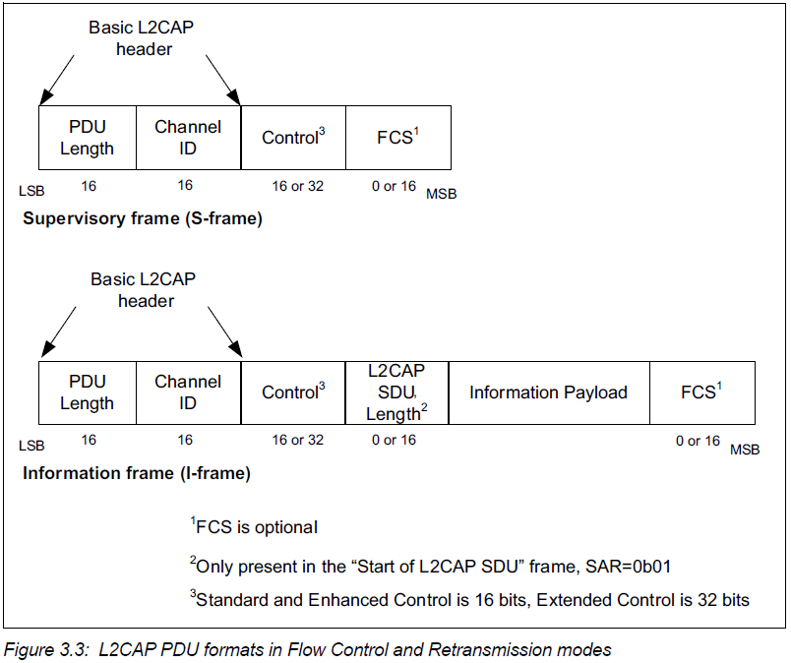

(1) Control field

The Control Field identifies whether the frame is an S-frame or I-frame and contains various information about the frame.

There are three different Control Field formats:

the Standard Control Field;

the Enhanced Control Field;

the Extended Control Field.

The Standard Control Field shall be used for Retransmission mode and Flow Control mode.

The Enhanced and Extended Control Fields shall be used for Enhanced Retransmission mode and

Streaming mode.

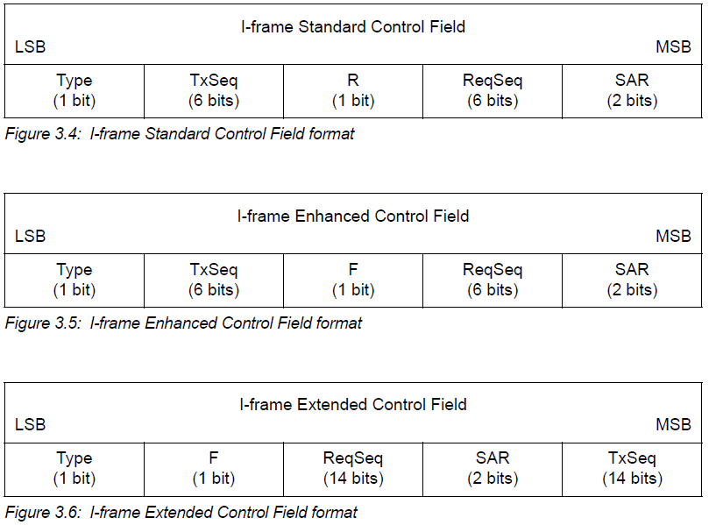

Type bit shall be 0 for an I-frame and 1 for an S-frame.

TxSeq(Send sequence number), ReqSeq(Receive sequence number) which can acknowledge additional I-frames received by the data Link Layer entity.

retransmission bit (R bit) that affects whether I-frames are retransmitted.

F-bit that is used in Poll/Final bit functions.

SAR field is used for segmentation and reassembly control.

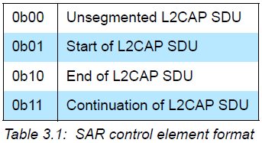

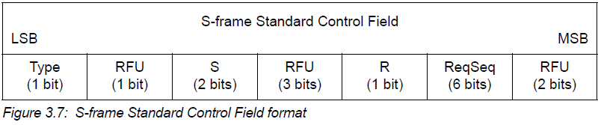

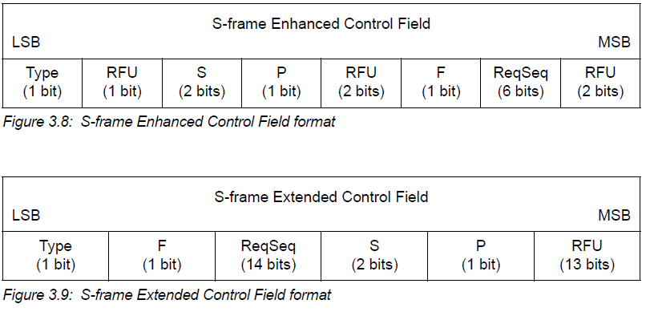

Each S-frame with an Enhanced Control field or an Extended Control Field has a Poll bit (P-bit)

and a Final bit (F-bit) and does not have an R-bit.

The P-bit is set to 1 to solicit a response from the receiver. The receiver shall respond immediately with a frame with the F-bit set to 1.

Supervisory function – S-bits mark the type of S-frame

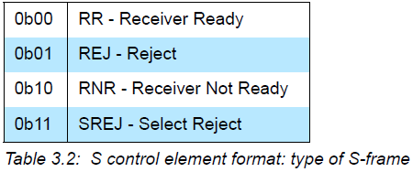

(2) L2CAP SDU Length

The L2CAP SDU Length field shall be present in I-frames with SAR=0b01 (Start of L2CAP SDU) and shall not be used in any other I-frames. When the SDU is unsegmented(SAR=0b00), the L2CAP SDU Length field is not needed and shall not be present.

(3)FCS- Frame Check Sequence

This field is mandatory in Retransmission and Flow Control modes. Whether it is present or absent in Enhanced Retransmission and Streaming modes is configurable.

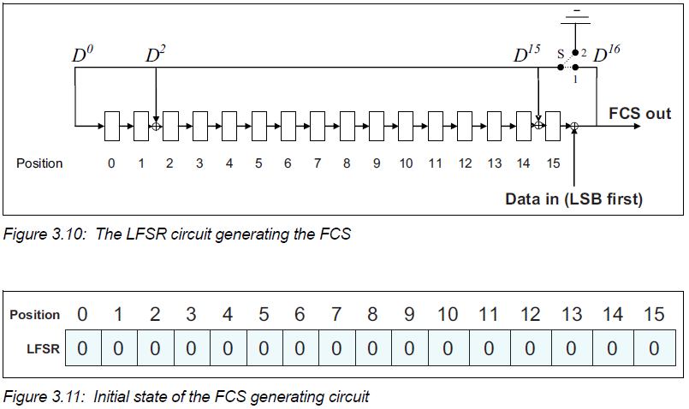

The FCS covers the Basic L2CAP header, Control, L2CAP SDU Length, and Information Payload fields, if present.

(4) Invalid Frame Detection (Retransmission and Flow Control modes)

For Retransmission mode and Flow Control mode, a received PDU shall be regarded as invalid if one of the following conditions occurs:

1. Contains an unknown CID.

2. Contains an FCS error.

3. I-frame with a payload size greater than the maximum PDU payload size (MPS).

4. I-frame that has fewer than 8 octets (i.e., PDU Length less than 4).

5. I-frame with SAR=0b01 (Start of L2CAP SDU) that has fewer than 10 octets (i.e., PDU Length less than 6).

6. I-frame with SAR bits that do not correspond to a normal sequence of either unsegmented or start, continuation, end for the given CID.

7. S-frame where the PDU Length field is not equal to 4.

## 3.4 K-frame

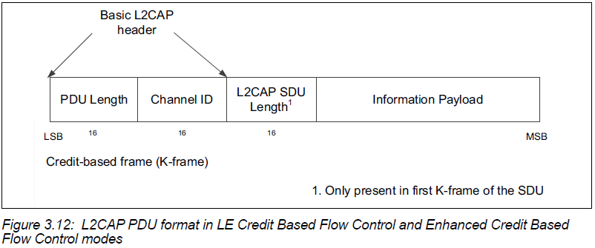

The first K-frame of the SDU shall contain the L2CAP SDU Length field that shall specify the total number of octets in the SDU. All subsequent K-frames that are part of the same SDU shall not contain the L2CAP SDU Length field.

If the SDU length field value exceeds the receiver's MTU, the receiver shall disconnect the channel.

If the payload size of any K-frame exceeds the receiver's MPS, the receiver shall disconnect the channel.

If the sum of the payload sizes for the K-frames exceeds the specified SDU length, the receiver shall disconnect the channel.

## 3.5 signaling packet format(C-frame)

This section describes the signaling commands passed between two L2CAP entities on peer devices. All signaling commands are sent over a signaling channel.

The signaling channel for managing channels over LE-U logical links shall use CID 0x0005.

The signaling channel for managing channels over ACL-U logical links shall use CID 0x0001.

Commands take the form of Requests, Responses, and Indications. _REQ for requests, _RSP for responses, and _IND for indications.

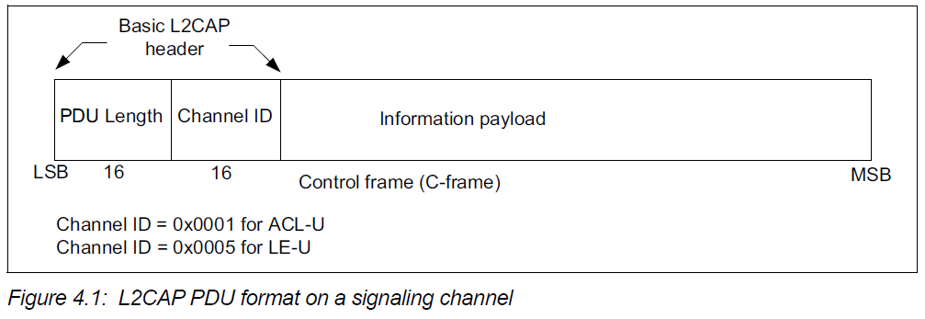

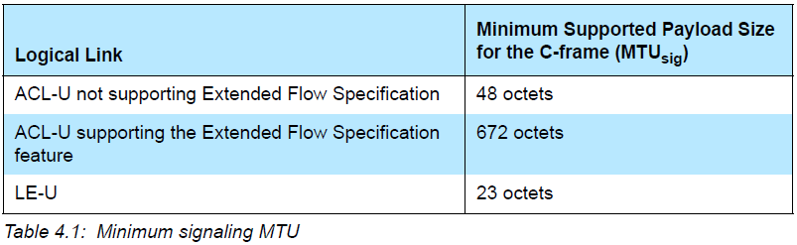

Blow displays the general format of all signaling commands:

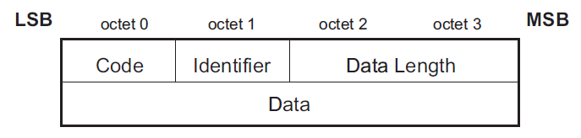

*• Code (1 octet)*

The Code field is one octet long and identifies the type of command.

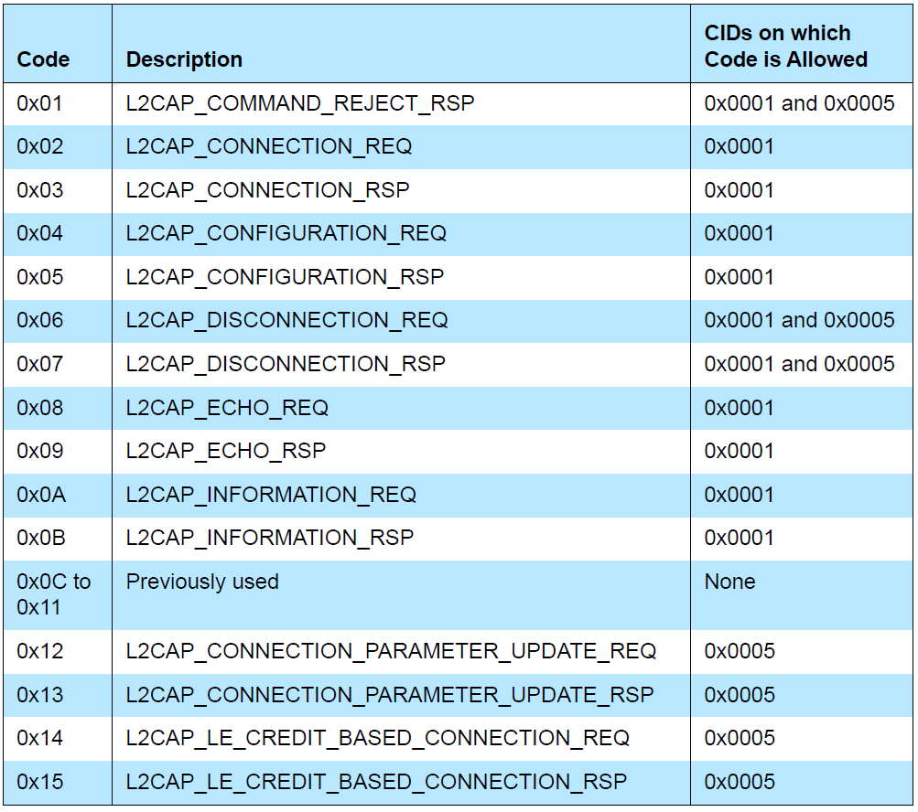

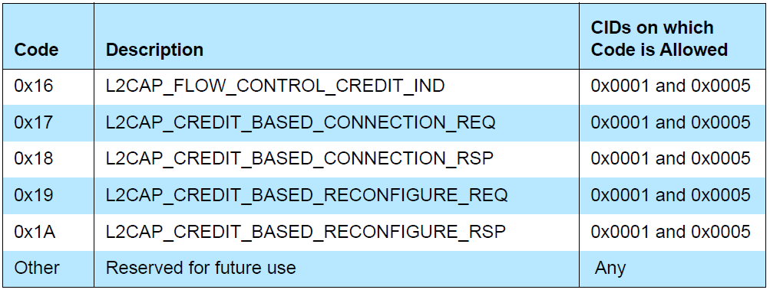

*• Identifier (1 octet)*

The Identifier field is one octet long and matches responses with requests.

The requesting device sets this field and the responding device uses the same value in its response.

The Identifier may be recycled if all other Identifiers have subsequently been used.

Signaling identifier 0x00 is an invalid identifier and shall never be used in any command.

*• Data Length (2 octets)*

*• Data (0 or more octets)*

The Code field determines the format of the Data field.

### 3.5.1 L2CAP_COMMAND_REJECT_RSP (CODE 0x01)

An L2CAP_COMMAND_REJECT_RSP packet shall be sent in response to a command packet with an unknown command code or when sending the corresponding response is inappropriate.

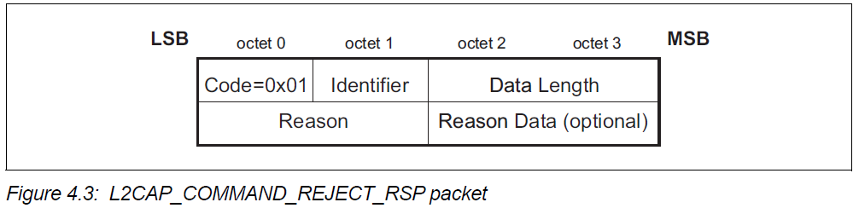

*• Reason (2 octets)*

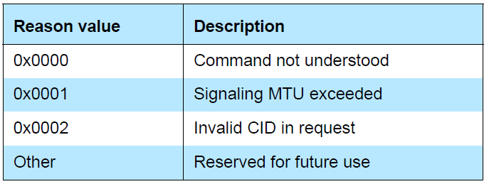

*• Reason Data (0 or more octets)*

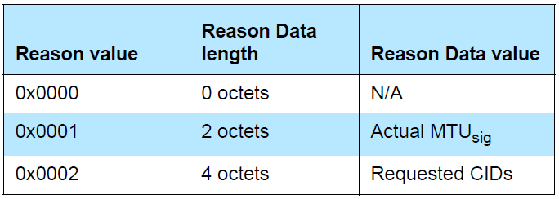

### 3.5.2 L2CAP_DISCONNECTION_REQ (CODE 0x06)

Terminating an L2CAP channel requires that an L2CAP_DISCONNECTION_REQ packet be sent and acknowledged by an L2CAP_DISCONNECTION_RSP packet.

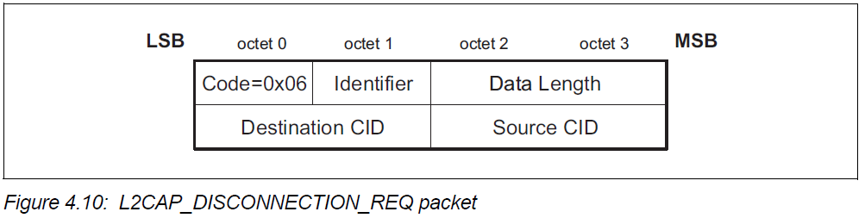

The receiver shall not initiate a disconnection if the source or destination CIDs do not match.

Once an L2CAP_DISCONNECTION_REQ packet is issued, all incoming data in transit on this L2CAP channel shall be discarded and any new additional outgoing data shall be discarded. Once an L2CAP_DISCONNECTION_REQ packet for a channel has been received, all data queued to be sent out on that channel shall be discarded.

### 3.5.3 L2CAP_DISCONNECTION_RSP (CODE 0x07)

L2CAP_DISCONNECTION_RSP packets shall be sent in response to each valid L2CAP_DISCONNECTION_REQ packet.

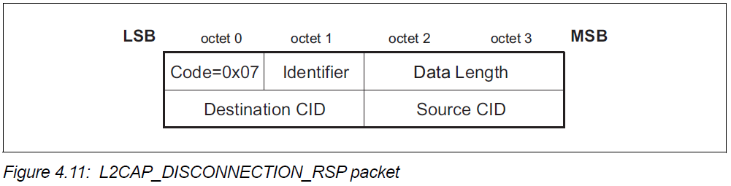

### 3.5.4 L2CAP_LE_CREDIT_BASED_CONNECTION_REQ (CODE 0x14)

L2CAP_LE_CREDIT_BASED_CONNECTION_REQ packets are sent to create and configure an L2CAP channel between two devices using LE Credit Based Flow Control mode.

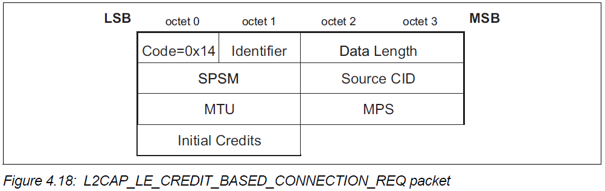

*• Simplified Protocol/Service Multiplexer – SPSM (2 octets)*

SPSM values are separated into two ranges. Values in the first range are assigned by the Bluetooth SIG and indicate protocols. Values in the second range are dynamically allocated and used in conjunction with services defined in the GATT Server.

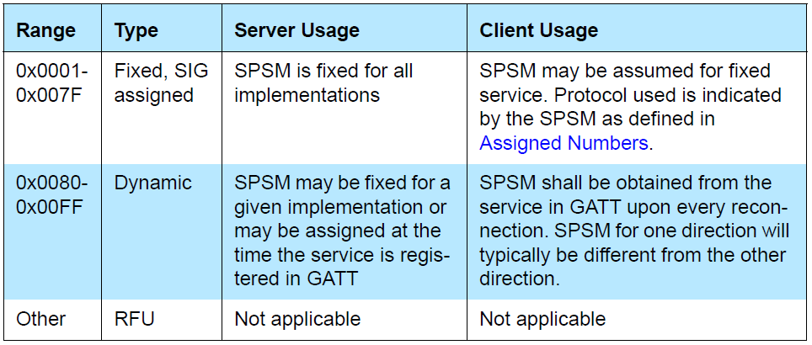

*• Source CID – SCID (2 octets)*

*• Maximum Transmission Unit – MTU (2 octets)*

*• Maximum PDU Payload Size – MPS (2 octets)*

*• Initial Credits – (2 octets)*

The initial credit value indicates the number of K-frames that the peer device can send to the L2CAP layer entity sending the L2CAP_LE_CREDIT_BASED_CONNECTION_REQ packet.

### 3.5.5 L2CAP_LE_CREDIT_BASED_CONNECTION_RSP (CODE 0x15)

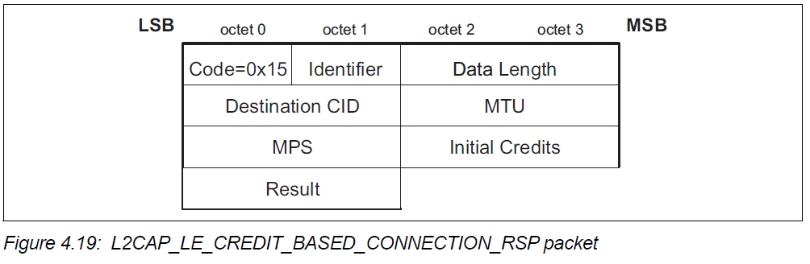

*• Result – (2 octets)*

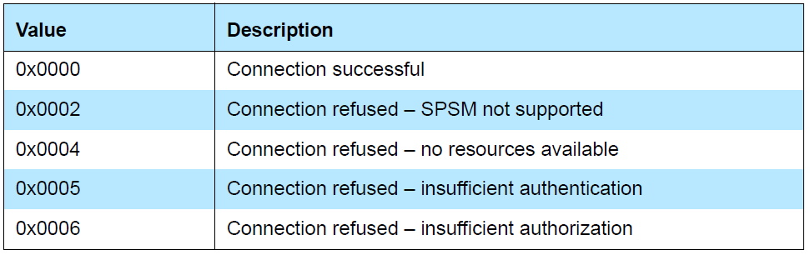

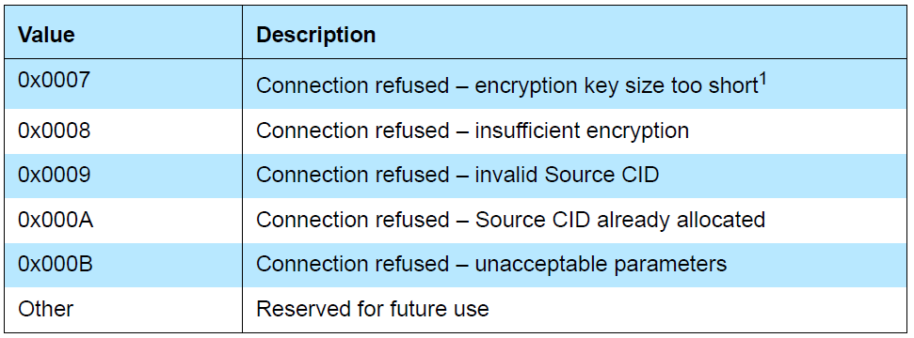

### 3.5.6 L2CAP_CONNECTION_PARAMETER_UPDATE_REQ (CODE 0x12)

This command shall only be sent from the Peripheral to the Central and only if one or more of the Peripheral’s Controller, the Central’s Controller, the Peripheral’s Host and the Central’s Host do not support the Connection Parameters Request Link Layer Control procedure.

If a Peripheral’s Host receives an L2CAP_CONNECTION_PARAMETER_UPDATE_REQ packet it shall respond with an L2CAP_COMMAND_REJECT_RSP packet with reason 0x0000 (Command not understood).

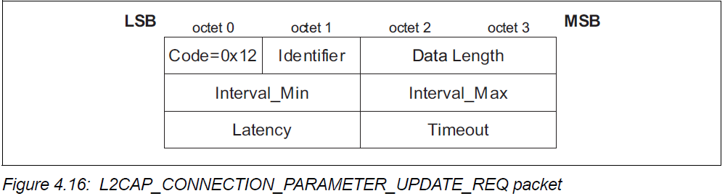

### 3.5.7 L2CAP_CONNECTION_PARAMETER_UPDATE_RSP (CODE 0x13)

This response shall only be sent from the Central to the Peripheral.

The L2CAP_CONNECTION_PARAMETER_UPDATE_RSP packet shall be sent by the Central’s Host when it receives an L2CAP_CONNECTION_PARAMETER_UPDATE_REQ packet. If the Central’s Host accepts the request it shall send the connection parameter update to its Controller.

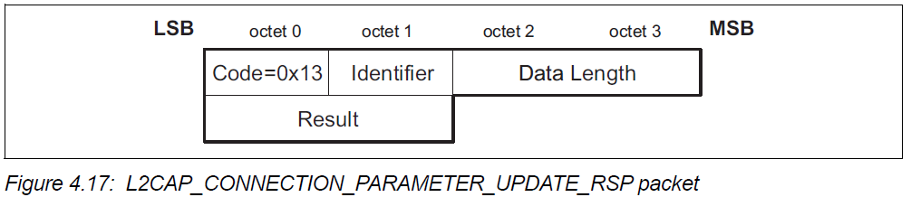

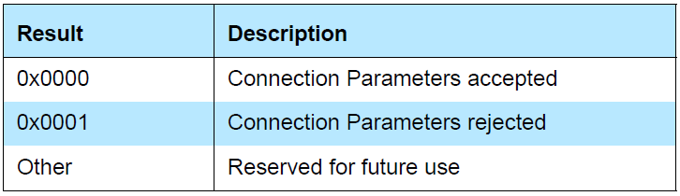

### 3.5.8 L2CAP_FLOW_CONTROL_CREDIT_IND (CODE 0x16)

A device shall send an L2CAP_FLOW_CONTROL_CREDIT_IND packet when it is capable of receiving additional K-frames (for example after it has processed one or more K-frames) in LE Credit Based Flow Control mode and Enhanced Credit Based Flow Control mode.

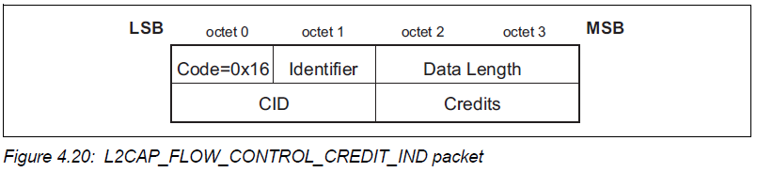

*• Credits – (2 octets)*

The credit value field represents number of credits the receiving device can increment, corresponding to the number of K-frames that can be sent to the peer device sending the L2CAP_FLOW_CONTROL_CREDIT_IND packet.

### 3.5.10 L2CAP_CREDIT_BASED_CONNECTION_REQ (CODE 0x17)

L2CAP_CREDIT_BASED_CONNECTION_REQ packets are sent to create and configure up to five L2CAP channels between two devices.

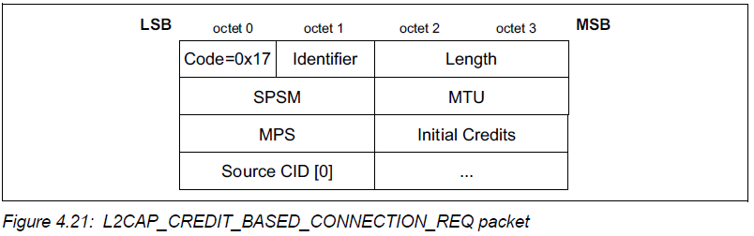

The Source CID is an array of up to 5 two-octet values. *(2 to 10 octets)*

The value of each Source CID shall be from the dynamically allocated range

### 3.5.11 L2CAP_CREDIT_BASED_CONNECTION_RSP (CODE 0x18)

When a device receives an L2CAP_CREDIT_BASED_CONNECTION_REQ packet, it shall send an L2CAP_CREDIT_BASED_CONNECTION_RSP packet.

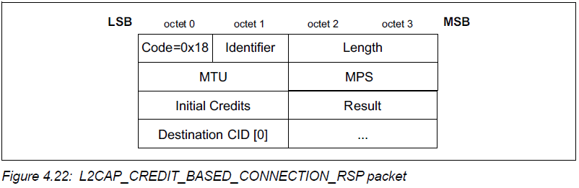

*• Result – (2 octets)*

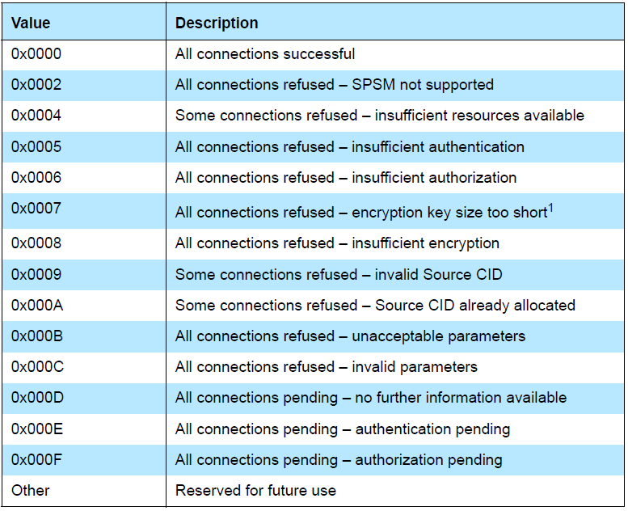

### 3.5.12 L2CAP_CREDIT_BASED_RECONFIGURE_REQ (CODE 0x19)

A device shall send an L2CAP_CREDIT_BASED_RECONFIGURE_REQ packet when its receive MTU or MPS values have changed compared to when the channel was created or last reconfigured.

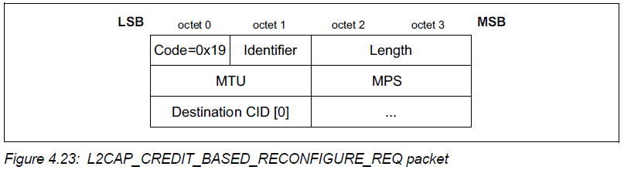

The Destination CID is an array of up to 5 two-octet values.

A device shall send an L2CAP_CREDIT_BASED_RECONFIGURE_REQ packet to the peer device with the new proposed MTU and MPS values and a set of channels to be reconfigured. The request shall not decrease the MTU of any channel and shall not decrease the MPS of a channel if more than one channel is specified.

### 3.5.13 L2CAP_CREDIT_BASED_RECONFIGURE_RSP (CODE 0x1A)

When a device receives an L2CAP_CREDIT_BASED_RECONFIGURE_REQ packet, it shall send an L2CAP_CREDIT_BASED_RECONFIGURE_RSP packet.

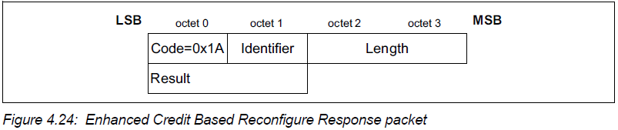

*• Result (2 octets)*

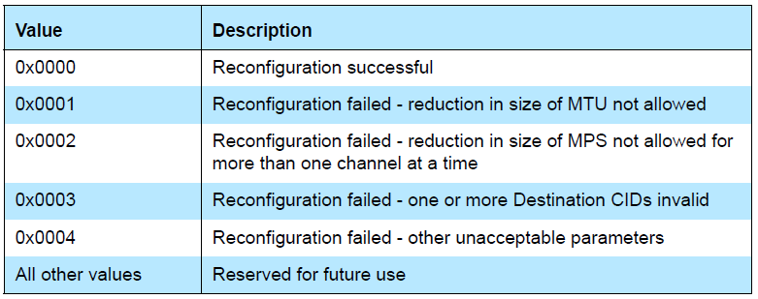

# 4. General procedures

## 4.1 Configuration process

Configuration consists of two processes, the Standard process and the Lockstep process.

The Lockstep process shall be used if both L2CAP entities support the Extended Flow Specification option otherwise the Standard process shall be used.

Each configuration parameter is one-directional. The configuration parameters describe the non default parameters the device sending an L2CAP_CONFIGURATION_REQ packet will accept.

## 4.2 Fragmentation and Recombination

An L2CAP implementation may fragment any L2CAP PDU for delivery to the lower layers.

If L2CAP runs above the HCI, then an implementation may send HCI transport sized fragments to the Controller.

As the Controller receives packet fragments, it either signals the L2CAP layer on the arrival of each fragment, or accumulates a number of fragments (before the receive buffer fills up or a timer expires) before passing packets to the L2CAP layer.

An L2CAP implementation shall use the PDU Length field in the header of L2CAP PDUs, as a consistency check and shall discard any L2CAP PDUs that fail to match the PDU Length field.

## 4.3 Encapsulation of SDUs

All SDUs are encapsulated into one or more L2CAP PDUs.

In Basic L2CAP mode, an SDU shall be encapsulated with a minimum of L2CAP protocol elements. (B-frame).

Segmentation and Reassembly operations are only used in Enhanced Retransmission mode, Streaming mode, Retransmission mode, and Flow Control mode.

SDUs may be segmented into a number of smaller packets called SDU segments. Each segment shall be encapsulated with L2CAP protocol elements resulting in an L2CAP PDU called an Information Frame (I-frame).

I-frames are subject to flow control and may be subject to retransmission procedures. The header carries a 2 bit SAR field that is used to identify whether the I-frame is a 'start', 'end' or 'continuation' packet or whether it carries a complete, un-segmented SDU.

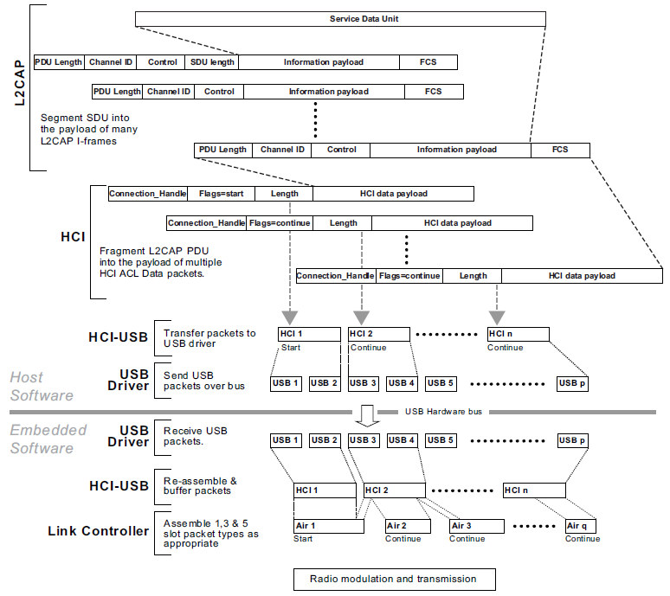

## 4.4 Flow Control and Retransmission

Retransmission mode and Enhanced Retransmission mode also allow the sender to resend frames with errors on request from the receiver.

Two frame formats are defined for Flow Control and Retransmission. I-frame is used to transport user information instead of the B-frame. The S-frame is used for supervision.

I-frames are sequentially numbered frames containing information fields.

The S-frame is used to control the transmission of I-frames. For Retransmission mode and Flow Control mode, the S-frame has two formats:

Receiver Ready (RR) and Reject (REJ).

The receiver ready (RR) S-frame is used to:

(1) Acknowledge I-frames numbered up to and including ReqSeq – 1;

(2) Enable or disable retransmission of I-frames by updating the receiver with

the current status of the Retransmission Disable Bit.

The reject (REJ) S-frame is used to request retransmission of all I-frames starting with the I-frame with TxSeq equal to ReqSeq specified in the REJ.

If there are any I-frames which have been sent and not acknowledged then they shall be retransmitted when the Retransmission Timer elapses. If the retransmission timer has not elapsed then a retransmission shall not be sent and only new I-frames may be sent.

The flow control operation is similar to the procedures in retransmission mode, but all operations dealing with CRC errors in received packets are not used. Therefore

(1) REJ frames shall not be used in Flow Control Mode;

(2) The RetransmissionDisableBit shall always be set to zero in the transmitter, and shall be ignored in the receiver.

Enhanced Retransmission mode operates as an HDLC balanced data link operational mode.

Enhanced Retransmission mode uses I-frames to transfer upper layer information and S-frames for supervision. All frames formats in Enhanced Retransmission mode shall use the **Enhanced Control Field**

Four S-frames defined:

Receiver Ready (RR), Reject (REJ), Receiver Not Ready (RNR), and Selective Reject (SREJ).

The RNR frame shall be used by an L2CAP entity to indicate a busy condition.

The SREJ frame shall be used by an L2CAP entity to request retransmission of one I-frame.

## 4.5 Credit-based flow control

There are two credit-based flow control modes: LE Credit Based Flow Control Mode and Enhanced Credit Based Flow Control Mode.

(1) LE Credit Based Flow Control Mode

used for LE L2CAP connection-oriented channels with flow control using a credit based scheme for L2CAP data.

The number of credits (K-frames) that can be received by a device on an L2CAP channel is determined during connection establishment. For each K-frame sent the device decreases the credit count for that L2CAP channel by one. The peer device may return credits for an L2CAP channel at any time by sending an L2CAP_FLOW_CONTROL_CREDIT_IND packet.

The device receiving the credit packet shall disconnect the L2CAP channel if the credit count exceeds 65535. The device shall also disconnect the L2CAP channel if it receives a K-frame on an L2CAP channel from the peer device that has a credit count of zero.

If an L2CAP_LE_CREDIT_BASED_CONNECTION_REQ packet is received and there is insufficient authentication between the two devices, the connection shall be rejected with a result value of “Connection refused – insufficient authentication”.

If an L2CAP_LE_CREDIT_BASED_CONNECTION_REQ packet is received and there is insufficient authorization between the two devices, the connection shall be rejected with a result value of “Connection refused - insufficient authorization”.

If an L2CAP_LE_CREDIT_BASED_CONNECTION_REQ packet is received and the encryption key size is too short, the connection shall be rejected with a result value of “Connection refused – insufficient encryption key size”.

(2) Enhanced Credit Based Flow Control Mode

used for L2CAP connection oriented channels on LE and BR/EDR with flow control using a credit-based scheme for L2CAP data.

This paragraph applies if an L2CAP_CREDIT_BASED_CONNECTION_REQ packet is received on the LE transport.

The credit count and authentication are similar to the Credit Based Flow Control Mode.