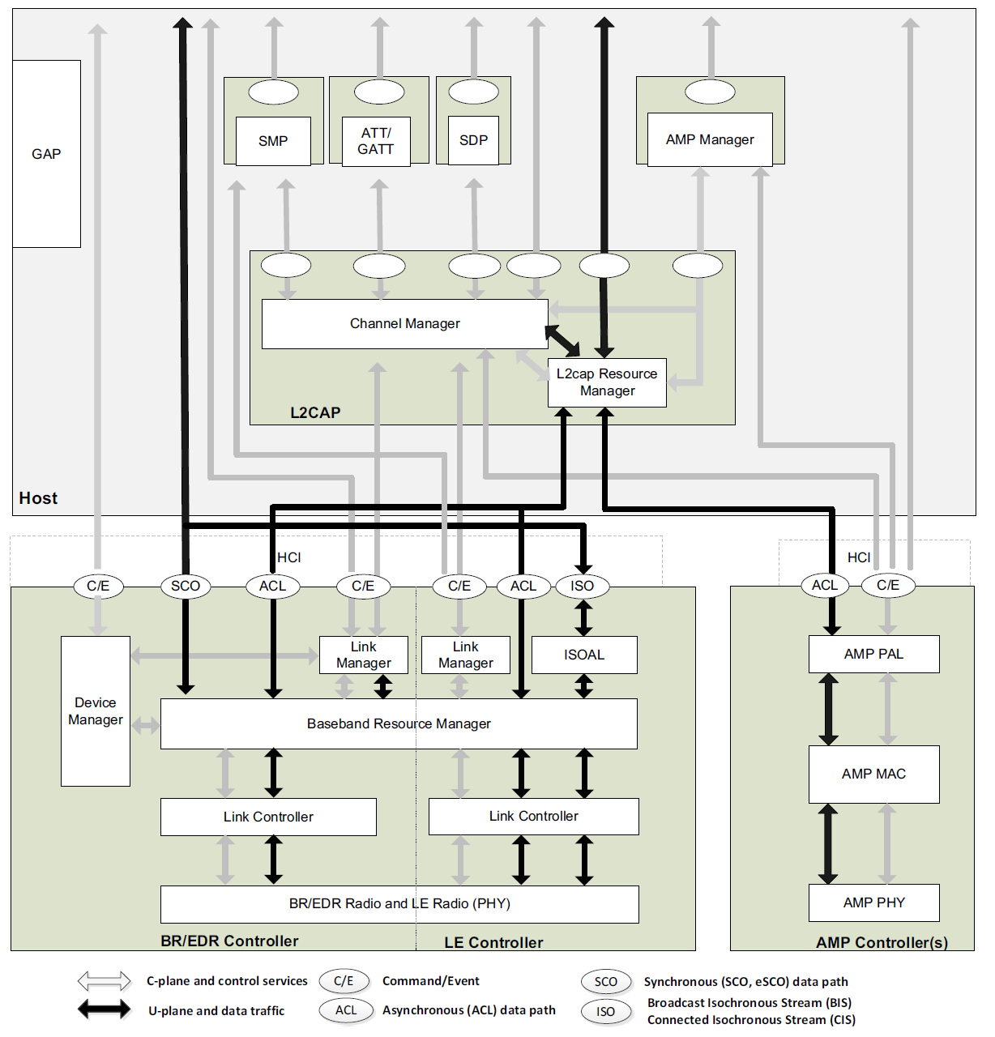

1. **Hardware Implement**

* UART transport
* USB transport
* Secure Digital (SD) transport
* Three-wire UART transport
  1. UART transport

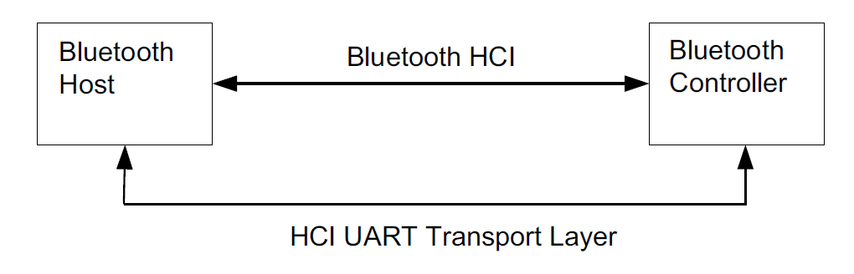

There are five kinds of HCI packets that can be sent via the UART Transport Layer; i.e. HCI Command packet, HCI Event packet, HCI ACL Data packet, HCI Synchronous Data packet, and HCI ISO Data packet.

HCI does not provide the ability to differentiate the four HCI packet types. Therefore, if the HCI packets are sent via a common physical interface, an HCI packet indicator has to be added as below:

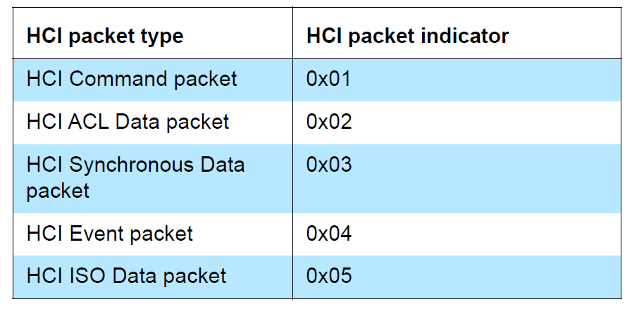

The HCI packet indicator shall be sent immediately before the HCI packet. All four kinds of HCI packets have a length field, which is used to determine how many bytes are expected for the HCI packet. When an entire HCI packet has been received, the next HCI packet indicator is expected for the next HCI packet.

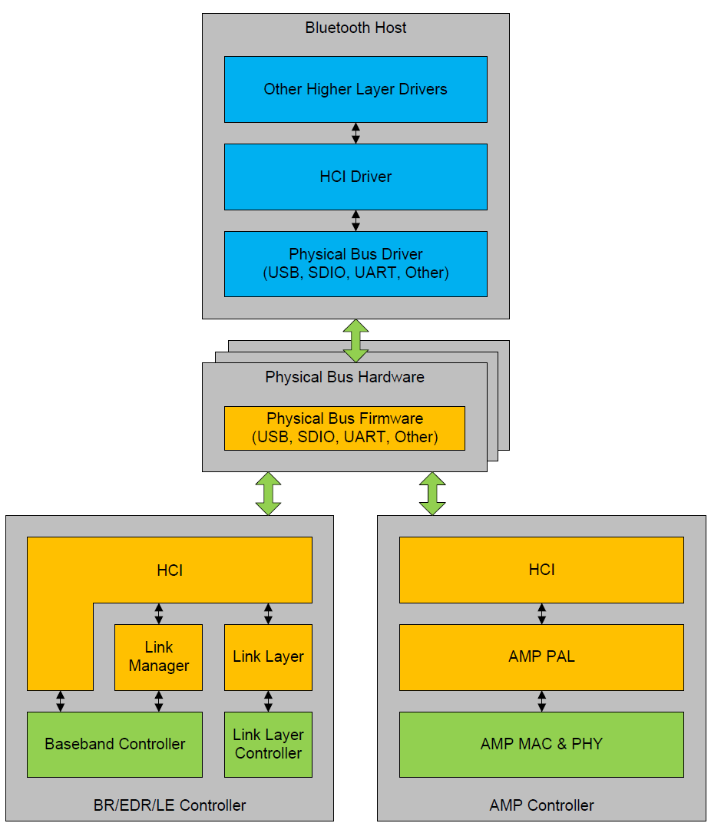

1. **Data formats**
   1. HCI Command packet

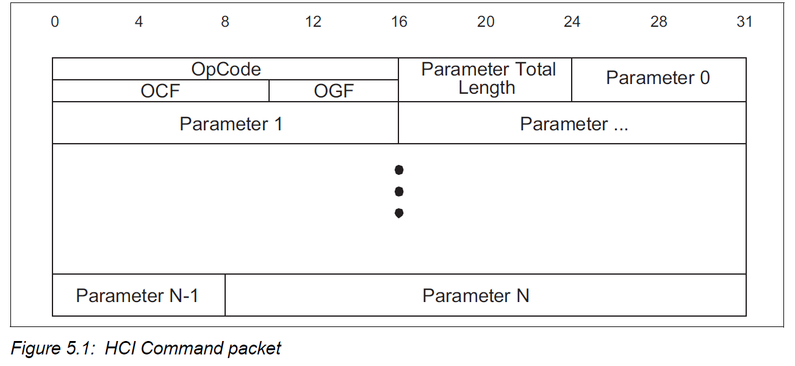

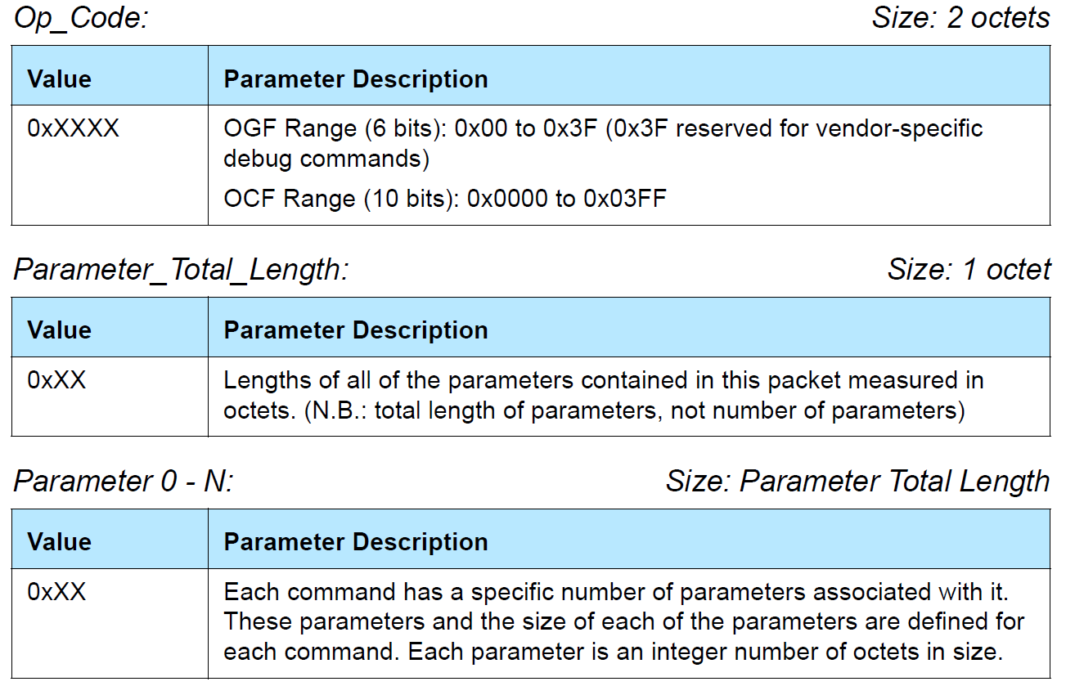

* 1. HCI Event packet

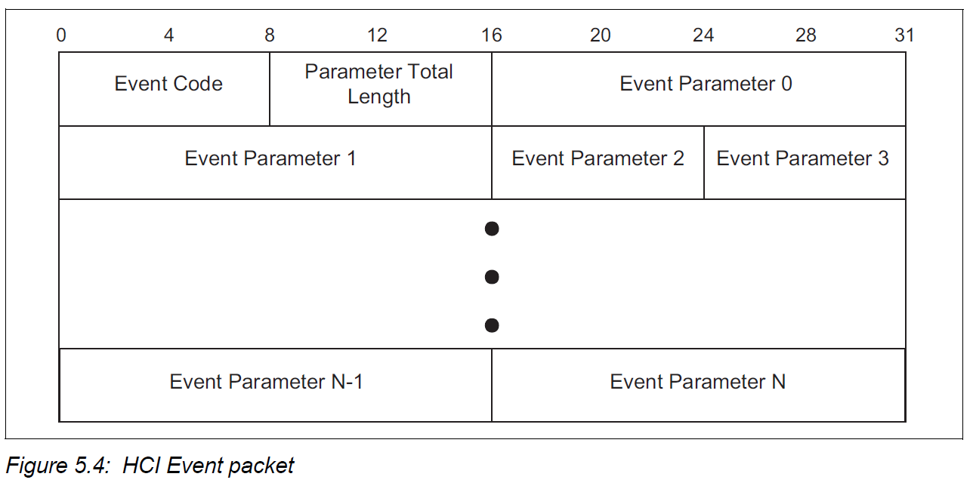

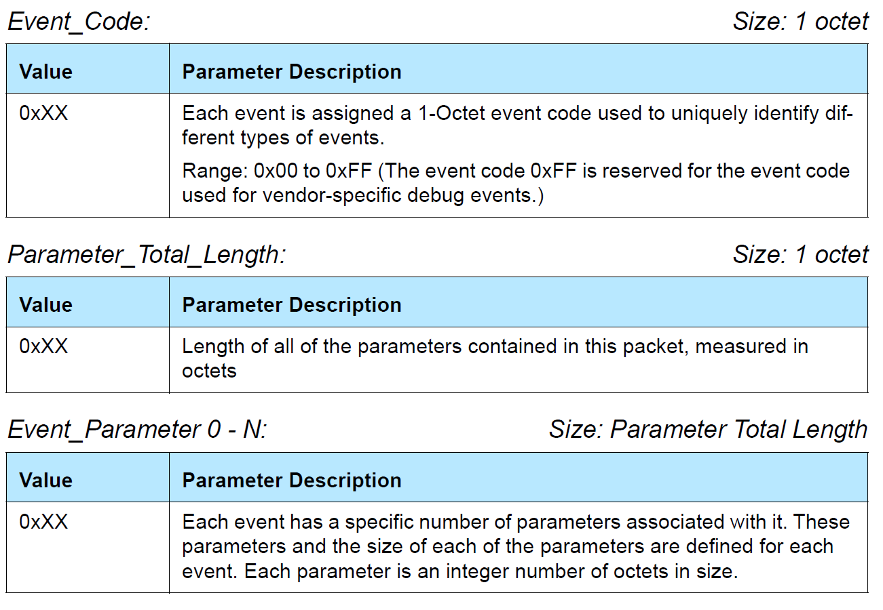

The LE Meta event is used to encapsulate all LE Controller specific events. The Event Code of all LE Meta events shall be 0x3E. The Subevent_Code is the first octet of the event parameters. The Subevent_Code shall be set to one of the valid Subevent_Codes from an LE specific event.

* 1. HCI ACL Data packets

There are two types of HCI ACL Data packets:

* Automatically-Flushable
* Non-Automatically-Flushable

Automatically-Flushable HCI Data packets are flushed based on the setting of an automatic flush timer (see Read Automatic Flush Timeout command). Non-Automatically-Flushable HCI Data packets are not controlled by the automatic flush timeout and shall not be automatically flushed.

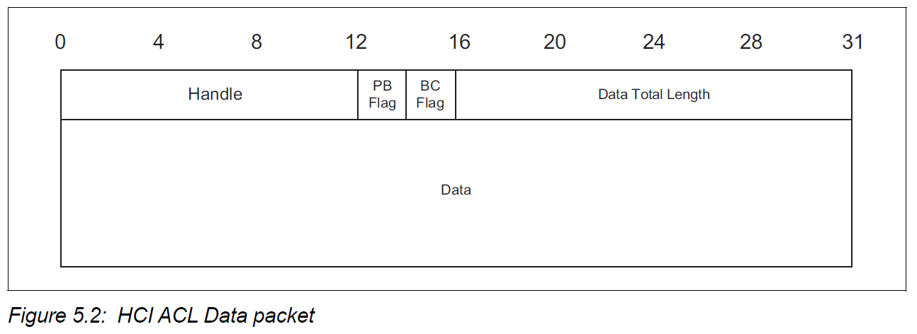

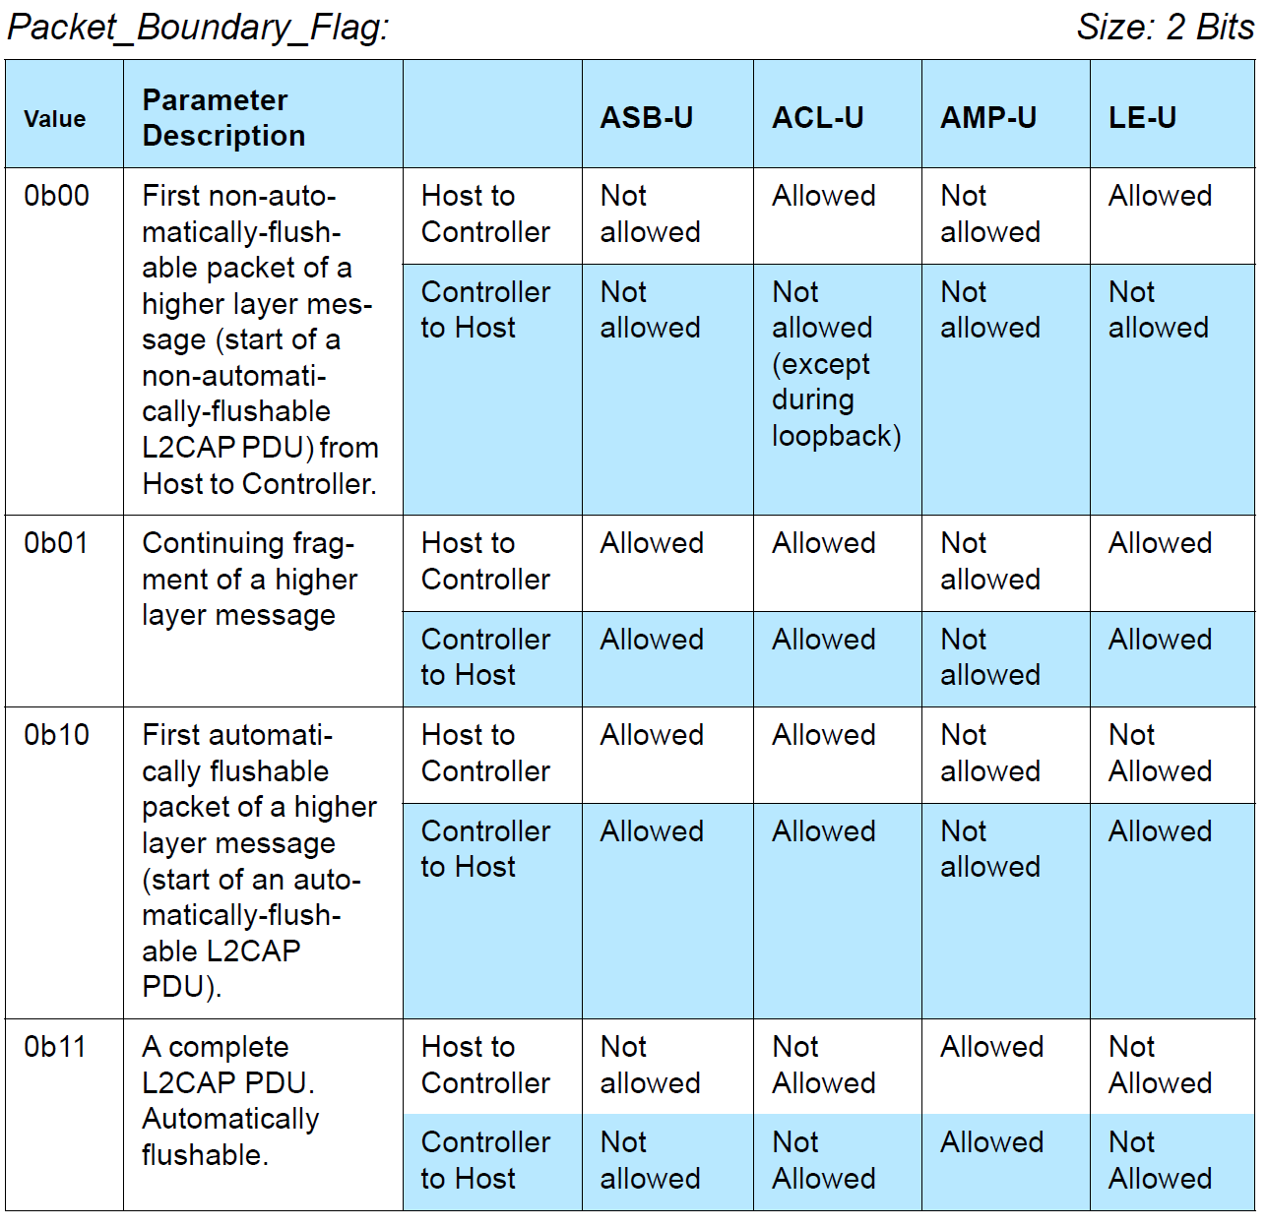

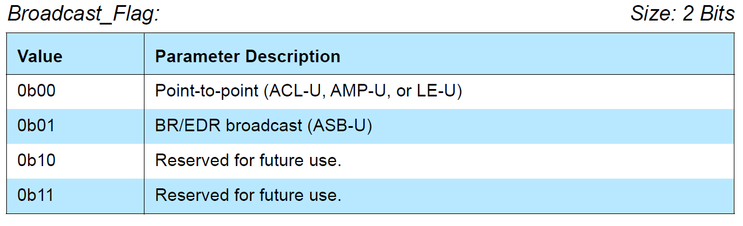

* 1. HCI ISO Data packets (TBD)

1. **Example**

Undirected advertising

