Bluetooth Low Energy has two ways of communicating. The first one is using advertisements, where a BLE peripheral device broadcasts packets to every device around it. The receiving devices can then act on this information or connect to receive more information. The second way to communicate is to receive packets using a connection, where both the peripheral and central send packets.

Advertising is by design unidirectional.

**1. Advertising channel**

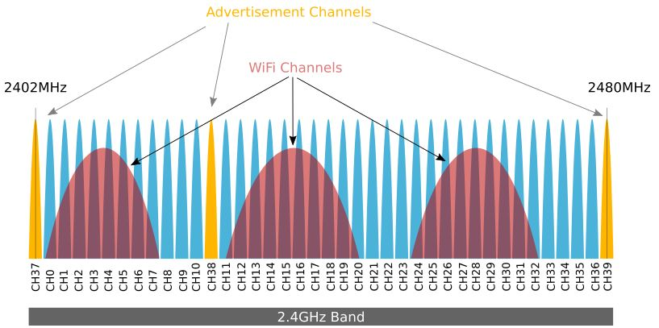

Channels 37, 38, and 39 are used only for sending advertisement packets. The rest are used for data exchange during a connection.

During BLE advertisement, a BLE Peripheral device transmits the same packet on the 3 advertising channels, one after the other.

**2. Advertising interval**

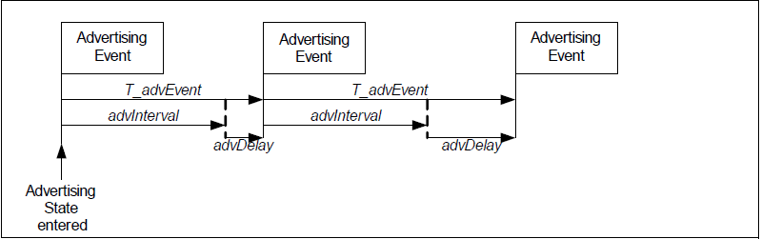

The advertising interval (advInterval) shall be an integer multiple of 0.625 ms in the range 20 ms to 10,485.759375 s.

The advDelay is a pseudo-random value with a range 0 ms to 10 ms generated by the Link Layer for each advertising event.

This randomness helps reduce the possibility of collisions between advertisements of different devices (if they fell in the same rate, they could interfere more easily).

Despite the wide range of advertising interval, most products use the following as a guideline:

* Less than 100ms - for very aggressive connections and usually for short periods of time
* 100ms to 500ms - normal fast advertising for most devices
* 1000ms to 2000ms for devices that connect to gateways and where latency is not critical

**3. Advertising Packets**

The Bluetooth Specification defines the top level packet in Bluetooth LE with two data units. The packet itself has several parts including a preamble and access address, as well as a CRC.

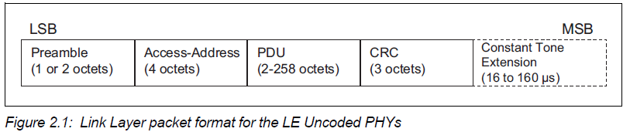

The Packet data unit for the advertising channel (called the Advertising Channel PDU) includes a 2-byte header and a variable payload from 1 to 255 bytes.

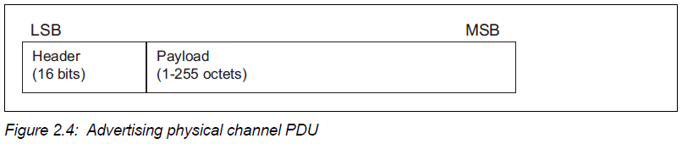

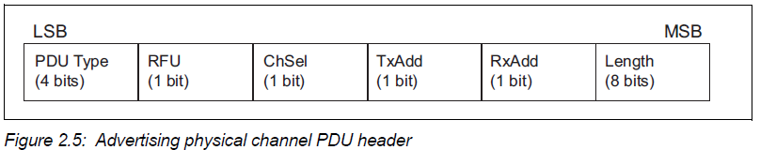

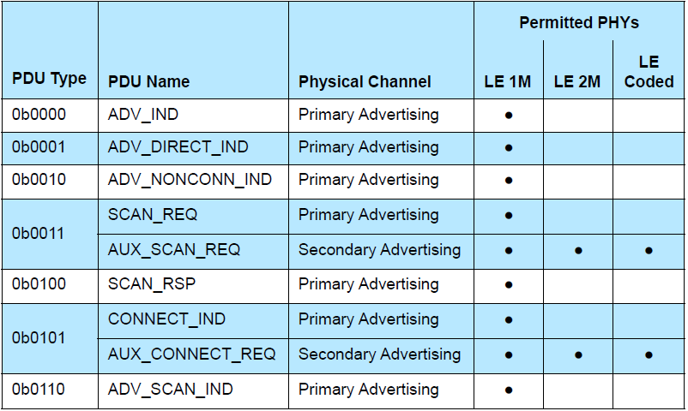

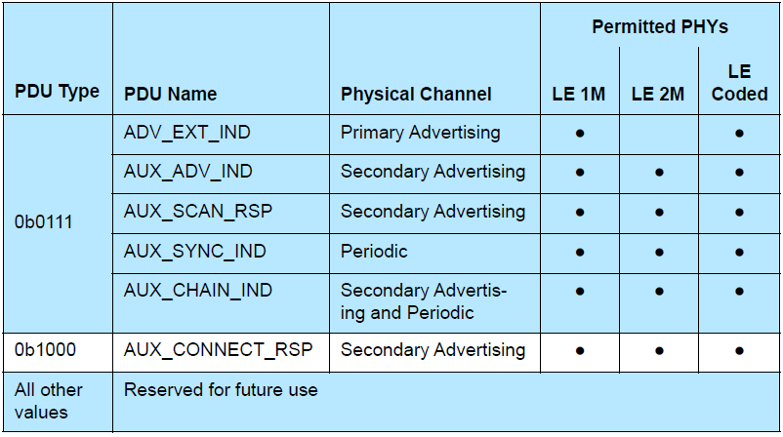

The ChSel, TxAdd and RxAdd fields contain information specific to the PDU type defined for each advertising physical channel PDU separately.

The Length field of the advertising physical channel PDU header indicates the length of the payload in octets. The valid range of the Length field shall be 1 to 255 octets.

Bluetooth 5 also enables an advertising packet to hold up to 255 bytes of data, which is a lot larger than the 37 packets that was possible in Bluetooth 4.0 up to Bluetooth 4.2. This makes it possible to get data without connections, which saves on power consumption and allows many devices to obtain the data.

Payload fields:

The Payload fields in the advertising physical channel PDUs are specific to the PDU Type.

The following advertising physical channel PDU Types are called advertising PDUs:

• ADV_IND

• ADV_DIRECT_IND

• ADV_NONCONN_IND

• ADV_SCAN_IND

• ADV_EXT_IND

• AUX_ADV_IND

• AUX_SYNC_IND

• AUX_CHAIN_IND

1. ADV_IND

The PDU shall be used in connectable and scannable undirected advertising events.

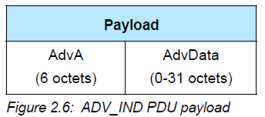

The AdvA field shall contain the advertiser’s public or random device address

The AdvData field, if not empty, shall contain Advertising Data from the advertiser’s Host.

1. ADV_DIRECT_IND

The PDU shall be used in connectable directed advertising events.

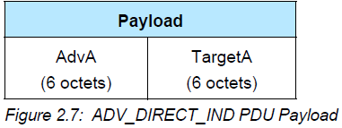

The AdvA field shall contain the advertiser’s public or random device address.

The TargetA field is the address of the device to which this PDU is addressed.

Note: This packet does not contain any Host data.

1. ADV_NONCONN_IND

The PDU shall be used in non-connectable and non-scannable undirected advertising events.

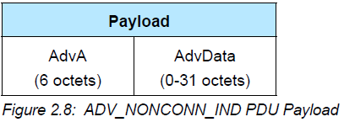

The AdvA field shall contain the advertiser’s public or random device address.

The AdvData field, if not empty, shall contain Advertising Data from the advertiser’s Host.

1. ADV_SCAN_IND

The PDU shall be used in scannable undirected advertising events.

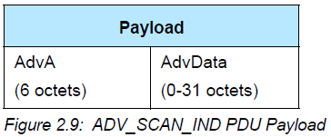

The AdvA field shall contain the advertiser’s public or random device address.

The AdvData field, if not empty, shall contain Advertising Data from the advertiser’s Host.

1. ADV_EXT_IND

The ADV_EXT_IND PDU uses the Common Extended Advertising Payload Format.

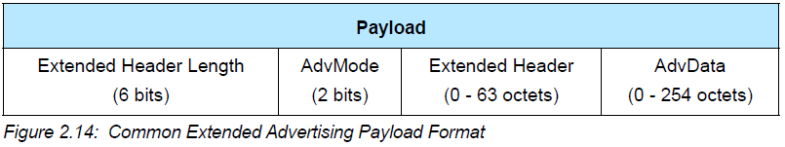

The Extended Header Length is a value between 0 and 63 and indicates the size of the variable length Extended Header field.

The AdvMode field indicates the mode of the advertisement.

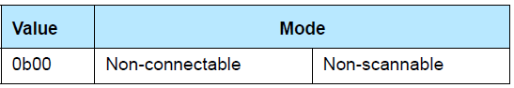

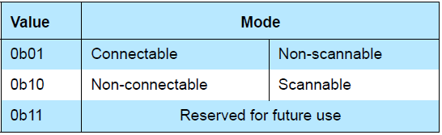

The maximum size of AdvData depends on the size of the Extended Header

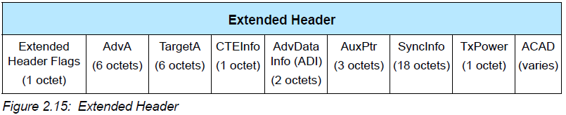

If a flag bit is set to 1, the corresponding Extended Header field is present; otherwise, the corresponding Extended Header field is not present.

***AdvDataInfo field***

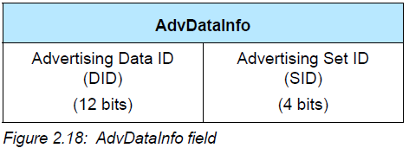

The Advertising Set ID (SID) is set by the advertiser to distinguish between different advertising sets transmitted by this device.

The Advertising Data ID (DID) is set by the advertiser to indicate to the scanner whether it can assume that the data contents in the AdvData are a duplicate of the previous AdvData sent in an earlier packet.

***AuxPtr field***

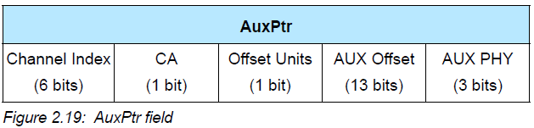

The AuxPtr field is three octets

The presence of the AuxPtr field indicates that some or all of the advertisement data is in a subsequent auxiliary packet.

The Channel Index field contains the general-purpose channel index used to transmit the auxiliary packet.

The Offset Units field indicates the units used by the Aux Offset Field. (30 μs or 300 μs)

The Aux Offset field contains the time from the start of the packet containing the AuxPtr field to the approximate start of the auxiliary packet.

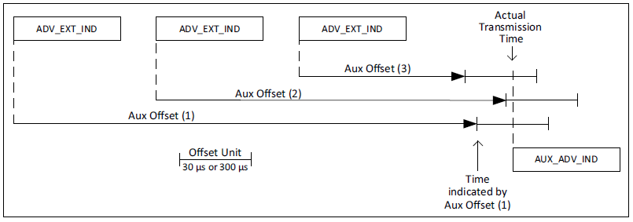

The auxiliary packet shall not start any earlier than the Aux Offset and shall start no later than the Aux Offset plus one Offset Unit. This allows the LL to round the Aux Offset to the Offset Unit.

The Aux PHY field indicates the PHY used to transmit the auxiliary packet.

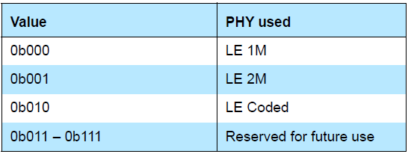

The CA field contains the clock accuracy of the advertiser that will be used between the packet containing this data and the auxiliary packet.

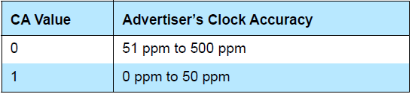

An AuxPtr field with an Aux Offset of zero is permitted and indicates that no auxiliary packet will be transmitted but the Host advertising data in the current PDU is incomplete.

***SyncInfo field***

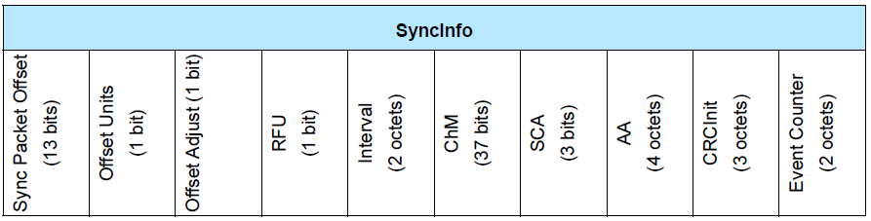

The SyncInfo field is 18 octets.

The contents of the SyncInfo field describe this periodic advertising train.

The Offset Units field indicates the units used by the Sync Packet Offset field. (30us or 300us)

The Sync Packet Offset field contains the time from a reference point to the start of the AUX_SYNC_IND packet that this SyncInfo field describes.

the reference point shall be no later than the Sync Packet Offset and no earlier than the Sync Packet Offset plus one Offset unit prior to the start of the AUX_SYNC_IND.

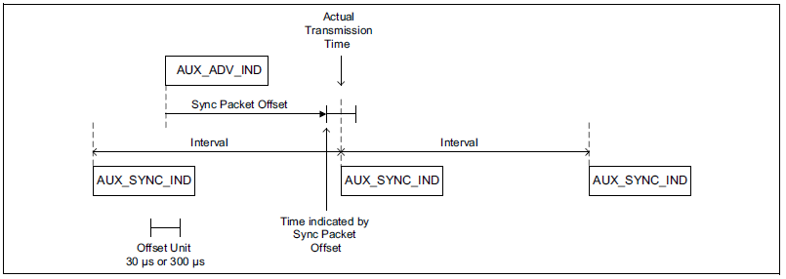

A value of 0 for the Sync Packet Offset indicates that the time to the next AUX_SYNC_IND packet is greater than can be represented.

if the Offset Adjust field is set to 1, adding 2.4576 seconds. The Offset Adjust field shall be set to 0 if the Offset Units field is set to 0 or if the SyncInfo field appears within an advertising PDU.

The Interval field contains the time in 1.25 ms units from the start of one packet of the periodic advertising train to the start of the next packet.

The ChM field contains the channel map indicating Used and Unused PHY channels on the periodic physical channel. A bit value of 0 indicates that the channel is Unused. A bit value of 1 indicates that the channel is Used.

The AA, CRCInit, and SCA fields have the same meaning as the corresponding fields in the CONNECT_IND PDU.

The Event Counter field: The initial value of this counter is implementation specific. The counter shall be incremented by one for each Periodic Advertising Interval.

***ACAD field***

Additional Controller Advertising Data (ACAD) field

The ACAD field, if present, shall hold data from the advertiser’s Controller or intended to be used by the recipient’s Controller.

***Host Advertising Data***

The Controller may support fragmentation of Host Advertising Data. The total amount of Host Advertising Data before fragmentation shall not exceed 1650 octets.

1. AUX_ADV_IND

The AUX_ADV_IND PDU uses the Common Extended Advertising Payload Format.

Any auxiliary packet shall be an AUX_ADV_IND packet with the same AdvMode as the ADV_EXT_IND packet.

The PHY used for the AUX_ADV_IND shall be specified in the AuxPtr field of the superior PDU.

The SyncInfo field, when present, shall point to an AUX_SYNC_IND PDU.

Any auxiliary PDU shall be an AUX_CHAIN_IND PDU.

1. AUX_SYNC_IND

The AUX_SYNC_IND PDU uses the Common Extended Advertising Payload Format.

The PDU is used in periodic advertising.

The AdvMode field shall be set to 0b00.

Any auxiliary PDU shall be an AUX_CHAIN_IND PDU.

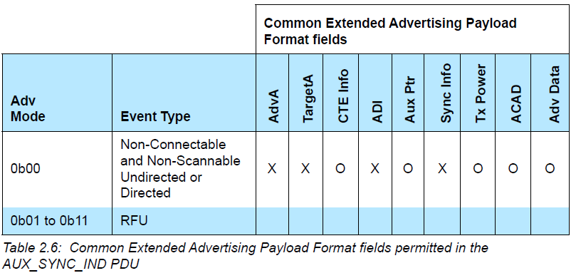

1. AUX_CHAIN_IND

The AUX_CHAIN_IND PDU uses the Common Extended Advertising Payload Format.

The PDU is used to hold additional AdvData. Its superior PDU is an AUX_ADV_IND, AUX_SYNC_IND, AUX_SCAN_RSP or another AUX_CHAIN_IND PDU.

The AdvMode field shall be set to 0b00.

Any auxiliary PDU shall be another AUX_CHAIN_IND PDU.

**4. Conclusion**

(1) Legacy adv

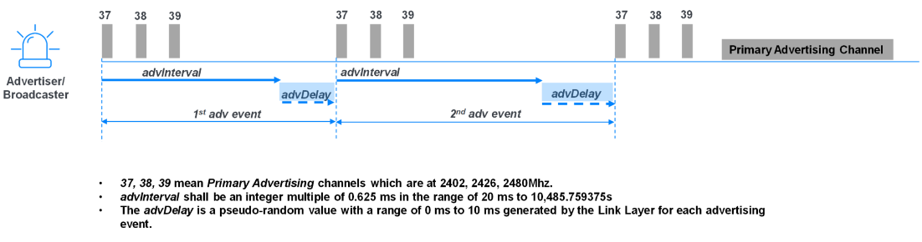

(2)Periodic adv

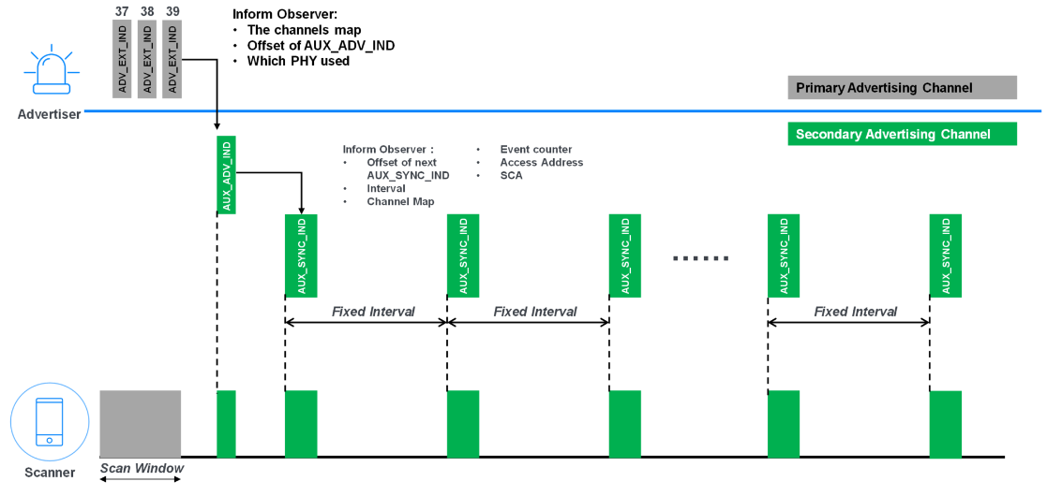

<https://www.bluetooth.com/blog/periodic-advertising-sync-transfer/#:~:text=1%20Feature%20Overview%2C%20the%20new,to%20the%20other%2C%20constrained%20device>.