# Terminology

* **Roles: Central peripheral**

Different parts of the Bluetooth LE Audio specifications use different names for the transmitting and receiving devices and what they do.

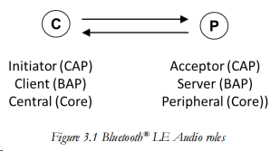

* **Classic Audio**

ACL(Asynchronous Connectionless Link):

SCO (Synchronous Connection Oriented Link)

* **Low Energy Audio**

ISOC(isochronous physical channel):

蓝牙LE同步通道功能是一种使用蓝牙LE在设备之间传输数据的新方法。它提供了一种算法机制，可以确保多个接收器设备能同步接收到主设备数据。其协议规定蓝牙发射机发送的每帧数据会带有一个时间期限，从设备在时间窗之后接收到的数据将被丢弃。这意味着接收器设备仅接收有效时间窗口内的数据，从而保证多个从设备接收数据的同步。

为了实现该新功能，BT5.2在协议栈Controller和Host之间增加ISOAL同步适配层（The Isochronous Adaptation Layer），提供数据流分段，重组服务。

## ISOAL: ISOCHRONOUS ADAPTATION LAYER

拆包，组包

The ISOAL provides a mechanism such that the timing used to generate or receive isochronous data in **the upper layer** can be independent of the timing used **in the CIS or BIS logical transport** used to carry the isochronous data.

Link Manager, Link Controller and BR/EDR Radio blocks comprise a BR/EDR Controller.

Link Manager, Link Controller and L**E Radio blocks** comprise an LE Controller.

L2CAP, SDP and GAP blocks comprise a BR/EDR Host.

L2CAP, SMP, Attribute Protocol, GAP and Generic Attribute Profile (GATT) blocks comprise an LE Host. (p203)

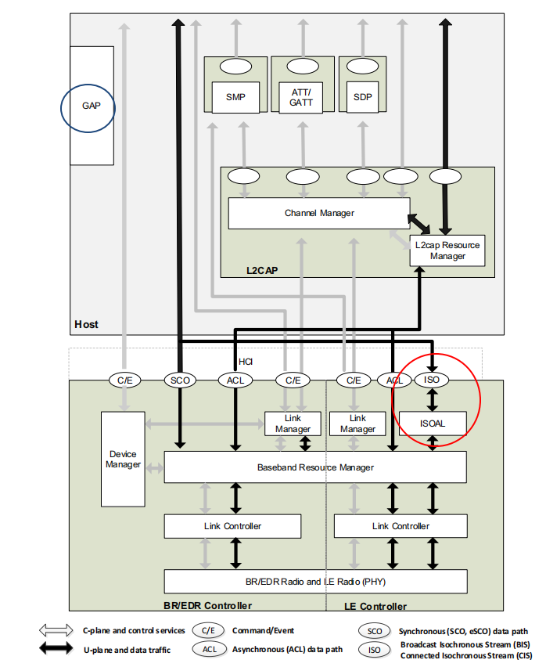

*Figure 2.1: Bluetooth core system architecture*

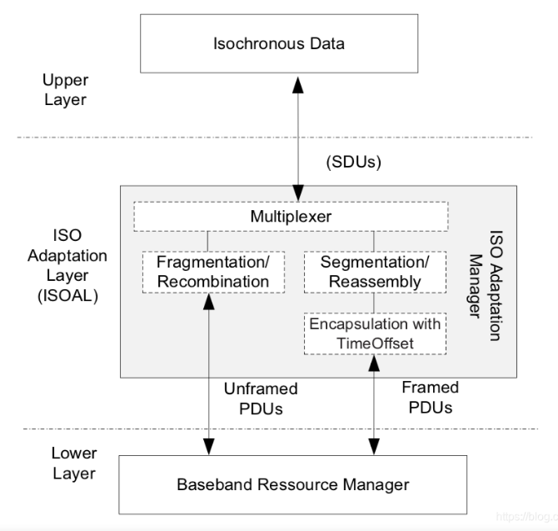 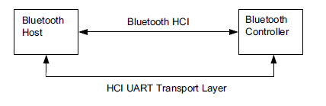

ISOAL allows devices to convert Service Data Units (SDUs) from the upper layer to differently sized Protocol Data Units (PDUs) at the Link Layer and vice versa.

The ISOAL uses fragmentation/recombination or segmentation/reassembly operations to convert upper layer data units into lower layer data units (or the other way around)

The reason this is needed is to cope with devices which may be using the recommended timing settings for the new LC3 codec

数据从HOST发来，然后发到ISOAL层，**最大SDU,** 每个SDU的长度最大为最大长度（Max_SDU） **4095，拆包后叫PDU，最大PDU 251** .page 3067使用HCI ISO数据包将SDU传输到上层或从下层传送到空中。

根据SDU的发送间隔SDU_Interval和PDU的发送间隔ISO_Interval，拆包的时候会分成两种模式，frame模式和unfram模式

## UNFRAMED /FRAMED PDU

page 3070

An unframed PDU shall only contain payload from a single SDU. Unframed refers to the case where a PDU consists of one or more complete codec frames. It is used where the **Isochronous Interval is an integer multiple of the codec frame length**.

Framed PDUs shall be used when the requirements for using unframed PDUs are not met. Framed PDUs support the aggregation of data from multiple SDUs into a single PDU. Each segment is encapsulated by a **Segmentation Header** and, for each first segment of a new SDU, a **Time_Offset** field is included to allow for reconstruction of the original SDU timing.

framed is where you have a mismatch between the codec frame length and the Isochronous Interval, which results **in a codec frame being segmented across multiple SDUs.** This starts to get complex, but is important where an Initiator may need to support Bluetooth connections which have different timings. ISOAL has been **designed to cope with this mismatch**.

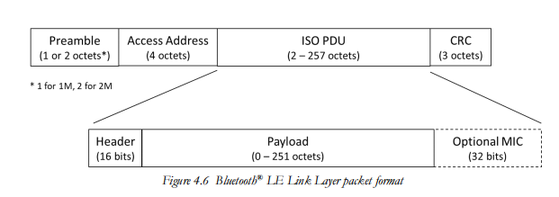

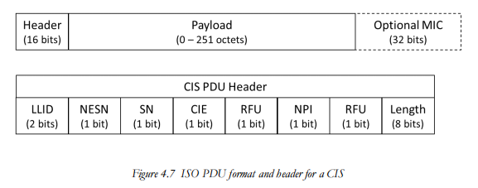

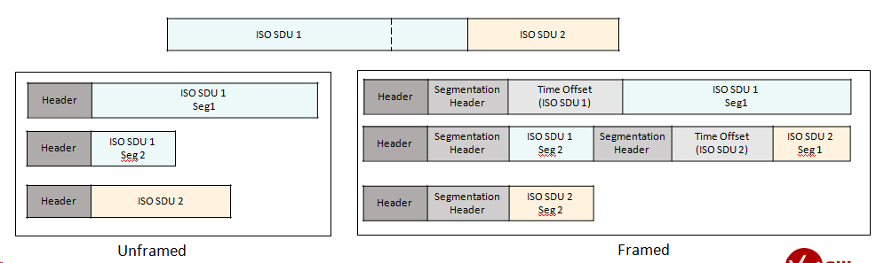

## ISO link

Synchronous links：provide a method of associating the transported data with the Bluetooth piconet clock. (时钟同步).This is achieved by reserving regular slots on the physical channel, and transmitting **fixed size packets** at these **regular intervals**. Such links are suitable for constant rate isochronous data.

Isochronous links：provide a method for transporting data that has time based characteristics. The data rate on the link need not be constant (this being the main difference from synchronous links).

**3.5.2 Scheduling and acknowledgment scheme**

## Isochronous Streams

Isochronous Streams provide h a much **wider range of topologies**. As well as connecting a mobile phone to a pair of headphones or a single speaker, Bluetooth LE Audio needed the ability to send separate left and right signals to a left earbud and a right earbud. It also needed to be able to send the same information to more than one set of earbuds and scale up the number of devices and streams. two types of Isochronous Stream – **unicast and broadcast**.

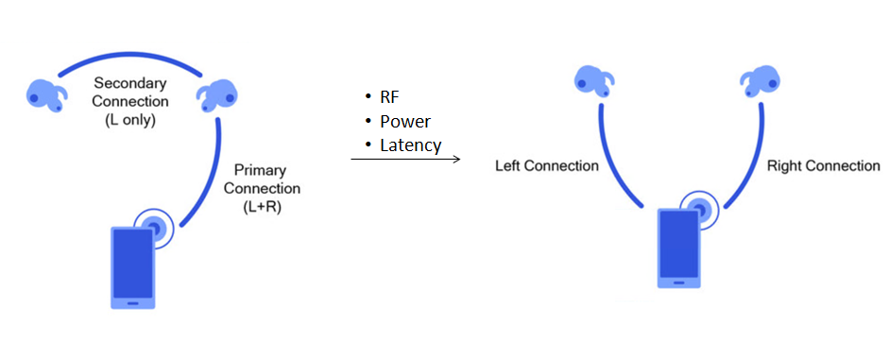

The **Isochronous Stream** is the term used to describe the transport of SDUs, **encapsulated in PDUs**, from encoder output to the decoder input. It includes retransmissions and any buffering required to synchronise multiple Isochronous Streams.

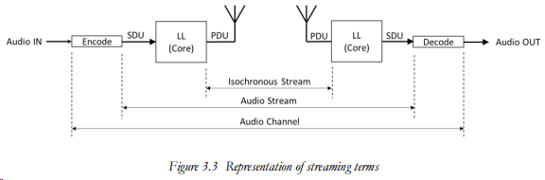

## DATA TRANSPORT ARCHITECTURE(P210)

L2CAP channels

above the Link Layer the L2CAP(Logical Link Control and Adaptation protocol) layer provides a channel based abstraction to applications and services.

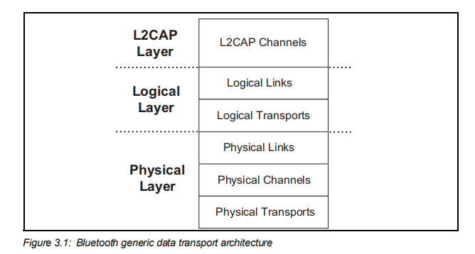



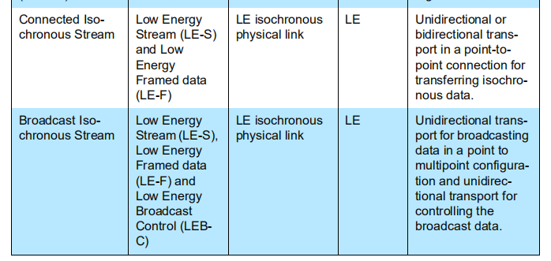

**p239**

All isochronous connections are terminated when the associated LE piconet physical channel is terminated.

CIS: data-symmetric or data-asymmetric, point-to-point logical transport between the Central and a specific Peripheral. The LE-S or LE F links are created by using Link Layer procedures.

BIS: A BIS supports transmission of multiple new isochronous data packets in every BIS event. There is no acknowledgment protocol and the traffic is **unidirectional** from the broadcasting device.

many applications will switch between unicast and broadcast to fulfil different use cases. (higher layers to the left and lower layers to the right).

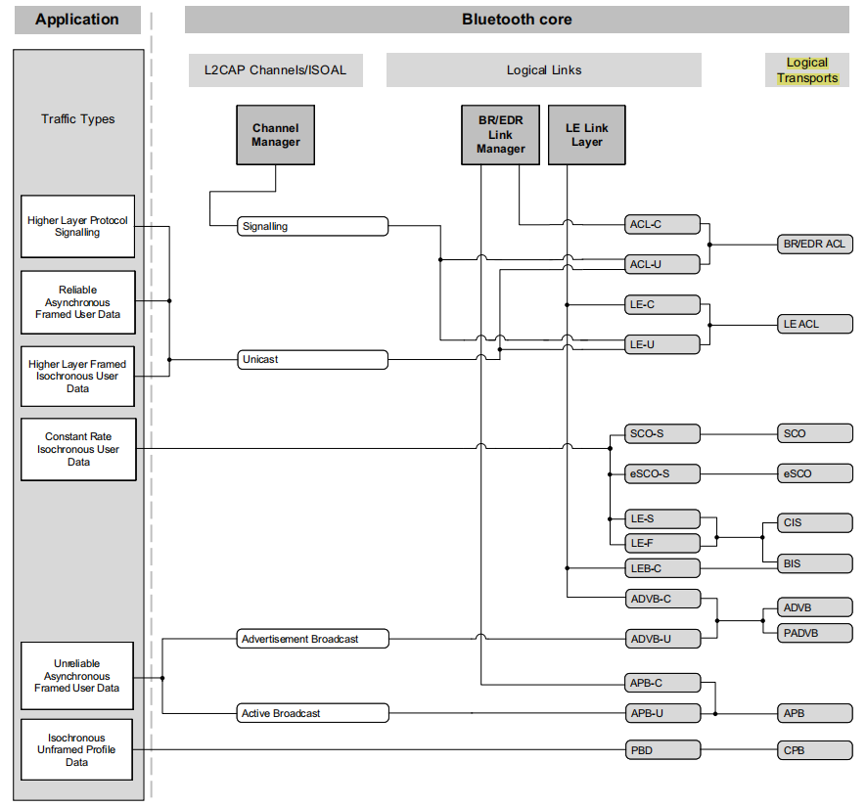

Figure 3.2 shows a number of application traffic types. These are used to classify the types of data that may be submitted to the Bluetooth core system.

# CIS

An isochronous connection is used to transfer isochronous data between the Central and a Peripheral by using a **logical transport**, which is referred to as a Connected Isochronous Stream (CIS).当CIS需要同步时（例如发送到左右耳塞的CIS），它们被配置为称为“**连接同步组（CIG）** ”的单个组的一部分。

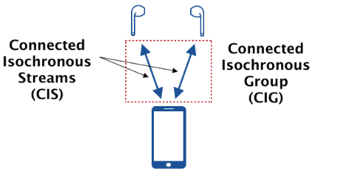

Using an ACL connection, a Central can establish one or more **isochronous connections** that use the isochronous physical channel.

As Figure shows, each CIS has an associated ACL link. The ACL link always needs to be present because it is used to set up the CIS and control it. If there are multiple CISes between an Initiator and an Acceptor, they can share the same ACL. If the ACL is lost for any reason, any associated CISes are terminated.

**CIS Connection process**

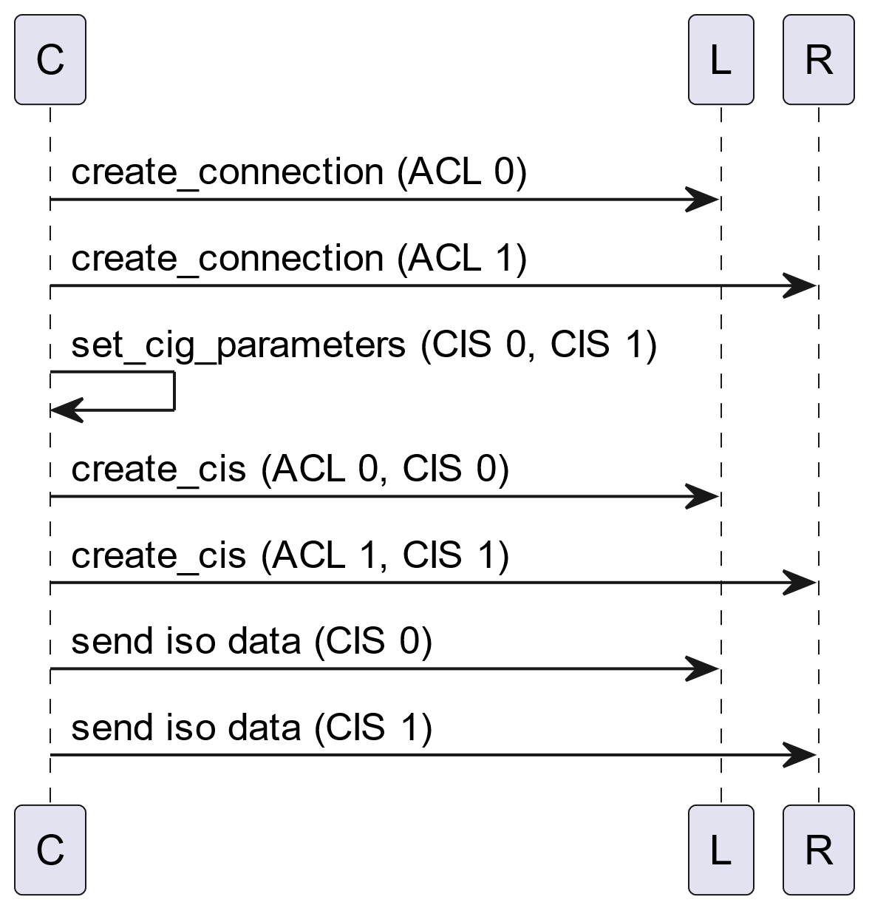

因为cis是面向连接的，是需要应答机制的，发一笔数据，对端要回复ACK

When the HCI_LE_Set_CIG_Parameters command has completed, an HCI_Command_Complete event shall be generated.

## *CIS command*

#### LE Set CIG Parameters command p2552

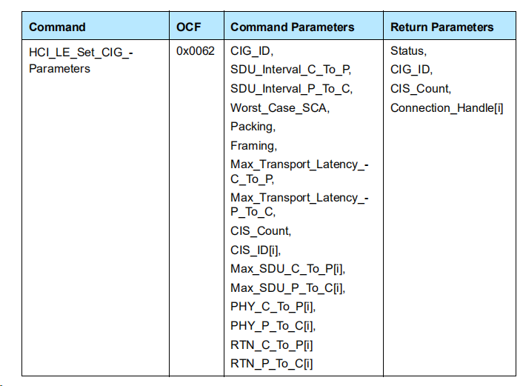

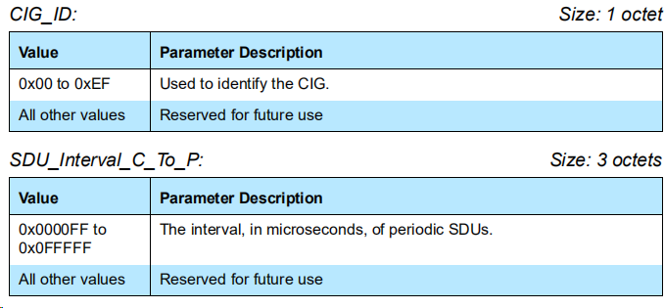

The Worst_Case_SCA: the worst-case **sleep clock accuracy of all the Peripherals** that will participate in the CIG. The Host should get the sleep clock accuracy from all the Peripherals before issuing this command. If the Host cannot get the sleep clock accuracy from all the Peripherals, it shall set the Worst_Case_SCA parameter to zero.

Part Per Million

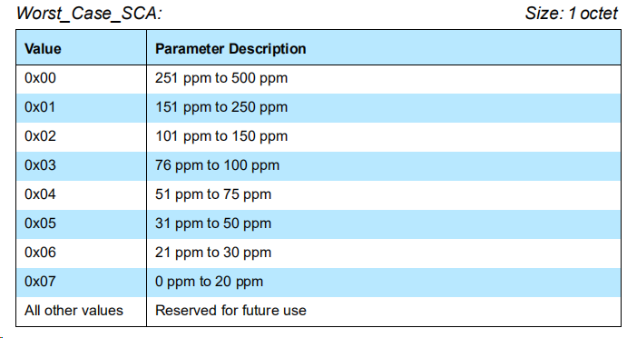

#### Framing: famed and unframed PDUs. Refs to 3074

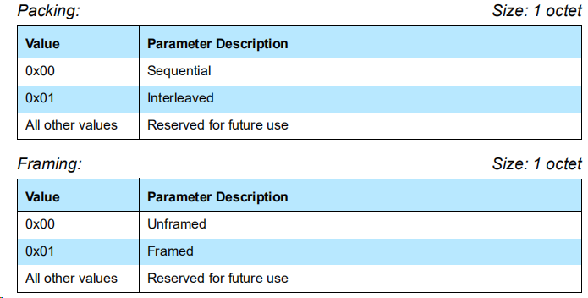

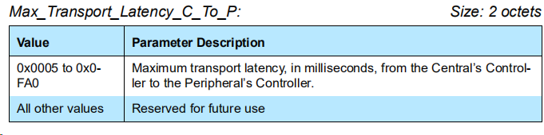

**EX: framed PDUs of CIG:**

The transport latency for a CIG is the actual latency of transmitting payloads of all CISes in the CIG, and calculates as:

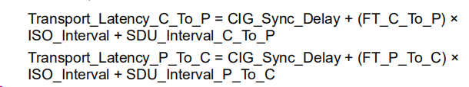

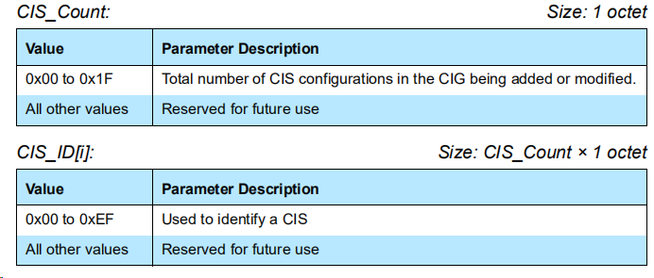

Host -> controller

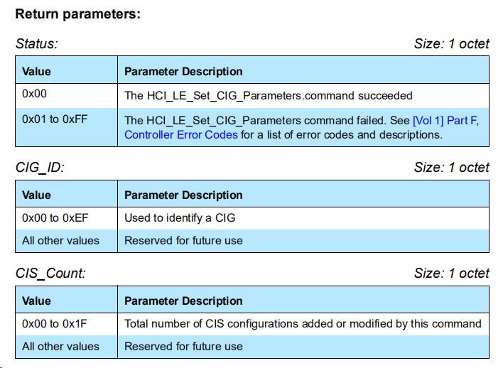

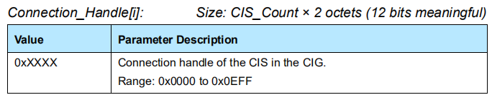

Connection_Handle: be set to the value provided in the HCI_LE_Create_CIS command on the Central and in the HCI_LE_CIS_Request event on the Peripheral. Connection_Handle: LE建立 (host<-->control) link的时候的句柄

#### 7.8.99 LE Create CIS command p2568

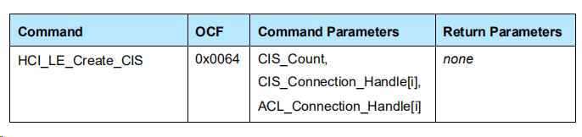

The CIS_Connection_Handle[i] parameter specifies the connection handle corresponding to the configuration of the CIS to be created and whose configuration is already stored in a CIG.

The ACL_Connection_Handle[i] parameter specifies the connection handle of the ACL connection associated with each CIS to be created. The list of the ACL_Connection_Handles shall be in the same order as the list of the CIS_Connection_Handles e.g., CIS_Connection_Handle[1] will connect to the Peripheral associated with the ACL_Connection_Handle[1].

If this command is issued on the Central before the devices have performed the Feature Exchange procedure, then the Controller shall complete that procedure before initiating the Connected Isochronous Stream Creation procedure

#### 7.8.101 LE Accept CIS Request command

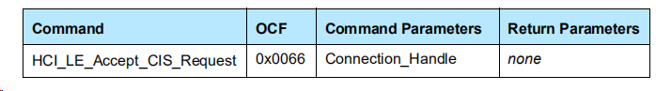

## LE CIS Established event P2293

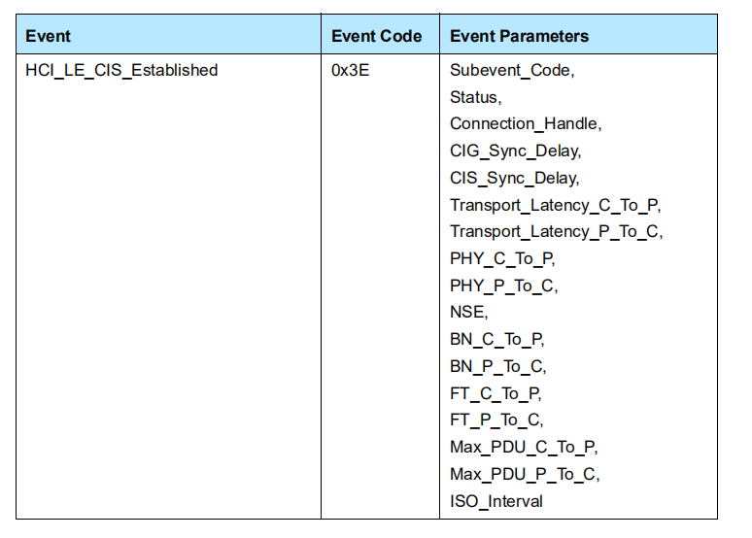

The HCI_LE_CIS_Established event indicates that a CIS has been established, was considered lost before being established, or—on the Central—was rejected by the Peripheral.It is generated by the Controller in the Central and Peripheral.

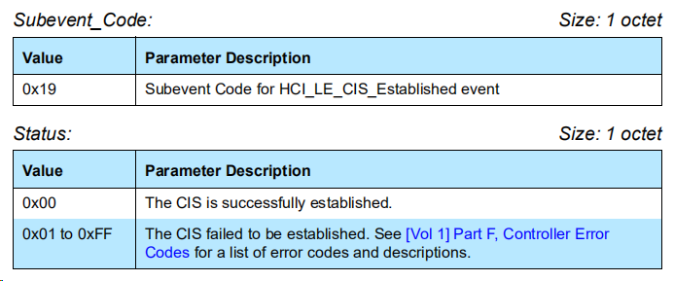

The Connection_Handle parameter shall be set to the value provided in the **HCI_LE_Create_CIS** command on the Central and in the **HCI_LE_CIS_Request** event on the Peripheral.

### CIG_Sync_Delay CIS_Sync_Delay

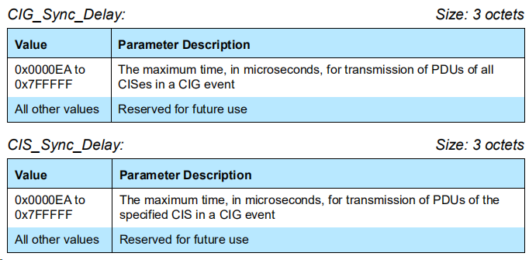

#### CIG event

Each CIG event shall have a **CIG reference point** and a **CIG synchronization** point; these shall be CIG_Sync_Delay apart.

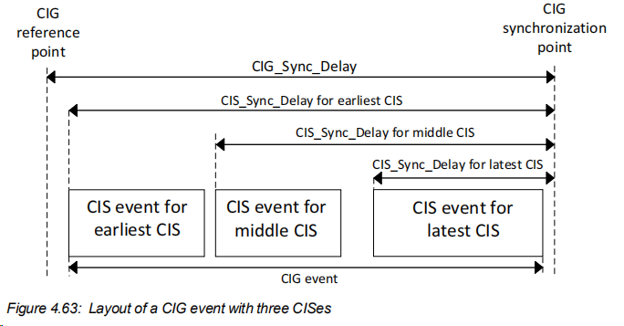

Each **CIG event** starts at the **anchor point** of the earliest (in transmission order) CIS of the CIG and ends at the end of the last subevent of the latest CIS of the same CIG event. Two CIG events on the same CIG shall not overlap (that is, **the last CIS event of a given CIG event shall end before the first CIS anchor point of the next CIG event**). For a given CIS, the CIS **anchor point shall be a fixed offset (which may be zero) after the CIG reference point**; therefore CIG reference points are spaced ISO_Interval apart and CIG synchronization points are also spaced ISO_Interval apart.

### ISO_Interval

A CIS consists of CIS events that occur at regular intervals (designated ISO_Interval). In each subevent, the Central transmits once and the Peripheral responds.

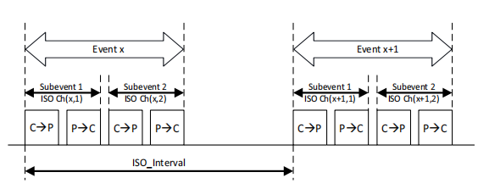

* ISO_Interval: **the time between the CIS anchor points of adjacent CIS events**. The Anchor Point is the point where the first packet of a CIS is transmitted by the Initiator and the start of each successive Isochronous Interval.

ISO_Interval shall be a multiple of 1.25 ms in the range of 5 ms to 4 s, shall be at least NSE × Sub_Interval.

* Sub_Interval: 可实现重传，防干扰

Each Subevent starts with the transmission from the Initiator and ends with the final point of **the expected response from an Acceptor**. All of the Subevents within a CIS form a CIS event, which starts at the Anchor Point of the CIS and finishes at the reception of the **last transmitted bit received from the Acceptor**

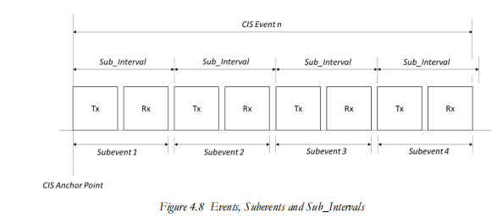

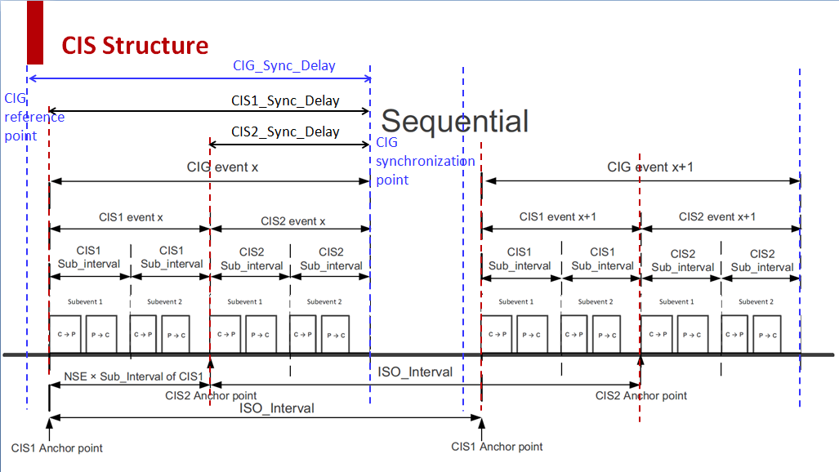

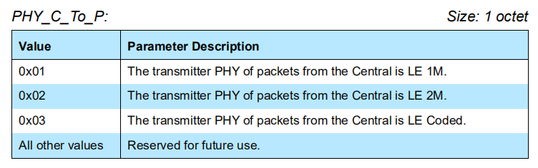

The Transport_Latency_C_To_P and Transport_Latency_P_To_C parameters are the actual transport latencies, in microseconds, as described in **3.2.1 SDU synchronization reference using framed PDUs (P3074) and 3.2.2 SDU synchronization reference using unframed PDUs (P3076)**

**HCI_LE_set_CIG_Pa_Test**

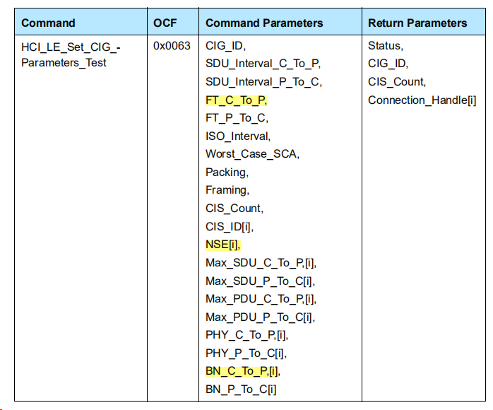

## Packing: p2839

* Packing: The subevents can be arranged in Sequential or Interleaved arrangement

***Arrangement of multiple CISes:*** The most common application for this is when an Initiator is sending audio to a left and a right earbud. In this case, the Initiator will **set up separate Isochronous Streams** with two different Acceptors.

Note that where we have more than one CIS, they always have the same Isochronous Interval. Their **Anchor Points are different**, as data is sent serially, but for each CIS their Anchor Points are the same ISO Interval apart.

The CISes in a CIG shall be arranged either sequentially or interleaved by setting the values of the Sub_Interval and the spacing between the CIS anchor points appropriately

在面向连接的通信中，在每个子事件中，主机将向从机发送一个数据包，而从机将以一个数据包进行响应。但是，在无连接通信中，只有主机会在每个子事件中发送一个数据包。在这种情况下，这些数据包可以是同步数据，也可以是广播控制信息。

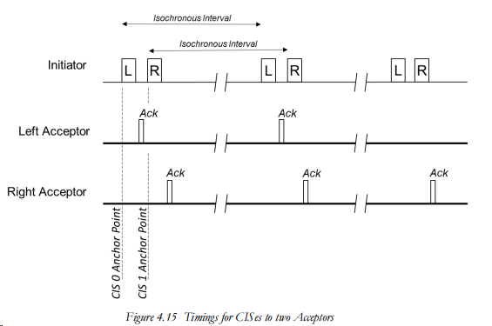

When an Initiator is scheduling two or more audio channels, there are two options for how they are transmitted

Sequential: the CIS events of the different CISes do not overlap and so all the subevents of a CIS event occur together. For each adjacent pair of CISes, the interval between their CIS anchor points shall be at least NSE × Sub_Interval, using the values for the lower numbered CIS.

all of the Subevents within CIS 1 being transmitted before the Subevents for CIS 2.

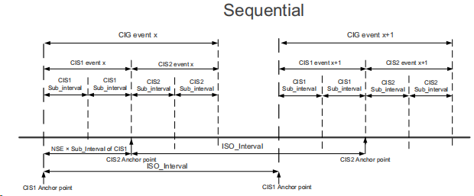

Interleaved, all the first subevents of the CISes are adjacent, followed by the second subevents, and so on.

SE_Length is the time that needs to be reserved for a subevent. Sub_Interval≥ SE_Length. For each adjacent pair of CISes, the interval between their CIS anchor points shall be at least SE_Length of the lower numbered CIS.

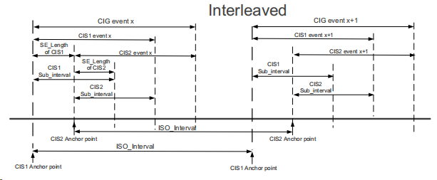

* NSE is the maximum number of subevents in each CIS event.
* SDU_Interval、Max_SDU、Max_PDU
* MTP

MPT_C and MPT_P：the **time** taken by the Central and Peripheral respectively to **transmit a packet** containing a CIS PDU with a payload of

**Max_PDU octets** (for that direction) on the PHY being used for the CIS

## *4*.5.13.1 CIS parameters p2832 BN、FT

### Flush Timeout

defines how many consecutive **Isochronous Intervals** can be used to transmit a PDU before it is discarded.The point at which it is no longer transmitted is called the **Flush Point**. **The Flush Timeout (FT) parameter is the maximum number of CIS events that may be used to transmit (and retransmit) a given payload.**

The FT_C_To_P parameter identifies the maximum time for a payload from the Central to Peripheral to be transmitted and re-transmitted, after which it is flushed (see [Vol 6] Part B, Section 4.5.13.5). This parameter is expressed in multiples of ISO_Interval.

### Burst Number

– The Burst Number, which is the number of payloads supplied for transmission in each CIS event. BN shall be in the range 0 to 15.

Each payload number shall have a flush point减少传输有效数据的延时



**flush point**

payload指除去协议首部之外实际传输的数据

**The flush point of a payload number occurs immediately after U subevents in the CIS event with *cisEventCounter* equal to**

**(E + FT – 1), where:**

**Pcounter 不包含重传的pdu的计数器**

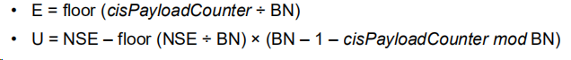

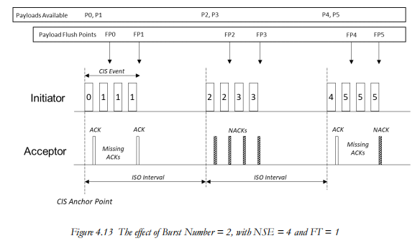

E=FT=0 表示当前evnet

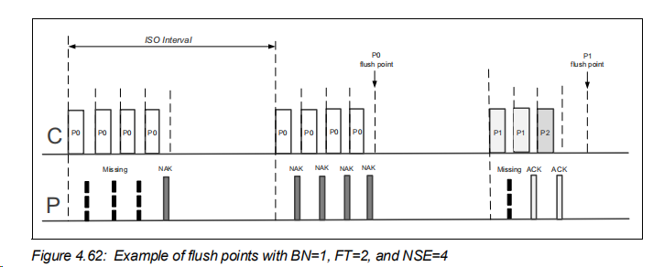

E+FT-1 = E+1,第二个event，U =4

4.62 实现p0的重传

**CIE** Looked at the isochronous PDU header, we saw that there's a **Close Isochronous Event bit – the CIE**. That's used by the Initiator to signify that it has received an acknowledgment from an Acceptor confirming that its packet was successfully received by the Acceptor, so that it will stop further retransmissions of that particular PDU.

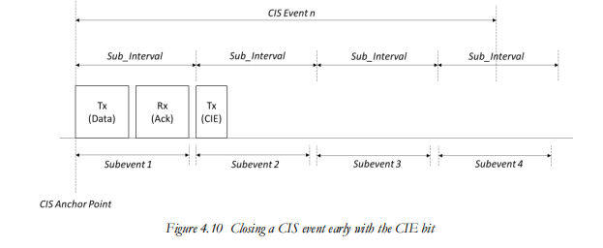

## LE CIS Request event

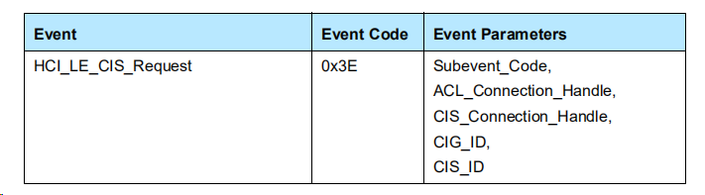

The HCI_LE_CIS_Request event indicates that a Controller has received a request to establish a CIS.

the Controller shall assign a connection handle for the requested CIS and send the handle in the **CIS_Connection_Handle** parameter of the event.

When the Host receives this event it shall respond with either an **HCI_LE_- Accept_CIS_Request** command or an **HCI_LE_Reject_CIS_Request**

command before the timer Connection_Accept_Timeout expires. If it does not（if time above the timer Connection_Accept_Timeout）the Controller shall reject the request and generate an HCI_LE_CIS_- Established event with the status *Connection Accept Timeout Exceeded* (0x10).

The ACL_Connection_Handle is the connection handle of the ACL connection that is associated with the requested CIS.

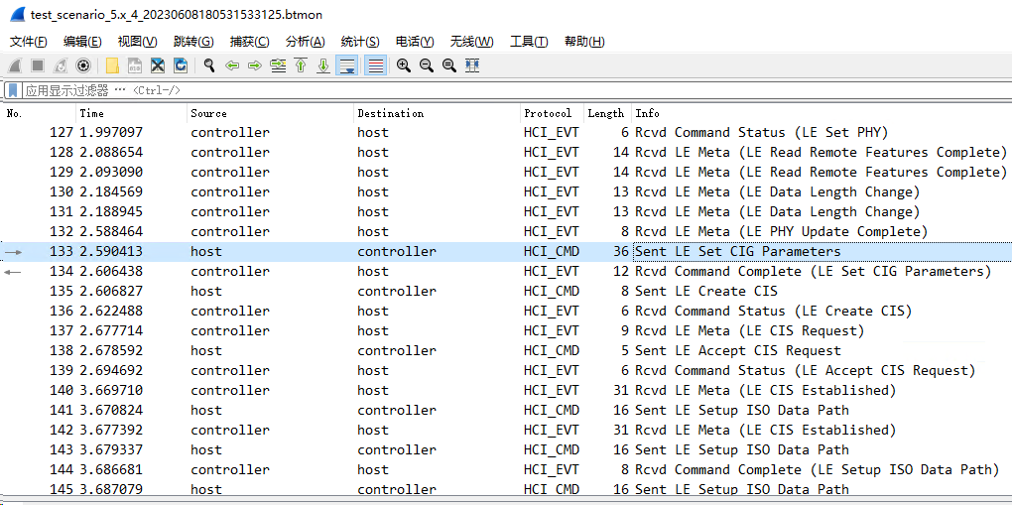

# BIS

Broadcast Isochronous Streams (BIS)：With broadcast, a device that transmits the Isochronous Streams has no knowledge of how many devices may be out there receiving the audio. There's **no connection** between devices and no need for an ACL link. A device can use an isochronous physical channel to broadcast isochronous data by **using isochronous connectionless logical transports**.



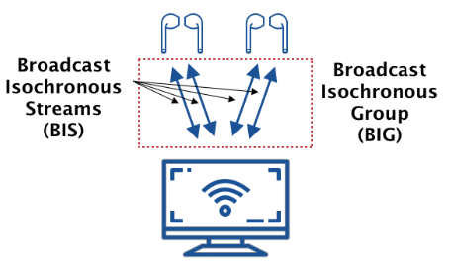

A BIS is a logical transport that enables a device to transfer isochronous data. The isochronous data can be either framed or unframed.

A BIS supports **variable size packets** and the transmission of one or more packets in each BIS event, allowing a range of data rates to be supported. The data traffic is unidirectional from the broadcasting device; hence there is no acknowledgment protocol and broadcast isochronous traffic is inherently unreliable. To improve the reliability of packet delivery, the BIS supports **multiple retransmissions**.

BIG

The maximum number of BISes in a BIG shall be 31.

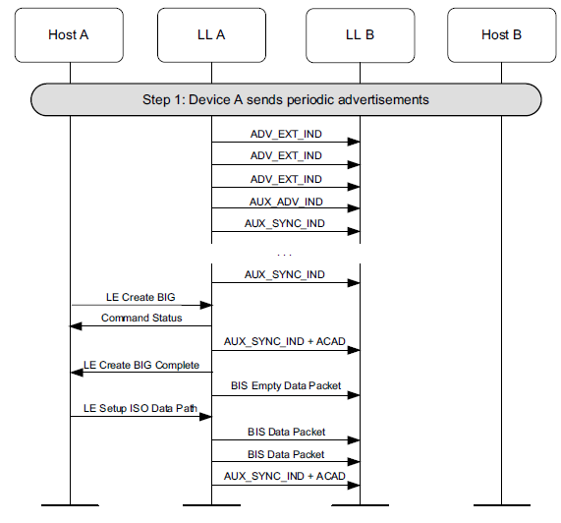

When the Controller receives the **HCI_LE_Create_BIG** command, the Controller sends the **HCI_Command_Status event** to the Host. When the HCI_LE_- Create_BIG command has completed, the **HCI_LE_Create_BIG_Complete event** is generated.

The **HCI_LE_Create_BIG_Complete event** indicates that the HCI_LE_- Create_BIG or HCI_LE_Create_BIG_Test command has completed and, if successful, the Link Layer has entered the Isochronous Broadcasting state

## 7.8.104 HCI_LE_Create_BIG command p2581

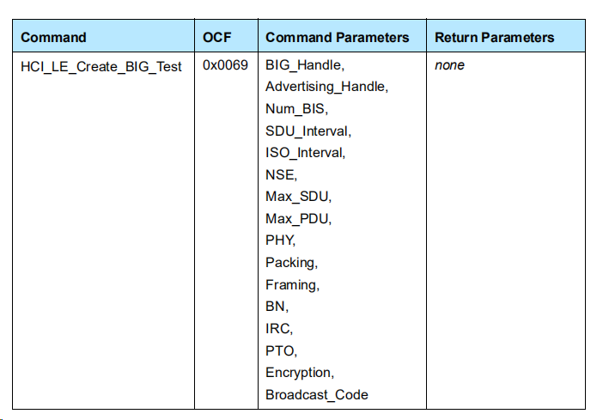

BIG_Handle: allocated by the Host and used by the Controller and the Host to identify a BIG. be the same as the one specified in the command that has completed.

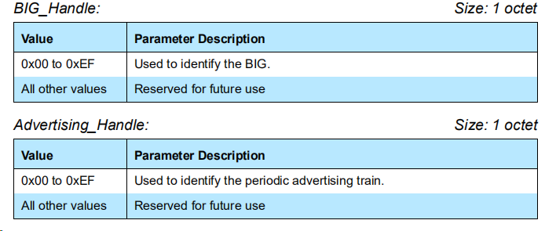

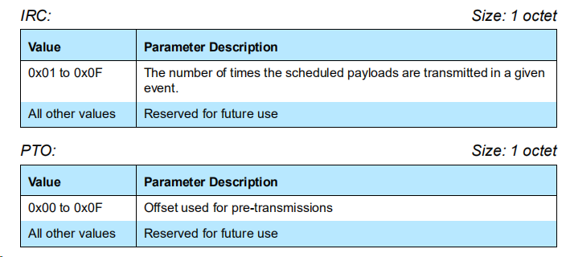

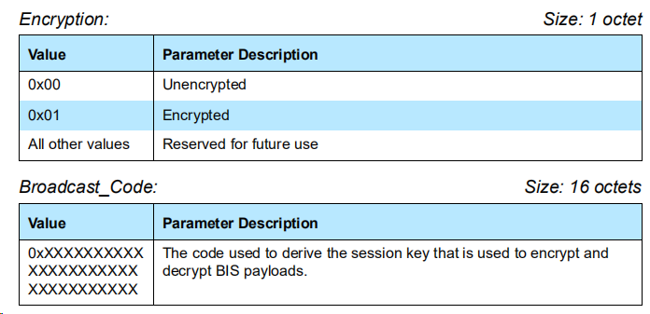

The Link Layer shall determine if a BIG is encrypted by examining the length of the BIGInfo. The length of the BIGInfo is 33 octets for an unencrypted BIG and 57 octets for

an encrypted BIG.

## 7.7.65.27 LE Create BIG Complete event

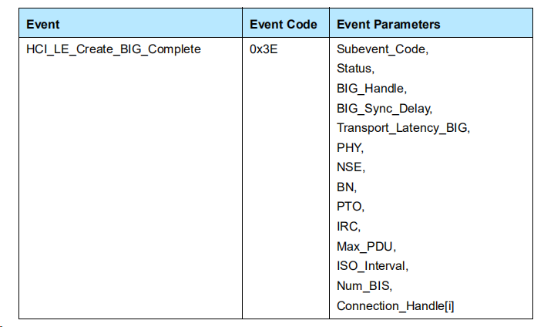

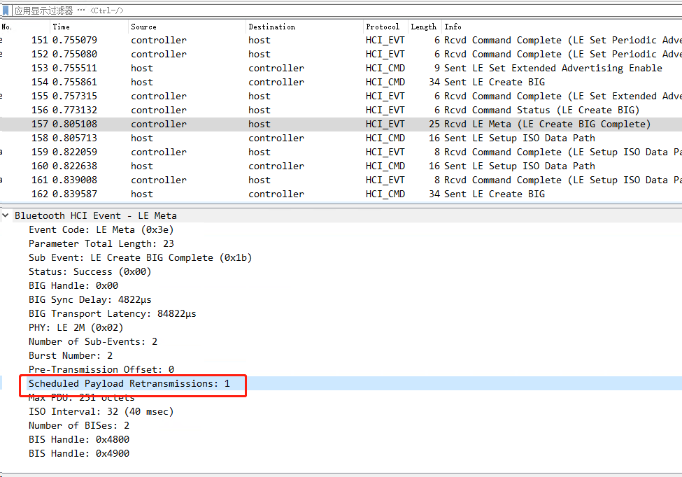

## 4.4.6.6 BIS subevents p2794

The Link Layer should transmit one BIS Data PDU at the start of each subevent of the isochronous broadcasting event, unless it has scheduling conflicts, but shall transmit at least one BIS PDU within any 6 consecutive BIS events on a given BIS.

Each BIS subevent ends at the end of the transmitted PDU or, if the Link Layer does not transmit a PDU, the subevent is MPT in duration.

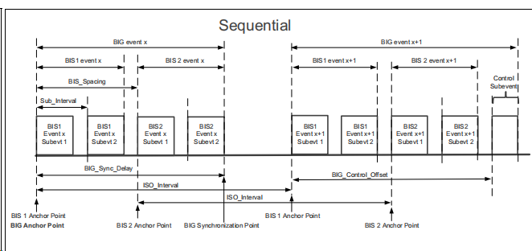

**Parameters**

BN, PTO, and IRC control which data is transmitted in each BIG event. The value of **BN** shall be between **1 and 7**. The value of **PTO** shall be between **0 and 15**. The value of **IRC** shall be between **1 and 15.**

**NSE** is the number of subevents per BIS in each BIG event. The value shall be between **1 and 3**1 and shall be an integer multiple of BN.

GC: The subevents of each BIS event are partitioned into groups of **BN subevents each**. Therefore, there are Group Count (GC) groups, where GC = NSE ÷ BN.

## IRC PTO

IRC ("Immediate Repetition Count") specifies the number of groups that carry the data associated with the current BIS event

PTO: 预先传输

the remaining groups carry data associated with the future BIS events specified by PTO ("Pre-Transmission Offset"). IRC >0 and IRC < GC. **If IRC = GC then PTO shall be ignored.** Otherwise PTO shall be greater than zero

Note: Setting GC to a value greater than 1 provides redundant transmissions to compensate for the lack of acknowledgments when broadcasting, while **setting IRC < GC (called pre-transmission) provides a greater time diversity among the redundant copies of the data.**

Figure 4.34 NSE(subevent) = 4 BN(payloads，p0,p1)=2,GC =IRC=2; 忽略PTO,不重传

Figure 4.35 NSE(subevent) = 5 BN(payloads,p0)=1,GC =5>IRC=3;

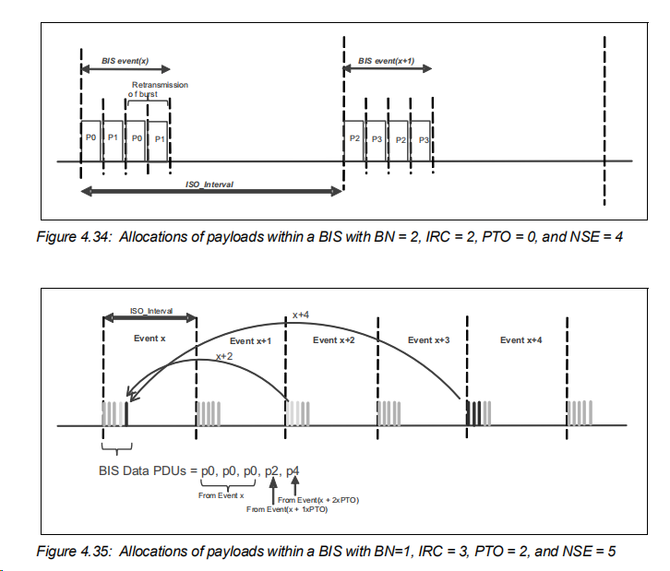

IRC 与当前event有关联的payloads的GC数

