<https://zhuanlan.zhihu.com/p/56621632>

An LE device can make its direction available for a peer device by transmitting direction finding enabled packets. Using direction information from several transmitters and profile-level information giving their locations, an LE radio can calculate its own position.

This feature is supported over the LE Uncoded PHYs, but not over the LE Coded PHY.

1. **Constant Tone Extension(CTE)**

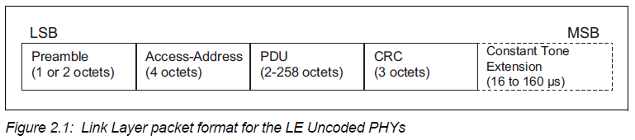

The Constant Tone Extension field shall not be present in a packet sent on the isochronous physical channel.

The Constant Tone Extension has a variable length; it shall be at least 16 μs and not greater than 160 μs.

Constant Tone Extension can be one of two types: AoA or AoD

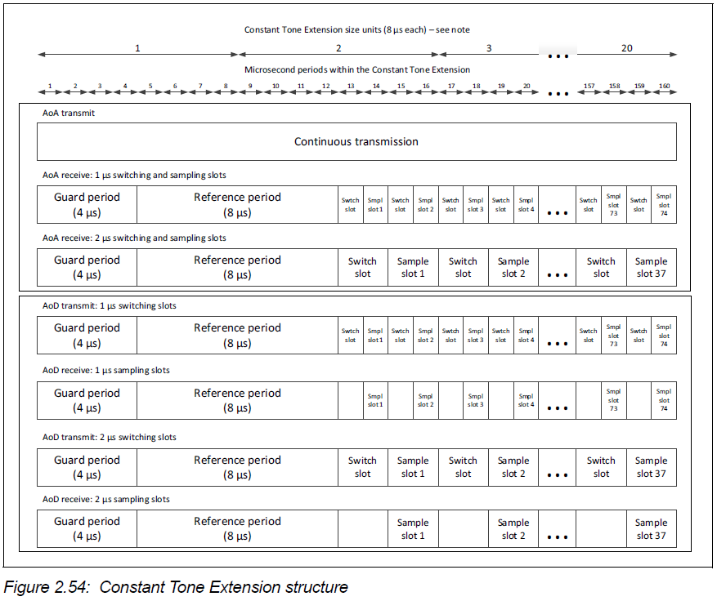

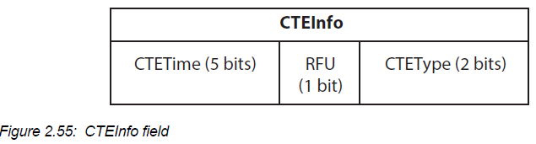

The presence of the CTEInfo field indicates that the packet includes a Constant Tone Extension.

The CTETime field defines the length of the Constant Tone Extension in 8 μs units. The value of the CTETime field shall be between 2 and 20; all other values are reserved for future use.

The CTEType field defines the type of the Constant Tone Extension and the duration of the switching slots.

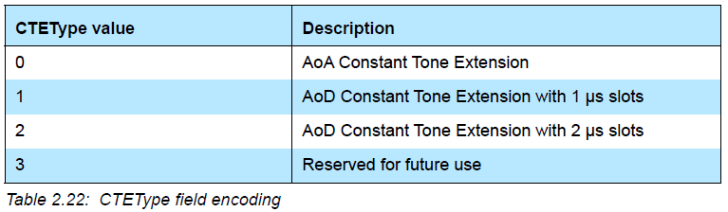

1. **IQ sampling**

When requested by the Host, the receiver shall perform IQ sampling when receiving a valid packet that contains a Constant Tone Extension and may perform IQ sampling when receiving a packet that contains a Constant Tone Extension but an incorrect CRC.

the receiver shall take an IQ sample each microsecond during the reference period and an IQ sample each sample slot (thus there will be 8 reference IQ samples, 1 to 37 IQ samples with 2 μs slots, and 2 to 74 IQ samples with 1 μs slots, meaning 9 to 82 samples in total).

The Controller shall report the IQ samples to the Host. The receiver shall sample the entire Constant Tone Extension, irrespective of length, unless this conflicts with other activities.

1. angle of arrival (AoA)

An LE device can make its direction available to a peer device by transmitting direction finding enabled packets using a single antenna.

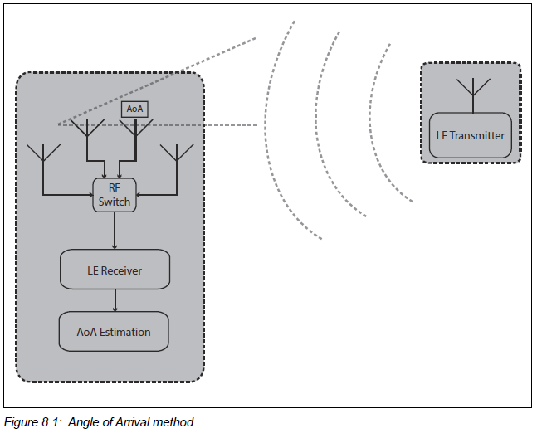

The peer device, consisting of an RF switch and antenna array, switches antennae while receiving part of those packets and captures IQ samples. The IQ samples can be used to calculate the phase difference in the radio signal received using different elements of the antenna array, which in turn can be used to estimate the angle of arrival (AoA).

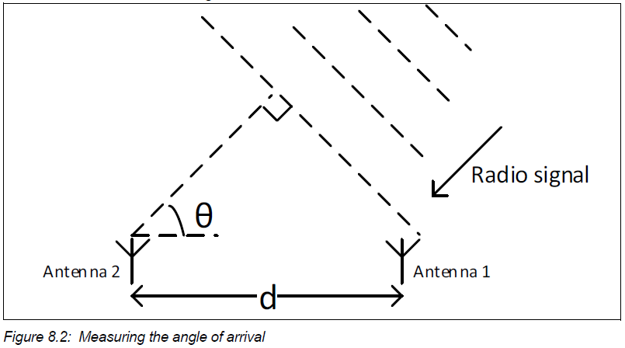

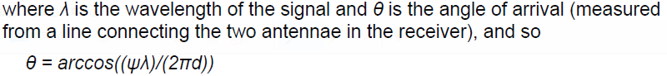

1. angle of departure (AOD)

A device consisting of an RF switch and antenna array can make its angle of departure (AoD) detectable by transmitting direction finding enabled packets, switching antennae during transmission.

The peer device receives those packets using a single antenna and captures IQ samples during part of those packets.

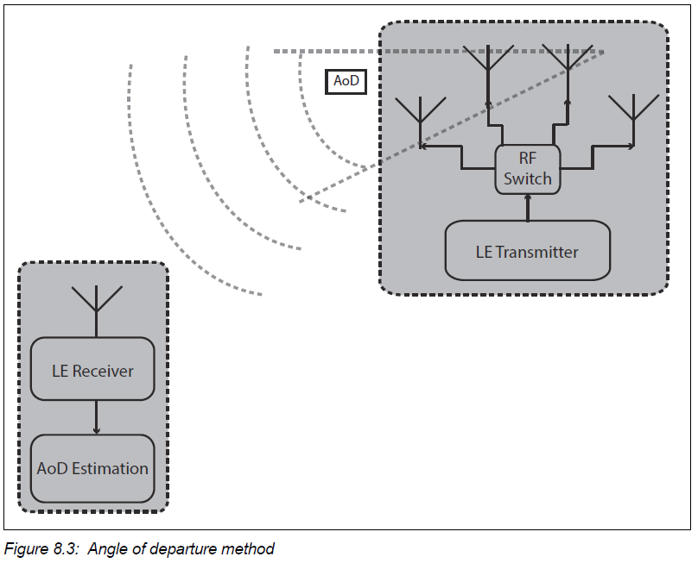

Determination of the direction is based on the different propagation delays of the LE radio signal between the transmitting elements of the antenna array and a receiving single antenna. The

propagation delays are detectable with IQ measurements

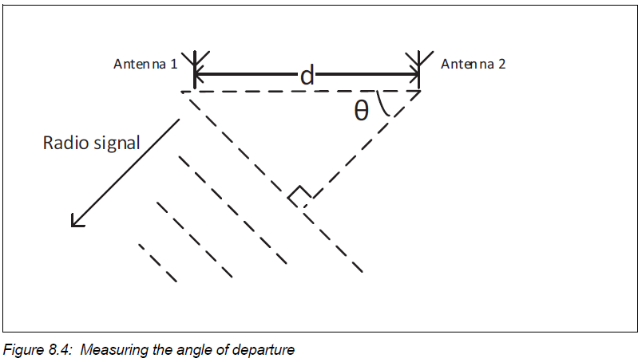

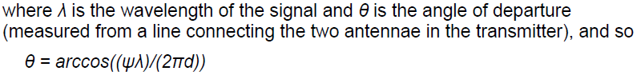

1. Message Sequence Charts
2. Advertising state

CTE transmission (page 3111)

A device may send periodic advertising packets containing a Constant Tone Extension

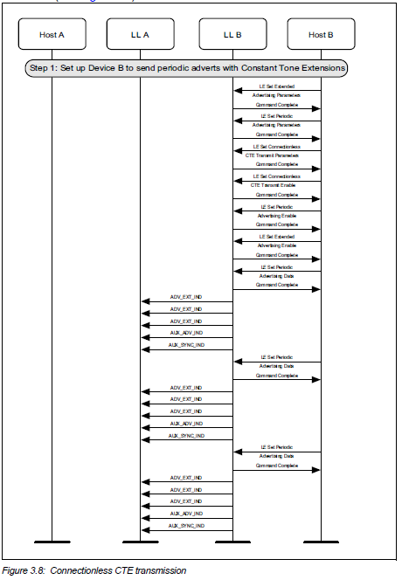

1. Scanning state

CTE reception (page 3125)

A device may receive periodic advertising packets containing a Constant Tone Extension and send IQ samples to the Host.

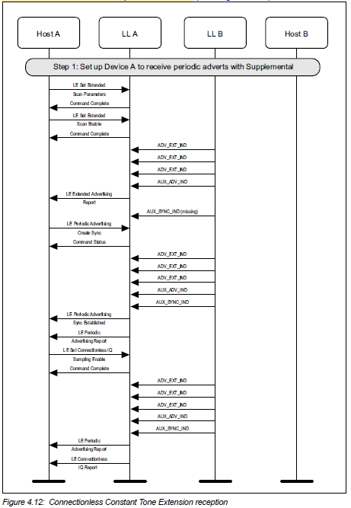

1. Connection state

CTE request (page 3158)

The master or slave of the connection may request the remote device to send an LL_CTE_RSP PDU with a Constant Tone Extension.

