Periodic advertising sync transfer (PAST)

<https://www.bluetooth.com/blog/periodic-advertising-sync-transfer/>

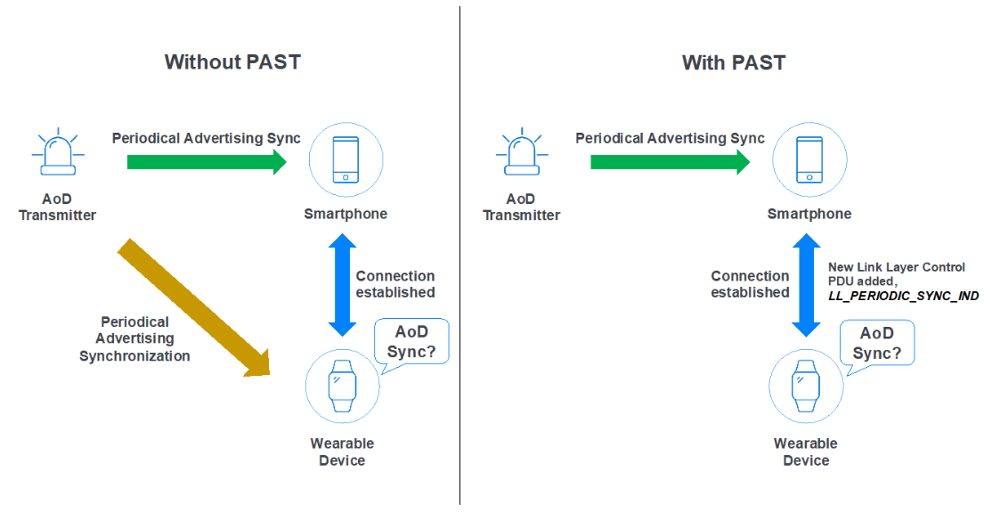

With PAST, if the wearable device wants to scan and perform periodic advertising synchronization with the AoD transmitter with PAST support, the smart-phone can transfer the periodic advertising synchronization information to the wearable device over the Bluetooth Low Energy link layer.

A new link layer control PDU, LL_PERIODIC_SYNC_IND, is added in the latest version of the Bluetooth Core Specification to support it. This (PAST) makes it easy and helps power constrained devices save power.

