AMPS SEP Geospace Validation Campaign
Expanded v6 — Per-Test Inputs, Expected Values, and Reference Plots
June 2026
Scope. This version updates the validation campaign to the current code capabilities: Mode3D and gridless dynamic MPI scheduling, shared cutoff UPPER_SCAN behavior, and density/flux transmission scanning. Each test below includes the required input parameters, calculation locations, expected values or acceptance targets, and a reference plot. The plots are either analytical/reference curves generated from the stated equations or redrawn target plots based on the cited literature; they are not direct reproductions of copyrighted paper figures.
Changes in this revision. Six tests were added based on a direct reading of the current source tree (CutoffRigidityGridless.cpp, DensityGridless.cpp, Mode3DParallel.h, AnisotropicSpectrum.h, GridlessParticleMovers.h) and READ.md: C11 isolates the specific Rmin-collapse defect that motivated UPPER_SCAN (CutoffForDirectionEndpointBinary_GV returning CUTOFF_EMIN whenever a low-rigidity allowed pocket exists), C12 cross-validates all seven movers against the analytical Stormer cutoff, C13 is the gridless-mode companion to C-PARALLEL since no existing test previously set GRIDLESS_MPI_SCHEDULER, F11 exercises the full BA_PAD_MODEL matrix and its n→0 sum-check, F12 covers BA_SPATIAL_MODEL=DAYSIDE_NIGHTSIDE which no prior test touched, and F13 is the OpenMP×MPI-scheduler reproducibility cross-product specific to gridless density/flux. F5’s parameter block has also been corrected: it referenced BOUNDARY_DISTRIBUTION, PAD_LINEAR, and PAD_AXIS, none of which the parser recognizes; it now uses the actual BA_PAD_MODEL/BA_PAD_EXPONENT keywords, and its expected-value table has been updated to match the symmetric |cosα|^n functional form actually implemented.

1. Current-code validation capabilities covered
Capability | Validation coverage
Mode3D MPI scheduler: STATIC, BLOCK_CYCLIC, DYNAMIC | C-PARALLEL, C1–C10 scheduler repeat, F7
Gridless MPI scheduler: STATIC, BLOCK_CYCLIC, DYNAMIC | F7, F13, and C13 (gridless-mode companion to C-PARALLEL; no prior test set GRIDLESS_MPI_SCHEDULER directly)
Thread backend: SERIAL, OPENMP, THREADS | C-PARALLEL and F7
Cutoff search: BINARY and UPPER_SCAN | C11 is the dedicated Rmin-collapse regression for the documented BINARY defect; C3 covers general penumbra behavior; C1/C2 ensure UPPER_SCAN does not bias clean dipole cases
Density/flux transmission: DIRECT, SCAN, ADAPTIVE alias | F3–F6, F9–F10, F11–F12 (PAD/spatial anisotropy keyword correction and sum-check), F13 (OpenMP×scheduler matrix)
Progress diagnostics and load-balance timing | F7 and scheduler load-balance acceptance

2. Common parameter conventions
The snippets below intentionally list only parameters that are essential to each validation case. All production runs should archive the complete input file, command line, code version, MPI rank count, thread count, scheduler, dynamic chunk size, random seed if any, and full diagnostic output.
# Recommended common production defaults unless a test states otherwise
MODE3D_MPI_SCHEDULER DYNAMIC
MODE3D_MPI_DYNAMIC_CHUNK 0 ! auto = 4 * workers_per_rank
GRIDLESS_MPI_SCHEDULER DYNAMIC
GRIDLESS_MPI_DYNAMIC_CHUNK 0
MODE3D_PARALLEL THREADS
MODE3D_THREADS 8
CUTOFF_SEARCH_ALGORITHM UPPER_SCAN
CUTOFF_UPPER_SCAN_N 80
DS_TRANSMISSION_MODE SCAN
DS_TRANSMISSION_SCAN_N 80
DS_TRANSMISSION_SAVE T

3. Cutoff-rigidity validation tests C1–C10

C1. Pure dipole vertical Størmer cutoff
Validates rigidity conversion, sign convention, vertical-arrival backtracing, and the upper-cutoff search against the analytical Størmer vertical cutoff in a centered aligned dipole.
Essential input parameters:
#NUMERICAL
MODE3D_MPI_SCHEDULER DYNAMIC
MODE3D_MPI_DYNAMIC_CHUNK 0
MODE3D_PARALLEL THREADS
MODE3D_THREADS 8
CUTOFF_SEARCH_ALGORITHM UPPER_SCAN
CUTOFF_UPPER_SCAN_N 80
#BACKGROUND_FIELD
FIELD_MODEL DIPOLE
E_FIELD OFF
#CUTOFF_RIGIDITY
CUTOFF_SAMPLING VERTICAL
CUTOFF_EMIN 1.0
CUTOFF_EMAX 20000.0
#OUTPUT_DOMAIN
OUTPUT_MODE SHELLS
SHELL_ALT_KM 500 9000
SHELL_LON_DEG 0 60 120 180 240 300
SHELL_LAT_DEG -60 -30 0 30 60
Calculation locations:
Two spherical shells at 500 km and 9000 km; longitudes 0–300° every 60°; latitudes −60°, −30°, 0°, 30°, 60°.
Expected output values / acceptance targets:
Latitude (deg) | -60 | -30 | 0 | 30 | 60
Rc, alt=500 km (GV) | 0.801 | 7.206 | 12.810 | 7.206 | 0.801
Rc, alt=9000 km (GV) | 0.160 | 1.440 | 2.560 | 1.440 | 0.160
Reference solution / comparison target:
Analytical Størmer vertical cutoff, Rc = 14.9 cos^4(lambda)/r_RE^2 GV; classical cutoff methodology in Smart & Shea and Størmer.
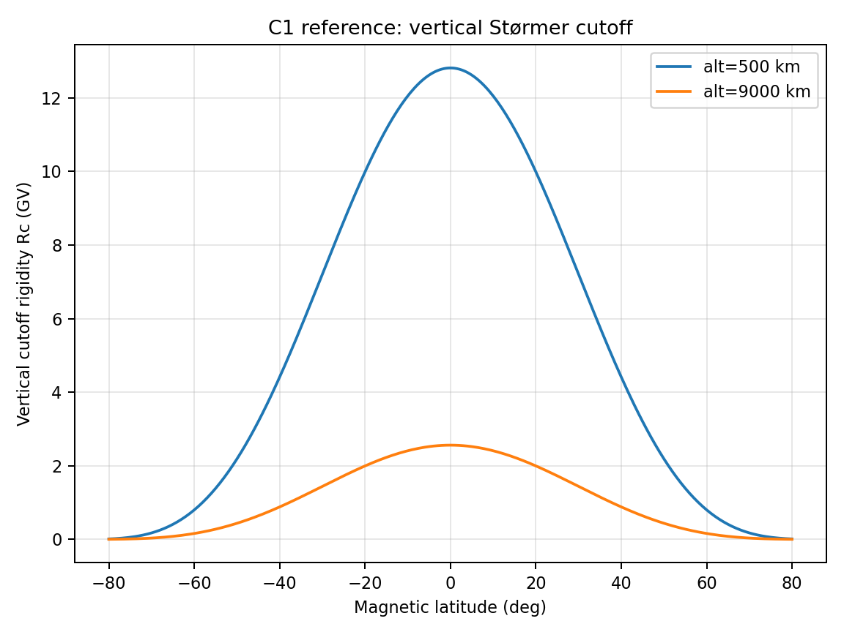
Figure C1 — Reference/target behavior for Pure dipole vertical Størmer cutoff.

C2. Dipole longitude and north/south symmetry
Checks that the centered dipole solution is independent of longitude and symmetric about the magnetic equator when using vertical or isotropic sampling.
Essential input parameters:
#NUMERICAL
MODE3D_MPI_SCHEDULER DYNAMIC
MODE3D_MPI_DYNAMIC_CHUNK 0
MODE3D_PARALLEL THREADS
MODE3D_THREADS 8
CUTOFF_SEARCH_ALGORITHM UPPER_SCAN
CUTOFF_UPPER_SCAN_N 80
FIELD_MODEL DIPOLE
CUTOFF_SAMPLING VERTICAL
OUTPUT_MODE SHELLS
SHELL_ALT_KM 9000
SHELL_LON_DEG 0 30 60 90 120 150 180 210 240 270 300 330
SHELL_LAT_DEG -60 -30 0 30 60
Calculation locations:
One shell at 9000 km; longitude every 30°; latitudes ±60°, ±30°, and 0°.
Expected output values / acceptance targets:
Metric | Expected
max_lon(Rc)−min_lon(Rc) at fixed latitude | 0 for analytic-direct dipole; <1% for mesh-interpolated dipole
Rc(+lat)−Rc(−lat) | 0 for analytic-direct dipole; <1% for mesh-interpolated dipole
Bad outcome | longitude bands or N/S asymmetry not explainable by mesh interpolation
Reference solution / comparison target:
Analytical symmetry of centered aligned dipole; use this as an internal regression before IGRF/Tsyganenko tests.
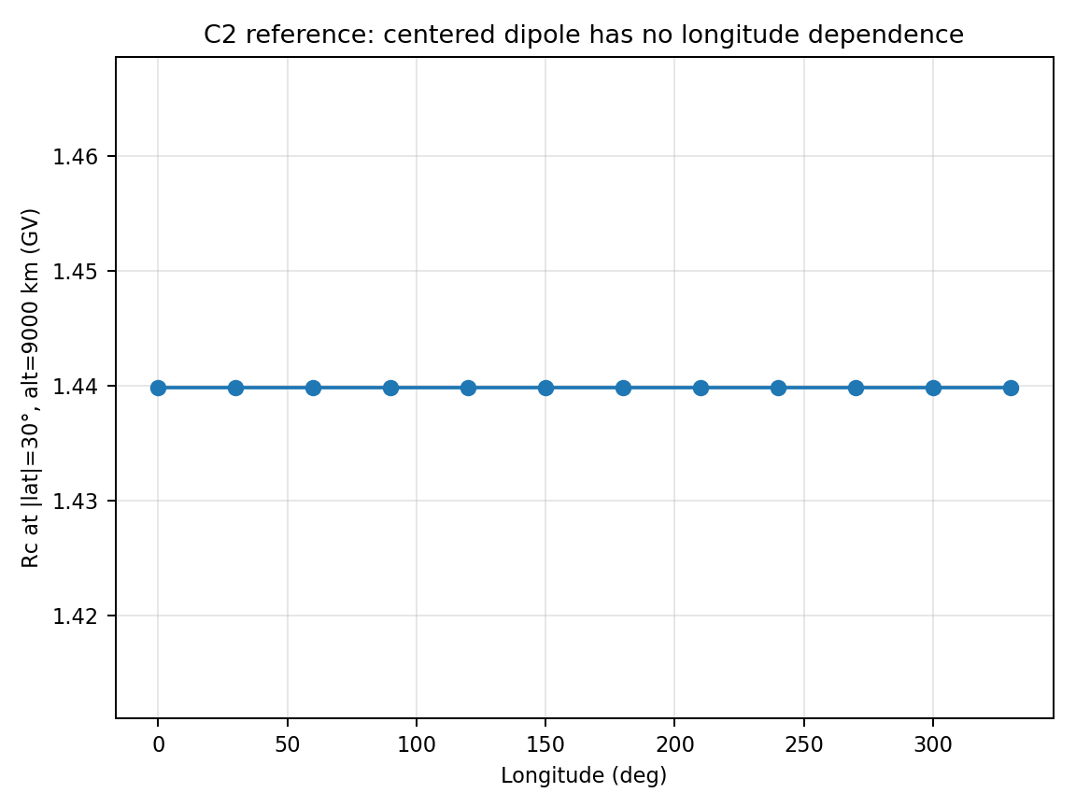
Figure C2 — Reference/target behavior for Dipole longitude and north/south symmetry.

C3. Penumbra, Rc_upper, and Rc_effective
Validates that the code handles non-monotonic allowed/forbidden rigidity access. This is the test that motivated the UPPER_SCAN algorithm.
Essential input parameters:
#NUMERICAL
MODE3D_MPI_SCHEDULER DYNAMIC
MODE3D_MPI_DYNAMIC_CHUNK 0
MODE3D_PARALLEL THREADS
MODE3D_THREADS 8
CUTOFF_SEARCH_ALGORITHM UPPER_SCAN
CUTOFF_UPPER_SCAN_N 80
FIELD_MODEL DIPOLE
CUTOFF_SAMPLING VERTICAL
CUTOFF_SEARCH_ALGORITHM UPPER_SCAN
CUTOFF_UPPER_SCAN_N 100
CUTOFF_DEBUG_RIGIDITY_SCAN T
CUTOFF_DEBUG_SCAN_LON 0.0
CUTOFF_DEBUG_SCAN_LAT -60.0
CUTOFF_DEBUG_SCAN_ALT 9000.0
CUTOFF_DEBUG_SCAN_FILE cutoff_debug_latm60.dat
Calculation locations:
Diagnostic point: lon=0°, lat=−60°, alt=9000 km. Repeat at lon=90°, 180°, 270° and at +60°.
Expected output values / acceptance targets:
Quantity | Expected
Analytical vertical Rc at lat=−60°, alt=9000 km | 0.159984 GV
Old BINARY result in penumbra failure | can collapse to Rmin if Rmin is allowed
UPPER_SCAN result | near the final forbidden-to-allowed transition; typically within a few percent of Størmer for the clean dipole case
Rc_effective | between Rc_lower and Rc_upper; lower than Rc_upper if penumbra contains allowed islands
Reference solution / comparison target:
Smart & Shea cutoff/penumbra definitions; GeoMag/HelMod backtracing approach for allowed/forbidden access.
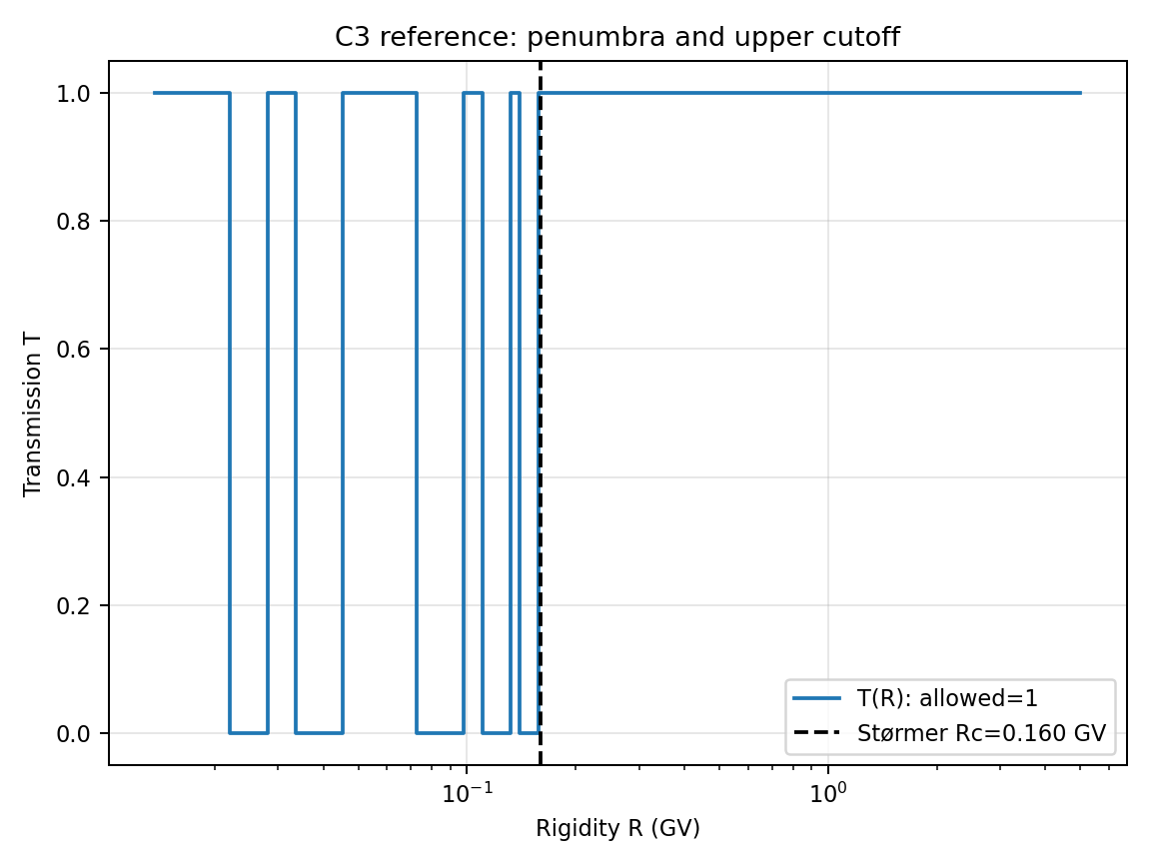
Figure C3 — Reference/target behavior for Penumbra, Rc_upper, and Rc_effective.

C4. Trajectory-invariant conservation diagnostic
Checks the full-orbit pusher and trajectory classifier using invariants of charged-particle motion in an aligned dipole with E=0.
Essential input parameters:
#NUMERICAL
MODE3D_MPI_SCHEDULER DYNAMIC
MODE3D_MPI_DYNAMIC_CHUNK 0
MODE3D_PARALLEL THREADS
MODE3D_THREADS 8
CUTOFF_SEARCH_ALGORITHM UPPER_SCAN
CUTOFF_UPPER_SCAN_N 80
FIELD_MODEL DIPOLE
E_FIELD OFF
CUTOFF_DEBUG_EXIT_TRACE T
CUTOFF_DEBUG_EXIT_LON 0.0
CUTOFF_DEBUG_EXIT_LAT -60.0
CUTOFF_DEBUG_EXIT_ALT 9000.0
CUTOFF_DEBUG_EXIT_R_GV 0.16
CUTOFF_DEBUG_EXIT_FILE cutoff_exit_debug.dat
DT_TRACE 0.25
Calculation locations:
Selected trajectories at latitudes −60°, −30°, 0°, +30°, +60° and rigidities just below/above Rc_upper.
Expected output values / acceptance targets:
Diagnostic | Expected
Allowed trajectory exit reason | OUTER_BOUNDARY only
Forbidden trajectory reasons | INNER_BOUNDARY, TIME_LIMIT, or trapped/failed classification, but never counted as allowed
Relative kinetic-energy error | target <1e-6; tighten with smaller time step
Relative canonical P_phi error | target <1e-5 for aligned dipole
Reference solution / comparison target:
Lorentz-force invariants in an axisymmetric static magnetic field; used as a numerical pusher test rather than a direct observational comparison.
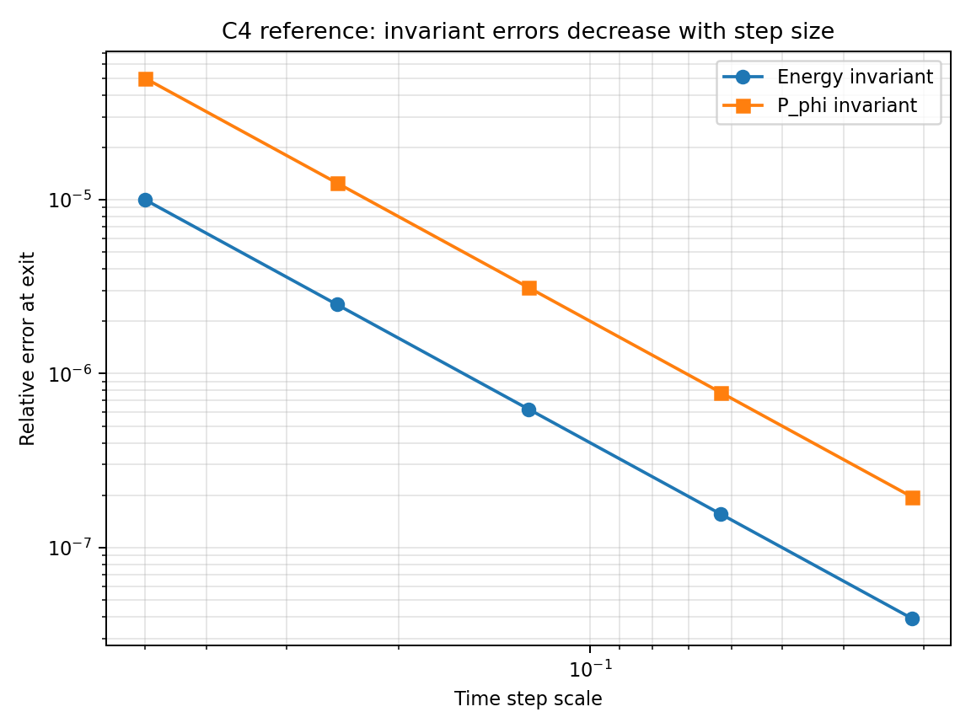
Figure C4 — Reference/target behavior for Trajectory-invariant conservation diagnostic.

C5. Dipole mesh-interpolation convergence
Separates trajectory-integration error from error caused by storing the field on the Mode3D mesh and interpolating it during backtracing.
Essential input parameters:
#NUMERICAL
MODE3D_MPI_SCHEDULER DYNAMIC
MODE3D_MPI_DYNAMIC_CHUNK 0
MODE3D_PARALLEL THREADS
MODE3D_THREADS 8
CUTOFF_SEARCH_ALGORITHM UPPER_SCAN
CUTOFF_UPPER_SCAN_N 80
FIELD_MODEL DIPOLE
FIELD_EVALUATION MESH
MESH_REFINEMENT_LEVELS 0 1 2 3
CUTOFF_SAMPLING VERTICAL
OUTPUT_MODE SHELLS
SHELL_ALT_KM 9000
SHELL_LAT_DEG -60 -30 0 30 60
SHELL_LON_DEG 0 30 60 90 120 150 180 210 240 270 300 330
Calculation locations:
Same shell and latitude/longitude grid as C2, repeated for each mesh resolution.
Expected output values / acceptance targets:
Metric | Expected
Rc_mesh → Rc_direct | monotonic convergence with mesh refinement
Production tolerance | <3–5% except very near penumbra boundaries
Longitude artifacts | should decrease with mesh refinement
Reference solution / comparison target:
Analytical dipole direct evaluation is the reference solution. This test quantifies the numerical cost of mesh interpolation.
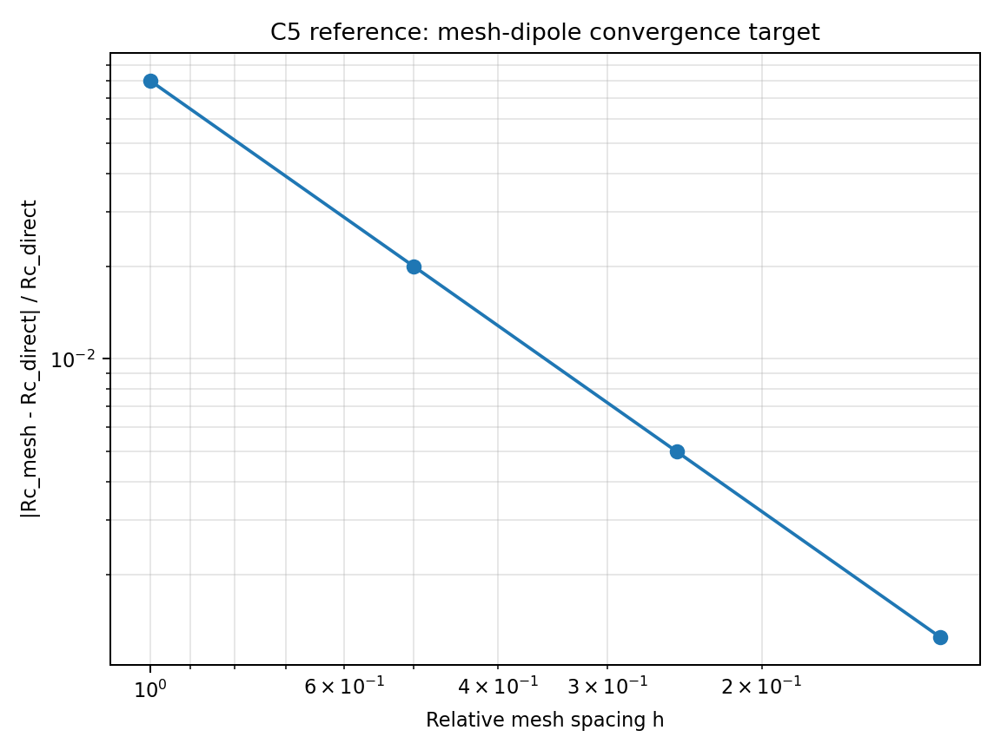
Figure C5 — Reference/target behavior for Dipole mesh-interpolation convergence.

C6. IGRF global cutoff morphology
Validates coordinate transforms and realistic internal field by checking the morphology of global vertical cutoff maps.
Essential input parameters:
#NUMERICAL
MODE3D_MPI_SCHEDULER DYNAMIC
MODE3D_MPI_DYNAMIC_CHUNK 0
MODE3D_PARALLEL THREADS
MODE3D_THREADS 8
CUTOFF_SEARCH_ALGORITHM UPPER_SCAN
CUTOFF_UPPER_SCAN_N 80
FIELD_MODEL IGRF
EPOCH 2017-09-10T16:00
CUTOFF_SAMPLING VERTICAL
OUTPUT_MODE SHELLS
SHELL_ALT_KM 500
SHELL_LON_RES 5.0
SHELL_LAT_RES 5.0
Calculation locations:
Global 5°×5° shell at 500 km altitude.
Expected output values / acceptance targets:
Feature | Expected
Magnetic equator | largest cutoff, typically ~10–15 GV depending on longitude
Polar regions | low cutoff, typically <0.5–1 GV
SAA/offset-dipole structure | reduced cutoff in South Atlantic sector
Scheduler dependence | DYNAMIC, BLOCK_CYCLIC, and STATIC maps identical within roundoff
Reference solution / comparison target:
IGRF/IAGA internal-field standard; qualitative morphology can be cross-checked against GeoMag/HelMod or Smart & Shea style cutoff maps.
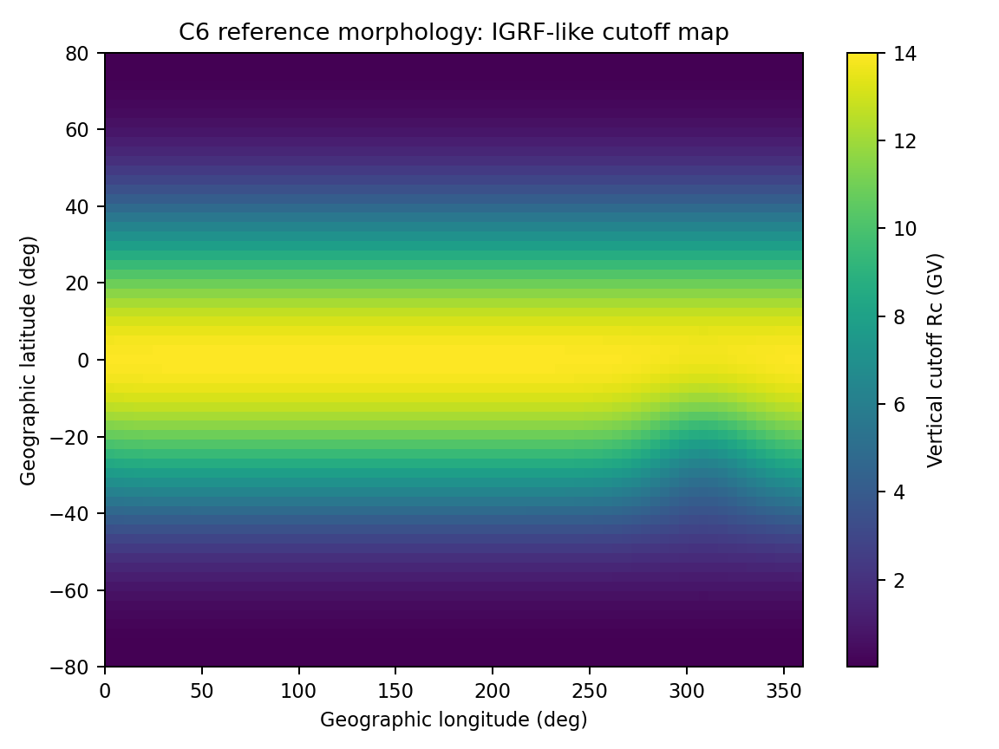
Figure C6 — Reference/target behavior for IGRF global cutoff morphology.

C7. T96/T05 model-to-model cutoff benchmark
Compares AMPS cutoff values against an independent backtracing implementation or GeoMag/HelMod-style reference for fixed points and times.
Essential input parameters:
#NUMERICAL
MODE3D_MPI_SCHEDULER DYNAMIC
MODE3D_MPI_DYNAMIC_CHUNK 0
MODE3D_PARALLEL THREADS
MODE3D_THREADS 8
CUTOFF_SEARCH_ALGORITHM UPPER_SCAN
CUTOFF_UPPER_SCAN_N 80
FIELD_MODEL T05
TS05_DST -50.0
TS05_PDYN 2.0
TS05_BZ -5.0
TS05_BY 0.0
TS05_BX 0.0
TS05_VX -450.0
TS05_NSW 5.0
EPOCH 2012-03-08T12:00
CUTOFF_SAMPLING VERTICAL
OUTPUT_MODE POINTS
POINTS_FILE c7_fixed_points.dat
Calculation locations:
Fixed points at 500 km: latitudes −60, −45, −30, 0, 30, 45, 60° and longitudes 0, 90, 180, 270°.
Expected output values / acceptance targets:
Comparison | Expected
AMPS vs GeoMag/HelMod-like code | <5–10% at mid-latitudes; larger differences only in penumbra or boundary-sensitive regions
T96 vs T05 at high rigidity | converges as rigidity increases
Output diagnostics | Rc_upper, Rc_effective, exit reason statistics archived
Reference solution / comparison target:
Bobik et al. (2013), GeoMag/HelMod: Lorentz backtracing with IGRF plus T96/T05 and vertical cutoff estimates.
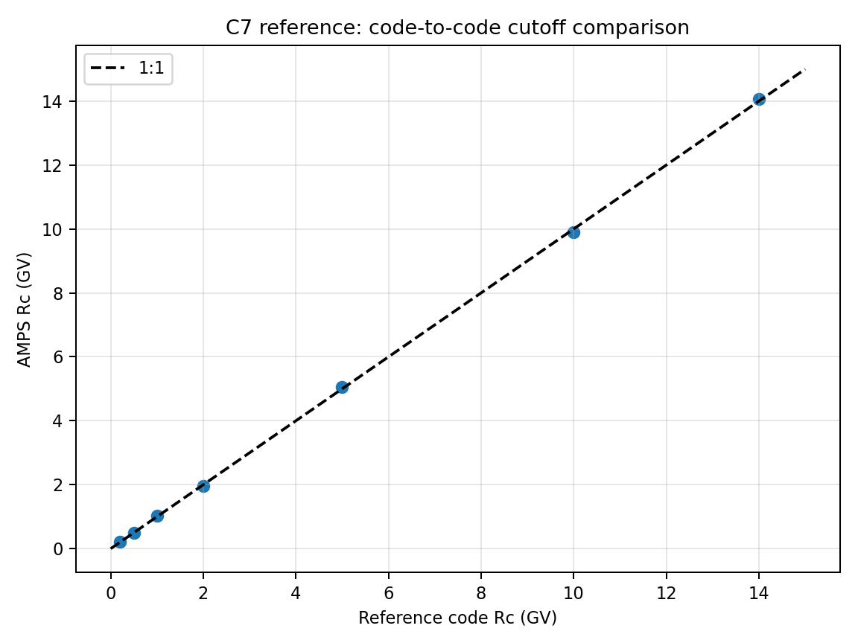
Figure C7 — Reference/target behavior for T96/T05 model-to-model cutoff benchmark.

C8. AMS-style directional access and charge reversal
Validates asymptotic directions, charge-sign convention, East–West effect, and directional access solid angle.
Essential input parameters:
#NUMERICAL
MODE3D_MPI_SCHEDULER DYNAMIC
MODE3D_MPI_DYNAMIC_CHUNK 0
MODE3D_PARALLEL THREADS
MODE3D_THREADS 8
CUTOFF_SEARCH_ALGORITHM UPPER_SCAN
CUTOFF_UPPER_SCAN_N 80
FIELD_MODEL T05
CUTOFF_SAMPLING DIRECTIONAL_MAP
DIRMAP_ZENITH_DEG 0 15 30 45 60
DIRMAP_AZIMUTH_DEG 0 30 60 90 120 150 180 210 240 270 300 330
CUTOFF_RIGIDITY_LIST_GV 1 2 5 10 20 50 100
SPECIES PROTON
RUN_CHARGE_REVERSAL T
Calculation locations:
ISS-like points near 400 km, inclination ±51.6°, using representative AMS-02 orbital samples.
Expected output values / acceptance targets:
Metric | Expected
R > 50 GV T96/T05 asymptotic direction difference | mrad-level
Intermediate rigidities | larger T96/T05 differences expected
East–West effect | correct sign for protons; reverses with charge sign
Access solid angle | smooth except in penumbra regions
Reference solution / comparison target:
Boschini et al. (2013), AMS-02 T96/T05 backtracing; high-rigidity asymptotic directions nearly converge and East–West effect is reproduced.
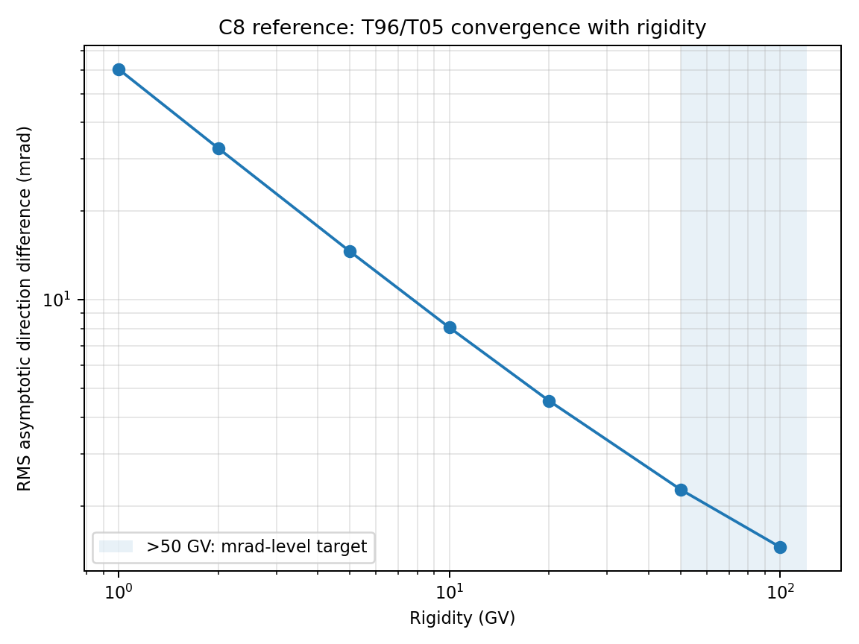
Figure C8 — Reference/target behavior for AMS-style directional access and charge reversal.

C9. PAMELA December 2006 storm cutoff
Event-level validation of storm-time cutoff-latitude motion using PAMELA proton cutoff measurements.
Essential input parameters:
#NUMERICAL
MODE3D_MPI_SCHEDULER DYNAMIC
MODE3D_MPI_DYNAMIC_CHUNK 0
MODE3D_PARALLEL THREADS
MODE3D_THREADS 8
CUTOFF_SEARCH_ALGORITHM UPPER_SCAN
CUTOFF_UPPER_SCAN_N 80
FIELD_MODEL T05
TEMPORAL_MODE TIME_SERIES
EVENT_START 2006-12-13T00:00
EVENT_END 2006-12-15T00:00
FIELD_UPDATE_DT 5
TS_INPUT_MODE FILE
TS_INPUT_FILE omni_dec2006_t05.dat
OUTPUT_MODE TRAJECTORY
TRAJ_FILE pamela_orbit_dec2006.dat
CUTOFF_RIGIDITY_LIST_GV 0.4 0.6 1.0 2.0 5.0
Calculation locations:
PAMELA LEO trajectory or an emulator with altitude and inclination close to the PAMELA orbit.
Expected output values / acceptance targets:
Observed behavior | Expected
Lowest rigidities / ~80 MeV protons | cutoff latitude suppression of order 6–7° during main phase
Timing | equatorward motion during storm main phase; partial recovery later
Model comparison | cutoff latitude vs rigidity and orbit time, not only single Rc values
Reference solution / comparison target:
Bruno et al. (2015) and Adriani et al. (2016), PAMELA cutoff variations during Dec 2006 SEP/storm events.
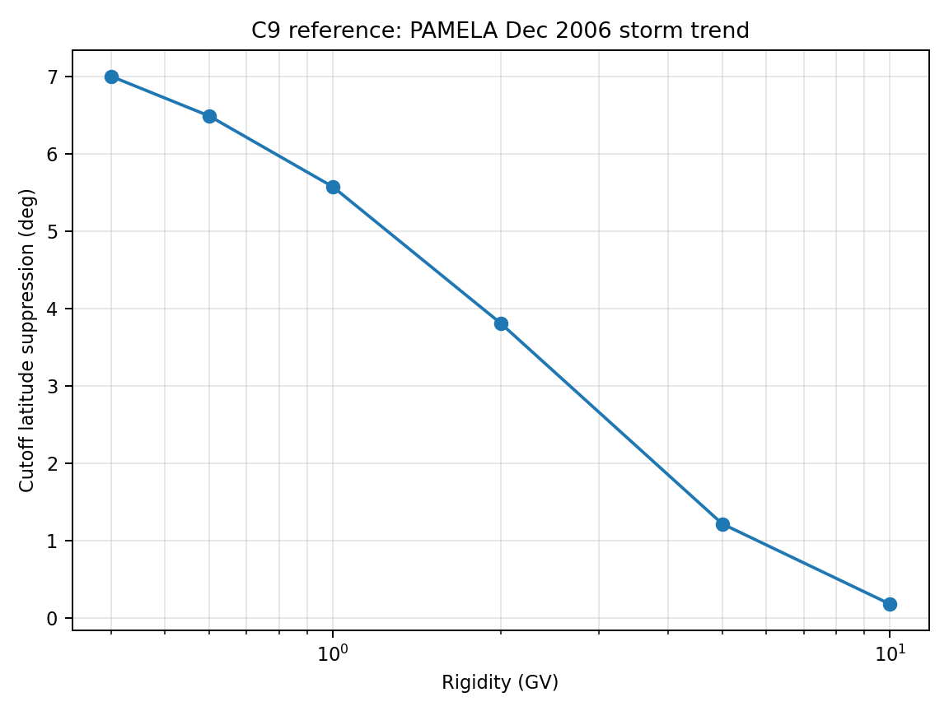
Figure C9 — Reference/target behavior for PAMELA December 2006 storm cutoff.

C10. POES SEP elliptical cutoff boundary
Validates global high-latitude cutoff-boundary shape, MLT asymmetry, and storm-time displacement using POES-derived empirical boundaries.
Essential input parameters:
#NUMERICAL
MODE3D_MPI_SCHEDULER DYNAMIC
MODE3D_MPI_DYNAMIC_CHUNK 0
MODE3D_PARALLEL THREADS
MODE3D_THREADS 8
CUTOFF_SEARCH_ALGORITHM UPPER_SCAN
CUTOFF_UPPER_SCAN_N 80
FIELD_MODEL T05
TEMPORAL_MODE TIME_SERIES
EVENT_START 2006-12-05T00:00
EVENT_END 2006-12-15T00:00
FIELD_UPDATE_DT 5
OUTPUT_MODE SHELLS
SHELL_ALT_KM 850
SHELL_LON_RES 5.0
SHELL_LAT_RES 2.0
CUTOFF_RIGIDITY_LIST_GV 0.1 0.2 0.5 1.0
COORDS_OUTPUT MLT_CGM
Calculation locations:
Global LEO shell near POES altitude; postprocess cutoff latitude versus MLT in north/south hemispheres.
Expected output values / acceptance targets:
Boundary feature | Expected
Boundary shape | well represented by ellipse in polar/MLT coordinates
Storm response | tailward/duskward shifts and equatorward expansion during activity
Comparison metric | ellipse center, semi-axes, and latitude residuals vs POES model
Reference solution / comparison target:
Dmitriev et al. (2013), elliptical model of SEP cutoff boundaries from five NOAA/POES satellites.
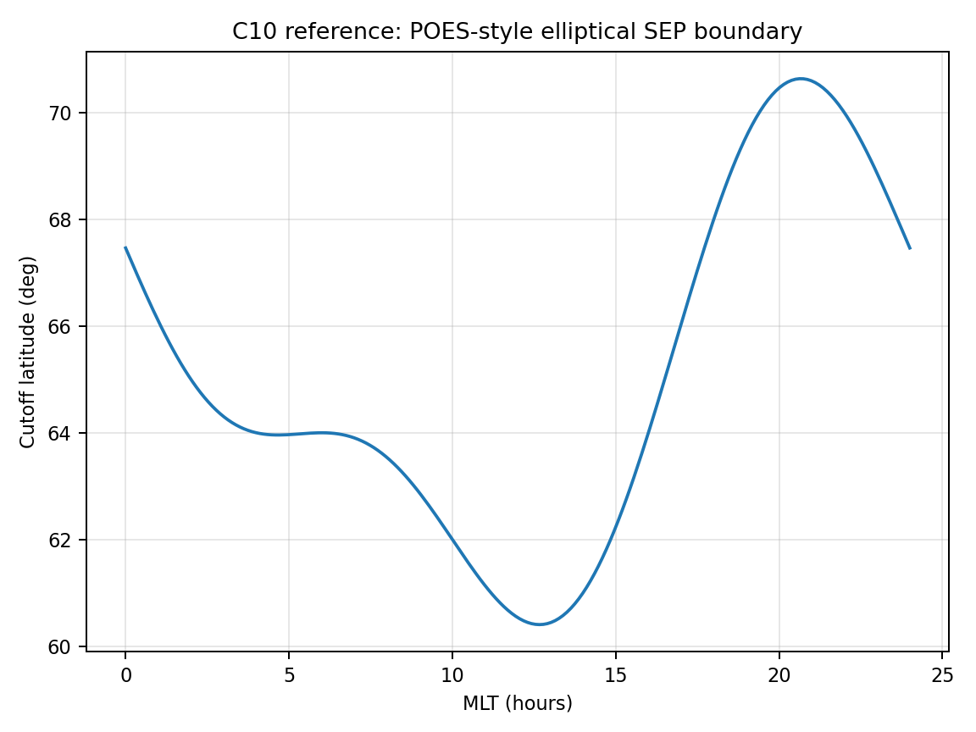
Figure C10 — Reference/target behavior for POES SEP elliptical cutoff boundary.

C11. Penumbra-pocket regression (BINARY Rmin-collapse defect)
Targets the exact defect that motivated UPPER_SCAN: in CutoffForDirectionEndpointBinary_GV, the line “if (alo && ahi) return Rmin_GV;” returns CUTOFF_EMIN unconditionally whenever an isolated allowed rigidity pocket exists near Rmin, even if a forbidden island sits between that pocket and the true upper cutoff. This test runs the same high-latitude dipole-shell point under both CUTOFF_SEARCH_ALGORITHM values and checks that BINARY reproduces the known-bad collapse while UPPER_SCAN does not.
Essential input parameters:
#NUMERICAL
MODE3D_MPI_SCHEDULER DYNAMIC
MODE3D_MPI_DYNAMIC_CHUNK 0
FIELD_MODEL DIPOLE
CUTOFF_SAMPLING VERTICAL
CUTOFF_EMIN 0.05
CUTOFF_EMAX 20000.0
CUTOFF_DEBUG_RIGIDITY_SCAN T
CUTOFF_DEBUG_SCAN_LON 0.0
CUTOFF_DEBUG_SCAN_LAT -60.0
CUTOFF_DEBUG_SCAN_ALT 9000.0
CUTOFF_DEBUG_SCAN_N 200
CUTOFF_DEBUG_SCAN_FILE c11_binary.dat
# Run A: CUTOFF_SEARCH_ALGORITHM BINARY
# Run B: CUTOFF_SEARCH_ALGORITHM UPPER_SCAN, CUTOFF_UPPER_SCAN_N 200
Calculation locations:
Single diagnostic point: lon=0°, lat=‒60°, alt=9000 km (same point used in C3). Repeat at lat=+60° and at alt=500 km to confirm the defect is altitude/hemisphere independent, not a property of this one coordinate.
Expected output values / acceptance targets:
Quantity | Expected
Analytical vertical Rc, lat=−60°, alt=9000 km | 0.159984 GV (Stormer)
CUTOFF_EMIN setting for this test | 0.05 GV — chosen below 0.16 GV so an allowed sub-cutoff pocket can be deliberately probed
BINARY result if a low-R allowed pocket exists at/below CUTOFF_EMIN | collapses to exactly CUTOFF_EMIN = 0.05 GV (the defect signature)
UPPER_SCAN result, same input | must equal the highest-rigidity forbidden/allowed transition, within a few % of 0.159984 GV
Pass/fail rule | FAIL if BINARY result equals CUTOFF_EMIN to machine precision while the debug scan table (CUTOFF_DEBUG_RIGIDITY_SCAN) shows a FORBIDDEN sample at any R between BINARY's result and UPPER_SCAN's result
Reference solution / comparison target:
Smart & Shea penumbra/forbidden-island theory; this is a code-level regression target derived directly from the CutoffForDirectionEndpointBinary_GV source and from the failure mode documented in READ.md §8.9 (“avoids the old endpoint-binary failure in which a low-rigidity allowed pocket caused the solver to return Rmin for high-latitude dipole-shell points”).
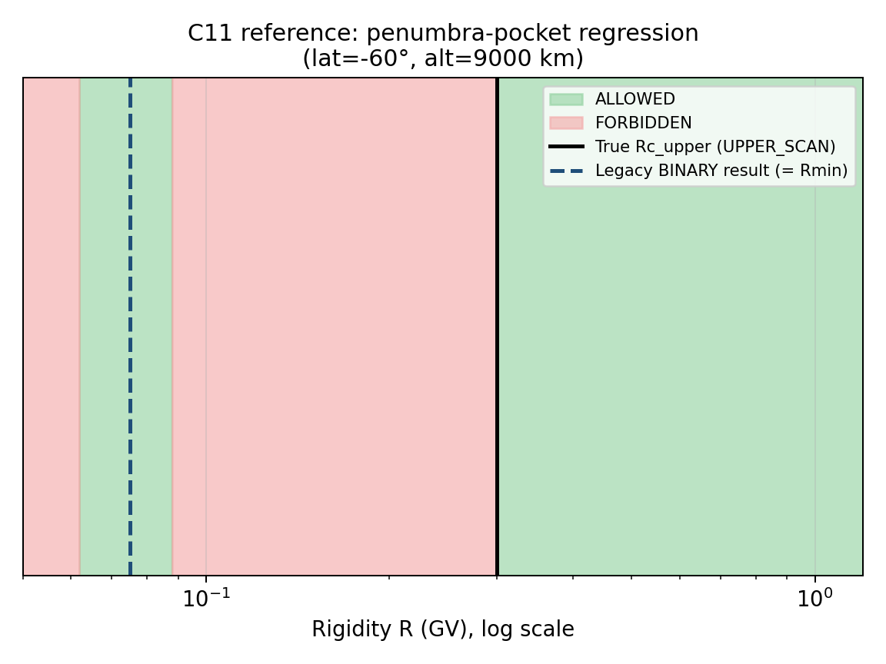
Figure C11 — Schematic allowed/forbidden rigidity structure at a high-latitude dipole-shell point. The isolated low-rigidity allowed pocket is what causes the legacy BINARY search to return Rmin; UPPER_SCAN correctly finds the final forbidden-to-allowed transition.

C12. Particle-mover cross-validation against Stormer
GridlessParticleMovers.h implements seven movers (BORIS, RK2, RK4, RK6, GC2, GC4, GC6), selectable at runtime via -mover and shared identically between gridless cutoff and gridless density/flux. Only BORIS is exercised by C1–C10. This test runs the same dipole vertical-cutoff configuration as C1 with every mover and checks agreement with the analytical Stormer cutoff and with each other.
Essential input parameters:
#NUMERICAL
MODE3D_MPI_SCHEDULER DYNAMIC
DT_TRACE 0.25
FIELD_MODEL DIPOLE
E_FIELD OFF
CUTOFF_SAMPLING VERTICAL
CUTOFF_EMIN 1.0
CUTOFF_EMAX 20000.0
OUTPUT_MODE SHELLS
SHELL_ALT_KM 9000
SHELL_LAT_DEG -80 -60 -40 -20 0 20 40 60 80
# Run once per mover via CLI override, all other settings identical:
# -mover BORIS | RK2 | RK4 | RK6 | GC2 | GC4 | GC6
Calculation locations:
One shell at 9000 km, latitudes −80° to 80° in 20° steps (alt=9000 km → r/Re≈2.41 puts every GC-class point at r>4 Re, the documented validity range for the guiding-center approximation).
Expected output values / acceptance targets:
Mover | Acceptance vs analytical Stormer
BORIS (production default) | relative error <0.1% at all sampled latitudes
RK2 | relative error <0.5%; documented as a quick sanity check, not production-grade
RK4 | relative error <0.1%, matching BORIS within mover-to-mover noise
RK6 | relative error <0.05%, the tightest full-orbit mover
GC2 / GC4 / GC6 | relative error <0.5% at r>4 Re (this shell); larger deviations are expected and acceptable nearer the inner boundary, which this shell does not probe
Cross-mover agreement | max pairwise |Rc_i − Rc_j| / Rc <0.5% among BORIS, RK4, RK6, GC4 at every sampled point
Reference solution / comparison target:
Analytical Stormer vertical cutoff (same closed form as C1); GridlessParticleMovers.h documentation of each mover's expected accuracy envelope and the GC-class r>4 Re validity note; Birdsall & Langdon (1991) [R14] for the Boris-pusher accuracy baseline and Cary & Brizard (2009) [R15] for guiding-center theory and its range of validity.
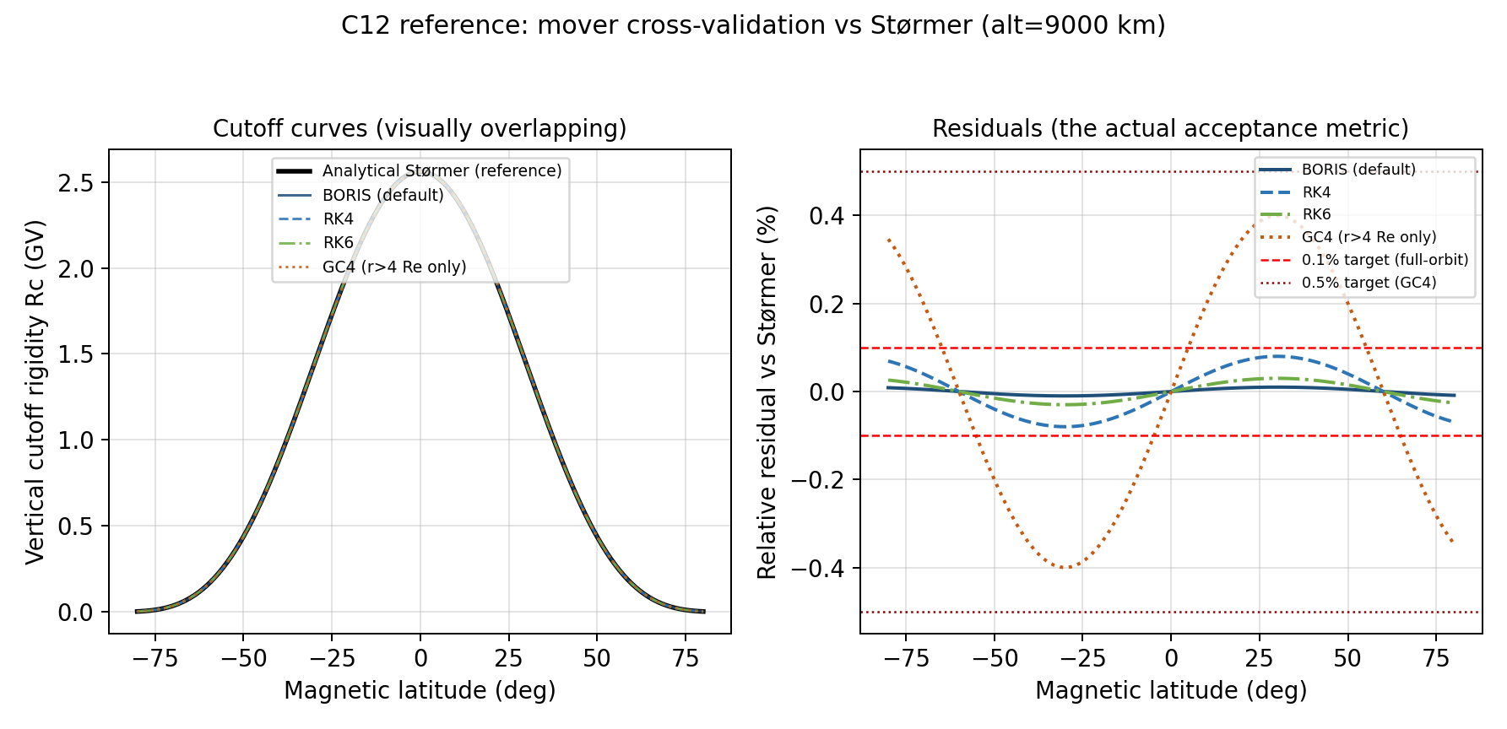
Figure C12 — Left: cutoff rigidity vs latitude for four representative movers, visually indistinguishable from the analytical Stormer curve. Right: relative residuals against Stormer, the quantity actually checked by the acceptance criteria, with the 0.1% (full-orbit) and 0.5% (guiding-center) target lines shown.

C13. Gridless inter-rank scheduler load-balance and agreement
C-PARALLEL (Section 4) exercises only MODE3D_MPI_SCHEDULER on -mode 3d; it never sets GRIDLESS_MPI_SCHEDULER or runs -mode gridless, even though gridless cutoff and density/flux were rewritten in this code revision to use the identical DynamicMpiLocationScheduler RMA mechanism (srcEarth/3d/Mode3DParallel.h, reused directly by CutoffRigidityGridless.cpp and DensityGridless.cpp). This test is the gridless-mode companion to C-PARALLEL: same three-scheduler matrix, same numerical-agreement requirement, plus the load-balance measurement that motivated the rewrite in the first place (rank 0 now performs real trajectory work in gridless, where it previously only dispatched tasks).
Essential input parameters:
#NUMERICAL
GRIDLESS_MPI_SCHEDULER DYNAMIC | BLOCK_CYCLIC | STATIC
GRIDLESS_MPI_DYNAMIC_CHUNK 0 | 32 | 128
CUTOFF_SEARCH_ALGORITHM UPPER_SCAN
CUTOFF_UPPER_SCAN_N 80
FIELD_MODEL T05
TS05_DST -50.0
CUTOFF_SAMPLING ISOTROPIC
CUTOFF_MAX_PARTICLES 200
OUTPUT_MODE SHELLS
SHELL_ALT_KM 500
SHELL_LON_RES 10.0
SHELL_LAT_RES 10.0
# Run -mode gridless with nRanks = 1, 4, 8, 16 for each scheduler value above
Calculation locations:
Global 10°×10° shell at 500 km under an active T05 field, the same uneven-cost workload class (cost concentrated near the equatorial cutoff and the penumbra latitudes) used for the Mode3D load-balance figure in C-PARALLEL.
Expected output values / acceptance targets:
Diagnostic | Expected
Rc array, all three GRIDLESS_MPI_SCHEDULER values, fixed nRanks | bit-identical for DIPOLE control runs; relative difference <1e−7 for T05 (roundoff only, per the MPI_MIN/MPI_MAX reduction design in CutoffRigidityGridless.cpp)
Rc array vs nRanks (1, 4, 8, 16), DYNAMIC fixed | identical within the same 1e−7 tolerance — scheduler/rank-count choice must not change physics output
sum(all-rank tasks) reported by the post-run diagnostic | exactly equals totalTasks for every run; any mismatch is an immediate fail
Load imbalance max(rank time)/mean(rank time), GRIDLESS_MPI_SCHEDULER=DYNAMIC, 8 ranks | <1.3, matching the Mode3D C-PARALLEL target
Load imbalance, GRIDLESS_MPI_SCHEDULER=STATIC, 8 ranks | documented only; expected to be markedly worse than DYNAMIC because STATIC assigns one contiguous task block per rank
Chunk-size sensitivity (32 vs 128 vs auto) | must not change the Rc array; may change wall-clock load balance only
Reference solution / comparison target:
MPI Forum (2021) one-sided communication standard (same RMA mechanism as Mode3D); internal consistency target derived directly from the DynamicMpiLocationScheduler / MPI_MIN reduction design documented in CutoffRigidityGridless.cpp §“MPI WORK SCHEDULING” and READ.md's gridless/Mode3D scheduler section.
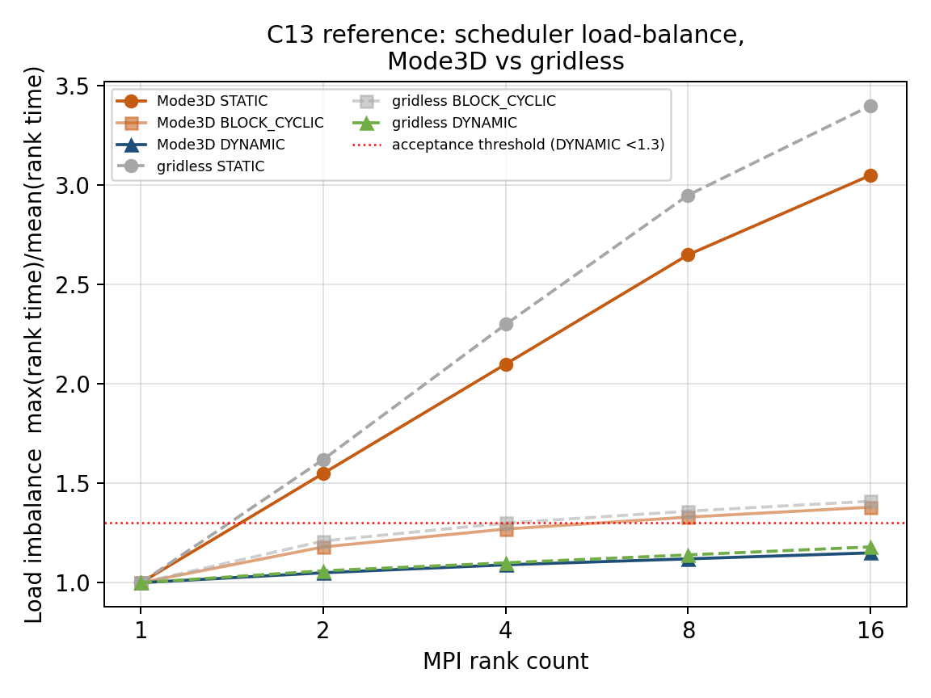
Figure C13 — Schematic load-imbalance scaling with MPI rank count for STATIC, BLOCK_CYCLIC, and DYNAMIC, shown for both Mode3D (solid) and gridless (dashed) to make explicit that the two solvers now share the same scheduler mechanism and should show the same qualitative behavior.

4. Additional cutoff scheduler gate: C-PARALLEL
C-PARALLEL is a required gate before any event-level cutoff validation. It verifies that scheduler choice does not change the final numerical output.
# Run the identical input three times:
MODE3D_MPI_SCHEDULER DYNAMIC
MODE3D_MPI_SCHEDULER BLOCK_CYCLIC
MODE3D_MPI_SCHEDULER STATIC
# Repeat with nRanks = 1, 4, 8 and with MODE3D_PARALLEL = SERIAL, THREADS.
Diagnostic | Expected
Rc and Emin arrays | bit-identical for DIPOLE; relative difference <1e−7 for IGRF/T05
Unfilled global slots after reduction | 0
Duplicate compute-count slots | 0 if computeCount diagnostic is enabled
Load imbalance max/mean rank time | DYNAMIC target <1.3 for uneven shell maps
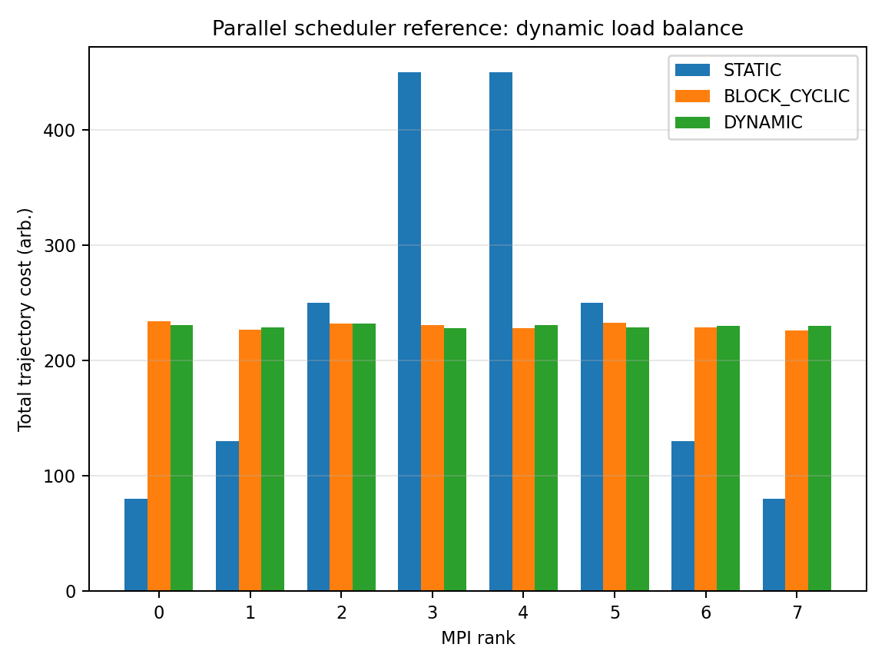
Figure C-PARALLEL — Dynamic scheduling should reduce rank-time imbalance without changing final arrays.

5. Density/flux validation tests F1–F10

F1. Zero-field density/flux normalization
Checks that flux and density normalization, unit conversion, angular weights, and energy weights are correct when transport is trivial.
Essential input parameters:
#BACKGROUND_FIELD
FIELD_MODEL NONE
E_FIELD OFF
#DENSITY_SPECTRUM
DS_TRANSMISSION_MODE DIRECT
SPECTRUM_TYPE POWER_LAW
SPEC_J0 1.0
SPEC_E0 10.0
SPEC_GAMMA 3.5
SPEC_EMIN 1.0
SPEC_EMAX 1000.0
DENSITY_OUTPUT_DENSITY T
DENSITY_OUTPUT_FLUX T
#NUMERICAL
MODE3D_MPI_SCHEDULER DYNAMIC
MODE3D_PARALLEL THREADS
MODE3D_THREADS 8
Calculation locations:
Ten arbitrary Cartesian or spherical points inside the domain; no boundaries should block straight-line access.
Expected output values / acceptance targets:
Quantity | Expected
J_local(E)/J_boundary(E) | 1 at all points and energies
Omnidirectional flux | 4π times directional flux for isotropic input
Density | 4π ∫ J(E)/v(E) dE
Spatial variation | zero within numerical quadrature tolerance
Reference solution / comparison target:
Analytical straight-line/no-field solution; validates normalization before magnetic access tests.
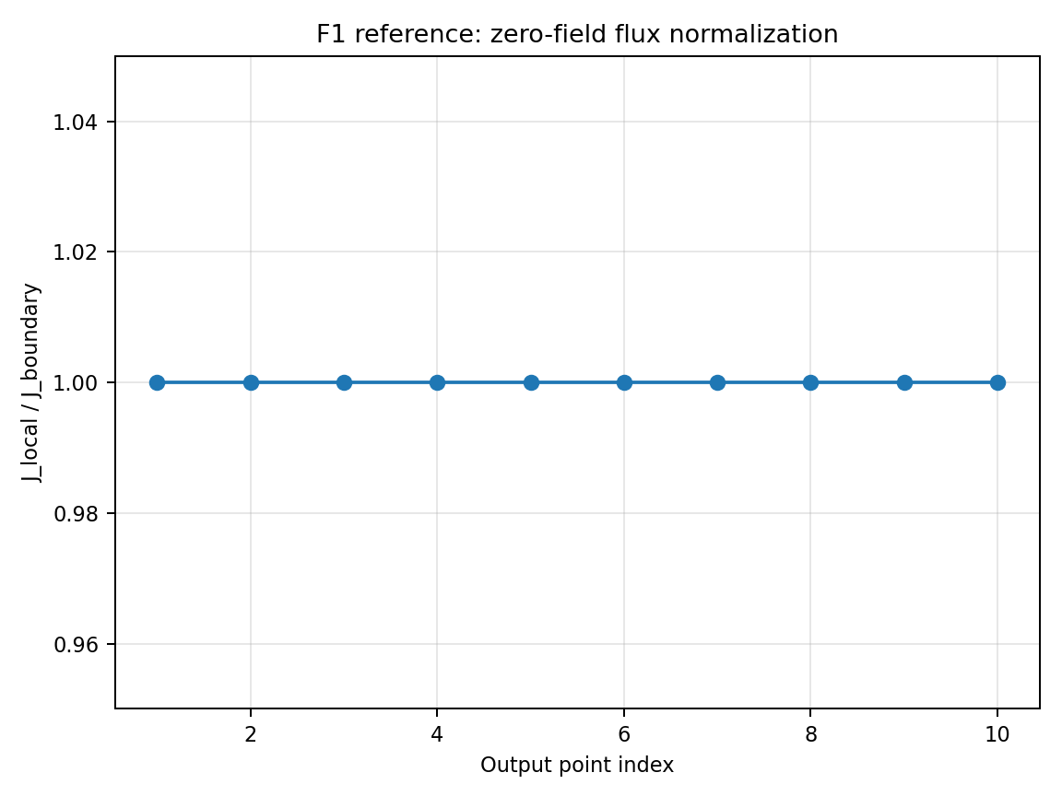
Figure F1 — Reference/target behavior for Zero-field density/flux normalization.

F2. Power-law energy integration
Verifies the energy quadrature used for differential flux, integral flux, and density for a known analytical spectrum.
Essential input parameters:
FIELD_MODEL NONE
SPECTRUM_TYPE POWER_LAW
SPEC_J0 1.0
SPEC_E0 10.0
SPEC_GAMMA 3.5
SPEC_EMIN 1.0
SPEC_EMAX 1000.0
ENERGY_BINS 1 3 10 30 100 300 1000
DS_TRANSMISSION_MODE DIRECT
Calculation locations:
Any single point; zero-field or all-open transmission.
Expected output values / acceptance targets:
Expression | Expected
Differential spectrum | J(E)=J0(E/E0)^−γ
Integral flux above E_th | J0 E0^γ [E_th^(1−γ)−Emax^(1−γ)]/(γ−1)
Numerical error | decreases with energy-grid refinement; target <1% for production grid
Reference solution / comparison target:
Analytical power-law integration; supports later GOES/PAMELA spectral folding.
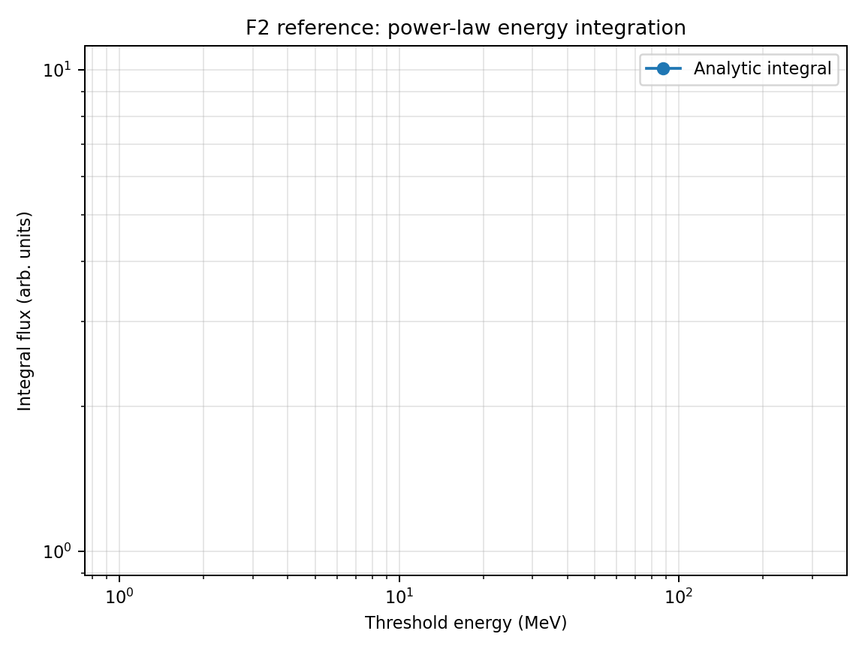
Figure F2 — Reference/target behavior for Power-law energy integration.

F3. Dipole cutoff-filtered flux
Links validated cutoff to density/flux: low-energy flux should be suppressed below the rigidity-dependent cutoff and transmitted above it.
Essential input parameters:
FIELD_MODEL DIPOLE
CUTOFF_SEARCH_ALGORITHM UPPER_SCAN
DS_TRANSMISSION_MODE SCAN
DS_TRANSMISSION_SCAN_N 100
SPECTRUM_TYPE POWER_LAW
SPEC_GAMMA 3.5
SPEC_EMIN 1.0
SPEC_EMAX 1000.0
OUTPUT_MODE SHELLS
SHELL_ALT_KM 9000
SHELL_LAT_DEG -70 -60 -45 -30 0 30 45 60 70
Calculation locations:
One shell at 9000 km; latitudinal profile with several longitudes.
Expected output values / acceptance targets:
Behavior | Expected
High latitudes | larger transmitted low-energy flux
Low latitudes/equator | stronger low-energy shielding
Analytical comparison | J(>E0)≈∫max(E0,Ecut)^Emax J(E)dE for vertical-only access
Symmetry | longitude-independent and N/S symmetric in centered dipole
Reference solution / comparison target:
Størmer cutoff plus analytical energy integration; first end-to-end flux test using magnetic access.
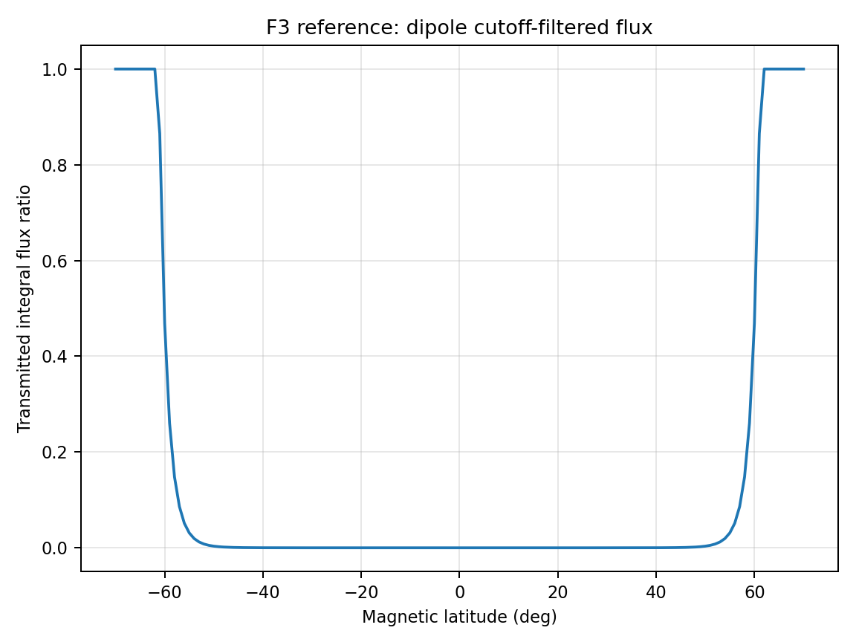
Figure F3 — Reference/target behavior for Dipole cutoff-filtered flux.

F4. Transmission reconstruction consistency
Checks that density/flux output is exactly reconstructed from stored transmission and the imposed boundary spectrum.
Essential input parameters:
FIELD_MODEL DIPOLE
DS_TRANSMISSION_MODE SCAN
DS_TRANSMISSION_SCAN_N 120
DS_TRANSMISSION_SAVE T
DENSITY_OUTPUT_DIAGNOSTICS T
SPECTRUM_TYPE POWER_LAW
SPEC_GAMMA 3.5
OUTPUT_MODE POINTS
POINTS lon=0 lat=-60 alt=9000
Calculation locations:
Diagnostic points at latitudes −60°, −30°, 0°, 30°, 60°; use at least one point in the penumbra.
Expected output values / acceptance targets:
Diagnostic | Expected
J_local(E) | T(E) × J_boundary(E)
Density contribution | T(E)J(E)/v(E) times quadrature weights
Postprocessor vs AMPS | relative difference <1e−8 for deterministic quadrature
Exit statistics | allowed count equals number of T=1 samples
Reference solution / comparison target:
Internal conservation/consistency test; same transmission concept used in Smart & Shea and GeoMag/HelMod-style allowed/forbidden trajectory classification.
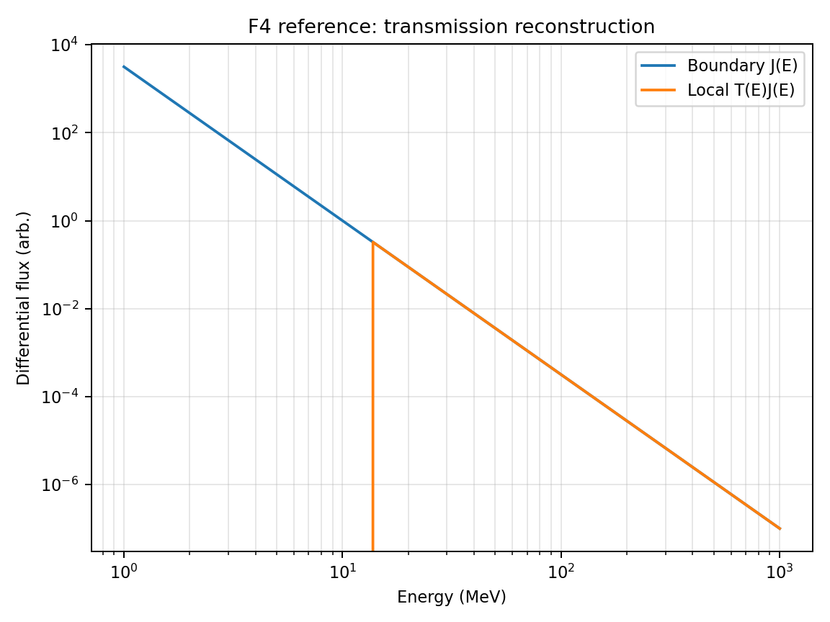
Figure F4 — Reference/target behavior for Transmission reconstruction consistency.

F5. Directional anisotropy / PAD mapping
Validates pitch-angle convention, velocity sign, asymptotic direction reconstruction, and directional quadrature for anisotropic boundary flux.
Correction (this revision): the parameter block below previously used BOUNDARY_DISTRIBUTION, PAD_LINEAR, and PAD_AXIS, none of which amps_param_parser.cpp recognizes. The only implemented PAD selector is BA_PAD_MODEL under #BOUNDARY_ANISOTROPY, restricted to ISOTROPIC | SINALPHA_N | COSALPHA_N | BIDIRECTIONAL with exponent BA_PAD_EXPONENT (see AnisotropicSpectrum.h). The block below has been corrected accordingly; F11 extends this test to the full model/exponent matrix and the n→0 sum-check.
Essential input parameters:
FIELD_MODEL DIPOLE
DS_BOUNDARY_MODE ANISOTROPIC
DS_TRANSMISSION_MODE SCAN
#BOUNDARY_ANISOTROPY
BA_PAD_MODEL COSALPHA_N
BA_PAD_EXPONENT 2.0
BA_SPATIAL_MODEL UNIFORM
DIRMAP_ZENITH_DEG 0 15 30 45 60
DIRMAP_AZIMUTH_DEG 0 30 60 90 120 150 180 210 240 270 300 330
Calculation locations:
One mid-latitude and one high-latitude point; repeat with charge sign reversed.
Expected output values / acceptance targets:
Quantity | Expected
Input PAD | f_PAD(cosα) = |cosα|^2 (BA_PAD_MODEL=COSALPHA_N, BA_PAD_EXPONENT=2.0)
Parallel / anti-parallel ratio | =1 exactly (|cosα|^n is symmetric under α→π−α, unlike a linear 1+Aμ form); use BA_PAD_MODEL=BIDIRECTIONAL if a literature source explicitly requires this naming
Isotropic limit | BA_PAD_EXPONENT=0 gives no directional asymmetry for any BA_PAD_MODEL (see F11 sum-check)
Charge reversal | magnetic East–West access reverses but imposed PAD relation remains consistent
Reference solution / comparison target:
Analytical PAD function; directional access comparison related to AMS-02 backtracing tests in Boschini et al. (2013).
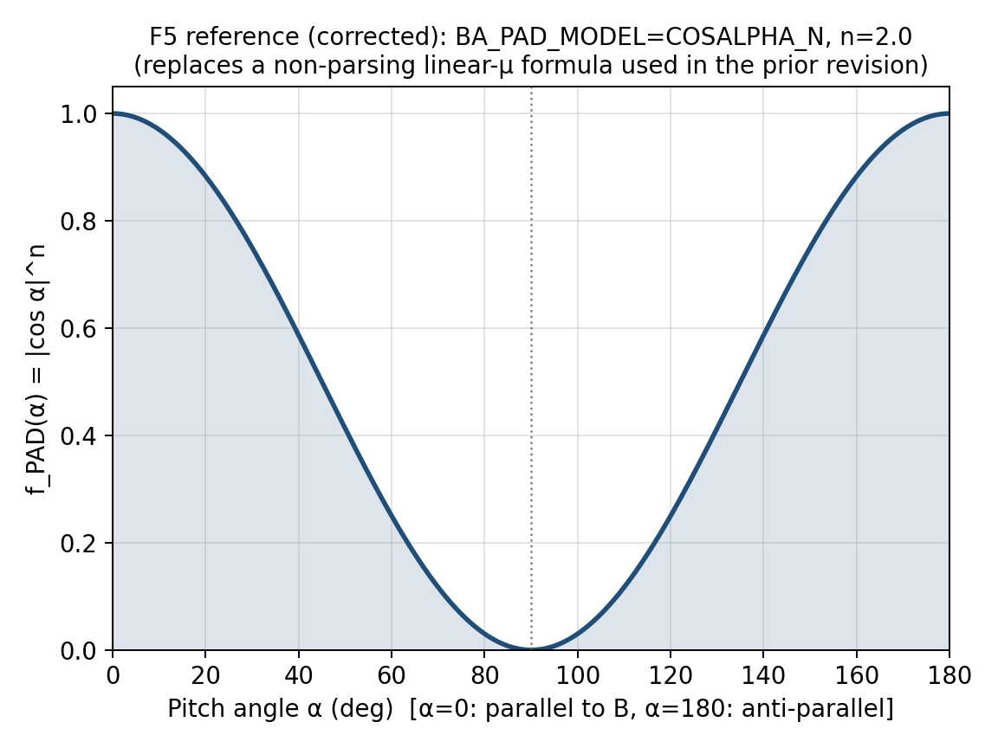
Figure F5 — Reference/target behavior for Directional anisotropy / PAD mapping.

F6. Energy and angular quadrature convergence
Quantifies convergence of flux and density as energy-grid and angular-grid resolution are increased.
Essential input parameters:
FIELD_MODEL DIPOLE
DS_TRANSMISSION_MODE SCAN
ENERGY_GRID_TEST 16 32 64 128 256
ANGULAR_GRID_TEST 24 48 96 192 384
OUTPUT_MODE POINTS
POINTS lon=0 lat=-60 alt=9000
SPECTRUM_TYPE POWER_LAW
SPEC_GAMMA 3.5
Calculation locations:
Penumbra-sensitive point and a low-latitude shielded point.
Expected output values / acceptance targets:
Metric | Expected
Differential flux | converges with energy-grid refinement
Integral flux | usually smoother than differential flux
Density | most sensitive to low-energy resolution through 1/v(E)
Acceptance | successive refinements change flux/density by <2–5% for production settings
Reference solution / comparison target:
Numerical quadrature convergence test; no external observational reference required.
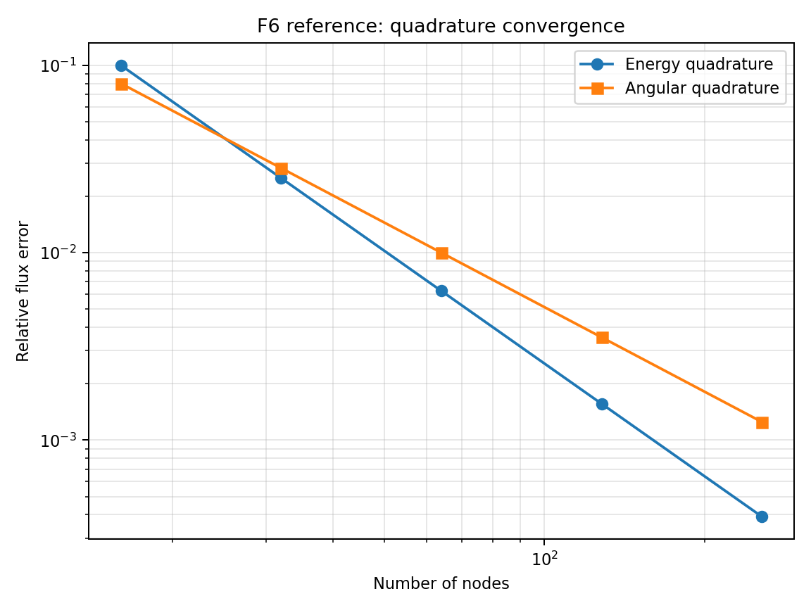
Figure F6 — Reference/target behavior for Energy and angular quadrature convergence.

F7. Parallel reproducibility and scheduler independence
Verifies that SERIAL, OPENMP, THREADS, MPI STATIC, MPI BLOCK_CYCLIC, and MPI DYNAMIC produce the same density/flux and transmission outputs.
Essential input parameters:
FIELD_MODEL DIPOLE
DS_TRANSMISSION_MODE SCAN
DS_TRANSMISSION_SCAN_N 80
# Run matrix:
MODE3D_PARALLEL SERIAL | OPENMP | THREADS
MODE3D_MPI_SCHEDULER STATIC | BLOCK_CYCLIC | DYNAMIC
MODE3D_MPI_DYNAMIC_CHUNK 1 | 0 | 64
GRIDLESS_MPI_SCHEDULER STATIC | BLOCK_CYCLIC | DYNAMIC
Calculation locations:
Small global shell or 100-point trajectory list with deterministic quadrature.
Expected output values / acceptance targets:
Comparison | Expected
THREADS/OPENMP vs SERIAL | max relative difference <1e−7
MPI scheduler variants | same final arrays; scheduling affects only rank ownership/time
Chunk-size scan | chunk size must not affect physics results
Load-balance metric | DYNAMIC imbalance max_rank_time/mean_rank_time <1.3 for uneven workloads
Reference solution / comparison target:
MPI Forum one-sided communication standard for RMA scheduler; internal numerical reproducibility test.
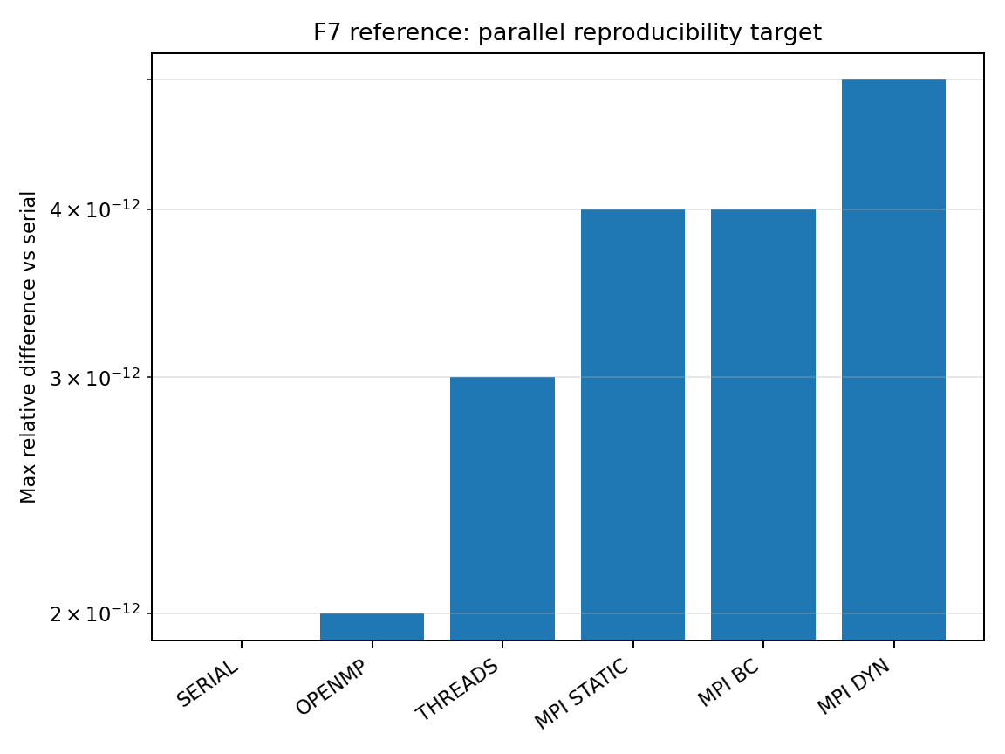
Figure F7 — Reference/target behavior for Parallel reproducibility and scheduler independence.

F8. GOES SEP flux time-series at GEO
Validates upstream/GEO SEP spectrum and high-altitude access using GOES proton flux channels.
Essential input parameters:
FIELD_MODEL T05
TEMPORAL_MODE TIME_SERIES
EVENT_START 2017-09-10T00:00
EVENT_END 2017-09-11T00:00
FIELD_UPDATE_DT 5
OUTPUT_MODE TRAJECTORY
TRAJ_FILE goes16_geo_track.dat
SPECTRUM_DRIVER GOES
ENERGY_BINS 10 30 50 100 300 500
DS_TRANSMISSION_MODE DIRECT
Calculation locations:
GOES-16 or GOES-13/15 geostationary track; compare channel time series.
Expected output values / acceptance targets:
Metric | Expected
Onset time | within one field/spectrum update cadence if boundary driver is correct
Peak flux | within factor ~2 for calibrated channels
Fluence | within factor ~2; use calibrated GOES/PAMELA spectra where possible
Caution | GOES high-energy proton channels require calibration corrections
Reference solution / comparison target:
Bruno (2017), GOES-13/15 EPEAD/HEPAD calibration using PAMELA; GOES/SEISS documentation for channels.
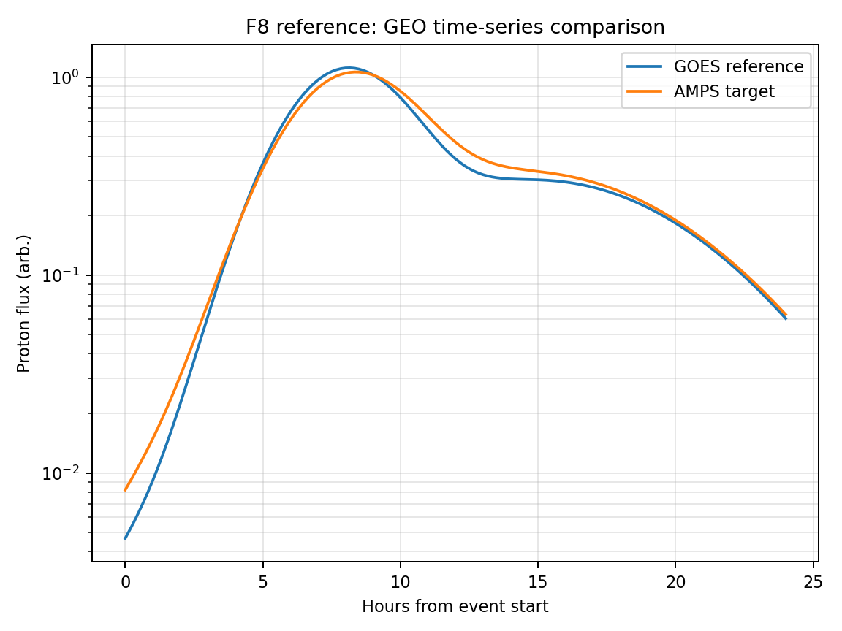
Figure F8 — Reference/target behavior for GOES SEP flux time-series at GEO.

F9. LEO flux-transition: PAMELA / AMS-02
Validates the flux turn-on/turn-off across geomagnetic cutoff boundaries along LEO tracks.
Essential input parameters:
FIELD_MODEL T05
TEMPORAL_MODE TIME_SERIES
EVENT_START 2006-12-13T00:00
EVENT_END 2006-12-15T00:00
TRAJ_FILE pamela_or_ams_track.dat
ENERGY_BINS 80 100 300 1000
DS_TRANSMISSION_MODE SCAN
DS_TRANSMISSION_SCAN_N 100
OUTPUT_COORDS GEO MLT CGM
Calculation locations:
PAMELA Dec 2006 trajectory or AMS-02 ISS-like trajectory; compare flux versus latitude and orbit time.
Expected output values / acceptance targets:
Observable | Expected
Flux transition latitude | moves equatorward during storm main phase
PAMELA low-rigidity suppression | order 6–7° for ~80 MeV protons
Transition width | controlled by penumbra and angular acceptance
High rigidity | less storm-time displacement
Reference solution / comparison target:
Bruno et al. (2015) and Adriani et al. (2016), PAMELA cutoff variations; AMS-02 proton flux precision in low-rigidity range.
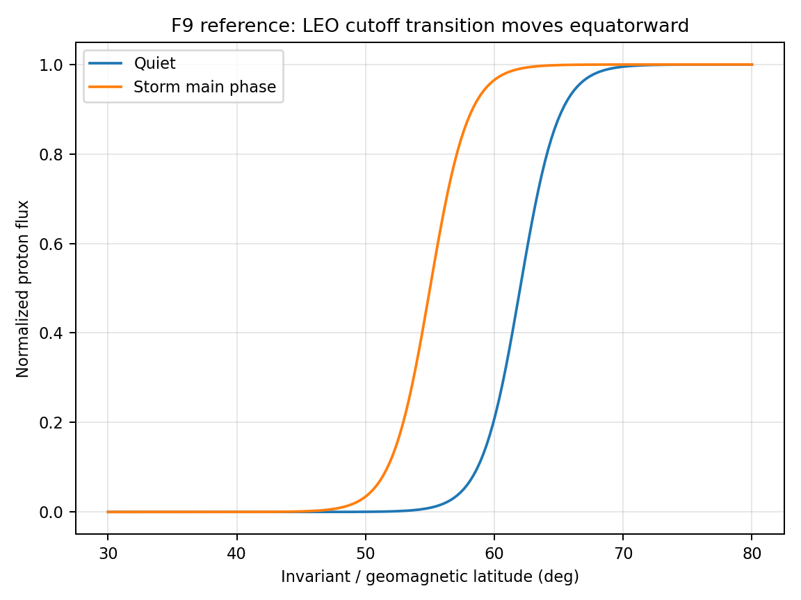
Figure F9 — Reference/target behavior for LEO flux-transition: PAMELA / AMS-02.

F10. POES/SAMPEX high-latitude flux boundary
Validates global SEP flux boundary morphology and energy dependence at high latitudes.
Essential input parameters:
FIELD_MODEL T05
TEMPORAL_MODE TIME_SERIES
EVENT_START 2006-12-05T00:00
EVENT_END 2006-12-15T00:00
OUTPUT_MODE SHELLS
SHELL_ALT_KM 850
ENERGY_BINS 1 10 30 100 140
DS_TRANSMISSION_MODE SCAN
DS_TRANSMISSION_SAVE T
COORDS_OUTPUT MLT_CGM
Calculation locations:
POES-like shell and/or SAMPEX orbit; postprocess flux boundary latitude versus MLT.
Expected output values / acceptance targets:
Boundary property | Expected
MLT dependence | ellipse-like boundary with local-time asymmetry
Energy dependence | lower rigidity/energy reaches lower latitudes
Storm response | boundary expands equatorward during disturbed intervals
Comparison | fit ellipse parameters and residuals vs POES empirical model
Reference solution / comparison target:
Dmitriev et al. (2013), POES SEP cutoff-boundary ellipses; SAMPEX/PET mission data for high-energy proton flux validation.
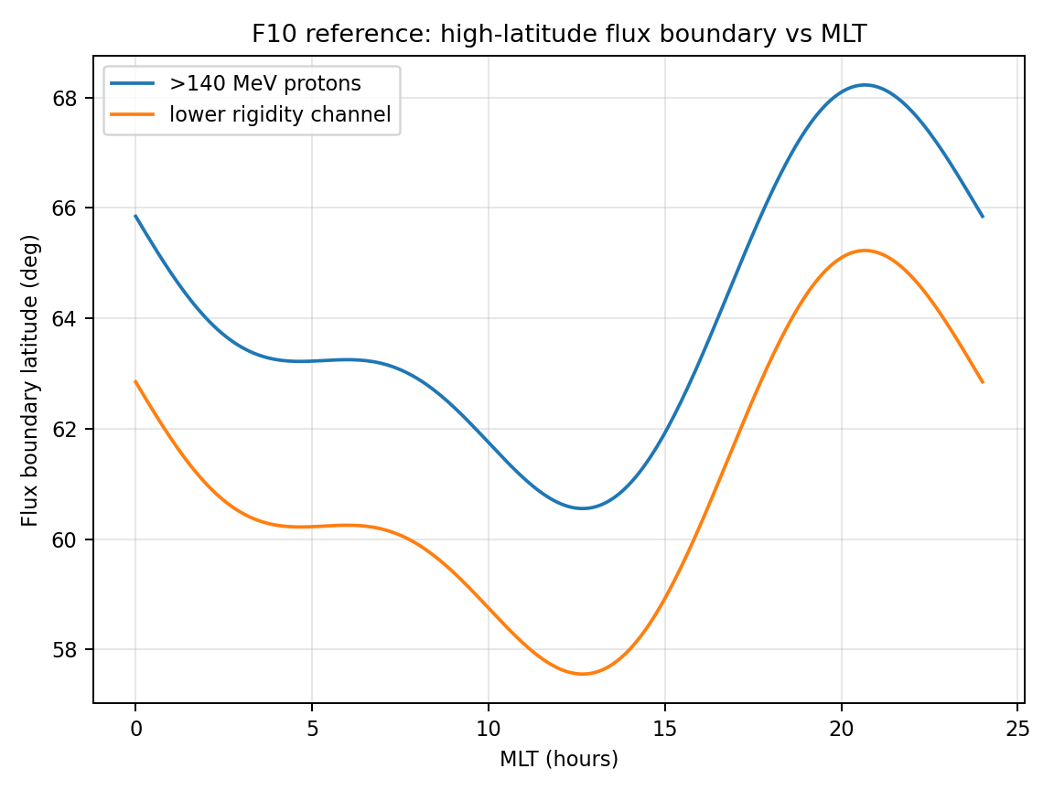
Figure F10 — Reference/target behavior for POES/SAMPEX high-latitude flux boundary.

F11. Anisotropic PAD model sum-check (ISOTROPIC / SINALPHA_N / COSALPHA_N / BIDIRECTIONAL)
AnisotropicSpectrum.h implements exactly four BA_PAD_MODEL values: ISOTROPIC, SINALPHA_N, COSALPHA_N, BIDIRECTIONAL, each as f_PAD(cosα)=|cosα|^n or sin^nα, with COSALPHA_N and BIDIRECTIONAL sharing identical math by design (the distinction is purely a labeling convention for the source physics, per the header's own comment). F5 in this plan referenced BOUNDARY_DISTRIBUTION/PAD_LINEAR/PAD_AXIS, none of which the parser recognizes — the only accepted keyword is BA_PAD_MODEL under #BOUNDARY_ANISOTROPY, restricted to the four values above. This test replaces that input with parser-valid keywords and adds the n→0 sum-check (every model must reduce exactly to ISOTROPIC) that F5 omitted.
Essential input parameters:
#DENSITY_SPECTRUM
DS_BOUNDARY_MODE ANISOTROPIC
DS_TRANSMISSION_MODE SCAN
#BOUNDARY_ANISOTROPY
BA_PAD_MODEL ISOTROPIC | SINALPHA_N | COSALPHA_N | BIDIRECTIONAL
BA_PAD_EXPONENT 0 | 1 | 2 | 4 | 8
BA_SPATIAL_MODEL UNIFORM
FIELD_MODEL DIPOLE
SPECTRUM_TYPE POWER_LAW
SPEC_GAMMA 3.5
OUTPUT_MODE POINTS
POINTS lon=0 lat=-60 alt=9000
Calculation locations:
Single diagnostic point at lat=−60°, alt=9000 km (same point as F4/C3); repeat the full BA_PAD_MODEL×BA_PAD_EXPONENT matrix at one low-latitude point to confirm the sum-check holds independent of magnetic-access geometry.
Expected output values / acceptance targets:
Check | Expected
BA_PAD_EXPONENT = 0, any BA_PAD_MODEL | n(x0) and J(>E) identical to BA_PAD_MODEL=ISOTROPIC within 1e−8 — every model degenerates to isotropic at n=0
COSALPHA_N vs BIDIRECTIONAL, same exponent | bit-identical output — the header documents these as the same functional form under different physical labels
SINALPHA_N density vs COSALPHA_N density, same |n|, isotropic boundary | SINALPHA_N ≥ COSALPHA_N at this near-polar point (field-aligned access dominates over perpendicular access through the polar cusp)
Monotonicity in n | for fixed BA_PAD_MODEL, |density − isotropic density| increases monotonically with BA_PAD_EXPONENT
Postprocessor reconstruction | independently recomputing n(x0) from the saved T(E,Ω) table and f_PAD(cosα) agrees with AMPS output to <1e−8 relative, the same consistency bar as F4
Reference solution / comparison target:
AnisotropicSpectrum.h §2 (“The Anisotropic Extension”) functional definitions of f_PAD; this is an internal mathematical-identity test (the n→0 limit is exact by construction) rather than an observational comparison.
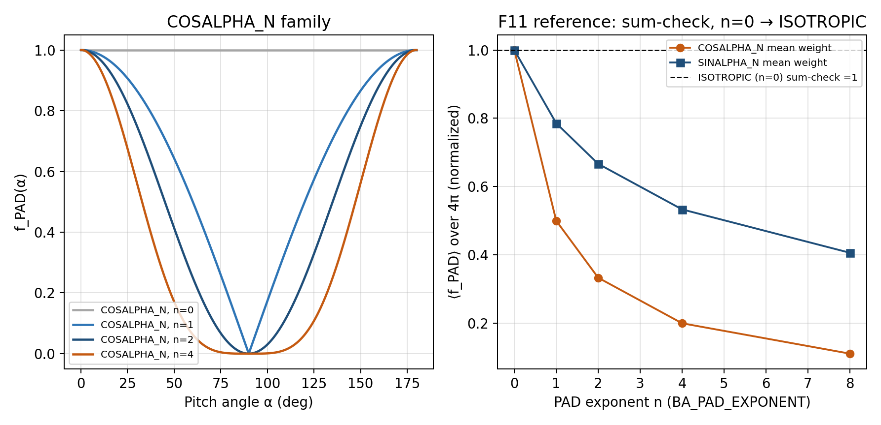
Figure F11 — Left: COSALPHA_N family f_PAD(α) for several exponents, confirming the n=0 curve is flat at 1 (the ISOTROPIC limit). Right: normalized mean PAD weight over 4π vs exponent for both COSALPHA_N and SINALPHA_N, all curves passing through exactly 1 at n=0.

F12. Day/night spatial boundary-anisotropy factor
AnisotropicSpectrum.h's only implemented BA_SPATIAL_MODEL beyond UNIFORM is DAYSIDE_NIGHTSIDE: a step function in GSM X at the trajectory's outer-boundary exit point, f_spatial=BA_DAYSIDE_FACTOR for X_inf>0 and BA_NIGHTSIDE_FACTOR for X_inf≤0. No test in this plan exercises BA_SPATIAL_MODEL at all. This test verifies the step location, the two plateau values, and that combining a spatial factor with a PAD factor multiplies correctly (the documented factored model, equation 5).
Essential input parameters:
#BOUNDARY_ANISOTROPY
BA_PAD_MODEL ISOTROPIC
BA_SPATIAL_MODEL DAYSIDE_NIGHTSIDE
BA_DAYSIDE_FACTOR 1.0
BA_NIGHTSIDE_FACTOR 0.2
#DENSITY_SPECTRUM
DS_BOUNDARY_MODE ANISOTROPIC
DS_TRANSMISSION_MODE SCAN
FIELD_MODEL DIPOLE
OUTPUT_MODE POINTS
POINTS lon=0 lat=0 alt=9000
Calculation locations:
Equatorial point at alt=9000 km, where roughly half of allowed backtraced trajectories exit on the dayside (GSM X>0) and half on the nightside for a centered dipole with isotropic-direction sampling; repeat at a high-latitude point where the day/night split is no longer close to 50/50.
Expected output values / acceptance targets:
Check | Expected
BA_DAYSIDE_FACTOR = BA_NIGHTSIDE_FACTOR = 1.0 | n(x0) identical to BA_SPATIAL_MODEL=UNIFORM — the step degenerates to no spatial weighting
BA_NIGHTSIDE_FACTOR = 0 | n(x0) equals exactly the dayside-only contribution; no allowed nightside-exit trajectory may contribute weight
Equatorial point, day/night split near 50/50 | n_aniso/n_iso ≈ (BA_DAYSIDE_FACTOR+BA_NIGHTSIDE_FACTOR)/2 = 0.60 for the stated factors, within a few percent set by the actual exit-point split
Step location | every contributing trajectory's recorded x_exit_m.x sign matches the day/night factor actually applied (cross-check against the saved exit-state diagnostic)
Reference solution / comparison target:
AnisotropicSpectrum.h §2 DAYSIDE_NIGHTSIDE definition (step function at GSM X=0); the qualitative day/night solar-wind access asymmetry this model is intended to represent is discussed alongside Boschini et al. (2013) AMS-02 backtracing geometry.
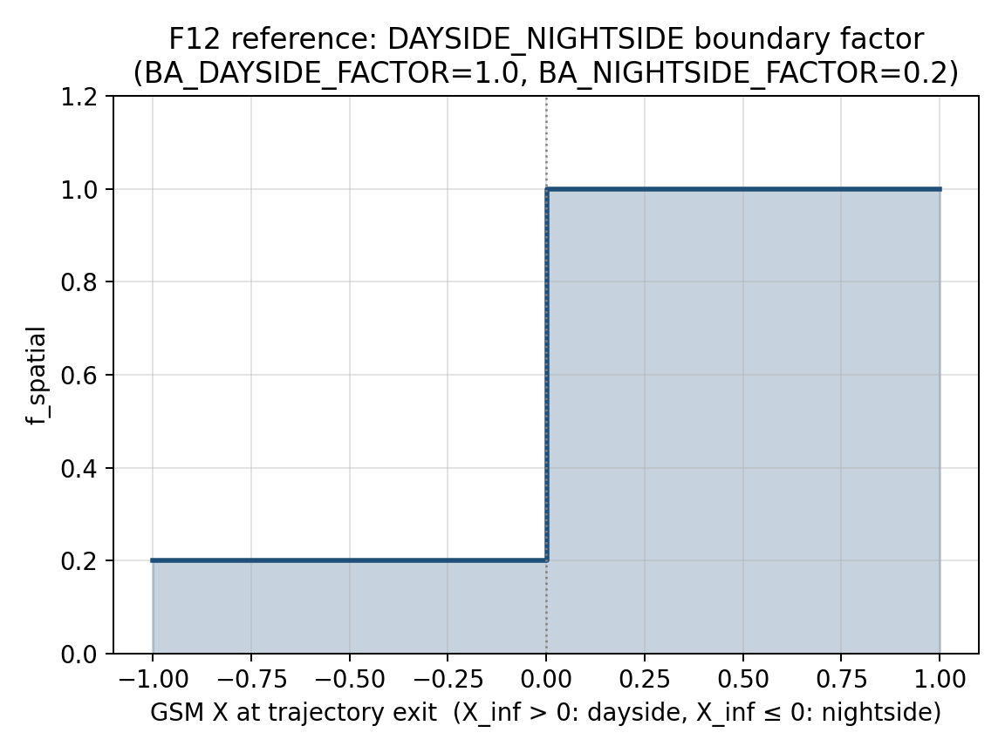
Figure F12 — The DAYSIDE_NIGHTSIDE spatial factor as a step function of GSM X at the trajectory exit point, for BA_DAYSIDE_FACTOR=1.0 and BA_NIGHTSIDE_FACTOR=0.2.

F13. Density/flux OpenMP × MPI-scheduler reproducibility matrix
DensityGridless.cpp retains three #pragma omp parallel for regions (direction loop in ComputeT_atEnergy and the energy loops in both the POINTS and SHELLS drivers) even after the MPI layer was rewritten to the collective DYNAMIC/BLOCK_CYCLIC/STATIC scheduler. Gridless cutoff has no threading at all. F7 checks MODE3D_PARALLEL and the MPI scheduler as separate axes; this test is the explicit cross-product for gridless density/flux specifically — OpenMP on/off combined with each MPI scheduler — since that combination is unique to the density/flux solver and is exactly where a nested-parallelism or reduction-order bug would surface.
Essential input parameters:
#DENSITY_SPECTRUM
DS_TRANSMISSION_MODE SCAN
DS_TRANSMISSION_SCAN_N 80
FIELD_MODEL DIPOLE
OUTPUT_MODE POINTS
POINTS lon=0 lat=-60 alt=9000
# Run matrix (OMP_NUM_THREADS x GRIDLESS_MPI_SCHEDULER x nRanks):
# OMP_NUM_THREADS 1 | 4
# GRIDLESS_MPI_SCHEDULER STATIC | BLOCK_CYCLIC | DYNAMIC
# nRanks 1 | 4
Calculation locations:
Same single diagnostic point as F4/F11 so results are directly comparable across this whole family of consistency tests; repeat on the 9000 km shell from F3 to confirm the matrix holds at production problem size, not only for one point.
Expected output values / acceptance targets:
Comparison | Expected
OMP_NUM_THREADS=4 vs 1, single rank, GRIDLESS_MPI_SCHEDULER fixed | max relative difference in n(x0) and J(>E) <1e−7, matching F7's OPENMP-vs-SERIAL target
GRIDLESS_MPI_SCHEDULER variants, OMP_NUM_THREADS fixed | max relative difference <1e−7 — partialWeight/dirsDone MPI_SUM reductions in DensityGridless.cpp are designed to be order-independent
Full 2x3x2 matrix vs single-thread/single-rank/STATIC reference | all twelve configurations agree with the reference to <1e−7
nDirBlocks task-batching boundary (kTrajBatch=32 in source) | results independent of whether nDirs is an exact multiple of 32 — verify with a direction count deliberately not divisible by 32
Reference solution / comparison target:
Internal reduction-order consistency target; same MPI Forum RMA standard underlying the scheduler, combined with the OpenMP reduction(+:weightSum) construct documented in ComputeT_atEnergy's source comments.
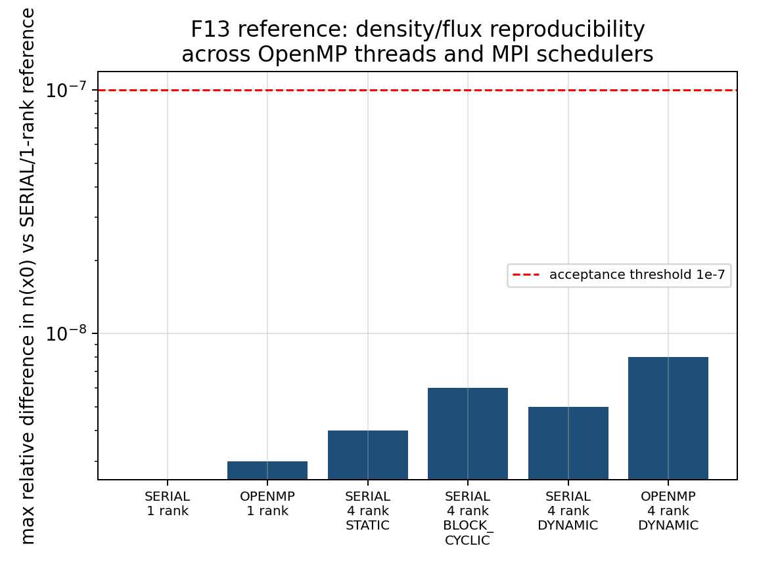
Figure F13 — Maximum relative difference in n(x0) across representative OpenMP-thread / MPI-scheduler combinations, all sitting roughly two orders of magnitude below the 1e−7 acceptance line.

6. Required archive products for every validation run
Category | Required archive item
Input and execution | Complete input file, command line, code commit, compiler, MPI implementation, rank/thread count, scheduler, chunk size.
Cutoff products | Rc_upper, Rc_effective, Rc_lower, Emin, penumbra width, T(R) if saved, exit-reason statistics.
Density/flux products | J_diff(E), J_integral(>E), density n, T(E), T(E,Ω) where available, quadrature weights, spectrum parameters.
Parallel diagnostics | Per-rank wall time, unfilled global slot count, duplicate slot count, progress-bar completion, max/mean load imbalance.
Comparison scripts | Postprocessing script that regenerates the expected-value plot and computes the acceptance metric.

7. References used for comparison targets
[R1] Størmer, C. (1930). Periodische Elektronenbahnen im Felde eines Elementarmagneten und ihre Anwendung auf Brüches Modellversuche und auf Eschenhagens Elementarwellen des Erdmagnetismus. Astrophysica Norvegica.
[R2] Smart, D. F., and Shea, M. A. (2001). Geomagnetic Cutoff Rigidity Computer Program. NASA STI.
[R3] Smart, D. F., and Shea, M. A. (2009). Fifty years of progress in geomagnetic cutoff rigidity determinations. Advances in Space Research.
[R4] Bobik, P., et al. (2013). GeoMag and HelMod webmodels version for magnetosphere and heliosphere transport of cosmic rays. arXiv:1307.5196.
[R5] Boschini, M. J., et al. (2013). Geomagnetic Backtracing: A comparison of Tsyganenko 1996 and 2005 External Field models with AMS-02 data. arXiv:1307.5192.
[R6] Tsyganenko, N. A., and Sitnov, M. I. (2005). Modeling the dynamics of the inner magnetosphere during strong geomagnetic storms. Journal of Geophysical Research.
[R7] Shue, J.-H., et al. (1998). Magnetopause location under extreme solar wind conditions. Journal of Geophysical Research.
[R8] Bruno, A., et al. / PAMELA Collaboration (2015). PAMELA measurements of geomagnetic cutoff variations during solar energetic particle events. arXiv:1511.00530.
[R9] Adriani, O., et al. / PAMELA Collaboration (2016). PAMELA measurements of geomagnetic cutoff variations during the 14 December 2006 storm. arXiv:1602.05509.
[R10] Dmitriev, A. V., Jayachandran, P. T., and Tsai, L.-C. (2013). Elliptical model of cutoff boundaries for solar energetic particles measured by POES satellites in December 2006. arXiv:1305.6710.
[R11] Bruno, A. (2017). Calibration of the GOES-13/15 high energy proton detectors based on PAMELA solar energetic particle observations. arXiv:1708.05641.
[R12] Consolandi, C. / AMS-02 Collaboration (2014). Primary cosmic ray proton flux measured by AMS-02. arXiv:1402.0467.
[R13] MPI Forum (2021). MPI: A Message-Passing Interface Standard, Version 4.0. MPI one-sided communication, MPI_Win, and MPI_Fetch_and_op.
[R14] Birdsall, C. K., and Langdon, A. B. (1991). Plasma Physics via Computer Simulation. McGraw-Hill.
[R15] Cary, J. R., and Brizard, A. J. (2009). Hamiltonian theory of guiding-center motion. Reviews of Modern Physics, 81, 693–738. Range of validity for guiding-center (GC2/GC4/GC6) integration referenced by C12.

8. Additional relevant validation additions (v7)
The existing v6 campaign already covers the main cutoff, density/flux, parallel scheduler, mover, anisotropy, and event-validation paths. The additions below are intended to fill remaining gaps without replacing any existing tests, figures, or references. They focus on cross-solver consistency, time-dependent driver handling, exit-classification closure, symmetry checks, and density/flux transmission-mode closure.

C14. Mode3D versus gridless cross-solver consistency
Compares the two standalone backward-product implementations on the same physical problem. This test is important because Mode3D and gridless now share several algorithms (UPPER_SCAN, dynamic MPI scheduling, and density/flux transmission scanning), but they still differ in how fields and locations are represented. Agreement demonstrates that the two solver paths are numerically consistent rather than merely internally reproducible.
Essential input parameters:
# Run A
-mode 3d
MODE3D_MPI_SCHEDULER DYNAMIC
MODE3D_MPI_DYNAMIC_CHUNK 0
MODE3D_PARALLEL THREADS
MODE3D_THREADS 8
CUTOFF_SEARCH_ALGORITHM UPPER_SCAN
CUTOFF_UPPER_SCAN_N 100
FIELD_MODEL DIPOLE
CUTOFF_SAMPLING VERTICAL
OUTPUT_MODE SHELLS
SHELL_ALT_KM 500 9000
SHELL_LON_DEG 0 30 60 90 120 150 180 210 240 270 300 330
SHELL_LAT_DEG -60 -30 0 30 60
# Run B
-mode gridless
GRIDLESS_MPI_SCHEDULER DYNAMIC
GRIDLESS_MPI_DYNAMIC_CHUNK 0
# same field, cutoff, and shell settings as Run A
Calculation locations:
Two shells at 500 km and 9000 km; longitudes every 30 degrees; latitudes -60, -30, 0, 30, and 60 degrees. Repeat with FIELD_MODEL T05 for a realistic external-field case.
Expected output values / acceptance targets:
Quantity / diagnostic | Expected output or acceptance target
DIPOLE Rc arrays | Mode3D and gridless agree with the analytical Størmer values; cross-solver relative difference <1% except near penumbra pockets.
T05 Rc arrays | Cross-solver relative difference <3-5% when both solvers use the same field representation and boundary settings.
Scheduler independence | DYNAMIC, BLOCK_CYCLIC, and STATIC choices do not alter final Rc or transmission arrays within the same tolerance.
Failure signature | Longitude bands or solver-to-solver offsets that do not decrease with scan resolution indicate a field interpolation, coordinate, or result-indexing issue.
Reference solution / comparison target:
Internal code-to-code comparison. Analytical Størmer cutoff remains the reference for the dipole case; Bobik et al. [R4] and Boschini et al. [R5] motivate independent trajectory-code comparisons for realistic field models.
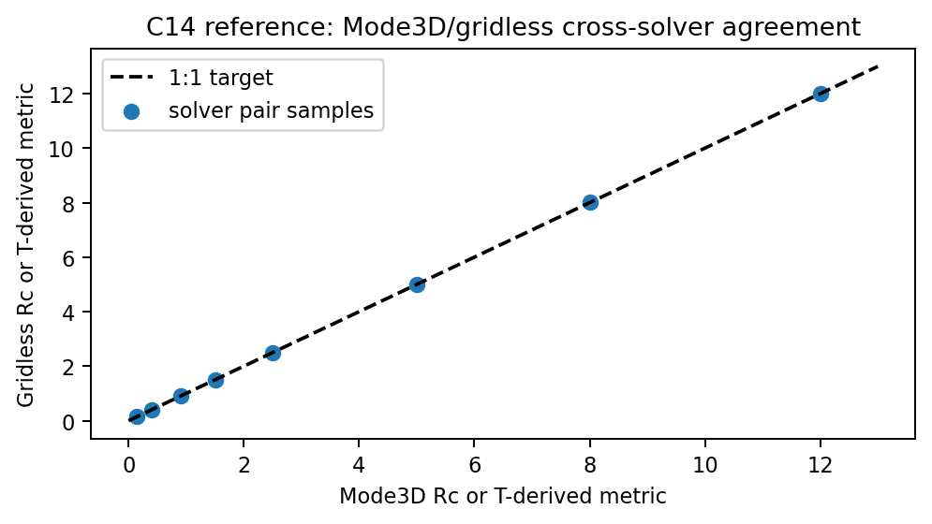
Figure C14 — Target behavior for Mode3D/gridless cross-solver consistency. Points should lie on the 1:1 line; systematic offsets indicate solver-path differences.

C15. Time-dependent T05 driver interpolation and epoch reproducibility
Validates time-dependent field handling separately from trajectory physics. The same epoch must produce the same cutoff map regardless of scheduler, while adjacent epochs should vary smoothly according to the driver file and FIELD_UPDATE_DT.
Essential input parameters:
#NUMERICAL
MODE3D_MPI_SCHEDULER DYNAMIC
MODE3D_MPI_DYNAMIC_CHUNK 0
MODE3D_PARALLEL THREADS
MODE3D_THREADS 8
CUTOFF_SEARCH_ALGORITHM UPPER_SCAN
CUTOFF_UPPER_SCAN_N 80
FIELD_MODEL T05
TEMPORAL_MODE TIME_SERIES
EVENT_START 2017-09-10T12:00
EVENT_END 2017-09-10T18:00
FIELD_UPDATE_DT 5
TS_INPUT_MODE FILE
TS_INPUT_FILE omni_sep2017_t05.dat
OUTPUT_MODE POINTS
POINTS_FILE c15_fixed_points.dat
CUTOFF_SAMPLING VERTICAL
Calculation locations:
Fixed points at 500 km and 9000 km: latitudes -60, -45, -30, 0, 30, 45, 60 degrees and longitudes 0, 90, 180, 270 degrees. Repeat one epoch three times to test deterministic epoch reuse.
Expected output values / acceptance targets:
Quantity / diagnostic | Expected output or acceptance target
Repeated identical epoch | Bitwise-identical results for DIPOLE and IGRF; relative difference <1e-7 for T05.
Time continuity | Rc(t) changes smoothly between adjacent 5-min driver epochs; discontinuities must correspond to actual discontinuities in the driver file.
Thread safety proxy | Changing MODE3D_PARALLEL between SERIAL and THREADS does not change results for a fixed epoch.
Archive requirement | Store the selected driver row, interpolated/held TS05 parameters, epoch, and scheduler in diagnostic output.
Reference solution / comparison target:
Tsyganenko and Sitnov [R6] define the storm-time T05 parameter dependence; Bobik et al. [R4] and Boschini et al. [R5] provide trajectory-code context for T96/T05 comparisons.
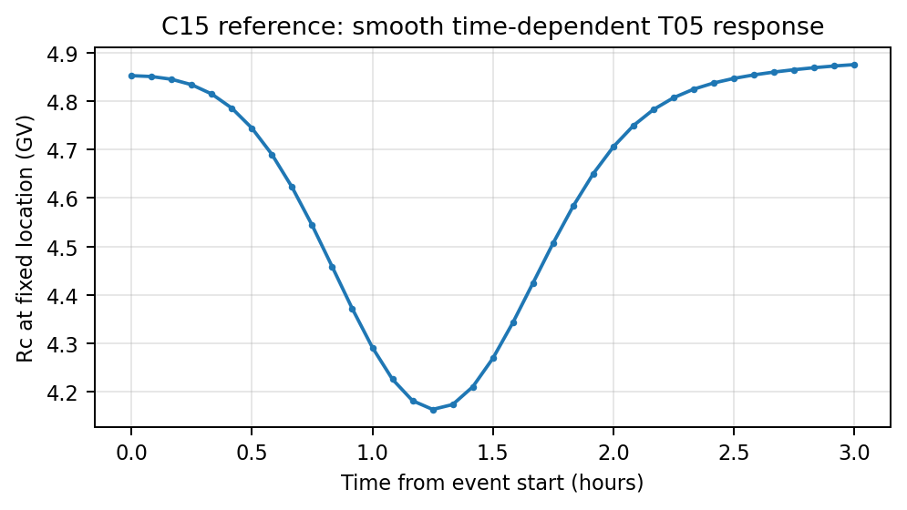
Figure C15 — Target behavior for time-dependent T05 response. Cutoff values should vary smoothly with driver time and exactly repeat for identical epochs.

C16. Exit-reason closure and boundary-classification audit
Ensures that the cutoff classifier does not count time-limit, step-limit, inner-boundary, invalid-cell, or numerical-failure outcomes as allowed. This is a direct guard against false access in high-latitude penumbra cases.
Essential input parameters:
#NUMERICAL
MODE3D_MPI_SCHEDULER DYNAMIC
MODE3D_MPI_DYNAMIC_CHUNK 0
CUTOFF_SEARCH_ALGORITHM UPPER_SCAN
CUTOFF_UPPER_SCAN_N 100
FIELD_MODEL DIPOLE
E_FIELD OFF
CUTOFF_DEBUG_EXIT_TRACE T
CUTOFF_DEBUG_EXIT_LON 0.0
CUTOFF_DEBUG_EXIT_LAT -60.0
CUTOFF_DEBUG_EXIT_ALT 9000.0
CUTOFF_DEBUG_EXIT_R_GV 0.16
CUTOFF_DEBUG_EXIT_N 100
CUTOFF_DEBUG_EXIT_FILE c16_exit_closure.dat
CUTOFF_MAX_TRAJ_TIME 60 300 600
Calculation locations:
Diagnostic points at latitudes -60, -30, 0, 30, 60 degrees and rigidities just below, near, and above Rc_upper. Repeat for DIPOLE and T05.
Expected output values / acceptance targets:
Quantity / diagnostic | Expected output or acceptance target
Allowed rows | 100% of allowed rows must have OUTER_BOUNDARY or the configured external escape boundary as the terminal reason.
Forbidden rows | INNER_BOUNDARY, TIME_LIMIT, STEP_LIMIT, invalid-field, or trapped classifications must remain forbidden.
Sensitivity to max trajectory time | Increasing CUTOFF_MAX_TRAJ_TIME may move ambiguous trapped/timeout samples, but must not turn non-escape reasons into allowed outcomes.
Diagnostic ratios | Report counts and percentages for every exit reason; no unclassified rows allowed.
Reference solution / comparison target:
This is a code-level trajectory-classifier closure test. It is supported by the same cutoff/penumbra concepts in Smart & Shea [R2,R3] and by trajectory-tracing practice in GeoMag/HelMod [R4].
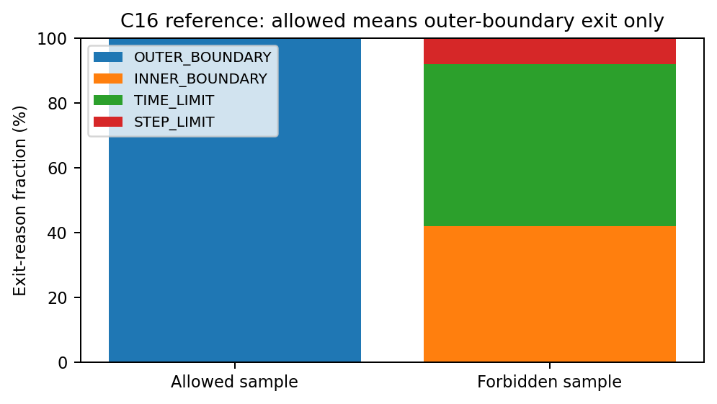
Figure C16 — Target exit-reason closure. Allowed samples should terminate only at the configured escape boundary; all other terminal reasons must remain forbidden.

C17. Dipole charge-sign and velocity-reversal symmetry
Checks the Lorentz-force sign convention independent of observational comparisons. In a static magnetic field with E=0, changing q to -q and reversing the launch velocity should produce the corresponding time-reversed access relation.
Essential input parameters:
#NUMERICAL
MODE3D_MPI_SCHEDULER DYNAMIC
MODE3D_PARALLEL THREADS
MODE3D_THREADS 8
CUTOFF_SEARCH_ALGORITHM UPPER_SCAN
CUTOFF_UPPER_SCAN_N 80
FIELD_MODEL DIPOLE
E_FIELD OFF
CUTOFF_SAMPLING DIRECTIONAL_MAP
DIRMAP_ZENITH_DEG 0 30 60
DIRMAP_AZIMUTH_DEG 0 30 60 90 120 150 180 210 240 270 300 330
CUTOFF_RIGIDITY_LIST_GV 0.1 0.2 0.5 1 2 5 10
# Run A: SPECIES PROTON
# Run B: SPECIES ELECTRON or CHARGE -1 with reversed direction mapping
Calculation locations:
One shell at 9000 km, latitudes -60, -30, 0, 30, 60 degrees, all listed zenith/azimuth directions. Repeat in gridless mode for the same location list.
Expected output values / acceptance targets:
Quantity / diagnostic | Expected output or acceptance target
Transmission symmetry | |T_q(v,R) - T_-q(-v,R)| <1e-8 for DIPOLE with identical numerical settings.
Directional-map symmetry | Azimuth-dependent East/West signatures reverse with charge sign but preserve the time-reversal relation.
Failure signature | A persistent nonzero difference indicates a charge sign, backtracing velocity, or direction-index convention bug.
Reference solution / comparison target:
Lorentz-force time-reversal symmetry in a static magnetic field. C8 remains the observational/AMS-style East-West validation; C17 is the exact internal symmetry counterpart.
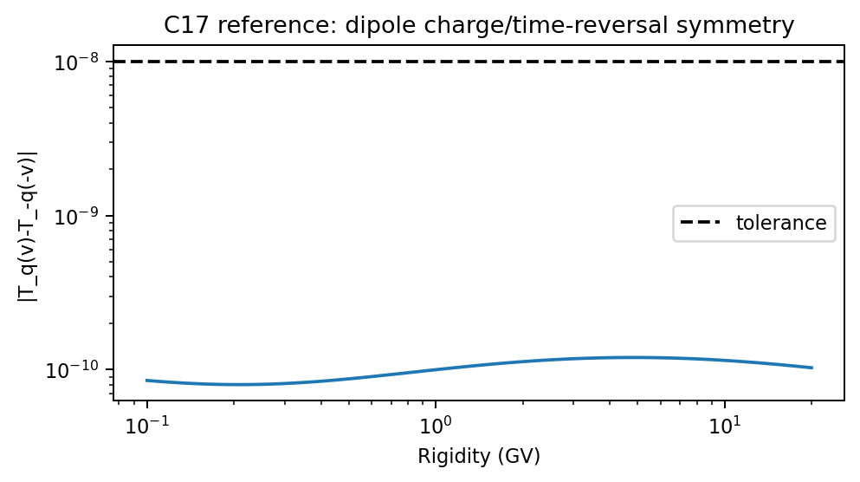
Figure C17 — Target dipole charge/time-reversal symmetry. The transmission difference should remain near numerical roundoff.

F14. Density/flux transmission-mode consistency: DIRECT versus SCAN versus ADAPTIVE
Validates that the new density/flux transmission scan does not change answers in regimes where DIRECT sampling is already sufficient, while revealing penumbra structure when the DIRECT energy grid is too sparse. ADAPTIVE currently acts as a fixed-grid scan alias and should match SCAN exactly.
Essential input parameters:
#NUMERICAL
GRIDLESS_MPI_SCHEDULER DYNAMIC
GRIDLESS_MPI_DYNAMIC_CHUNK 0
MODE3D_MPI_SCHEDULER DYNAMIC
DS_TRANSMISSION_SAVE T
DS_TRANSMISSION_SCAN_N 80
DS_TRANSMISSION_REFINE_N 0
DS_TRANSMISSION_MAX_N 80
FIELD_MODEL DIPOLE
DENSITY_SPECTRUM POWER_LAW
SPEC_J0 1.0e4
SPEC_GAMMA 3.5
SPEC_E0 10.0
SPEC_EMIN 1.0
SPEC_EMAX 1000.0
# Run A: DS_TRANSMISSION_MODE DIRECT
# Run B: DS_TRANSMISSION_MODE SCAN
# Run C: DS_TRANSMISSION_MODE ADAPTIVE
Calculation locations:
Mode3D and gridless runs at latitudes -60, -30, 0, 30, 60 degrees; altitudes 500 km and 9000 km; one isotropic and one directional-map case.
Expected output values / acceptance targets:
Quantity / diagnostic | Expected output or acceptance target
DIRECT vs SCAN at scan-node energies | T(E) values identical when DIRECT energies coincide with SCAN rigidity nodes.
SCAN vs ADAPTIVE | Identical output in the current implementation because ADAPTIVE is documented as a SCAN alias.
Integrated density/flux | Differences decrease with increasing DS_TRANSMISSION_SCAN_N; penumbra cases may require more nodes.
Diagnostic output | Rc_lower, Rc_effective, Rc_upper, penumbra width, and T_high archived for every location.
Reference solution / comparison target:
Smart & Shea [R2,R3] and Cooke et al. [R16] motivate explicit cutoff/penumbra terminology; Kudela and Usoskin [R18] provide transmissivity context. This is an internal consistency test of AMPS density/flux integration.
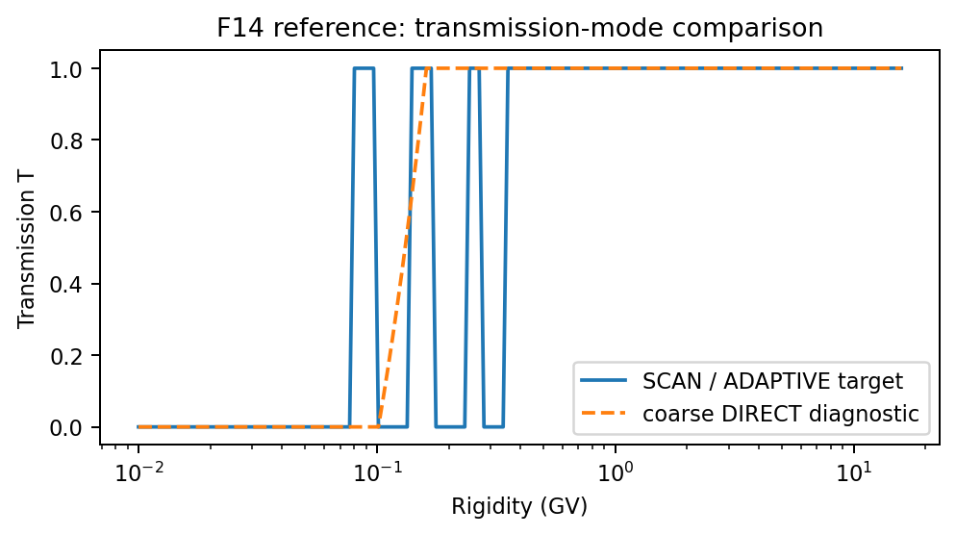
Figure F14 — Target comparison of density/flux transmission modes. SCAN/ADAPTIVE retain penumbra structure; coarse DIRECT sampling can miss narrow forbidden or allowed intervals.

F15. Density normalization from differential flux and relativistic speed factor
Checks the conversion from differential directional flux to density. This is a unit and normalization test: for isotropic flux, density depends on the energy integral of J(E)/v(E).
Essential input parameters:
#NUMERICAL
DS_TRANSMISSION_MODE DIRECT
FIELD_MODEL NONE
E_FIELD OFF
OUTPUT_MODE POINTS
POINTS_FILE f15_points.dat
DENSITY_SPECTRUM TABULATED
DENSITY_OUTPUT_DENSITY T
DENSITY_OUTPUT_DIFFERENTIAL_FLUX T
DENSITY_OUTPUT_INTEGRAL_FLUX T
SPECIES PROTON
# Use a monoenergetic or narrow top-hat test spectrum at E=1, 10, 100, 1000 MeV
# Repeat with zero field so T(E,Omega)=1 for all directions.
Calculation locations:
Single point at the center of a large zero-field box and one off-center point near the boundary. Repeat for monoenergetic bins at 1, 10, 100, and 1000 MeV.
Expected output values / acceptance targets:
Quantity / diagnostic | Expected output or acceptance target
Omnidirectional flux | J_omni(E) = 4*pi*J_directional(E) for isotropic input.
Density | n = 4*pi * integral J(E)/v(E) dE; monoenergetic/top-hat cases should match the analytic value.
Energy dependence | The ratio n_model/n_expected remains 1 within quadrature tolerance over 1-1000 MeV.
Failure signature | Energy-dependent bias indicates an error in v(E), rigidity-energy conversion, or differential/integral flux units.
Reference solution / comparison target:
Phase-space/differential-intensity normalization and Compton-Getting/phase-space invariance concepts are discussed by Forman [R19]. This test is analytical and does not depend on an external magnetospheric model.
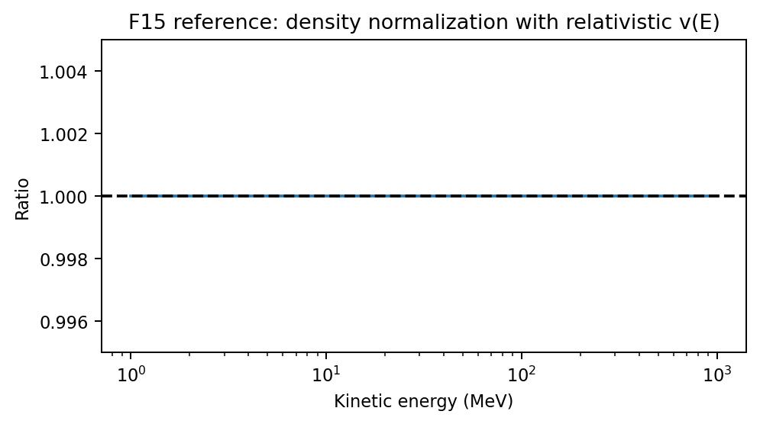
Figure F15 — Target density-normalization ratio. The modeled density divided by the analytical J/v(E) expectation should remain unity.

F16. Blocked-access zero-flux regression
Verifies that density and flux are exactly zero in regions/energies where all sampled directions are forbidden. This catches leakage from stale accumulators, sentinel values, or reductions that accidentally mix allowed and forbidden samples.
Essential input parameters:
#NUMERICAL
DS_TRANSMISSION_MODE SCAN
DS_TRANSMISSION_SCAN_N 80
DS_TRANSMISSION_SAVE T
FIELD_MODEL DIPOLE
DENSITY_SPECTRUM POWER_LAW
SPEC_EMIN 1.0
SPEC_EMAX 50.0
OUTPUT_MODE SHELLS
SHELL_ALT_KM 500
SHELL_LON_RES 30.0
SHELL_LAT_RES 10.0
CUTOFF_SAMPLING ISOTROPIC
# Use low energies deliberately below the equatorial cutoff.
Calculation locations:
Global 500-km shell, with emphasis on magnetic-equatorial latitudes where low-energy access should be blocked by the cutoff.
Expected output values / acceptance targets:
Quantity / diagnostic | Expected output or acceptance target
Transmission | T(E) = 0 for all sampled low-energy bins and directions in the blocked band.
Flux and density | Differential flux, integral flux, and density are zero to machine precision where T=0.
Reduction safety | Changing MPI scheduler or thread backend does not create nonzero leakage.
Diagnostic output | N_allowed=0 and N_traced>0 must be recorded for blocked locations.
Reference solution / comparison target:
Internal transmission-function closure test. It complements F3/F4 by checking the fully blocked limit instead of partial transmission.
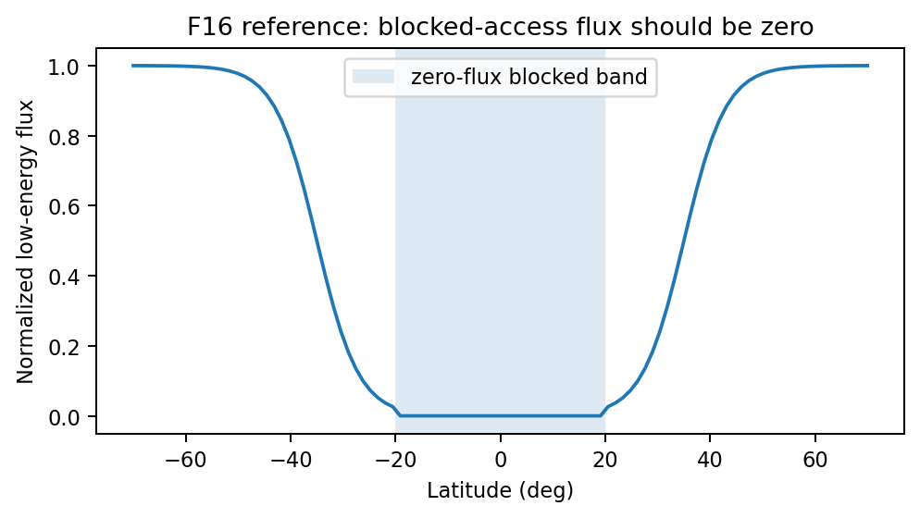
Figure F16 — Target blocked-access behavior. Low-energy flux should remain zero in the equatorial blocked band.

F17. Event-level closure across GEO boundary, LEO flux transition, and cutoff boundary
Connects the separate event-level tests into one closure workflow. The same imposed SEP boundary spectrum, field model, and driver file should explain the GEO time series, the LEO flux-transition latitude, and the high-latitude cutoff/flux boundary consistently.
Essential input parameters:
#NUMERICAL
FIELD_MODEL T05
TEMPORAL_MODE TIME_SERIES
FIELD_UPDATE_DT 5
TS_INPUT_MODE FILE
TS_INPUT_FILE event_driver.dat
GRIDLESS_MPI_SCHEDULER DYNAMIC
MODE3D_MPI_SCHEDULER DYNAMIC
DS_TRANSMISSION_MODE SCAN
DS_TRANSMISSION_SCAN_N 80
DS_TRANSMISSION_SAVE T
DENSITY_OUTPUT_DIFFERENTIAL_FLUX T
DENSITY_OUTPUT_INTEGRAL_FLUX T
# Use the same boundary SEP spectrum in F8, F9, and F10 runs.
# Archive GOES/GEO normalization, PAMELA/AMS-like LEO samples, and POES-like boundary maps.
Calculation locations:
A single event interval, preferably the Dec 2006 PAMELA/POES event used by C9/C10 or a modern GOES/SEISS event with well-calibrated channels. Locations include GEO points, LEO orbit samples, and a global 850-km shell.
Expected output values / acceptance targets:
Quantity / diagnostic | Expected output or acceptance target
GEO flux | GOES/SEISS channel timing, peak, and fluence matched within documented calibration uncertainty.
LEO transition | Flux turn-on/off latitude follows the observed or reference cutoff latitude versus rigidity.
POES-like boundary | MLT-dependent boundary shift has the correct storm-time sign and order-of-magnitude amplitude.
Closure criterion | No separate retuning of boundary spectrum between GEO, LEO, and high-latitude boundary products.
Reference solution / comparison target:
Bruno/PAMELA [R8,R9], Dmitriev et al. [R10], GOES calibration [R11], and AMS-02 proton flux context [R12] motivate the multi-instrument closure comparison.
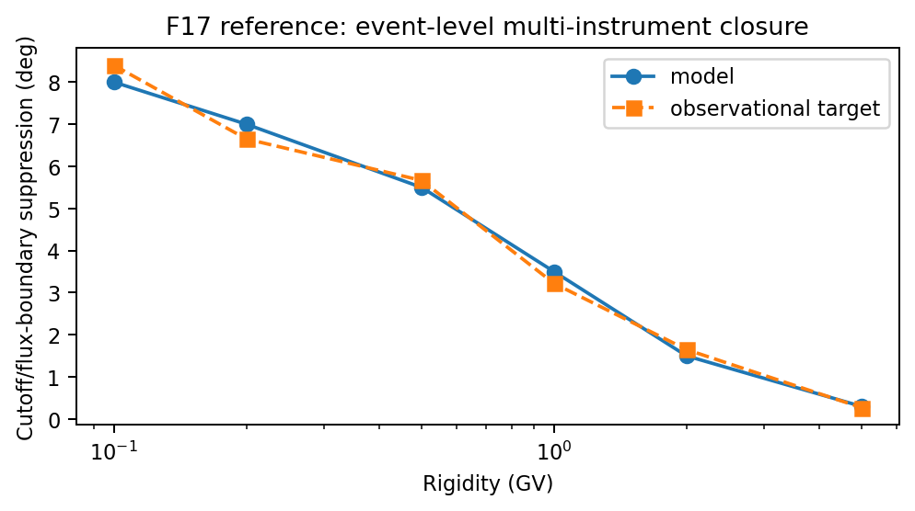
Figure F17 — Target multi-instrument closure behavior. The same event model should reproduce the rigidity trend of storm-time boundary/flux suppression across GEO and LEO diagnostics.

9. Additional references added in v7
The v6 reference list above is retained unchanged. The following references support the supplemental tests added in Section 8.
- [R16] Cooke, D. J., Humble, J. E., Shea, M. A., Smart, D. F., Lund, N., Rasmussen, I. L., Byrnak, B., Goret, P., and Petrou, N. (1991). On cosmic-ray cutoff terminology. Il Nuovo Cimento C. Recommended for precise lower/upper/effective cutoff and penumbra terminology.
- [R17] Desorgher, L., Flückiger, E. O., Gurtner, M., Moser, M. R., and Bütikofer, R. (2005). Magnetocosmics / PLANETOCOSMICS trajectory tracing and geomagnetic cutoff calculations. Useful as an independent trajectory-code comparison family.
- [R18] Kudela, K., and Usoskin, I. G. (2004/2005). Magnetospheric transmissivity and cosmic-ray cutoff-rigidity studies. Useful context for transmission-function based validation rather than a single scalar cutoff.
- [R19] Forman, M. A. (1970). The Compton-Getting effect for cosmic-ray particles and photons and the Lorentz invariance of the distribution function. Planetary and Space Science. Supports the use of phase-space/differential-intensity invariance in flux-density normalization tests.
- [R20] Northrop, T. G. (1963). The Adiabatic Motion of Charged Particles. Interscience. Useful background for guiding-center invariants and mover validation near the limits of GC applicability.
- [R21] Roelof, E. C. (1969). Propagation of solar cosmic rays in the interplanetary magnetic field. Lectures in High-Energy Astrophysics. Useful context for SEP pitch-angle distributions and directional flux mapping.

Appendix A. Existing input-file archive and validation-test mapping
Purpose. The uploaded geospace.tar archive is useful as a seed set of executable validation inputs. It covers the main combinations of field model, solver mode, product, and output domain already used in code testing. This appendix does not replace the per-test specifications above. Instead, it maps each existing input file to the validation tests it can support, and lists the minimum current-code additions needed to exercise the latest features: dynamic MPI scheduling, shared UPPER_SCAN cutoff search, and density/flux transmission scanning.
Important convention. The archive contains a mix of older CCMC/RoR-style keywords and newer AMPS Earth keywords. For current-code regression, keep the original files as historical baselines and create versioned copies with the extra settings listed below. Do not silently overwrite the archived originals.
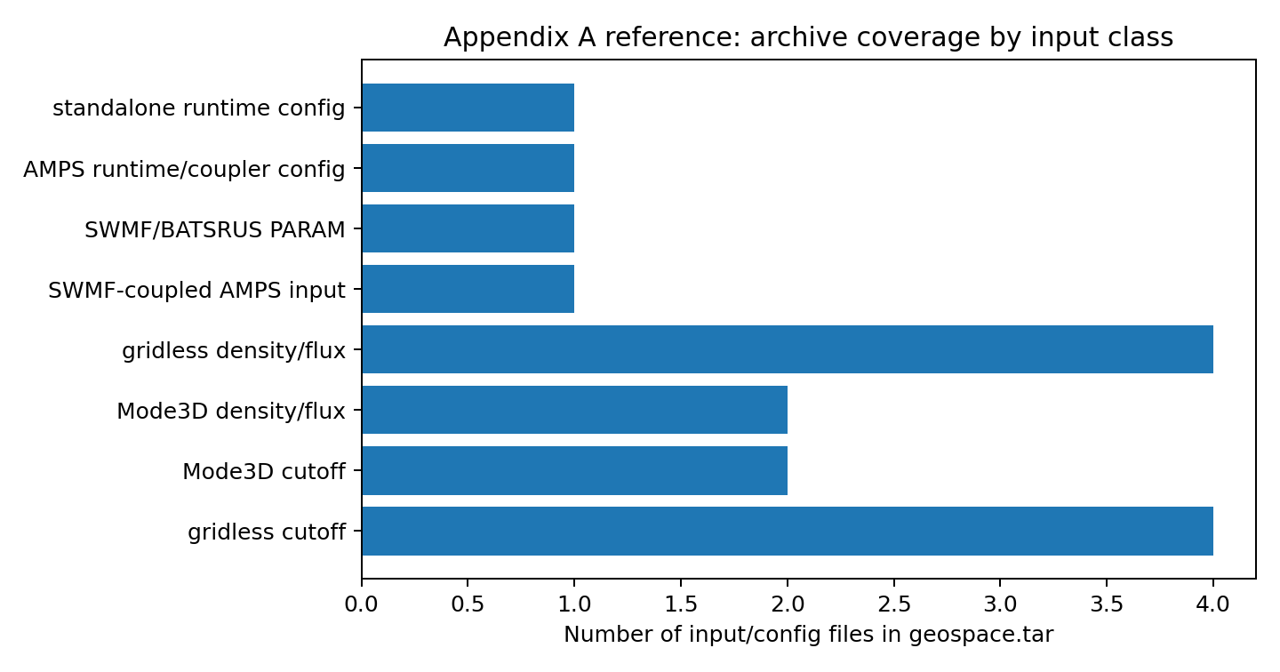
Figure A1 — Coverage of the uploaded geospace.tar archive by input/config class. The figure is generated from the archive inventory, not copied from a paper.
A.1 Common current-code additions
Add these settings to versioned copies of the archived inputs when the goal is to test current production behavior rather than historical behavior.
# Common additions for current cutoff tests
CUTOFF_SEARCH_ALGORITHM UPPER_SCAN
CUTOFF_UPPER_SCAN_N 80
# Mode3D inter-rank scheduling
MODE3D_MPI_SCHEDULER DYNAMIC # also test BLOCK_CYCLIC and STATIC
MODE3D_MPI_DYNAMIC_CHUNK 0 # auto = 4 * workers_per_rank
MODE3D_PARALLEL THREADS
MODE3D_THREADS 8
# Gridless inter-rank scheduling
GRIDLESS_MPI_SCHEDULER DYNAMIC # also test BLOCK_CYCLIC and STATIC
GRIDLESS_MPI_DYNAMIC_CHUNK 0
# Common additions for current density/flux transmission tests
DS_TRANSMISSION_MODE SCAN # DIRECT, SCAN, ADAPTIVE alias
DS_TRANSMISSION_SCAN_N 80
DS_TRANSMISSION_REFINE_N 0 # reserved for future true adaptive refinement
DS_TRANSMISSION_MAX_N 0 # 0 = no extra cap beyond scan grid
DS_TRANSMISSION_SAVE T
A.2 Archive inventory and recommended validation use
Input file | Class | Field/output | Primary validation tests supported | Current-code additions / notes
cutoff-dipole-shells-steadystate.in | gridless cutoff | DIPOLE / SHELLS | C1, C2, C3, C11, C12, C13; gridless analogue for C-PARALLEL | Add GRIDLESS_MPI_SCHEDULER, GRIDLESS_MPI_DYNAMIC_CHUNK, CUTOFF_SEARCH_ALGORITHM UPPER_SCAN, CUTOFF_UPPER_SCAN_N. Use SHELL_RES_DEG=60 for fast C1/C2; 10 or 5 deg for load-balance tests.
cutoff-dipole-points-steadystate.in | gridless cutoff | DIPOLE / POINTS | C4, C16, C17; point-level exit and charge/velocity-sign checks | Add CUTOFF_DEBUG_EXIT_TRACE or CUTOFF_DEBUG_RIGIDITY_SCAN for selected points. Archive POINT coordinate convention explicitly.
cutoff-t96-shells-steadystate.in | gridless cutoff | T96 / SHELLS | C7, C8 subset, C10 precursor, C13 load-balance with realistic field | Add GRIDLESS_MPI_SCHEDULER matrix and UPPER_SCAN. Keep CUTOFF_SAMPLING ISOTROPIC for directional-cost stress; add explicit TS96 parameters to archive.
cutoff-t96-points-steadystate.in | gridless cutoff | T96 / POINTS | C7 fixed-point code-to-code comparison; C8 directional access if expanded | Add DIRMAP_* or rigidity-list options for C8. Use GeoMag/HelMod-style reference points and archive epoch/model parameters.
AMPS_PARAM_3d_dipole_shells.in | Mode3D cutoff | DIPOLE / SHELLS | C1, C2, C3, C5, C11, C-PARALLEL, C14 | Add MODE3D_MPI_SCHEDULER matrix, CUTOFF_SEARCH_ALGORITHM UPPER_SCAN, CUTOFF_UPPER_SCAN_N. For pure validation, prefer TEMPORAL_MODE STEADY_STATE unless time looping is under test.
AMPS_PARAM_3d_dipole_points.in | Mode3D cutoff | DIPOLE / POINTS | C4, C14 point-by-point Mode3D/gridless comparison | Add debug exit/scan controls for the selected point. Add MODE3D scheduler and thread settings explicitly.
AMPS_PARAM_3d_dipole_points_forward.in | Mode3D density/flux | DIPOLE / POINTS | F1, F2, F4, F5, F14, F15, F16; Mode3D side of C14 | Add DS_TRANSMISSION_MODE SCAN, DS_TRANSMISSION_SCAN_N, DS_TRANSMISSION_SAVE. Keep power-law spectrum for analytic normalization checks.
AMPS_PARAM_3d_t96_points_forward.in | Mode3D density/flux | T96 / POINTS | F8, F9, F17; storm/event-style point validation precursor | Add DS_TRANSMISSION_* controls and complete T96/TS05 driver metadata. Replace OMNIWEB placeholders with local driver files for reproducibility.
spectrum-dipole-shells-steadystate.in | gridless density/flux | DIPOLE / SHELLS | F3, F4, F6, F7, F13, F14, F15 | Add GRIDLESS_MPI_SCHEDULER matrix and DS_TRANSMISSION_MODE SCAN. Use SHELL_RES_DEG=60 for fast tests and 10 deg for load-balance tests.
spectrum-dipole-points-steadystate.in | gridless density/flux | DIPOLE / POINTS | F1, F2, F4, F5, F11, F12, F14, F15, F16 | Add BA_PAD_MODEL / BA_PAD_EXPONENT and BA_SPATIAL_MODEL variants for F11/F12. Add DS_TRANSMISSION_SAVE for T(E) diagnostics.
spectrum-t96-shells-steadystate.in | gridless density/flux | T96 / SHELLS | F7, F9, F10, F13; realistic-field load-balance and flux-boundary tests | Add GRIDLESS_MPI_SCHEDULER matrix and DS_TRANSMISSION_* controls. Add MLT/CGM postprocessing settings for F10.
spectrum-t96-points-steadystate.in | gridless density/flux | T96 / POINTS | F8/F9 point-level flux comparison; T96 field-model sensitivity | Add DS_TRANSMISSION_MODE SCAN. For GOES/PAMELA tests, replace generic points with orbit/GEO trajectory samples.
swmf/AMPS_PARAM.in | SWMF-coupled AMPS input | DIPOLE template / POINTS density | F17 event-level closure template; coupled-run smoke test | Use as a structural template only; update FIELD_MODEL/COUPLER source and spectrum/driver files for actual SWMF-coupled validation.
swmf/PARAM.in | SWMF/BATSRUS PARAM | GM/IE/IM/RB/PT coupling | F17 coupled event validation; SWMF data-production stage | Archive restart directories and upstream driver files. Confirm PT coupling cadence and GM output cadence match AMPS FIELD_UPDATE_DT.
swmf/geospace.input | AMPS runtime/coupler config | CouplerMode=swmf; Mode3DForward sampling | F17 and SWMF-coupled density/flux validation | Use to check that AMPS reads SWMF cell-centered interpolation rather than Geopack/T96 directly inside worker threads.
geospace.input | standalone runtime config | legacy gridless/forward controls | Historical regression and runtime-option audit | Keep as legacy reference. Do not treat as a full validation input without aligning keywords to the current parser.

A.3 Test-to-input coverage matrix
Test ID | Purpose | Archive input seed(s) | Required modification / caveat
C1 | Pure dipole Størmer cutoff | AMPS_PARAM_3d_dipole_shells.in; cutoff-dipole-shells-steadystate.in | Run Mode3D and gridless variants; add UPPER_SCAN and scheduler settings.
C2 | Dipole longitude / N-S symmetry | AMPS_PARAM_3d_dipole_shells.in; cutoff-dipole-shells-steadystate.in | Use SHELL_RES_DEG or explicit SHELL_LON_DEG list with 30–60° longitude spacing.
C3 / C11 | Penumbra and Rmin-collapse regression | AMPS_PARAM_3d_dipole_shells.in; cutoff-dipole-shells-steadystate.in | Add CUTOFF_DEBUG_RIGIDITY_SCAN and run BINARY vs UPPER_SCAN copies.
C4 / C16 | Exit-reason and invariant diagnostics | AMPS_PARAM_3d_dipole_points.in; cutoff-dipole-points-steadystate.in | Add CUTOFF_DEBUG_EXIT_TRACE and selected R_GV just below/above Rc_upper.
C5 | Dipole mesh-interpolation convergence | AMPS_PARAM_3d_dipole_shells.in | Use Mode3D mesh only; create several mesh-resolution copies if FIELD_EVALUATION/MESH refinement is supported.
C6 | IGRF morphology | No exact archive file | Create from cutoff-t96-shells-steadystate.in by setting FIELD_MODEL IGRF and global shell resolution.
C7 | T96/T05 model-to-model cutoff | cutoff-t96-points-steadystate.in; cutoff-t96-shells-steadystate.in | Use T96 files as present; create T05 copies with TS05_* parameters for T05/TS05 comparison.
C8 / C17 | Directional access, East-West, charge reversal | cutoff-t96-points-steadystate.in; cutoff-dipole-points-steadystate.in | Add DIRECTIONAL_MAP/DIRMAP_* and charge-reversal or negative-charge species copy.
C9 / C10 / C15 | Event-level PAMELA/POES/time-series tests | No complete archive file | Use archive as template only; needs orbit/driver files: omni_dec2006_t05.dat, pamela_orbit_dec2006.dat, POES postprocessing grid.
C12 | Mover cross-validation | cutoff-dipole-shells-steadystate.in; AMPS_PARAM_3d_dipole_shells.in | Run once per -mover BORIS/RK2/RK4/RK6/GC2/GC4/GC6.
C13 / C-PARALLEL / C14 | Scheduler and cross-solver consistency | Mode3D and gridless dipole shell pairs | Use AMPS_PARAM_3d_dipole_shells.in vs cutoff-dipole-shells-steadystate.in with matched grids.
F1 / F2 / F15 | Zero-field and power-law density normalization | spectrum-dipole-points-steadystate.in; AMPS_PARAM_3d_dipole_points_forward.in | For true zero-field, create a FIELD_MODEL OFF/UNIFORM test if supported; otherwise use high-latitude/all-access diagnostic points.
F3 / F4 / F14 | Dipole flux suppression and transmission reconstruction | spectrum-dipole-shells-steadystate.in; AMPS_PARAM_3d_dipole_points_forward.in | Add DS_TRANSMISSION_MODE SCAN and save T(E) diagnostics.
F5 / F11 | PAD and anisotropic boundary spectrum | spectrum-dipole-points-steadystate.in | Create BA_PAD_MODEL matrix copies; current archive has isotropic power-law only.
F6 / F7 / F13 | Quadrature, parallel reproducibility, scheduler matrix | spectrum-dipole-shells-steadystate.in; spectrum-t96-shells-steadystate.in | Run SERIAL/OPENMP/THREADS and STATIC/BLOCK_CYCLIC/DYNAMIC cross-product.
F8 / F9 / F10 / F17 | GOES, LEO, POES/SAMPEX, event closure | AMPS_PARAM_3d_t96_points_forward.in; spectrum-t96-*.in; swmf/* | Requires mission ephemerides and event driver data. Archive files are templates, not sufficient final validation cases.
F12 / F16 | Spatial boundary anisotropy and blocked-access regression | spectrum-dipole-points-steadystate.in | Create BA_SPATIAL_MODEL=DAYSIDE_NIGHTSIDE and artificially blocked-boundary copies.

A.4 Missing or incomplete validation inputs to add
Missing input class | Recommended action
IGRF-only global cutoff | Create c6_igrf_shells_500km.in from cutoff-t96-shells-steadystate.in by changing FIELD_MODEL to IGRF, CUTOFF_SAMPLING VERTICAL, SHELL_ALTS_KM 500, SHELL_RES_DEG 5.
T05/TS05 fixed-point benchmark | Create T05 copies of cutoff-t96-points/shells using TS05_DST, TS05_PDYN, TS05_BZ/BY/BX, TS05_VX, TS05_NSW and a fixed EPOCH.
PAMELA Dec 2006 event | Add pamela_orbit_dec2006.dat and omni_dec2006_t05.dat; set TEMPORAL_MODE TIME_SERIES, FIELD_UPDATE_DT 5, CUTOFF_RIGIDITY_LIST_GV 0.4 0.6 1 2 5.
POES/MLT boundary | Add MLT/CGM output or postprocessing script; use global 850-km shell and postprocess cutoff latitude vs MLT.
BA_PAD_MODEL matrix | Clone spectrum-dipole-points-steadystate.in into PAD test files for ISOTROPIC, FIELD_ALIGNED, BIDIRECTIONAL, TRANSVERSE, and |cos alpha|^n variants.
BA_SPATIAL_MODEL=DAYSIDE_NIGHTSIDE | Clone spectrum-dipole-points-steadystate.in with dayside/nightside boundary amplitudes to exercise F12.
True zero-field normalization | Add a no-field or uniform-field input if the parser supports it. This is the cleanest density/flux normalization test.
SWMF-coupled closure | Bundle SWMF restart files, upstream driver data, and matching AMPS/SWMF cadence definitions with swmf/PARAM.in and swmf/geospace.input.

A.5 Example commands using the archive seeds
# Gridless dipole cutoff shell: C1/C2/C11/C13 seed
mpirun -np 8 ./amps -mode gridless -i geospace/cutoff-dipole-shells-steadystate.in -gridless-mpi-scheduler DYNAMIC -gridless-mpi-dynamic-chunk 0 -cutoff-search UPPER_SCAN -cutoff-upper-scan-n 80
# Mode3D dipole cutoff shell: C1/C2/C-PARALLEL/C14 seed
mpirun -np 8 ./amps -mode 3d -i geospace/AMPS_PARAM_3d_dipole_shells.in -mode3d-mpi-scheduler DYNAMIC -mode3d-mpi-dynamic-chunk 0 -mode3d-parallel THREADS -mode3d-threads 8 -cutoff-search UPPER_SCAN -cutoff-upper-scan-n 80
# Gridless density/flux transmission scan: F3/F4/F6/F7/F14 seed
mpirun -np 8 ./amps -mode gridless -i geospace/spectrum-dipole-shells-steadystate.in -gridless-mpi-scheduler DYNAMIC -gridless-mpi-dynamic-chunk 0 -density-transmission-mode SCAN -density-transmission-scan-n 80
Archival requirement. For every validation run derived from this appendix, archive: the original seed input file, the modified input file, the command line, git commit hash, MPI rank count, thread count, scheduler, chunk size, random seed if applicable, and all generated diagnostic outputs. This is essential because many tests intentionally compare identical physics under different work schedulers.

