One Pipe, Its Own Clock
How swmm524-fvlink solves the conduits you choose by finite volume while dynamic wave runs the rest of the model, what that buys, and what it costs
The Doc tab of the FV Link Lab, for Robert Dickinson's swmm524-fvlink branch of EPA SWMM 5.2.4. October 2026.

1. The job
Here is the job. You have a sewer model with four hundred pipes. Three hundred and ninety-nine of them are ordinary 300-ft pipes: thirty-nine lengths of 6-ft trunk and 360 laterals of 1.5-ft pipe that feed it. The four hundredth, CT21, is a piece of the 6-ft trunk only ten feet long. Every real network has a few of these, short connectors between two structures that sit close together. This one is in a synthetic test tree built for the purpose, so we know exactly what is in it.
SWMM's dynamic wave solver picks one time step for the whole network, and it picks the step to suit the most demanding conduit. CT21 is the most demanding by a factor of nearly ten. So the model runs at an average step of 1.14 seconds, and all four hundred pipes are computed at that step because one of them needs it. You are paying for that ten-foot pipe four hundred times over.
The second example is worse, because it is quiet about it. EPA's regression model user2 has an irregular channel, TW01290, 544 ft long and falling 8.1 ft. Run it in stock SWMM 5.2.4 and look at the flow every five seconds. The channel peaks at 1,921 cfs while the channel feeding it never carries more than 891 cfs and the channel it feeds never more than 537. Between 12.53 and 12.88 hours it runs backwards 83 times. The report's instability table says All links are stable.
The question that started this was short: in SWMM6, can one link be finite volume and the rest dynamic wave? OpenSWMM's finite-volume routing is a switch for the whole model. This branch is the per-link version, built on EPA SWMM 5.2.4. You list a conduit, and that conduit, and only that conduit, is solved by finite volume on its own mesh of cells. Everything else is stock dynamic wave (Figure 1).
That last sentence is the real job. A new solver that changes everything a little is easy to build and impossible to trust. One that changes nothing until you ask, and then changes only what you asked for, can be checked. Most of what follows is about how it was checked.
Figure 1. Two ways to put finite volume in a sewer model
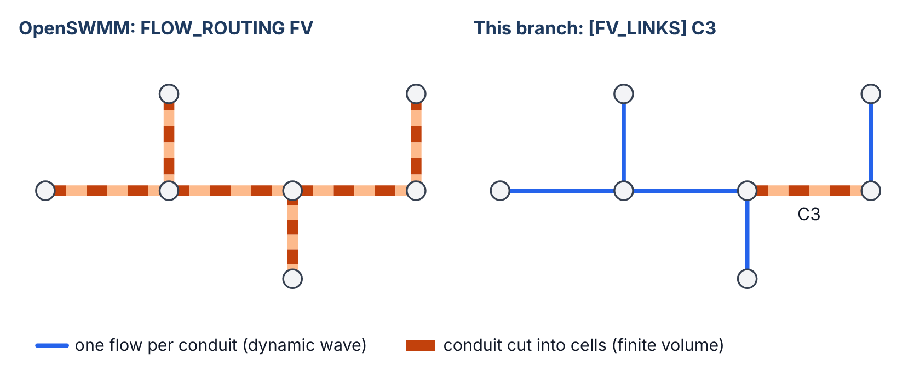
OpenSWMM switches the whole network to finite volume; this branch switches only the conduits you list. Diagram.

2. What it is
swmm524-fvlink is EPA SWMM 5.2.4 with one new source file, fvlink.c (1,403 lines), and short hooks in eleven existing files. It adds an input section, [FV_LINKS], that names conduits and optionally how many cells to cut each into. During a dynamic wave run those conduits are marched by an explicit Godunov-type finite-volume scheme with many small substeps inside each routing step, and their end nodes exchange water with them through exactly booked face volumes. With no [FV_LINKS] section, none of the new code runs and the engine writes the same output, byte for byte, as stock 5.2.4. This app runs both engines, stock and patched, compiled to WebAssembly, in your browser, so you can try it on your own model and see the difference for yourself.

3. Why one pipe sets the clock
Start with what dynamic wave carries. For each conduit it keeps one flow. For each node it keeps one head. Every routing step it solves the momentum equation for each conduit's flow from the two heads at its ends, then updates each node's head from the flows in and out, and repeats that pair of updates (SWMM calls the repeats trials, up to eight of them) until the heads stop moving by more than the head tolerance, 0.005 ft in the tree. That is three numbers for a pipe: two heads and a flow. For a 300-ft pipe carrying a slow flood wave, three numbers are plenty.
The step size comes from the Courant condition. Courant, Friedrichs and Lewy wrote it down in 1928, and every explicit calculation of waves has lived under it since. A disturbance travels along a conduit at the water's velocity plus the wave celerity, c = √(g·A/T), where A is the flow area and T the top width. If the step is long enough for the disturbance to cross the whole conduit, the calculation is no longer following the wave, and it goes wrong. SWMM's variable step takes the model's factor (0.75 in the tree) times L/(v + c) for every conduit that is neither empty, nor full, nor nearly still, and uses the smallest.
Now look at the tree with that rule (Figure 2). Of the four hundred conduits, every one but CT21 allows five seconds or more at its tightest moment. CT21 allows half a second. The network takes the half second.
Figure 2. One conduit sets the pace
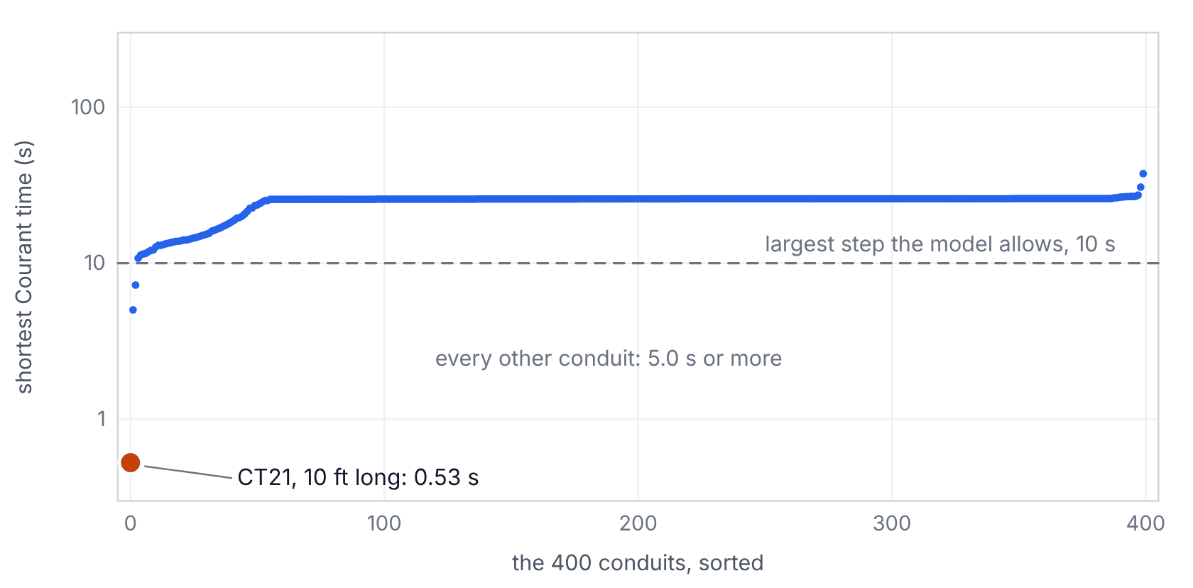
Each of the tree's 400 conduits at its tightest moment, by stock SWMM's own rule: 0.75·L/(v + c), skipping empty, full and nearly still pipes. CT21 allows 0.53 s; every other conduit allows 5.0 s or more. From the stock run's .out file.
SWMM's own report shows what that does (Figure 3). With CT21 in the model as ordinary dynamic wave, almost every step falls in the shortest bins and the average is 1.14 s. Hand CT21 to the finite-volume solver and the average goes to 9.89 s. The same tree with the short pipe simply removed averages 9.87 s. In other words, the rest of the network runs as if the short pipe were not there, while the short pipe is still there, at its true length, carrying its flow.
Figure 3. The steps the model actually took
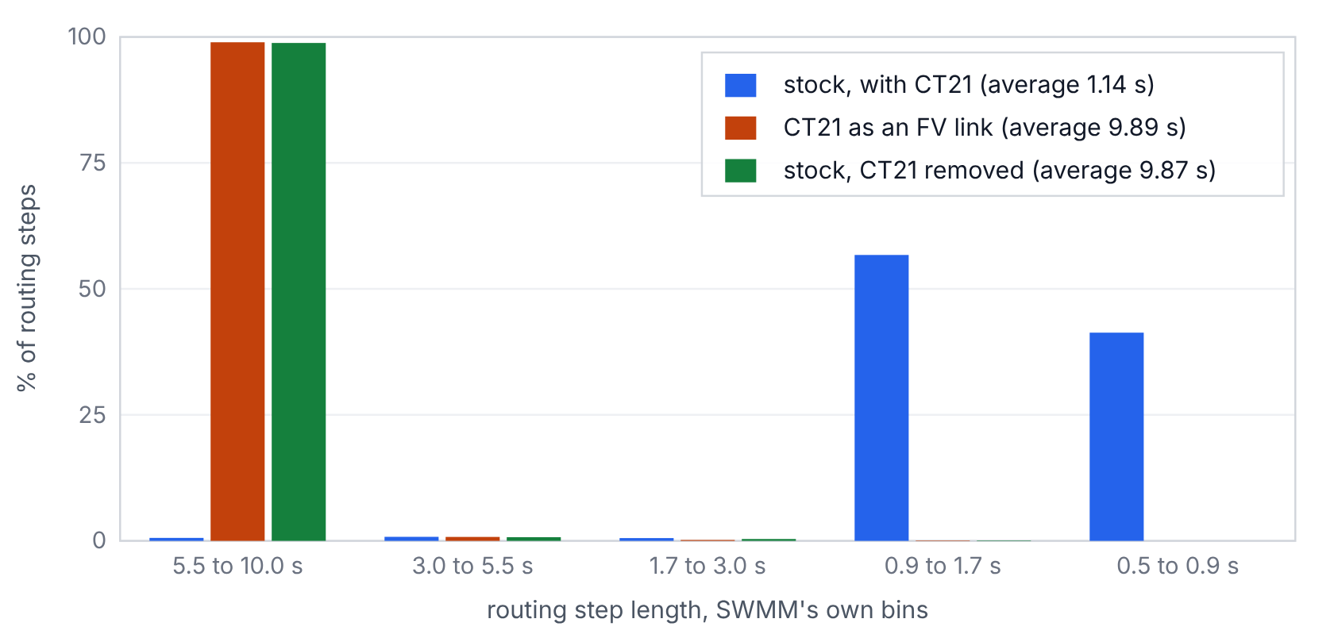
From SWMM's Routing Time Step Summary for three runs of the tree. With CT21 handed to the FV solver, the network takes the steps it would take if the short pipe were not there.
SWMM has an older answer to this, the LENGTHENING_STEP option. It makes short conduits longer, and adjusts their roughness, until they stop setting the step. That works, and engineers have used it for decades, but it changes the pipe. The finite-volume link keeps the pipe and pays for its short length with its own small substeps, inside the link, where nobody else has to take them. Nothing here is free. What it buys is that the small step is taken only where it is needed.

4. Cutting the pipe into cells
The finite-volume link does not carry one flow. It cuts the conduit into cells, about 25 ft each by default and never fewer than four, and carries two numbers in every cell: the area of water, A, and the flow, Q, per barrel (Figure 4). CT21 gets four cells of 2.5 ft. A 300-ft pipe gets twelve. You can give any link the count you want.
Figure 4. The mechanism
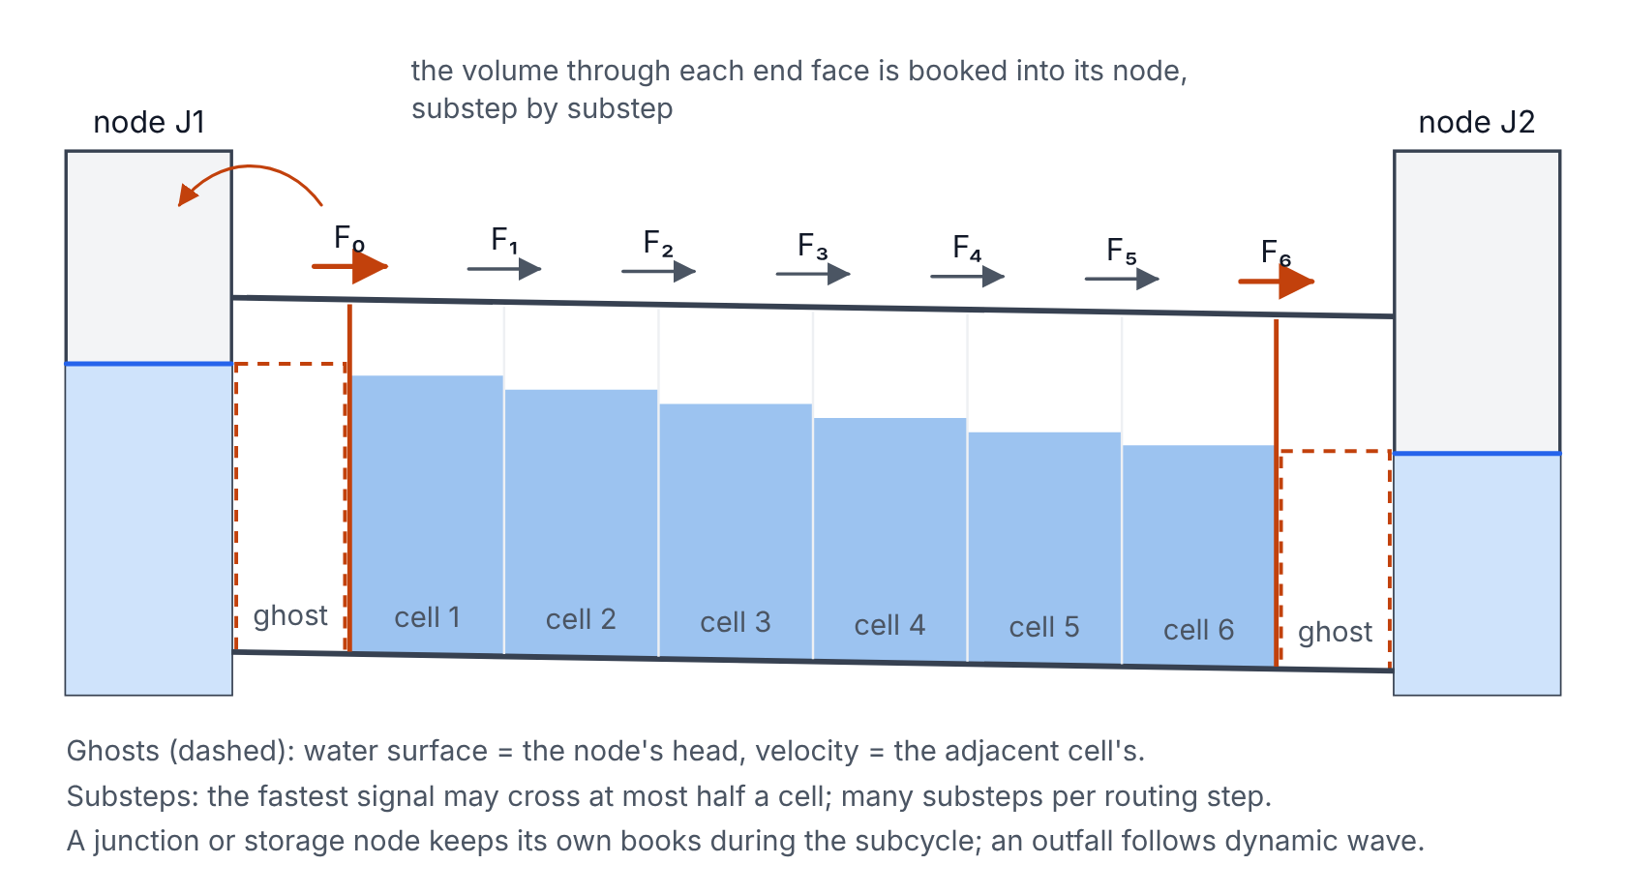
The listed conduit is cut into cells. Each face between cells is solved as a small dam break; each end face sees a ghost built from the node's head and the adjacent cell's velocity. Diagram, not to scale.
Between every pair of cells there is a face, and the whole method is a ledger kept at the faces. In one substep, whatever water crosses a face leaves the cell on one side and enters the cell on the other. A cell's area changes by what came in minus what went out, divided by its length. Add that up along the pipe and every interior face cancels, because each one was counted once as a loss and once as a gain. Only the two end faces are left (Figure 5). That is why the link's volume balance closes to round-off: the stored water changes by exactly what crossed the ends, by construction, not by luck. Measured over 37 EPA models and 14 synthetic cases, the largest volume balance error in any FV link was 2.7e-12 %.
Figure 5. The ledger that makes the volume exact
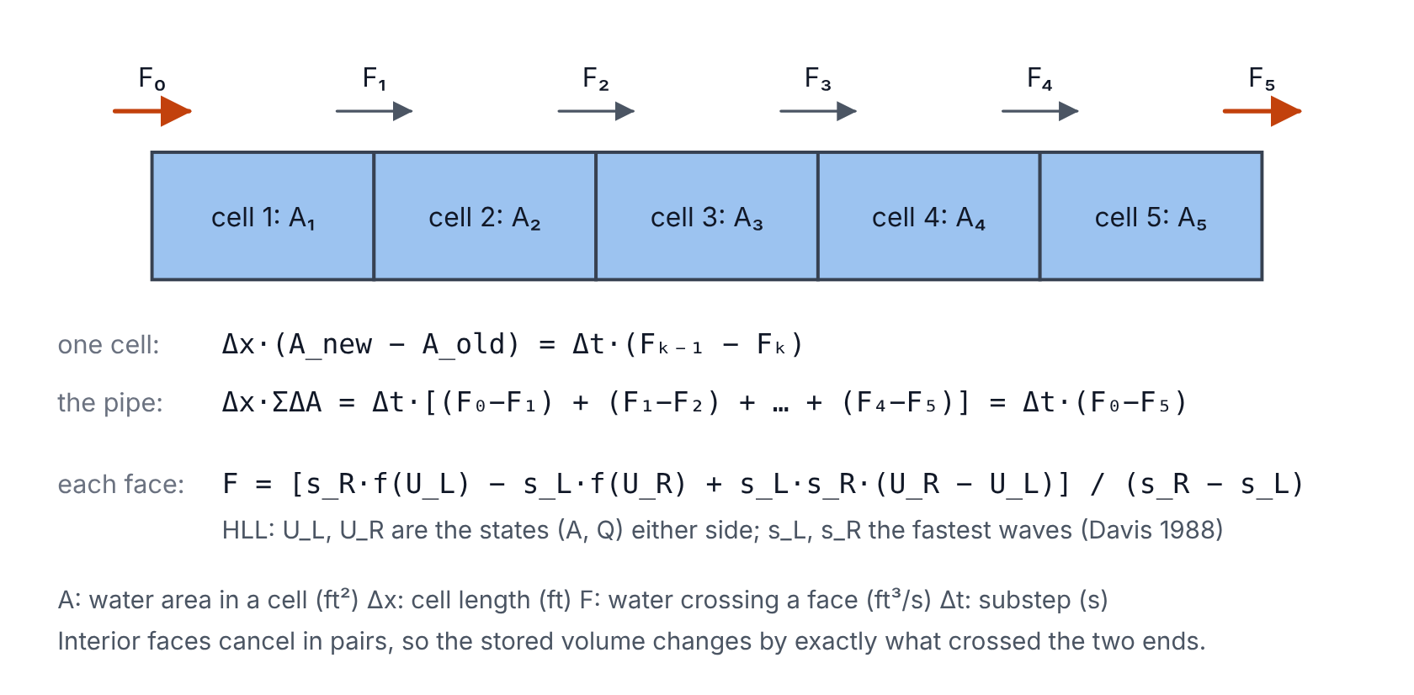
What one cell gains, its neighbor lost. Summed along the pipe, only the two end faces remain. The HLL formula sets each face's flux from the states on either side.
What crosses each face is decided the way Godunov decided it in 1959: treat the two states on either side as a small dam break and ask what water would flow through the face. Solving each dam break exactly is expensive, so the face uses the HLL approximation of Harten, Lax and van Leer (1983). It needs only the fastest waves moving left and right out of the face, and those come from Davis's 1988 estimates, with special cases for a dry bed on either side. The result is a flux that is upwind when the flow is fast and centered when it is slow, without anyone having to say which is which.
There are four places where a careless scheme goes wrong in a sewer, and each one cost a decision.
- Still water must stay still. A bed that slopes, or a pipe that enters a manhole above its floor, puts a step in the bottom. A naive scheme sees the pressure difference across the step and makes a current out of nothing. The faces here use the hydrostatic reconstruction of Audusse and his colleagues (2004), which balances the pressure against the bed exactly. The test is a lake at rest, and it comes later.
- A full pipe must still carry a wave. When a closed pipe fills, the free surface disappears and the open-channel equations stop being well posed. The link adds Preissmann's slot (1961), an imaginary narrow slot in the crown whose width makes the pressure wave travel at 100 ft/s, capped at 5 % of the pipe's maximum width (Figure 6). The price is the substep: a full pipe subcycles at 100 ft/s whatever its length.
- Friction must not blow up when the pipe runs shallow. Manning friction is applied semi-implicitly, and on the real section area only. The slot holds water, but it does not convey any. A first version let the slot area count as conveyance (FVL-4).
- No cell may be drained below empty. Each face's outflow is limited by what the cell or node it drains from actually holds, so a dry cell stays dry instead of going negative.
Figure 6. Preissmann's slot
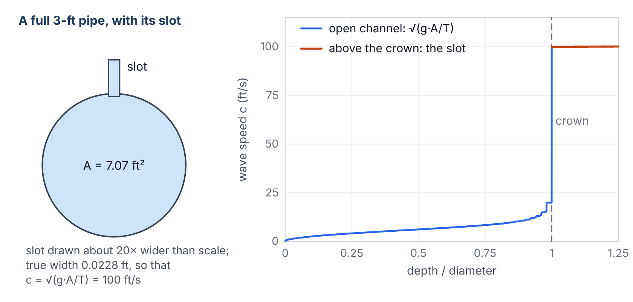
A closed pipe that fills behaves as if it had a narrow slot in its crown, sized so the pressure wave travels at 100 ft/s. Right: the wave speed in the engine's own table for a 3-ft circle.
The geometry comes from SWMM itself. When the link starts, it asks SWMM's own xsect_getAofY for the area at 256 depths and joins them with straight lines. That makes the top width the exact derivative of that table and the pressure moment its exact integral, so depth from area is an exact inverse. On eleven of SWMM's built-in shapes the round trip, depth to area and back, closes to 3.4e-14 ft or better. The FV link sees the same pipe dynamic wave sees, not a lookalike.
Every substep is held to half of what the Courant condition allows inside the link: the fastest signal in any cell may cross at most half a cell. CT21's shortest substep was 0.0878 s, and it took about 105 of them per routing step (the count includes every trial of every step). That is the cost of the short pipe, paid in one place.

5. The handshake at the nodes
The hard part of a hybrid is never either half. It is the joint. At each end of the FV link sits a node that dynamic wave also owns, with other conduits attached that are still dynamic wave. The two methods have to agree on how much water is in that node and how high it stands, every substep, or the model leaks.

The ghost
Each end face needs a state on its outer side, and there is no cell there. So the link builds a ghost: a state whose water surface is the node's head and whose velocity is the velocity of the adjacent cell. Head given, velocity extrapolated. The first draft gave the ghost zero velocity, which sounds harmless and is not. Water leaving the pipe ran into a still pool, backed up, and the node upstream of the FV link in the 30 cfs test chain reached 8.83 ft against stock's 1.73 ft (FVL-1). This is the line that did it:
fvlink.c, first draft, the downstream ghost (FVL-1)
zR = f->z2;
etaR = NdH[f->n2];
hR = MAX(0.0, etaR - zR);
uR = 0.0;
With the ghost taking the cell's velocity, the same node peaks at 1.92 ft. OpenSWMM's ExplicitFvSolver.cpp makes the same choice.

Who keeps the books for the node
During the subcycle, an end node can be in one of two modes. A junction, storage unit or divider is LOCAL: it keeps its own continuity, substep by substep, with the FV face flows and the dynamic wave flows from its other links. An outfall is PRESCRIBED: its head is whatever dynamic wave says it is, and so is the head of a node surcharged under EXTRAN, whose head stock SWMM computes from the net flow rather than from a volume. A flap-gated outfall lets no water into the pipe.
How a LOCAL node's head is advanced turned out to matter more than anything else in the branch. A manhole on a pipe is a weight on a spring. Water in the pipe accelerates toward the lower head, overshoots, and comes back. The second draft moved the node with the head it had at the start of each substep: the face fluxes were fixed from the old head, and those fluxes then moved the head. That is forward Euler on an oscillator, and forward Euler adds a little energy every cycle (Figure 7).
Figure 7. A manhole on a pipe is a weight on a spring
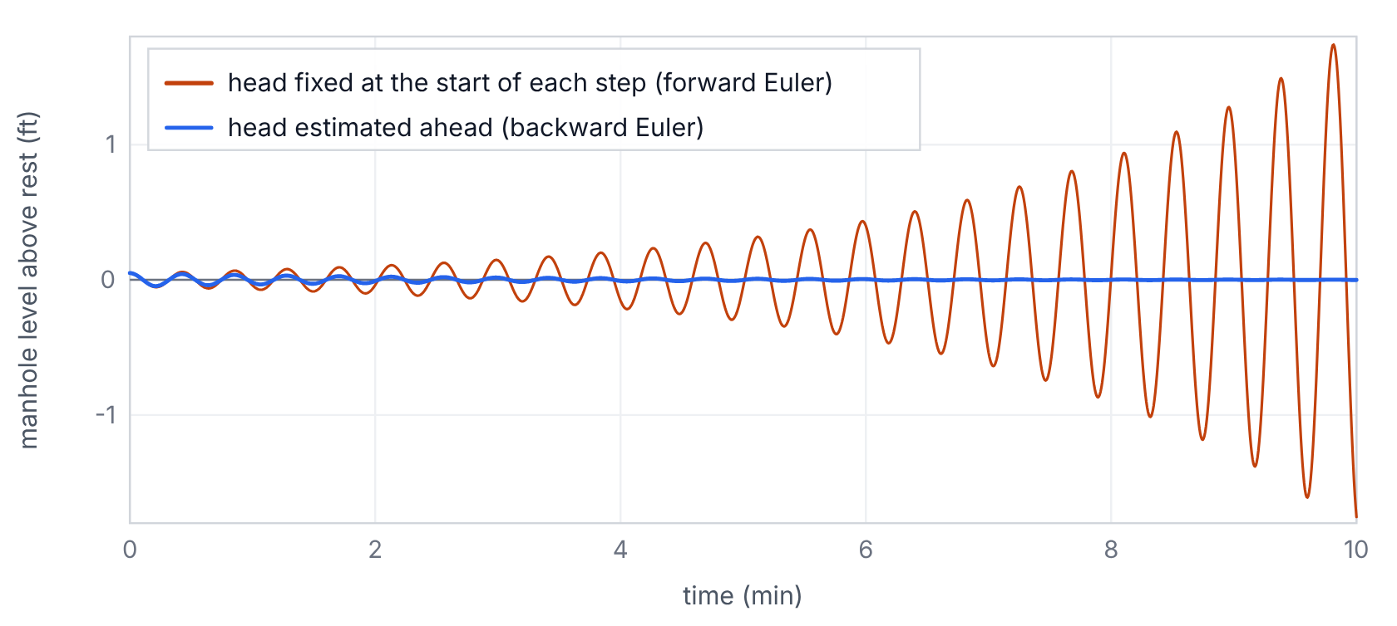
A toy model, not a SWMM run: a 12.566 ft² manhole on a 300-ft, 3-ft pipe, 0.2-s steps, started 0.05 ft high. Fixing the head at the start of each step adds energy every cycle; estimating it ahead takes a little away.
In the resonator test, a dead-end manhole on a surcharged 300-ft pipe started 0.05 ft high, and the draft grew it to a ±2.1 ft limit cycle (FVL-2). Mass was exact the whole time, so the continuity report could not see anything wrong. The lake-at-rest gate caught it. The code was:
fvlink.c, second draft, explicit node coupling (FVL-2)
for (i = 0; i < NNodes; i++)
{
n = NodeList[i];
NdH[n] = nodeHead(n, t, dt);
...
NdV[f->n1] -= f->fm[0] * f->barrels * dts;
NdV[f->n2] += f->fm[nc] * f->barrels * dts;
The fix looks ahead. For each substep the link estimates the node's new head by backward Euler, using the end faces' conductance, √(g·A·T), as the node's dQ/dH, and then re-solves those faces at that head. Up to four estimates are allowed per substep. A node stability limit keeps the substep below the node's area divided by that conductance, A/K. Turn that limit off and the user2 oscillation comes back: user2's largest node depth difference from stock rose from 1.31 ft to 7.05 ft. So the limit stays. With it, the resonator's disturbance falls about 4.6 times in every half hour until the output file can no longer resolve it (Figure 8).
Figure 8. The real resonator, final build
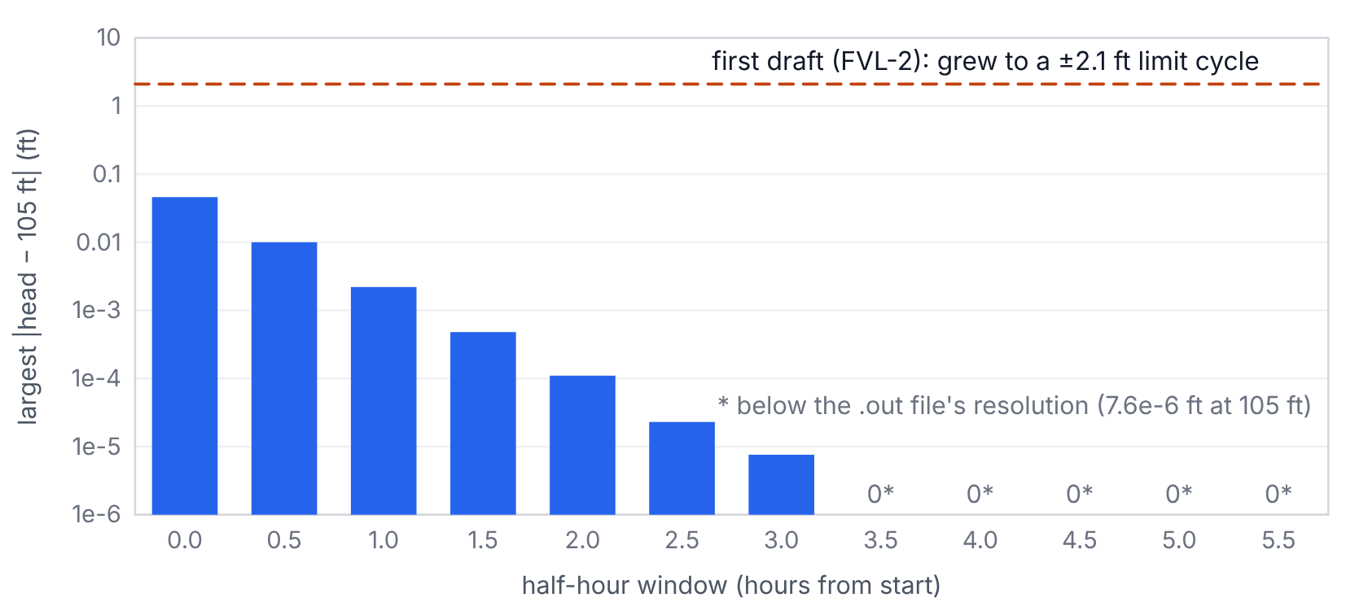
A dead-end manhole on a surcharged 300-ft FV pipe, started 0.05 ft high. Each bar is the largest departure in a half hour; it falls about 4.6 times per window. The first draft's explicit coupling grew instead.
No substep is allowed below 0.001 s. If a stability limit ever asks for less, the substep is raised to the floor and the report counts it as a floor hit, so you know. In the final build no test or sweep model hit the floor. Getting that count right took its own fix: FVL-13 was a substep cut after the fourth estimate that went unrecorded, 18 times in 17.9 million substeps.

Booking the water
Stock SWMM updates a node's volume with the trapezoid rule: half the old flow plus half the new flow, times the step. For an FV link that would be wrong, because the flow through the end face during a routing step is not a straight line between its two end values; it is whatever a hundred substeps made it. So the link books the actual volume that crossed each end face, substep by substep, into the node's continuity (Figure 9). The node's other links keep the trapezoid. The one exception is a node surcharged under EXTRAN, where stock sets the head from the net flow instead of a volume, so the booking cannot be exact there.
Figure 9. Booking the water
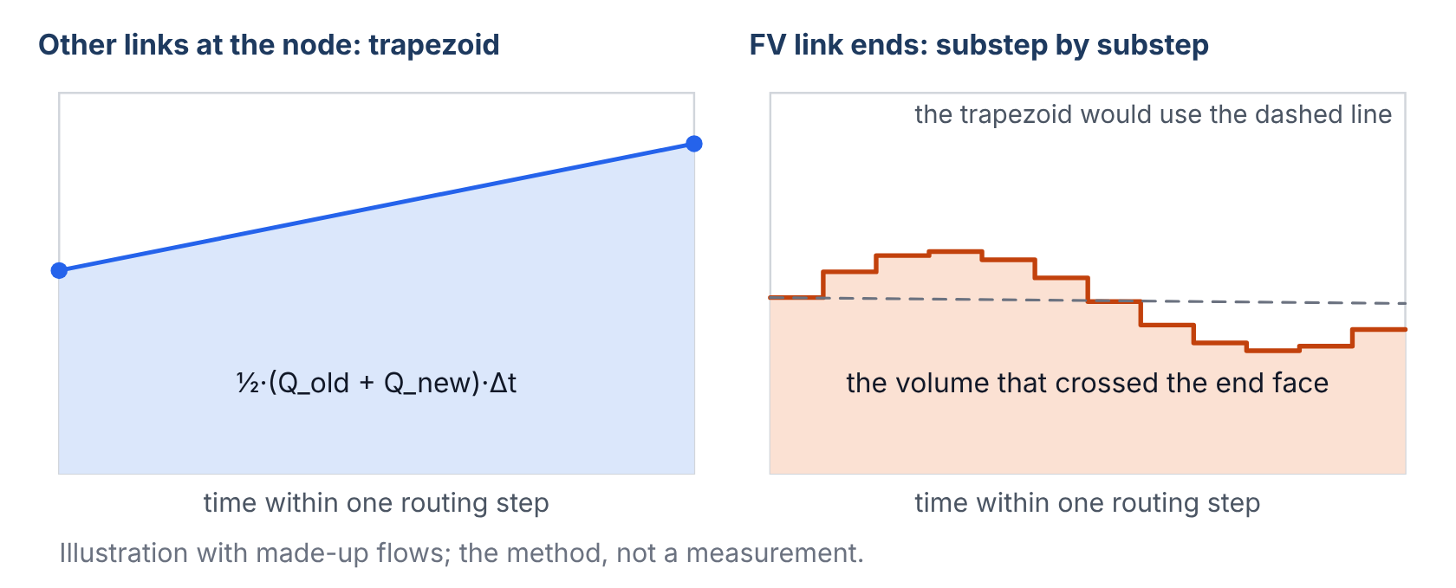
Stock books each link's flow into a node by the trapezoid rule. The FV link books the volume that actually crossed its end face, substep by substep. Illustration.
The flow the link reports is the flow it delivers: the time-averaged flow out of its downstream face, or out of its upstream face when the net movement is upstream. That is not a cosmetic choice. Quality routing treats a conduit as one inflow plus a change in storage, and the first version reported a flow that counted the storage twice. One pollutant through two FV links gave a quality continuity error of −38,402 % (FVL-8). With the delivered flow, the same model closes to 0.093 % and every concentration is within 0.1 mg/L of stock.
Two more agreements finish the handshake. The FV links are subcycled inside every trial of the dynamic wave step, each time starting again from the state saved at the start of the step, so a trial that is thrown away throws away the FV work too. And the FV links take no part in dynamic wave's Courant step, which is the whole point.

6. Follow the data
Here is the path a number takes, from your input file to your report (Figure 10). The section is read by input.c, which hands each line to fvlink_readParams. A name that is not a link stops the run with ERROR 209; a cell count that is not a positive whole number stops it with ERROR 211. When the project is complete, fvlink_validate checks each listed link and stops the run with ERROR 116 if it cannot be an FV link. When routing starts, fvlink_init builds the 256-depth tables and the cells. Then, every routing step, dynamic wave solves its own links, skipping the FV ones, calls fvlink_findFlows to subcycle them against the current node heads, and updates each node from its booked volumes. At the end, stats.c writes the new Finite-Volume Link Summary, and the .out file carries each FV link's delivered flow like any other link's.
Figure 10. Follow the data
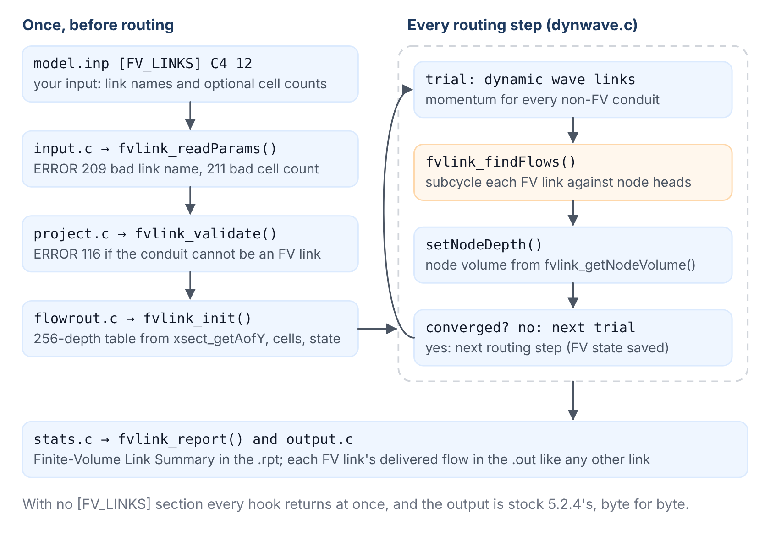
Every hook into stock SWMM is a call into fvlink.c, named here by the file that makes it. Diagram.
Stock SWMM 5.2.4 reading a file with an [FV_LINKS] section stops with ERROR 205 and writes no .out. That is deliberate. An old engine fails loudly instead of quietly ignoring the section and giving you a dynamic wave answer you think is something else.
The FV Link Summary follows the Routing Time Step Summary. For each FV link it gives the cell count, the cell length, the substeps per routing step (counting every trial), the most substeps in one solve, the smallest substep, the link's volume balance error, and the floor hits. If SWMM's own area table for the link had to be repaired, because its area fell as depth rose (it happens on some irregular transects, never on a built-in shape), the report says so.

7. Checking the work
A solver is an instrument, and you do not use an instrument you have not calibrated. The checks below are mechanical: byte comparisons, rebuilds, analytic answers, mass balances, interleaved timing and sanitizer runs. None of them is somebody's opinion that the curves look about right.

First, prove it changes nothing
With no [FV_LINKS] section, the patched engine was run against stock 5.2.4 on all 73 models of EPA's regression suite. 72 wrote byte-identical .out files. The 73rd stops with the same error in both, because it reads a rain file the suite does not ship. The same FV run made twice writes identical bytes. The patch applied to a fresh clone of the v5.2.4 tag rebuilds a byte-identical binary. Under AddressSanitizer and UBSan, 13 models ran clean, and an OpenMP build with two threads wrote the same .out as the serial build on 13 FV models.

Then, the cases with known answers
The lake at rest. A small network filled to 105 ft everywhere, with an outfall fixed at 105 ft, over a sloped bed, a 0.5 ft offset, two barrels and a surcharged pipe. Nothing should move. With every conduit FV, the largest flow anywhere in two hours was 1.2e-11 cfs (Figure 11). With only some conduits FV, the dynamic wave links settle at about 4e-3 cfs, which is dynamic wave's own noise floor: stock reaches the same level from a 1e-7 ft seed.
Figure 11. A lake at rest
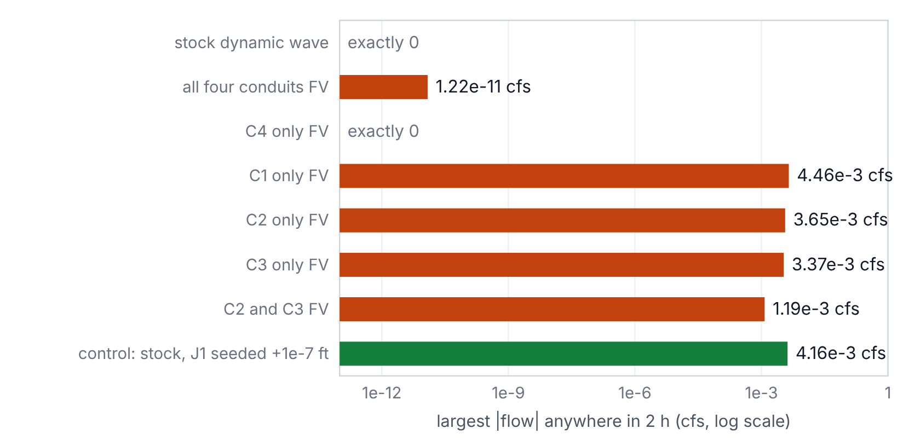
Head 105 ft everywhere, outfall fixed at 105 ft, two hours. With every conduit FV the water stays still to round-off. Mixed models sit at dynamic wave's own noise floor, which stock reaches from a 1e-7 ft seed.
Normal depth. A 10-ft rectangular channel carrying 60 cfs at n = 0.015 and S = 0.001 has a Manning normal depth of 1.6559 ft. The FV reach settles at 1.6592 ft (+0.20 %) and carries 60.0001 cfs.
The resonator, already shown, decays as it should. The flap gate, a gated outfall 4 ft above the junction, lets no water back in, the same as stock.

Then, the case that started it
Back to user2 (Figure 12). With TW01290 listed as an FV link, it peaks at 449 cfs instead of 1,921, never reverses, and moves almost exactly the same water: the net volume through the link agrees to 0.02 %. The routing continuity error hardly changes (0.285 % to 0.280 %), which tells you something about continuity: by that measure nothing happened.
Figure 12. EPA user2, channel TW01290, every 5 seconds
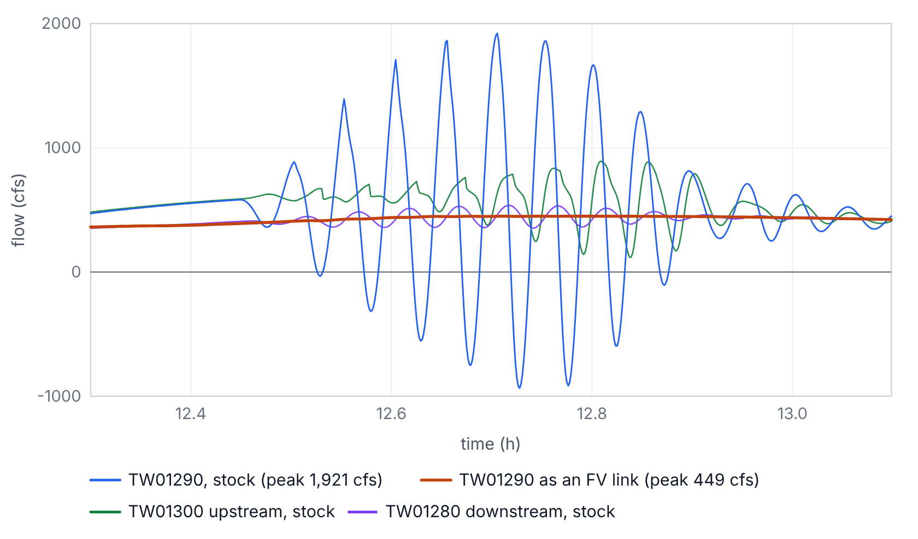
Stock dynamic wave peaks at 1,921 cfs and runs backwards 83 times between 12.53 and 12.88 h, while its neighbors never carry more than 891 and 537 cfs. As an FV link it peaks at 449 cfs with no reversal; net volume agrees to 0.02 %.
Why did SWMM's instability index call the stock run stable? It counts turns, sign changes in a link's step-to-step change in flow, not their size, and lists a link only when the count is high enough. user2 runs 36 hours at 5-s steps, about 25,900 steps, so a link needs roughly 173 turns to appear at all. An oscillation with a period of minutes makes a few dozen. Stock's TW01290 had 45. The FV run has 449 small wiggles in its delivered flow and gets listed with an index of 3, which is the index working as written, not a sign of trouble. If you want to know whether a link is sloshing, look at its total variation, the sum of the sizes of the changes: 38,260 cfs for stock against 965 for FV.

Then, the price at the joints
Here is a cost you should know about before you use it. The node just upstream of an FV link peaks a little higher than in stock (Figure 13). In the 30 cfs chain the excess is 0.41 ft with one cell, 0.19 ft with the default twelve, and 0.13 ft with 48. It shrinks as the cells get shorter, so it is numerical, not a model of entrance loss. The likely causes are the half-cell step in the bed where the pipe meets the node, which OpenSWMM's hydraulics reference describes and cures the same way, with more cells, and the dissipation of the Riemann solver at the end faces. How much is which was not measured.
Figure 13. The price at the joints
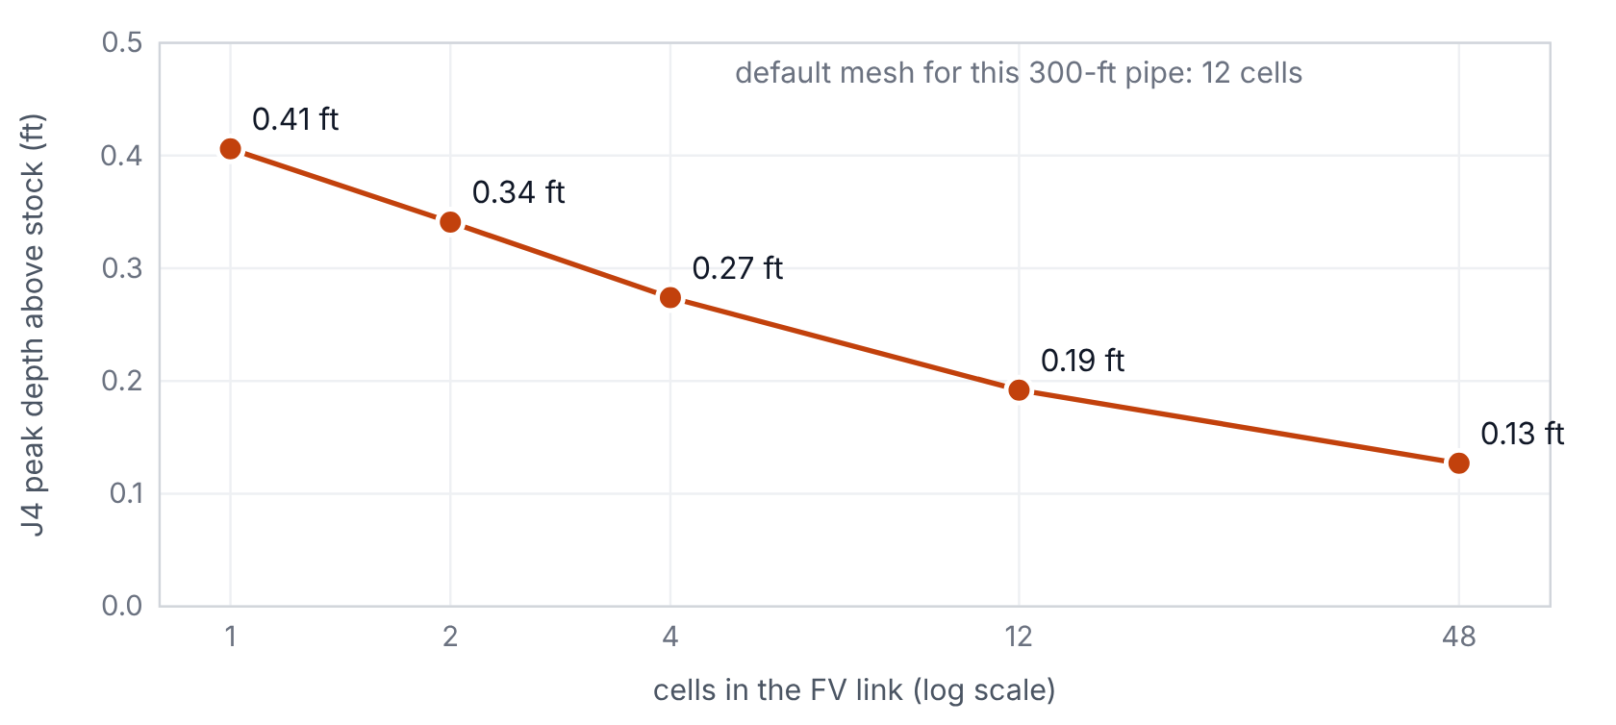
The node upstream of the FV link in the 30 cfs chain peaks higher than in stock. The excess shrinks as the cells get shorter, so it is numerical, not an entrance loss.

Then, what it buys
Back to the tree. Seven interleaved runs each, medians: stock with CT21 takes 4.783 s; with CT21 as an FV link it takes 0.896 s (Figure 14). That is 0.19× the wall time, with every interleaved pair between 0.16 and 0.19. The same tree without the short pipe takes 0.580 s in stock, so the FV link itself costs about 1.4× on this network; that comparison is between two different networks, so read it as the price of the link, not a like-for-like test.
Figure 14. What it buys
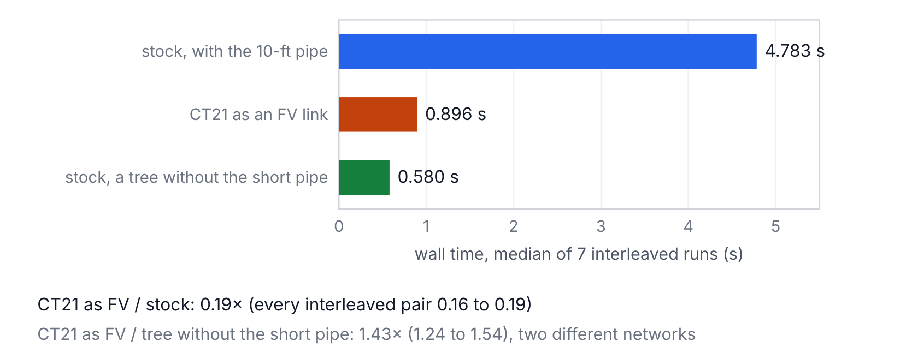
The 400-pipe tree, medians of seven interleaved runs on one machine. The third bar is a different network: the same tree with the short pipe removed.
And the answer barely moves. Every one of the 400 conduits' peak flows is within 0.53 % of stock, and every node's peak depth within 0.80 % (Figure 15).
Figure 15. What it costs in the answer
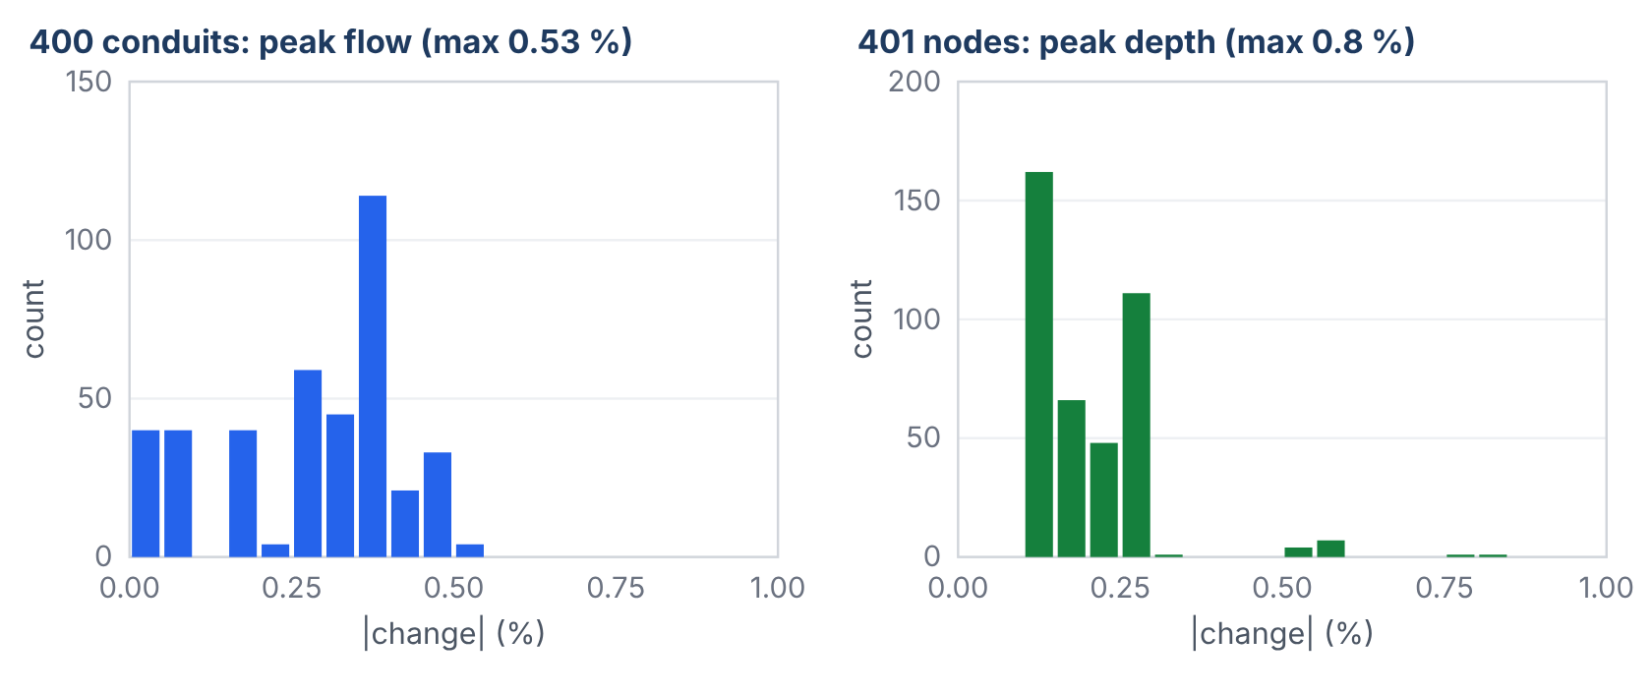
Stock against CT21 as an FV link: the change in every conduit's peak flow and in every wet node's peak depth.

Then, everybody else's models
The sweep took each of the 37 dynamic wave models in EPA's suite that has conduits, flagged the conduit with the largest stock peak flow that the validator accepts, and ran it both ways. The flagged conduit's peak moved by a median of 0.04 % (Figure 16). Four moved more than 5 %: user2 (−73 %) and user5 (−38 %), both oscillations; gate_control_2 (+23 %), a gate-release surge that the FV link carries with a sharper front and the same volume; and gate_control_3 (−13 %), a single spike in one 60-s report. The system outflow volume changed by a median of 0.014 %. One model, extran8a, moved 22.7 %, and that traced to stock SWMM, not the branch: it starts two links with an initial flow, and stock recomputes each link's volume from its end depths in the first step. In stock the two jumps cancel; with one link FV the other's stands. It is logged as S5-DW1.
Figure 16. Everybody else's models
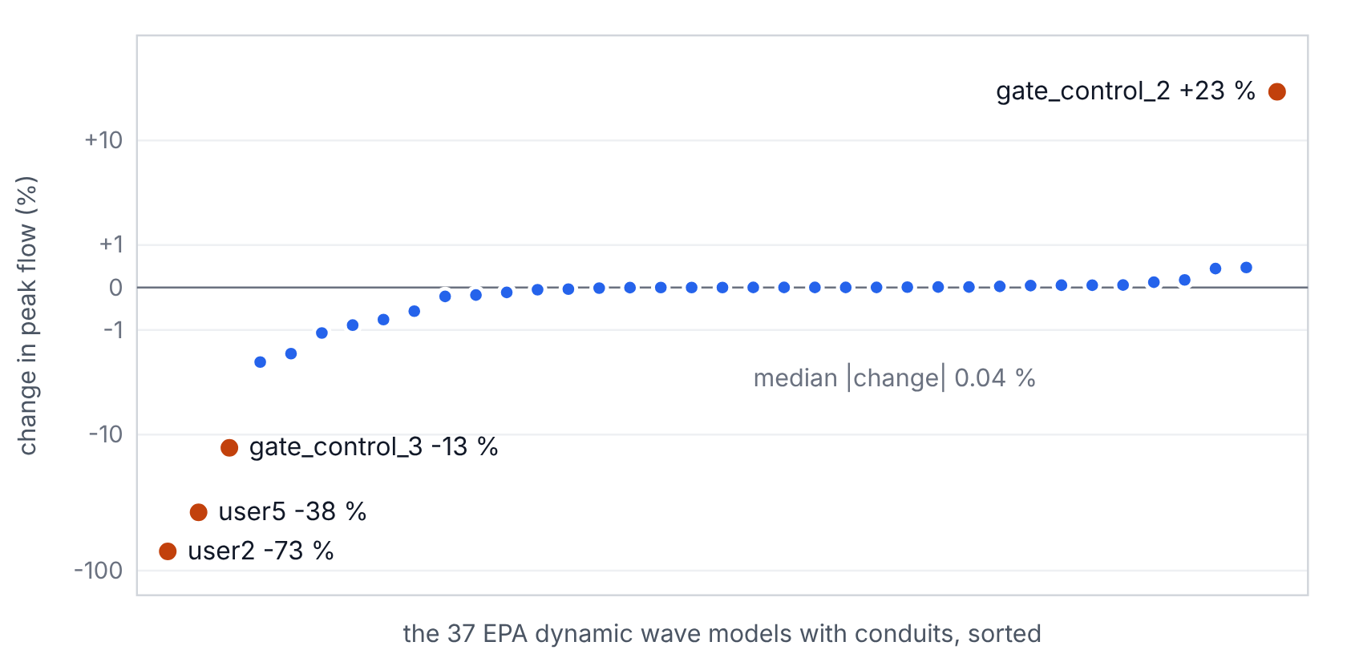
One conduit flagged in each of EPA's 37 dynamic wave models with conduits: the change in that conduit's peak flow. Four moved more than 5 %; two of them are the oscillations this branch removes.

Then, somebody who had not seen it built
A second agent that had not watched the work read the code cold and wrote its own probe models. It found five defects: pumps at an FV end node read the wrong inflow, a flap-gated outfall let water back up the pipe, quality routing counted storage twice, a long link ID overflowed the report line, and the node limiter ignored the node's other outflows. Two more agents checked the written description against the code and the results, and each exposed one more defect. All fourteen are in the defect register, each with the code as it stood when it failed (Figure 17). They are kept because each one is a trap for the next person who writes a scheme like this.
Figure 17. Fourteen defects, found and fixed
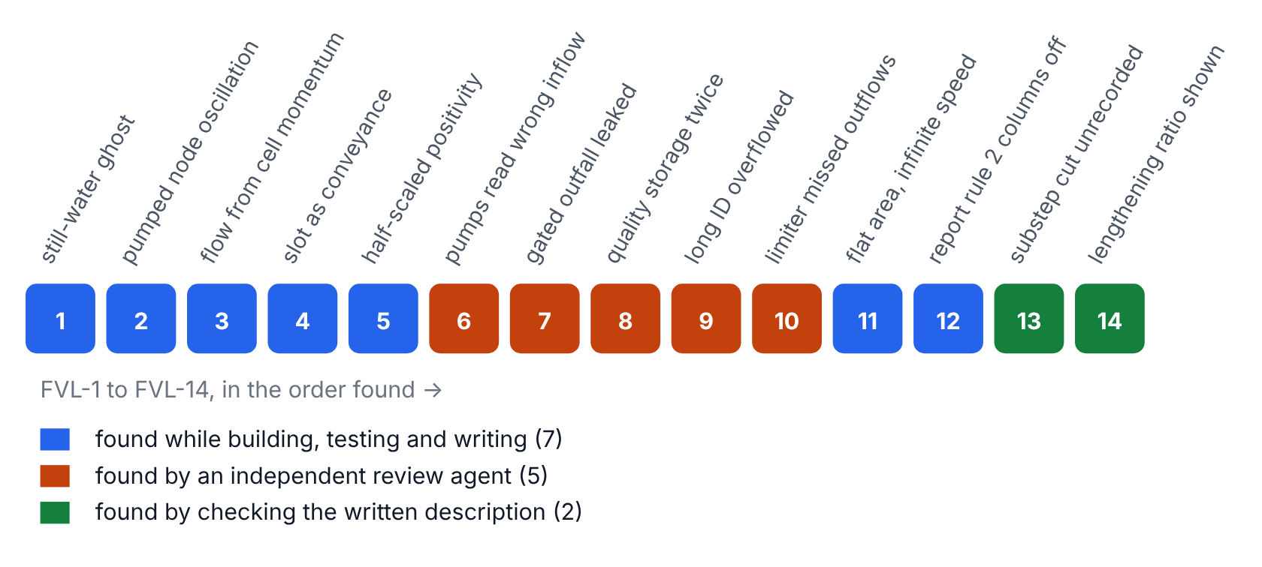
The register keeps the code as it stood when each bug was live. Colour shows who found it.

And the engines in this browser
The engines this app runs are not the binaries that were tested above. They are the same source compiled a second time, to WebAssembly, with Emscripten 3.1.51 and LLVM 18, and a second instrument has to be calibrated against the first. Every test, gate and probe model, and all 73 EPA models, were run both ways (Figure 18). Inside the browser the null effect holds exactly: the stock and patched WebAssembly engines write identical bytes on all 73 EPA models. Against the native builds, most runs are byte-identical too. Where they are not, usually only the report differs, in the last digit of a 1e-13 % volume balance or the minute at which a flat peak is reported. The .out values differ on 2 of the 67 test-set runs and on 6 of the 73 EPA models (the same 6 for both engines). The largest absolute difference is 16 cfs in a 1,962-cfs peak, in stock dynamic wave itself on EPA user5 (0.8 %). The largest relative one is 0.44 cfs in a 30-cfs peak (1.5 %), on the reviewer's reversed two-barrel model with every conduit FV. A native Clang build matches the native GCC build on that model, so the compiler is not the cause; the difference follows the math library (musl in the browser build, glibc natively) seeding round-off that a sensitive run amplifies. That was traced by elimination, not proven function by function.
Figure 18. Calibrating the second instrument
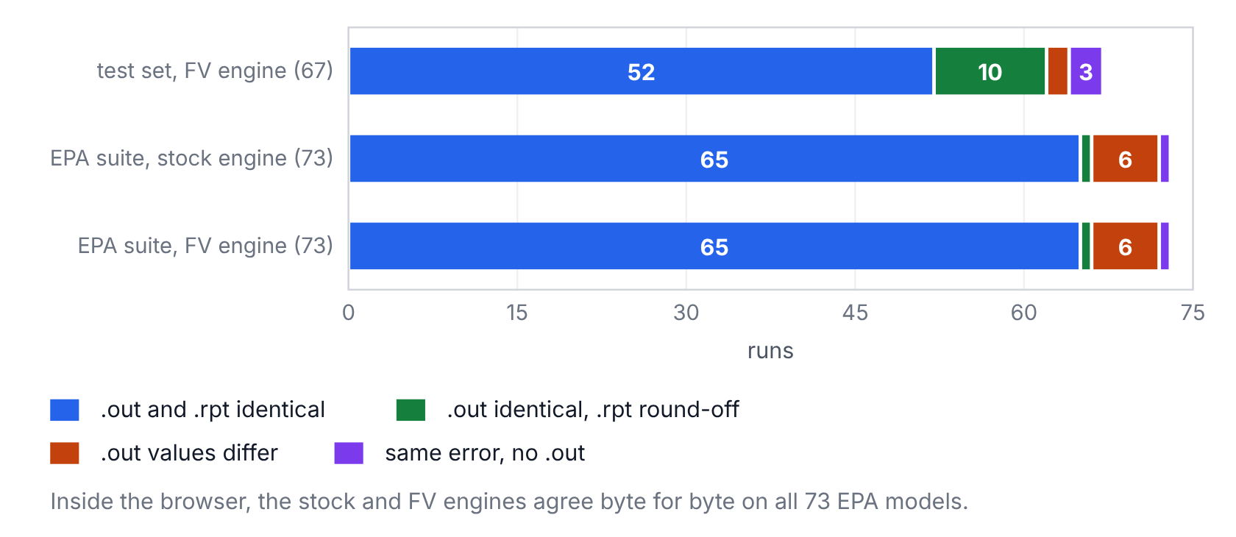
The WebAssembly engines in this app against the native builds that were tested, on every test, gate and probe model and all 73 EPA models (2026-10-21).

8. What this does not show
Every instrument comes with a specification, and the specification is the list of things it will not do. Here is this one's.
- No field data. Stock dynamic wave is the reference here, not the truth. When the FV link and stock disagree, nothing in this work says which is closer to the real sewer.
- Extra head at the joints. The node upstream of an FV link sits higher than in stock, by 0.19 ft at the default mesh in the 30 cfs chain and by 0.47 ft at the storage node in the mixed case. It is numerical and shrinks with refinement. It is not calibrated entrance-loss physics.
- What an FV link can be (Figure 20). A non-dummy conduit under DYNWAVE routing. Not a force main, not a culvert, not a conduit with a flap gate, any entry, exit or average loss, seepage, a maximum flow, or a street inlet, and not a conduit whose end node feeds a pump or a dummy conduit. Those stop the run with ERROR 116. They are rejected, not supported.
- What an FV link does not model. Evaporation and seepage inside the link. Water quality was tested with one conservative pollutant only. Hot start files store no cell state, so an FV link restarts at uniform depth.
- Surcharge. A node surcharged under EXTRAN does not book the FV volume exactly. All 37 EPA sweep models use EXTRAN, and how often their FV end nodes surcharged was not measured.
- Lengthening. LENGTHENING_STEP does not apply to FV links. In user4, stock lengthens the flagged 1.88-ft link 509-fold; the FV link keeps its true length.
- Cost (Figure 19). Very short cells and full pipes are expensive. user4's 1.88-ft link has 0.47-ft cells and fast shallow flow: 791 substeps per step, 15.5 s against stock's 3.0 s. A full pipe subcycles at the slot's 100 ft/s whatever its length: extran10's 1,000-ft pipe, under fixed 60-s routing steps, took 957 substeps per step. Use fewer cells on short links, and don't flag a pipe that runs full for hours unless you mean to pay for it.
- A mixed model at rest sits at dynamic wave's noise floor, about 4e-3 cfs, not at zero.
- Not tested: reactive pollutants, ponding, hot-start continuity, control rules acting on an FV link, and egg, horseshoe, gothic or custom conduits in a running model (those shapes are covered only by the geometry closure test).
- Not compared against OpenSWMM's own finite-volume engine.
- Two platforms. Native Linux with GCC 13.3, serial and OpenMP, and the WebAssembly build in this app. No Windows or MSVC build.
- This app shows single runs, and browser timing is noisy. Treat its wall-time ratio as a quick look; the 0.19× above comes from interleaved runs on one machine.
Figure 19. Where the subcycle is expensive
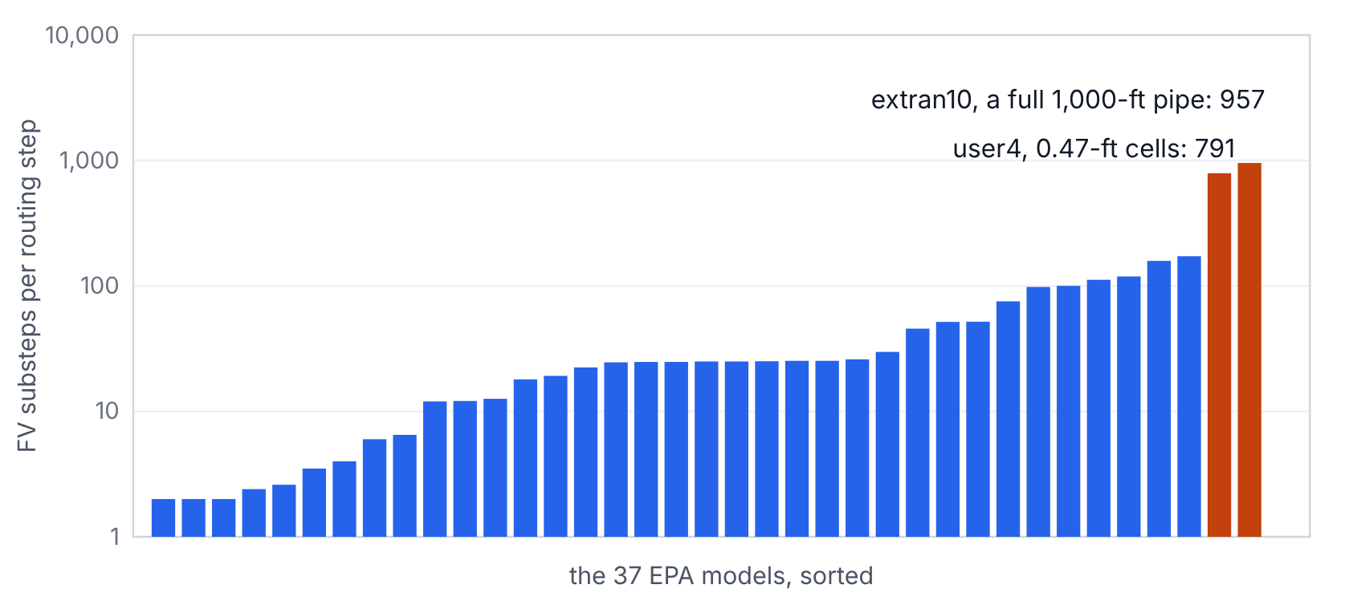
FV substeps per routing step for the flagged conduit in each EPA model. Short cells and full pipes cost the most.
Figure 20. The specification
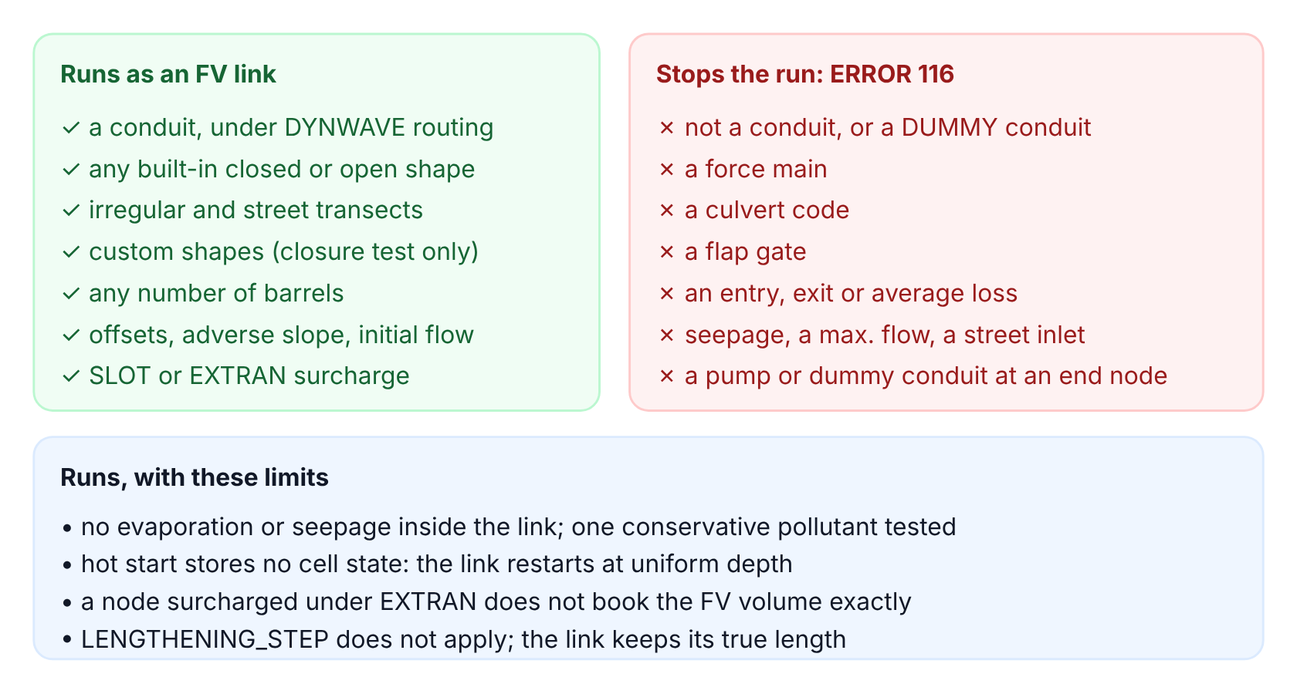
What the engine accepts as an FV link, what stops the run, and what it does not model inside the link.

9. How to use it

In this app
- On the Run tab, pick a sample, or open your own .inp (add any rain or inflow files it reads, in the same picker).
- Click a conduit on the network, or tick it in the conduit table, to list it as an FV link. Leave Cells blank for the default (about 25 ft per cell, at least 4). The pre-check marks conduits the engine will reject and says why; the engine has the final word.
- Press Run both. The app runs stock 5.2.4 on your model without the FV section, then the patched engine with it, one after the other in a background worker.
- Read the cards (wall time, average routing step, continuity), the FV Link Summary, and the peak table. Pick any link or node to compare its hydrograph.
- Press Null check to run the patched engine with no FV links and compare its .out with stock's, byte by byte, on your own model.
- Export the FV model as .inp, either engine's .rpt and .out, or the comparison tables as CSV.

In an input file
the [FV_LINKS] section
[OPTIONS]
FLOW_ROUTING DYNWAVE

[FV_LINKS]
;;Link Cells
C4 ; default mesh: about 25 ft cells, at least 4
TW01290 40 ; 40 cells
C3 * ; * = default
Build the native engine from the patch with git apply swmm524-fvlink.patch on a clone of the v5.2.4 tag, then gcc -O2 -U_FORTIFY_SOURCE -D_FORTIFY_SOURCE=0 -Isrc/solver -Isrc/solver/include src/solver/*.c src/run/*.c -lm. The package's README, VERIFICATION and DEFECTS files hold the full record.

10. AI use
This branch, its tests, this app and this essay were made with Claude, Anthropic's AI model, in Claude Code sessions from October 13 to 21, 2026, under the direction of Robert (Bob) Dickinson. He asked for finite volume on chosen links with dynamic wave on the rest, for the technical description and the essays, and for this app; responsibility for the work is his.
What Claude did. It read the EPA SWMM 5.2.4 and OpenSWMM source, designed the method and chose its parameters, wrote fvlink.c, the hooks, the test networks and the scripts, ran every test, and fixed the defects in the register. For this app it compiled both engines to WebAssembly, wrote the app (its input, report and output parsers, the network view, the charts and the worker), drew every figure from the results files, and wrote this essay and its Word version. A second Claude agent reviewed the code without the build history, and two more checked drafts of the technical description against the code.
How it was checked. The checks are mechanical: byte comparison with stock on EPA's 73 regression models, rebuilds from the patch, analytic answers, mass balances, interleaved timing, sanitizer runs, the WebAssembly-against-native census, and a headless browser test of this app. What no person has checked yet: fvlink.c line by line, a run on a project model, the design choices listed in the README, and this app's parsers beyond its automated tests.

References
Audusse, E., Bouchut, F., Bristeau, M.-O., Klein, R., and Perthame, B. (2004). A fast and stable well-balanced scheme with hydrostatic reconstruction for shallow water flows. SIAM Journal on Scientific Computing 25(6), 2050-2065.
Courant, R., Friedrichs, K., and Lewy, H. (1928). Über die partiellen Differenzengleichungen der mathematischen Physik. Mathematische Annalen 100, 32-74.
Davis, S. F. (1988). Simplified second-order Godunov-type methods. SIAM Journal on Scientific and Statistical Computing 9(3), 445-473.
Godunov, S. K. (1959). A difference method for numerical calculation of discontinuous solutions of the equations of hydrodynamics. Matematicheskii Sbornik 47(89), 271-306.
Harten, A., Lax, P. D., and van Leer, B. (1983). On upstream differencing and Godunov-type schemes for hyperbolic conservation laws. SIAM Review 25(1), 35-61.
HydroCouple/openswmm.engine, commit 8dd7387: ExplicitFvSolver.cpp and the hydraulics reference, Chapter 8 (Finite Volume).
Preissmann, A. (1961). Propagation des intumescences dans les canaux et rivières. First Congress of the French Association for Computation, Grenoble.
Rossman, L. A. (2017). Storm Water Management Model Reference Manual, Volume II: Hydraulics. U.S. Environmental Protection Agency, EPA/600/R-17/111.
U.S. EPA. Stormwater-Management-Model, tag v5.2.4 (commit 7952ca8), and swmm-nrtestsuite, v2.5.0-dev. github.com/USEPA.
This document is the Doc tab of the FV Link Lab app, rendered from the same source file. The app and its engines: index.html in the swmm524-fvlink Netlify folder.

