Forks in the Road
How swmm5-kw teaches EPA SWMM 5.2.4's kinematic wave and steady flow to split a junction and run a loop, what it proved about itself, and what it still cannot do.

The one-way street
Kinematic wave is the plainest honest way to move water through a sewer model. Each pipe takes what its upstream junction hands it, runs that through Manning's equation and the continuity equation, and passes the result on. No pipe ever asks what is happening below it. That is why it is fast. It is also why it is fussy.
Because every pipe waits on its upstream junction, SWMM has to put the pipes in order before it routes a drop: each pipe after every pipe that feeds it. The ordering is called a topological sort, and toposort.c does it once, before the run. A network with one way out of every junction and no way back sorts cleanly. Mathematicians call that shape a tree. So do sewer designers, for the same reason.
Hand stock SWMM 5.2.4 anything else under KINWAVE or STEADY routing and it stops before it starts. A junction with two outlets gets you this:
ERROR 133: Node J2 has more than one outlet link.
A path that leads back to where it began gets you this:
ERROR 131: the following links form cyclic loops in the drainage system:
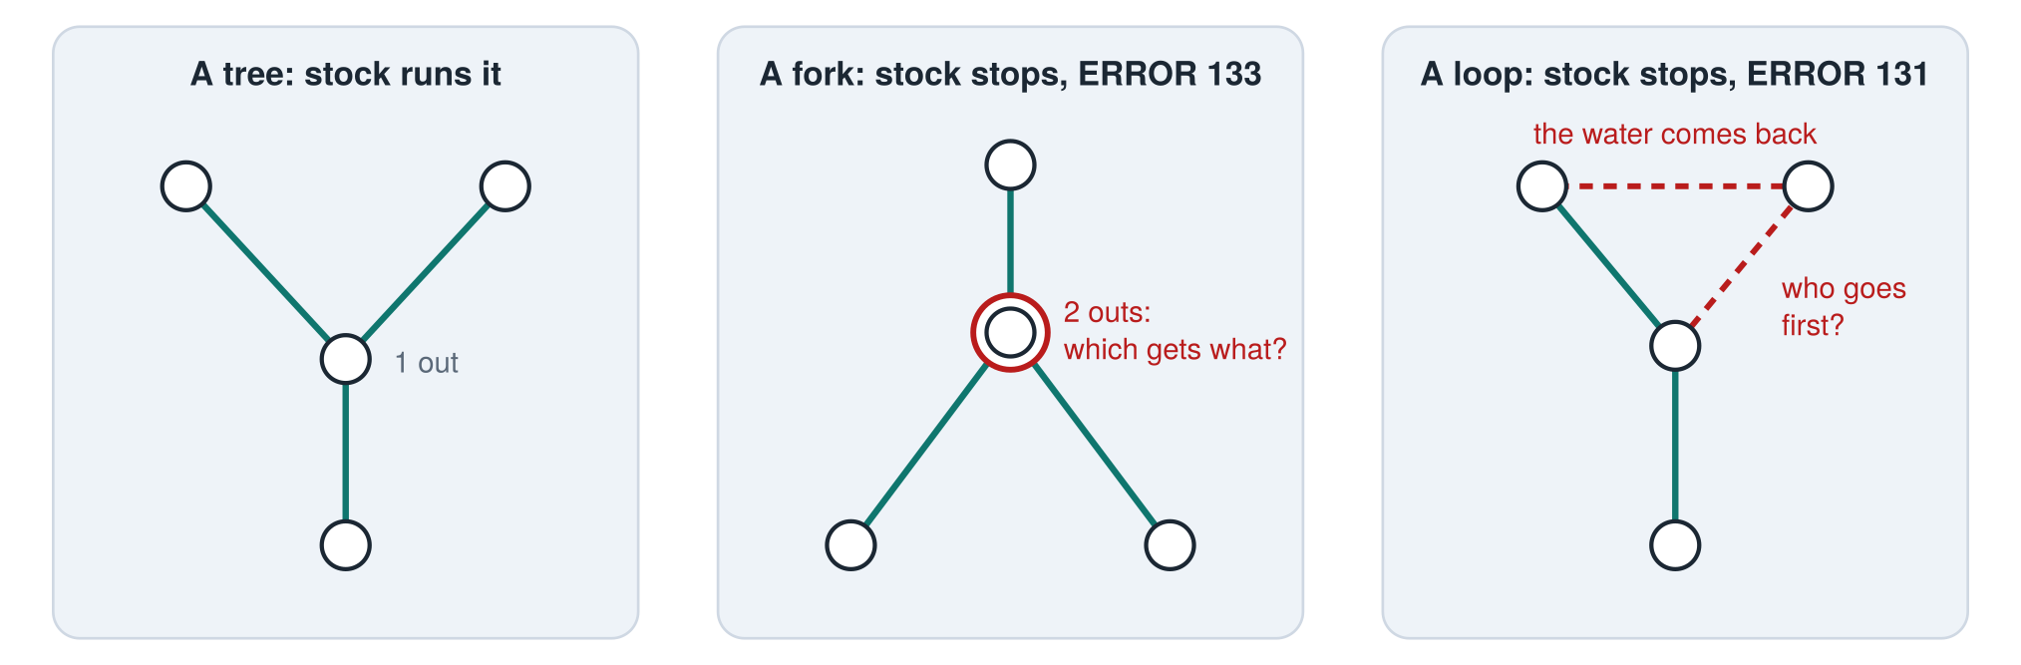
Figure 1. Stock SWMM routes kinematic wave and steady flow in one pass, upstream to downstream. A fork leaves the pass without a rule for dividing the water; a loop leaves it without a place to start.

Why the rule is there
The rule is not an oversight. The engine knows exactly how much water reaches a junction. What it does not know is how to divide it. Dynamic wave never needs telling: it solves for the water surface at every node at once, and the head difference along each pipe settles the share. Kinematic wave has no head to speak of. It knows depth in a pipe, not level at a junction.
So SWMM gives you a node built for the job, the DIVIDER, with four ways to divide (CUTOFF, OVERFLOW, TABULAR and WEIR), and it makes you pick one and supply its numbers. The old Transport block worked the same way with its flow-divider elements. The position is "you tell me how the water splits, and I will route it." That is a sound engineering position.
It is also a tax. Real systems are full of forks: relief sewers, twin barrels laid forty years apart, a storm drain that parts around a building and meets itself on the other side. Each one has to become a divider, and each divider needs a curve somebody made up. A made-up curve is a guess dressed as data, and it does not get better because it sits in an input file.
In September 2026 Bob asked for a SWMM5 whose kinematic wave and steady flow would run loops and node bifurcations. swmm5-kw is that engine.

What swmm5-kw is
swmm5-kw is EPA SWMM 5.2.4, built from the official v5.2.4 tag, with seven source files changed: one new file, kwmod.c, and small edits to flowrout.c, toposort.c, node.c, swmm5.c, swmm5.h and funcs.h, 622 lines added and 4 removed. It has two switches, set through one new API call, swmm_setKwOptions(split, loop). The split switch picks a rule for dividing a junction's outflow among its outlets. The loop switch lets a directed loop iterate within each routing step. Both start off. With both off the engine is stock 5.2.4, byte for byte, refusals included. Dynamic wave is never touched.

One water level for every outlet
The default split rule is called HEAD, and it borrows the one idea kinematic wave lacks. Imagine water standing in the junction at some level, call it y. Every outlet pipe sees that level at its own entrance, less its own offset above the junction floor. At normal depth, each pipe carries whatever Manning's equation gives for that depth. Add up those flows. Too much water leaving? Lower y. Too little? Raise it. Halve the bracket each time, and after 22 to 31 halvings on average (in the test runs) you have the one level at which the outlets together carry exactly what came in.
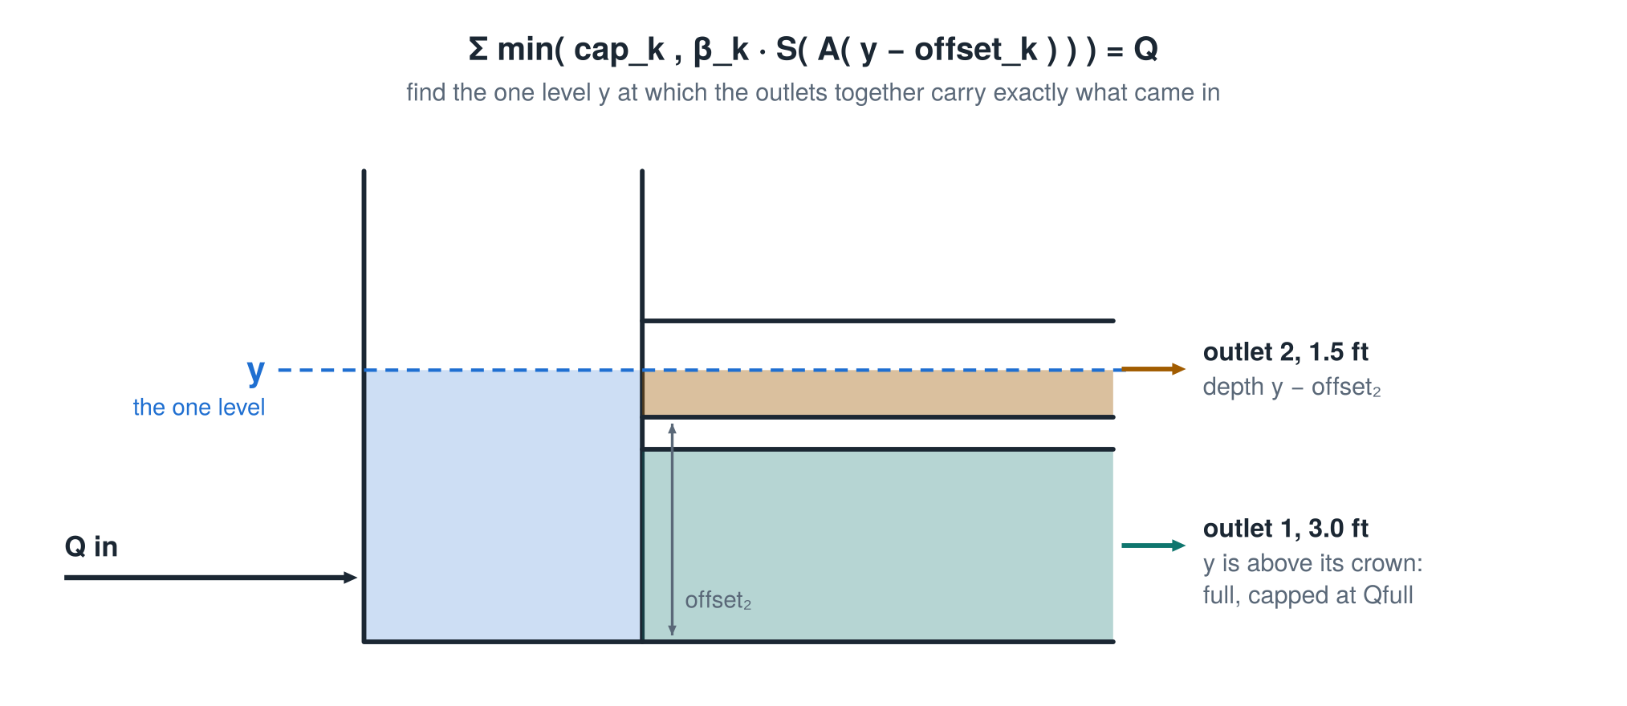
Figure 2. HEAD in elevation. The same level y fills each outlet to a different depth because each sits at a different height. The small pipe takes y minus its offset; the large pipe, with y above its crown, is full and capped.
There is one trap, and it is an old one. A circular pipe carries more than its full-pipe flow when it runs just short of full. The wetted perimeter shrinks faster than the area near the crown, so Manning's flow climbs past full at 0.82 of the diameter and peaks at 1.076 times full flow at 0.94. Let that curve run free and the total is no longer a steady climb in y, and a bisection can be fooled. So HEAD caps each outlet at its full-flow capacity. Water beyond the sum of the capacities stays in the junction and ponds or floods, which is exactly what SWMM's kinematic wave already does with a single pipe that is full.
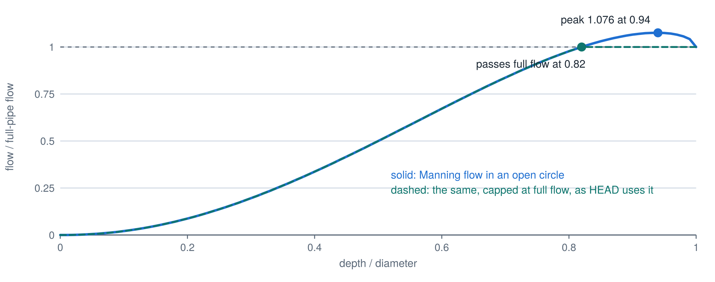
Figure 3. Flow against depth in a circular pipe, from Manning's equation. The open-channel curve passes full-pipe flow at 0.82 of the diameter and peaks 7.6% above it. HEAD uses the capped curve, which only ever rises.
The other two rules are simpler. CAPACITY divides in proportion to each outlet's full-flow capacity. AREA divides in proportion to each outlet's flow area at the end of the previous step, falling back to CAPACITY on the first step, when every area is zero. AREA was the first rule Bob asked for, in August 2026. All three compute every outlet of a junction together, once per sweep, so the answer cannot depend on which outlet happens to ask first.

What the numbers say
The first test network, split.inp, is as small as a fork can be: one 3 ft pipe carrying 20 cfs into a junction with two outlets, a 3.0 ft pipe and a 1.5 ft pipe, both 400 ft long on the same slope. Stock 5.2.4 refuses it under kinematic wave with ERROR 133 and runs it under dynamic wave. swmm5-kw runs it under all three rules.
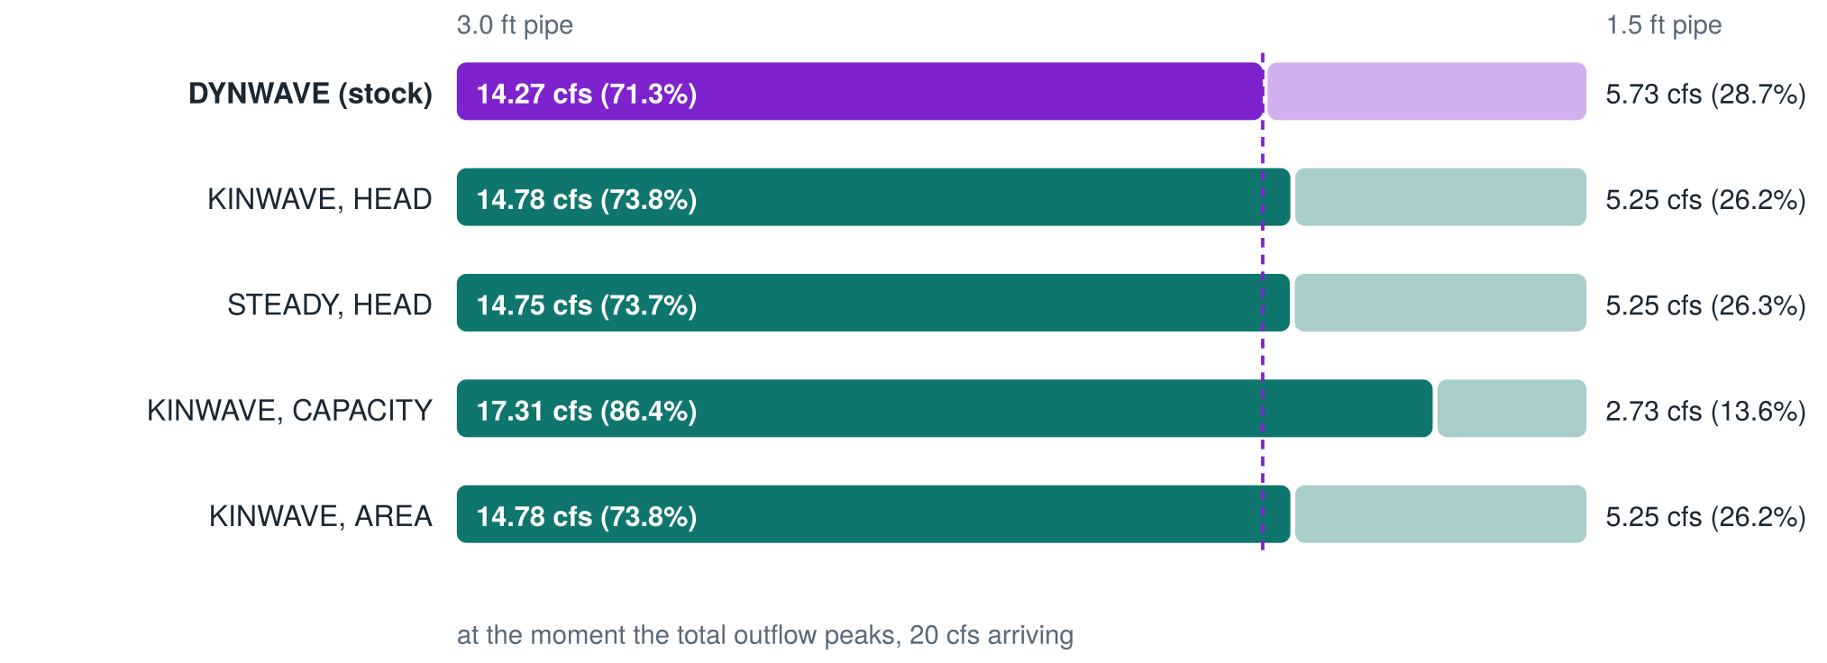
Figure 4. How split.inp divides its 20 cfs at the moment the total outflow peaks. HEAD and AREA put the 1.5 ft pipe at its full-flow capacity; dynamic wave pushes 5.73 cfs through it under pressure. CAPACITY sends far too much down the big pipe.
HEAD sends 73.8% of the flow down the big pipe. Dynamic wave sends 71.3%. The gap is not a flaw in the rule. It is the one thing dynamic wave can do that kinematic wave cannot: push a pipe past full. Dynamic wave drives 5.73 cfs through the 1.5 ft pipe, about 9% beyond the 5.25 cfs it can carry flowing full by gravity, because the junction's water surface rises and the pipe runs under pressure. Under kinematic wave, full is full. AREA lands in the same place here, because the small pipe is at its cap either way. CAPACITY sends 86.4% down the big pipe and misses by 15 points. Capacity says what a pipe could carry flowing full, not what it takes when both pipes see the same water level.
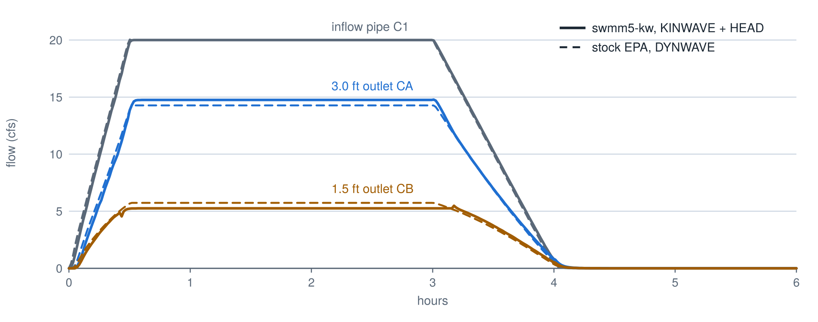
Figure 5. The whole storm at the fork in split.inp. Solid lines are swmm5-kw under KINWAVE with HEAD; dashed lines are stock EPA under DYNWAVE. The small outlet runs at its capacity through the plateau; dynamic wave puts it under pressure.
Two more networks split and rejoin: diamond.inp, one fork and one merge, and braid.inp, two of each. Every pipe's peak flow under swmm5-kw lands within 1.8% of dynamic wave, and within 4.3% on split.inp. Steady flow with HEAD gives a routing continuity error of 0.000% on split.inp; kinematic wave gives 0.131%, about what stock kinematic wave gives on the plain three-pipe chain at 30 cfs (0.124%).
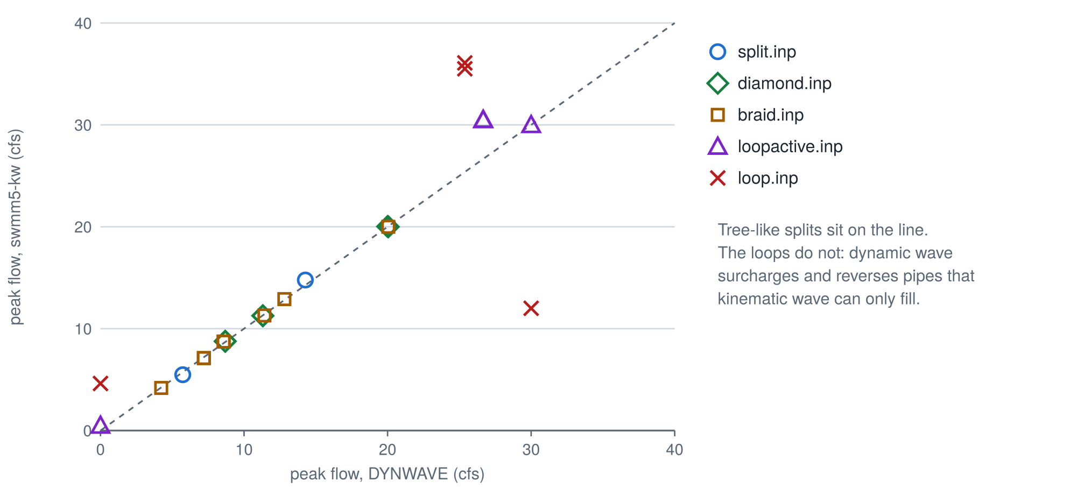
Figure 6. Peak flow in every link of the five test networks, swmm5-kw (KINWAVE, HEAD, loops iterated) against stock EPA under DYNWAVE. The splits sit on the line. The loops do not, for reasons the next two sections give. R1's dynamic-wave flow is negative all storm, so its peak plots at zero.

Water that comes back
A loop breaks the sort itself. Kahn's algorithm, which toposort.c uses, repeatedly takes a junction whose inflows are all accounted for. In a loop, every junction is waiting on another, and the algorithm runs out of candidates with pipes still unsorted. Stock SWMM reports ERROR 131 at that point.
swmm5-kw instead picks one junction and declares its waiting over. It takes the unfinished junction with the fewest unsorted inflows; on a tie, the one with the most inflows already sorted, which is the loop's natural entrance; on a further tie, the smallest ID in alphabetical order. That last rule matters more than it looks. The first version broke ties by position in the input file, and the loop models' continuity changed between 0.122% and 0.125% when the file's lines were shuffled. An engine whose answer depends on line order is not an engine you can trust. After sorting, any pipe that delivers water to a junction already processed is marked as loop-closing.
Then, each routing step, the engine has to route water it has not computed yet. It guesses. Each loop-closing pipe is assumed to deliver what it delivered last step. The engine sweeps the network in order, compares what each loop-closing pipe actually routed with the guess, and if they disagree, puts everything back the way it was at the start of the step and sweeps again with better guesses.
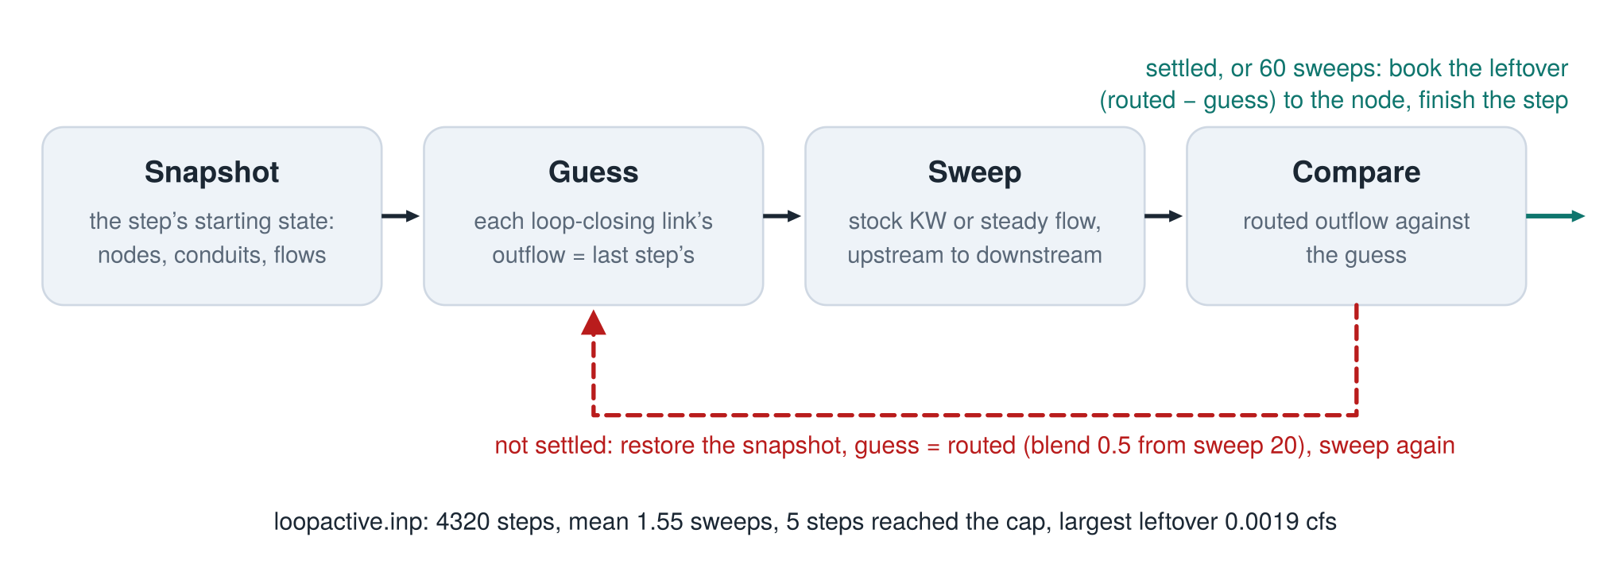
Figure 7. One routing step on a network with a loop. The snapshot is what makes this sound for kinematic wave: each trial sweep must start from the same pipe state, or water is counted twice.
"Puts everything back" is the important part. A kinematic-wave pipe carries its state from one step to the next: flow and area at both ends. A trial sweep changes that state. Sweep again without restoring it and the second trial starts from the first trial's answer, which is how you count water twice. After 60 sweeps, or as soon as the guesses stop changing, the engine books any remaining difference to the receiving junction, so the books balance whether the iteration settled or not. On loopactive.inp, a relief pipe that spills from the bottom of the network back to the top, it took 1.55 sweeps per step on average; 5 of 4320 steps reached the cap, and the largest leftover was 0.0019 cfs.

The pipe that ran backwards
Here is the result that matters most, and it corrects something. In September this engine's write-up compared the flow in that relief pipe, R1, under the two methods: 0.51 cfs under swmm5-kw, 3.34 cfs under dynamic wave, and called both of them recirculation. Claude wrote that comparison. It looked only at the size of the two flows. It never looked at their sign.
The sign is the whole story. Under dynamic wave, R1 runs backwards for the entire storm, from J1 to J3, down to -3.34 cfs. The water at J1 stands higher than the water at J3, so the "relief" pipe becomes a second path downstream, beside the main line. That is what a relief pipe in that position would really do. Kinematic wave cannot run a pipe backwards. A link's direction is fixed by the way it is drawn in the input file. So under swmm5-kw, R1 can only carry water the way it points, from J3 back to J1, and it carries 0.51 cfs spilling over its 3.5 ft offset.
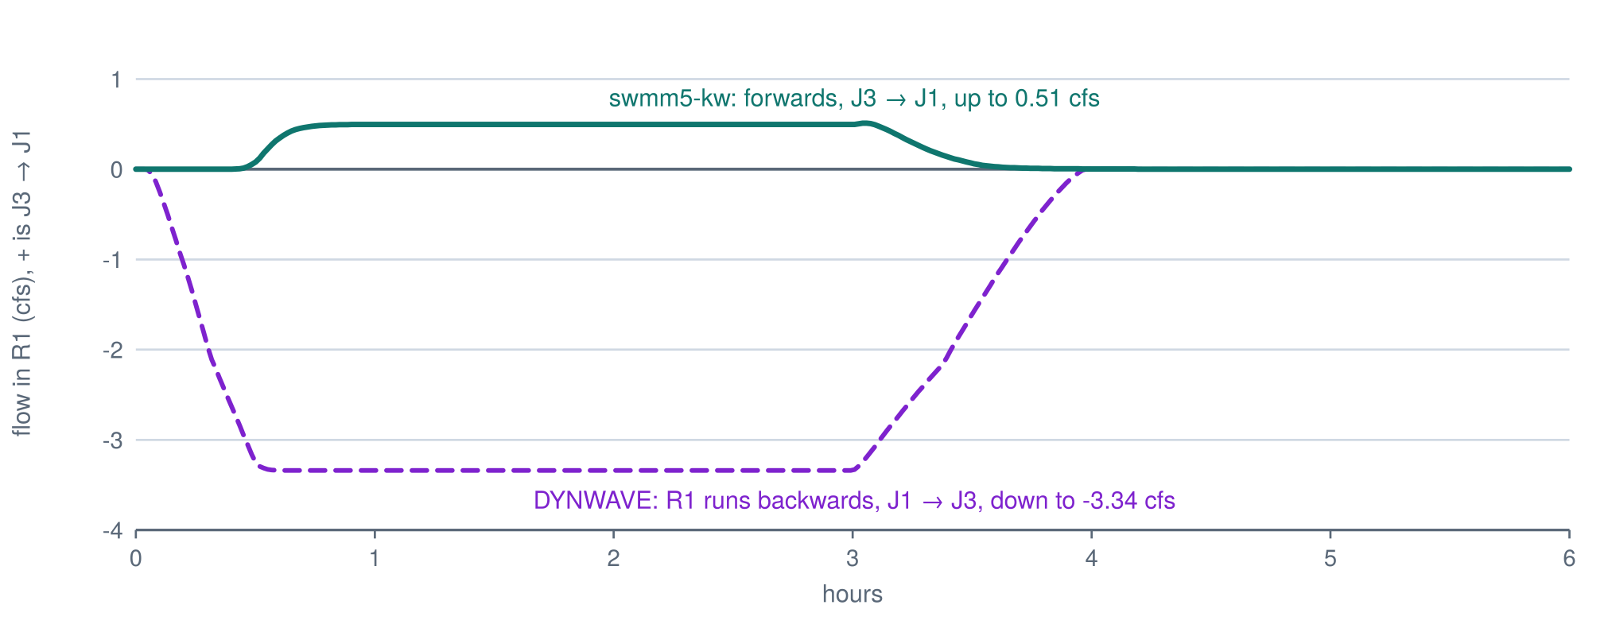
Figure 8. Flow in the relief pipe R1 of loopactive.inp. Dynamic wave runs it backwards all storm as a second path downstream. Kinematic wave cannot reverse a pipe, so swmm5-kw sends a small flow the way the pipe is drawn.
loop.inp shows the same thing harder. There dynamic wave sends 30 cfs through a 2 ft outlet under pressure, and kinematic wave, which caps the pipe at full flow, gets 12 cfs through it and floods the rest. Its routing continuity error is -2.25%. September's pipe-by-pipe accounting put all of that imbalance in the two pipes running exactly at capacity, every junction in balance: a stock kinematic-wave behaviour described below.
The lesson is plain, and it belongs on every result swmm5-kw produces for a loop: a kinematic-wave loop is honest only where the ground fixes the direction of every pipe in it, where nothing would ever run backwards. Where backwater would reverse a pipe, kinematic wave is answering a different question, and no amount of iteration will make it answer yours. Loops are exactly where backwater tends to govern. Treat a kinematic-wave loop as screening, never as design.

Proof that nothing else moved
An engine change is easy to make and hard to trust, so this one was built to be checked by machine. The first promise is that where the extension has no work, it does nothing at all. Not "nearly nothing": the same bytes.
Bob's corpus of SWMM5 models (the 1729-SWMM5-Models-2030 repository) supplied the test. The same 3,759 models swmm5-rust was gated on went through stock 5.2.4 and swmm5-kw, side by side, with the same calling sequence. The 357 models that route KINWAVE or STEADY ran four times through swmm5-kw: extension off, then each split rule with loops on. 352 of them gave a .out file identical to stock byte for byte, and a report identical apart from its three clock lines, in all four runs. The 3,239 dynamic-wave models ran with the extension switched on and were identical to stock in 3,226 cases. Models that share interface files ran one at a time, so two runs never wrote the same file: 159 of 163 identical. Not one model differed. 10 more are decks from the OpenSWMM 2026 code review that crash stock 5.2.4 outright; swmm5-kw crashes at the same point and leaves the same partial output, which says the extension changed nothing there and says nothing else, because what C does after a crash like that is undefined. 11 could not be compared at all, because stock 5.2.4 itself never finished.
And how many of those models did the extension actually change? 1: NCIMM_ROUTING/water.inp, which stock refuses with ERROR 131 and swmm5-kw runs. The corpus is a strong test that the extension leaves everything else alone and a weak test of the extension itself, because real models that need it have been converted to dividers or to dynamic wave long ago. The five small networks above are, so far, most of the evidence about the splits themselves.
So the corpus was asked a harder question. Each of its 3,218 dynamic-wave models (all but those that share interface files) was copied with its routing switched to KINWAVE and run through both engines. That is not how anyone built those models, and many fail kinematic wave's other checks first (a regulator that does not leave a storage unit, for one). But it shows how often a real network has a fork or a loop. Stock 5.2.4 refused 925 of them with ERROR 133 or 131. swmm5-kw ran 234 of those to the end. The other 691 stopped on a check the extension leaves alone: a conduit sloping uphill (ERROR 115, in 583 of them), a regulator that does not leave a storage unit (ERROR 139, 357), or a fork with a pump or regulator among its outlets, which keeps stock's ERROR 133 (323). Of the 1,412 that stock could run under kinematic wave, every one gave identical bytes from swmm5-kw; another 874 stopped on an input check in both engines with the same report.
Among the networks swmm5-kw ran, the median had 1 split junction and 0 loop-closing links; the largest had 15 and 8. Their kinematic-wave routing continuity errors had a median magnitude of 0.17%, and 60 of 234 exceeded 1%. That says the extension runs real networks. It says nothing about whether their answers are right: these models were built for dynamic wave, and the backwater they depend on is exactly what kinematic wave leaves out.
The large continuity errors were run down one at a time, with a build that keeps a volume balance for every conduit (tools/conduit_balance.sh). Almost all of those errors are negative, and in SWMM's arithmetic a negative continuity error means the run reports more water leaving than ever came in. Of the 30 largest, 18 make their extra water in conduits pinned at full capacity and 11 in flat conduits that never fill: two stock kinematic-wave behaviours described below. The last is a deck that makes water under stock dynamic wave too (it pumps 5 cfs out of an empty wet well). Three were tested directly by deleting forks until stock 5.2.4 would route the network: XPSWMM/ATTEN.inp, NCIMM_ROUTING/river.inp and XPSWMM/UPWSH1.inp. Each time stock's error was as large as swmm5-kw's or larger. On UPWSH1 stock kinematic wave reports −10,069%: one ditch, full for every step of the run, hands on 39.6 million cubic feet more than it is given.
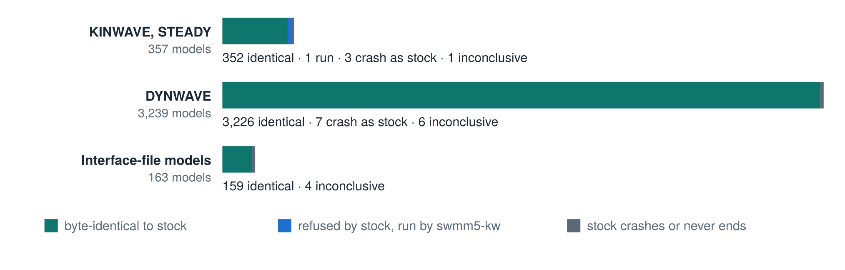
Figure 9. The corpus gate. Every model stock 5.2.4 runs gives the same bytes from swmm5-kw, in every mode; the ones stock refuses for a loop or a fork, swmm5-kw runs.
Three more checks ran on the shipped networks. Shuffling the order of junctions and conduits in the input file changed nothing, in five networks with three shuffles each. On those networks no allocation created or destroyed water: the largest difference between what a junction handed out and what it had was 3.6e-15 cfs, which is arithmetic rounding. And the WebAssembly engine this page runs gave the same bytes as a native build of the same source on all 52 runs, provided the native build uses the same maths library. That proviso turned out to be a finding of its own.
The corpus found the one place where that is not true. In XPSWMM/EXTUT17.inp a junction feeds a 1 ft pipe that can carry 0.1126658 cfs and an overflow channel 100 ft up that can carry 14,812. At one step 0.1126642 cfs arrived, a hair under the small pipe's capacity. HEAD's bisection stops when it is within a tolerance set by the junction's total capacity:
if ( fabs(f) <= 1.0e-10 * capSum ) break;
With 14,812 cfs of capacity, that tolerance is 1.48e-6 cfs, coarser than the gap between the inflow and the small pipe's capacity. The bisection stopped just past it, the pipe was marked full at 0.1126658 cfs, and the correction step that follows only adjusts outlets below their caps:
if ( sumFree > 0.0 && qT > sumCapped )
Here the capped pipe alone was over the inflow, so nothing ran, and the junction handed out 1.48e-6 cfs it did not have. It happened in 20 of the 234 corpus networks swmm5-kw routed, never more than 1.48e-06 cfs. At its worst that is a rate of about five fluid ounces an hour. Still a defect: the engine promises never to make water. Version 1.1 of the engine adds one branch, which scales every outlet down to the inflow when the capped ones alone exceed it. Tried on all 234 networks before it went in, it brought the largest gap to 1.8e-12 cfs and changed output only where the defect fired.
A second defect turned up the same day, and not from the corpus. An outside reviewer built a junction with sixty-five outlets, put a small flow limit on one of them, and moved that outlet from first in the file to last. Under AREA the junction then left part of its water behind and flooded. The water-filling loop that CAPACITY and AREA share kept its record of which outlets were full in an array sixty-four long:
char done[64];
...
if ( AllocQ[L] > cap ) { AllocQ[L] = cap; if ( idx < 64 ) done[idx] = 1; capped = 1; }
An outlet past the sixty-fourth that hit its cap was clipped and then forgotten: its share never came out of what was left to divide, and the others were never topped up. No test reached it, because the gates ran CAPACITY and AREA only on the five small networks, none with more than three outlets at a junction, and the corpus pass ran HEAD alone. A limit no one wrote down is still a limit. Version 1.1 keeps one flag per outlet, however many there are, and a new gate runs 63, 64, 65, 66 and 130 outlets with the limited one in every position. It fails on the old engine and passes on the new.
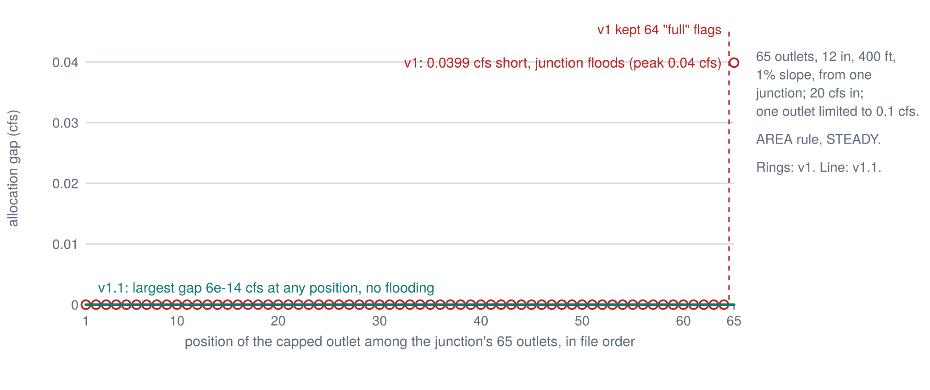
Figure 10. The review's junction: the capped outlet moved through all 65 positions in the file, AREA rule, steady flow. Rings: v1, exact until the 65th position, then 0.04 cfs short and flooding. Line: v1.1, exact at every position. Measured with both builds.
Both fixes went into version 1.1 together, on Bob's decision, since either one meant a new WebAssembly file for the apps that carry the engine. On the thirteen shipped networks the two versions write the same bytes.
The same review found five ways this page could tell you something that was not so, and they are worth naming because none of them was a wrong number from the engine. Results stayed on screen after you picked another model, and the export took the new model's name for the old model's flows. A run you stopped a few minutes in still got the green verdict. A run that wrote no results exported its peaks as minus infinity. A pipe that ran backwards all storm showed a peak of zero, because the peak was the largest signed value. And every hydrograph sat one report step early: SWMM stamps its first reporting period at the end of the first step, and the chart put it at the start. Each result now carries the run that made it and says when it is out of date; a stopped run is not a result; a missing value is blank; a peak keeps its sign, with the maximum, the minimum and a backwards flag beside it; and every point sits at the time stamped on it in the .out file.
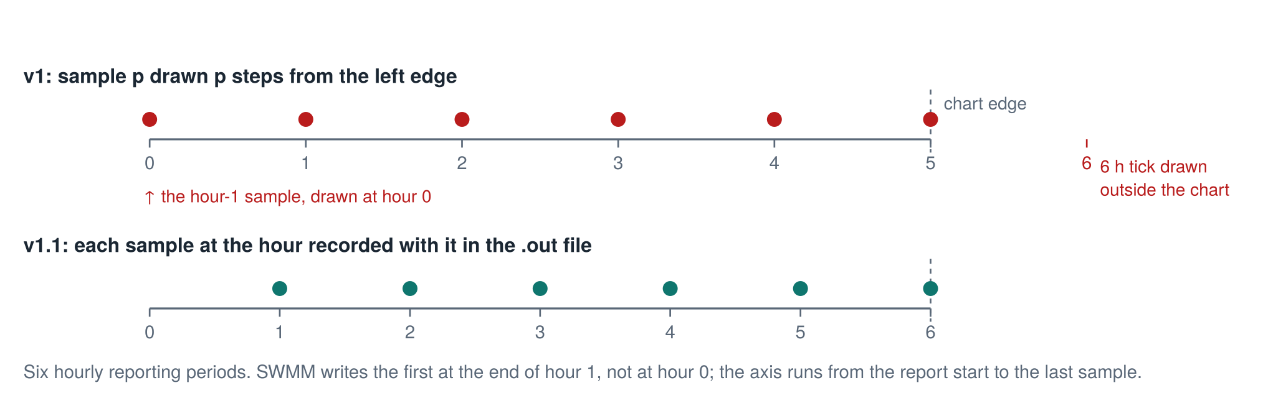
Figure 11. Six hourly reporting periods on the chart's time axis. v1 drew the hour-1 sample at hour 0 and put the 6-hour tick past the chart's edge; v1.1 uses the times stored in the .out file.

Three things stock 5.2.4 does by itself
Building and checking this engine meant running a great many kinematic-wave models, and three behaviours of unmodified EPA 5.2.4 came to light. None has anything to do with the extension. Each shows up on a network with nothing to split and no loop.
The first is a continuity error at capacity. Feed the chain less than its full-pipe capacity of 33.35 cfs and the routing continuity error is about a tenth of a percent. Feed it a little more and the error grows, steadily, to -10.18% at 37.5 cfs, four cfs over capacity, then drops back to -0.48% at 38 cfs. The minus sign matters: the run reports more water leaving than came in. A model whose peak happens to sit in that band reports a tenth more water out than in. In September only three inflows were run, 30, 34 and 40 cfs, and the worst of the three was -1.60%. The sweep found the band they had stepped over.
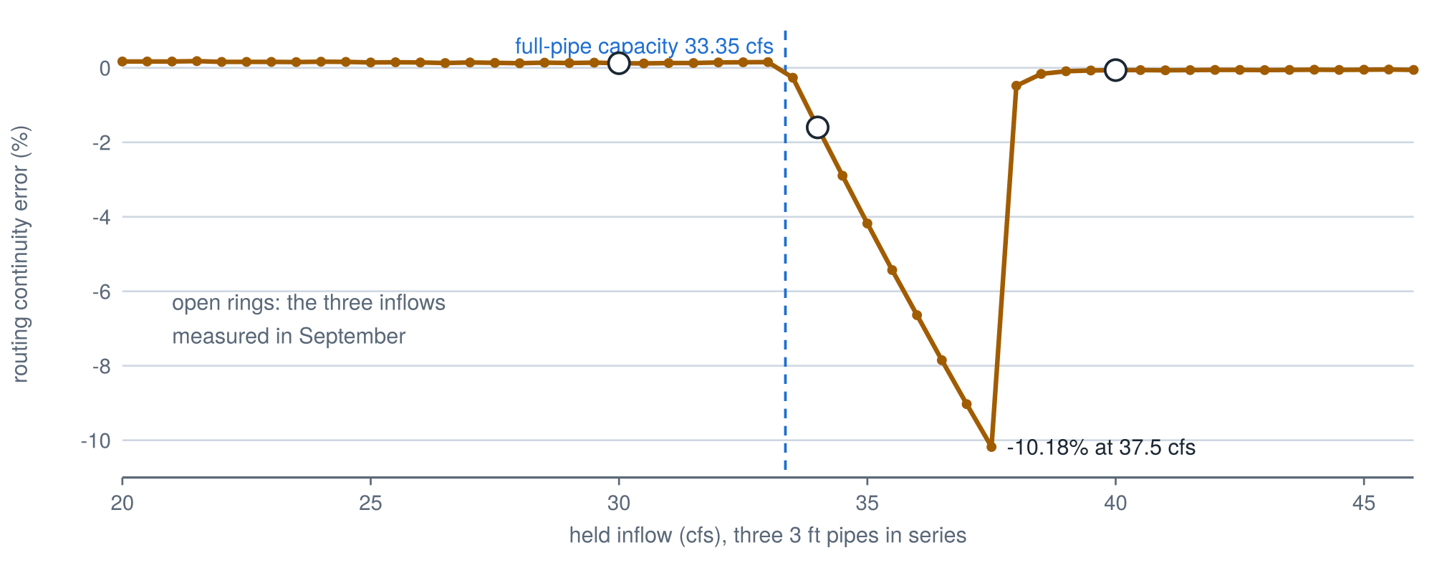
Figure 12. Stock EPA 5.2.4, kinematic wave, three 3 ft pipes in series: routing continuity error against the inflow held for two and a half hours. Measured every 0.5 cfs. The open rings are the three inflows measured in September.
The likely cause sits in kinwave.c. When a pipe's inflow reaches full-pipe flow, the solver sets its inlet area to full. Just below, it takes the lower of the two depths that carry that flow, because a circle carries full flow twice, once at 82% depth and once at 100%. A pipe hovering at capacity can flip between the two from one step to the next, a jump of about 18% of the full area, and every flip is booked as stored water that was never there. The sudden recovery at 38 cfs is not explained yet.
The second is that kinematic-wave answers depend on the maths library. The same source compiled against glibc and against musl agree for the first 241 minutes of a storm on the 30 cfs chain and then part company by up to 2% on the recession. Dynamic wave and steady flow gave identical answers under both libraries. So "the same engine" means little for kinematic wave unless you also say which libm it was linked against. The browser engine uses musl's mathematics, and its gate compares against a musl build for exactly that reason.
The third came out of the corpus. Kinematic wave makes water in flat channels, and makes relatively more the less water there is. Run one 1,000 ft trapezoidal channel with no fall at all and a steady 0.03 cfs for a day, and stock 5.2.4 reports a routing continuity error of -11.01%: eleven percent more water out than in. EPA flags such a channel with WARNING 04 and gives it a minimum fall, but the error stays. Give the channel a tenth of a foot of fall and the error is -2.48%; a full foot, -1.21%; at 3 cfs on a foot of fall, -0.22%. Old models converted from other programs are full of flat channels, which is why this showed up in the what-if pass. Where in kinwave.c the extra water comes from has not been traced.
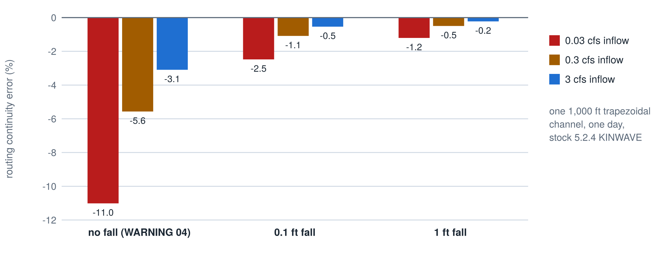
Figure 13. Stock EPA 5.2.4, kinematic wave, one 1,000 ft trapezoidal channel, a steady inflow for one day: routing continuity error against the channel's fall, for three inflows. Measured.

What this does not show
- That kinematic wave can represent backwater, surcharge or flow reversal. It cannot, in a split or a loop or anywhere else. HEAD is an allocation at normal depth.
- That swmm5-kw's loop results are fit for design. Where a pipe in a loop would run backwards, the answer is wrong in direction, not just in size.
- How the three split rules compare across real networks. Five small test networks were compared with dynamic wave. The corpus contains one model the extension changes.
- Anything about dynamic wave, which the extension never touches.
- That every continuity error in the what-if pass is stock behaviour. The 30 largest were traced; three of them by a direct test, the rest by a matching signature. The long tail below them was not examined.
- That the version 1.1 fixes are right for every network. They were checked on the shipped networks, on every corpus network the what-if pass routes, and on junctions of up to 130 outlets.
- A Windows build. The engine was built and gated on Linux (GCC 13, musl 1.2.4) and as WebAssembly (Clang 18, wasi-libc). EPA's optional .def export file does not list the two new functions.
- A person's review of the C changes, line by line. The checks above are mechanical.

How to use it
In this page. Pick a test network or drop in your own .inp, choose a rule, and press Run. The page runs stock EPA 5.2.4, swmm5-kw and a dynamic-wave reference, and shows whether stock refused the model, how each split junction shared its water, and every link's peak flow side by side. The Verify tab runs the gates in your browser.
On your own machine. tools/build.sh builds the extended engine as kwswmm, and stock 5.2.4 beside it. Run KWSPLIT=1 KWLOOP=1 build/kw/kwswmm model.inp model.rpt model.out. KWSPLIT takes 1 for HEAD, 2 for CAPACITY, 3 for AREA; unset means stock. EPA's own CMake build also works on this tree and gives runswmm and libswmm5, which behave as stock until a program calls swmm_setKwOptions.
In another app. wasm/swmm524kw.wasm with wasm/kwengine.js and wasm/wasi-shim.iife.js runs anywhere a browser or Node runs, with no compiler. For a SWMM5 tree of your own, apply patch/swmm524-kw.patch, then run the gates before calling it the same engine.

AI use
This engine, its tests, this page and this essay were made with Claude, Anthropic's AI model, under the direction of Robert (Bob) Dickinson, who asked for kinematic wave and steady flow that run loops and bifurcations, asked for the AREA rule first, chose to keep the work in its own repository, and supplies the model corpus. The engine was written on 29 September 2026; the repository, the corpus gate, this page and the essay on 29 October 2026, with Claude Opus 5.5. Claude designed and wrote the C changes, the test networks, the drivers, the gates, the WebAssembly builds and the JavaScript that runs them, the figures and this text. The checks are mechanical: byte comparison against stock 5.2.4 built from EPA's tag, on the shipped networks and the corpus, and the wasm against native builds. Claude also made the September errors this essay corrects, about the relief pipe and the continuity sweep, and the two allocation defects fixed in version 1.1. On 31 October 2026 an outside review of this page found the 64-outlet defect and five ways the page could misreport a run; Claude reproduced each one, fixed the engine (on Bob's decision) and the page, and added the gates that would have caught them. No person has yet reviewed the C changes line by line.

