A Pipe With No Slot
How SWMM5 RASPIPE moves water through a full pipe, where the method came from, and what it took to put it inside SWMM
SWMM5 RASPIPE 1.2. November 2026.

The trouble with a full pipe
Take a 3 ft pipe running half full. The water has a surface. Push more water in at the top end and the surface rises, and the rise travels down the pipe the way a swell crosses a pond. Every sewer model ever written is built on that fact.
Now fill the pipe to the crown. The surface is gone. Water does not squeeze, not to speak of, so a push at one end is felt at the other almost at once. The equations that worked a moment ago have the width of the water surface in them, and that width just went to zero. Divide by that and the computer will tell you what it thinks of you.
Engineers are practical people and they found two ways around it. The first is the slot. Preissmann and Cunge proposed it in 1961: cut an imaginary narrow slit in the crown of the pipe. Now the pipe always has a free surface, the same equations keep running, and the height of water in the slit stands in for pressure. The second is what EXTRAN does: stop using the surface equation at the crown and switch to a different rule that balances flows at the nodes. SWMM 5 carries both, as SURCHARGE_METHOD SLOT and SURCHARGE_METHOD EXTRAN.
The slot is a lie told for a good reason. The trouble with a lie is that you have to keep track of it. That slit holds water that does not exist, and every formula that touches the pipe has to remember which area is real. Here is a case where the bookkeeping slipped. A pump pushes into a 1 ft pipe held full by an 8 ft tailwater, a problem you can do with a pump curve and a pencil. The answer is 4.599 cfs. EXTRAN gets 4.599. The slot in EPA SWMM 5.2.4 gets 5.141, which is 11.8% high. That is one implementation on one deck, not a verdict on slots, and further on we will name the two lines of code that do it.
The Hydrologic Engineering Center reached the same opinion. HEC-RAS used the slot through version 6.5. Its manual now says the slot "alters the geometry and physics of the problem, has problems with instabilities," and "incorrectly predicts the propagation speed of surge flows." So they replaced it with a method from Vincenzo Casulli and Guus Stelling, published in 2013. There is no slot in it and no switch at the crown. One set of equations runs from a dry pipe to a pipe under 100 ft of head.
The obvious question is what happens if you put that method inside SWMM. So we did.

What this engine is
SWMM5 RASPIPE is EPA SWMM 5.2.4 with one new source file and a few small patches that hand it control. Write FLOW_ROUTING RASPIPE in the options and the dynamic wave solver steps aside for a semi-implicit finite volume solve over a mesh of pipe cells. Rainfall, runoff, infiltration and controls are EPA's code, unchanged, and the .out file is EPA's format. Leave the word out and you have EPA 5.2.4, and the .out file comes back identical byte for byte.
HEC-RAS is closed source, so this is an independent build from what HEC has published. The first two versions of this essay said HEC publishes only an outline. That was wrong, and it took an outside reviewer to say so. HEC's page on numerical methods for pipe flow gives the advection scheme, the friction term and the nested iteration, equation by equation, and the mesh page gives the table formulas. Version 1.2 went back and read them properly, and it changed the solver as well as this sentence. The section called Where this departs from HEC lays the two side by side.

Cut the pipe into cells
SWMM thinks of a conduit as one object with one flow in it. A 4,000 ft pipe gets one number. That is a remarkably good bargain for what it costs, and it is why SWMM runs so fast. It is also why a flood wave going down a long pipe gets smeared.
The new solver cuts each conduit into cells, the way HEC-RAS does. HEC's manual has a 120 ft pipe with a 10 ft cell length, which makes 12 cells. Between two cells is a face. Water levels live in cells and flows live on faces. A manhole is a cell too, and it borrows a piece of each pipe that meets it, so that a short stub of pipe does not turn into a tiny cell that sets the pace for everything else.
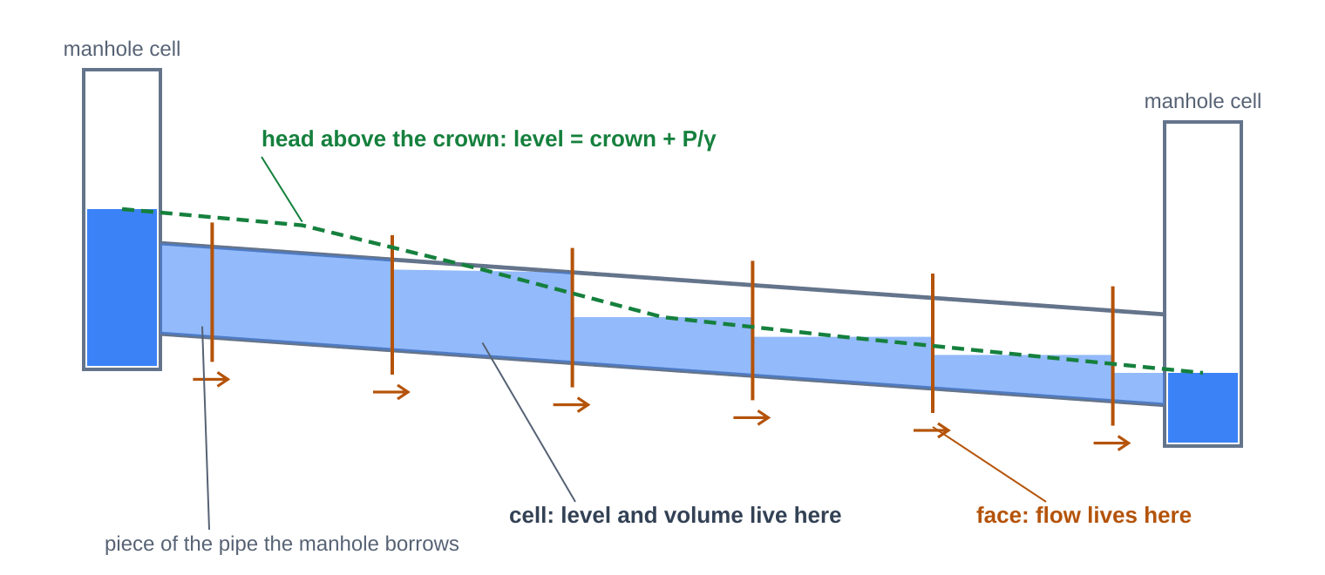
Figure 1. One conduit between two manholes. Levels live in cells and flows live on faces. Each manhole cell borrows the first part of each pipe. Where the head is above the crown the cell is simply full, and the level is crown plus pressure head.
A cell has one flat level. In a sloping pipe that takes some care, because a flat level in a long cell makes a wedge of water. So each cell carries a table that gives the volume held at every level, computed from the real cross section through SWMM's own geometry routines. Circles, arches, baskets and irregular transects all work with no special cases. HEC calls these sub-grid tables.

The table that goes flat
Now the whole trick. Plot the volume in a closed pipe cell against the water level. It rises, and at the crown it stops. The cell is full. Raise the head to 100 ft and it holds the same water. That is why no slot is needed: above the crown, level has no effect on volume, so the level is free to be whatever the pressure says. HEC writes it as ceiling elevation plus P/γ.
That flat stretch is good physics and poison for a solver. Newton's method divides by the slope of the function it is working on, and here the slope is zero. The conference paper on the HEC solver says Newton can fail to converge under pressure, and it is right. Near the crown the iteration can throw the level far outside the pipe and never find its way back.
Casulli's way out is a piece of mathematics that any engineer can follow with no help. The slope of the volume table is a storage derivative, dV/dη, the plan area of the water surface in that cell, in square feet. In a level cell that is the top width times the cell length. Call it T. It rises to the springline and falls to zero at the crown. Split it in two. Let T1 be the running sum of every rise and T2 the running sum of every fall. Then T = T1 − T2, and the volume is V = V1 − V2, and neither V1 nor V2 ever curves downward.
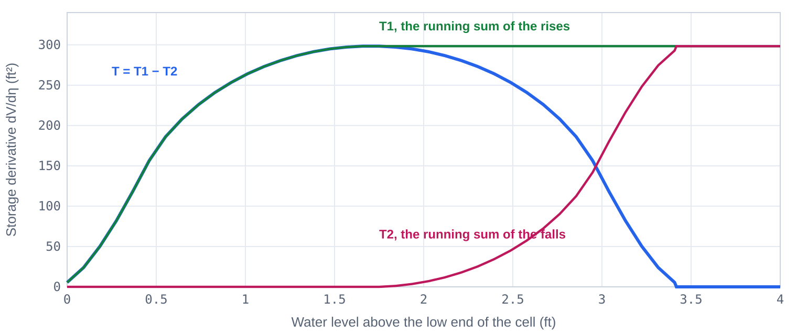
Figure 2. A 3 ft pipe in a 100 ft cell at 0.5% slope, computed by the same table routine the engine uses. T is dV/dη, the plan area of the water surface, in ft². T1 and T2 only rise, and above the crown they are equal, so the volume stops growing.
An upward-curving function is the case where Newton has a proof behind it. So the solver runs two loops, one inside the other. The outer loop freezes V2 as a straight line. The inner loop solves the upward-curving remainder. Casulli and Zanolli proved in 2012 that their algorithm walks to the answer under their assumptions, and a proof covers the algorithm it was written for, not every variation somebody builds on it. HEC writes the same two loops out in full, outer index m on the falling part and inner index k on the rising part. They cost more per step, so this engine tries plain Newton first and falls back to the nested loops only when plain Newton fails, which HEC's page does not do. That is a departure of ours and it needs its own evidence. The answer ought to be the same either way, because each cell's equation has only one solution. We checked: forcing the nested path on every solve moved a 59 cfs peak by 0.00066 cfs.

One equation for every cell
The equations are shorter than you may fear. For a cell, the water it holds at the end of the step is what it held, plus what came in, minus what left through its faces. For a face, velocity is set by the head difference across it, slowed by friction. SWMM's dynamic wave solves those two one after the other and iterates. Here the second goes into the first, and the whole network is solved at once as one matrix.
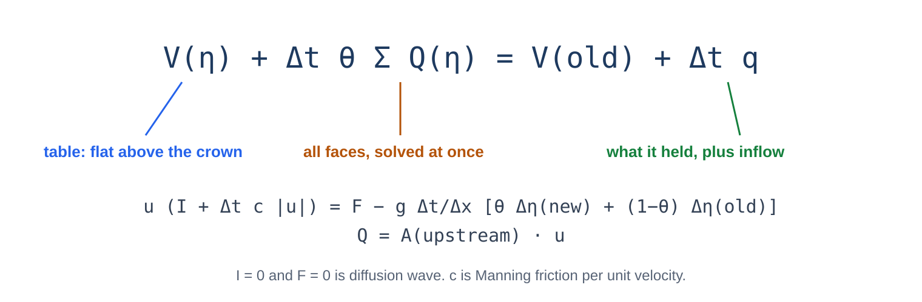
Figure 3. The cell equation. V is the table, so the crown takes care of itself. The face flow is the only thing that ties one cell to the next, and it is implicit, so a pressure wave crossing a cell in a fraction of a second sets no limit on the time step.
Two equation sets are offered, as in HEC-RAS. Diffusion wave drops inertia, and friction balances the slope of the water surface exactly, so steady flow is Manning. Full shallow water keeps inertia and advection. HEC's tutorial for importing a SWMM model selects diffusion wave, and that is the default here.
Advection is the term that carries velocity along with the water, and since version 1.2 it is HEC's. Ask what a parcel of water brought with it. It arrives at a face with the velocity it had a time step ago, at the spot it started from. So walk back upstream a distance V* Δt, read the old velocity there, and call it V_X. HEC's formula is one line, and the only art is in V*. Where the flow chokes down hard, V* is the plain average of the two velocities, which keeps energy head constant. Everywhere else it is flow over area, which conserves momentum. That is the Stelling and Duinmeijer idea, and it matters because a hydraulic jump loses energy and keeps momentum, and a sudden contraction does the reverse. Get that backward and a bore runs at the wrong speed, as we are about to see.
The matrix has a pleasant shape. Off the diagonal every entry is negative or zero, and the diagonal dominates, which mathematicians call an M-matrix. Nothing needs pivoting. In a sewer most cells have two neighbors, so a sparse factorization with a minimum degree ordering is hardly more work than a tridiagonal solve. There is no iteration on the linear system at all.
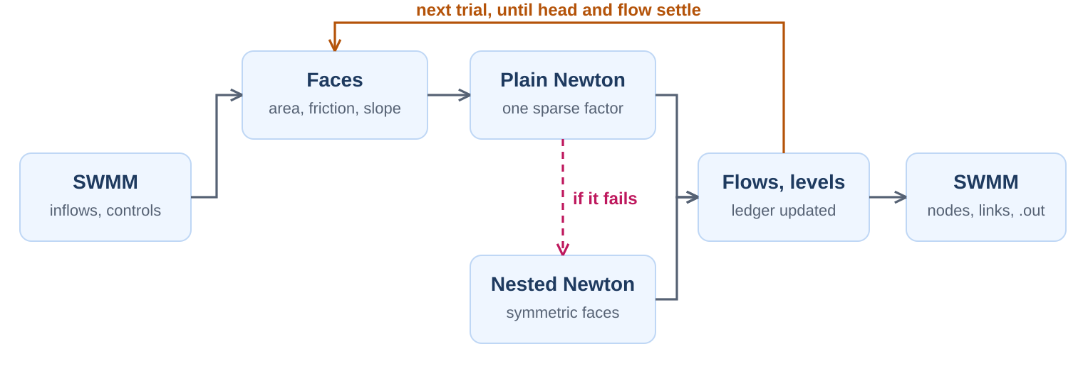
Figure 4. One routing step. SWMM supplies inflows and takes back node depths and link flows. Everything between is new. If a trial's Newton fails, that trial falls back to a symmetric form of the faces and nested Newton.

What sits on the faces
A face between two pipe cells is simple. The interesting faces are at the ends of things.
A pipe set above a manhole floor is a sill. When the water on the far side is below the sill, the head difference across the face stops meaning anything, because the water is falling. The flow is held to critical flow at the crest and the far side is ignored. A free outfall is the same thing, a control on the last face and not a depth imposed from outside.
That last point was not learned cheaply. The first version took outfall depth from the last flow, the way stock SWMM does, in this line inside the trial loop:
for (i = 0; i < Nobjects[LINK]; i++) link_setOutfallDepth(i);
On a siphon with 44 ft pipes, depth and flow fed each other until the model reported 732,000 cfs in a 2,000 cfs system. With the control on the face, the same model runs steady at exactly 2,000 cfs.
Orifices, weirs, outlets and pumps use SWMM's own functions. The solver gets their flow, then finds its slope by nudging each end node 0.001 ft and asking again. HEC's way with gates is to change the friction of the face until it delivers the gate flow, and the fallback form here does much the same.

Where this departs from HEC
You should know where HEC's description stops and this code's own work begins, because that is the first place a reviewer ought to dig. An outside reviewer dug, and asked for this table.
Part | HEC documentation | RASPIPE 1.2 | Difference, and the test
Advection | Explicit Eulerian-Lagrangian. V_X = V_j - V* dt (V_j - V_j-1)/dx, backtracked at Courant up to 1. V* = (V_j + V_j-1)/2 in strong contractions, keeping energy head, and (A_j V_j + A_j-1 V_j-1)/(2 A_j) elsewhere, conserving momentum (Stelling and Duinmeijer 2003). The choice depends on local flow. No number is given for strong. | The same form since 1.2. Versions 1.0 and 1.1 used an implicit upwind form written here. Choices made here: strong means the upwind area is over 1.5 times the face area with velocity rising; the A under the fraction is the mean of the two sides; water in a node is at rest, except at a junction of exactly two conduits, where momentum crosses. | Stoker dam break: bore speed error -13.2% in v1.1, -3.3% at theta 1 and +0.2% at theta 0.6 in v1.2. The 1.5 hardly matters here: 1.1 to 4 gives the same answer to 0.002 ft. With momentum crossing the junction, the wave's head error at that junction went from 0.16 to 0.005 ft.
Friction | Implicit, c_f = g A^2 |V| / K^2, updated at each iteration. | Implicit. The quadratic in V is solved exactly at each trial. | Pressurized pipe (V3) and normal depth (V5) against closed forms.
Cell volume tables | Volume found at 15 Gaussian quadrature points between the lowest and highest elevation, with a flat water surface in a sloping pipe. Piecewise linear volume, piecewise constant area, split into running sums A+ and A-. | The same split and the same piecewise forms. Break points evenly spaced at D/32 over the same range, 33 to 129 of them, with the exact prismatic integral. | Against a fine numerical integral over nine pipes: largest volume error 0.11% of full here, 0.61% with 15 Gauss points plus the ends, 0.63% with 15 even points. HEC's exact placement is not stated, so those two are readings of it. Either table is used consistently, so this moves levels slightly and does not lose water.
Nonlinear iteration | Outer loop m linearizes the falling part, inner loop k the rising part, both to convergence. Max Iterations default 20. Tolerances are not on that page. | The same two loops, up to 80 outer and 24 inner, 1e-8 ft3. Plain Newton is tried first with a linearized face, and the nested loop is the fallback. Up to 8 trials outside that, 16 if a trial is unsolved. | Forcing the nested path on every solve moved a 59 cfs peak by 0.0007 cfs (V7). Unsolved steps are listed one by one below.
Time step control | Adaptive Time Step, on by default: compares estimated residence time Courant values with a target of 0.9 for each cell, and the base interval is reduced or increased. No formula on the page. | C = dt x outflow / volume, largest over cells that hold pipe. Pipe steps inside the SWMM routing step, 15 s or less while water is moving, and a quiet rule that stretches the step. The formula, the exclusions and the limits are choices made here. | The report gives pipe step min / mean / max and the largest Courant reached, and the wave table above shows them. V14 is what it fixed.
Theta | Theta weights the pressure term between old and new levels. | Default 1.0, range 0.5 to 1. | U-tube and dam break: 0.6 is more accurate, at least on these, with less damping. The default stays at 1.0 because the corpus was run there.

Beyond the table, these came from here and not from HEC:
- How a face picks its wetted area. It takes the lesser of the area at the upstream level and the mean area of the upstream cell, so a thin film can drain out of a sloping cell and normal depth comes out right.
- The Newton linearization, including how flow changes with upstream wetted area. Without that term a surcharged small manhole chatters. With it the same deck takes about 2 trials a step.
- The sparse solver and a level floor.
- The rule for a face that is dry at the start of a trial, described below.
- Leaving out manhole cells that hold no pipe when the Courant number is computed.
- Letting momentum cross a junction that joins exactly two conduits.
A run of real HEC-RAS would very likely differ from this engine in the details, and no such run has been made.

What was tested
A closed-form answer, a second solver and a start-up check don't prove the same thing, and for a while this write-up let them stand in one line as if they did. So each test now wears a label: analytical answer, numerical reference, initialization check, regression check, or cross-engine comparison. The Verify tab has the full list, with tolerances, and the engine zip has a manifest that ties each one to its deck and to the build that ran it.
Start with problems that have exact answers. A full pipe between two fixed heads gave 3.56280 cfs against 3.56280 from Manning. Three full pipes in series, with no free surface anywhere in the system, gave 3.56280 against 3.56280. Normal depth in four pipes came within 0.63%. Water at rest in a sloping network stayed at rest, with zero flow to the last digit. Turning the feature off gave a byte-identical .out on 4 of 4 decks, and that control is what lets you trust every other comparison.
Back to the pump, and to a sentence that claimed too much. Earlier versions said the slot's phantom water was the reason, and left it there. A reviewer asked which term, in which implementation, and what removes it. Fair questions. Here is the steady momentum balance in EPA's dwflow.c, in two lines:
v = qLast / aMid;
dq2 = dt * GRAVITY * aWtd * (h2 - h1) / length;
Both aMid and aWtd include the slot area. The first feeds the friction term and the second is the push from the head difference. At steady flow friction balances the push, and when you work that through, Q² goes as aMid times aWtd. The slot inflates each one by the same factor, so each should carry about half the error. So we tried it, one term at a time, in a test copy of EPA's file.
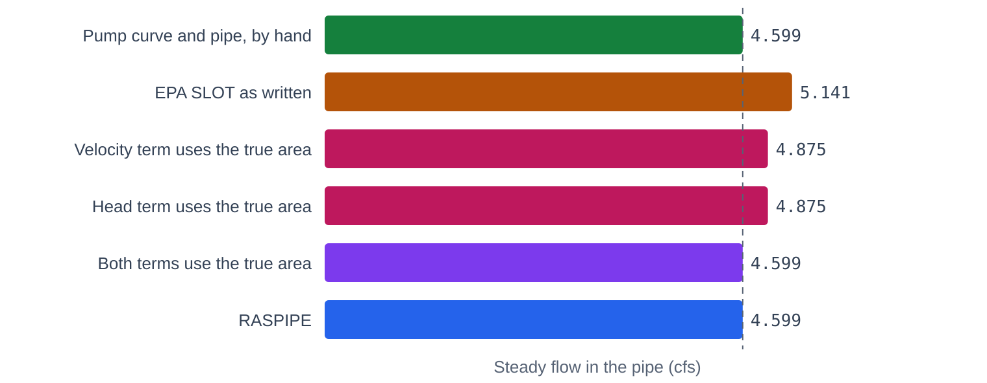
Figure 5. Pump into a full 1 ft pipe, steady flow, with SLOT changed one term at a time in a test copy of EPA 5.2.4. Each term alone removes about half the error. Both together land on EXTRAN and the pencil answer to four places. RASPIPE has no slot to keep track of and gets there as well.
That is the whole of it, for this implementation on this deck. Cap the area at the true full area in both places and SLOT gives 4.599 cfs. It says nothing about slots in general, and it says nothing about what those two caps would do to SLOT's stability on other decks, because we didn't test that. EPA issue 231 is the place to follow that question.

Problems nobody here wrote
Every test so far was set up by the same party that wrote the solver, and the reviewer put a finger on the sore spot. The wave reference below is a separate solver with no shared code, but it came from the same AI session, so it could share the same mistaken idea. What you want is a test with an answer that was on paper before any of this existed. So we took two.
The first is Stoker's dam break, from the 1950s. Ten feet of water stands behind a gate, two feet in front of it, and the gate lifts. A bore runs downstream at a speed you can get from mass and momentum with a pocket calculator: 17.01 ft/s, with 5.08 ft of water behind it. Nothing in the mesh knows that. We ran it in a 4,000 ft rectangular channel with almost no friction, and read the water surface at 60 s.
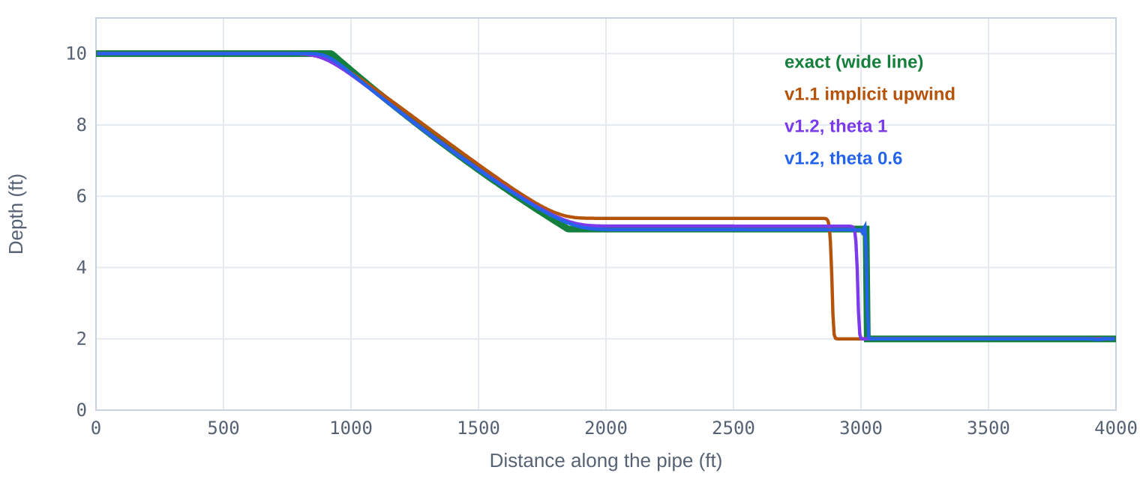
Figure 6. Depth along the pipe 60 s after the gate lifts, 5 ft cells. The old advection runs the bore short and stands the water too high behind it. HEC's form with θ = 0.6 sits on the exact line. Cells are 5 ft and the step is 0.125 s.
Version 1.1 ran the bore 13.2% slow. Halving the cells and the step together did nothing for it, which is the mark of a scheme headed for the wrong answer, and diffusion wave and the corpus had never gone near it. HEC's formula with the face area taken from upstream, the way this engine's faces work, gave -5.6%. Taking the area under V* as the mean of the two sides gave -3.3% at θ = 1 and +0.2% at θ = 0.6. That mean is what conservation of momentum across a jump needs, and it is our reading of Stelling and Duinmeijer. HEC's page doesn't say which area it uses. HEC doesn't give a number for how strong a contraction has to be, so we chose 1.5. Trying 1.1 through 4 on this problem moved nothing, which also means this problem doesn't test that choice.
The θ result is worth a moment. θ = 1 holds the pressure term all at the new time while the advection looks at the old time. We think that mismatch is why the bore lags, though we haven't proved it. The lag closes up as the step shrinks, to -1.0% at 0.02 s. θ = 0.6 gets it at ordinary steps. The default stays at 1.0, because that is what the corpus ran and it is the safer setting, but if a sharp front is what you care about, try 0.6.
The second is a U-tube: two tanks, one frictionless pipe, and water sloshing between them. The period is 2π√(L A_s / (2 g A_p)), which is 441.7 s for this deck. RASPIPE with the full equations gets 441.7 s. So far so good. Then we ran stock SWMM as a control, expecting a dull line in the table, and it came back 521.2 s, 18% long.
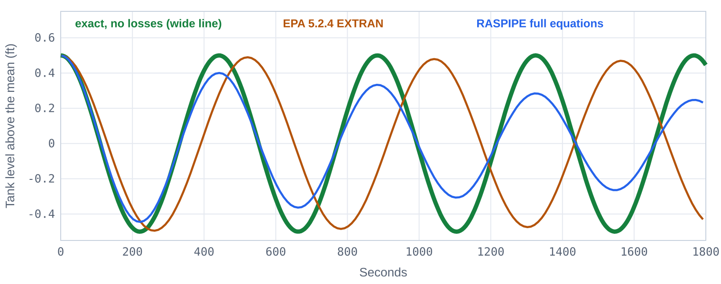
Figure 7. Tank level against time. RASPIPE keeps the exact period and loses height to the velocity head given up at each end of the pipe. EPA 5.2.4 hardly loses any height at all and runs 18% long, with continuity at 0.000%.
A period that long means something is acting like extra tank, and EXTRAN's node update is where to look. A full pipe has no free surface, but this line in dwflow.c gives it one anyway:
if (y / xsect->yFull >= CrownCutoff && !xsect_isOpen(xsect->type))
y = CrownCutoff * xsect->yFull;
So the pipe reports the width at 96% of depth, and half its length of that goes onto each end node, and then dynwave.c does dy = dV / surfArea;. For this pipe that's 392 ft² of water surface that isn't there, on a 1,000 ft² tank. Multiply the period by the square root of 1.392 and you get 521.2 s. Measured, 521.2. With 4,000 ft² tanks the same arithmetic says 925.7 and the run says 925.8. Zero out that area in a test copy when the pipe is full and the period drops to 441.8 s. And all the while routing continuity reads 0.000%, because the books balance over a full swing. That is one more thing continuity can't see. It matters when the pipe is big next to the tank, and it is register entry EPA-3.

One cause at a time
The more interesting test has no closed form, so we made a reference. A hydrograph rises from 2 to 16 cfs and back, down 8,000 ft of 3 ft pipe at 0.1% slope, built in SWMM as two 4,000 ft conduits, with 2 cfs running steady before the wave starts. To learn the truth we wrote a separate shock-capturing solver of the full Saint-Venant equations, sharing no code with SWMM, and ran it with cells of 25, 12.5 and 6.25 ft. Its peak 6,000 ft down the pipe is 14.97 cfs, and it is still rising about 0.1% as the cells halve. It is a numerical reference, written in the same session, and that is all it is.
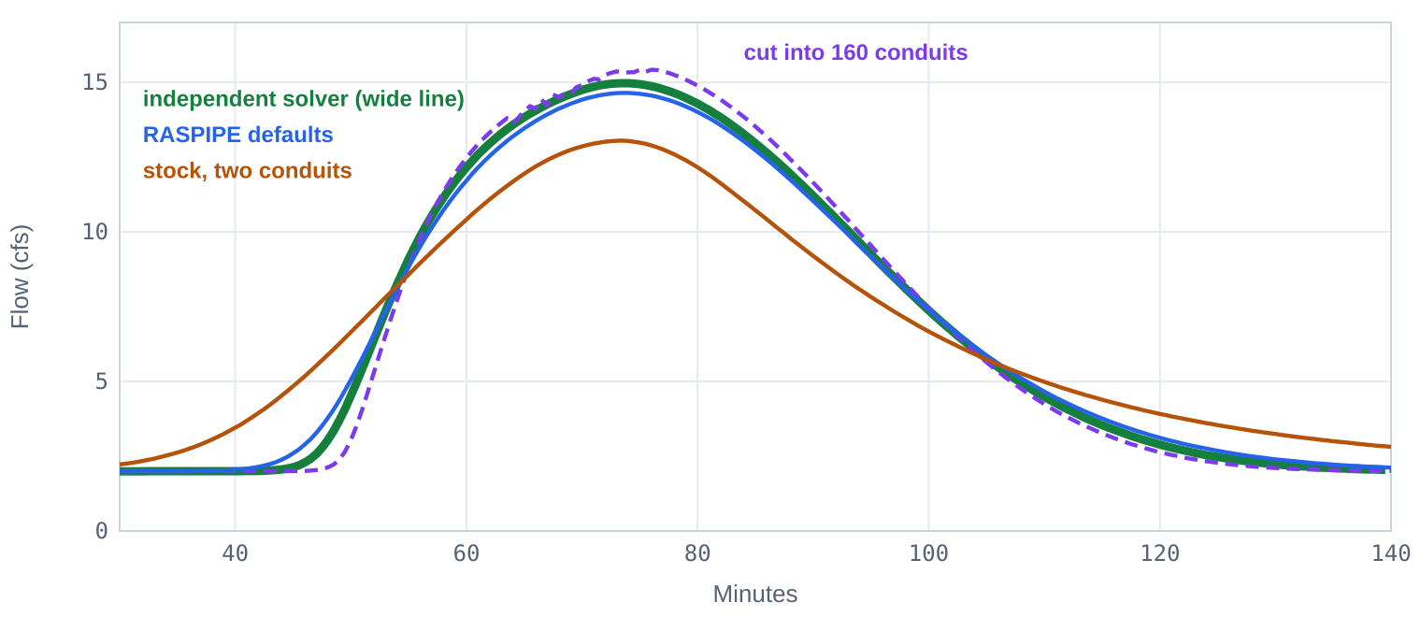
Figure 8. Flow 6,000 ft down an 8,000 ft pipe. Stock SWMM with two long conduits flattens the wave. RASPIPE at its defaults sits close to the independent solution. Cutting the stock model into 160 pieces overshoots it.
Peak flow is one number, and it flatters. So the wave is now scored on the whole hydrograph, on arrival, on the head at the junction, on volume, and with one cause moved at a time. The numbers are in the Verify table. Here is the budget.
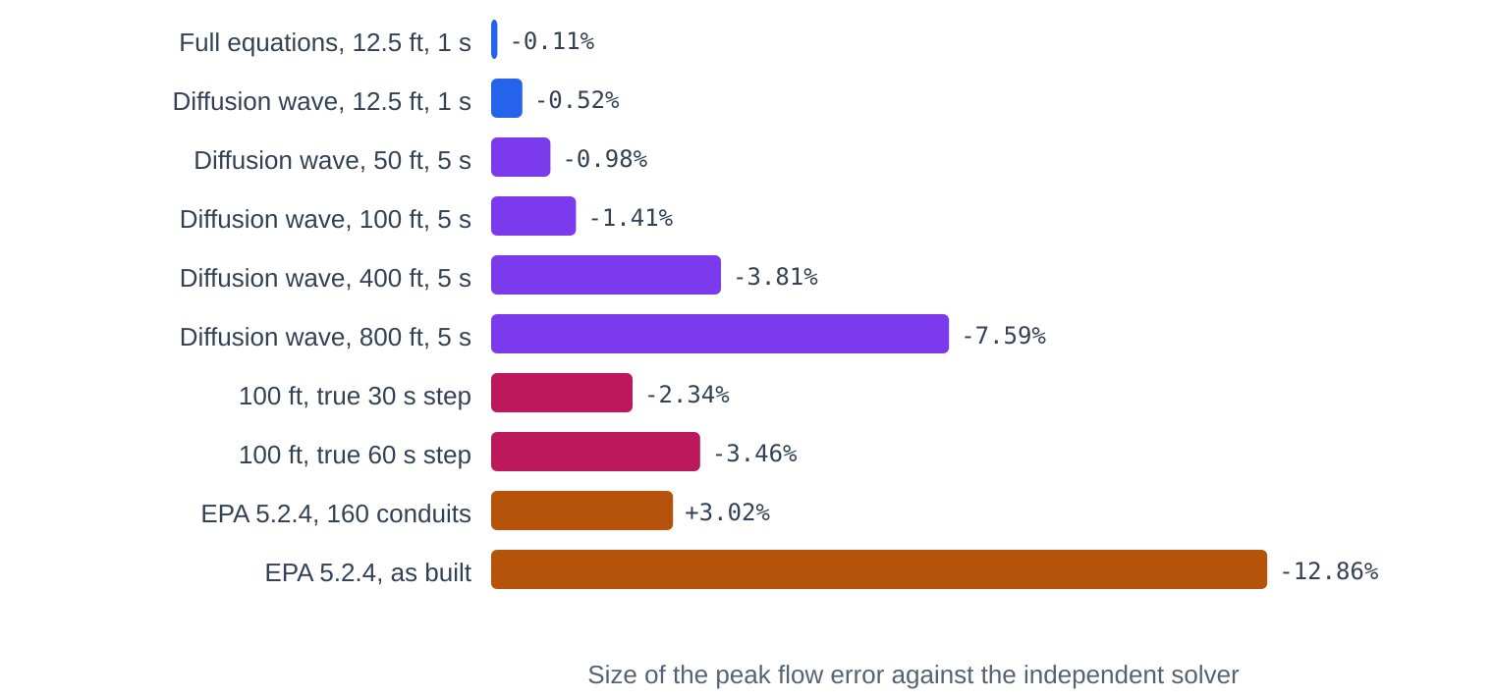
Figure 9. Peak error against the independent solver, one cause at a time. Full equations on a fine mesh are the floor. Diffusion wave adds its own small share, the mesh adds more, and a long true time step adds more again. Stock SWMM as built is off the same chart. Every row is version 1.2.
The full equations at 12.5 ft and 1 s come within 0.11% of the reference at the peak, with an NSE of 1.0000 and 0.005 ft of head error at the junction. That is the numerical floor. Drop inertia and keep the mesh, and the peak goes to -0.52%, so the diffusion wave approximation costs about 0.4 of a percent on this pipe. Go to 100 ft cells at 5 s and it is -1.41%; go to 800 ft and it is -7.59%. So the mesh is the big lever. A true 30 s step, with the Courant control off, gives -2.34% against -1.00% at 5 s.
That head figure has a story. Our first run of the new advection had the junction 0.16 ft off, where diffusion wave was 0.01 ft off, and the fancier equations shouldn't lose to the simpler ones. The reason was this: a node holds water at rest, so water going through a junction stopped and restarted, and paid a full velocity head. In a straight run that is false. Momentum now crosses a junction that joins exactly two conduits, and the error fell to 0.005 ft. Junctions with more than two get the old treatment, and that may be too much loss or too little. That's an open question.
Stock SWMM as built gives 13.05 cfs, 12.9% low, and it loses 2.84% of continuity doing it. That is the one-number-per-conduit smear. Cut the same pipe into 160 short conduits and stock SWMM gives 15.42, 3.0% high.
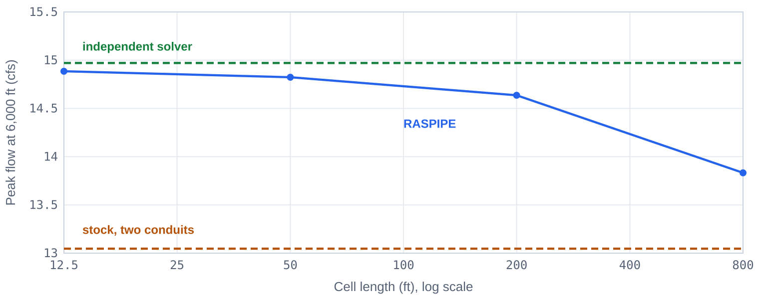
Figure 10. Peak flow against cell length, RASPIPE diffusion wave, Courant control on. Accuracy is limited by the mesh first. The full equations at 12.5 ft reach 14.96 cfs.
One warning for anyone repeating this. Changing ROUTING_STEP is not a clean time step study when the Courant control is on, because pipe steps run inside it. A routing step of 30 s ran pipe steps of 7.5 / 14.526 / 15 s here, min, mean and max. The report now prints those three numbers, and the app shows them.

What the corpus did to it
A solver that passes its textbook problems has proved that it can pass textbook problems. The test of a sewer solver is a sewer, and the test of the fellow who wrote it is whether he reads the list of his worst results from the top.
So we drew 1,600 models at random from the 1729 corpus, stratified by file size, and ran each through EPA 5.2.4 and RASPIPE with a 60 s limit per run. The first pass looked fine. The median continuity error was small. Then we sorted the list worst first and started finding real defects, none of which any textbook problem had touched.
Seepage took water the cells did not have. SWMM limits a conduit's loss to the conduit's volume, and that volume includes the pieces the manholes borrow. The loss then came out of the interior cells alone, in this line:
Cell[p->c0 + i].src -= r * Cell[p->c0 + i].vOld / tot;
When r times the step exceeded tot, the cell had a negative right side, no solution existed, and the solver thrashed through a thousand factorizations a step. Worse, the bookkeeping quietly reported the rate it had not delivered. The loss is now capped at what the cells hold, and the reported rate is cut to match.
A sealed run of full cells has no storage. Line up several full cells between a manhole and a closed face and the matrix for that run is singular, because nothing in it can store anything. The true answer is that the head rises until a manhole overflows, and a singular matrix cannot say so. Nested Newton just sat there. A trace on a model with pipes set 58 ft up the shaft showed it plainly: zero movement, residual of 1,207 ft³. A vanishingly small area on the diagonal gives Newton a direction to raise the whole run.
A dry face is a wall. Face areas are taken from the previous trial, which means a face dry at the start of a trial stays shut for that trial. A front moving more than a cell per step in a steep pipe piles into its own closed door, and the head goes up and out the nearest manhole. On a model that stock SWMM floods by a hair, the first cure for the sealed run produced 83,000 ft³ of flood that was pure artifact. It looked fine by continuity. Continuity will always look fine. It took a side-by-side with the stock numbers to catch it. Now a dry face opens as soon as the level upstream passes its invert, at about critical velocity, and the next trial replaces that with the real thing.
Four trials were not enough. One deck set MAX_TRIALS 4, a harmless number for stock SWMM. With fronts to chase, RASPIPE needs more. That deck flooded 21.6 ac-ft that stock did not. At 8 trials it flooded 0.1 and stock flooded 0.02. The engine now always allows 8 and stops early when it has converged.
Demand at a dry node has no solution either. A negative lateral inflow at a cell that has run dry, with nothing able to reach it in this step, is an impossible request. The unmet part is now dropped for the step and stays out of the volume ledger, so the solver no longer beats its head against it. The report shows it honestly as a continuity error.
Quality routing assumed one flow. EPA's quality code mixes each conduit using a single flow and makes up the difference from the change in volume. RASPIPE has a different flow at each end, so handing it the mid-conduit flow created or lost pollutant mass, 21% on one model. Quality routing now gets the flow that actually crosses each end. The same model came down to 1.3%, against 3.0% on stock. This is the one place EPA's logic outside the hand-off changes, and only when RASPIPE is on.
Models that had been failing started to run. One that had timed out at 60 s finished in 2 s.
So we froze the engine and ran the sample again, and it was not done with us. Two models segfaulted, inside EPA's culvert routine, because the first face of a conduit can sit below the culvert inlet when the end cell borrows the top of the pipe, and this line then handed the FHWA equations a head below the inlet:
Qc = MIN(Qc, p->barrels * culvert_getInflow(j, Q / p->barrels, etaL));
A flat outlet channel at a NORMAL outfall passed 58 cfs where stock passed 1,415, because normal flow on a zero slope is next to nothing. SWMM tops normal depth out at the crown and lets head drive the flow above that, and now so does this code. And a chain of short steep chutes off a fixed-stage outfall carried 11.3 cfs from 0.54 ft of head. Diffusion wave has no inertia, so nothing told the water it had to be accelerated from rest. A hand calculation of critical flow says 2.0 cfs. Stock says 2.6. Flow leaving a node is now held to critical, and that chute carries 2.0. The fix cost something: a steep run through a junction now stands about 0.6% deeper than normal depth, and it is in the table above.
That made nine. We froze it, ran the sample a third time, and called that version 1.0.

A clock for the pipes
One deck stayed wrong in version 1.0. Pipes set 58 ft up 60 ft shafts, steep runs, 164 cfs. It surged and flooded 7.2 ac-ft where stock floods 0.02. The entry cap that fixed the chute had made it worse, and it went out the door as an open item.
Then Bob Dickinson pointed out what the HEC-RAS pipe network options actually do about instability, and the first thing to say is that the answer was on HEC's own page the whole time. Most modelers meet instability by cutting the time step for the entire model. HEC-RAS doesn't have to. It gives the pipe network its own clock.
The option is called Adaptive Time Step, and it is on by default. The pipe interval is adjusted "by comparing the estimated residence time Courant values to the Target Courant value for each cell," and the default target is 0.9. Residence time is how long water stays in a cell: what it holds over what leaves. HEC's pages give no formula. CivilGEO's note on the 2D version says it in words, the flow leaving a cell over the step divided by the volume in the cell, and that is how this engine reads it. For each cell, C = Δt × outflow / volume. Hold the largest C in the network at 0.9.
Look at what that does to the bug. Face areas are frozen for a trial, so a dry face is a wall until the trial after, and the whole trouble was a front moving more than a cell per step. At a Courant number under 1 a front has no time to. The defect isn't so much patched as starved.
So a SWMM routing step now runs as many pipe steps inside it as the target needs, and the rest of SWMM never knows. Hydrology, controls, the report and the .out file keep their own step, and mean flows go back at the end so SWMM's totals see what really moved. That steep deck takes about 10 pipe steps per routing step, floods nothing, and sends 88.96 ac-ft out the end against stock's 89.12. That is one engine against another, not against an exact answer, but flooding 7 ac-ft that stock doesn't flood wasn't a close call.
It paid twice. A step can now also grow. HEC says the base interval is "reduced or increased," and SWMM's own variable step stretches through dry weather, so when the target would allow the whole ROUTING_STEP and next to nothing is arriving, RASPIPE takes it. While water is moving the step stays at 15 s or less. An 8 month continuous run that used to hit the time limit now finishes in 14 s, and time step sensitivity on the mixed model fell to about a third: at a 60 s step the peak is within 0.45%, where it was 1.46%.
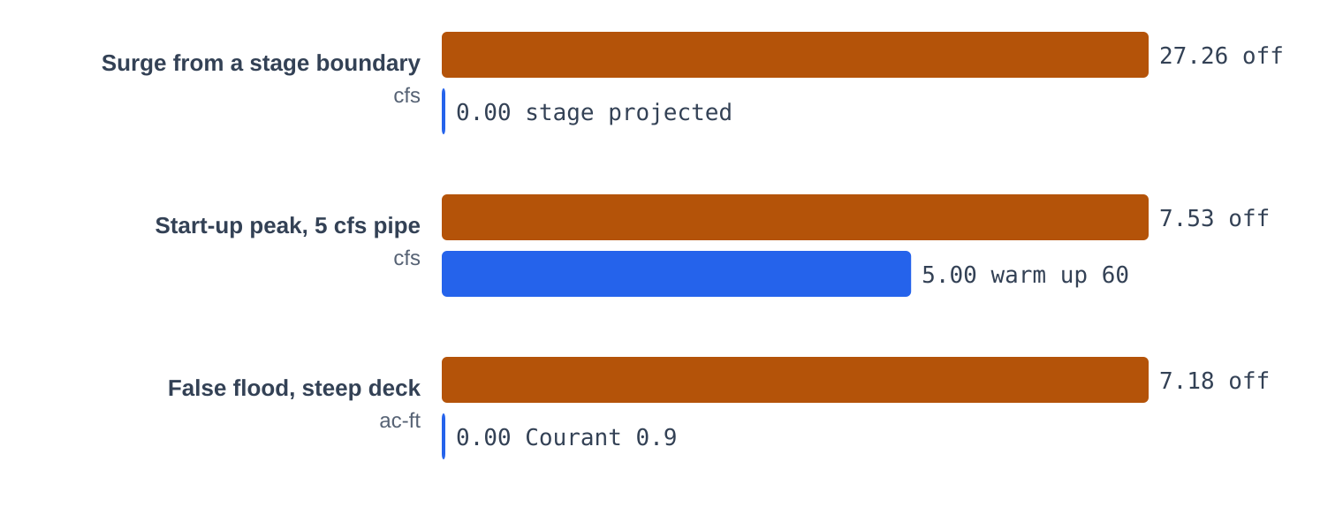
Figure 11. What HEC's start-up and time step options do on three test decks. The bars in each row are scaled to that row, so compare within a row and not between rows.
Two more options deal with the first moments of a run, where a model can throw a spike nobody asked for.
Use Initial Stage. HEC recommends it for stage boundaries: "the first value in the stage timeseries will be projected into the upstream conduits and that flat water surface used as the initial condition." Without it, a tide standing 5 ft up an outfall pours into a dry network on the first step. We tested exactly that. RASPIPE without the option surged 27.3 cfs and stock surged 22.5 cfs, against nothing at all with it on. Be clear about what that shows. A network that really is dry under a higher stage would take that inflow. Zero flow doesn't mean the solver got a transient right. It means the run began from a different state, already filled, which is what HEC intends and usually what a modeler wants. That's an initialization check and not an accuracy test. Here it covers FIXED, TIDAL and TIMESERIES outfalls, runs up open conduits only, and stops at flap gates and at the top of a manhole. It is on by default, as at HEC.
Warm Up. HEC ramps the water surfaces feeding the network "over the first 2/3 of the warmup period," then holds them, and insists on 30 or more steps. SWMM has no such period, so RASPIPE_WARMUP runs one before the clock starts: inflows come up over the first 2/3, then hold, nothing is reported, and whatever ends up in the pipes goes to initial storage and not to inflow. A full manhole dumping into a dry 5 cfs pipe peaked at 7.53 cfs without it and 5.00 with 60 warm up steps. That shows spin-up works, nothing more. It is off by default, because it changes what a run starts from.
HEC's fourth item, Compute Every 2D Iteration, has no SWMM counterpart. There is no 2D area to couple to.
One defect came out of all this. On a deck with 492 ft pipes, where a 6 inch pipe was entered in the wrong units, a dead dry network made 328 ft³ of water from nothing. A rounding error in a dry cell became a flow through an opening face, and the next dry cell, with no width to hold it, turned that into a big level. It now takes 0.001 ft of water to open a dry face.
All three options switch off, and with RASPIPE_COURANT 0 and RASPIPE_INITIAL_STAGE NO the .out matches version 1.0 byte for byte on 3 of 3 decks.

The final count
Version 1.2 changed the full equations and left diffusion wave alone, and the corpus sweep is diffusion wave. So we didn't have to take that on faith. Diffusion wave never calls the new advection code, so the corpus numbers carry over: .out files were byte identical to frozen v1.1 on 23 of 23 test decks and 60 of 60 corpus models drawn at random (16 more were skipped for time or error). Every corpus number here comes from the version 1.1 build for that reason. Run time didn't move either: on two decks timed in interleaved pairs against version 1.1, the ratios ran 0.95 to 1.01 and 0.95 to 1.12, which is inside the noise.
Version 1.1 went through the sample, and it caught its own mistake on the way. The new quiet rule let the very first step run the whole ROUTING_STEP, an hour on some decks, before any inflow was known, and reported continuity went from 0.01% to 10%. The step now can't stretch until the run is under way, and never past 300 s. Models with a long ROUTING_STEP and VARIABLE_STEP on were rerun, 40 others were rerun to show they hadn't moved, and every corpus number here comes from that build.
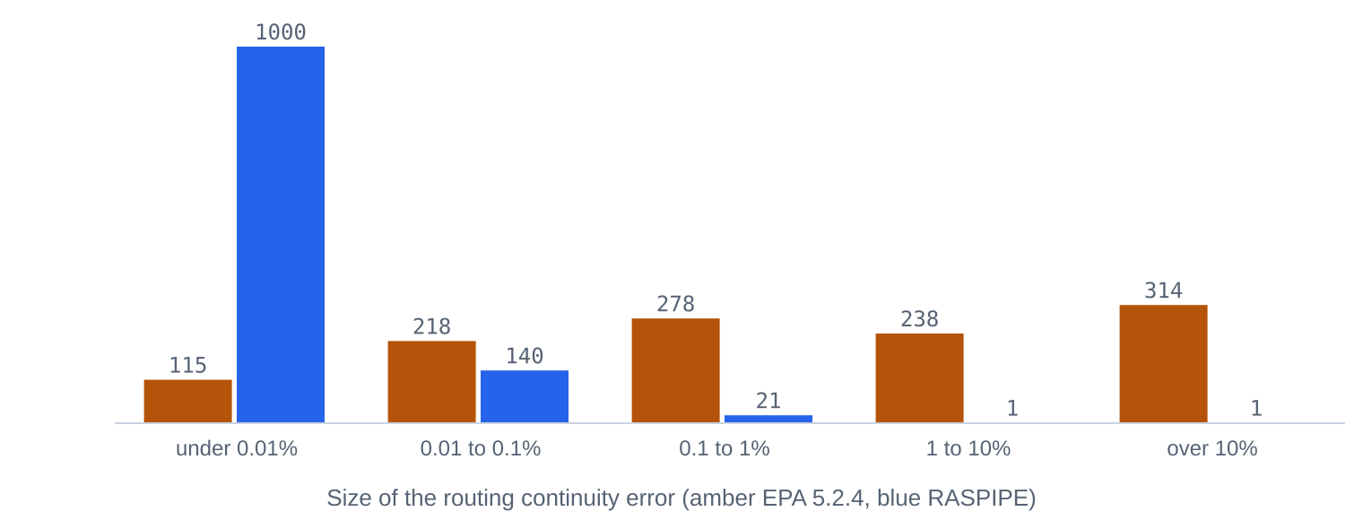
Figure 12. Routing continuity error across the corpus sample, version 1.1. The corpus is rich in stress tests, so the stock numbers describe those decks and are not typical of a well-built model.
Of the 1,600 models drawn, 134 had no conduits to route and 1,466 went through both engines. 1,163 finished in both with a continuity figure to compare. The median routing continuity error went from 0.795% to 0.005%. 552 models were past 1% on stock and 2 on RASPIPE. The stock figure is inflated by decks written to break things, and the worst RASPIPE entry, NUM-19_outfall-inflow.inp at 1,341%, is a stock bookkeeping gap and not a solver error: a fixed outfall that feeds the network is never booked as inflow, by either engine, and the solver's own ledger closes on it to 0.0001 ft³.
Continuity is no proof of being right, and a solver built on a cell balance closes its books by construction. So the solver also keeps its own ledger of volume in, out, flooded and stored, and on the mixed test model that ledger closes to 3.8e-06 ft³ on 304,200 ft³ of inflow. 14 models finished with any step left unsolved.
The cost is time, and the pipe clock raised it. RASPIPE took a median of 2.6 times as long as stock on this sample and 12 times at the 90th percentile, because it has many more cells, solves a matrix, and now takes as many pipe steps as the target asks for. 124 models hit the 60 s limit on RASPIPE, up from 76 in version 1.0, against 26 on stock. Those sweep times are single runs on a busy machine, so three models were also timed in five interleaved pairs: 2.5 times stock (pairs 2.3 to 2.5), 0.86 times (0.83 to 0.90) and 33 times (31 to 34), with run-to-run spread of 5 to 7%. Version 1.0 on the same three was 1.2, 0.79 and 6.8. Every pair agreed on the sign, and yes, one of them still beats stock. The third shows what the target can cost: 9 s in version 1.0 and 46 s now, and the sweep has worse. If a model doesn't need it, raise RASPIPE_COURANT, or set it to 0 and have version 1.0 back. Nobody hands you a better answer for free.
A reviewer pointed out that those paragraphs account for 1,163 models out of 1,466, and asked what became of the rest. Fair enough. Conservation is one measure, and a solver that times out has no continuity error to report.
Outcome | EPA 5.2.4 | RASPIPE | Models
Both finished, compared below | finished | finished | 1,163
Both rejected the input (ERROR 205 and the like) | input rejected | input rejected | 171
RASPIPE hit the 60 s limit, EPA finished | finished | time limit | 101
Both hit the limit | time limit | time limit | 22
EPA hit the limit, RASPIPE finished | time limit | finished | 4
Both crashed in shared EPA code | crash | crash | 2
Both ended with no continuity report | no report | no report | 2
EPA no report, RASPIPE hit the limit | no report | time limit | 1
Conduit models in the sample |  |  | 1,466
No conduits to route, not run |  |  | 134
Drawn |  |  | 1,600

101 models hit the limit on RASPIPE and finished on stock. That is the real cost of this method on those models, and it doesn't show in a continuity table. Fourteen models finished with a step the solver couldn't close to its target. 13 of those stopped less than 0.002 ft³ short and are accepted by a stated rule. 1 is not accepted and stays open. The list is on the Verify tab, one line each.
The full equations had never seen the corpus, so version 1.2 ran them on a random 160. 114 of 147 finished in both engines at θ = 1, median continuity 0.006%, 17 hit a 45 s limit, 0 crashed. At θ = 0.6, 109 finished, median 0.004%, 22 hit the limit, 0 crashed.

What this does not show
- No field data appears anywhere in this work. Agreement with Manning, with a pump curve and with another solver shows the arithmetic is right. It says nothing about whether a model predicts a real sewer.
- It has not been run against HEC-RAS. It uses the published method and may differ from HEC's code in any detail the manuals leave out.
- Where the two engines disagree in the corpus, nobody has yet sorted out which is right, model by model. A few we looked at are startup transients in nearly dry pipes, and one is a sill control limiting a backflow that stock lets through.
- A manhole here is a real tank up to its MaxDepth. EXTRAN stores nothing above the crown. A deck with a fake 1,000 ft MaxDepth gets 1,000 ft tanks. On one pressure network the heads now start at the outfall stage and sink slowly toward their steady values, and after 2 hours they are still on their way, where stock sits at steady head from the first step.
- A conduit holds one concentration, as in EPA's code, while its flow now varies along the cells. Across 46 sample models with pollutants, the median quality continuity error was 1.73% on stock and 0.07% on RASPIPE, with a worst case of 99.5% and 950.0%. Nothing here tests concentrations against a reference.
- Hot start files carry node and link states, not cell states, so a restart begins from a slightly different profile inside each conduit.
- Pressure transients such as water hammer are not modeled. HEC says the same of its own solver.
- The WebAssembly build matched the native .out byte for byte on 15 of 16 test decks. On the others the largest difference was 0.01 cfs on an 8 cfs link, on the mixed model with the full equations, from a different math library, from a different math library.
- Timing here is one machine. Treat the ratio as an order of magnitude.
- HEC does not publish its Courant formula or how far its interval may move. Residence time as outflow over volume is this engine's reading of their words.
- The Stoker test uses a test build, because a deck can't place a step inside a conduit and the .out file doesn't hold cells. The advection code is the same. It is one rectangular channel, and the U-tube is one pipe.
- What counts as a strong contraction is our number, and the benchmarks here don't exercise it. Neither does anything here test a real contraction, such as a pipe stepping down in size.
- Momentum crosses a junction of two conduits and stops at any other junction. Real junctions are somewhere in between, and no test here measures them.
- The wave reference was written in the same AI session as the engine. It shares no code, and it could share a mistaken idea.
- The full equations have run on 160 corpus models, against 1,466 for diffusion wave.
- The slot finding is one term by term test on one deck.
- The defect list above is what the sample found. The other 2,900 models in the local corpus have not been run on the final engine.
- No person has reviewed this code yet.

How to use it
- Put FLOW_ROUTING RASPIPE in [OPTIONS]. That is all you must do.
- Run at your usual ROUTING_STEP. The pipes keep their own clock at a target Courant number of 0.9, and RASPIPE_COURANT changes it. If instability shows up, lower the target before you touch the step for the whole model. RASPIPE_COURANT 0 turns it off.
- Set RASPIPE_CELL_LENGTH, and raise RASPIPE_MAX_CELLS for long pipes. Run it twice, halving the cell length, and watch whether your answer moves. If it moves, you were not done.
- Read the RASPIPE block near the end of the report. It gives the build, the mesh you really got, how many conduits hit the cell limit, the pipe steps, the largest Courant number, the volume ledger and any steps left unsolved.
- Use RASPIPE_EQUATIONS SWE when inertia matters. Try RASPIPE_THETA 0.6 with it when a sharp front matters, and hold the step down if you do. Water loses a velocity head at any junction of three or more pipes.
- If the first minutes throw a spike, try RASPIPE_WARMUP 60. Stage boundaries already project up the pipes, and RASPIPE_INITIAL_STAGE NO turns that off.

Use of AI
SWMM5 RASPIPE was built with Claude, Anthropic's AI model, in a Claude session in November 2026, at the request of Robert (Bob) Dickinson, who pointed it to the HEC-RAS time step and start-up options used in version 1.1, supplied the outside review that drove version 1.2, and set the standing requirements for testing, documentation and units. Responsibility for the work is his. He has not yet reviewed this build.
What Claude did. It read HEC's public manuals and the papers named below, designed the solver, wrote raspipe.c and the small patches to EPA's files, wrote the independent Saint-Venant reference solver and every test, ran the corpus sweeps, found and fixed the defects in the register, compiled the WebAssembly build, built this app, and wrote the essay and the Word document. For version 1.2 it replaced the advection with HEC's form, added the benchmarks, the run record, the Profile tab and the evidence labels, and corrected its own earlier statement that HEC publishes only an outline, a mistake the outside review caught.
How the results were checked. The checks are mechanical, not the AI's judgment: closed-form answers (Manning, normal depth, a pump curve, Stoker's dam break, the U-tube period), a byte comparison of the .out file with the feature off and of diffusion wave against version 1.1, a separately written Saint-Venant solver, the solver's own volume ledger, a sweep of 1,600 corpus models through both engines, and a Playwright run of this page.
What no person has checked. No person has reviewed the code, the figures or this text. It has not been compared with a run of HEC-RAS or with field data. The review Bob supplied covered the version 1.1 app and its documents, not the C solver. Casulli and Stelling's 2013 paper and Stelling and Duinmeijer's 2003 paper were not read directly; the methods were taken from HEC's description and the sources listed.

Sources
- HEC-RAS 1D Technical Reference Manual 7.0: Numerical Methods (Pipe Flow), for the advection, friction and nested iteration
- HEC-RAS 1D Technical Reference Manual: Computational Mesh and Subgrid Bathymetry (Pipe Flow), for the volume tables
- CivilGEO, Advanced Time Step Control, for residence time Courant described in words for 2D cells
- Stelling & Duinmeijer (2003), Int. J. Numer. Meth. Fluids 43, cited by HEC for the advective speed. Used through HEC's page and general knowledge
- Stoker (1957), Water Waves, for the dam break. Standard textbook result
- EPA SWMM issue 231, slot area in the momentum equation velocity
- HEC-RAS User's Manual 6.6: Pipe Network Simulations, for the adaptive time step, stage projection and warm up options
- HEC-RAS 1D Technical Reference Manual: Modeling Pipe Networks
- HEC-RAS Technical Reference: Pipe Network Hydraulic Structures
- HEC-RAS User's Manual 7.0: Pipe Network Geometry
- HEC-RAS tutorial: SWMM import, Beaver Lake
- Improved Urban Drainage Modeling with HEC-RAS (CWEMF paper)
- Casulli & Stelling (2013), Int. J. Numer. Meth. Fluids 73:600-614. Cited by HEC, paywalled, not read directly
- Brutto et al. (2023), Int. J. Numer. Meth. Fluids, for the Jordan decomposition and nested Newton
- Casulli & Zanolli (2012), nested Newton. Described from the secondary sources above and general knowledge
- Fuamba (2002), cited by HEC on the Preissmann slot
- EPA SWMM 5.2.4 source
- 1729 SWMM5 Models corpus

