SRS BF 03 Kiểm soát chất lượng chấm
Quality control of scores
Chuyển từ SRS.pdf. Đọc kèm docs/SRS_Overview.md và database/schema.sql (bảng appeals, appeal_criteria, appeal_resolutions, appeal_rule_configs, cross_review_batches, cross_review_tasks, reviewer_deviation_indices, audit_logs).
Ghi chú (Vấn đề #5 — đã chốt): BF-03 là luồng appeal (khiếu nại / chấm mù dưới đây), tiền tố class Appeal, CrossReview, ReviewerDeviation. Duyệt đăng (UC-33) thuộc assessment (BF-02). Xem AGENTS.md mục 2.
Phạm vi tài liệu: file này đặc tả nghiệp vụ BF-03 và các điểm tích hợp cần có với BF-01, BF-02, BF-04, BF-05. Các điểm tích hợp được mô tả để các luồng dùng cùng một quy tắc; file này không thay thế tài liệu hoặc schema thuộc luồng khác.

Các quyết định nghiệp vụ đã chốt cho BF-03:
- Chỉ tác giả chính (articles.author_id) được gửi khiếu nại. Đồng tác giả được xem kết quả nhưng không được dùng lượt khiếu nại của bài.
- Bài được khiếu nại khi đã công bố điểm, ở trạng thái SCORE_PUBLISHED hoặc PUBLISHED.
- Hạn khiếu nại tính từ score_approvals.announced_at. Gửi đúng thời điểm hết hạn vẫn hợp lệ; sau thời điểm đó bị từ chối.
- Người chấm mù không được thấy tiêu chí bị khiếu nại hoặc lý do khiếu nại, ngoài các dữ liệu đã bị ẩn theo BR-QC-03.
- Hệ thống tính kết quả đề xuất; Trưởng ban là người xác nhận và hoàn tất khiếu nại.
- Một khiếu nại có nhiều nhất hai đợt chấm lại: S1 là điểm chấm lại lần 1, S2 là điểm chấm lại lần 2. S0 là điểm gốc đã công bố và không tính là một đợt chấm lại.
- Cả S0, S1, S2 dùng cùng phiên bản bài, thể loại, bộ tiêu chí và trọng số; mỗi tiêu chí và tổng điểm đều theo thang 0–100.
- Nếu ABS(S1 - S0) <= T, điểm đề xuất cuối là S1. Nếu ABS(S1 - S0) > T, bắt buộc có S2 và dùng quy tắc trọng tài S2 tại BR-QC-07.
- Điểm cuối có thể tăng hoặc giảm so với S0; không có sàn bảo vệ điểm gốc. Điểm nằm ngoài cặp gần nhất chỉ được coi là điểm lệch so với nhóm để tính kết quả, không tự động kết luận người chấm vi phạm.
- Trigger (mục 2.3): Phóng viên gửi khiếu nại.
- End condition (mục 2.3): Nhận khiếu nại và chấm lại, sau đó cập nhật chỉ số.

Swimlane
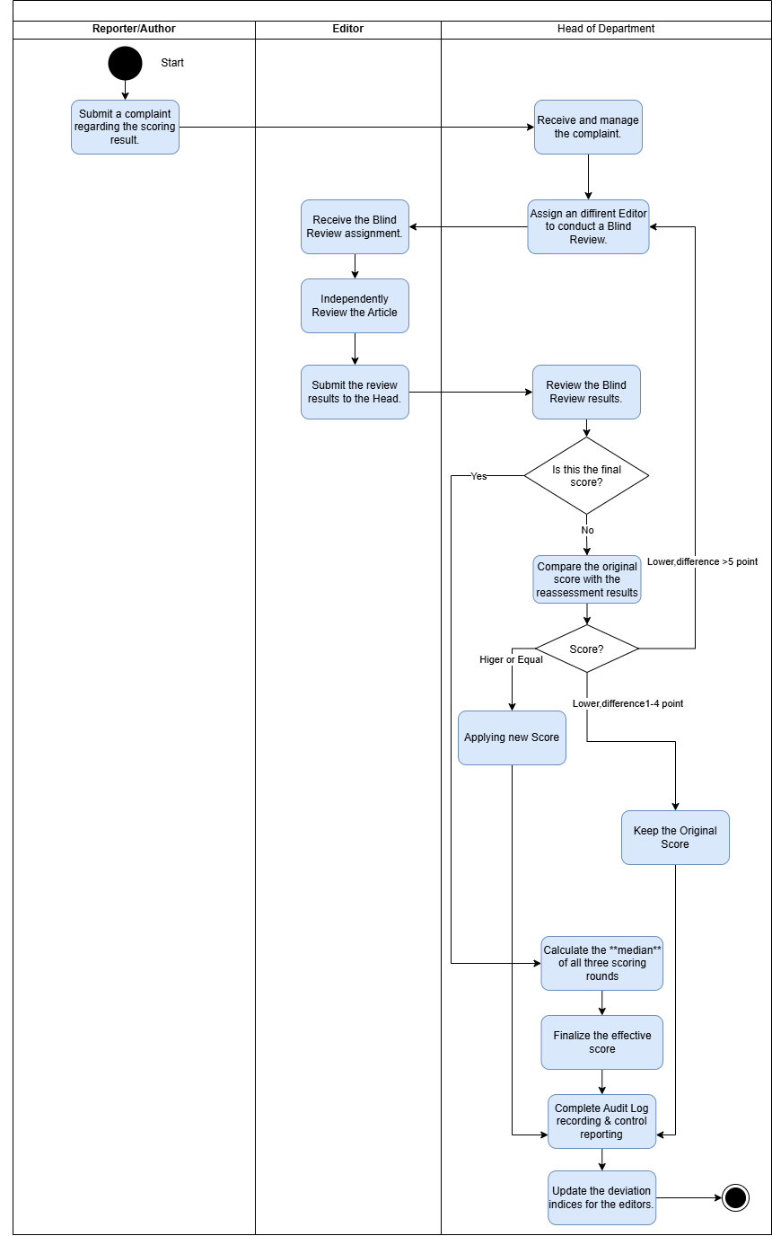
BF-03 swimlane
Mô tả sơ đồ (3 làn: Reporter/Author | Editor | Head of Department):
1. Reporter: Submit a complaint regarding the scoring result.
2. Head: Receive and manage the complaint → Assign a different Editor to conduct a Blind Review.
3. Editor: Receive the Blind Review assignment → Independently Review the Article → Submit the review results to the Head.
4. Head: Review the Blind Review results → Is this the final score?
- Chỉ có S0 và S1: nếu ABS(S1 - S0) <= T → dùng S1; nếu lớn hơn T → quay lại bước 2 để giao BTV thứ ba thực hiện đợt chấm lại lần 2 (S2).
- Đã có S2 → so sánh D0 = ABS(S2 - S0) và D1 = ABS(S2 - S1), lấy trung bình của cặp gồm S2 và điểm gần S2 hơn; nếu D0 = D1 thì dùng S2.
5. Mọi nhánh → Complete Audit Log recording & control reporting → Update the deviation indices for the editors → End.
Quy tắc chốt: T là variance_threshold của cấu hình được gắn với khiếu nại, giá trị nghiệp vụ mặc định là 5 điểm. Chênh lệch được lấy theo trị tuyệt đối nên cả trường hợp tăng và giảm quá T đều phát sinh S2. Nếu chênh lệch đúng bằng T thì dùng S1 và không chấm lại lần 2. database/data.sql hiện đang để 10 điểm và cần người phụ trách DB xử lý riêng trước khi triển khai (xem mục Phụ thuộc cần nhóm xử lý sau).

Use Case Diagram
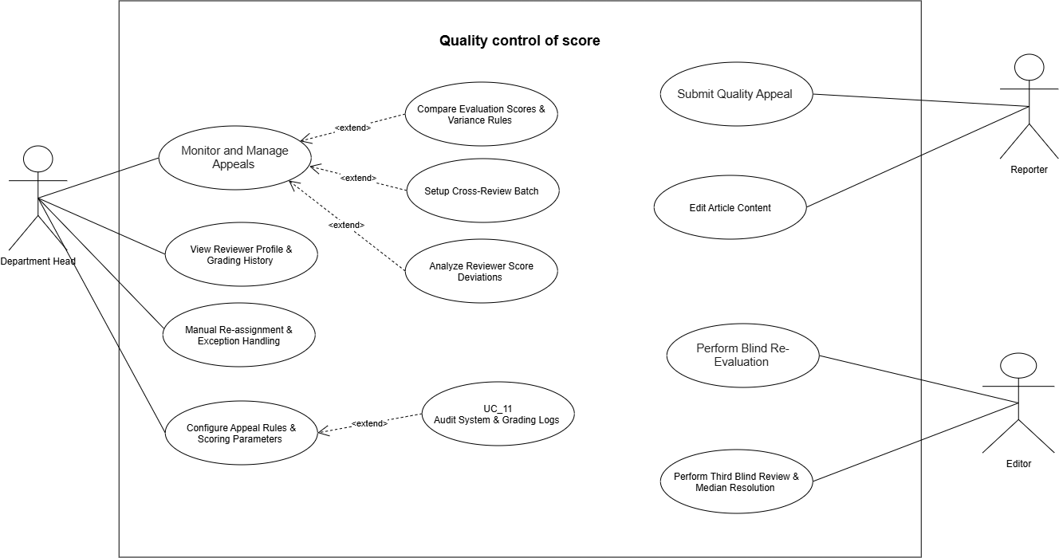
UC BF-03
- Department Head: Monitor and Manage Appeals, View Reviewer Profile & Grading History, Manual Re-assignment & Exception Handling.
- Admin: Configure Appeal Rules & Scoring Parameters. Ảnh use-case gốc gắn UC-44 với Department Head, nhưng đặc tả BF-03 giao cho Admin vì appeal_rule_configs là cấu hình toàn hệ thống, không có section_id.
- «extend» Monitor and Manage Appeals: Compare Evaluation Scores & Variance Rules, Setup Cross-Review Batch, Analyze Reviewer Score Deviations.
- «extend» Configure Appeal Rules & Scoring Parameters: Audit System & Grading Logs.
- Reporter: Submit Quality Appeal. "Edit Article Content" trong ảnh là UC-10 của BF-01, không phải chức năng của BF-03.
- Editor: Perform Blind Re-Evaluation, Perform Second Re-Evaluation & Third-Reviewer Arbitration.

Use Cases (4.2.3)
Actor chính: Reporter, Head of ED, Editor · 11 use case · ID 35–45
ID | Use Case | Feature | Use Case Description
35 | Submit Quality Appeal | Submit & Track Appeal | Allows the main author to submit one formal quality appeal for an article within the configured number of days after score_approvals.announced_at, requiring specific criteria selection and detailed reasoning
36 | Perform Blind Re-Evaluation | Re-evaluation Scorecard - Blind Review | Assigned editor conducts an independent blind re-grading without seeing prior scores or comments, applying the same criteria version and category as the initial evaluation
37 | Perform Second Re-Evaluation & Third-Reviewer Arbitration | Re-evaluation Scorecard - Blind Review | Triggered when the absolute difference between S0 and S1 exceeds the bound threshold T, requiring a second re-evaluation by a third independent Editor and Head confirmation of the S2 arbitration result
38 | Monitor and Manage Appeals | Complaint List & Management | Enables Department Head to monitor all submitted quality appeals, oversee reviewer assignments, and track resolution workflows
39 | Compare Evaluation Scores & Variance Rules | Score Comparison & Evaluation Detail | Displays detailed comparison across evaluation rounds and applies decision rules to finalize the effective score
40 | Setup Cross-Review Batch | Setup Cross-Review Batch | Configures peer cross-review campaigns to measure reviewer grading variance. Scores from cross-reviews are strictly analytical and do not alter official article scores
41 | Analyze Reviewer Score Deviations | Reviewer Score Deviation Report | Generates analytical reporting on reviewer grading consistency, updating deviation indices to maintain grading quality control
42 | View Reviewer Profile & Grading History | Reviewer Profile / Details | Displays comprehensive profiles and grading history of editors, tracking evaluation reliability, past appeal rates, and workload distribution
43 | Manual Re-assignment & Exception Handling | Manual Re-assignment / Exception | Allows the Head to reassign an unfinished blind review or select an eligible cross-department Editor when the home department has no eligible Editor; a reason and audit entry are mandatory
44 | Configure Appeal Rules & Scoring Parameters | Configure Appeal Rules & Scoring Scale | Allows the Admin to create a new effective-dated appeal-rule version; existing versions and in-progress appeal rules are not edited retroactively
45 | Audit System & Grading Logs | System Audit Log / Grading Audit Log | Allows authorized users to inspect immutable appeal and grading audit records without exposing hidden information to blind reviewers

Use cases full dressed (II.1.2.3 — Flow 3)

UC-35: Submit Quality Appeal
Field | Value
Actor | Reporter (main author of the article)
Trigger | The Reporter opens a published scoring result and clicks Submit Appeal.
Preconditions | The Reporter is articles.author_id; the article is SCORE_PUBLISHED or PUBLISHED; the appealed scoring attempt has an APPROVED score_approvals record with announced_at; the configured appeal window has not expired; no appeal has previously been submitted for this article.
Postconditions | A quality appeal is saved as SUBMITTED; the selected disputed criteria and detailed reason are recorded; the Head of Editorial Department is notified; an audit log entry is written.
Business Rules | BR-QC-01, 02

Normal Flow
1. System shows the published result by criterion, the Editor's comments, the publication time of the score, and the remaining appeal time.
2. Reporter selects one or more disputed criteria and enters a detailed reason for each disputed item.
3. Reporter clicks Submit Appeal.
4. System validates that the current user is the main author, the article status is eligible, and currentTime <= announced_at + appeal_window_days.
5. System validates the one-appeal limit and verifies that every selected criterion belongs to the criteria_set_version_id of the appealed scoring attempt (BR-QC-01, 02).
6. System binds the active appeal-rule version, saves the appeal as SUBMITTED, writes the audit log, and notifies the Head of Editorial Department.

Alternative / Exceptions
- A1 Reporter cancels before submitting: no appeal is created.
- E1 The appeal window has expired: "Thời hạn khiếu nại đã kết thúc."
- E2 An appeal already exists for the article: "Mỗi bài viết chỉ được khiếu nại một lần."
- E3 No criterion is selected or a reason is blank: "Phải chọn ít nhất một tiêu chí và nhập lý do cho từng tiêu chí."
- E4 A co-author or another Reporter attempts to submit: "Chỉ tác giả chính được gửi khiếu nại."
- E5 A selected criterion does not belong to the appealed scorecard: "Tiêu chí khiếu nại không thuộc phiếu chấm đã công bố."

UC-36: Perform Blind Re-Evaluation
Field | Value
Actor | Assigned Editor
Trigger | The assigned Editor opens a blind re-evaluation task.
Preconditions | The appeal is IN_REVIEW; the Editor is ACTIVE, is assigned to this appeal, has not performed an earlier evaluation of this appeal, and the appealed article version and criteria set version are available.
Postconditions | The first re-evaluation attempt (S1) is saved and locked; the system records its total score and sends the result to variance comparison in UC-39; prior scores and comments remain hidden from the Editor.
Business Rules | BR-QC-03, 04, 05, 09

Normal Flow
1. System shows the appealed article version and the same category and criteria set version used in the original scoring, but hides all previous scores, comments, reviewer identities, comparison results, disputed criteria, appeal reasons, and appeal outcomes (BR-QC-03).
2. Editor independently enters a score from 0 to 100 for every criterion.
3. Editor enters a comment for every criterion scored below 50.
4. System calculates total = SUM(criterion score * criterion weight / 100) using the locked criteria weights, validates that the total is from 0 to 100, and stores at most two decimal places using HALF_UP rounding (BR-QC-05).
5. Editor reviews and submits the re-evaluation.
6. System validates the scorecard, saves and locks S1, writes the audit log, and continues to UC-39.

Alternative / Exceptions
- A1 Editor saves the scorecard as an incomplete draft and resumes it later; no comparison runs until submission.
- E1 A criterion is not scored or a required comment is missing: system lists the missing items and keeps the attempt open.
- E2 The task is assigned to another Editor or the attempt is already locked: the scorecard is read-only and cannot be submitted.
- E3 The Editor account is no longer ACTIVE: submission is refused and the Head uses UC-43 to reassign the unfinished review.

UC-37: Perform Second Re-Evaluation and Third-Reviewer Arbitration
Field | Value
Actor | Third assigned Editor; Head of Editorial Department
Trigger | UC-39 determines that ABS(S1 - S0) > T, where S0 is the original score and S1 is the first re-evaluation score.
Preconditions | The original attempt and first re-evaluation attempt are locked; the appeal is IN_REVIEW; a third eligible Editor who did not perform either earlier evaluation can be assigned.
Postconditions | The second re-evaluation attempt (S2) is saved and locked; the system proposes the final score from the S2 arbitration rule; the Head confirms the effective score; the appeal is RESOLVED; affected users and downstream processes are notified.
Business Rules | BR-QC-03, 04, 05, 06, 07, 09, 10

Normal Flow
1. System flags the appeal for the second and final re-evaluation and creates a new blind-review task (BR-QC-06).
2. Head of Department assigns a third eligible Editor using the same eligibility rules as UC-38.
3. System shows the third Editor the same article version, category, and criteria set version while hiding all prior scores, comments, reviewer identities, and variance information.
4. Third Editor completes and submits the scorecard under the same validation rules as UC-36.
5. System saves and locks S2. No further re-evaluation can be created for this appeal.
6. System calculates D0 = ABS(S2 - S0) and D1 = ABS(S2 - S1). If D0 < D1, the proposed final score is (S0 + S2) / 2; if D1 < D0, it is (S1 + S2) / 2; if D0 = D1, it is S2. An average is rounded to at most two decimal places using HALF_UP (BR-QC-07).
7. Head confirms the proposed numeric score. System records finalized_by, resolves the appeal, writes the audit log, notifies the main author and affected roles, and propagates the effective score to BF-04 and BF-05 where applicable (BR-QC-10).

Alternative / Exceptions
- A1 No eligible Editor is available in the home department: Head of Department uses UC-43 for cross-department assignment.
- E1 The S2 scorecard is incomplete: system lists the missing items and does not calculate the arbitration result.
- E2 The appeal was resolved by another valid operation before submission: the third attempt is shown read-only and no score is overwritten.

UC-38: Monitor and Manage Appeals
Field | Value
Actor | Head of Editorial Department
Trigger | The Head of Department opens the complaint list after a quality appeal is submitted.
Preconditions | The appeal exists in SUBMITTED or IN_REVIEW status; the Head manages the article's department; the article, appealed scoring attempt, and disputed criteria are available.
Postconditions | The appeal status and assignment are updated; an eligible Editor is assigned for blind re-evaluation; the assigned Editor is notified; the assignment is audited.
Business Rules | BR-QC-03, 04, 09

Normal Flow
1. System shows the appeal queue with article, Reporter, submission time, deadline status, assigned reviewer, and appeal status.
2. Head of Department opens an appeal and reviews the disputed criteria and the Reporter's reasons.
3. System lists eligible Editors: ACTIVE account, role EDITOR, did not perform the original scoring, and did not perform any earlier review of the same appeal. Same-department Editors are listed first (BR-QC-03, 04).
4. Head of Department selects an Editor and confirms the assignment.
5. System sets the appeal to IN_REVIEW, creates a blind re-evaluation task, writes the audit log, and notifies the assigned Editor.

Alternative / Exceptions
- A1 No eligible Editor is available in the home department: Head of Department uses UC-43 to assign a qualified Editor from another department.
- A2 Head of Department filters the queue by status, date, department, article, or assigned reviewer.
- E1 The selected Editor performed an earlier evaluation of the same article: the assignment is refused.
- E2 The appeal has already been RESOLVED: it is displayed read-only.

UC-39: Compare Evaluation Scores and Apply Variance Rules
Field | Value
Actor | Head of Editorial Department; System
Trigger | A blind re-evaluation attempt is submitted and locked.
Preconditions | The original scoring attempt and at least one blind re-evaluation attempt are locked; the appeal is IN_REVIEW.
Postconditions | The bound variance rule is applied; either S2 is required or the Head confirms the proposed resolution; the numeric effective score and resolution history are recorded.
Business Rules | BR-QC-06, 07, 09, 10

Normal Flow
1. System displays the original and completed re-evaluation results by criterion to the Head of Department and identifies S0, S1, and S2 when available.
2. System reads the variance threshold T bound when the appeal was submitted and calculates difference = ABS(S1 - S0) (BR-QC-06).
3. If difference <= T, system proposes S1 as the final score and does not create S2. If difference > T, system requires UC-37 and keeps the appeal IN_REVIEW.
4. When S2 exists, system applies the S2 arbitration rule in BR-QC-07. For example, S0 = 50, S1 = 90, S2 = 40 produces (50 + 40) / 2 = 45; the score 90 is outside the pair selected by S2, but this does not automatically establish reviewer misconduct.
5. The proposed score may be higher or lower than S0; the system does not apply a floor based on the original score.
6. Head reviews and confirms the proposal. System records the numeric effective score, sets the appeal to RESOLVED, preserves every attempt, writes the audit log, and notifies the main author and Head of Department.
7. System sends the effective score to royalty and KPI calculations; if the related royalty period is already LOCKED, BF-04 creates an adjustment line in the next OPEN period (BR-QC-10).

Alternative / Exceptions
- A1 Head of Department opens the criterion-level comparison to inspect where the variance occurred before resolution.
- A2 The effective score is unchanged: system resolves the appeal without creating a downstream adjustment.
- E1 A required attempt is incomplete or not locked: comparison is not finalized.
- E2 The appeal is already RESOLVED: the comparison is read-only and cannot be run again.
- E3 Another valid operation resolves the appeal before confirmation: the Head receives "Khiếu nại đã được xử lý trước đó." and no result is overwritten.

UC-40: Setup Cross-Review Batch
Field | Value
Actor | Head of Editorial Department
Trigger | The Head opens quality-control campaigns and clicks Create Batch.
Preconditions | The Head is ACTIVE; the date range is valid; eligible submitted scoring attempts exist in the Head's department.
Postconditions | An OPEN cross-review batch and its PENDING tasks are created; assigned Editors are notified; the creation is audited.
Business Rules | BR-QC-03, 04, 08, 09

Normal Flow
1. Head enters a unique batch name, period start and period end.
2. System lists eligible official scoring attempts from articles in the Head's department and excludes unfinished attempts.
3. Head selects articles and assigns one eligible Editor to each article. The Editor must not be the original reviewer.
4. System creates the OPEN batch and PENDING tasks. Each task uses the article version and criteria version of original_scoring_id.
5. The assigned Editor performs an analytical blind review using the same 0–100 criterion scale and weighted-total formula in BR-QC-05. The system hides the original score, comments and reviewer identity.
6. On submission, system stores the analytical total, calculates deviation = analytical score - original score, marks the task DONE and updates quality-control statistics.
7. Head closes the batch only after every task is DONE.

Alternative / Exceptions
- A1 Head removes an unstarted task while the batch is OPEN; the removal is audited.
- E1 The selected Editor is the original reviewer or is not ACTIVE: "Biên tập viên không đủ điều kiện chấm chéo."
- E2 The date range is invalid: "Ngày bắt đầu phải trước hoặc bằng ngày kết thúc."
- E3 A batch still has PENDING tasks: "Không thể đóng đợt khi vẫn còn bài chưa chấm."

UC-41: Analyze Reviewer Score Deviations
Field | Value
Actor | Head of Editorial Department; System
Trigger | A cross-review task is completed, an appeal is resolved, or the Head opens the deviation report.
Preconditions | At least one valid comparison exists for the selected period.
Postconditions | Reviewer deviation indicators are recalculated for the selected month; no official article score is changed by cross-review data.
Business Rules | BR-QC-08, 09

Normal Flow
1. System groups comparison records by original reviewer and calendar month.
2. For a cross-review, absolute deviation is ABS(cross-review score - original score).
3. For a resolved appeal, absolute deviation is ABS(effective score - original score).
4. avg_deviation is the average of all valid absolute deviations in the period. Signed cross_review_tasks.deviation remains available for detailed analysis.
5. appeal_count is the number of appeals against that reviewer's original attempts that were resolved in the period.
6. overturn_rate = overturned resolved appeals / resolved appeals * 100; an appeal is overturned when its confirmed effective score differs from S0. If the denominator is zero, the rate is 0.
7. workload_count is the number of submitted non-APPEAL scoring attempts completed by the Editor in the period.
8. System updates reviewer_deviation_indices and shows the report. The report is analytical and does not automatically lock an account or change an assignment.

Alternative / Exceptions
- A1 Head filters by month, Editor or department.
- E1 No comparison data exists: system shows "Chưa có dữ liệu độ lệch trong kỳ đã chọn." without creating a misleading index.

UC-42: View Reviewer Profile and Grading History
Field | Value
Actor | Head of Editorial Department; Admin
Trigger | An authorized user opens an Editor from an assignment, appeal or deviation report.
Preconditions | The Editor exists; a Head may view Editors in the Head's department, while Admin may view all departments.
Postconditions | None; this is read-only.
Business Rules | BR-QC-09

Normal Flow
1. System shows the Editor's account status, department and current workload.
2. System shows submitted scoring history, appeal count, overturn rate, average deviation and cross-review history by period.
3. Head uses the information to support assignment decisions; the system does not automatically rank or punish Editors.

Alternative / Exceptions
- A1 User changes the reporting period.
- E1 A Head requests an out-of-scope profile: "Bạn không có quyền xem hồ sơ biên tập viên này."

UC-43: Manual Re-assignment and Exception Handling
Field | Value
Actor | Head of Editorial Department
Trigger | No eligible same-department Editor exists, or an assigned Editor cannot finish an unlocked blind review.
Preconditions | The appeal is IN_REVIEW; the current blind attempt is not submitted; the Head manages the article's department.
Postconditions | An eligible Editor is assigned; cross-department assignment is marked when applicable; reason, old assignment and new assignment are audited; affected Editors are notified.
Business Rules | BR-QC-04, 09

Normal Flow
1. Head selects Reassign and enters a mandatory reason.
2. System lists ACTIVE Editors who did not perform the original scoring or any earlier review of this appeal.
3. Same-department Editors are preferred. If none exists, Head selects an eligible Editor from another department.
4. System invalidates access of the previous Editor to the unfinished attempt, assigns the new Editor and marks the review as cross-department when sections differ.
5. System writes an immutable audit entry and sends notifications.

Alternative / Exceptions
- A1 The previous Editor has not opened the task: reassignment still requires a reason.
- E1 The attempt was already submitted: "Không thể đổi người chấm cho phiếu đã nộp."
- E2 The selected Editor reviewed this appeal before: "Biên tập viên đã tham gia chấm khiếu nại này."

UC-44: Configure Appeal Rules and Scoring Parameters
Field | Value
Actor | Admin
Trigger | Admin opens Appeal Rule Configuration and clicks Create New Version.
Preconditions | The user is ACTIVE with the Admin role.
Postconditions | A new effective-dated configuration is created; existing configurations and in-progress appeals keep their bound rules; the change is audited.
Business Rules | BR-QC-01, 06, 09, 12

Normal Flow
1. System shows configuration history: appeal window, maximum appeals per article, variance threshold, effective date and active state.
2. Admin enters values for a new version. The business defaults are 7 days, one appeal per article and a 5-point variance threshold.
3. System validates positive values, threshold from 0 to 100, and a non-duplicate effective date.
4. Admin saves. System creates a new configuration row rather than editing a version already bound to an appeal.
5. System writes the old/new configuration values to the audit log.

Alternative / Exceptions
- A1 Admin schedules a future effective date.
- E1 Invalid values: "Giá trị cấu hình khiếu nại không hợp lệ."
- E2 Duplicate effective date: "Đã có cấu hình áp dụng từ ngày này."

UC-45: Audit System and Grading Logs
Field | Value
Actor | Head of Editorial Department; Admin
Trigger | An authorized user opens the audit view from an appeal, scoring attempt or configuration version.
Preconditions | Head may view records for the Head's department; Admin may view all records.
Postconditions | None; audit records are read-only and are never exposed through blind-review endpoints.
Business Rules | BR-QC-03, 09

Normal Flow
1. User filters by article, appeal, Editor, action type or time range.
2. System shows append-only events for appeal submission, assignment, reassignment, score submission, comparison, finalization, configuration change and downstream synchronization.
3. Each event shows actor, action, entity, timestamp and relevant old/new values.
4. Sensitive prior-score data is visible only in this authorized audit view and never to an Editor performing a blind review.

Alternative / Exceptions
- A1 A system job created the event: actor is displayed as "Hệ thống" when actor_id is NULL.
- E1 User lacks scope: "Bạn không có quyền xem nhật ký này."

Business Rules for Quality Control of Scores (BR-QC)
BR-ID | Rule
BR-QC-01 | Only the article's main author may appeal. The article must be SCORE_PUBLISHED or PUBLISHED. Submission is valid when currentTime <= score_approvals.announced_at + appeal_window_days; each article is limited to one appeal.
BR-QC-02 | An appeal must identify at least one criterion from the appealed attempt's criteria-set version and include a detailed reason for each selected criterion. Submitting an appeal does not erase or modify the original scoring attempt.
BR-QC-03 | Every re-evaluation is strictly blind. The assigned Editor sees the appealed article version and the same category and criteria-set version as the original attempt, but cannot see prior scores, comments, reviewer identities, comparison results, disputed criteria, appeal reasons, or appeal outcomes.
BR-QC-04 | An eligible blind reviewer is an ACTIVE user with role EDITOR who did not perform the original scoring or any earlier evaluation of the same appeal. Same-department Editors are preferred. A cross-department assignment through UC-43 requires a reason and must be audited.
BR-QC-05 | Every evaluation uses the same article version, category, criteria-set version, and locked weights as the appealed attempt. Each criterion score is from 0 to 100; a comment is mandatory below 50. The total is SUM(criterion score * criterion weight / 100), must be from 0 to 100, and is stored with at most two decimal places using HALF_UP rounding.
BR-QC-06 | Let S0 be the original total, S1 the first re-evaluation total, and T the variance threshold bound to the appeal, with a business default of 5 points. Calculate difference = ABS(S1 - S0). If difference <= T, propose S1 as final and create no more review; if difference > T, require exactly one second re-evaluation (S2). An appeal may therefore have no more than two re-evaluation attempts.
BR-QC-07 | S2 is the arbitration score. Calculate D0 = ABS(S2 - S0) and D1 = ABS(S2 - S1). If D0 < D1, propose (S0 + S2) / 2; if D1 < D0, propose (S1 + S2) / 2; if D0 = D1, propose S2. This rule compares only the two distances from S2; it does not independently select the nearest pair among all three possible pairs. A calculated average uses HALF_UP rounding and at most two decimal places. The result may increase or decrease from S0; no original-score floor applies. A score outside the pair selected by S2 is an analytical outlier only and does not by itself prove reviewer misconduct. The Head confirms the numeric result before the appeal becomes RESOLVED.
BR-QC-08 | Cross-review campaign scores are analytical only and never change an official or effective article score. avg_deviation uses absolute deviations; overturn_rate is the percentage of resolved appeals whose confirmed effective score differs from S0, or 0 when there is no resolved appeal in the period.
BR-QC-09 | All appeal submissions, reviewer assignments, scoring attempts, comparisons, score updates, configuration changes, and workflow transitions are stored in immutable audit logs. Historical scores remain stored but are hidden from blind reviewers.
BR-QC-10 | The resolved numeric effective score is the canonical score source for royalty and KPI processes. A LOCKED or PAID royalty period never changes; a score difference discovered after locking creates an adjustment line in the next OPEN period. A FINALIZED KPI snapshot remains immutable.
BR-QC-11 | The persisted appeal lifecycle is SUBMITTED to IN_REVIEW to RESOLVED. Detailed working phases are derived from the number of APPEAL scoring attempts and their submitted_at values. A RESOLVED appeal is read-only and cannot be evaluated again.
BR-QC-12 | The rule configuration is bound when the appeal is submitted. A later configuration version must not change an in-progress or resolved appeal. Configuration changes create new effective-dated versions and are audited.

Điểm tích hợp với các luồng liên quan
Luồng | Dữ liệu BF-03 cần / cung cấp | Quy tắc tích hợp
BF-01 article | articles.author_id, trạng thái bài và quan hệ tác giả | Chỉ articles.author_id được gửi khiếu nại. BF-03 không sửa nội dung hoặc phiên bản bài.
BF-02 assessment | Lần chấm được duyệt, score_approvals.announced_at, article version, category và criteria-set version | Hạn khiếu nại bắt đầu từ announced_at. Lần chấm mù dùng đúng version/category/criteria-set của lần bị khiếu nại. BF-03 không sửa lần chấm gốc.
BF-04 royalty | Điểm hiệu lực số của appeal sau khi RESOLVED | Chưa chấm nhuận bút thì dùng điểm hiệu lực mới. Kỳ OPEN tính lại bằng phiên bản grading mới. Kỳ LOCKED/PAID giữ nguyên và tạo ADJUSTMENT ở kỳ OPEN tiếp theo. Cách xử lý kỳ CLOSED cần người phụ trách BF-04 xác nhận.
BF-05 kpi | Điểm hiệu lực của bài đã xuất bản | KPI DRAFT được tính lại. KPI FINALIZED không đổi; người phụ trách BF-05 cần chặn finalize khi còn cửa sổ khiếu nại hoặc appeal chưa RESOLVED.
Dùng chung | notifications, audit_logs | BF-03 gọi service dùng chung; không tự truy cập repository thuộc phần dùng chung. Blind-review API không trả dữ liệu điểm/lý do bị ẩn.

Nguồn điểm hiệu lực duy nhất:
1. Nếu chưa có appeal RESOLVED, dùng scoring attempt đã được score_approvals APPROVED và công bố.
2. Nếu có appeal RESOLVED, dùng điểm số hiệu lực đã được Trưởng ban xác nhận trong appeal_resolutions; điểm này có thể là S1, S2, hoặc trung bình của cặp gồm S2 và điểm gần S2 hơn.
3. Trong khi appeal còn SUBMITTED hoặc IN_REVIEW, điểm cũ tạm thời vẫn có hiệu lực; quy trình xuất bản không bị dừng.
4. Appeal chỉ thay điểm hiệu lực, không tự thay đổi quyết định xuất bản hoặc trạng thái bài.

Phụ thuộc cần nhóm xử lý sau
Các điểm dưới đây được ghi rõ để không code sai, nhưng không được sửa trong phạm vi BF-03 này:
1. database/data.sql đang đặt variance_threshold = 10.00, trong khi giá trị nghiệp vụ mặc định đã chốt trong tài liệu này là 5 điểm.
2. appeal_resolutions hiện chỉ lưu effective_attempt_id, nhưng kết quả theo BR-QC-07 có thể là trung bình của hai lần chấm và không thuộc riêng attempt nào. Nhóm DB cần bổ sung điểm hiệu lực số, đề xuất effective_score DECIMAL(5,2) NOT NULL, và chốt cách dùng hoặc thay thế effective_attempt_id.
3. appeal_resolutions.rule_applied hiện chỉ có KEEP_ORIGINAL và USE_RESCORE, không mô tả được các kết quả USE_S1, AVERAGE_S0_S2, AVERAGE_S1_S2, hoặc USE_S2_TIE. Nhóm DB cần chốt lại enum trước khi triển khai.
4. scoring_attempts.assignment_id hiện bắt buộc và lần đã nộp bắt buộc có decision; hai ràng buộc này chưa phù hợp với APPEAL attempt không có quyết định ACCEPT/REVISION/REJECT.
5. appeals chưa có rule_config_id, nên chưa thể đóng băng cấu hình áp dụng cho từng appeal như BR-QC-12.
6. Luật một appeal mỗi bài mới được kiểm tra ở service; schema chưa có UNIQUE trên appeals(article_id), nên vẫn có rủi ro tạo trùng khi hai request chạy đồng thời.
7. BF-04 chưa quy định cách xử lý một kỳ CLOSED khi điểm thay đổi. BF-05 chưa quy định điều kiện chờ hết cửa sổ khiếu nại trước khi FINALIZED. Hai chủ luồng cần xác nhận các điểm tích hợp trong bảng trên.
8. SRS_Overview.md (GBR-07) và ảnh use-case/swimlane gốc vẫn mô tả chấm lần 3 rồi lấy trung vị. Theo phạm vi đã chốt, lần sửa này chỉ cập nhật BF-03; nhóm cần đồng bộ các tài liệu/ảnh liên quan trong một thay đổi riêng.

Luật chung liên quan
GBR-06 (khiếu nại trong 7 ngày, 1 lần/bài, chấm mù), GBR-07 (quy tắc xử lý chênh lệch điểm), GBR-11 (kỳ đã khoá không đổi, sinh dòng điều chỉnh) — xem SRS_Overview.md. BF-03 hiện dùng trị tuyệt đối, tối đa hai đợt chấm lại và quy tắc trọng tài S2 theo BR-QC-06/07; nội dung GBR-07 đang ghi cách lấy trung vị cũ và cần được nhóm đồng bộ trong một thay đổi riêng.

