

**Mentor Appointment Scheduling Application**

**Software Design Document**

– Ho Chi Minh, May 2022 –

**Table of Contents**

I. Overview **6**

1. Code Packages/Namespaces 6

1.1 Back-end Code Packages 6

1.2 Front-end Code Packages 8

2. Database Schema 9

II. Code Designs **10**

1. Major Features 10

a. Class Diagram 10

b. Class Specifications 10

MajorsController Class 10

IMajorService Interface 11

MajorService Class - Implement from IMajorService 11

IMajorRepository Interface 12

MajorRepository Class - Implement from IMajorRepository 12

Major Class 12

MajorResponse Class 12

MajorCreateRequest Class 13

MajorUpdateRequest Class 13

2. Subject Features 14

a. Class Diagram 14

b. Class Specifications 14

SubjectsController Class 14

ISubjectService Interface 15

SubjectService Class - Implement from ISubjectService 15

ISubjectRepository Interface 15

SubjectRepository Class - Implement from ISubjectRepository 16

Subject Class 16

SubjectResponse Class 16

SubjectDetailResponse Class 17

SubjectCreateRequest Class 17

SubjectUpdateRequest Class 17

3. MasUser Features 19

a. Class Diagram 19

b. Class Specifications 19

UsersController Class 19

IMasUserService Interface 20

MasUserService Class - Implement from IMasUserService 20

IMasUserRepository Interface 20

MasUserRepository Class - Implement from IMasUserRepository 21

MasUser Class 21

UserGetBasicInfoResponse Class 21

UserGetByAdminResponse Class 22

UserSearchResponse Class 22

PersonalInfoResponse Class 23

UserPersonalInfoUpdateRequest Class 23

MentorRequest Class 24

IsActiveChangeRequest Class 24

4. MentorSubject Features 25

a. Class Diagram 25

b. Class Specifications 25

MentorSubjectsController Class 25

IMentorSubjectService Interface 26

MentorSubjectService Class - Implement from IMentorSubjectService 26

IMentorSubjectRepository Interface 27

MentorSubjectRepository Class - Implement from IMentorSubjectRepository 27

MentorSubjectResponse Class 27

MentorSubjectRegisterRequest Class 28

MentorSubjectUpdateRequest Class 28

5. Slot Features 29

a. Class Diagram 29

b. Class Specifications 29

SlotsController Class 29

ISlotService Interface 30

SlotService Class - Implement from ISlotService 30

ISlotRepository Interface 30

SlotRepository Class - Implement from ISlotRepository 31

Slot Class 31

SlotResponse Class 31

SlotDetailResponse Class 32

SlotCreateRequest Class 32

6. Appointment Features 33

a. Class Diagram 33

b. Class Specifications 33

AppointpmentsController Class 33

IAppointpmentService Interface 33

AppointpmentService Class - Implement from IAppointmentService 34

IAppointpmentRepository Interface 34

AppointpmentrRepository Class - Implement from IAppointpmentRepository 34

AppointmentAdminDetailResponse Class 34

AppointmentSubjectResponse Class 35

AppointmentUpdateRequest Class 35

AppointmentProcessRequest Class 35

AppointmentCreateRequest Class 36

AppointmentSubjectCreateRequest Class 36

7. Question Features 37

a. Class Diagram 37

b. Class Specifications 37

QuestionsController Class 37

IQuestionService Interface 37

QuestionService Class - Implement from QuestionService 37

IQuestionRepository Interface 38

QuestionRepository Class - Implement from QuestionRepository 38

QuestionClass 38

QuestionResponse Class 38

QuestionCreateRequest Class 39

AnswerQuestionRequest Class 39

8. Rating 40

a. Class Diagram 40

b. Class Specifications 40

RatingsController Class 40

IRatingService Interface 40

RatingService Class - Implement from IRatingService 41

IRatingRepository Interface 41

RatingRepository Class - Implement from IRatingRepository 41

Rating Class 41

RatingResponse Class 42

RatingCreateRequest Class 42

ProcessRatingRequest Class 42

III. Database Tables **42**

1. Majors 42

2. Subjects 43

3. MasUsers 43

4. MentorSubjects 44

5. Slots 44

6. Appointments 44

7. Questions 45

8. Ratings 45

9. AppointmentSubjects 45

# I. Overview

## 1. Code Packages/Namespaces

### 1.1 Back-end Code Packages

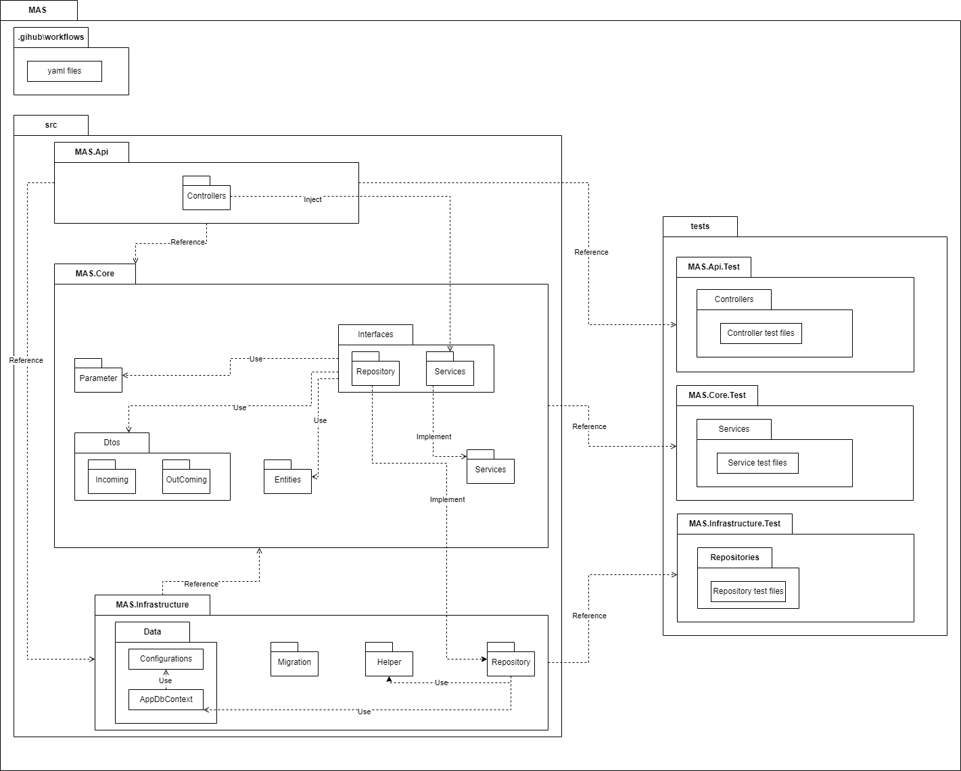

***Package descriptions & package class naming conventions***

| **No** | **Package** | **Description** |
| --- | --- | --- |
| 01 | .github\workflows | Contain config files (YAML files) used to work with GitHub Actions for CI/CD source code. |
| 02 | src | Contains the main source code of project API, include MAS.Api, MAS.Core and MAS.Infrastructure. |
| 03 | MAS.API | Contains the source code of the .NET 5 API, it is a Web API project. It has two main packages: Helpers and Controllers. |
| 04 | Helpers | Contains config files for the API such as service injection (declare the dependency injection into Dependency Inject Container of Asp.Net Core), config for swagger UI to easy testing API on Web browser, auto Seed Data file use to seed data to Database if it does not exist, constant file for the constant value of API. |
| 05 | Controllers | Contains controller files responsible for handling HTTP requests and returning responses with values. |
| 06 | MAS.Core | Contains source code of the Core Business of API, It is a Classlib project, including some main packages such as Parameters, Interfaces (contains Repository interfaces and Service interfaces), Data Transfer Object (Dtos), and Services (Implement level). |
| 07 | Entities | Contains all model classes for mapping with database tables. |
| 08 | Parameters | Contains all Parameters class files, it is used for query routes in API. |
| 09 | Exceptions | Contains files used for logging in Product Environment (Deploy in Azure). |
| 10 | Dtos | Contains Data transfer object classes used for data binding input object (Incoming package) and response mapping output object (Outcoming package). |
| 11 | Interfaces | Contains Interface classes of Repositories (which are working with Entity Framework Core and Database SQL Server to get data), and Services (which will be used by the API, they are same to the Repository Interfaces but they call and use the Repository Interfaces). |
| 12 | Services | Contains the Implement classes of the Interfaces/Services, It calls the Repository, catches the error from the input parameters from users, then passes these input parameters through the repository (Dependency Injection). |
| 13 | MAS.Infrastructure | Contains main files used for Entity Framework Core Object Relational Mapping with Database and the Repository (Implementation from the Repository Interfaces in Core layer). |
| 14 | Data | This package contains the AppDbContext class, where all entities or model classes use mapping with the table in the Database. |
| 15 | Entities | Contains all model classes for mapping with database tables. |
| 16 | Migrations | Contains migrations file, history design, and modified database. |
| 17 | Helpers | Contains files that help populate new model objects. |
| 18 | Repository | Contains files implementation of the Repository Interface in the Core layer. |
| 19 | tests | Contain test projects and test files. |

### 1.2 Front-end Code Packages

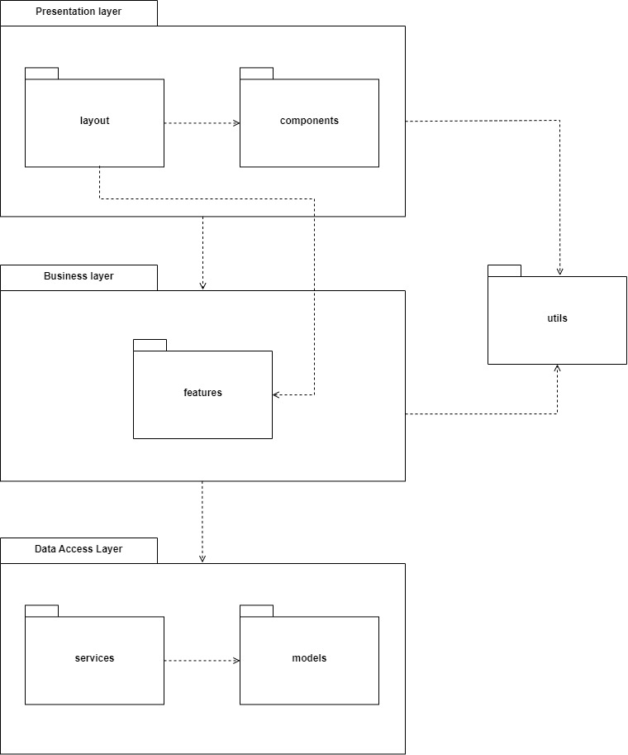

## 2. Database Schema

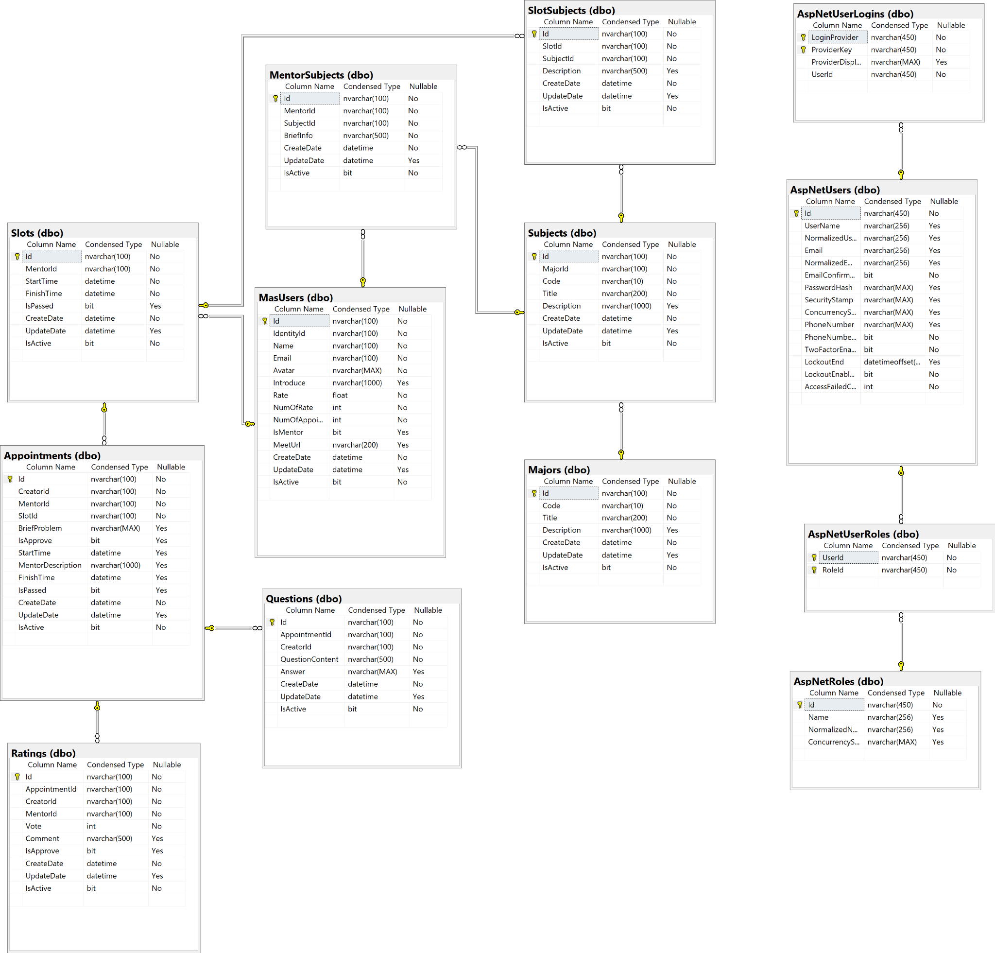

***Table descriptions & package class naming conventions are as below***

| **No** | **Table** | **Description** |
| --- | --- | --- |
| 1 | pages | The package contains pages, responsible for grouping components together |
| 2 | components | The package contains components for specific use in a specific page. |
| 3 | utils | The package contains utility methods for common use. |
| 4 | features | The package contains classes used for handling business logic, managing state. |
| 5 | services | The package contains classes responsible for handling data between REST APIs and web application. |
| 6 | models | The package contains model classes for data binding. |

# II. Code Designs

## 1. Major Features

### a. Class Diagram

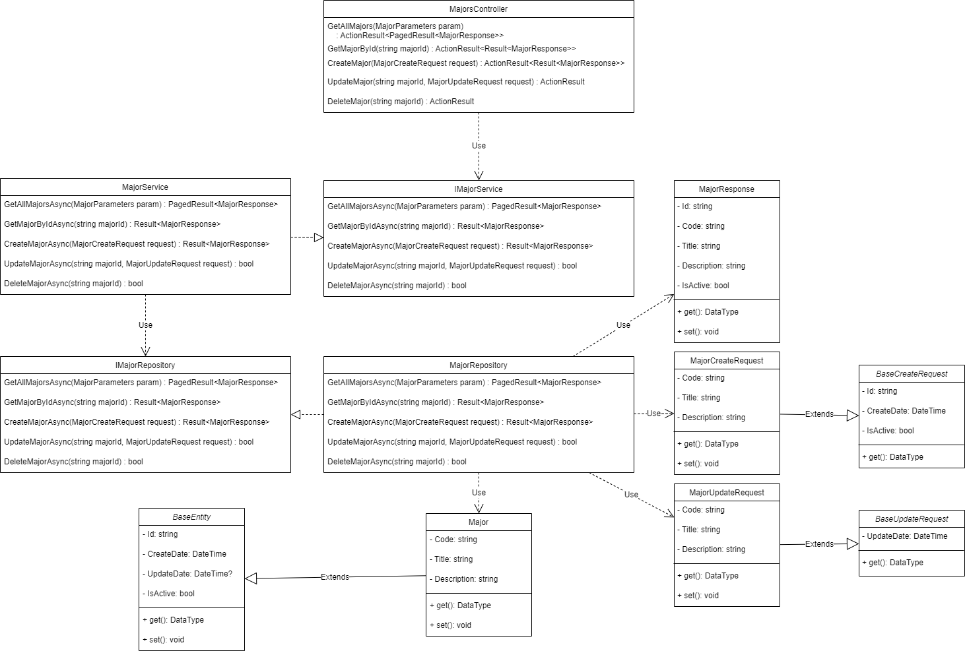

### b. Class Specifications

#### MajorsController Class

| **No** | **Method** | **Description** |
| --- | --- | --- |
| 01 | GetAllMajors | Get all Majors in System, **Input** is *MajorParameters*, **Output** is *ActionResult<PagedResult<MajorResponse>>*, **Internal method processing** is *GetAllMajorsAsync* from *IMajorService* by **Inject** it into *MajorsController* |
| 02 | GetMajorById | Get a Major Info by its Id, **Input** is *majorId,* **Output** is *ActionResult<Result<MajorResponse>>*, **Internal method processing** is *GetMajorByIdAsync* from *IMajorService* by **Inject** it into *MajorsController* |
| 03 | CreateMajor | Create a Major or Add a Major into System, **Input** is *MajorCreateRequest,* **Output** is *ActionResult<Result<MajorResponse>>*, **Internal method processing** is *CreateMajorAsync* from *IMajorService* by **Inject** it into *MajorsController* |
| 04 | UpdateMajor | Update info of Major, **Input** is *majorId, MajorUpdateRequest*, **Output** is*ActionResult*, **Internal method processing** is *UpdateMajorAsync* from *IMajorService* by **Inject** it into *MajorsController* |
| 05 | DeleteMajor | Disable Major, **Input** is *majorId*, **Output** is *ActionResult*, **Internal method processing** is *DeleteMajorAsync* from *IMajorService* by **Inject** it into *MajorsController* |

#### IMajorService Interface

| **No** | **Method** | **Description** |
| --- | --- | --- |
| 01 | GetAllMajorsAsync | Get all Majors in System, **Input** is *MajorParameters*, **Output** is *PagedResult<MajorResponse>* |
| 02 | GetMajorByIdAsync | Get a Major Info by its Id, **Input** is *majorId,* **Output** is *Result<MajorResponse>* |
| 03 | CreateMajorAsync | Create a Major or Add a Major into System, **Input** is *MajorCreateRequest,* **Output** is *Result<MajorResponse>* |
| 04 | UpdateMajorAsync | Update info of Major, **Input** is *majorId, MajorUpdateRequest*, **Output** is*bool* |
| 05 | DeleteMajorAsync | Disable Major, **Input** is *majorId*, **Output** is *bool* |

#### MajorService Class - Implement from IMajorService

| **No** | **Method** | **Description** |
| --- | --- | --- |
| 01 | GetAllMajorsAsync | Get all Majors in System, **Input** is *MajorParameters*, **Output** is *PagedResult<MajorResponse>*, **Internal method processing** is *GetAllMajorsAsync* from *IMajorRepository* by **Inject** it into *MajorService* |
| 02 | GetMajorByIdAsync | Get a Major Info by its Id, **Input** is *majorId,* **Output** is *Result<MajorResponse>*, **Internal method processing** is *GetMajorByIdAsync* from *IMajorRepository* by **Inject** it into *MajorService* |
| 03 | CreateMajorAsync | Create a Major or Add a Major into System, **Input** is *MajorCreateRequest,* **Output** is *Result<MajorResponse>*, **Internal method processing** is *CreateMajorAsync* from *IMajorRepository* by **Inject** it into *MajorService* |
| 04 | UpdateMajorAsync | Update info of Major, **Input** is *majorId, MajorUpdateRequest*, **Output** is*bool*, **Internal method processing** is *UpdateMajorAsync* from *IMajorRepository* by **Inject** it into *MajorService* |
| 05 | DeleteMajorAsync | Disable Major, **Input** is *majorId*, **Output** is *bool*, **Internal method processing** is *DeleteMajorAsync* from *IMajorRepository* by **Inject** it into *MajorService* |

#### IMajorRepository Interface

| **No** | **Method** | **Description** |
| --- | --- | --- |
| 01 | GetAllMajorsAsync | Get all Majors in System, **Input** is *MajorParameters*, **Output** is *PagedResult<MajorResponse>* |
| 02 | GetMajorByIdAsync | Get a Major Info by its Id, **Input** is *majorId,* **Output** is *Result<MajorResponse>* |
| 03 | CreateMajorAsync | Create a Major or Add a Major into System, **Input** is *MajorCreateRequest,* **Output** is *Result<MajorResponse>* |
| 04 | UpdateMajorAsync | Update info of Major, **Input** is *majorId, MajorUpdateRequest*, **Output** is*bool* |
| 05 | DeleteMajorAsync | Disable Major, **Input** is *majorId*, **Output** is *bool* |

#### MajorRepository Class - Implement from IMajorRepository

| **No** | **Method** | **Description** |
| --- | --- | --- |
| 01 | GetAllMajorsAsync | Get all Majors in System, **Input** is *MajorParameters*, **Output** is *PagedResult<MajorResponse>* |
| 02 | GetMajorByIdAsync | Get a Major Info by its Id, **Input** is *majorId,* **Output** is *Result<MajorResponse>* |
| 03 | CreateMajorAsync | Create a Major or Add a Major into System, **Input** is *MajorCreateRequest,* **Output** is *Result<MajorResponse>* |
| 04 | UpdateMajorAsync | Update info of Major, **Input** is *majorId, MajorUpdateRequest*, **Output** is*bool* |
| 05 | DeleteMajorAsync | Disable Major, **Input** is *majorId*, **Output** is *bool* |

#### Major Class

| **Attribute** | **Type** | **Visibility** | **Description** |
| --- | --- | --- | --- |
| Id | string | private | Unique identifier of a Major. |
| Code | string | private |  |
| Title | string | private |  |
| Description | string | private |  |
| CreateDate | DateTime | private |  |
| UpdateDate | DateTime? | private |  |
| IsActive | bool | private | This info is active or not. |

#### 

| **No** | **Method** | **Description** |
| --- | --- | --- |
| 01 | getter | Get attribute value |
| 02 | setter | Set attribute value |

#### MajorResponse Class

| **Attribute** | **Type** | **Visibility** | **Description** |
| --- | --- | --- | --- |
| Id | string | private | Unique identifier of a Major. |
| Code | string | private |  |
| Title | string | private |  |
| Description | string | private |  |
| IsActive | bool | private | This info is active or not. |

#### 

| **No** | **Method** | **Description** |
| --- | --- | --- |
| 01 | getter | Get attribute value |
| 02 | setter | Set attribute value |

#### MajorCreateRequest Class

| **Attribute** | **Type** | **Visibility** | **Description** |
| --- | --- | --- | --- |
| Id | string | private | Unique identifier of a Major. Auto setting value. |
| Code | string | private |  |
| Title | string | private |  |
| Description | string | private |  |
| CreateDate | DateTime | private | Auto setting value. |
| IsActive | bool | private | This info is active or not. Auto setting value. |

#### 

| **No** | **Method** | **Description** |
| --- | --- | --- |
| 01 | getter | Get attribute value |
| 02 | setter | Set attribute value |

#### MajorUpdateRequest Class

| **Attribute** | **Type** | **Visibility** | **Description** |
| --- | --- | --- | --- |
| Code | string | private |  |
| Title | string | private |  |
| Description | string | private |  |
| UpdateDate | DateTime | private | Auto setting value. |

#### 

| **No** | **Method** | **Description** |
| --- | --- | --- |
| 01 | getter | Get attribute value |
| 02 | setter | Set attribute value |

## 2. Subject Features

### a. Class Diagram

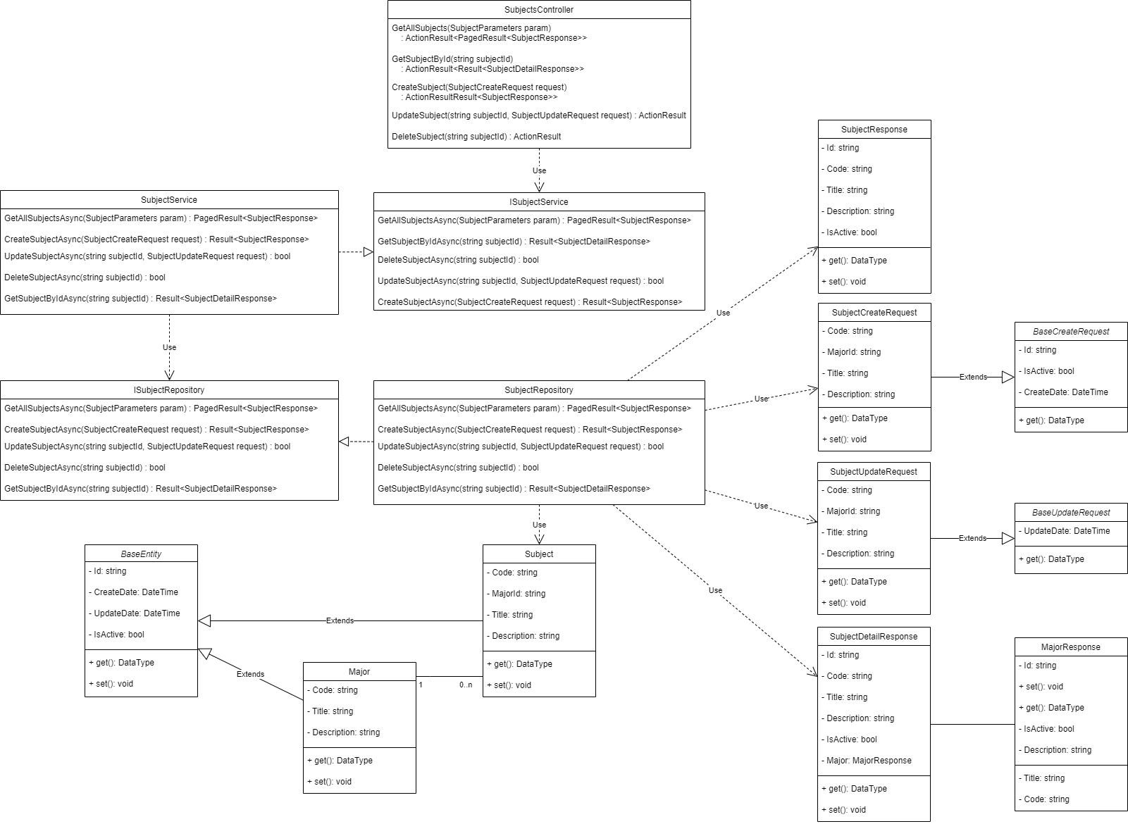

### b. Class Specifications

#### SubjectsController Class

| **No** | **Method** | **Description** |
| --- | --- | --- |
| 01 | GetAllSubjects | Get all Subjects in System, **Input** is *SubjectParameters*, **Output** is *ActionResult<PagedResult<SubjectResponse>>*, **Internal method processing** is *GetAllSubjectsAsync* from *ISubjectService* by **Inject** it into *SubjectsController* |
| 02 | GetSubjectById | Get a Subject Info by its Id, **Input** is *subjectId,* **Output** is *ActionResult<Result<SubjectDetailResponse>>*, **Internal method processing** is *GetSubjectByIdAsync* from *ISubjectService* by **Inject** it into *SubjectsController* |
| 03 | CreateSubject | Create or Add a Subject into System, **Input** is *SubjectCreateRequest,* **Output** is *ActionResult<Result<SubjectResponse>>*, **Internal method processing** is *CreateSubjectAsync* from *ISubjectService* by **Inject** it into *SubjectsController* |
| 04 | UpdateSubject | Update info of Subject, **Input** is *subjectId, SubjectUpdateRequest*, **Output** is*ActionResult*, **Internal method processing** is *UpdateSubjectAsync* from *ISubjectService* by **Inject** it into *SubjectsController* |
| 05 | DeleteMajor | Disable Subject, **Input** is *subjectId*, **Output** is *ActionResult*, **Internal method processing** is *DeleteSubjectAsync* from *ISubjectService* by **Inject** it into *SubjectsController* |

#### ISubjectService Interface

| **No** | **Method** | **Description** |
| --- | --- | --- |
| 01 | GetAllSubjectsAsync | Get all Subjects in System, **Input** is *SubjectParameters*, **Output** is *PagedResult<SubjectResponse>* |
| 02 | GetSubjectByIdAsync | Get a Subject Info by its Id, **Input** is *subjectId,* **Output** is *Result<SubjectDetailResponse>* |
| 03 | CreateSubjectAsync | Create or Add a Subject into System, **Input** is *SubjectCreateRequest,* **Output** is *Result<SubjectResponse>* |
| 04 | UpdateSubjectAsync | Update info of Subject, **Input** is *subjectId, SubjectUpdateRequest*, **Output** is*Result<bool>* |
| 05 | DeleteSubjectAsync | Disable Subject, **Input** is *subjectId*, **Output** is *Result<bool>* |

#### SubjectService Class - Implement from ISubjectService

| **No** | **Method** | **Description** |
| --- | --- | --- |
| 01 | GetAllSubjectsAsync | Get all Subjects in System, **Input** is *SubjectParameters*, **Output** is *PagedResult<SubjectResponse>*, **Internal method processing** is *GetAllSubjectsAsync* from *ISubjectRepository* by **Inject** it into *SubjectService* |
| 02 | GetSubjectByIdAsync | Get a Subject Info by its Id, **Input** is *subjectId,* **Output** is *Result<SubjectDetailResponse>*, **Internal method processing** is *GetSubjectByIdAsync* from *ISubjectRepository* by **Inject** it into *SubjectService* |
| 03 | CreateSubjectAsync | Create or Add a Subject into System, **Input** is *SubjectCreateRequest,* **Output** is *Result<SubjectResponse>*, **Internal method processing** is *CreateSubjectAsync* from *ISubjectRepository* by **Inject** it into *SubjectService* |
| 04 | UpdateSubjectAsync | Update info of Subject, **Input** is *subjectId, SubjectUpdateRequest*, **Output** is*Result<bool>*, **Internal method processing** is *UpdateSubjectAsync* from *ISubjectRepository* by **Inject** it into *SubjectService* |
| 05 | DeleteSubjectAsync | Disable Subject, **Input** is *subjectId*, **Output** is *Result<bool>*, **Internal method processing** is *DeleteSubjectAsync* from *ISubjectRepository* by **Inject** it into *SubjectService* |

#### ISubjectRepository Interface

| **No** | **Method** | **Description** |
| --- | --- | --- |
| 01 | GetAllSubjectsAsync | Get all Subjects in System, **Input** is *SubjectParameters*, **Output** is *PagedResult<SubjectResponse>* |
| 02 | GetSubjectByIdAsync | Get a Subject Info by its Id, **Input** is *subjectId,* **Output** is *Result<SubjectDetailResponse>* |
| 03 | CreateSubjectAsync | Create or Add a Subject into System, **Input** is *SubjectCreateRequest,* **Output** is *Result<SubjectResponse>* |
| 04 | UpdateSubjectAsync | Update info of Subject, **Input** is *subjectId, SubjectUpdateRequest*, **Output** is*Result<bool>* |
| 05 | DeleteSubjectAsync | Disable Subject, **Input** is *subjectId*, **Output** is *Result<bool>* |

#### SubjectRepository Class - Implement from ISubjectRepository

| **No** | **Method** | **Description** |
| --- | --- | --- |
| 01 | GetAllSubjectsAsync | Get all Subjects in System, **Input** is *SubjectParameters*, **Output** is *PagedResult<SubjectResponse>* |
| 02 | GetSubjectByIdAsync | Get a Subject Info by its Id, **Input** is *subjectId,* **Output** is *Result<SubjectDetailResponse>* |
| 03 | CreateSubjectAsync | Create or Add a Subject into System, **Input** is *SubjectCreateRequest,* **Output** is *Result<SubjectResponse>* |
| 04 | UpdateSubjectAsync | Update info of Subject, **Input** is *subjectId, SubjectUpdateRequest*, **Output** is*Result<bool>* |
| 05 | DeleteSubjectAsync | Disable Subject, **Input** is *subjectId*, **Output** is *Result<bool>* |

#### Subject Class

| **Attribute** | **Type** | **Visibility** | **Description** |
| --- | --- | --- | --- |
| Id | string | private | Unique identifier of a Subject. |
| Code | string | private |  |
| MajorId | string | private | Unique identifier of Major. |
| Title | string | private |  |
| Description | string | private |  |
| CreateDate | DateTime | private |  |
| UpdateDate | DateTime? | private |  |
| IsActive | bool | private | This info is active or not. |

#### 

| **No** | **Method** | **Description** |
| --- | --- | --- |
| 01 | getter | Get attribute value |
| 02 | setter | Set attribute value |

#### 

#### SubjectResponse Class

| **Attribute** | **Type** | **Visibility** | **Description** |
| --- | --- | --- | --- |
| Id | string | private | Unique identifier of a Subject. |
| Code | string | private |  |
| Title | string | private |  |
| Description | string | private |  |
| IsActive | bool | private | This info is active or not. |

#### 

| **No** | **Method** | **Description** |
| --- | --- | --- |
| 01 | getter | Get attribute value |
| 02 | setter | Set attribute value |

#### SubjectDetailResponse Class

| **Attribute** | **Type** | **Visibility** | **Description** |
| --- | --- | --- | --- |
| Id | string | private | Unique identifier of a Subject. |
| Code | string | private |  |
| Title | string | private |  |
| Description | string | private |  |
| IsActive | bool | private | This info is active or not. |
| Major | MajorResponse | private | This info has been describe in *<Major Features>* |

#### 

| **No** | **Method** | **Description** |
| --- | --- | --- |
| 01 | getter | Get attribute value |
| 02 | setter | Set attribute value |

#### SubjectCreateRequest Class

| **Attribute** | **Type** | **Visibility** | **Description** |
| --- | --- | --- | --- |
| Id | string | private | Unique identifier of a Subject. Auto setting value. |
| Code | string | private |  |
| MajorId | string | private |  |
| Title | string | private |  |
| Description | string | private |  |
| CreateDate | DateTime | private | Auto setting value. |
| IsActive | bool | private | This info is active or not. Auto setting value. |

#### 

| **No** | **Method** | **Description** |
| --- | --- | --- |
| 01 | getter | Get attribute value |
| 02 | setter | Set attribute value |

#### SubjectUpdateRequest Class

| **Attribute** | **Type** | **Visibility** | **Description** |
| --- | --- | --- | --- |
| Code | string | private |  |
| MajorId | string | private |  |
| Title | string | private |  |
| Description | string | private |  |
| UpdateDate | DateTime | private | Auto setting value. |

#### 

| **No** | **Method** | **Description** |
| --- | --- | --- |
| 01 | getter | Get attribute value |
| 02 | setter | Set attribute value |

## 3. MasUser Features

### a. Class Diagram

### b. Class Specifications

#### UsersController Class

| **No** | **Method** | **Description** |
| --- | --- | --- |
| 01 | UpdatePersonalInfo | Update the user's own information |
| 02 | GetPersonalInfo | Get the user's own information |
| 03 | GetAllMentor | Get all user as Mentor |
| 04 | GetUserBasicInfoById | Get user by Id |
| 05 | GetAllUser | Get all User for admin |
| 06 | ActiveUser | Active/Disable account |
| 07 | MentorRequest | Send request to be mentor |
| 08 | AcceptRequest | Accept the mentor request |
| 09 | GetAllAppointmentsOfOwn | Get all appointment user has sent |
| 10 | GetAllAppointmentsOfMentor | Get all appointment user has received |
| 11 | GetAllAppointmentsOfMentorForAdmin | Get all appointment of user as Mentor for Admin |
| 12 | GetAppointmentOfOwnById | Get Appointment by its Id for user as Student |
| 13 | GetAppointmentOfMentorById | Get Appointment by its Id for user as Mentor |

#### IMasUserService Interface

| **No** | **Method** | **Description** |
| --- | --- | --- |
| 01 | GetPersonalInfoByIdentityIdAsync | Get the user's own information |
| 02 | UpdatePersonalInfoAsync | Update the user's own information |
| 03 | SendMentorRequest | Send request to be mentor |
| 04 | AcceptRequest | Accept the mentor request |
| 05 | GetUserBasicInfoByIdAsync | Get user by Id |
| 06 | GetAllMentorsAsync | Get all user as Mentor |
| 07 | GetAllUsersForAdminAsync | Get all User for admin |
| 08 | ChangeIsActiveUserForAdminAsync | Accept the mentor request |

#### MasUserService Class - Implement from IMasUserService

| **No** | **Method** | **Description** |
| --- | --- | --- |
| 01 | GetPersonalInfoByIdentityIdAsync | Get the user's own information |
| 02 | UpdatePersonalInfoAsync | Update the user's own information |
| 03 | SendMentorRequest | Send request to be mentor |
| 04 | AcceptRequest | Accept the mentor request |
| 05 | GetUserBasicInfoByIdAsync | Get user by Id |
| 06 | GetAllMentorsAsync | Get all user as Mentor |
| 07 | GetAllUsersForAdminAsync | Get all User for admin |
| 08 | ChangeIsActiveUserForAdminAsync | Accept the mentor request |

#### IMasUserRepository Interface

| **No** | **Method** | **Description** |
| --- | --- | --- |
| 01 | GetPersonalInfoByIdentityIdAsync | Get the user's own information |
| 02 | UpdatePersonalInfoAsync | Update the user's own information |
| 03 | SendMentorRequest | Send request to be mentor |
| 04 | AcceptRequest | Accept the mentor request |
| 05 | GetUserBasicInfoByIdAsync | Get user by Id |
| 06 | GetAllMentorsAsync | Get all user as Mentor |
| 07 | GetAllUsersForAdminAsync | Get all User for admin |
| 08 | ChangeIsActiveUserForAdminAsync | Accept the mentor request |

#### MasUserRepository Class - Implement from IMasUserRepository

| **No** | **Method** | **Description** |
| --- | --- | --- |
| 01 | GetPersonalInfoByIdentityIdAsync | Get the user's own information |
| 02 | UpdatePersonalInfoAsync | Update the user's own information |
| 03 | SendMentorRequest | Send request to be mentor |
| 04 | AcceptRequest | Accept the mentor request |
| 05 | GetUserBasicInfoByIdAsync | Get user by Id |
| 06 | GetAllMentorsAsync | Get all user as Mentor |
| 07 | GetAllUsersForAdminAsync | Get all User for admin |
| 08 | ChangeIsActiveUserForAdminAsync | Accept the mentor request |

#### MasUser Class

| **Attribute** | **Type** | **Visibility** | **Description** |
| --- | --- | --- | --- |
| Id | string | private | Unique identifier of a User. |
| IdentityId | string | private |  |
| Name | string | private |  |
| Email | string | private |  |
| Avatar | string | private |  |
| Introduce | string | private |  |
| Rate | float | private |  |
| NumOfRate | int | private |  |
| NumOfAppointment | int | private |  |
| MeetUrl | string | private |  |
| IsMentor | bool? | private |  |
| CreateDate | DateTime | private |  |
| UpdateDate | DateTime? | private |  |
| IsActive | bool | private | This info is active or not. |

#### 

| **No** | **Method** | **Description** |
| --- | --- | --- |
| 01 | getter | Get attribute value |
| 02 | setter | Set attribute value |

#### 

#### UserGetBasicInfoResponse Class

| **Attribute** | **Type** | **Visibility** | **Description** |
| --- | --- | --- | --- |
| Id | string | private | Unique identifier of a User. |
| IdentityId | string | private |  |
| Name | string | private |  |
| Email | string | private |  |
| Avatar | string | private |  |
| Introduce | string | private |  |
| Rate | float | private |  |
| NumOfRate | int | private |  |
| NumOfAppointment | int | private |  |
| MeetUrl | string | private |  |
| IsMentor | bool? | private |  |
| CreateDate | DateTime | private |  |
| UpdateDate | DateTime? | private |  |
| IsActive | bool | private | This info is active or not. |

#### 

| **No** | **Method** | **Description** |
| --- | --- | --- |
| 01 | getter | Get attribute value |
| 02 | setter | Set attribute value |

#### 

#### UserGetByAdminResponse Class

| **Attribute** | **Type** | **Visibility** | **Description** |
| --- | --- | --- | --- |
| Id | string | private | Unique identifier of a User. |
| IdentityId | string | private |  |
| Name | string | private |  |
| Email | string | private |  |
| Avatar | string | private |  |
| Introduce | string | private |  |
| Rate | float | private |  |
| NumOfRate | int | private |  |
| NumOfAppointment | int | private |  |
| MeetUrl | string | private |  |
| IsMentor | bool? | private |  |
| CreateDate | DateTime | private |  |
| UpdateDate | DateTime? | private |  |
| IsActive | bool | private | This info is active or not. |

#### 

| **No** | **Method** | **Description** |
| --- | --- | --- |
| 01 | getter | Get attribute value |
| 02 | setter | Set attribute value |

#### UserSearchResponse Class

| **Attribute** | **Type** | **Visibility** | **Description** |
| --- | --- | --- | --- |
| Id | string | private | Unique identifier of a User. |
| IdentityId | string | private |  |
| Name | string | private |  |
| Email | string | private |  |
| Avatar | string | private |  |
| Introduce | string | private |  |
| Rate | float | private |  |
| NumOfRate | int | private |  |
| NumOfAppointment | int | private |  |
| MeetUrl | string | private |  |

#### 

| **No** | **Method** | **Description** |
| --- | --- | --- |
| 01 | getter | Get attribute value |
| 02 | setter | Set attribute value |

#### PersonalInfoResponse Class

| **Attribute** | **Type** | **Visibility** | **Description** |
| --- | --- | --- | --- |
| Id | string | private | Unique identifier of a User. |
| IdentityId | string | private |  |
| Name | string | private |  |
| Email | string | private |  |
| Avatar | string | private |  |
| Introduce | string | private |  |
| Rate | float | private |  |
| NumOfRate | int | private |  |
| NumOfAppointment | int | private |  |
| MeetUrl | string | private |  |
| IsMentor | bool? | private |  |
| IsActive | bool | private |  |

#### 

| **No** | **Method** | **Description** |
| --- | --- | --- |
| 01 | getter | Get attribute value |
| 02 | setter | Set attribute value |

#### UserPersonalInfoUpdateRequest Class

| **Attribute** | **Type** | **Visibility** | **Description** |
| --- | --- | --- | --- |
| Name | string | private |  |
| Avatar | int | private |  |
| Introduce | string | private |  |
| MeetUrl | string | private |  |
| CreateDate | DateTime | private | Auto setting value. |

#### 

| **No** | **Method** | **Description** |
| --- | --- | --- |
| 01 | getter | Get attribute value |
| 02 | setter | Set attribute value |

#### 

#### MentorRequest Class

| **Attribute** | **Type** | **Visibility** | **Description** |
| --- | --- | --- | --- |
| IsMentor | bool? | private |  |
| UpdateDate | DateTime | private | Auto setting value. |

#### 

| **No** | **Method** | **Description** |
| --- | --- | --- |
| 01 | getter | Get attribute value |
| 02 | setter | Set attribute value |

#### IsActiveChangeRequest Class

| **Attribute** | **Type** | **Visibility** | **Description** |
| --- | --- | --- | --- |
| IsActive | bool | private |  |
| Note | string | private |  |
| UpdateDate | DateTime | private | Auto setting value. |

#### 

| **No** | **Method** | **Description** |
| --- | --- | --- |
| 01 | getter | Get attribute value |
| 02 | setter | Set attribute value |

## 4. MentorSubject Features

### a. Class Diagram

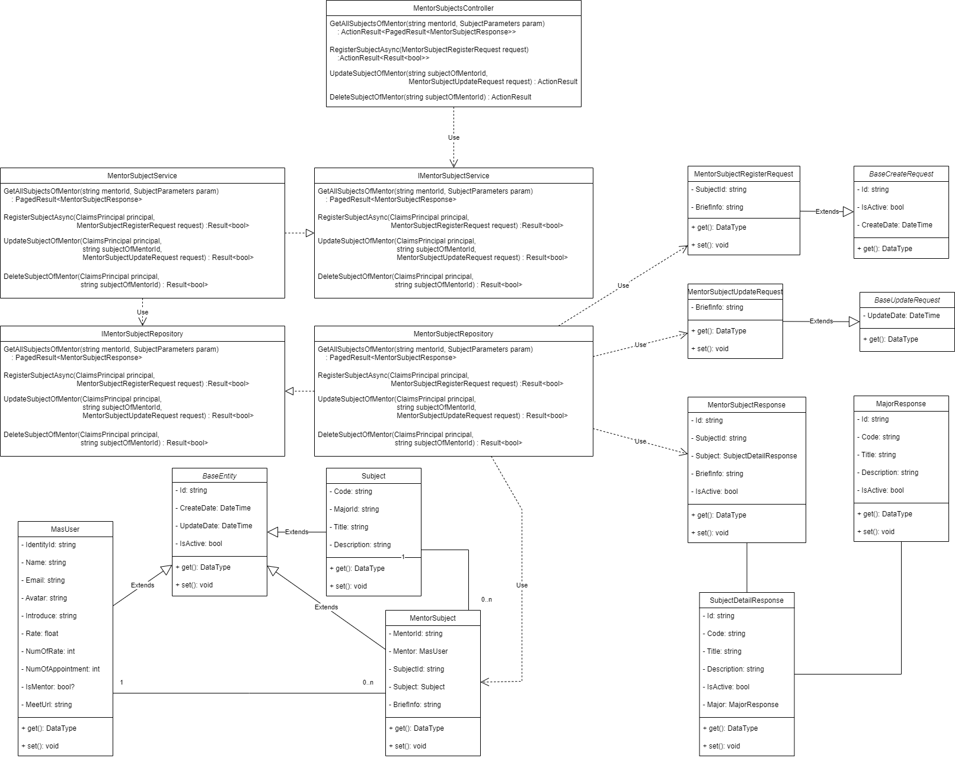

### b. Class Specifications

#### MentorSubjectsController Class

| **No** | **Method** | **Description** |
| --- | --- | --- |
| 01 | GetAllSubjectsOfMentor | Get all Subjects of a Mentor in System, **Input** is *mentorId, MentorSubjectParameters*, **Output** is *ActionResult<PagedResult<MentorSubjectResponse>>*, **Internal method processing** is *GetAllSubjectsOfMentorAsync* from *IMentorSubjectService* by **Inject** it into *MentorSubjectsController* |
| 02 | RegisterSubject | Register Subject into Mentor Profile, **Input** is *MentorSubjectRegisterRequest,* **Output** is *ActionResult<Result<bool>>*, **Internal method processing** is *RegisterSubjectAsync* from *IMentorSubjectService* by **Inject** it into *MentorSubjectsController* |
| 03 | UpdateSubjectOfMentor | Update Subject info of Mentor Profile, **Input** is *subjectOfMentorId*, *MentorSubjectRegisterRequest*, **Output** is *ActionResult*, **Internal method processing** is *UpdateSubjectOfMentorAsync* from *IMentorSubjectService*  by Inject it into *MentorSubjectsController* |
| 04 | DeleteSubjectOfMentor | Disable Subject from Mentor Profile, **Input** is *subjectOfMentorId*, **Output** is *ActionResult*, **Internal method processing** is *DeleteSubjectOfMentorAsync* from *IMentorSubjectService*  by Inject it into *MentorSubjectsController* |

#### IMentorSubjectService Interface

| **No** | **Method** | **Description** |
| --- | --- | --- |
| 01 | GetAllSubjectsOfMentorAsync | Get all Subjects of a Mentor in System, **Input** is *mentorId, MentorSubjectParameters*, **Output** is *PagedResult<MentorSubjectResponse>* |
| 02 | RegisterSubjectAsync | Register Subject into Mentor Profile, **Input** is *MentorSubjectRegisterRequest,* **Output** is *Result<bool>* |
| 03 | UpdateSubjectOfMentorAsync | Update Subject info of Mentor Profile, **Input** is *subjectOfMentorId*, *MentorSubjectRegisterRequest*, **Output** is *Result<bool>* |
| 04 | DeleteSubjectOfMentorAsync | Disable Subject from Mentor Profile, **Input** is *subjectOfMentorId*, **Output** is *Result<bool>* |

#### MentorSubjectService Class - Implement from IMentorSubjectService

| **No** | **Method** | **Description** |
| --- | --- | --- |
| 01 | GetAllSubjectsOfMentorAsync | Get all Subjects of a Mentor in System, **Input** is *mentorId, MentorSubjectParameters*, **Output** is *PagedResult<MentorSubjectResponse>*, **Internal method processing** is *GetAllSubjectsOfMentorAsync* from *IMentorSubjectRepository* by **Inject** it into *MentorSubjectService* |
| 02 | RegisterSubjectAsync | Register Subject into Mentor Profile, **Input** is *MentorSubjectRegisterRequest,* **Output** is *Result<bool>*, **Internal method processing** is *RegisterSubjectAsync* from *IMentorSubjectRepository* by **Inject** it into *MentorSubjectService* |
| 03 | UpdateSubjectOfMentorAsync | Update Subject info of Mentor Profile, **Input** is *subjectOfMentorId*, *MentorSubjectRegisterRequest*, **Output** is *Result<bool>*, **Internal method processing** is *UpdateSubjectOfMentorAsync* from *IMentorSubjectRepository* by **Inject** it into *MentorSubjectService* |
| 04 | DeleteSubjectOfMentorAsync | Disable Subject from Mentor Profile, **Input** is *subjectOfMentorId*, **Output** is *Result<bool>*, **Internal method processing** is *DeleteSubjectOfMentorAsync* from *IMentorSubjectRepository* by **Inject** it into *MentorSubjectService* |

#### IMentorSubjectRepository Interface

| **No** | **Method** | **Description** |
| --- | --- | --- |
| 01 | GetAllSubjectsOfMentorAsync | Get all Subjects of a Mentor in System, **Input** is *mentorId, MentorSubjectParameters*, **Output** is *PagedResult<MentorSubjectResponse>* |
| 02 | RegisterSubjectAsync | Register Subject into Mentor Profile, **Input** is *MentorSubjectRegisterRequest,* **Output** is *Result<bool>* |
| 03 | UpdateSubjectOfMentorAsync | Update Subject info of Mentor Profile, **Input** is *subjectOfMentorId*, *MentorSubjectRegisterRequest*, **Output** is *Result<bool>* |
| 04 | DeleteSubjectOfMentorAsync | Disable Subject from Mentor Profile, **Input** is *subjectOfMentorId*, **Output** is *Result<bool>* |

#### MentorSubjectRepository Class - Implement from IMentorSubjectRepository

| **No** | **Method** | **Description** |
| --- | --- | --- |
| 01 | GetAllSubjectsOfMentorAsync | Get all Subjects of a Mentor in System, **Input** is *mentorId, MentorSubjectParameters*, **Output** is *PagedResult<MentorSubjectResponse>* |
| 02 | RegisterSubjectAsync | Register Subject into Mentor Profile, **Input** is *MentorSubjectRegisterRequest,* **Output** is *Result<bool>* |
| 03 | UpdateSubjectOfMentorAsync | Update Subject info of Mentor Profile, **Input** is *subjectOfMentorId*, *MentorSubjectRegisterRequest*, **Output** is *Result<bool>* |
| 04 | DeleteSubjectOfMentorAsync | Disable Subject from Mentor Profile, **Input** is *subjectOfMentorId*, **Output** is *Result<bool>* |

#### MentorSubjectResponse Class

| **Attribute** | **Type** | **Visibility** | **Description** |
| --- | --- | --- | --- |
| Id | string | private | Unique identifier of a MentorSubject. |
| SubjectId | string | private | Unique identifier of Subject. |
| Subject | SubjectDetailResponse | private | Describe in *<Subject Features>* |
| BriefInfo | string | private |  |
| IsActive | bool | private | This info is active or not. |

#### 

| **No** | **Method** | **Description** |
| --- | --- | --- |
| 01 | getter | Get attribute value |
| 02 | setter | Set attribute value |

#### MentorSubjectRegisterRequest Class

| **Attribute** | **Type** | **Visibility** | **Description** |
| --- | --- | --- | --- |
| Id | string | private | Unique identifier of a MentorSubject. Auto setting value. |
| SubjectId | string | private | Unique identifier of a Subject. |
| BriefInfo | string | private |  |
| CreateDate | DateTime | private | Auto setting value. |
| IsActive | bool | private | This info is active or not. Auto setting value. |

#### 

| **No** | **Method** | **Description** |
| --- | --- | --- |
| 01 | getter | Get attribute value |
| 02 | setter | Set attribute value |

#### MentorSubjectUpdateRequest Class

| **Attribute** | **Type** | **Visibility** | **Description** |
| --- | --- | --- | --- |
| BriefInfo | string | private |  |
| UpdateDate | DateTime | private | Auto setting value. |

#### 

| **No** | **Method** | **Description** |
| --- | --- | --- |
| 01 | getter | Get attribute value |
| 02 | setter | Set attribute value |

## 5. Slot Features

### a. Class Diagram

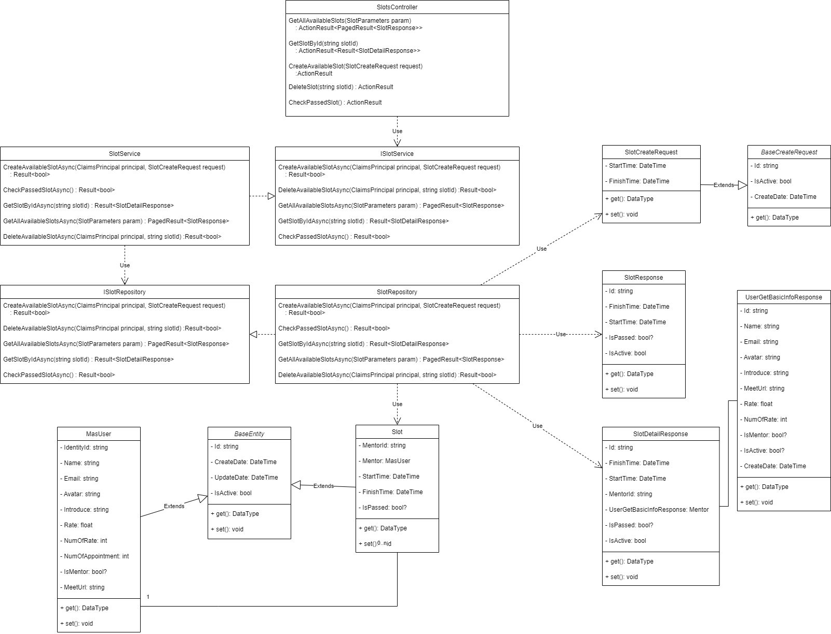

### b. Class Specifications

#### SlotsController Class

| **No** | **Method** | **Description** |
| --- | --- | --- |
| 01 | GetAllAvailableSlots | Get all available Slots, **Input** is *SlotParameters*, **Output** is *ActionResult<PagedResult<SlotResponse>>*, **Internal method processing** is *GetAllAvailableSlotsAsync* from *ISlotService* by **Inject** it into *SlotsController* |
| 02 | GetSlotById | Get a Slot Info by its Id, **Input** is *slotId,* **Output** is *ActionResult<Result<SlotDetailResponse>>*, **Internal method processing** is *GetSlotByIdAsync* from *ISlotService* by **Inject** it into *SlotsController* |
| 03 | CreateAvailableSlot | Create or Add a Slot, **Input** is *SlotCreateRequest,* **Output** is *ActionResult*, **Internal method processing** is *CreateAvailableSlotAsync* from *ISlotService* by **Inject** it into *SlotsController* |
| 04 | DeleteSlot | Delete or disable a Slot, **Input** is *slotId*, **Output** is*ActionResult*, **Internal method processing** is *DeleteAvailableSlotAsync* from *ISlotService* by **Inject** it into *SlotsController* |
| 05 | CheckPassedSlot | Check which Slot is passed time, none **Input** , **Output** is *ActionResult*, **Internal method processing** is *CheckPassedSlotAsync* from *ISlotService* by **Inject** it into *SlotsController* |

#### ISlotService Interface

| **No** | **Method** | **Description** |
| --- | --- | --- |
| 01 | GetAllAvailableSlotsAsync | Get all available Slots, **Input** is *SlotParameters*, **Output** is *PagedResult<SlotResponse>* |
| 02 | GetSlotByIdAsync | Get a Slot Info by its Id, **Input** is *slotId,* **Output** is *Result<SlotDetailResponse>* |
| 03 | CreateAvailableSlotAsync | Create or Add a Slot, **Input** is *SlotCreateRequest,* **Output** is *Result<bool>* |
| 04 | DeleteSlotAsync | Delete or disable a Slot, **Input** is *slotId*, **Output** is*Result<bool>* |
| 05 | CheckPassedSlotAsync | Check which Slot is passed time, none **Input** , **Output** is *Result<bool>* |

#### SlotService Class - Implement from ISlotService

| **No** | **Method** | **Description** |
| --- | --- | --- |
| 01 | GetAllAvailableSlotsAsync | Get all available Slots, **Input** is *SlotParameters*, **Output** is *PagedResult<SlotResponse>*, **Internal method processing** is *GetAllAvailableSlotsAsync* from *ISlotRepository* by **Inject** it into *SlotService* |
| 02 | GetSlotByIdAsync | Get a Slot Info by its Id, **Input** is *slotId,* **Output** is *Result<SlotDetailResponse>*, **Internal method processing** is *GetSlotByIdAsync* from *ISlotRepository* by **Inject** it into *SlotService* |
| 03 | CreateAvailableSlotAsync | Create or Add a Slot, **Input** is *SlotCreateRequest,* **Output** is *Result<bool>*, **Internal method processing** is *CreateAvailableSlotAsync* from *ISlotRepository* by **Inject** it into *SlotService* |
| 04 | DeleteSlotAsync | Delete or disable a Slot, **Input** is *slotId*, **Output** is*Result<bool>*, **Internal method processing** is *DeleteSlotAsync* from *ISlotRepository* by **Inject** it into *SlotService* |
| 05 | CheckPassedSlotAsync | Check which Slot is passed time, none **Input** , **Output** is *Result<bool>*, **Internal method processing** is *CheckPassedSlotAsync* from *ISlotRepository* by **Inject** it into *SlotService* |

#### ISlotRepository Interface

| **No** | **Method** | **Description** |
| --- | --- | --- |
| 01 | GetAllAvailableSlotsAsync | Get all available Slots, **Input** is *SlotParameters*, **Output** is *PagedResult<SlotResponse>* |
| 02 | GetSlotByIdAsync | Get a Slot Info by its Id, **Input** is *slotId,* **Output** is *Result<SlotDetailResponse>* |
| 03 | CreateAvailableSlotAsync | Create or Add a Slot, **Input** is *SlotCreateRequest,* **Output** is *Result<bool>* |
| 04 | DeleteSlotAsync | Delete or disable a Slot, **Input** is *slotId*, **Output** is*Result<bool>* |
| 05 | CheckPassedSlotAsync | Check which Slot is passed time, none **Input** , **Output** is *Result<bool>* |

#### SlotRepository Class - Implement from ISlotRepository

| **No** | **Method** | **Description** |
| --- | --- | --- |
| 01 | GetAllAvailableSlotsAsync | Get all available Slots, **Input** is *SlotParameters*, **Output** is *PagedResult<SlotResponse>* |
| 02 | GetSlotByIdAsync | Get a Slot Info by its Id, **Input** is *slotId,* **Output** is *Result<SlotDetailResponse>* |
| 03 | CreateAvailableSlotAsync | Create or Add a Slot, **Input** is *SlotCreateRequest,* **Output** is *Result<bool>* |
| 04 | DeleteSlotAsync | Delete or disable a Slot, **Input** is *slotId*, **Output** is*Result<bool>* |
| 05 | CheckPassedSlotAsync | Check which Slot is passed time, none **Input** , **Output** is *Result<bool>* |

#### Slot Class

| **Attribute** | **Type** | **Visibility** | **Description** |
| --- | --- | --- | --- |
| Id | string | private | Unique identifier of a Slot. |
| MentorId | string | private | Unique identifier of Mentor. |
| StartTime | DateTime | private |  |
| FinishTime | DateTime | private |  |
| IsPassed | bool? | private |  |
| CreateDate | DateTime | private |  |
| UpdateDate | DateTime? | private |  |
| IsActive | bool | private | This info is active or not. |

#### 

| **No** | **Method** | **Description** |
| --- | --- | --- |
| 01 | getter | Get attribute value |
| 02 | setter | Set attribute value |

#### 

#### SlotResponse Class

| **Attribute** | **Type** | **Visibility** | **Description** |
| --- | --- | --- | --- |
| Id | string | private | Unique identifier of a Slot. |
| StartTime | DateTime | private |  |
| FinishTime | DateTime | private |  |
| IsPassed | bool? | private |  |
| IsActive | bool | private | This info is active or not. |

#### 

| **No** | **Method** | **Description** |
| --- | --- | --- |
| 01 | getter | Get attribute value |
| 02 | setter | Set attribute value |

#### SlotDetailResponse Class

| **Attribute** | **Type** | **Visibility** | **Description** |
| --- | --- | --- | --- |
| Id | string | private | Unique identifier of a Slot. |
| StartTime | DateTime | private |  |
| FinishTime | DateTime | private |  |
| MentorId | string | private | Unique identifier of Mentor (MasUser). |
| Mentor | UserGetBasicInfoResponse | private | Describe in *<MasUser Features>* |
| IsPassed | bool? | private |  |
| IsActive | bool | private | This info is active or not. |

#### 

| **No** | **Method** | **Description** |
| --- | --- | --- |
| 01 | getter | Get attribute value |
| 02 | setter | Set attribute value |

#### SlotCreateRequest Class

| **Attribute** | **Type** | **Visibility** | **Description** |
| --- | --- | --- | --- |
| Id | string | private | Unique identifier of a Slot. Auto setting value. |
| StartTime | DateTime | private |  |
| FinishTime | DateTime | private |  |
| CreateDate | DateTime | private | Auto setting value. |
| IsActive | bool | private | This info is active or not. Auto setting value. |

#### 

| **No** | **Method** | **Description** |
| --- | --- | --- |
| 01 | getter | Get attribute value |
| 02 | setter | Set attribute value |

## 6. Appointment Features

### a. Class Diagram

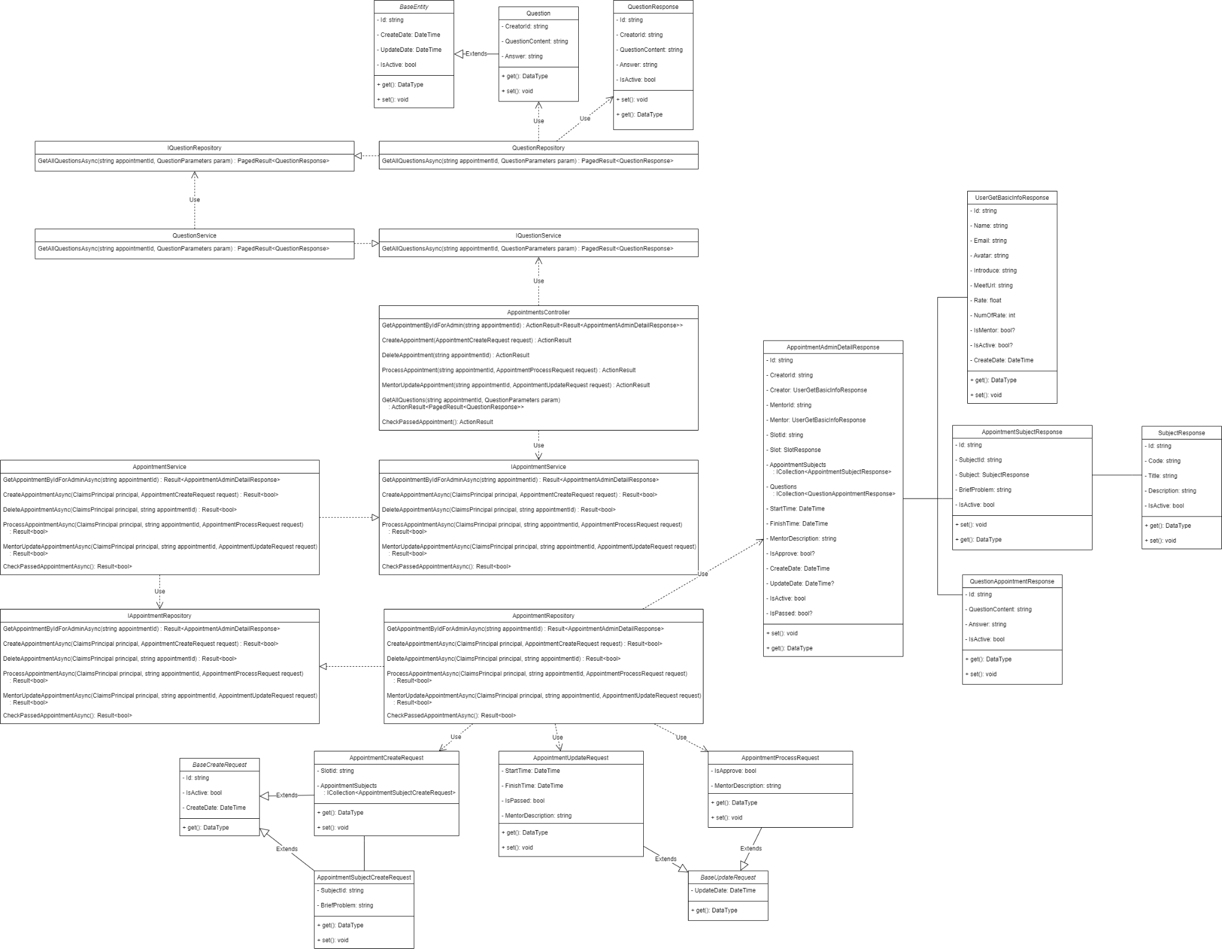

### b. Class Specifications

#### AppointpmentsController Class

| **No** | **Method** | **Description** |
| --- | --- | --- |
| 01 | GetAppointmentByIdForAdmin | Get Appointment for Admin by Id |
| 02 | CreateAppointment | Create Appointment for user as Student |
| 03 | DeleteAppointment | Delete specific Appointment |
| 04 | ProcessAppointment | Approve Appointment or not |
| 05 | MentorUpdateAppointment | Update time, status and description |
| 06 | GetAllQuestions | Get all question in appointment |
| 07 | CheckPassedAppointment | Confirm appointment is completed |

#### IAppointpmentService Interface

| **No** | **Method** | **Description** |
| --- | --- | --- |
| 01 | GetAppointmentByIdForAdminAsync | Get Appointment for Admin by Id |
| 02 | CreateAppointmentAsync | Create Appointment for user as Student |
| 03 | DeleteAppointmentAsync | Delete specific Appointment |
| 04 | ProcessAppointmentAsync | Approve Appointment or not |
| 05 | MentorUpdateAppointmentAsync | Update time, status and description |
| 06 | CheckPassedAppointmentAsync | Confirm appointment is completed |

#### AppointpmentService Class - Implement from IAppointmentService

| **No** | **Method** | **Description** |
| --- | --- | --- |
| 01 | GetAppointmentByIdForAdminAsync | Get Appointment for Admin by Id |
| 02 | CreateAppointmentAsync | Create Appointment for user as Student |
| 03 | DeleteAppointmentAsync | Delete specific Appointment |
| 04 | ProcessAppointmentAsync | Approve Appointment or not |
| 05 | MentorUpdateAppointmentAsync | Update time, status and description |
| 06 | CheckPassedAppointmentAsync | Confirm appointment is completed |

#### IAppointpmentRepository Interface

| **No** | **Method** | **Description** |
| --- | --- | --- |
| 01 | GetAppointmentByIdForAdminAsync | Get Appointment for Admin by Id |
| 02 | CreateAppointmentAsync | Create Appointment for user as Student |
| 03 | DeleteAppointmentAsync | Delete specific Appointment |
| 04 | ProcessAppointmentAsync | Approve Appointment or not |
| 05 | MentorUpdateAppointmentAsync | Update time, status and description |
| 06 | CheckPassedAppointmentAsync | Confirm appointment is completed |

#### AppointpmentrRepository Class - Implement from IAppointpmentRepository

| **No** | **Method** | **Description** |
| --- | --- | --- |
| 01 | GetAppointmentByIdForAdminAsync | Get Appointment for Admin by Id |
| 02 | CreateAppointmentAsync | Create Appointment for user as Student |
| 03 | DeleteAppointmentAsync | Delete specific Appointment |
| 04 | ProcessAppointmentAsync | Approve Appointment or not |
| 05 | MentorUpdateAppointmentAsync | Update time, status and description |
| 06 | CheckPassedAppointmentAsync | Confirm appointment is completed |

#### AppointmentAdminDetailResponse Class

| **Attribute** | **Type** | **Visibility** | **Description** |
| --- | --- | --- | --- |
| Id | string | private | Unique identifier of a User. |
| CreatorId | string | private |  |
| Creator | string | private |  |
| MentorId | string | private |  |
| Mentor | string | private |  |
| AppointmentSubjects | ICollection<AppointmentSubjectResponse> | private |  |
| Questions | ICollection<QuestionAppointmentResponse> | private |  |
| StartTime | DateTime | private |  |
| FinishTime | DateTime | private |  |
| MentorDescription | string | private |  |
| IsApprove | bool? | private |  |
| CreateDate | DateTime | private |  |
| UpdateDate | DateTime? | private |  |
| IsActive | bool | private |  |
| IsPassed | bool? |  |  |

#### 

| **No** | **Method** | **Description** |
| --- | --- | --- |
| 01 | getter | Get attribute value |
| 02 | setter | Set attribute value |

#### 

#### AppointmentSubjectResponse Class

| **Attribute** | **Type** | **Visibility** | **Description** |
| --- | --- | --- | --- |
| Id | string | private | Unique identifier of a User. |
| SubjectId | string | private |  |
| Subject | SubjectResponse | private |  |
| BriefProblem | string | private |  |
| IsActive | bool | private | This info is active or not. |

#### 

| **No** | **Method** | **Description** |
| --- | --- | --- |
| 01 | getter | Get attribute value |
| 02 | setter | Set attribute value |

#### AppointmentUpdateRequest Class

| **Attribute** | **Type** | **Visibility** | **Description** |
| --- | --- | --- | --- |
| StartTime | DateTime | private |  |
| FinishTime | DateTime | private |  |
| MentorDescription | string | private |  |
| IsPassed | bool | private |  |
| UpdateDate | DateTime | private | Auto setting value. |

#### 

| **No** | **Method** | **Description** |
| --- | --- | --- |
| 01 | getter | Get attribute value |
| 02 | setter | Set attribute value |

#### AppointmentProcessRequest Class

| **Attribute** | **Type** | **Visibility** | **Description** |
| --- | --- | --- | --- |
| MentorDescription | string | private |  |
| IsPassed | bool | private |  |
| UpdateDate | DateTime | private | Auto setting value. |

#### 

| **No** | **Method** | **Description** |
| --- | --- | --- |
| 01 | getter | Get attribute value |
| 02 | setter | Set attribute value |

#### AppointmentCreateRequest Class

| **Attribute** | **Type** | **Visibility** | **Description** |
| --- | --- | --- | --- |
| SlotId | string | private |  |
| AppointmentSubject | ICollection<AppointmentSubjectCreateRequest> | private |  |
| CreateDate | DateTime | private | Auto setting value. |

#### 

| **No** | **Method** | **Description** |
| --- | --- | --- |
| 01 | getter | Get attribute value |
| 02 | setter | Set attribute value |

#### 

#### AppointmentSubjectCreateRequest Class

| **Attribute** | **Type** | **Visibility** | **Description** |
| --- | --- | --- | --- |
| SubjectId | string | private |  |
| BriefProblem | string |  |  |
| CreateDate | DateTime | private | Auto setting value. |

#### 

| **No** | **Method** | **Description** |
| --- | --- | --- |
| 01 | getter | Get attribute value |
| 02 | setter | Set attribute value |

## 7. Question Features

### a. Class Diagram

### b. Class Specifications

#### QuestionsController Class

| **No** | **Method** | **Description** |
| --- | --- | --- |
| 01 | GetAllQuestions | Get all Question in specific Appointment |
| 02 | GetQuestionById | Get a Question detail by its Id |
| 03 | CreateQuestionFeedback | Create Question |
| 04 | AnswerQuestion | Manage Answer in the Question |
| 05 | DeleteQuestion | Delete Question |

#### IQuestionService Interface

| **No** | **Method** | **Description** |
| --- | --- | --- |
| 01 | GetAllQuestionsAsync | Get all Question in specific Appointment |
| 02 | GetQuestionByIdAsync | Get a Question detail by its Id |
| 03 | CreateQuestionFeedbackAsync | Create Question |
| 04 | AnswerQuestionAsync | Manage Answer in the Question |
| 05 | DeleteQuestionAsync | Delete Question |

#### QuestionService Class - Implement from QuestionService

| **No** | **Method** | **Description** |
| --- | --- | --- |
| 01 | GetAllQuestionsAsync | Get all Question in specific Appointment |
| 02 | GetQuestionByIdAsync | Get a Question detail by its Id |
| 03 | CreateQuestionFeedbackAsync | Create Question |
| 04 | AnswerQuestionAsync | Manage Answer in the Question |
| 05 | DeleteQuestionAsync | Delete Question |

#### IQuestionRepository Interface

| **No** | **Method** | **Description** |
| --- | --- | --- |
| 01 | GetAllQuestionsAsync | Get all Question in specific Appointment |
| 02 | GetQuestionByIdAsync | Get a Question detail by its Id |
| 03 | CreateQuestionFeedbackAsync | Create Question |
| 04 | AnswerQuestionAsync | Manage Answer in the Question |
| 05 | DeleteQuestionAsync | Delete Question |

#### QuestionRepository Class - Implement from QuestionRepository

| **No** | **Method** | **Description** |
| --- | --- | --- |
| 01 | GetAllQuestionsAsync | Get all Question in specific Appointment |
| 02 | GetQuestionByIdAsync | Get a Question detail by its Id |
| 03 | CreateQuestionFeedbackAsync | Create Question |
| 04 | AnswerQuestionAsync | Manage Answer in the Question |
| 05 | DeleteQuestionAsync | Delete Question |

#### QuestionClass

| **Attribute** | **Type** | **Visibility** | **Description** |
| --- | --- | --- | --- |
| Id | string | private | Unique identifier of a Rating. |
| CreatorId | string | private | Unique identifier of User as student. |
| QuestionContent | string | private |  |
| Answer | string | private |  |
| IsActive | bool | private |  |
| CreateDate | DateTime | private |  |
| UpdateDate | DateTime? | private |  |

#### 

| **No** | **Method** | **Description** |
| --- | --- | --- |
| 01 | getter | Get attribute value |
| 02 | setter | Set attribute value |

#### 

#### QuestionResponse Class

| **Attribute** | **Type** | **Visibility** | **Description** |
| --- | --- | --- | --- |
| Id | string | private | Unique identifier of a Rating. |
| CreatorId | string | private | Unique identifier of User as student. |
| QuestionContent | string | private |  |
| Answer | string | private |  |
| IsActive | bool | private |  |

#### 

| **No** | **Method** | **Description** |
| --- | --- | --- |
| 01 | getter | Get attribute value |
| 02 | setter | Set attribute value |

#### QuestionCreateRequest Class

| **Attribute** | **Type** | **Visibility** | **Description** |
| --- | --- | --- | --- |
| AppointmentId | string | private | Unique identifier of a Appointment |
| CreatorId | string | private | Unique identifier of User as student. |
| QuestionContent | string | private |  |
| IsActive | bool | private |  |
| CreateDate | DateTime | private | Auto setting value. |

#### 

| **No** | **Method** | **Description** |
| --- | --- | --- |
| 01 | getter | Get attribute value |
| 02 | setter | Set attribute value |

#### 

#### AnswerQuestionRequest Class

| **Attribute** | **Type** | **Visibility** | **Description** |
| --- | --- | --- | --- |
| Answer | string | private |  |
| UpdateDate | DateTime | private | Auto setting value. |

#### 

| **No** | **Method** | **Description** |
| --- | --- | --- |
| 01 | getter | Get attribute value |
| 02 | setter | Set attribute value |

## 8. Rating

### a. Class Diagram

### b. Class Specifications

#### RatingsController Class

| **No** | **Method** | **Description** |
| --- | --- | --- |
| 01 | GetAllRatings | Get all Rating of specific Mentor |
| 02 | GetRatingById | Get a Rating detail by its Id |
| 03 | CreateRatingFeedback | Create Rating after complete Appointment |
| 04 | GetAllRatingsForAdmin | Get all Ratings for admin |
| 05 | ProcessRating | Check Rating violate or not |

#### IRatingService Interface

| **No** | **Method** | **Description** |
| --- | --- | --- |
| 01 | GetAllRatingsAsync | Get all Rating in System |
| 02 | GetRatingByIdAsync | Get a Rating detail by its Id |
| 03 | CreateRatingFeedbackAsync | Create Rating after complete Appointment |
| 04 | GetAllRatingsForAdminAsync | Get all Ratings for admin |
| 05 | ProcessRatingAsync | Check Rating violate or not |

#### RatingService Class - Implement from IRatingService

| **No** | **Method** | **Description** |
| --- | --- | --- |
| 01 | GetAllRatingsAsync | Get all Rating in System |
| 02 | GetRatingByIdAsync | Get a Rating detail by its Id |
| 03 | CreateRatingFeedbackAsync | Create Rating after complete Appointment |
| 04 | GetAllRatingsForAdminAsync | Get all Ratings for admin |
| 05 | ProcessRatingAsync | Check Rating violate or not |

#### IRatingRepository Interface

| **No** | **Method** | **Description** |
| --- | --- | --- |
| 01 | GetAllRatingsAsync | Get all Rating in System |
| 02 | GetRatingByIdAsync | Get a Rating detail by its Id |
| 03 | CreateRatingFeedbackAsync | Create Rating after complete Appointment |
| 04 | GetAllRatingsForAdminAsync | Get all Ratings for admin |
| 05 | ProcessRatingAsync | Check Rating violate or not |

#### RatingRepository Class - Implement from IRatingRepository

| **No** | **Method** | **Description** |
| --- | --- | --- |
| 01 | GetAllRatingsAsync | Get all Rating in System |
| 02 | GetRatingByIdAsync | Get a Rating detail by its Id |
| 03 | CreateRatingFeedbackAsync | Create Rating after complete Appointment |
| 04 | GetAllRatingsForAdminAsync | Get all Ratings for admin |
| 05 | ProcessRatingAsync | Check Rating violate or not |

#### Rating Class

| **Attribute** | **Type** | **Visibility** | **Description** |
| --- | --- | --- | --- |
| Id | string | private | Unique identifier of a Rating. |
| CreatorId | string | private | Unique identifier of User as student. |
| AppointmentId | string | private | Unique identifier of Appointment. |
| MentorId | string | private | Unique identifier of User as mentor. |
| Vote | int | private |  |
| Comment | string | private |  |
| IsApprove | bool? | private |  |
| CreateDate | DateTime | private |  |
| UpdateDate | DateTime? | private |  |
| IsActive | bool | private | This info is active or not. |

#### 

| **No** | **Method** | **Description** |
| --- | --- | --- |
| 01 | getter | Get attribute value |
| 02 | setter | Set attribute value |

#### 

#### RatingResponse Class

| **Attribute** | **Type** | **Visibility** | **Description** |
| --- | --- | --- | --- |
| Id | string | private | Unique identifier of a rating. |
| CreatorId | string | private |  |
| AppointmentId | string | private |  |
| MentorId | string | private |  |
| Vote | int | private |  |
| Comment | string | private |  |
| IsApprove | bool? | private |  |
| IsActive | bool | private |  |

#### 

| **No** | **Method** | **Description** |
| --- | --- | --- |
| 01 | getter | Get attribute value |
| 02 | setter | Set attribute value |

#### RatingCreateRequest Class

| **Attribute** | **Type** | **Visibility** | **Description** |
| --- | --- | --- | --- |
| Id | string | private | Unique identifier of a Rating. Auto setting value. |
| Vote | int | private |  |
| Comment | string | private |  |
| CreateDate | DateTime | private | Auto setting value. |
| IsActive | bool | private | This info is active or not. Auto setting value. |

#### 

| **No** | **Method** | **Description** |
| --- | --- | --- |
| 01 | getter | Get attribute value |
| 02 | setter | Set attribute value |

#### 

#### ProcessRatingRequest Class

| **Attribute** | **Type** | **Visibility** | **Description** |
| --- | --- | --- | --- |
| IsApprove | bool | private |  |
| UpdateDate | DateTime | private | Auto setting value. |

#### 

| **No** | **Method** | **Description** |
| --- | --- | --- |
| 01 | getter | Get attribute value |
| 02 | setter | Set attribute value |

# III. Database Tables

## 1. Majors

Contains Major data from FPT University.

| **Field name** | **Type** | **Size** | **Unique** | **Allow Null** | **PK/FK** | **Notes** |
| --- | --- | --- | --- | --- | --- | --- |
| Id | nvarchar | 100 | Yes | No | PK |  |
| Code | nvarchar | 10 | No | No |  |  |
| Title | nvarchar | 200 | No | No |  |  |
| Description | nvarchar | 1000 | No | Yes |  |  |
| CreatedDate | datetime |  | No | No |  |  |
| UpdateDate | datetime |  | No | Yes |  |  |
| IsActive | bit |  | No | No |  | This data is activated or not. |

## 2. Subjects

Contain Subjects data in Major.

| **Field name** | **Type** | **Size** | **Unique** | **Allow Null** | **PK/FK** | **Notes** |
| --- | --- | --- | --- | --- | --- | --- |
| Id | nvarchar | 100 | Yes | No | PK |  |
| MajorId | nvarchar | 100 | Yes | No | FK |  |
| Code | nvarchar | 10 | No | No |  |  |
| Title | nvarchar | 200 | No | No |  |  |
| Description | nvarchar | 1000 | No | Yes |  |  |
| CreatedDate | datetime |  | No | No |  |  |
| UpdateDate | datetime |  | No | Yes |  |  |
| IsActive | bit |  | No | No |  | This data is activated or not. |

## 3. MasUsers

Contain MAS Users data, including Student data and Mentor data, distinguish by IsMentor attribute

| **Field name** | **Type** | **Size** | **Unique** | **Allow Null** | **PK/FK** | **Notes** |
| --- | --- | --- | --- | --- | --- | --- |
| Id | nvarchar | 100 | Yes | No | PK |  |
| IdentityId | nvarchar | 100 | Yes | No |  | tbl.AspNetUsers primary key. |
| Name | nvarchar | 100 | No | No |  |  |
| Email | nvarchar | 100 | Yes | No |  |  |
| Avatar | nvarchar | MAX | Yes | No |  |  |
| Introduce | nvarchar | 1000 | No | Yes |  |  |
| Rate | float |  | No | No |  |  |
| NumOfRate | int |  | No | No |  |  |
| NumOfAppointment | int |  | No | No |  |  |
| IsMentor | bit |  | No | Yes |  |  |
| MeetUrl | nvarchar | 200 | No | Yes |  |  |
| CreatedDate | datetime |  | No | No |  |  |
| UpdateDate | datetime |  | No | Yes |  |  |
| IsActive | bit |  | No | No |  | This data is activated or not. |

## 4. MentorSubjects

Contain Subjects data of Mentor.

| **Field name** | **Type** | **Size** | **Unique** | **Allow Null** | **PK/FK** | **Notes** |
| --- | --- | --- | --- | --- | --- | --- |
| Id | nvarchar | 100 | Yes | No | PK |  |
| MentorId | nvarchar | 100 | Yes | No | FK |  |
| SubjectId | nvarchar | 10 | No | No | FK |  |
| BriefInfo | nvarchar | 500 | No | No |  |  |
| CreatedDate | datetime |  | No | No |  |  |
| UpdateDate | datetime |  | No | Yes |  |  |
| IsActive | bit |  | No | No |  | This data is activated or not. |

## 

## 5. Slots

Contain Subjects data in Major.

| **Field name** | **Type** | **Size** | **Unique** | **Allow Null** | **PK/FK** | **Notes** |
| --- | --- | --- | --- | --- | --- | --- |
| Id | nvarchar | 100 | Yes | No | PK |  |
| MentorId | nvarchar | 100 | Yes | No | FK |  |
| StartTime | datetime |  | No | No |  |  |
| FinishTime | datetime |  | No | No |  |  |
| CreatedDate | datetime |  | No | No |  |  |
| UpdateDate | datetime |  | No | Yes |  |  |
| IsActive | bit |  | No | No |  | This data is activated or not. |

## 

## 6. Appointments

Contain Appointment Data registered by Student to Mentor based on available slot of Mentor.

| **Field name** | **Type** | **Size** | **Unique** | **Allow Null** | **PK/FK** | **Notes** |
| --- | --- | --- | --- | --- | --- | --- |
| Id | nvarchar | 100 | Yes | No | PK |  |
| CreatorId | nvarchar | 100 | Yes | No |  |  |
| MentorId | nvarchar | 100 | Yes | No |  |  |
| SlotId | nvarchar | 100 | Yes | No | FK |  |
| IsApproved | bit |  | No | Yes |  |  |
| StartTime | datetime |  | No | Yes |  |  |
| MentorDescription | nvarchar | 1000 | No | Yes |  |  |
| FinishTime | datetime |  | No | No |  |  |
| CreatedDate | datetime |  | No | No |  |  |
| UpdateDate | datetime |  | No | Yes |  |  |
| IsActive | bit |  | No | No |  | This data is activated or not. |

## 

## 7. Questions

Contain Question data in Appointment.

| **Field name** | **Type** | **Size** | **Unique** | **Allow Null** | **PK/FK** | **Notes** |
| --- | --- | --- | --- | --- | --- | --- |
| Id | nvarchar | 100 | Yes | No | PK |  |
| AppointmentId | nvarchar | 100 | Yes | No | FK |  |
| CreatorId | nvarchar | 100 | Yes | No |  |  |
| QuestionContent | nvarchar | 500 | No | No |  |  |
| Answer | nvarchar | MAX | No | Yes |  |  |
| CreatedDate | datetime |  | No | No |  |  |
| UpdateDate | datetime |  | No | Yes |  |  |
| IsActive | bit |  | No | No |  | This data is activated or not. |

## 

## 8. Ratings

Contain Rating data on Appointment.

| **Field name** | **Type** | **Size** | **Unique** | **Allow Null** | **PK/FK** | **Notes** |
| --- | --- | --- | --- | --- | --- | --- |
| Id | nvarchar | 100 | Yes | No | PK |  |
| AppointmentId | nvarchar | 100 | Yes | No | FK |  |
| CreatorId | nvarchar | 100 | Yes | No |  |  |
| MentorId | nvarchar | 100 | Yes | No |  |  |
| Vote | int |  | No | No |  |  |
| Comment | nvarchar | 500 | No | Yes |  |  |
| IsApprove | bit |  | No | Yes |  |  |
| CreatedDate | datetime |  | No | No |  |  |
| UpdateDate | datetime |  | No | Yes |  |  |
| IsActive | bit |  | No | No |  | This data is activated or not. |

## 

## 9. AppointmentSubjects

Contain Appointment detail, including the Subjects of this Appointment, a brief problem summary.

| **Field name** | **Type** | **Size** | **Unique** | **Allow Null** | **PK/FK** | **Notes** |
| --- | --- | --- | --- | --- | --- | --- |
| Id | nvarchar | 100 | Yes | No | PK |  |
| AppointmentId | nvarchar | 100 | Yes | No | FK |  |
| SubjectId | nvarchar | 100 | Yes | No | FK |  |
| BriefProblem | nvarchar | 500 | Yes | No |  |  |
| CreatedDate | datetime |  | No | No |  |  |
| UpdateDate | datetime |  | No | Yes |  |  |
| IsActive | bit |  | No | No |  | This data is activated or not. |

## 